Supplementary Material
Figure S1. Flowchart of this study
Figure S2. Visualization of the hippocampal subfield segmentations for a single subject
Table S1. Partial correlation between cognitive scores and hippocampal subfield volume in KOA individuals and HCs.
Table S2. Partial correlation between cognitive scores and KOOS subscales in KOA individuals and HCs.
Table S3. Partial correlation between hippocampal subfield volume and serum TIM-3 levels in KOA individuals.

Figure S1. Flowchart of this study
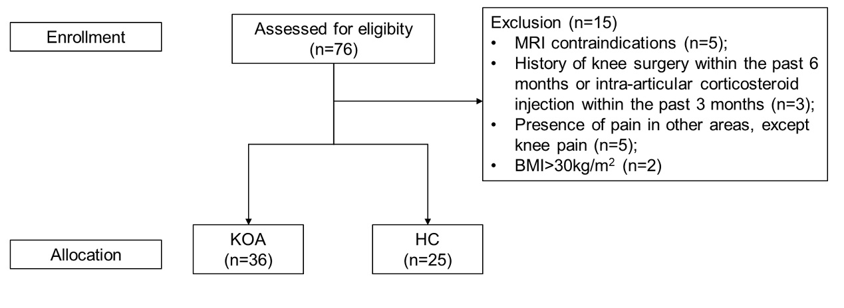

Figure S2. Visualization of the hippocampal subfield segmentations for a single subject
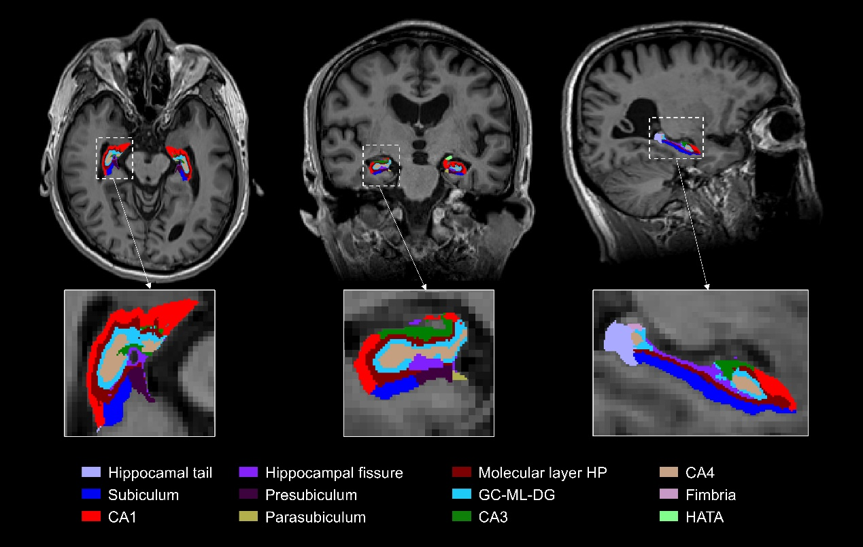
Abbreviations: GC-ML-DG, molecular layer of the dentate gyrus; HATA, hippocampal amygdala transition area.

Table S1. Partial correlation between cognitive scores and hippocampal subfield volume in KOA individuals and HCs.
 | MoCA scores |  | DCT-Correct responses
KOA (n=36) | r | P | r | P
left hippocampal fissure | -0.082 | 0.663 | 0.187 | 0.314
right hippocampal tail | -0.168 | 0.366 | -0.356 | 0.049
right subiculum | -0.078 | 0.675 | 0.042 | 0.823
right hippocampal fissure | 0.235 | 0.204 | 0.159 | 0.393
HCs (n=25)
left hippocampal fissure | -0.554 | 0.009 | -0.199 | 0.388
right hippocampal tail | 0.643 | 0.002 | 0.349 | 0.121
right subiculum | 0.441 | 0.045 | -0.305 | 0.178
right hippocampal fissure | -0.187 | 0.417 | -0.044 | 0.849
Notes: Abbreviations: KOA, knee osteoarthritis; HCs, healthy controls; MoCA, the Montreal Cognitive Assessment; DCT, digit cancellation test; Correct responses, the number of digits of correct responses.

Table S2. Partial correlation between cognitive scores and KOOS subscales in KOA individuals and HCs.
 | MoCA scores |  | DCT-Correct responses
 | r | P | r | P
KOA (n=36)
Pain | 0.349 | 0.059 | 0.123 | 0.519
Symptoms | 0.227 | 0.227 | -0.028 | 0.884
ADL | 0.444 | 0.014 | 0.230 | 0.221
Sport | 0.313 | 0.092 | 0.231 | 0.219
Quality of life | 0.167 | 0.378 | 0.161 | 0.395
HCs (n=25)
Pain | 0.071 | 0.754 | -0.141 | 0.530
Symptoms | -0.059 | 0.795 | -0.184 | 0.413
ADL | 0.218 | 0.330 | -0.060 | 0.792
Sport | 0.168 | 0.454 | 0.303 | 0.171
Quality of life | -0.049 | 0.827 | 0.034 | 0.881
Notes: Abbreviations: KOA, knee osteoarthritis; HCs, healthy controls; MoCA, the Montreal Cognitive Assessment; DCT, digit cancellation test; Correct responses, the number of digits of correct responses; ADL, the KOOS subtest of activities of daily living; Sport, the KOOS subtest of sport and recreation function; Quality of life, the KOOS subtest of knee-related quality of life.
Table S3. Partial correlation between hippocampal subfield volume and serum TIM-3 levels in KOA individuals.
The volume of the hippocampal subfields | Tim-3
The volume of the hippocampal subfields | r | P
left hippocampal fissure | -0.404 | 0.030
right hippocampal tail | 0.077 | 0.692
right subiculum | -0.072 | 0.710
right hippocampal fissure | -0.144 | 0.455
Notes: Abbreviations: KOA, knee osteoarthritis; TIM-3, T-cell immunoglobulin and mucin-domain containing-3 protein.

