Supplemental Information
Injectable self-assembling procyanidin nanospheres for effective osteoarthritis treatment
Guangjie Li^{1,2,#}, Fei He^{2,#}, Jianbao Feng³, Ge Xu¹, Chengye Wu¹, Yufei Qiao¹, Yang Liu³, Hanlin Chen¹, Pengcheng Du⁴, Jizeng Wang^{2,}*
¹The First Hospital of Lanzhou University, Lanzhou, 730030, China.
²College of Civil Engineering and Mechanics, Lanzhou University, Lanzhou, 730000, China.
³Hospital of Stomatology, Lanzhou University, Lanzhou, 730000, China.
⁴College of chemistry and chemical engineering, Lanzhou University, 730000, China.
*Correspondence: Jizeng Wang Email: jzwang@lzu.edu.cn

Materials and methods
MRI
After Rats were anesthetized with 10% chloral hydrate, the MRI scans of the knee joint was performed by a 3.0 Tesla magnetic resonance scanner and 16-channel knee coil, and the scan were acquired using a T2-weighted magnetic resonance imaging (TR= TR=2700ms, TE=120ms, image matrix 256×256, thickness 2.0mm, 11 slices).
Histological
After MRI the rats were immediately euthanized. The knee joints were removed and fixed in the 4% paraformaldehyde (Solarbio, Beijing, China) for 24 h at room temperature. Decalcification was performed using 10% nitric acid (Beijing Chemical Works, Beijing, China) for 24 h. The decalcified joints were dehydrated using gradient alcohol (70%-100%), embedded in paraffin and cut into 5 µm thick sections. The slides were baked at 60 ℃ until completely dried. The sections were stained with hematoxylin for 30 min and eosin for 5 s, visualization was performed by using a microscope (BX53, Olympus, Japan) after the sections were sealed with neutral balsam (Solarbio, Beijing, China).

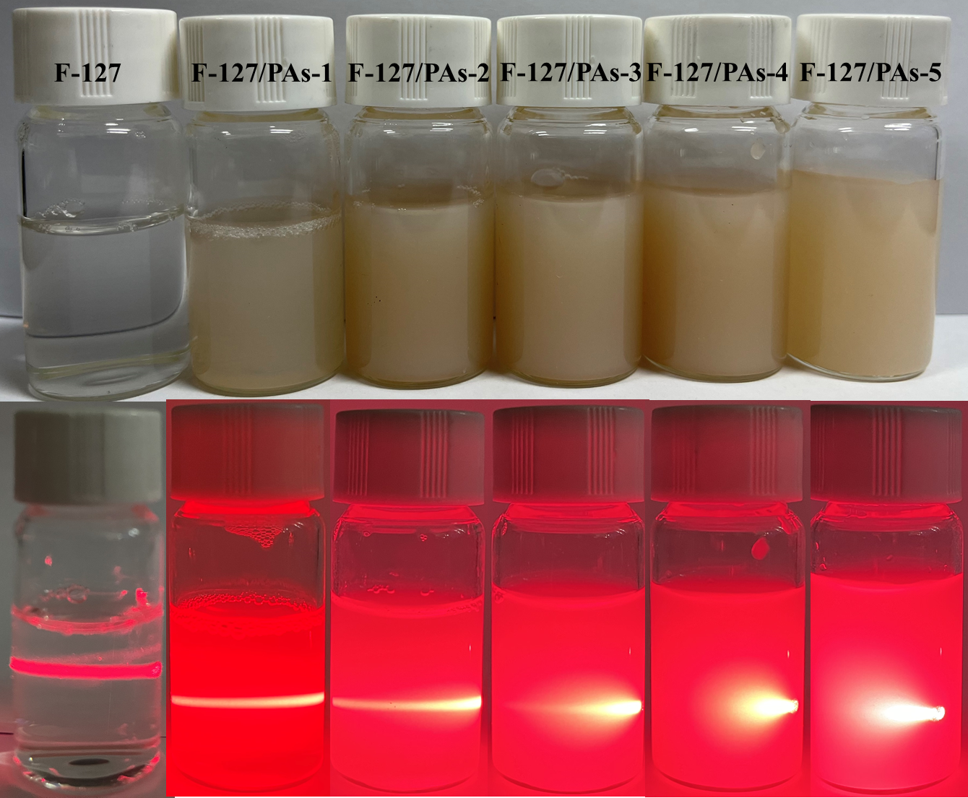
Fig. S1. Phots of Picture of PF127, PA-1/PF127, PA-2/PF127, PA-3/PF127, PA-4/PF127, and PA-5/PF127 and their Tyndall effect.

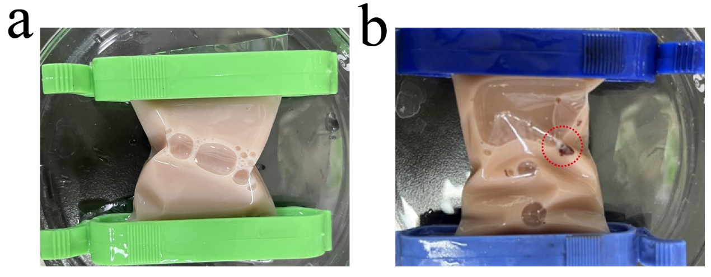
Fig. S2. The dispersibility of PAs-4/PF127 (a) and PAs-5/PF127 (b). The PAs-5/PF127 had agglomerated (Red dotted line).

Fig. S3. COL1A1 and COL3A1 expression of L929 fibroblast after 14 days’ co-culture with procyanidins. *p < 0.05.

Table S1 P-valve of Figure 3A
 | Vehicle | 5% PAs/PF127 | 10% PAs/PF127 | 20% PAs/PF127
Vehicle | — | 0.049 | ＜0.001 | ＜0.001
5% PAs/PF127 | 0.049 | — | 0.541 | ＜0.001
10% PAs/PF127 | ＜0.001 | 0.541 | — | ＜0.001
20% PAs/PF127 | ＜0.001 | ＜0.001 | ＜0.001 | —

Table S2 P-valve of Figure 3A box
 | 10% PAs/PF127 | PF127 | PAs
10% PAs/PF127 | — | 0.314 | ＜0.001
PF127 | 0.314 | — | ＜0.001
PAs | ＜0.001 | ＜0.001 | —

Table S3 P-valve of Figure 3B
 | Vehicle | 5% PAs/PF127 | 10% PAs/PF127 | 20% PAs/PF127
Vehicle | — | ＜0.001 | ＜0.001 | ＜0.001
5% PAs/PF127 | ＜0.001 | — | 1 | ＜0.001
10% PAs/PF127 | ＜0.001 | 1 | — | ＜0.001
20% PAs/PF127 | ＜0.001 | ＜0.001 | ＜0.001 | —

Table S4 P-valve of Figure 3B box
 | 10% PAs/PF127 | PF127 | PAs
10% PAs/PF127 | — | 0.002 | ＜0.001
PF127 | 0.002 | — | ＜0.001
PAs | ＜0.001 | ＜0.001 | —

Table S5 P-valve of Figure 4Aa (COL1A1)
 | Vehicle | 5% PAs/PF127 | 10% PAs/PF127 | 20% PAs/PF127
Vehicle | — | 0.003 | ＜0.001 | ＜0.001
5% PAs/PF127 | 0.003 | — | 0.002 | ＜0.001
10% PAs/PF127 | ＜0.001 | 0.002 | — | ＜0.001
20% PAs/PF127 | ＜0.001 | ＜0.001 | ＜0.001 | —

Table S6 P-valve of Figure 4Aa box (COL1A1)
 | 10% PAs/PF127 | PF127 | PAs
10% PAs/PF127 | — | ＜0.001 | 0.001
PF127 | ＜0.001 | — | ＜0.001
PAs | 0.001 | ＜0.001 | —

Table S7 P-valve of Figure 4Ab (COL3A1)
 | Vehicle | 5% PAs/PF127 | 10% PAs/PF127 | 20% PAs/PF127
Vehicle | — | ＜0.001 | ＜0.001 | ＜0.001
5% PAs/PF127 | ＜0.001 | — | 0.002 | ＜0.001
10% PAs/PF127 | ＜0.001 | ＜0.001 | — | ＜0.001
20% PAs/PF127 | ＜0.001 | ＜0.001 | ＜0.001 | —

Table S8 P-valve of Figure 4Ab box (COL3A1)
 | 10% PAs/PF127 | PF127 | PAs
10% PAs/PF127 | — | ＜0.001 | 0.03
PF127 | ＜0.001 | — | ＜0.001
PAs | 0.03 | ＜0.001 | —

Table S9 P-valve of Figure 4Bb
 | Vehicle | PAs | PF127 | 5% PAs/PF127 | 10% PAs/PF127 | 20% PAs/PF127
Vehicle | — | ＜0.001 | ＜0.001 | ＜0.001 | ＜0.001 | ＜0.001
PAs | ＜0.001 | — | ＜0.001 | ＜0.001 | ＜0.001 | ＜0.001
PF127 | ＜0.001 | ＜0.001 | — | ＜0.001 | ＜0.001 | ＜0.001
5% PAs/PF127 | ＜0.001 | ＜0.001 | ＜0.001 | — | ＜0.001 | ＜0.001
10% PAs/PF127 | ＜0.001 | ＜0.001 | ＜0.001 | ＜0.001 | — | ＜0.001
20% PAs/PF127 | ＜0.001 | ＜0.001 | ＜0.001 | ＜0.001 | ＜0.001 | —

Table S10 P-valve of Figure 4Bc (COL2A1)
 | Vehicle | 5% PAs/PF127 | 10% PAs/PF127 | 20% PAs/PF127
Vehicle | — | 1 | 0.122 | 0.285
5% PAs/PF127 | 1 | — | 0.032 | 0.072
10% PAs/PF127 | 0.122 | 0.032 | — | 1
20% PAs/PF127 | 0.285 | 0.072 | 1 | —

Table S11 P-valve of Figure 4Bc box (COL2A1)
 | 10% PAs/PF127 | PF127 | PAs
10% PAs/PF127 | — | 0.038 | 0.007
PF127 | 0.038 | — | 0.524
PAs | 0.007 | 0.524 | —

Table S12 P-valve of Figure S3 (COL1A1)
 | Control | 1 μg/mL PAs | 10 μg/mL PAs
Control | — | 0.454 | 0.22
1 μg/mL PAs | 0.454 | — | 1
10 μg/mL PAs | 0.22 | 1 | —

Table S13 P-valve of Figure S3 (COL3A1)
 | Control | 1 μg/mL PAs | 10 μg/mL PAs
Control | — | 0.724 | 0.382
1 μg/mL PAs | 0.724 | — | 1
10 μg/mL PAs | 0.382 | 1 | —

