Supplementary Tables

Table S1
Table S1. All the antibodies and reagents utilized in this investigation
Antibodies and Reagents | Manufacturer, Country, Cat number, Lot number | Concentration
Roswell Park Memorial Institute 1640 (RPMI-1640) | Gibco, USA, 31870082, 8123063 | -
Dulbecco’s modified Eagle’s medium (DMEM) | Gibco, USA, C11995500BT, 8122778 | -
Phosphate buffered saline (PBS) | Gibco, USA, 70011-044, 8123148 | -
Fetal bovine serum (FBS) | Gibco, USA, 10099-141, 2375386CP | -
Trypsin | Gibco, USA, 25300-054, 2509042 | -
Puromycin | Beyotime Biotechnology, China，ST551-10mg,050823230613 | -
4% Paraformaldehyde | Biosharp, China, BL539A,23159313
4',6-diamidino-2-phenylindole  (DAPI) | Beyotime Biotechnology, China, C1002,  091620210520 | -
Immunastaining Permeabilization Buffer with TritonX-100 | Beyotime Biotechnology, China, P0096-100ml,042921211027 | -
Protease and phosphatase inhibitor cocktail for genneraluse,50X | Beyotime Biotechnology, China, P1045,051823230618 | -
bovine serum albumin (BSA) | Vazyme, USA, B2270DBA,027E2270DA | -
Crystal violet | Beyotime Biotechnology, China, C0121-100ml,121322230524 | -
Radioimmunoprecipitation assay buffer (RIPA buffer) | Beyotime Biotechnology,China，P0013B,052523230703 | -
Sodium dodecyl-sulfate polyacrylamide gel electrophoresis (SDS-PAGE) | EpiZyme, China, LK209,02652030 | -
Tricolor Prestained Protein Marker | EpiZyme, China, WJ103,027352000 | -
Lipofectamine 3000 | Invitrogen, USA, L3000-015, 2395298 | -
Opti-MEM | Gibco, USA, 31985-070, 2276923 | -
Bicinchoninic acid (BCA)  Assay Kit | Thermo Fisher Scientific, USA, 23227, XJ357433 | -
Tyramide signal amplification biotin system kit | UElady Biotechnology, China, Y6082L,210413L2-1 | -
Hematoxylin-Eosin staining Kit | Solarbio life sciences, China, G1120, 20220325 | -
POLR2C Polyclonal antibody | Proteintech, USA, 13428-1-AP, 00142052 | IHC 1:100  IF 1:100  WB 1:1000
CDK2 Polyclonal antibody | Proteintech, USA, 10122-1-AP, 10038341 | IF 1:100
Anti-CK Rabbit polyclonal Antibody | Cell Signaling Technology, USA, 12509, 3 | IF 1:100
NSD1 Polyclonal Antibody | Thermo Fisher Scientific, USA, PA5-147548, WJ3394133 | IF 1:100
RPB5 (POLR2E) Polyclonal antibody | Proteintech, USA, 15217-1-AP, 93570 | WB 1:1000
POLR3K Polyclonal Antibody | Thermo Fisher Scientific, USA, PA5-103798, ZE4322048A | WB 1:1000
POLR3H Polyclonal antibody | Proteintech, USA, 16423-1-AP, 58018 | WB 1:1000
POLR2L Polyclonal antibody | Proteintech, USA, 15779-1-AP, 83762 | WB 1:1000
YY1 Monoclonal antibody | Proteintech, USA, 66281-1-Ig, 10017826 | IHC 1:200  WB 1:1000
Anti-β-actin Mouse polyclonal Antibody | Proteintech, USA, 20536-1-AP, 81115-1-RR | WB 1:5000
Anti-CXCR4 antibody | Abcam, England, ab124824, g2195839-2 | IF 1:100  IHC 1:400
Anti-CD44 antibody | Abcam, England, ab254530, g23242263-6 | IF 1:100  IHC 1:200
CD74 Monoclonal antibody | Proteintech, USA, 66390-1-Ig, 10021293 | IF 1:200  IHC 1:200
Anti-GAPDH Mouse polyclonal Antibody | Abbrab, China, AB300016, 4659180001 | WB 1:3000
Anti-CD8 Mouse polyclonal Antibody | Cell Signaling Technology, USA, 55397, 3 | IHC 1:400
MIF Polyclonal antibody | Proteintech, USA, 20415-1-AP, 104042 | IHC 1:200  IF 1:100
CoraLite488-conjugated Goat Anti-Rabbit IgG(H+L) | Proteintech, USA, SA00013-2, 205001014 | IF 1:300
CoraLite594-conjugated Goat Anti-Mouse IgG(H+L) | Proteintech, USA, SA00013-3, 20000154 | IF 1:300
CoraLite647-conjugated Mouse Anti-Heavy Chain of Rabbit IgG | Proteintech, USA, SA00014-6, 20000129 | IF 1:300
Highly Cross-Adsorbed Goat (Polyclonal) Anti-Mouse IgG(H+L) Antibody | LI-COR, USA, 926-68070, Q04695 | WB 1:5000
Highly Cross-Adsorbed Goat (Polyclonal) Anti-Rabbit IgG(H+L) Antibody | LI-COR, USA, 926-68071, S11385 | WB 1:5000
Human MIF ELISA Kit | Shanghai Enzyme Linked Biology, mlsw_E1264, 06/2024 | -
Alexa Fluor® 488 anti-human CD3 | BioLegend, USA, clone: OKT3, 317310, B369206 | 2ul/1×10⁶ Cell
EasySep™ Human CD3 Positive Selection Kit | STEMCELL Technologies, Canada,  17851,1000142711 | -

Table S2
Table S2 Plasmid information
Item | Sequence (5′-3′)
si-RNA plasmid
si-YY1-3 | CGAGGAUCAGAUUCUCAUC
si-NC | UUCUCCGAACGUGUCACGU
Overexpression plasmid
POLR2C forward | ATGTTCGTTCCCTGCGGGGAGTCG
POLR2C reverse | TCAGAAAAGTGCAGGGGGAAGACCAC

Supplementary Figures

Figure S1
Figure S1. Transfection efficiency was verified by Western blot.
(A) Verification of siRNA YY1 knockdown efficiency.
(B) The transfection efficiency of POLR2C overexpression plasmid was validated via western blot analysis.
Data are shown as mean ± SEM, **** P <0.0001, *** P <0.001, ** P < 0.01, *P < 0.05 vs. NC group (ANOVA). All assays were replicated thrice, independently.

Figure S2
Figure S2. CD3+ T cells were isolated using CD3 magnetic beads and were at least 95% pure.

Figure S3

Figure S3. The POLRs and related molecules regulatory network constructed by the NetworkAnalyst.

Figure S4
Figure S4. Copy number variation (CNV) analysis of POLR genes across various cancer types.
(A) The amplification and deletion percentage of heterozygous CNV for each POLR gene in each cancer type. The left panel displays heterozygous amplifications (red dots), and the right panel shows heterozygous deletions (blue dots). The size of the dots corresponds to the percentage of CNV, with larger dots indicating higher frequency.
(B) The amplification and deletion percentage of homozygous CNV for each POLR gene in each cancer type. The left panel displays homozygous amplifications (red dots), and the right panel shows homozygous deletions (blue dots). The size of the dots corresponds to the percentage of CNV, with larger dots indicating higher frequency.

Figure S5
Figure S5. The bubble chart shows the correlation between methylation of the 34 POLR-related molecules and mRNA expression. Red shows a positive correlation and blue shows a negative correlation. The darker color indicates a larger correlation index. Bubble size indicates the FDR.

Figure S6
Figure S6. POLR expression level ascend in malignant cells.
(A) Uniform manifold approximation and projection (UMAP) plots showing the distribution of annotated cell types identified in single-cell RNA-seq (scRNA-seq) datasets: GSE103322 (HNSC), GSE172577 (OSCC), and GSE150321 (LSCC). Cell types include malignant cells, immune cells (e.g., CD8+ T cells, CD4+ T cells, Tregs), stromal cells (e.g., fibroblasts, endothelial cells), and others.
(B) Bubble plots displaying the expression levels and percentage of marker genes specific to each cell type in the scRNA-seq datasets GSE103322 (HNSC), GSE172577 (OSCC), and GSE150321 (LSCC). The size of the bubbles represents the percentage of cells expressing the marker, while the color intensity reflects the average expression level.
(C) Bar plots depicting the proportion of each cell type across samples in the scRNA-seq datasets GSE103322 (HNSC), GSE172577 (OSCC), and GSE150321 (LSCC). Malignant cells constitute a significant proportion of the cellular composition in all datasets.

Figure S7
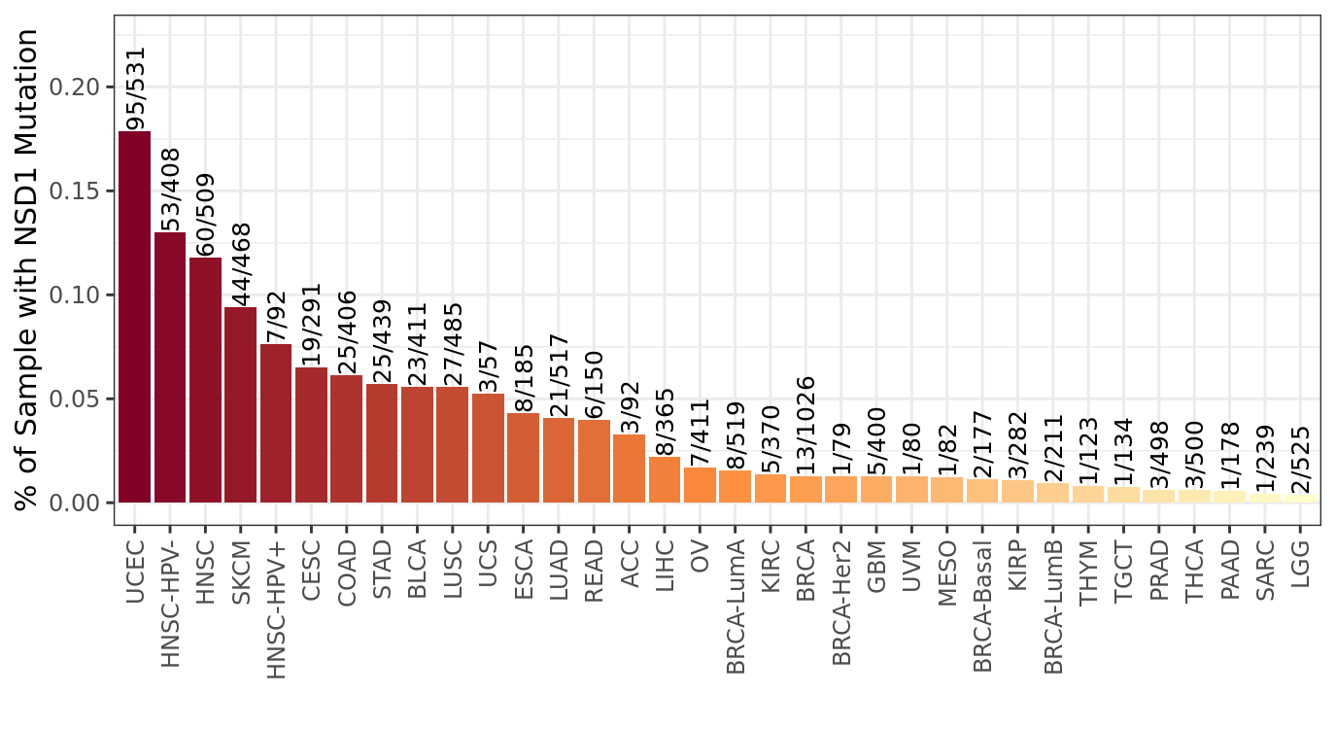
Figure S7. Bar graph generated by TIMER demonstrating the mutation frequency of NSD1 in pan-cancer.

Figure S8
Figure S8. Cell-cycle analysis of POLRs based on HPA database.
(A-B) Relative expression levels of POLR1A (A) and POLR3E (B) at different cell division phases. Left: protein level (blue); right: transcriptome level (orange). Data are from HPA database, only POLR1A- and POLR3E-related information can be obtained.

Figure S9
Figure S9. UMAP dimensionality reduction analysis.
UMAP plots showing the distribution of cell clusters identified in single-cell RNA-seq datasets from head and neck squamous cell carcinoma (HNSC), oral squamous cell carcinoma (OSCC), and laryngeal squamous cell carcinoma (LSCC) based on data provided by TISCH. A total of 20, 35, and 19 cell clusters were identified in HNSC, OSCC, and LSCC datasets, respectively. Each cluster is color-coded, and cluster identities are annotated with numbers, representing distinct transcriptional profiles and cellular states.

Figure S10
Figure S10. Cellchat analysis.
(A-C) Heatmaps showing the differences in input (left), output (middle), and total (right) signaling patterns between POLR-high and POLR-low groups in HNSC (A), OSCC (B), and LSCC (C).

