Figure S1. Video screenshots of LNCaP cells and T cells co-cultured for 16 h. (A) Co-culture only; (B) co-culture with a low concentration of BiPTE; and (C) co-culture with a high concentration of BiPTE.

Figure S2. Video screenshots of PC3 cells and T cells co-cultured for 16 h. (A) Co-culture only; (B) co-culture with a low concentration of BiPTE; and (C) co-culture with a high concentration of BiPTE.

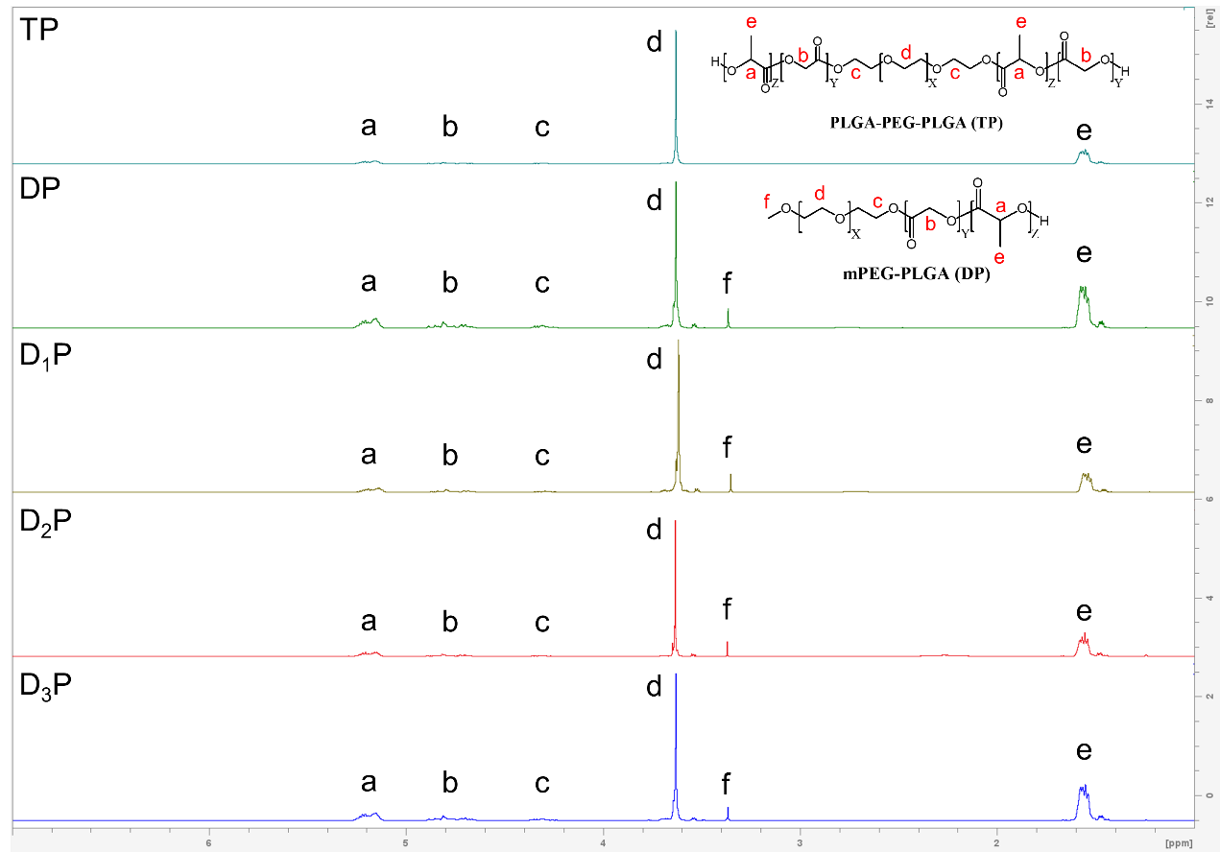
Figure S3. The ¹H-NMR spectrum of mPEG–PLGA (DP) and PLGA–PEG–PLGA (TP).

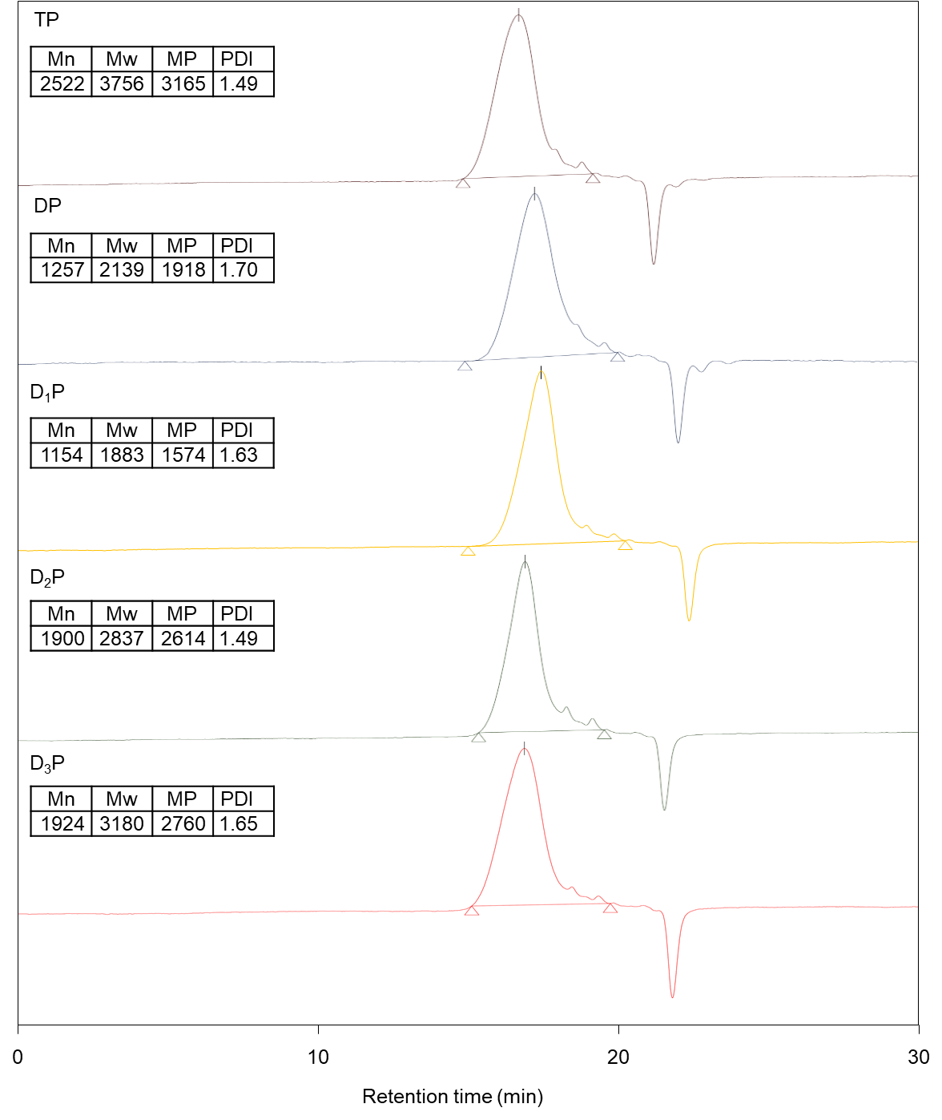
Figure S4. The GPC analysis of mPEG–PLGA (DP) and PLGA–PEG–PLGA (TP).

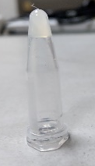
Figure S5. Image of the sample in the gelling type after inversion.

Figure S6. In the equation $ln{{[(1-M}_{t}}/{M_{0})/{(8}/{π^{2})}]}=(-π^{2}D/l^{2})t$, linear regression was performed for the release profiles of each nsTPPgel group. For each group, 4–6 time points were used to achieve the maximum 𝑅² value.

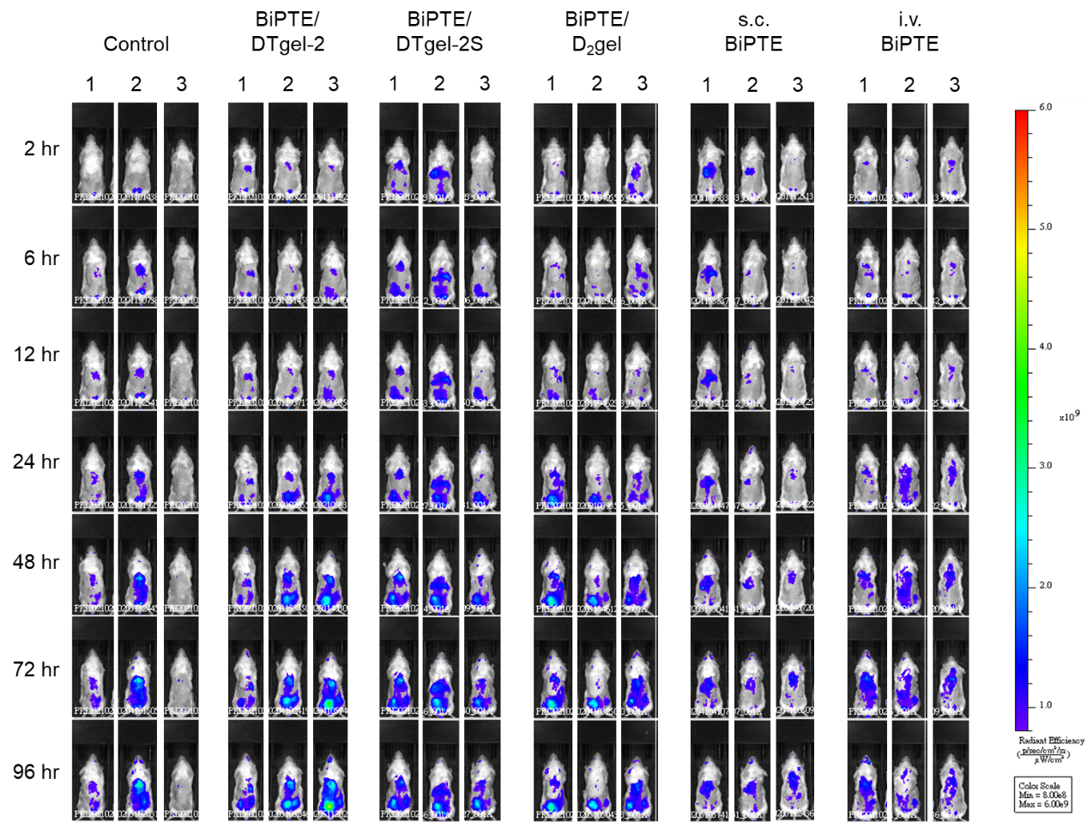Figure S7. In vivo images of LNCaP-xenograft mice injected with DiR-labeled a-huPBMCs after being administrated intravenous (i.v.) BiPTE sol, subcutaneous (s.c.) BiPTE sol, BiPTE/DTgel-2, BiPTE/DTgel-2S, and BiPTE/D₂gel (at 5 mg/kg body weight) at 2, 6, 12, 24, 52, 72 and 96 h, obtained with an IVIS spectrum optical imaging system.

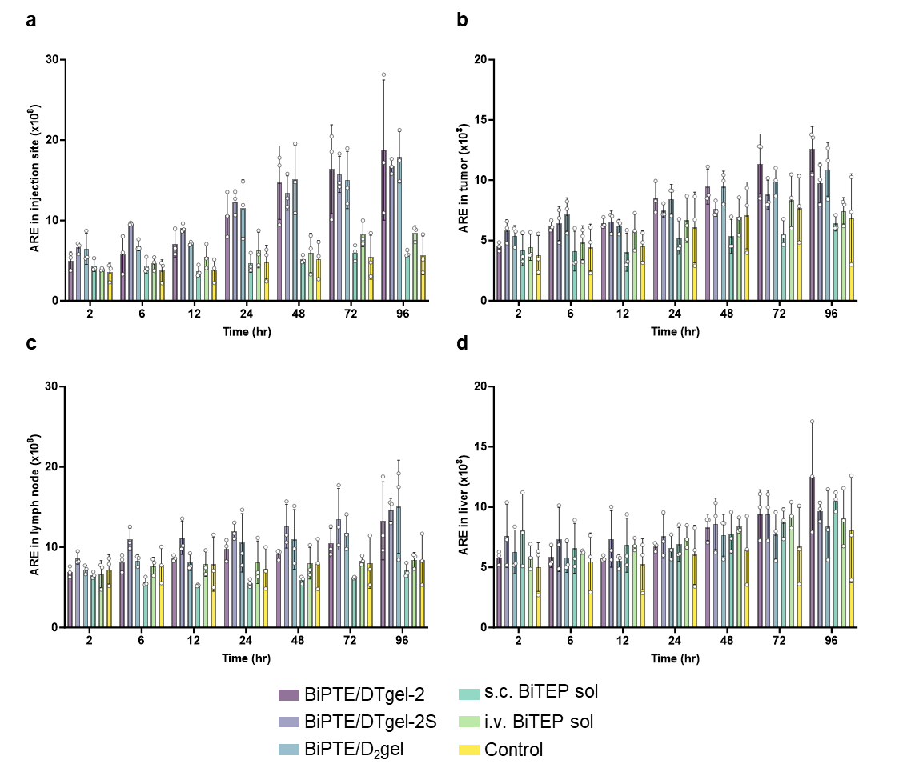Figure S8. Average radiant efficiencies (ARE) of DiR-labeled a-huPBMCs in the injection site (a), tumor site (b), lymph nodes (c), and liver (d) at 2, 6, 12, 24, 52, 72, and 96 h. Data are expressed as mean ± standard deviation (n = 3).
Table S1. The formulations of 15% and 20% BSA or /nsTPPgel.
Formulation | 25% TP (µL) | 25% DP (µL) | PBS  (µL) | 10× PBS (µL) | BSA  (µg) | BiPTE  (µg)
20% DTgel-2 | 240 | 160 | 100 | 0 | 500 | -
20% DTgel-2S | 240 | 160 | 73 | 27 | 500 | -
20% D₂gel | 0 | 400 | 100 | 0 | 500 | -
15% DTgel-2 | 180 | 120 | 200 | 0 | 500 | 500
15% DTgel-2S | 180 | 120 | 173 | 27 | 500 | 500
15% D₂gel | 0 | 300 | 200 | 0 | 500 | 500
BiPTE, bispecific anti-PSMA Fab/anti-CD3 scFv T cell engager; BSA, bovine serum albumin; DP, diblock copolymer; PBS, phosphate-buffered saline; TP, triblock copolymer

Table S2. The gelling temperature and storage modulus (G′) of each nsTPPgel formulation.
Formulation | Gelling temperature (°C) | G’ (Pa) at 37 °C
20% DTgel-2 | 29.5 | 61.7
20% DTgel-2S | 22.3 | 185.2
20% D₂gel | 21.2 | 162.5
15% DTgel-2 | 30.5 | 51.8
15% DTgel-2S | 30.5 | 52.0
15% D₂gel | 29.5 | 67.4

Table S3. The tumor volume of each group on day 0, day 14, and day 21. Data are expressed as mean ± SD (n = 4). The statistical differences were analyzed using one-way ANOVA followed by Tukey post hoc test for comparisons between groups.
Group | Day 0 tumor volume (mm³) | Day 14 tumor volume (mm³) | Day 21 tumor volume (mm³)
Control | 84.5±38.6 | 243.3±121.2 | 443.4±145.1
i.v. BiPTE solution | 82.5±33.2 | 233.4±132.3 | 309.2±117.7
s.c. BiPTE solution | 81.3±34.2 | 200.2±65.5 | 275.1±64.7
BiPTE/DTgel-2 | 80.6±23.4 | 96.9±54.3 | 181.6±87.6*
BiPTE/DTgel-2S | 77.0±24.5 | 39.4±16.8*, # | 91.9±16.1**
BiPTE/D₂gel | 79.4±29.3 | 29.4±21.6*, # | 32.5±20.8***, #, †
*p < 0.05, **p < 0.01, and ***p < 0.001 compared to the control group in one-way ANOVA.
#p < 0.05 compared to intravenous (i.v.) BiPTE solution group in one-way ANOVA.
†p < 0.05 compared to subcutaneous (s.c.) BiPTE solution group in one-way ANOVA.

