Novel nanozyme-based multicomponent in situ hydrogels with antibacterial, hypoxia-relieving and proliferative properties for promoting gastrostomy tube tract maturation
Feng Xiao^{1,} *, Bisong Yan^{2,} *, Tianwen Yuan², Yang He², Xiaojun Zhang³, Xiaoyun He¹, Wei Peng¹, Ying Xu³, Jun Cao^{,1,4}

¹ Shanghai Eighth People's Hospital, Xuhui District, Shanghai, China, 200030;
² Department of Interventional Oncology, Dahua Hospital, Xuhui District, Shanghai, China, 200237;
³ College of Pharmacy, Jiangsu University, Zhenjiang, China, 212013;
⁴ Shanghai University of Medicine and Health Science, Pudong New Area, Shanghai, 201318.

*These authors contributed equally to this work.

Results：
Figure S1. DLS analysis of n-MO (particle size based on volume and number).
Figure S2. The fluorescence intensity of the RDPP solution without n-MO and H₂O₂ under pH 7.4 or4.0.
Figure S3. TNF-α, IL-1β, and IL-6 concentrations of control and MO-HPA_{1.0} hydrogels treated group (*p < 0.05, **p < 0.01***p < 0.001, 95% CI, n=3).

Figure S1. DLS analysis of n-MO (particle size based on volume and number).

Figure S2. The fluorescence intensity of the RDPP solution without n-MO and H₂O₂ under pH 7.4 or 4.0.

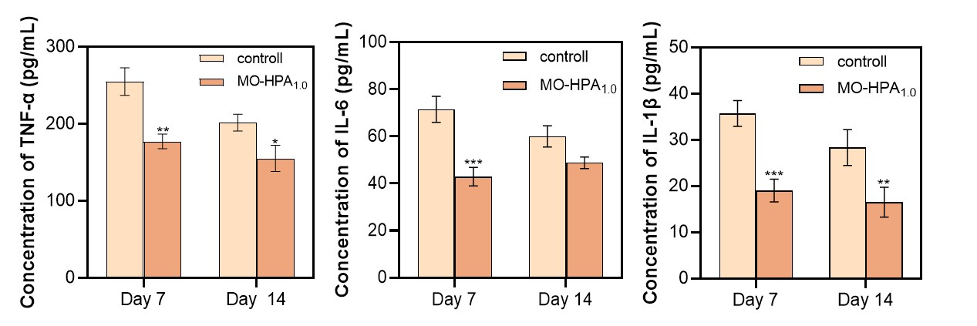
Figure S3. TNF-α, IL-1β, and IL-6 concentrations of control and MO-HPA_{1.0} hydrogels treated group (*p < 0.05, **p < 0.01***p < 0.001, 95% CI, n=3).

