Supplementary Materials

Supplementary Table 1: Parameters estimate for different administration with one compartment kinetic with no delayed absorption for vancomycin models.
Parameter | Bolus and linear elimination |  | Bolus no delay and non-linear elimination |  | Infusion no delay and linear elimination |  | Infusion no delay and non-linear elimination
 | Value | RES % | Value | RES % | Value | RES % | Value | RES %
-2LL | 377.54 |  | 383.34 |  | 377.54 |  | 383.34
AIC | 387.54 |  | 397.34 |  | 387.54 |  | 397.34
BIC | 406.69 |  | 424.14 |  | 406.69 |  | 424.14
V | 180.23 | 12.2 | 233.09 | 8.35 | 180.23 | 12.2 | 233.09 | 8.35
CL | 0.94 | 32.9 | -- | -- | 0.94 | 32.9 | -- | --
Vm | -- | -- | 0.041 | 376 | -- | -- | 0.041 | 376
Km | -- | -- | 0.86 | 874 | -- | -- | 0.86 | 874
Omega V | 0.34 | 35.8 | 0.39 | 18.3 | 0.34 | 35.8 | 0.39 | 18.3
Omega CL | 0.64 | 54 | -- | -- | 0.64 | 54 | -- | --
Omega, Vm | -- | -- | 2.71 | 114 | -- | -- | 2.71 | 114
Omeag, Km | -- | -- | 2.94 | 153 | -- | -- | 2.94 | 153
b | 0.39 | 14.6 | 0.36 | 20.8 | 0.39 | 14.6 | 0.36 | 20.8

Supplementary Table 2: Parameters estimate for different administration with one compartment kinetic with lag time absorption for vancomycin models.
Parameter | Bolus and linear elimination |  | Bolus and non-linear elimination |  | Infusion and linear elimination |  | Infusion and non-linear elimination
 | Value | RES % | Value | RES % | Value | RES % | Value | RES %
-2LL | 375.53 |  | 383.28 |  | 375.53 |  | 383.28
AIC | 389.53 |  | 401.28 |  | 389.53 |  | 401.28
BIC | 416.34 |  | 435.74 |  | 416.34 |  | 435.74
Tlag | 0.067 | 338 | 0.2 | 161 | 0.067 | 338 | 0.2 | 161
V | 158.62 | 12.5 | 229.36 | 6.79 | 158.62 | 12.5 | 229.36 | 6.79
CL | 1.33 | 16.2 | -- | -- | 1.33 | 16.2 | -- | --
Vm | -- | -- | 0.033 | 552 | -- | -- | 0.033 | 552
Km | -- | -- | 5.79 | 310 | -- | -- | 5.79 | 310
Omega Tlag | 2.22 | 39 | 1.99 | 40.4 | 2.22 | 39 | 1.99 | 40.4
Omega V | 0.49 | 28.5 | 0.38 | 31 | 0.49 | 28.5 | 0.38 | 31
Omega CL | 0.31 | 42.2 | -- | -- | 0.31 | 42.2 | -- | --
Omega Vm | -- | -- | 2.87 | 132 | -- | -- | 2.87 | 132
Omega Km | -- | -- | 1.92 | 247 | -- | -- | 1.92 | 247
b | 0.37 | 14.3 | 0.37 | 13.7 | 0.37 | 14.3 | 0.37 | 13.7

Supplementary Table 3: Parameters estimate for different administration with two compartment kinetic with no delayed absorption for vancomycin models.
Parameter | Bolus and linear elimination |  | Bolus and non-linear elimination |  | Infusion and linear elimination |  | Infusion and non-linear elimination
 | Value | RES % | Value | RES % | Value | RES % | Value | RES %
-2LL | 375.44 |  | 378.7 |  | 375.44 |  | 378.7
AIC | 393.44 |  | 400.7 |  | 393.44 |  | 400.7
BIC | 427.9 |  | 442.82 |  | 427.9 |  | 442.82
V1 | 0.000000067 | 494 | 178.12 | 31.8 | 0.000000067 | 494 | 178.12 | 31.8
Q | 6.78 | 59.3 | 1.74 | 63.5 | 6.78 | 59.3 | 1.74 | 63.5
V2 | 127.91 | 25.7 | 125.58 | 346 | 127.91 | 25.7 | 125.58 | 346
CL | 0.97 | 55 | -- | -- | 0.97 | 55 | -- | --
Vm | -- | -- | 0.27 | 107 | -- | -- | 0.27 | 107
Km | -- | -- | 149.94 | 1110 | -- | -- | 149.94 | 1110
Omega V1 | 4.72 | 75.3 | 0.43 | 35.2 | 4.72 | 75.3 | 0.43 | 35.2
Omega Q | 0.56 | 73.5 | 0.85 | 108 | 0.56 | 73.5 | 0.85 | 108
Omega V2 | 0.39 | 79.4 | 1.52 | NaN | 0.39 | 79.4 | 1.52 | NaN
Omega CL | 0.26 | 55.9 | -- | -- | 0.26 | 55.9 | -- | --
Omega, Vm | -- | -- | 1.56 | 78 | -- | -- | 1.56 | 78
Omeag, Km | -- | -- | 5.7 | 31.2 | -- | -- | 5.7 | 31.2
b | 0.39 | 18.4 | 0.37 | 19.9 | 0.39 | 18.4 | 0.37 | 19.9

Supplementary Table 4: Parameters estimate for different administration with two compartment kinetic with lag time absorption for vancomycin models.
Parameter | Bolus and linear elimination |  | Bolus and non-linear elimination |  | Infusion and linear elimination |  | Infusion and non-linear elimination
 | Value | RES % | Value | RES % | Value | RES % | Value | RES %
-2LL | 376.31 |  | 376.4 |  | 376.31 |  | 376.4
AIC | 398.31 |  | 402.4 |  | 398.31 |  | 402.4
BIC | 440.43 |  | 452.19 |  | 440.43 |  | 452.19
Tlag | 0.17 | 130 | 0.31 | 70.9 | 0.17 | 130 | 0.31 | 70.9
V1 | 0.000032 | 271 | 137.81 | 19.7 | 0.000032 | 271 | 137.81 | 19.7
Q | 0.48 | 15.5 | 1.91 | 28.9 | 0.48 | 15.5 | 1.91 | 28.9
V2 | 41.3 | NaN | 740.13 | 99.9 | 41.3 | NaN | 740.13 | 99.9
CL | 0.51 | 9.76 | -- | -- | 0.51 | 9.76 | -- | --
Vm | -- | -- | 0.0017 | NaN | -- | -- | 0.0017 | NaN
Km | -- | -- | 784146821.5 | 1040 | -- | -- | 784146821.5 | 1040
Omega Tlag | 1.85 | 41.2 | 1.14 | 53.7 | 1.85 | 41.2 | 1.14 | 53.7
Omega V1 | 4.11 | 64 | 0.51 | 32.9 | 4.11 | 64 | 0.51 | 32.9
Omega Q | 0.19 | 55.7 | 0.43 | 61.5 | 0.19 | 55.7 | 0.43 | 61.5
Omega V2 | 0.29 | 61.2 | 1.38 | 33.7 | 0.29 | 61.2 | 1.38 | 33.7
Omega CL | 0.21 | 53.2 | -- | -- | 0.21 | 53.2 | -- | --
Omega, Vm | -- | -- | 1.87 | 41.5 | -- | -- | 1.87 | 41.5
Omeag, Km | -- | -- | 6.89 | NaN | -- | -- | 6.89 | NaN
b | 0.36 | 22.3 | 0.37 | 15.2 | 0.36 | 22.3 | 0.37 | 15.2

Supplementary Table 5: Parameters estimate for different administration with three compartment kinetic with no delayed absorption for vancomycin models.
Parameter | Bolus and linear elimination |  | Bolus and non-linear elimination |  |  |  | Infusion and linear elimination |  | Infusion and non-linear elimination
 | Value | RES % |  | Value | RES % |  | Value | RES % |  | Value | RES %
-2LL | 385.42 |  | 397.09 |  |  |  | 385.42 |  | 397.09
AIC | 401.42 |  | 409.09 |  |  |  | 401.42 |  | 409.09
BIC | 451.2 |  | 466.52 |  |  |  | 451.2 |  | 466.52
V1 | 0.02 | 588 | 208.36 |  |  | 42.3 | 0.02 | 588 | 208.36 |  |  | 42.3
Q | 12.55 | NaN | 0.82 |  |  | 241 | 12.55 | NaN | 0.82 |  |  | 241
V2 | 146.79 | 23.3 | 203.77 |  |  | 1370 | 146.79 | 23.3 | 203.77 |  |  | 1370
Q2 | 0.92 | 309 | 0.0000000000000061 |  |  | Nan | 0.92 | 309 | 0.0000000000000061 |  |  | Nan
V3 | 5.37 | 146 | 0.0028 |  |  | Nan | 5.37 | 146 | 0.0028 |  |  | Nan
CL | 0.85 | 36.6 | -- |  |  | -- | 0.85 | 36.6 | -- |  |  | --
Vm | -- | -- | 0.0037 |  |  | 975 | -- | -- | 0.0037 |  |  | 975
Km | -- | -- | 359.09 |  |  | 467 | -- | -- | 359.09 |  |  | 467
Omega V1 | 2.97 | 120 | 0.39 |  |  | 79.2 | 2.97 | 120 | 0.39 |  |  | 79.2
Omega Q | 1.47 | 48.5 | 0.44 |  |  | 192 | 1.47 | 48.5 | 0.44 |  |  | 192
Omega V2 | 0.35 | 83.7 | 4.92 |  |  | 101 | 0.35 | 83.7 | 4.92 |  |  | 101
Omega Q2 | 3.51 | NaN | 14.49 |  |  | 59.8 | 3.51 | NaN | 14.49 |  |  | 59.8
Omega V3 | 0.97 | 249 | 4.16 |  |  | NaN | 0.97 | 249 | 4.16 |  |  | NaN
Omega CL | 0.25 | 185 | -- |  |  | -- | 0.25 | 185 | -- |  |  | --
Omega, Vm | -- | -- | 3.61 |  |  | 35.3 | -- | -- | 3.61 |  |  | 35.3
Omeag, Km | -- | -- | 5.54 |  |  | 227 | -- | -- | 5.54 |  |  | 227
b | 0.33 | 35.2 | 0.4 |  |  | 64.1 | 0.33 | 35.2 | 0.4 |  |  | 64.1

Supplementary Table 6: Parameters estimate for different administration with three compartment kinetic with lag time absorption for vancomycin models.
Parameter | Bolus and linear elimination |  | Bolus and non-linear elimination |  |  |  | Infusion and linear elimination |  |  | Infusion and non-linear elimination
 | Value | RES % |  | Value | RES % |  | Value | RES % |  | Value | RES %
-2LL | 375.44 |  | 370.89 |  |  |  | 375.44 |  |  | 370.89
AIC | 405.44 |  | 404.89 |  |  |  | 405.44 |  |  | 404.89
BIC | 462.87 |  | 469.98 |  |  |  | 462.87 |  |  | 469.98
Tlag | 0.62 | Nan | 4.35 |  |  | 57.3 | 0.62 |  | Nan | 4.35 |  | 57.3
V1 | 0.0037 | 333 | 149.65 |  |  | 19.6 | 0.0037 |  | 333 | 149.65 |  | 19.6
Q | 0.067 | NaN | 2.89 |  |  | 59.3 | 0.067 |  | NaN | 2.89 |  | 59.3
V2 | 4.19 | NaN | 0.32 |  |  | 43.6 | 4.19 |  | NaN | 0.32 |  | 43.6
Q2 | 1.52 | 27.1 | 0.32 |  |  | NaN | 1.52 |  | 27.1 | 0.32 |  | NaN
V3 | 59.99 | 11.6 | 0.00035 |  |  | 507 | 59.99 |  | 11.6 | 0.00035 |  | 507
CL | 0.9 | 16.8 | -- |  |  | -- | 0.9 |  | 16.8 | -- |  | --
Vm | -- | -- | 0.02 |  |  | 422 | -- |  | -- | 0.02 |  | 422
Km | -- | -- | 76832.93 |  |  | NaN | -- |  | -- | 76832.93 |  | NaN
Omega Tlag | 1.54 | 25.7 | 0.59 |  |  | 114 | 1.54 |  | 25.7 | 0.59 |  | 114
Omega V1 | 2.23 | 43.9 | 0.45 |  |  | 43.1 | 2.23 |  | 43.9 | 0.45 |  | 43.1
Omega Q | 0.87 | 48 | 0.59 |  |  | NaN | 0.87 |  | 48 | 0.59 |  | NaN
Omega V2 | 2.59 | 106 | 0.53 |  |  | 45.2 | 2.59 |  | 106 | 0.53 |  | 45.2
Omega Q2 | 0.46 | 36.8 | 7.65 |  |  | NaN | 0.46 |  | 36.8 | 7.65 |  | NaN
Omega V3 | 0.24 | NaN | 4 |  |  | NaN | 0.24 |  | NaN | 4 |  | NaN
Omega CL | 0.18 | 43.9 | -- |  |  | -- | 0.18 |  | 43.9 | -- |  | --
Omega, Vm | -- | -- | 2.84 |  |  | NaN | -- |  | -- | 2.84 |  | NaN
Omeag, Km | -- | -- | 7.17 |  |  | 35.6 | -- |  | -- | 7.17 |  | 35.6
b | 0.36 | 21.8 | 0.37 |  |  | 16.1 | 0.36 |  | 21.8 | 0.37 |  | 16.1

Supplementary Table 7: Covariates testing on the base pharmacokinetic model.
Parameter | OFV (-2LL) | Difference | P-value
Base model | 377.5
CrCl effect on CL | 368.5
CRP effect on CL | 365.3
Age effect on CL | 376.2
Gender effect on CL | 373.5
Weight effect on CL | 376.4
Albumin effect on CL | 376.3
CrCl effect on V | 376.4
CRP effect on V | 369.5
Age effect on V | 376.6
Gender effect on V | 378.9
Weight effect on V | 377.3
Albumin effect on V | 374.3

Supplementary Table 8: Backward deletion of statistically significant covariates from near final model
Parameter | OFV (-2LL) | Difference | P-value
Covariate Base model | 348.6
CRP effect on V | 349.7
CrCl effect on CL | 364.3
CRP effect on CL | 361.1
Gender effect on CL | 355

Supplementary Table 9: Simulated volume of distribution and clearance for different groups based on their CRP or CrCl value.
 | CRP | CrCl | Median V | Median Cl
Group 1 | 20 | 90 | 198 | 3
Group 2 | 85 | 90 | 195 | 0.2
Group 3 | 180 | 90 | 196 | 0.001
Group 4 | 20 | 60 | 195 | 2.2
Group 5 | 70 | 60 | 195 | 0.2
Group 6 | 150 | 60 | 193 | 0.0007
Group 7 | 10 | 30 | 192 | 1.6
Group 8 | 70 | 30 | 195 | 0.1
Group 9 | 150 | 30 | 194 | 0.0005

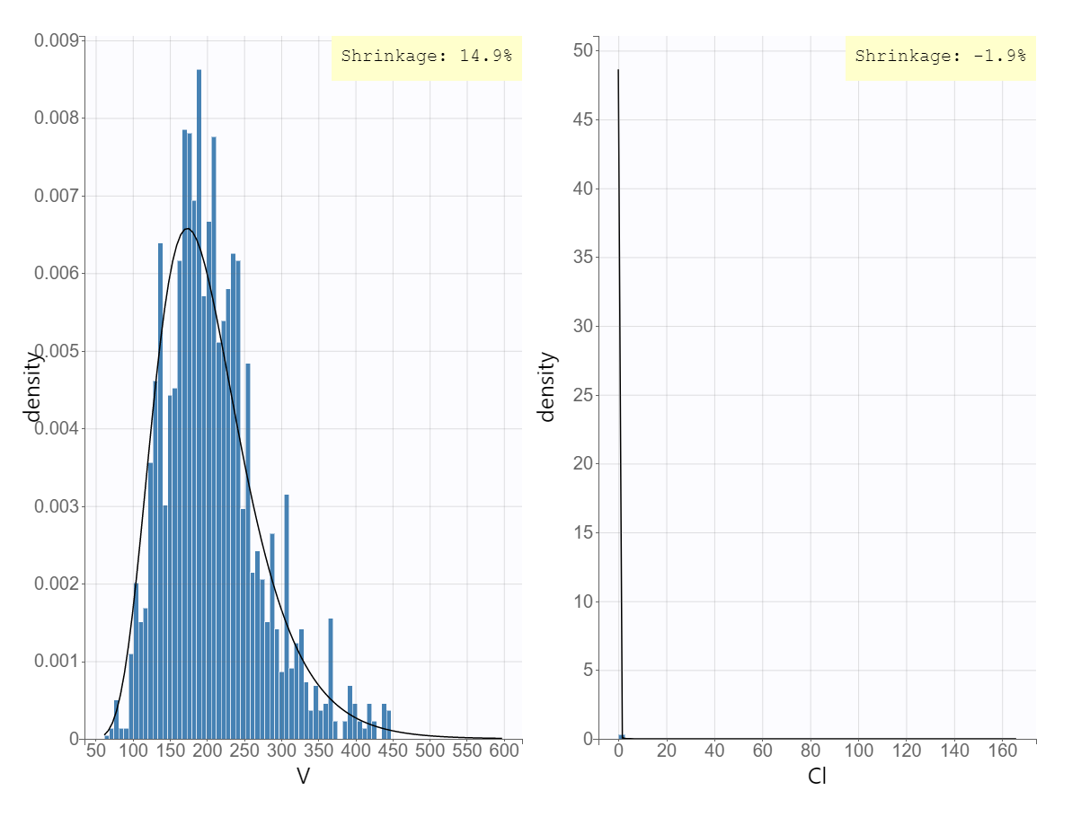
Supplementary Figure 1: Shrinkage value of the final pharmacokinetic model.

