Supplementary materials
- Supplementary Table S1. 1000 Bootstrap of the Boruta algorithm. - Page 2.
- Supplementary Table S2. VIFs of the 13 selected features within RSF model. - Page 3.
- Supplementary Table S3. Hyperparametric search space and results.
- Page 3.
- Supplementary Table S4. Web Application User Guide for Survival Prediction. - Page 4.
- Supplementary Fig. S1: Heat map of Spearman’s correlation analyses among variables. - Page 5.
- Supplementary Fig.S2. (A). The C-index value, (B) AUC, and (C) Brier score of the final RSF model in the internal validation cohort. - Page 6.
- Supplementary Fig. S3. ROC curve analysis of the five machine learning algorithms for predicting OS in the internal validation cohort. - Page 6.
- Supplementary Fig. S4. Decision curve analysis of the five machine learning algorithms for predicting OS in the internal validation cohort. - Page 7.
- Supplementary Fig. S5. Screenshot of web app of RSF prognostic model.
- Page 8.

Table S1. 1000 Bootstrap of the Boruta algorithm
Training cohort |  | External validation cohort
Variables | Times | Variables | Times
Entered in the model |  | Entered in the model
BCLC | 1000 | BCLC | 893
PVTT | 1000 | PVTT | 802
Tumor size | 1000 | Tumor size | 991
Extrahepatic metastases | 1000 | Extrahepatic metastases | 957
Metformin use | 1000 | Metformin use | 843
AFP | 1000 | AFP | 845
PT | 1000 | PT | 736
Bilirubin | 1000 | Bilirubin | 930
NLR | 1000 | NLR | 812
Hemoglobin | 1000 | Hemoglobin | 836
Liver cirrhosis | 976 | Liver cirrhosis | 858
PLR | 1000 | PLR | 830
HBA1c | 1000 | HBA1c | 803
Not entered in the model |  | Not entered in the model
Creatinine | 530 | Creatinine | 446
ECOG | 745 | ECOG | 8
Hepatitis | 879 | Hepatitis | 207
Hyperlipaemia | 743 | Hyperlipaemia | 25
Hypertension | 736 | Hypertension | 55
Leukocyte | 472 | Leukocyte | 549
ALT | 659 | ALT | 511
CHILD | 319 | CHILD | 15
Coronary heart disease | 643 | Coronary heart disease | 1
PSE or splenectomy | 313 | PSE or splenectomy | 132
Duration | 784 | Duration | 438
Age | 506 | Age | 439
Tumor number | 330 | Tumor number | 73
Albumin | 873 | Albumin | 805
Two hour FGC | 742 | Two hour FGC | 578
BMI | 607 | BMI | 433
FPG | 834 | FPG | 594
Gender | 686 | Gender | 32

Table S2. VIFs of the 13 selected features within RSF model
BCLC | 1.603
PVTT | 1.506
Tumor size | 1.453
Metformin use | 1.054
Extrahepatic metastases | 1.302
AFP | 1.244
PT | 1.035
Hemoglobin | 1.041
NLR | 1.165
Bilirubin | 1.021
PLR | 1.273
Liver cirrhosis | 1.069

Table S3. Hyperparametric search space and results
Parameters | Range | Result
Coxph
none | none | none
XGboost
nrounds | [100,300] | 107
max_depth | [2.0,4.0] | 2.0
eta | [0.01,0.3] | 0.111
GBM
n.trees | [100,1000] | 100
shrinkage | [0.001,0.1] | 0.034
interaction.depth | [1,5] | 3
RSF
ntree | [200,500] | 500
mtry | [3,5] | 3
nodesize | [15,21] | 21
Rpart
cp | [0.001,0.1] | 0.001
minsplit | [1,20] | 20

Table S4. Web Application User Guide for Survival Prediction
Step 1
Access the website (https://osprediction.shinyapps.io/survival_1y_2y_3y_prediction/) from any internet-enabled device.
Step 2
Click the "Application" button to enter the prediction interface.
Step 3
Input the patient's preoperative clinical information into the "Variables of New sample" section under the "Predict new observation" heading, and then click the "Predict" button. The web application will automatically calculate the patient’s 1-, 2-, and 3-year survival probabilities, displaying the results graphically in the "PredictSurvProb" section.
Note: If the predicted value for a given time point is greater than 0.5, the patient is predicted to survive; otherwise, the patient is predicted to not survive.

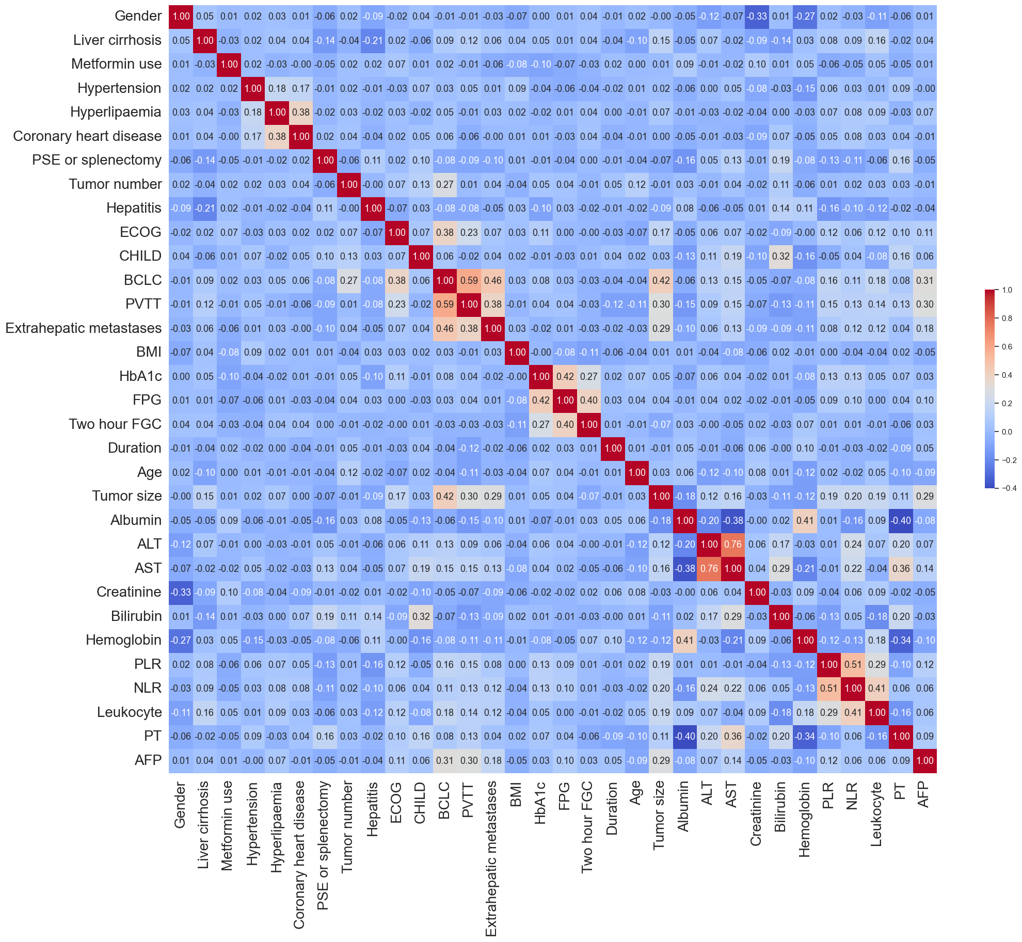
Fig. S1. Heat map of Spearman’s correlation analyses among variables.
Variables of HCC patients who underwent TACE with diabetes from the derivation cohort were included in Spearman’s correlation analyses. Variables in Supplemental Table S1 were chosen for the Spearman’s correlation analyses, and the correlation coefficient values were displayed as a heat map.
AFP = Alpha-Fetoprotein; ALT= Alanine aminotransferase; AST = Aspartate aminotransferase; BCLC = Barcelona Clinic Liver Cancer; BMI =Body mass index; CHILD = Child-Pugh score; ECOG = Eastern Cooperative Oncology Group performance status; FPG = Fasting plasma glucose; HbA1c = Glycosylated hemoglobin; NLR = Neutrophil-to-Lymphocyte Ratio; PLR = Platelet-to-Lymphocyte Ratio; PT = Prothrombin time. PVTT =Portal Vein Tumor Thrombosis.
Fig. S2. ROC curve analysis of the five machine learning algorithms for predicting OS in the internal validation cohort.

Fig. S3. (A). The C-index value, (B) AUC, and (C) Brier score of the final RSF model in the internal validation cohort. AUC: Area Under Curve; RSF: random survival forest.

Fig. S4. Decision curve analysis of the five machine learning algorithms for predicting OS in the internal validation cohort.

Fig. S5. Online prediction model for 1-, 2-, and 3-year survival probabilities in HCC patients with diabetes after TACE. (A). For a case with a 7-month survival, the model predicted 1-year, 2-year, and 3-year survival probabilities to be 0.35, 0.132, and 0.063, respectively (B). For a case with a 42-month survival, the model predicted 1-year, 2-year, and 3-year survival probabilities to be 0.959, 0.854, and 0.734, respectively.
HCC, hepatocellular carcinoma; TACE, transarterial chemoembolization

