Supplementary Figure 1: Single cell pre-processing
(A) Quality control visualizations of single-cell RNA sequencing data. Each subgraph shows the number of genes, UMI count, mitochondrial gene proportion (%MT), and ribosomal gene proportion (%Ribo), respectively. The X-axis represents the cell, and the Y-axis represents the corresponding index value.
(B) Scatter plot of the relationship between cell sequencing depth and mitochondrial gene content. The figure on the left shows a positive correlation between cell sequencing depth (total UMI counts) and mitochondrial gene proportion (R-value 0.33), and the figure on the right shows an example of a negative correlation (R-value -0.53). The X-axis represents the sequencing depth of each cell (total UMI counts) and the Y-axis represents the mitochondrial gene ratio (%MT). Cyan dots indicate cells in the normal range, and red dots may be abnormal or low-quality cells. The correlation coefficient at the top is used to quantify the strength and direction of the relationship.
(C) Volcano map of differentially expressed genes. The X-axis represents the log fold change in gene expression level between samples, and the Y-axis represents the significance of the differential expression (-log10(p-value)). The red dots are significantly differentially expressed genes (FDR < 0.05), and the marker genes are candidate genes of biological significance.
(D) Crushed stone map of principal component analysis (PCA) results. The X-axis is the number of principal components, and the Y-axis is the proportion of the variance contribution of each principal component. Used to select the number of significant principal components.
(E) PCA result visualization. A two-dimensional scatter plot of the first two principal components (PC1 and PC2). Each dot represents a cell, and different colors represent different groups of cells.
(F) Double principal component analysis (PCA) results were re-visualized after adjustment. The color and point distribution is updated to explore potential batch effects or other technical deviations.

Supplementary Figure 2. Co-expression analysis of key genes in single cells
(A-I) Gene co-expression of disease genes and key genes in single-cell data, and coexpressed gene correlations. The feature distribution, gene expression correlation and regulatory characteristics of multiple cell subsets UMAP were presented. Each line presents analysis results for a different gene or trait, including UMAP visualization, gene expression correlation heat maps, and scatter regression analysis.

1.Immunofluorescence double labeling

group | Number | 200times | area（mm²） | CD4⁺+CD62L⁺ | Density (mean） | Density (mean） | Density (mean）
5 | 1 | 123 | 0.0432 | 5 | 116 | 139 | 187.69
5 | 1 | 456 | 0.0518 | 10 | 193 | 139 | 187.69
5 | 1 | 789 | 0.0274 | 3 | 109 | 139 | 187.69
5 | 2 | 123 | 0.0592 | 13 | 220 | 218 | 187.69
5 | 2 | 456 | 0.0673 | 12 | 178 | 218 | 187.69
5 | 2 | 789 | 0.1014 | 26 | 256 | 218 | 187.69
5 | 3 | 123 | 0.0168 | 7 | 417 | 340 | 187.69
5 | 3 | 456 | 0.0184 | 8 | 435 | 340 | 187.69
5 | 3 | 789 | 0.0239 | 4 | 167 | 340 | 187.69
5 | 4 | 123 | 0.0350 | 1 | 29 | 71 | 187.69
5 | 4 | 456 | 0.0394 | 2 | 51 | 71 | 187.69
5 | 4 | 789 | 0.0299 | 4 | 134 | 71 | 187.69
5 | 5 | 123 | 0.0524 | 5 | 95 | 170 | 187.69
5 | 5 | 456 | 0.0499 | 13 | 261 | 170 | 187.69
5 | 5 | 789 | 0.0581 | 9 | 155 | 170 | 187.69
对 | 1 | 123 | 0.0239 | 1 | 42 | 44 | 54.73
对 | 1 | 456 | 0.0301 | 1 | 33 | 44 | 54.73
对 | 1 | 789 | 0.0353 | 2 | 57 | 44 | 54.73
对 | 2 | 123 | 0.0443 | 2 | 45 | 56 | 54.73
对 | 2 | 456 | 0.0458 | 3 | 66 | 56 | 54.73
对 | 2 | 789 | 0.0530 | 3 | 57 | 56 | 54.73
对 | 3 | 123 | 0.0422 | 2 | 47 | 92 | 54.73
对 | 3 | 456 | 0.0473 | 3 | 63 | 92 | 54.73
对 | 3 | 789 | 0.0305 | 5 | 164 | 92 | 54.73
对 | 4 | 123 | 0.0462 | 2 | 43 | 39 | 54.73
对 | 4 | 456 | 0.0772 | 2 | 26 | 39 | 54.73
对 | 4 | 789 | 0.0856 | 4 | 47 | 39 | 54.73
对 | 5 | 123 | 0.0645 | 4 | 62 | 44 | 54.73
对 | 5 | 456 | 0.0588 | 2 | 34 | 44 | 54.73
对 | 5 | 789 | 0.0568 | 2 | 35 | 44 | 54.73
光 | 1 | 123 | 0.0316 | 20 | 633 | 459 | 291.06
光 | 1 | 456 | 0.0338 | 15 | 444 | 459 | 291.06
光 | 1 | 789 | 0.0534 | 16 | 300 | 459 | 291.06
光 | 2 | 123 | 0.0513 | 11 | 214 | 257 | 291.06
光 | 2 | 456 | 0.0976 | 23 | 236 | 257 | 291.06
光 | 2 | 789 | 0.0993 | 32 | 322 | 257 | 291.06
光 | 3 | 123 | 0.0530 | 14 | 264 | 219 | 291.06
光 | 3 | 456 | 0.0699 | 15 | 215 | 219 | 291.06
光 | 3 | 789 | 0.0727 | 13 | 179 | 219 | 291.06
光 | 4 | 123 | 0.0907 | 8 | 88 | 221 | 291.06
光 | 4 | 456 | 0.0604 | 17 | 281 | 221 | 291.06
光 | 4 | 789 | 0.0512 | 15 | 293 | 221 | 291.06
光 | 5 | 123 | 0.0924 | 30 | 325 | 299 | 291.06
光 | 5 | 456 | 0.1044 | 28 | 268 | 299 | 291.06
光 | 5 | 789 | 0.0756 | 23 | 304 | 299 | 291.06
Note: Immunofluorescent photos were analyzed using IPP 6.0 software. Three 200 times photos were selected for each section to count the number of colocalized cells, area as area, and density (mean) as the average number of positive cells per unit area.

2. Western blotting

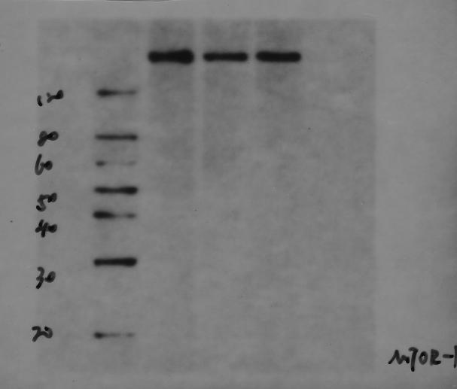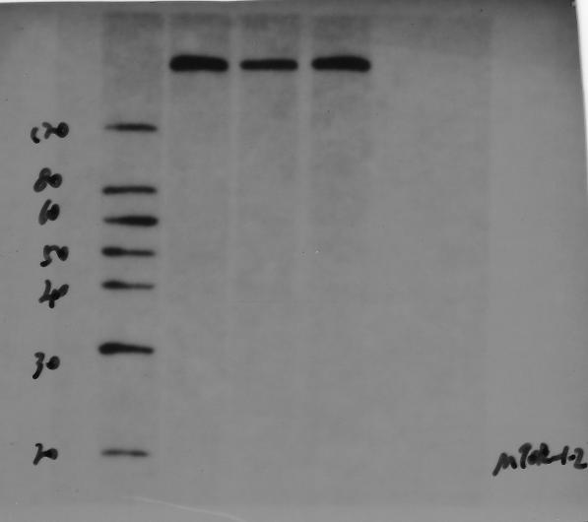
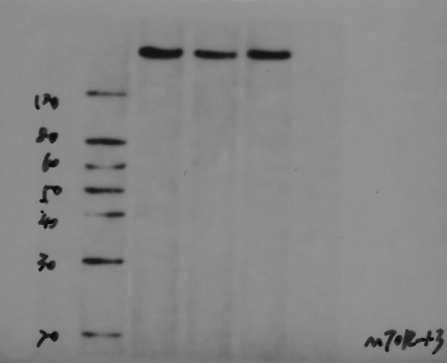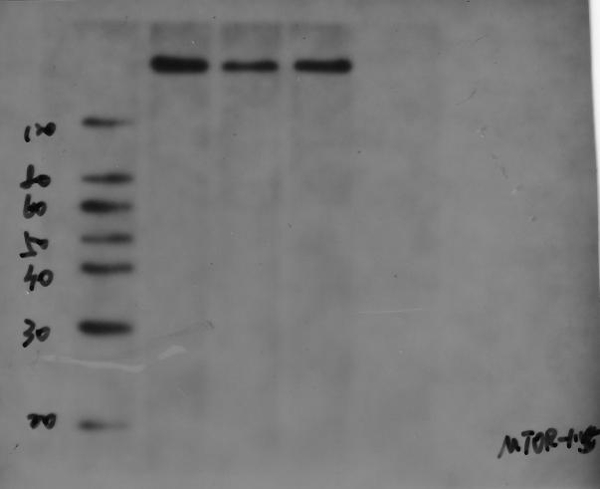
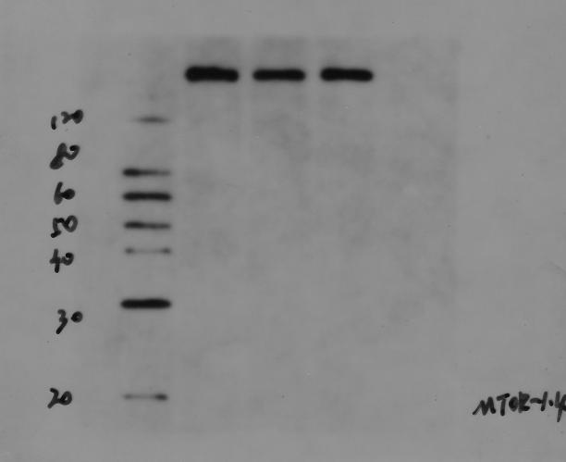
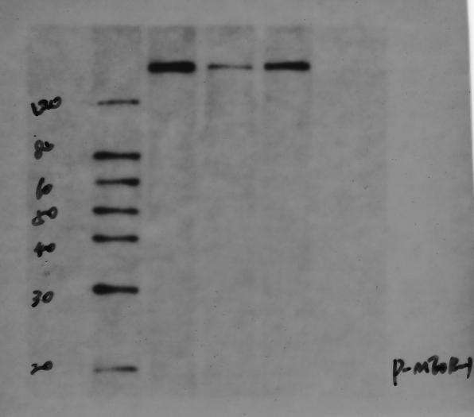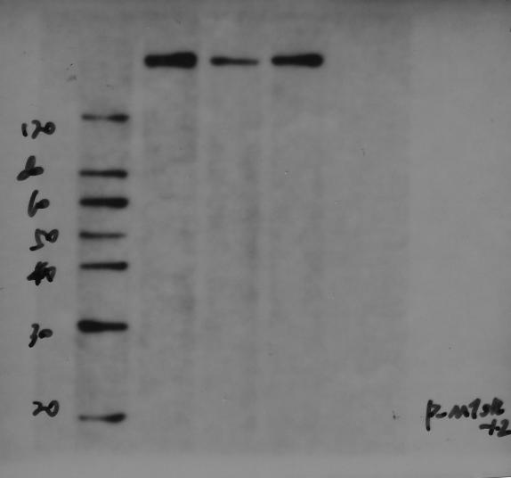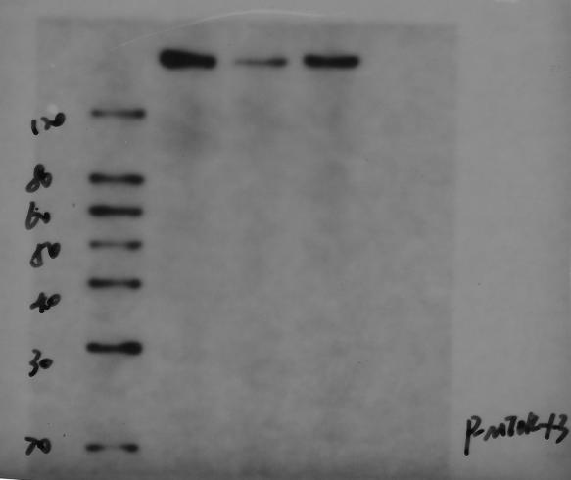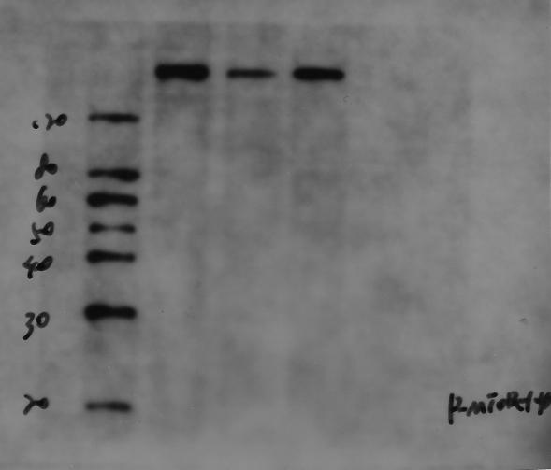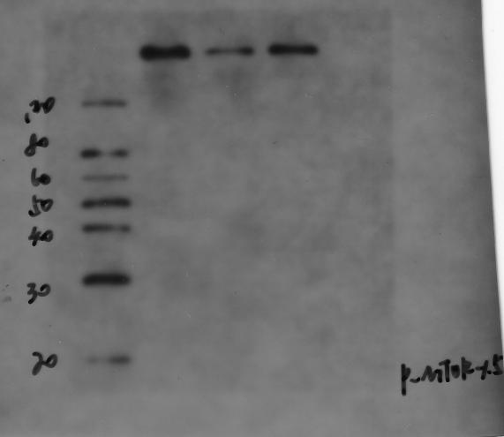
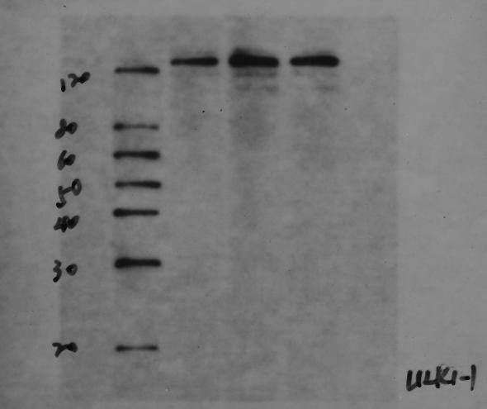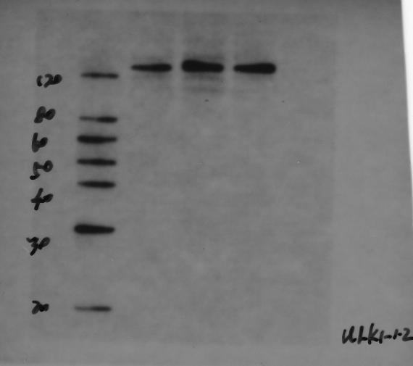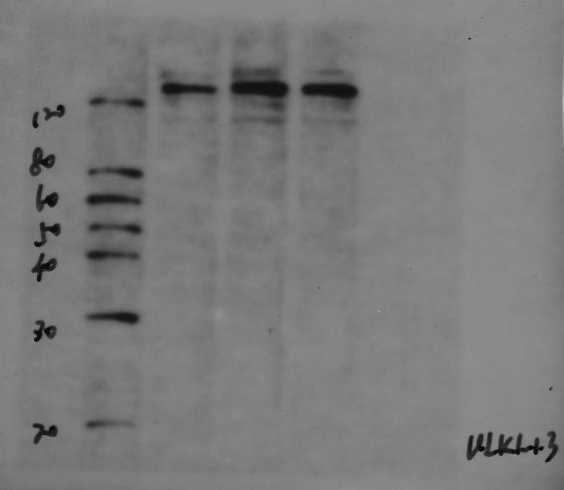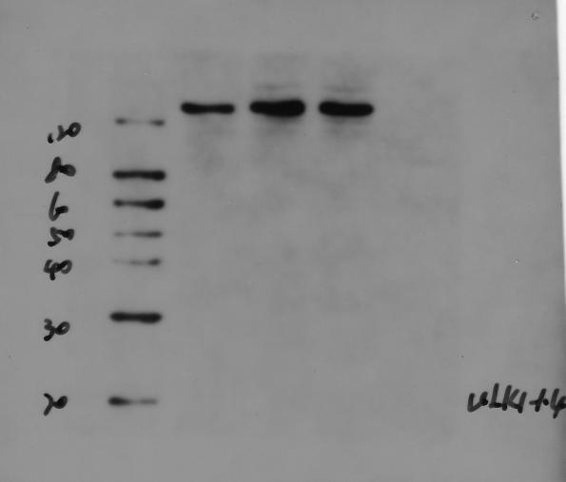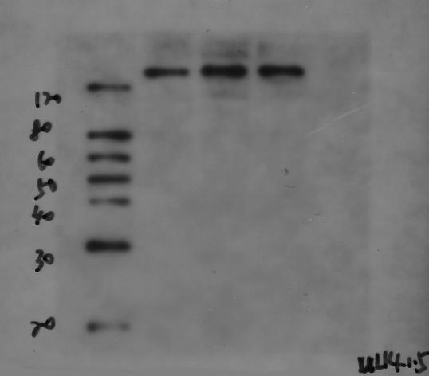
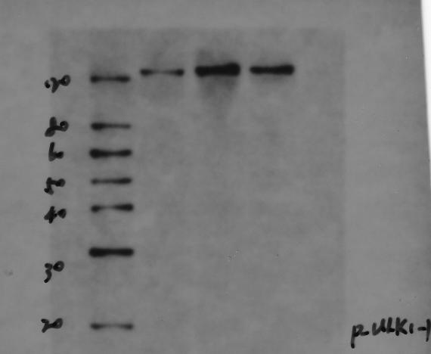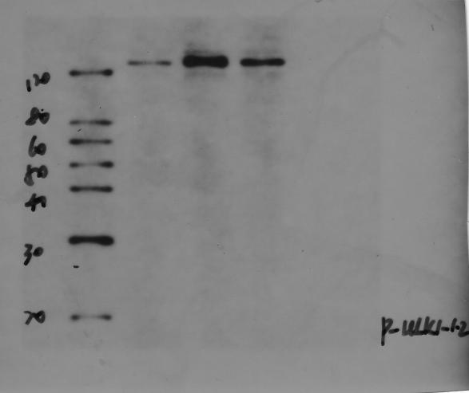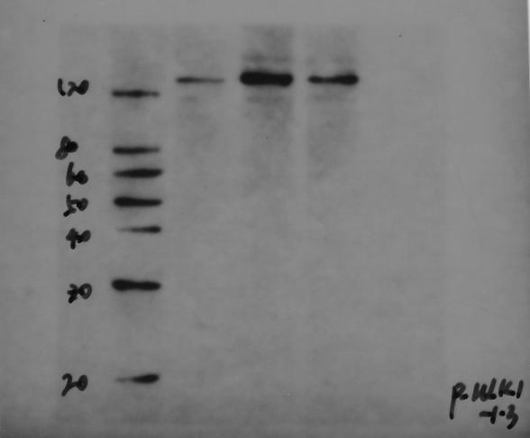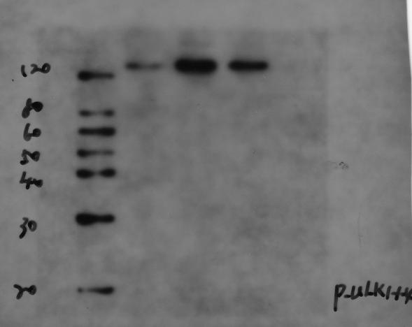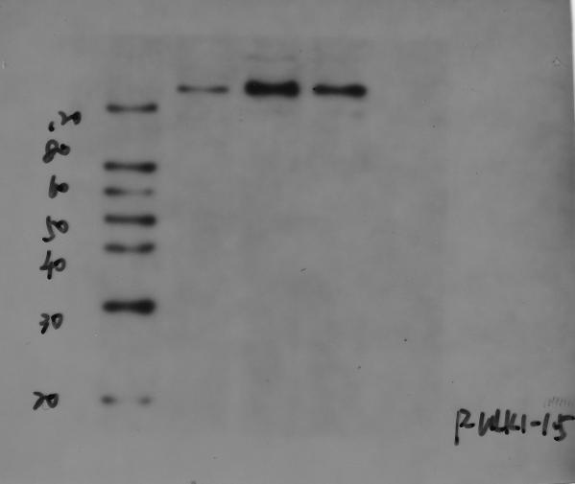
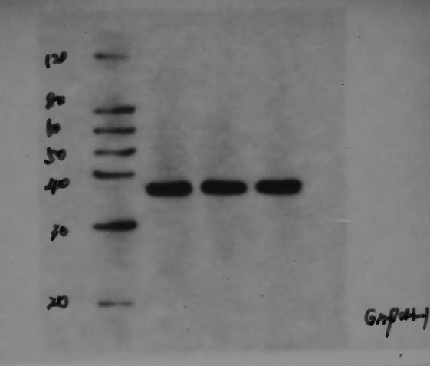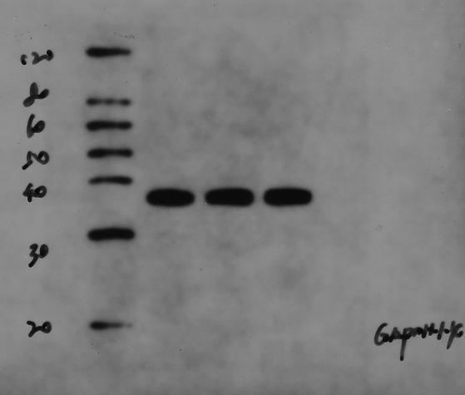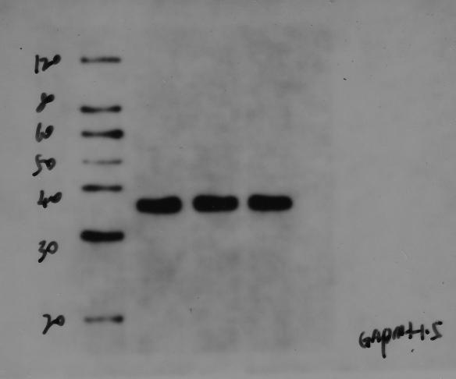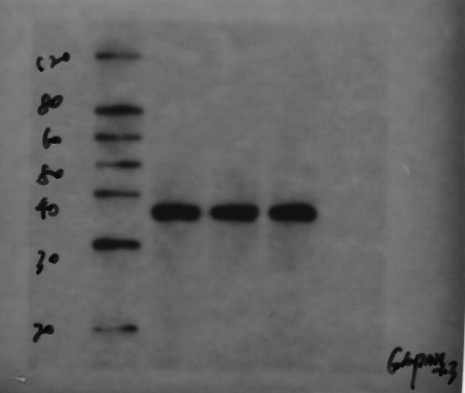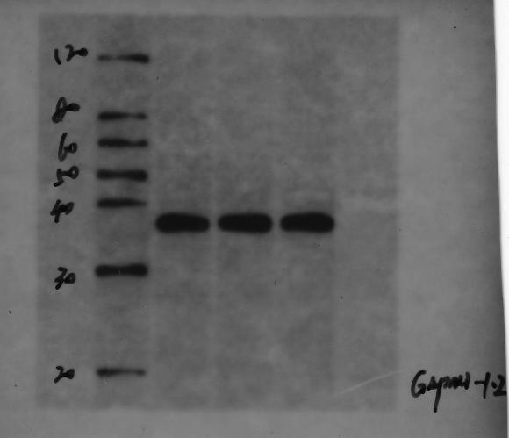

3.Immunofluorescence single labeling of CD68 and immunofluorescence double labeling of CD68/CD86 and CD68/CD206

 | CD86 | CD206 | CD86/CD206
Control | 0.141 | 1.539 | 0.091617934
Control | 0.429 | 2.601 | 0.164936563
Control | 0.665 | 2.668 | 0.249250375
UVR | 5.363 | 0.639 | 8.392801252
UVR | 4.355 | 1.361 | 3.199853049
UVR | 5.465 | 0.29 | 18.84482759
Vicenin-2 | 2.535 | 0.719 | 3.525730181
Vicenin-2 | 1.395 | 1.502 | 0.928761651
Vicenin-2 | 3.034 | 0.749 | 4.050734312

4.qPCR
 | Control-1 | Control-2 | Control-3 | Control-4 | Control-5 | UVR1 | UVR2 | UVR3 | UVR4 | UVR5 | UVRvicenin-2-1 | UVRvicenin-2-2 | UVR+vicenin-2-3 | UVR+vicenin-2-4 | UVR+vicenin-2-5
Mus GAPDH | 20.385 | 20.632 | 19.797 | 20.522 | 19.847 | 20.841 | 19.784 | 20.629 | 20.707 | 21.214 | 21.354 | 20.387 | 20.720 | 19.720 | 20.482
 | 20.220 | 20.962 | 19.777 | 20.764 | 19.624 | 20.702 | 19.969 | 20.574 | 20.520 | 21.422 | 21.217 | 20.136 | 20.629 | 19.892 | 20.346
 | 20.159 | 20.813 | 19.625 | 20.674 | 19.996 | 20.788 | 19.820 | 20.434 | 20.669 | 21.388 | 21.186 | 20.259 | 20.726 | 19.516 | 20.397
Mus Atp2b1 | 30.183 | 30.577 | 29.117 | 30.485 | 30.112 | 31.577 | 30.451 | 31.864 | 32.189 | 32.596 | 31.593 | 30.457 | 31.022 | 30.492 | 31.046
 | 30.382 | 30.628 | 29.291 | 30.512 | 30.056 | 31.623 | 30.606 | 31.720 | 31.831 | 32.426 | 31.690 | 30.635 | 31.072 | 30.267 | 30.870
 | 30.166 | 30.875 | 29.490 | 30.608 | 30.189 | 31.736 | 30.776 | 31.434 | 31.943 | 32.370 | 31.817 | 30.864 | 30.776 | 30.377 | 30.733
Δt | 9.797 | 9.945 | 9.320 | 9.963 | 10.265 | 10.736 | 10.667 | 11.234 | 11.483 | 11.381 | 10.240 | 10.070 | 10.301 | 10.773 | 10.565
 | 10.161 | 9.666 | 9.515 | 9.748 | 10.432 | 10.921 | 10.637 | 11.146 | 11.311 | 11.005 | 10.473 | 10.498 | 10.443 | 10.375 | 10.524
 | 10.007 | 10.061 | 9.865 | 9.934 | 10.193 | 10.947 | 10.956 | 10.999 | 11.275 | 10.983 | 10.630 | 10.604 | 10.050 | 10.861 | 10.336
ΔΔt | 0.000 | 0.000 | -0.625 | 0.018 | 0.319 | 0.939 | 0.722 | 1.289 | 1.537 | 1.436 | 0.442 | 0.125 | 0.356 | 0.827 | 0.619
 | 0.000 | 0.000 | -0.152 | 0.081 | 0.765 | 0.759 | 0.971 | 1.479 | 1.645 | 1.338 | 0.312 | 0.832 | 0.776 | 0.709 | 0.857
 | 0.000 | 0.000 | -0.197 | -0.127 | 0.131 | 0.940 | 0.895 | 0.938 | 1.213 | 0.922 | 0.623 | 0.543 | -0.011 | 0.800 | 0.275
2-ΔΔt | 1.000 | 1.000 | 1.542 | 0.988 | 0.801 | 0.522 | 0.606 | 0.409 | 0.345 | 0.370 | 0.736 | 0.917 | 0.781 | 0.564 | 0.651
 | 1.000 | 1.000 | 1.111 | 0.945 | 0.588 | 0.591 | 0.510 | 0.359 | 0.320 | 0.396 | 0.806 | 0.562 | 0.584 | 0.612 | 0.552
 | 1.000 | 1.000 | 1.146 | 1.092 | 0.913 | 0.521 | 0.538 | 0.522 | 0.431 | 0.528 | 0.649 | 0.686 | 1.008 | 0.574 | 0.826
mean | 1.000 | 1.000 | 1.266 | 1.008 | 0.768 | 0.545 | 0.551 | 0.430 | 0.365 | 0.431 | 0.730 | 0.722 | 0.791 | 0.583 | 0.676
SD
 | Control-1 | Control-2 | Control-3 | Control-4 | Control-5 | UVR1 | UVR2 | UVR3 | UVR4 | UVR5 | UVRvicenin-2-1 | UVRvicenin-2-2 | UVR+vicenin-2-3 | UVR+vicenin-2-4 | UVR+vicenin-2-5
Mus Plekho2 | 29.969 | 30.362 | 29.825 | 29.792 | 29.864 | 29.969 | 29.238 | 29.791 | 29.916 | 31.083 | 30.614 | 29.777 | 30.831 | 29.488 | 29.459
 | 29.849 | 30.289 | 29.793 | 29.897 | 29.998 | 29.849 | 29.057 | 29.517 | 30.195 | 31.131 | 30.837 | 29.993 | 30.945 | 29.615 | 29.325
 | 29.793 | 30.159 | 29.630 | 29.721 | 29.824 | 29.793 | 29.189 | 29.889 | 29.893 | 31.225 | 30.598 | 29.820 | 30.647 | 29.737 | 29.730
Δt | 9.583 | 9.730 | 9.193 | 9.160 | 9.232 | 9.583 | 8.606 | 9.159 | 9.284 | 10.451 | 9.261 | 9.145 | 10.199 | 8.855 | 8.827
 | 9.629 | 9.327 | 8.831 | 8.936 | 9.037 | 9.629 | 8.095 | 8.555 | 9.233 | 10.169 | 9.620 | 9.032 | 9.984 | 8.653 | 8.364
 | 9.635 | 9.346 | 8.816 | 8.908 | 9.010 | 9.635 | 8.375 | 9.075 | 9.079 | 10.411 | 9.412 | 9.006 | 9.834 | 8.924 | 8.916
ΔΔt | 0.000 | 0.000 | -0.537 | -0.570 | -0.498 | 0.000 | -1.124 | -0.571 | -0.446 | 0.721 | -0.323 | -0.586 | 0.469 | -0.875 | -0.904
 | 0.000 | 0.000 | -0.496 | -0.392 | -0.291 | 0.000 | -1.232 | -0.772 | -0.094 | 0.842 | -0.009 | -0.296 | 0.656 | -0.674 | -0.964
 | 0.000 | 0.000 | -0.529 | -0.438 | -0.336 | 0.000 | -0.971 | -0.270 | -0.266 | 1.066 | -0.223 | -0.340 | 0.488 | -0.422 | -0.429
2-ΔΔt | 1.000 | 1.000 | 1.451 | 1.485 | 1.412 | 1.000 | 2.180 | 1.486 | 1.362 | 0.607 | 1.251 | 1.501 | 0.722 | 1.834 | 1.871
 | 1.000 | 1.000 | 1.410 | 1.312 | 1.223 | 1.000 | 2.349 | 1.708 | 1.067 | 0.558 | 1.006 | 1.228 | 0.634 | 1.596 | 1.950
 | 1.000 | 1.000 | 1.443 | 1.355 | 1.262 | 1.000 | 1.960 | 1.206 | 1.203 | 0.478 | 1.167 | 1.265 | 0.713 | 1.340 | 1.347
mean | 1.000 | 1.000 | 1.435 | 1.384 | 1.299 | 1.000 | 2.163 | 1.467 | 1.211 | 0.548 | 1.141 | 1.331 | 0.690 | 1.590 | 1.723
SD
 | Contorl-1 | Control-2 | Control-3 | Control-4 | Control-5 | UVR1 | UVR2 | UVR3 | UVR4 | UVR5 | UVRvicenin-2-1 | UVRvicenin-2-2 | UVR+vicenin-2-3 | UVR+vicenin-2-4 | UVR+vicenin-2-5
Mus Tspan13 | 28.347 | 28.652 | 28.074 | 28.653 | 27.891 | 30.168 | 28.972 | 31.109 | 30.114 | 30.564 | 29.929 | 29.296 | 29.640 | 28.556 | 28.722
 | 28.198 | 28.419 | 28.243 | 28.444 | 28.243 | 29.982 | 28.953 | 31.295 | 30.323 | 30.885 | 29.730 | 28.992 | 29.330 | 28.298 | 28.813
 | 28.484 | 28.794 | 27.940 | 28.553 | 28.137 | 29.939 | 29.123 | 30.974 | 30.093 | 30.636 | 29.655 | 29.041 | 29.415 | 27.974 | 28.989
Δt | 7.961 | 8.020 | 8.277 | 8.131 | 8.043 | 9.326 | 9.188 | 10.479 | 9.408 | 9.349 | 8.576 | 8.909 | 8.920 | 8.837 | 8.241
 | 7.978 | 7.458 | 8.466 | 7.680 | 8.619 | 9.280 | 8.984 | 10.721 | 9.803 | 9.463 | 8.513 | 8.855 | 8.701 | 8.406 | 8.467
 | 8.326 | 7.981 | 8.315 | 7.879 | 8.141 | 9.150 | 9.303 | 10.540 | 9.424 | 9.249 | 8.469 | 8.782 | 8.688 | 8.458 | 8.592
ΔΔt | 0.000 | 0.000 | 0.257 | 0.111 | 0.023 | 1.365 | 1.168 | 2.459 | 1.387 | 1.329 | 0.614 | 0.888 | 0.900 | 0.817 | 0.220
 | 0.000 | 0.000 | 1.008 | 0.222 | 1.161 | 1.302 | 1.526 | 3.263 | 2.345 | 2.005 | 0.535 | 1.397 | 1.243 | 0.948 | 1.010
 | 0.000 | 0.000 | 0.334 | -0.102 | 0.160 | 0.825 | 1.322 | 2.559 | 1.443 | 1.268 | 0.143 | 0.801 | 0.707 | 0.477 | 0.612
2-ΔΔt | 1.000 | 1.000 | 0.837 | 0.926 | 0.984 | 0.388 | 0.445 | 0.182 | 0.382 | 0.398 | 0.653 | 0.540 | 0.536 | 0.568 | 0.858
 | 1.000 | 1.000 | 0.497 | 0.857 | 0.447 | 0.405 | 0.347 | 0.104 | 0.197 | 0.249 | 0.690 | 0.380 | 0.422 | 0.518 | 0.497
 | 1.000 | 1.000 | 0.794 | 1.073 | 0.895 | 0.565 | 0.400 | 0.170 | 0.368 | 0.415 | 0.905 | 0.574 | 0.613 | 0.718 | 0.654
mean | 1.000 | 1.000 | 0.709 | 0.952 | 0.776 | 0.453 | 0.397 | 0.152 | 0.316 | 0.354 | 0.750 | 0.498 | 0.524 | 0.602 | 0.670

