Supplementary material
Supplementary Figure S1. Study design
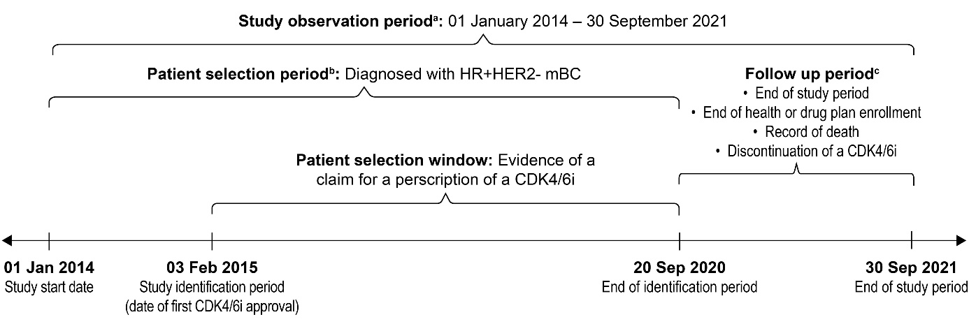
Notes^{: a}The study index date was defined as the date of the first observed claim for a prescription of a CDK4/6i in first- or second-line settings during the patient selection window. The preindex period consisted of a 6-month period before the index date, and the follow-up period extended from the index date until the end of health or drug plan enrollment, death, or end of study period. For the evaluation of study outcomes, all patients were followed from the study index date to discontinuation of CDK4/6i, disenrollment from health or drug plan, or end of study period, whichever occurred first.
^{b}Adult patients with HR+/HER2− mBC who had ≥ 1 prescription claim for CDK4/6i therapy in the first- or second-line setting were included. Patients were required to have ≥ 2 claims containing ≥ 1 diagnosis codes for BC (International Classification of Diseases, Ninth Revision, Clinical Modification [ICD-9-CM] codes: 174.xx/175.x or International Classification of Diseases, Tenth Revision, Clinical Modification [ICD-10-CM] codes: C50.x1/C50.x2) ≥ 30 days apart but occurring within 1 year during the study period. To identify patients with mBC, they were required to have ≥ 2 claims after January 1, 2015 on distinct dates with a secondary malignancy diagnosis (ICD-9-CM codes 196.xx, 197.xx, 198.xx or ICD-10-CM codes C77.xx, C78.xx, and C79.xx). Incident diagnosis of mBC was defined as having no evidence of secondary malignancy during the 12 months before the first claim of secondary malignancy.
^{c}Follow-up starts after the date of CDK4/6i initiation (i.e., study index date).
Abbreviations: CDK4/6i, cyclin-dependent kinase 4/6 inhibitor; HER2, human epidermal growth factor receptor 2–negative; HR, hormone receptor; mBC, metastatic breast cancer.
Supplementary Table S1. List and Codes Used to Identify Metastatic Sites
Site(s) of metastatic disease | ICD-9-CM diagnosis codes | ICD-10-CM diagnosis codes
Bone metastasis | 198.5, 209.73 | C79.5x, C7B03
Visceral disease | 197.0, 197.1,  197.2, 197.3, 197.4, 197.5, 197.6, 197.7, 197.8, 198.0, 198.1, 198.6, 198.7, 198.82, 209.72, 209.74 | C78.0x, C78.1, C78.2, C78.3x, C78.4, C78.5, C78.6, C78.7, C78.8, C79.0x, C79.1x, C79.6x, C79.7x, C79.82, C7B02, C7B04
Brain/CNS metastasis | 198.3, 198.4 | C79.3x, C79.4x
Abbreviations: CNS, central nervous system; ICD-9/10-CM, International Classification of Diseases, Ninth/Tenth Revision, Clinical Modification.
Supplementary Figure S2. Phase of care approach for medical costs.
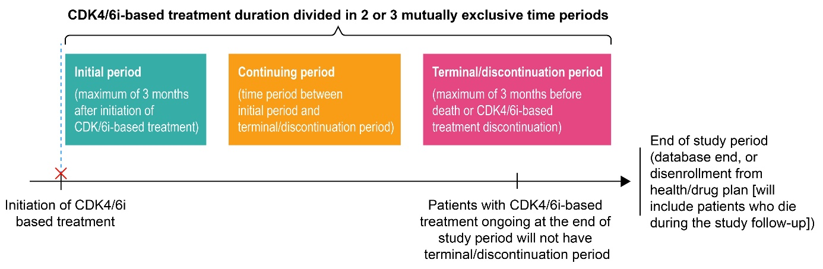
Notes: Compared with Yabroff et al, 2007,³⁸ the phase analysis periods were divided differently in our study due to only looking at CDK4/6i use. For patients with enough follow-up, the first 3 months are allocated to the initial phase by both studies. However, when the follow-up data are limited, Yabroff et al, 2007 prioritized the terminal phase over the initial phase, whereas we prioritize the initial 3 months.
Abbreviations: CDK4/6i, cyclin-dependent kinase 4/6 inhibitor.

Supplementary Figure S3. Mean PPPM HCRU in patients treated with abemaciclib and ribociclib compared to palbociclib.
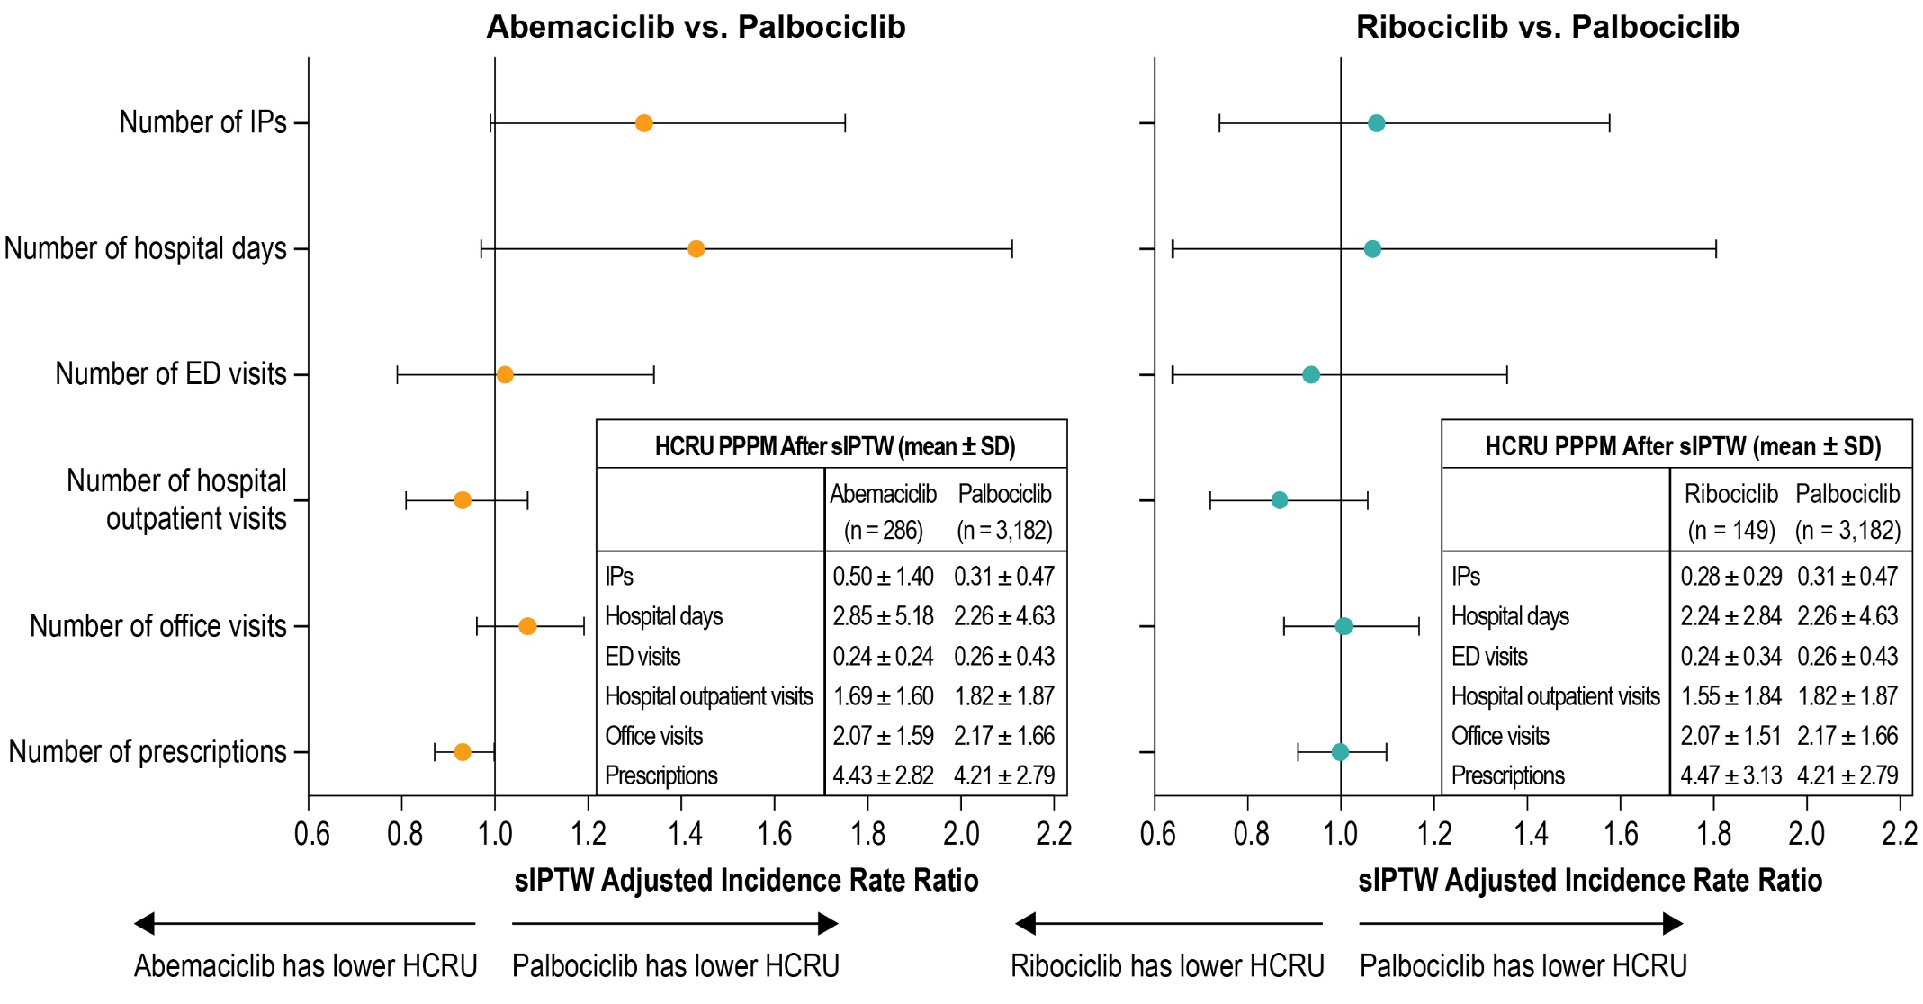
Abbreviations: ED, emergency department; HCRU, healthcare resource utilization; IP, inpatient; PPPM, per patient per month; SD, standard deviation; sIPTW, stabilized inverse probability treatment weighting.

Supplementary Figure S4. Mean all-cause PPPM healthcare costs in patients treated with palbociclib, abemaciclib, or ribociclib aged ≥ 65 years and enrolled in Medicare Advantage.

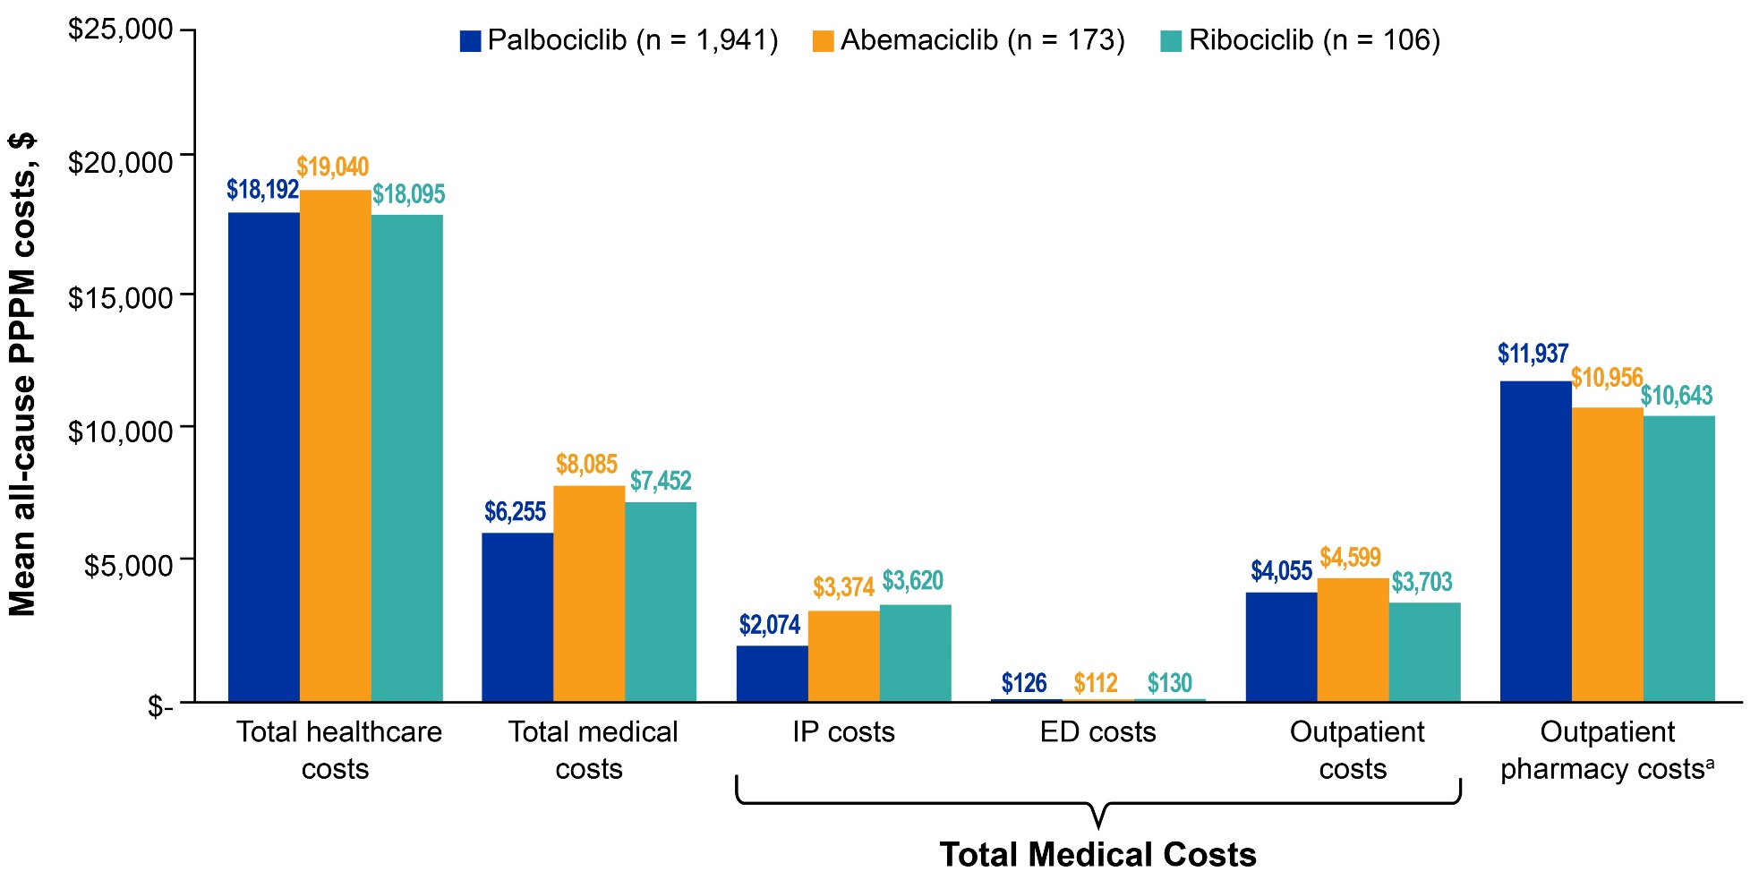
Notes^{: a}Wholesale acquisition costs for CDK4/6i accounting for dose adjustments and wastage.
Abbreviations: CDK4/6i, cyclin-dependent kinase 4/6 inhibitor; ED, emergency department; IP, inpatient; PPPM, per patient per month.

Supplementary Figure S5. Incremental mean all-cause PPPM costs among patients aged ≥ 65 years and enrolled in Medicare Advantage treated with abemaciclib or ribociclib compared with palbociclib.ª
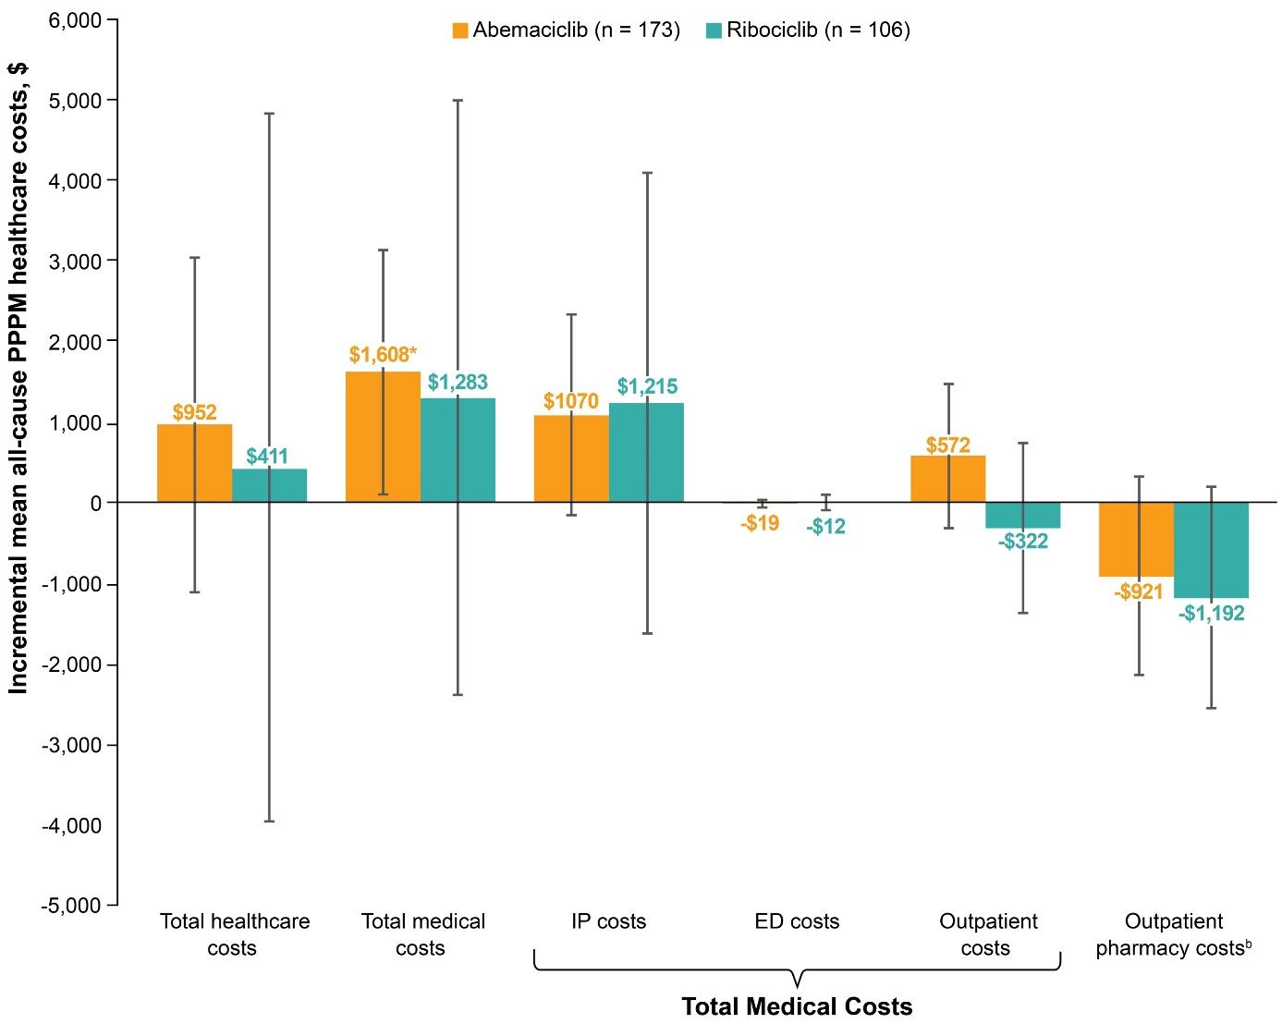
Notes: ªThe incremental costs were computed using regression analysis, which adjusted for factors that remained imbalanced between the cohorts.
^{b}Wholesale acquisition costs for CDK4/6i accounting for dose adjustments and wastage.
*P < 0.05.
Abbreviations: CDK4/6i, cyclin-dependent kinase 4/6 inhibitor; ED, emergency department; IP, inpatient; PPPM, per patient per month.

