Supplementary Material
Supplementary Figures
Supplementary figure 1.
Results of the Bootstrap internal validation of Clinical-SIRI model(AUC=0.788 95%CI:0.738-0.838).
SIRI, Systemic inflammation response index; AUC, area under the curve; CI, confidence interval
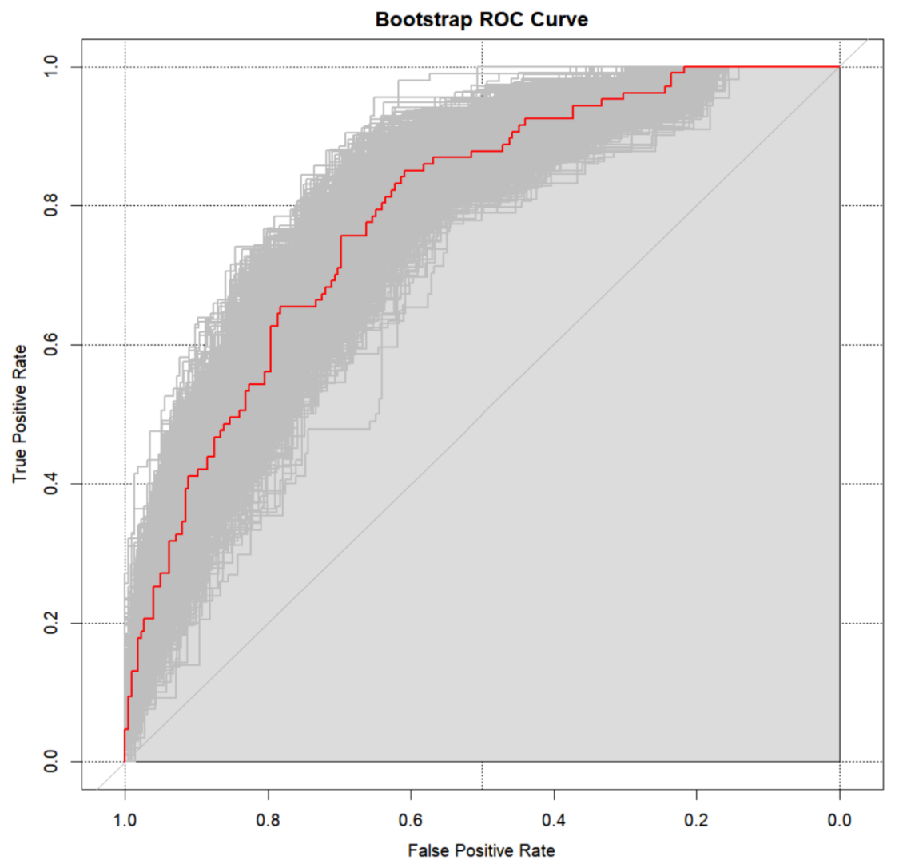

Supplemental Figure 2. CIC of the Clinical-SIRI model. The two horizontal axes depict this correspondence. The solid red lines indicate the total number of high-risk patients for each risk threshold out of a sample size of 1,000 patients. The dashed blue line represents the number of actual positive events that occur in high-risk patients.
CIC, clinical impact curves, SIRI, systemic inflammation response index.
