Supplemental materials

Impact of Obstructive Sleep Apnea and Continuous Positive Airway Pressure Treatment on Dry Eye Disease: A Systematic Review and Meta-analysis
Table of Contents

PRISMA checklist 3
Supplementary Table 1 7
Supplementary Figure 1(a) – 4(e) 10
Supplementary Table 2 15
Supplementary Table 3 18
References 19

Section and Topic | Item # | Checklist item | Location where item is reported (Manuscript)
TITLE
Title | 1 | Identify the report as a systematic review. | P. 1
ABSTRACT
Abstract | 2 | See the PRISMA 2020 for Abstracts checklist. | P. 3
INTRODUCTION
Rationale | 3 | Describe the rationale for the review in the context of existing knowledge. | P. 6
Objectives | 4 | Provide an explicit statement of the objective(s) or question(s) the review addresses. | P. 6
METHODS
Eligibility criteria | 5 | Specify the inclusion and exclusion criteria for the review and how studies were grouped for the syntheses. | P. 8
Information sources | 6 | Specify all databases, registers, websites, organisations, reference lists and other sources searched or consulted to identify studies. Specify the date when each source was last searched or consulted. | P. 7
Search strategy | 7 | Present the full search strategies for all databases, registers and websites, including any filters and limits used. | P. 7-8
Selection process | 8 | Specify the methods used to decide whether a study met the inclusion criteria of the review, including how many reviewers screened each record and each report retrieved, whether they worked independently, and if applicable, details of automation tools used in the process. | P. 7-9
Data collection process | 9 | Specify the methods used to collect data from reports, including how many reviewers collected data from each report, whether they worked independently, any processes for obtaining or confirming data from study investigators, and if applicable, details of automation tools used in the process. | P. 9-11
Data items | 10a | List and define all outcomes for which data were sought. Specify whether all results that were compatible with each outcome domain in each study were sought (e.g. for all measures, time points, analyses), and if not, the methods used to decide which results to collect. | P. 10
Data items | 10b | List and define all other variables for which data were sought (e.g. participant and intervention characteristics, funding sources). Describe any assumptions made about any missing or unclear information. | P. 9-10
Study risk of bias assessment | 11 | Specify the methods used to assess risk of bias in the included studies, including details of the tool(s) used, how many reviewers assessed each study and whether they worked independently, and if applicable, details of automation tools used in the process. | P. 11
Effect measures | 12 | Specify for each outcome the effect measure(s) (e.g. risk ratio, mean difference) used in the synthesis or presentation of results. | P. 10
Synthesis methods | 13a | Describe the processes used to decide which studies were eligible for each synthesis (e.g. tabulating the study intervention characteristics and comparing against the planned groups for each synthesis (item #5)). | P. 7-8
Synthesis methods | 13b | Describe any methods required to prepare the data for presentation or synthesis, such as handling of missing summary statistics, or data conversions. | P. 7-8
Synthesis methods | 13c | Describe any methods used to tabulate or visually display results of individual studies and syntheses. | P. 10-11
Synthesis methods | 13d | Describe any methods used to synthesize results and provide a rationale for the choice(s). If meta-analysis was performed, describe the model(s), method(s) to identify the presence and extent of statistical heterogeneity, and software package(s) used. | P. 10-11
Synthesis methods | 13e | Describe any methods used to explore possible causes of heterogeneity among study results (e.g. subgroup analysis, meta-regression). | P. 11
Synthesis methods | 13f | Describe any sensitivity analyses conducted to assess robustness of the synthesized results. | P. 11
Reporting bias assessment | 14 | Describe any methods used to assess risk of bias due to missing results in a synthesis (arising from reporting biases). | P. 11
Certainty assessment | 15 | Describe any methods used to assess certainty (or confidence) in the body of evidence for an outcome. | P. 11
RESULTS
Study selection | 16a | Describe the results of the search and selection process, from the number of records identified in the search to the number of studies included in the review, ideally using a flow diagram. | P. 12
Study selection | 16b | Cite studies that might appear to meet the inclusion criteria, but which were excluded, and explain why they were excluded. | P. 12
Study characteristics | 17 | Cite each included study and present its characteristics. | Table 1(a), (b)
Risk of bias in studies | 18 | Present assessments of risk of bias for each included study. | Supplementary Table 2
Results of individual studies | 19 | For all outcomes, present, for each study: (a) summary statistics for each group (where appropriate) and (b) an effect estimate and its precision (e.g. confidence/credible interval), ideally using structured tables or plots. | P. 12, 15
Results of syntheses | 20a | For each synthesis, briefly summarise the characteristics and risk of bias among contributing studies. | P. 14, 17
Results of syntheses | 20b | Present results of all statistical syntheses conducted. If meta-analysis was done, present for each the summary estimate and its precision (e.g. confidence/credible interval) and measures of statistical heterogeneity. If comparing groups, describe the direction of the effect. | Table 2, Supplementary Figure 1-3
Results of syntheses | 20c | Present results of all investigations of possible causes of heterogeneity among study results. | Supplementary Figure 1-3
Results of syntheses | 20d | Present results of all sensitivity analyses conducted to assess the robustness of the synthesized results. | P. 13
Reporting biases | 21 | Present assessments of risk of bias due to missing results (arising from reporting biases) for each synthesis assessed. | N/A
Certainty of evidence | 22 | Present assessments of certainty (or confidence) in the body of evidence for each outcome assessed. | Supplementary Table 3
DISCUSSION
Discussion | 23a | Provide a general interpretation of the results in the context of other evidence. | P. 18
Discussion | 23b | Discuss any limitations of the evidence included in the review. | P. 23-24
Discussion | 23c | Discuss any limitations of the review processes used. | P. 23-24
Discussion | 23d | Discuss implications of the results for practice, policy, and future research. | P. 23-24
OTHER INFORMATION
Registration and protocol | 24a | Provide registration information for the review, including register name and registration number, or state that the review was not registered. | P. 7
Registration and protocol | 24b | Indicate where the review protocol can be accessed, or state that a protocol was not prepared. | P. 7
Registration and protocol | 24c | Describe and explain any amendments to information provided at registration or in the protocol. | P. 7
Support | 25 | Describe sources of financial or non-financial support for the review, and the role of the funders or sponsors in the review. | P. 25
Competing interests | 26 | Declare any competing interests of review authors. | P. 25
Availability of data, code and other materials | 27 | Report which of the following are publicly available and where they can be found: template data collection forms; data extracted from included studies; data used for all analyses; analytic code; any other materials used in the review. | P. 25

From: Page MJ, McKenzie JE, Bossuyt PM, Boutron I, Hoffmann TC, Mulrow CD, et al. The PRISMA 2020 statement: an updated guideline for reporting systematic reviews. BMJ 2021;372:n71. doi: 10.1136/bmj.n71
For more information, visit: http://www.prisma-statement.org/

Supplementary Table 1. Search strategies for databases.
Database | Keywords | Results
The impact of OSA on DED.
PubMed | ("obstructive sleep apnoea"[All Fields] OR "sleep apnea, obstructive"[MeSH Terms] OR ("sleep"[All Fields] AND "apnea"[All Fields] AND "obstructive"[All Fields]) OR "obstructive sleep apnea"[All Fields] OR ("obstructive"[All Fields] AND "sleep"[All Fields] AND "apnea"[All Fields]) OR (("sleep breath"[Journal] OR ("sleep"[All Fields] AND "breathing"[All Fields]) OR "sleep breathing"[All Fields]) AND ("disease"[MeSH Terms] OR "disease"[All Fields] OR "disorder"[All Fields] OR "disorders"[All Fields] OR "disorder s"[All Fields] OR "disordes"[All Fields])) OR "OSA"[All Fields]) AND ("dry eye syndromes"[MeSH Terms] OR ("dry"[All Fields] AND "eye"[All Fields] AND "syndromes"[All Fields]) OR "dry eye syndromes"[All Fields] OR ("dry"[All Fields] AND "eye"[All Fields]) OR "dry eye"[All Fields] OR ("ocul surf"[Journal] OR ("ocular"[All Fields] AND "surface"[All Fields]) OR "ocular surface"[All Fields]))  Translations  obstructive sleep apnea: "obstructive sleep apnoea"[All Fields] OR "sleep apnea, obstructive"[MeSH Terms] OR ("sleep"[All Fields] AND "apnea"[All Fields] AND "obstructive"[All Fields]) OR "obstructive sleep apnea"[All Fields] OR ("obstructive"[All Fields] AND "sleep"[All Fields] AND "apnea"[All Fields])  sleep breathing: "Sleep Breath"[Journal:__jid9804161] OR ("sleep"[All Fields] AND "breathing"[All Fields]) OR "sleep breathing"[All Fields]  disorder: "disease"[MeSH Terms] OR "disease"[All Fields] OR "disorder"[All Fields] OR "disorders"[All Fields] OR "disorder's"[All Fields] OR "disordes"[All Fields]  dry eye: "dry eye syndromes"[MeSH Terms] OR ("dry"[All Fields] AND "eye"[All Fields] AND "syndromes"[All Fields]) OR "dry eye syndromes"[All Fields] OR ("dry"[All Fields] AND "eye"[All Fields]) OR "dry eye"[All Fields]  ocular surface: "Ocul Surf"[Journal:__jid101156063] OR ("ocular"[All Fields] AND "surface"[All Fields]) OR "ocular surface"[All Fields] | 80
Embase | ('obstructive sleep apnea'/exp OR 'sleep breathing disorder' OR osa) AND ('dry eye'/exp OR 'ocular surface'/exp) | 61
ScienceDirect | ("obstructive sleep apnea" OR "sleep breathing disorder" OR "OSA" ) AND ("Dry eye" OR "ocular surface") | 266
Cochrane Library | #1 obstructive sleep apnea 7120  #2 sleep breathing disorder 844  #3 OSA 4421  #4 #1 OR #2 OR #3 8227  #5 dry eye 4330  #6 ocular surface 2839  #7 #6 OR #5 5766  #8 #4 AND #7 24 | 24
Web of Science | 1: obstructive sleep apnea OR sleep breathing disorder OR OSA (All Fields) Results: 80765  2: ALL=(dry eye OR ocular surface) Results: 35046  3: #2 AND #1 Results: 90 | 90
The impact of CPAP use on DED.
PubMed | ("Continuous Positive Airway Pressure"[Mesh]) OR ( "Positive-Pressure Respiration, Intrinsic"[Mesh] OR "Intermittent Positive-Pressure Ventilation"[Mesh] ) AND ("dry eye syndromes"[MeSH Terms] OR ("dry"[All Fields] AND "eye"[All Fields] AND "syndromes"[All Fields]) OR "dry eye syndromes"[All Fields] OR ("dry"[All Fields] AND "eye"[All Fields]) OR "dry eye"[All Fields] OR ("ocul surf"[Journal] OR ("ocular"[All Fields] AND "surface"[All Fields]) OR "ocular surface"[All Fields]))  Translations  CPAP: "Continuous Positive Airway Pressure"[Mesh]  positive airway pressure: "Positive-Pressure Respiration, Intrinsic"[Mesh] OR "Intermittent Positive-Pressure Ventilation"[Mesh]  dry eye: "dry eye syndromes"[MeSH Terms] OR ("dry"[All Fields] AND "eye"[All Fields] AND "syndromes"[All Fields]) OR "dry eye syndromes"[All Fields] OR ("dry"[All Fields] AND "eye"[All Fields]) OR "dry eye"[All Fields]  ocular surface: "Ocul Surf"[Journal:__jid101156063] OR ("ocular"[All Fields] AND "surface"[All Fields]) OR "ocular surface"[All Fields] | 14
Embase | ('cpap'/exp OR cpap OR 'positive airway pressure'/exp OR 'positive airway pressure' OR (positive AND ('airway'/exp OR airway) AND ('pressure'/exp OR pressure))) AND ('dry eye'/exp OR 'dry eye' OR (dry AND ('eye'/exp OR eye)) OR 'ocular surface'/exp OR 'ocular surface' OR (ocular AND ('surface'/exp OR surface))) | 58
ScienceDirect | ("CPAP" OR "positive airway pressure") AND ("dry eye" OR "ocular surface") | 4
Cochrane Library | #1 CPAP 5698  #2 positive airway pressure 5866  #3 #1 OR #2 7718  #4 dry eye 4330  #5 ocular surface 2839  #6 #4 OR #5 5766  #7 #3 AND #6 4 | 4
Web of Science | 1: "CPAP" OR "positive airway pressure" (All Fields) Results: 24408  2: ALL=(dry eye OR ocular surface) Results: 35046  3: #2 AND #1 Results: 23 | 23

Results of the meta-analysis regarding the impact of OSA on DED.

- TBUT
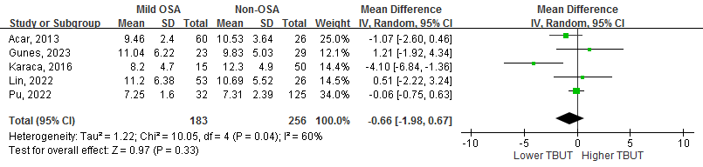
Supplementary Figure 1(a). Mild-OSA versus non-OSA.

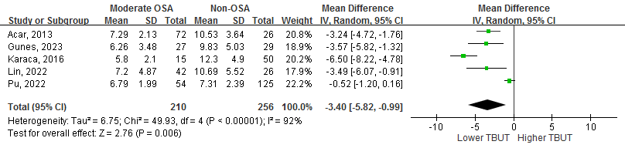
Supplementary Figure 1(b). Moderate-OSA versus non-OSA.

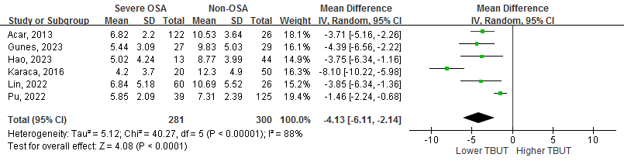
Supplementary Figure 1(c). Severe-OSA versus non-OSA.

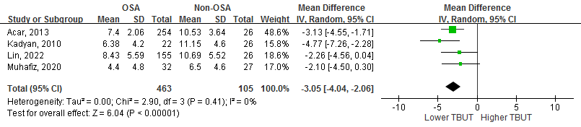
Supplementary Figure 1(d). OSA patients versus non-OSA patients in prospective cohort study.

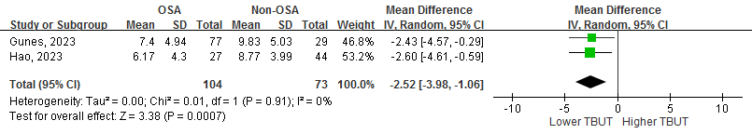
Supplementary Figure 1(e). OSA patients versus non-OSA patients in cross-sectional study.

- Schirmer’s test
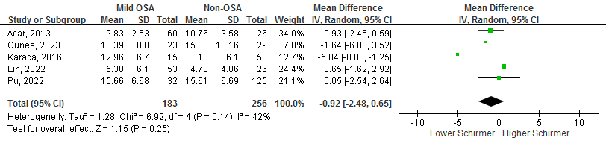
Supplementary Figure 2(a). Mild-OSA versus non-OSA.

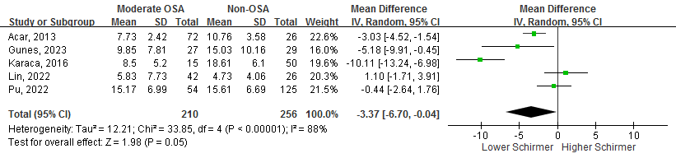
Supplementary Figure 2(b). Moderate-OSA versus non-OSA.

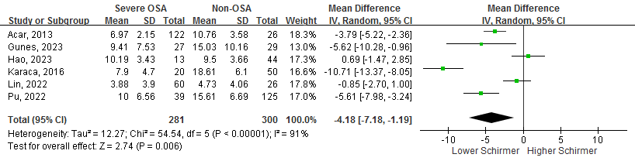
Supplementary Figure 2(c). Severe-OSA versus non-OSA.

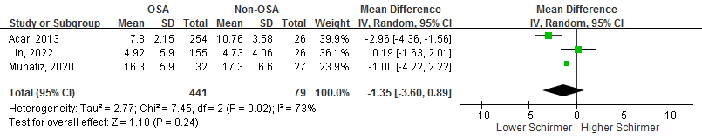
Supplementary Figure 2(d). OSA patients versus non-OSA patients in prospective cohort study.

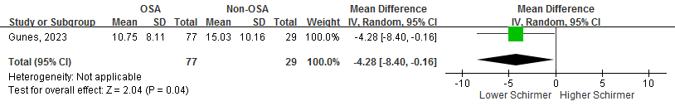
Supplementary Figure 2(e). OSA patients versus non-OSA patients in cross-sectional study.

- OSDI
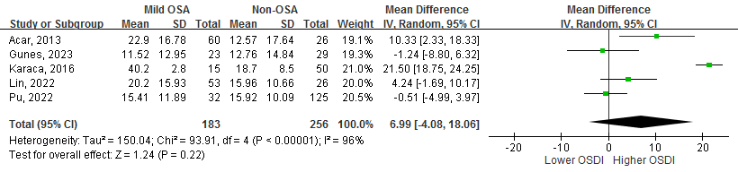
Supplementary Figure 3(a). Mild-OSA versus non-OSA.

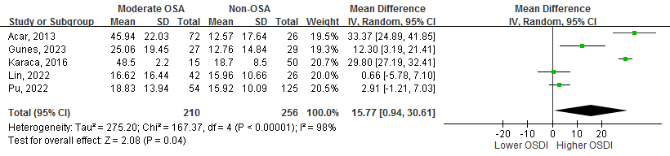
Supplementary Figure 3(b). Moderate-OSA versus non-OSA.

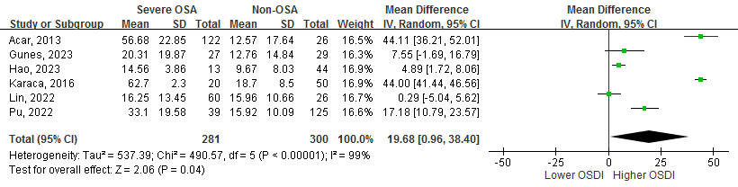
Supplementary Figure 3(c). Severe-OSA versus non-OSA.

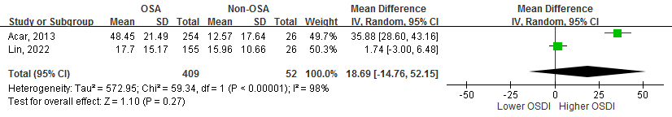
Supplementary Figure 3(d). OSA patients versus non-OSA patients in prospective cohort study.

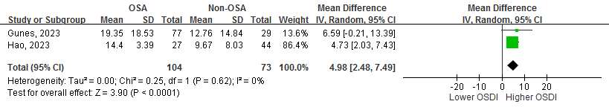
Supplementary Figure 3(e). OSA patients versus non-OSA patients in cross-sectional study.

- CFS
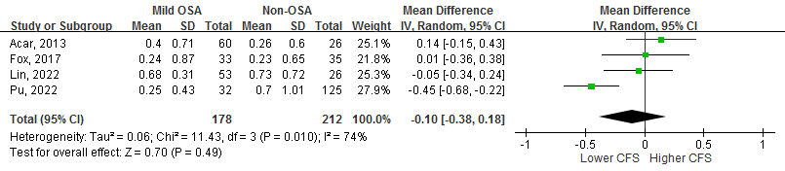
Supplementary Figure 4(a). Mild-OSA versus non-OSA.

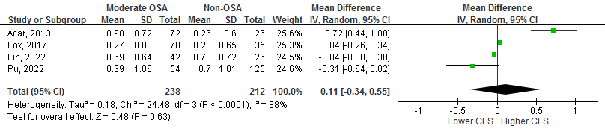
Supplementary Figure 4(b). Moderate-OSA versus non-OSA.

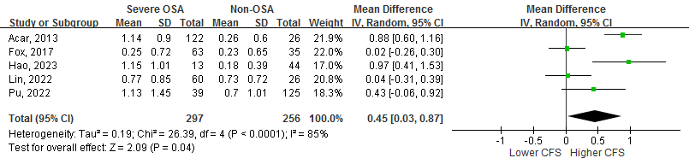
Supplementary Figure 4(c). Severe-OSA versus non-OSA.

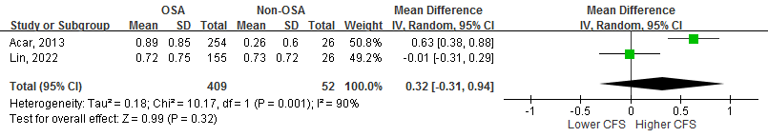
Supplementary Figure 4(d). OSA patients versus non-OSA patients in prospective cohort study.

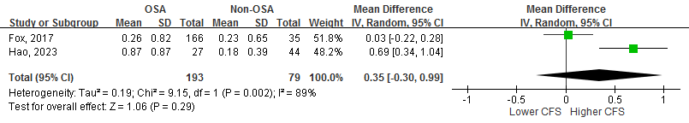
Supplementary Figure 4(e). OSA patients versus non-OSA patients in cross-sectional study.

Supplementary Table 2. Results of the risk of bias assessment.
The impact of OSA on DED.
 | Selection |  |  |  |  |  |  |  |  |  |  |  |  |  | Comparability |  |  |  |  | Outcome
Cohort study^{a,c} | Representativeness of the exposed cohort |  |  |  | Selection of exposure |  |  | Ascertainment of exposure |  |  | Outcome of interest not present at the start of the study |  |  |  | Cohorts comparable on the basis of design or analysis |  |  |  |  | Assessment of outcome |  |  |  | Adequacy of duration or follow-up |  |  |  | Adequacy of completeness of follow-up |  |  | Total |  |  |  | Risk
Acar, 2013^{b} [1] | * |  |  |  | * |  |  | * |  |  | - |  |  |  | * |  |  |  |  | * |  |  |  | * |  |  |  | * |  |  | 7/9 |  |  |  | Low
Kadyan, 2010^{b} [2] | * |  |  |  | * |  |  | * |  |  | - |  |  |  | * |  |  |  |  | * |  |  |  | * |  |  |  | * |  |  | 7/9 |  |  |  | Low
Karaca, 2016^{b} [3] | * |  |  |  | * |  |  | * |  |  | - |  |  |  | ** |  |  |  |  | * |  |  |  | * |  |  |  | * |  |  | 8/9 |  |  |  | Low
Lin, 2022^{b} [4] | * |  |  |  | * |  |  | * |  |  | - |  |  |  | ** |  |  |  |  | * |  |  |  | * |  |  |  | * |  |  | 8/9 |  |  |  | Low
Liu, 2022 [5] | * |  |  |  | * |  |  | * |  |  | - |  |  |  | ** |  |  |  |  | * |  |  |  | * |  |  |  | * |  |  | 8/9 |  |  |  | Low
Muhafiz, 2020^{b} [6] | * |  |  |  | * |  |  | * |  |  | - |  |  |  | ** |  |  |  |  | * |  |  |  | * |  |  |  | * |  |  | 8/9 |  |  |  | Low
 | Selection |  |  |  |  |  |  |  |  |  |  |  | Comparability |  |  |  |  | Exposure
Case-control study^{a,c} | Definition of cases | Representative-ness of cases |  |  |  |  |  |  | Selection of controls | Definition of controls |  |  | Comparability based on design or analysis |  |  |  |  | Ascertainment of exposure |  |  |  |  |  |  | Same methods of ascertainment for cases and controls |  |  |  |  | Non-  response rate |  | Total |  |  | Risk
Pu, 2022^{b} [7] | * | * |  |  |  |  |  |  | - | * |  |  | ** |  |  |  |  | * |  |  |  |  |  |  | * |  |  |  |  | * |  | 8/9 |  |  | Low
 | Selection |  |  |  |  |  |  |  |  |  |  |  |  |  |  | Comparability |  |  |  |  | Outcome
Cross-sectional study^{a,c} | Representative-ness of cases | Sample size justified |  |  |  |  |  |  | Non-  respondents | Ascertainment of exposure |  |  |  |  |  | Confounding controlled |  |  |  |  | Outcome assessment |  |  |  |  |  |  |  | Statistics |  |  |  |  | Total | Risk
Fox, 2017^{b} [8] | * | - |  |  |  |  |  |  | * | ** |  |  |  |  |  | ** |  |  |  |  | ** |  |  |  |  |  |  |  | * |  |  |  |  | 9/10 | Very low
Gunes, 2023^{b} [9] | * | - |  |  |  |  |  |  | * | ** |  |  |  |  |  | ** |  |  |  |  | ** |  |  |  |  |  |  |  | * |  |  |  |  | 9/10 | Very low
Hao, 2023^{b} [10] | * | - |  |  |  |  |  |  | - | ** |  |  |  |  |  | ** |  |  |  |  | ** |  |  |  |  |  |  |  | * |  |  |  |  | 8/10 | Low
Karaca, 2019 [11] | * | - |  |  |  |  |  |  | * | ** |  |  |  |  |  | * |  |  |  |  | ** |  |  |  |  |  |  |  | * |  |  |  |  | 8/10 | Low
The impact of CPAP use on DED.
RCTª | Random sequence generation | Allocation concealment |  |  |  |  | Blinding of participants and personnel |  |  |  |  | Blinding of outcome assessment |  |  |  |  | Incomplete outcome data |  |  |  |  | Selective reporting |  |  |  | Other bias |  |  |  |  |  |  |  |  | Risk
Acar, 2014 [12] | Some concerns | Low risk |  |  |  |  | High risk |  |  |  |  | Low risk |  |  |  |  | Low risk |  |  |  |  | Low risk |  |  |  | Some concerns (ages) |  |  |  |  |  |  |  |  | High
 | Selection |  |  |  |  |  |  |  |  |  |  |  |  | Comparability |  |  |  |  | Exposure
Cohort study^{a,c} | Representativeness of the exposed cohort |  |  | Selection of exposure |  | Ascertainment of exposure |  |  |  | Outcome of interest not present at the start of the study |  |  |  | Cohorts comparable on the basis of design or analysis |  |  |  |  | Assessment of outcome |  |  |  | Adequacy of duration or follow-up |  |  |  | Adequacy of completeness of follow-up |  |  |  |  |  | Total |  | Risk
Hayirci, 2012 [13] | * |  | * |  |  | * |  |  |  | * |  |  |  | ** |  |  |  |  | * |  |  |  | * |  |  |  | * |  |  |  |  |  | 9/9 |  | Low
Kadyan, 2010^{b} [2] | * |  | * |  |  | * |  |  |  | * |  |  |  | * |  |  |  |  | * |  |  |  | * |  |  |  | * |  |  |  |  |  | 8/9 |  | Low
ª Cohort studies and case-control studies were assessed using the Newcastle-Ottawa Scale; the risk of bias were graded based on total points of the individual study (7-9: low risk; 4-6: intermediate risk; <4: high risk). Cross-sectional studies were assessed using the validated modified Newcastle-Ottawa Scale (Herzog, et al), in which we interpreted the severity of risk of bias based on total points of the individual study as well (9-10: very low risk; 7-8: low risk; 5-6: intermediate risk; <5: high risk). RCTs were assessed using the Cochrane risk of bias 2 (RoB 2) tool.
^{b} Studies were enrolled for quantitative analysis.
^{c} For cohort studies, case-control studies and cross-sectional studies, generally, a “*” was awarded for each subject if the study met the required statement; and a “-” indicated that the study did not meet the required statement. Additionally, the following subjects were awarded with a maximum of two “*”s if they totally met the required statements: (1) “Comparability” in all of the study types; (2) “Ascertainment of exposure” and “Outcome assessment” in cross-sectional studies.

Supplementary Table 3. Quality of evidence following the Grading of Recommendations, Assessment, Development and Evaluations (GRADE) criteria.
Number of studies | Study design | Risk of bias | Imprecision | Inconsistency | Indirectness | Other considerations | Quality of evidence
The impact of OSA on DED.
11 (1,526 patients) | Observational studies | Not serious | Not serious | Not serious^{c} | Not serious | None | ⊕♁○○ Low
The impact of CPAP use on DED.
3 (180 patients) | Observational studies majorlyª | Not serious | Serious^{b} | Not serious | Not serious | None | ⊕○○○ Very low
ª Including one RCT.
^{b} The available study number and patient features (consecutive patients or head-to-head analysis) were considered.
^{c} Despite statistical variation existed in some of the parameters, decreased heterogeneity was turned out in certain subgroups; with the results based on the analysis and the individual study, we deemed that the effect may not be substantial enough for generating serious risks in this entity.

Reference
- Acar M, Firat H, Acar U, Ardic S. Ocular surface assessment in patients with obstructive sleep apnea-hypopnea syndrome. Sleep Breath. 2013;17(2):583-588.
- Kadyan A, Asghar J, Dowson L, Sandramouli S. Ocular findings in sleep apnoea patients using continuous positive airway pressure. Eye (Lond). 2010;24(5):843-850.
- Karaca EE, Akcam HT, Uzun F, Ozdek S, Ulukavak Ciftci T. Evaluation of Ocular Surface Health in Patients with Obstructive Sleep Apnea Syndrome. Turk J Ophthalmol. 2016;46(3):104-108.
- Lin PW, Lin HC, Chang CT, et al. Alterations of Ocular Surface and Tear Film in Patients with Obstructive Sleep Apnea/Hypopnea Syndrome. Nat Sci Sleep. 2022;14:277-290.
- Liu S, Li S, Li M, Zeng S, Chen B, Zhang L. Evaluation of the Ocular Surface and Meibomian Gland in Obstructive Sleep Apnea Hypopnea Syndrome. Front Med (Lausanne). 2022;9:832954.
- Muhafiz E, Ölçen M, Erten R, Bozkurt E. Evaluation of Meibomian Glands in Obstructive Sleep Apnea-Hypopnea Syndrome. Cornea. 2020;39(6):685-690.
- Pu Q, Wu Z, Li AL, Guo XX, Hu JJ, Li XY. Association between poor sleep quality and an increased risk of dry eye disease in patients with obstructive sleep apnea syndrome. Front Med (Lausanne). 2022;9:870391.
- Fox TP, Schwartz JA, Chang AC, et al. Association Between Eyelid Laxity and Obstructive Sleep Apnea. JAMA Ophthalmol. 2017;135(10):1055-1061.
- Gunes I, Oltulu R, Oltulu P, Turk N, Yosunkaya S. Ocular Surface in Patients With Obstructive Sleep Apnea Syndrome: Evaluation of Clinical Parameters and Impression Cytology. Eye Contact Lens. 2023;49(1):14-18.
- Hao L, Tian Q, Liu S, Xu Z, Yang L. Alterations of ocular surface parameters in patients with obstructive sleep apnea syndrome. Front Med (Lausanne). 2023;10:1220104.
- Karaca I, Yagci A, Palamar M, Tasbakan MS, Basoglu OK. Ocular surface assessment and morphological alterations in meibomian glands with meibography in obstructive sleep apnea Syndrome. Ocul Surf. 2019;17(4):771-776.
- Acar M, Firat H, Yuceege M, Ardic S. Long-term effects of PAP on ocular surface in obstructive sleep apnea syndrome. Can J Ophthalmol. 2014;49(2):217-221.
- Hayirci E, Yagci A, Palamar M, Basoglu OK, Veral A. The effect of continuous positive airway pressure treatment for obstructive sleep apnea syndrome on the ocular surface. Cornea. 2012;31(6):604-608.

