Supplementary Table 1: List of Centres that Screened at Least One Patient
Dr. med. Azzola, Andrea | Cantonal Hospital Luzern, Pulmonology Clinic, Luzern, Switzerland
Prof. Dr. med. Bridevaux, Pierre-Olivier | Centre Hospitalier du Valais Romand, Service de Pneumologie, Sion, Switzerland
Dr. med. Charbonnier, Florian | University Hospital Geneva (HUG), Pulmonology Division, Geneva, Switzerland
Dr. med. Fiechter, René | Pulmonary Specialty Center, Aathal, Switzerland
Dr. med. Hauser, Thomas | Immunology Centre Zurich, Zurich, Switzerland
Dr. med. Huber, Michael | Hospital Wetzikon (GZO), Pulmonology Clinic, Wetzikon, Switzerland
Dr. med. Jandus, Peter | University Hospital Geneva (HUG), Immunology and Allergology Division, Geneva, Switzerland
Prof. Dr. med. Leuppi, Jörg D. | Cantonal Hospital Baselland, University Centre of Internal Medicine, Liestal, Switzerland
Dr. med. Pavlov, Nikolay | Department for Pulmonary Medicine, Allergology and Clinical Immunology, University Hospital Bern, Bern, Switzerland
Dr. med. Piecyk, Andreas | Pulmonary Center Hirslanden, Zurich, Switzerland
Dr. med. Rothe, Thomas | Cantonal Hospital Graubünden, Pulmonology Clinic, Chur, Switzerland
Prof. Dr. med. Stolz, Daiana | University Hospital Basel, Pulmonology Clinic, Basel, Switzerland
Dr. med. Scherer, Thomas | Pulmonary Clinic Bethanien, Zurich, Switzerland

Supplementary Table 2: Non-serious adverse events by system organ class (SOC) and preferred terms (PT)
System organ class (SOC) | Preferred term (PT) | Number of patients
System organ class (SOC) | Preferred term (PT) | N | %
Cardiac disorders | Arteriospasm coronary | 1 | 1.4
Ear and labyrinth disorders | Ear pain | 1 | 1.4
Ear and labyrinth disorders | Ear discomfort | 1 | 1.4
Eye disorders | Retinal vascular thrombosis | 1 | 1.4
Gastrointestinal disorders | Abdominal pain upper | 1 | 1.4
Gastrointestinal disorders | Diarrhoea | 1 | 1.4
Gastrointestinal disorders | Dysphagia | 1 | 1.4
Gastrointestinal disorders | Gastroesophageal reflux disease | 1 | 1.4
Gastrointestinal disorders | Oral pain | 1 | 1.4
Gastrointestinal disorders | Vomiting | 1 | 1.4
Gastrointestinal disorders | Tongue discomfort | 1 | 1.4
General disorders and administration site conditions | Asthenia | 2 | 2.7
General disorders and administration site conditions | Burning sensation | 1 | 1.4
General disorders and administration site conditions | Chest discomfort | 4 | 5.5
General disorders and administration site conditions | Chest pain | 3 | 4.1
General disorders and administration site conditions | Chills | 3 | 4.1
General disorders and administration site conditions | Fatigue | 5 | 6.8
General disorders and administration site conditions | Influenza like illness | 1 | 1.4
General disorders and administration site conditions | Injection site paraesthesia | 1 | 1.4
General disorders and administration site conditions | Oedema | 1 | 1.4
General disorders and administration site conditions | Pyrexia | 3 | 4.1
General disorders and administration site conditions | Injection site hypoaesthesia | 1 | 1.4
Immune system disorders | Periorbital oedema | 1 | 1.4
Immune system disorders | Seasonal allergy | 1 | 1.4
Infections and infestations | Bronchitis | 3 | 4.1
Infections and infestations | Herpes zoster | 1 | 1.4
Infections and infestations | Infection | 1 | 1.4
Infections and infestations | Nasopharyngitis | 7 | 9.6
Infections and infestations | Oral candidiasis | 1 | 1.4
Infections and infestations | Rhinitis | 1 | 1.4
Infections and infestations | Sinusitis | 2 | 2.7
Infections and infestations | Sputum purulent | 1 | 1.4
Infections and infestations | Pneumonia bacterial | 1 | 1.4
Infections and infestations | Respiratory tract infection | 1 | 1.4
Infections and infestations | COVID-19 | 3 | 4.1
Infections and infestations | Suspected COVID-19 | 1 | 1.4
Injury, poisoning and procedural complications | Alcohol poisoning | 1 | 1.4
Injury, poisoning and procedural complications | Infusion related reaction | 1 | 1.4
Injury, poisoning and procedural complications | Bone contusion | 1 | 1.4
Investigations | Peak expiratory flow rate decreased | 1 | 1.4
Investigations | Rheumatoid factor positive | 1 | 1.4
Investigations | Weight increased | 1 | 1.4
Investigations | SARS-CoV-2 test positive | 1 | 1.4
Investigations | SARS-CoV-2 test false positive | 2 | 2.7
Musculoskeletal and connective tissue disorders | Arthralgia | 3 | 4.1
Musculoskeletal and connective tissue disorders | Back pain | 1 | 1.4
Musculoskeletal and connective tissue disorders | Muscle spasms | 1 | 1.4
Musculoskeletal and connective tissue disorders | Myalgia | 1 | 1.4
Musculoskeletal and connective tissue disorders | Pain in extremity | 2 | 2.7
Musculoskeletal and connective tissue disorders | Polyarthritis | 1 | 1.4
Musculoskeletal and connective tissue disorders | Musculoskeletal chest pain | 1 | 1.4
Nervous system disorders | Ageusia | 2 | 2.7
Nervous system disorders | Anosmia | 1 | 1.4
Nervous system disorders | Dysgeusia | 1 | 1.4
Nervous system disorders | Headache | 6 | 8.2
Nervous system disorders | Hypoaesthesia | 1 | 1.4
Nervous system disorders | Somnolence | 1 | 1.4
Nervous system disorders | Tremor | 1 | 1.4
Psychiatric disorders | Depression | 1 | 1.4
Reproductive system and breast disorders | Heavy menstrual bleeding | 1 | 1.4
Respiratory, thoracic and mediastinal disorders | Asthma | 18 | 24.7
Respiratory, thoracic and mediastinal disorders | Cough | 9 | 12.3
Respiratory, thoracic and mediastinal disorders | Dysphonia | 2 | 2.7
Respiratory, thoracic and mediastinal disorders | Dyspnoea | 12 | 16.4
Respiratory, thoracic and mediastinal disorders | Epistaxis | 1 | 1.4
Respiratory, thoracic and mediastinal disorders | Nasal congestion | 2 | 2.7
Respiratory, thoracic and mediastinal disorders | Nasal polyps | 2 | 2.7
Respiratory, thoracic and mediastinal disorders | Parosmia | 1 | 1.4
Respiratory, thoracic and mediastinal disorders | Productive cough | 2 | 2.7
Respiratory, thoracic and mediastinal disorders | Rhinorrhoea | 4 | 5.5
Respiratory, thoracic and mediastinal disorders | Rhonchi | 1 | 1.4
Respiratory, thoracic and mediastinal disorders | Viral upper respiratory tract infection | 1 | 1.4
Respiratory, thoracic and mediastinal disorders | Wheezing | 1 | 1.4
Respiratory, thoracic and mediastinal disorders | Obstructive airways disorder | 1 | 1.4
Respiratory, thoracic and mediastinal disorders | Oropharyngeal pain | 4 | 5.5
Respiratory, thoracic and mediastinal disorders | NSAID exacerbated respiratory disease | 1 | 1.4
Skin and subcutaneous tissue disorders | Alopecia | 1 | 1.4
Skin and subcutaneous tissue disorders | Eczema | 1 | 1.4
Skin and subcutaneous tissue disorders | Pruritus | 2 | 2.7
Skin and subcutaneous tissue disorders | Rash | 2 | 2.7

Supplementary Table 3: Serious adverse events by system organ class (SOC) and preferred terms (PT)
System organ class (SOC) | Preferred term (PT) | Number of patients
System organ class (SOC) | Preferred term (PT) | N | %
Cardiac disorders | Acute myocardial infarction | 1 | 1.4
General disorders and administration site conditions | Chest pain | 2 | 2.7
Infections and infestations | Erysipelas | 1 | 1.4
Infections and infestations | Gastroenteritis yersinia | 1 | 1.4
Infections and infestations | Pneumonia | 1 | 1.4
Infections and infestations | Postoperative wound infection | 1 | 1.4
Infections and infestations | Septic shock | 1 | 1.4
Infections and infestations | Pneumonia bacterial | 1 | 1.4
Investigations | Bronchoscopy | 1 | 1.4
Investigations | Sputum abnormal | 1 | 1.4
Neoplasms benign, malignant and unspecified | Basal cell carcinoma | 1 | 1.4
Neoplasms benign, malignant and unspecified | Squamous cell carcinoma | 1 | 1.4
Nervous system disorders | Generalised tonic-clonic seizure | 1 | 1.4
Nervous system disorders | Syncope | 1 | 1.4
Respiratory, thoracic and mediastinal disorders | Asthma | 6 | 8.2
Respiratory, thoracic and mediastinal disorders | Dyspnoea | 1 | 1.4
Respiratory, thoracic and mediastinal disorders | Chronic rhinosinusitis with nasal polyps | 1 | 1.4
Skin and subcutaneous tissue disorders | Actinic keratosis | 1 | 1.4
Surgical and medical procedures | Appendicectomy | 1 | 1.4
Surgical and medical procedures | Breast reconstruction | 1 | 1.4
Surgical and medical procedures | Rehabilitation therapy | 1 | 1.4
Surgical and medical procedures | Hernia repair | 1 | 1.4
Surgical and medical procedures | Thyroidectomy | 1 | 1.4

Supplementary Table 4: Benralizumab-related events by system organ class (SOC) and preferred terms (PT)
System organ class (SOC) | Preferred term (PT) | Number of patients
System organ class (SOC) | Preferred term (PT) | N | %
General disorders and administration site conditions | Asthenia | 2 | 2.7
General disorders and administration site conditions | Chills | 2 | 2.7
General disorders and administration site conditions | Fatigue | 2 | 2.7
General disorders and administration site conditions | Injection site paraesthesia | 1 | 1.4
General disorders and administration site conditions | Pyrexia | 3 | 4.1
General disorders and administration site conditions | Injection site hypoaesthesia | 1 | 1.4
Immune system disorders | Periorbital oedema | 1 | 1.4
Injury, poisoning and procedural complications | Infusion related reaction | 1 | 1.4
Injury, poisoning and procedural complications | Bone contusion | 1 | 1.4
Musculoskeletal and connective tissue disorders | Arthralgia | 2 | 2.7
Musculoskeletal and connective tissue disorders | Muscle spasms | 1 | 1.4
Musculoskeletal and connective tissue disorders | Myalgia | 1 | 1.4
Nervous system disorders | Ageusia | 1 | 1.4
Nervous system disorders | Anosmia | 1 | 1.4
Nervous system disorders | Dysgeusia | 1 | 1.4
Nervous system disorders | Headache | 4 | 5.5
Nervous system disorders | Tremor | 1 | 1.4
Skin and subcutaneous tissue disorders | Pruritus | 2 | 2.7

Supplementary Figure 1: Changes in fraction of patients according to asthma control levels (ACQ-5) over time.
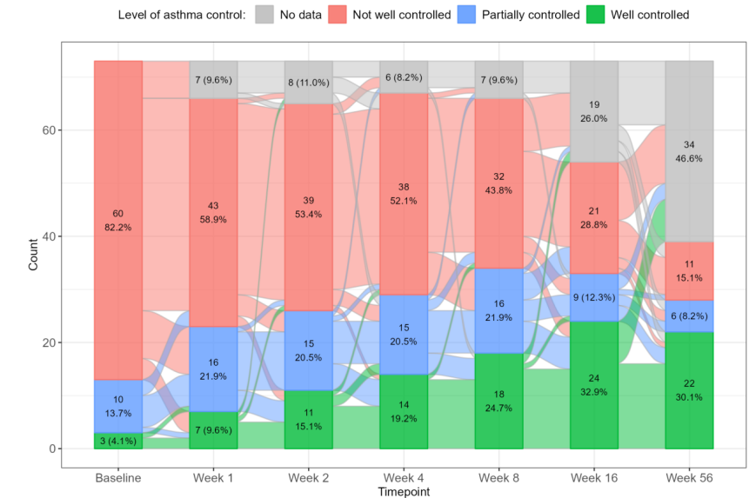

Supplementary Figure 2: PGI-S over time. Development of PGI-S in percent of patient response over the course of the study (transfer bands depict changes in flow over time).
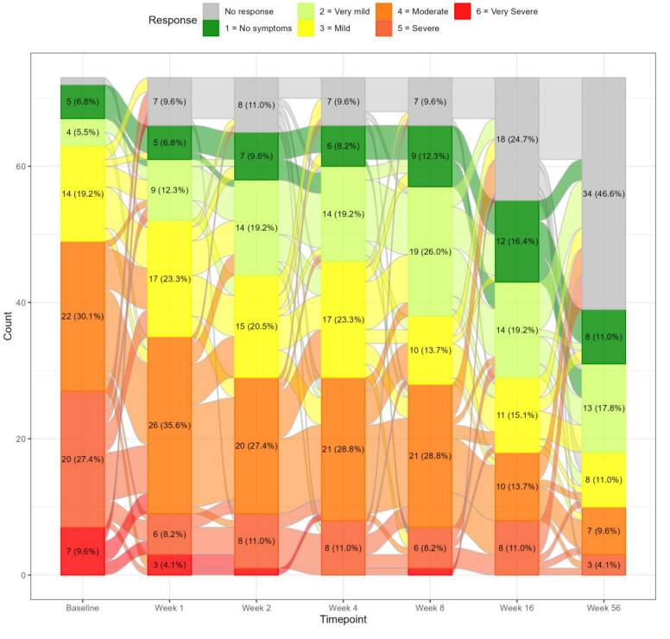

Supplementary Figure 3: PGI-C over time. Development of changes compared to baseline (in percent of patient response) over the course of the study (transfer bands depict changes in flow over time).
