A Supplementary Figure 1
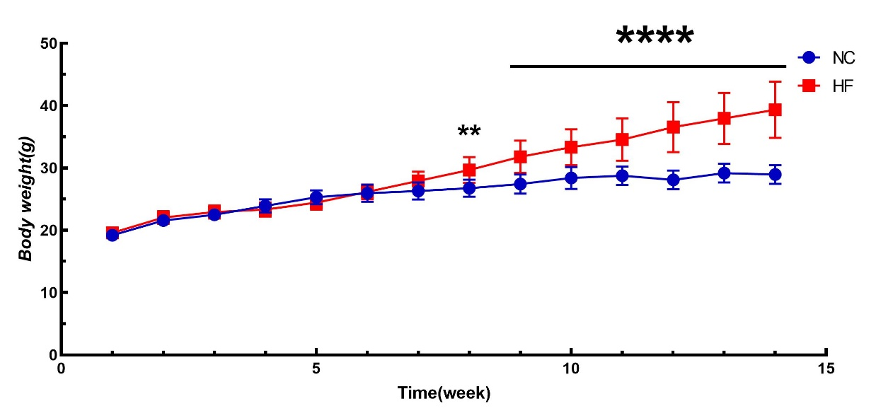

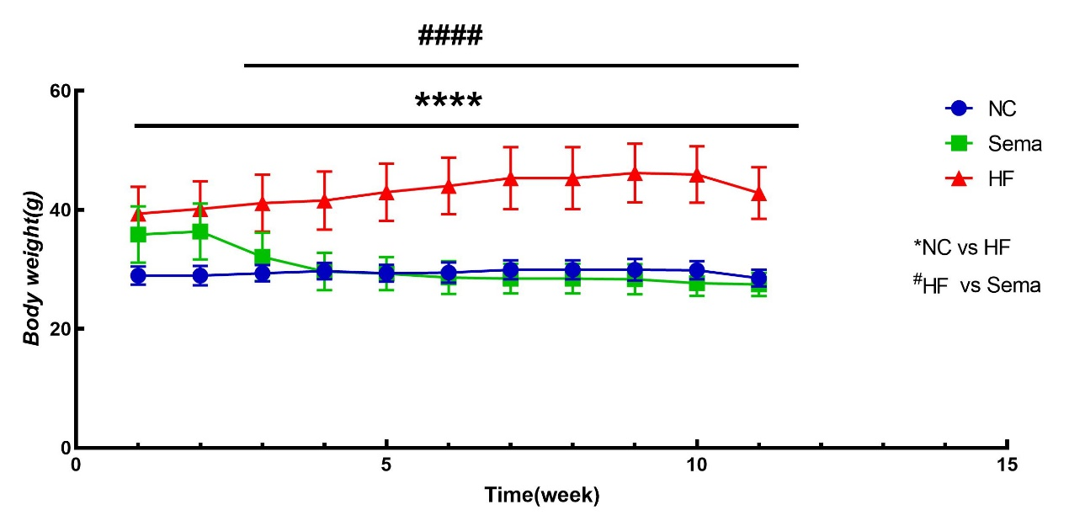
Supplementary Figure 2

Supplementary Figure 3

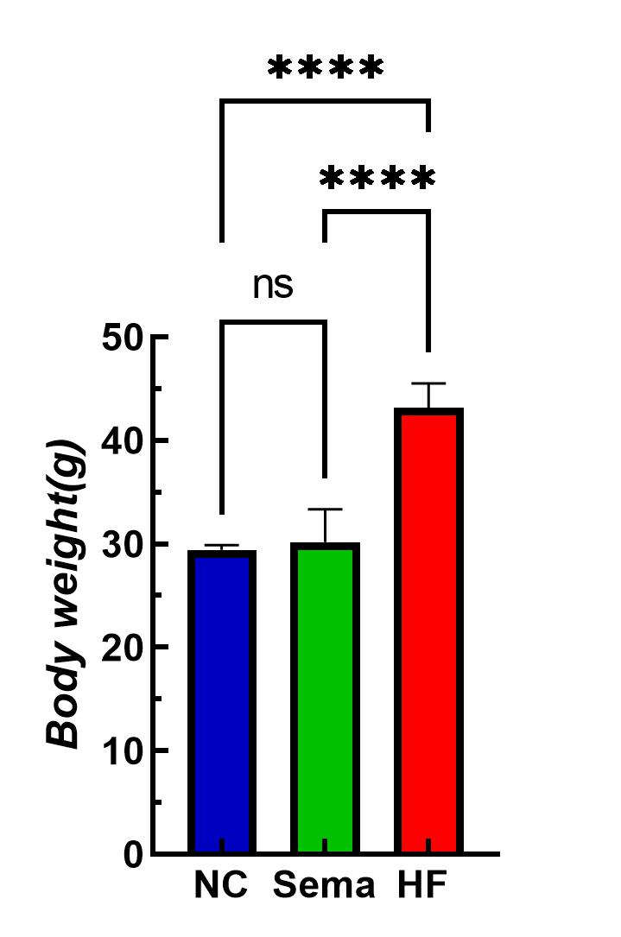

Supplementary Figure 4

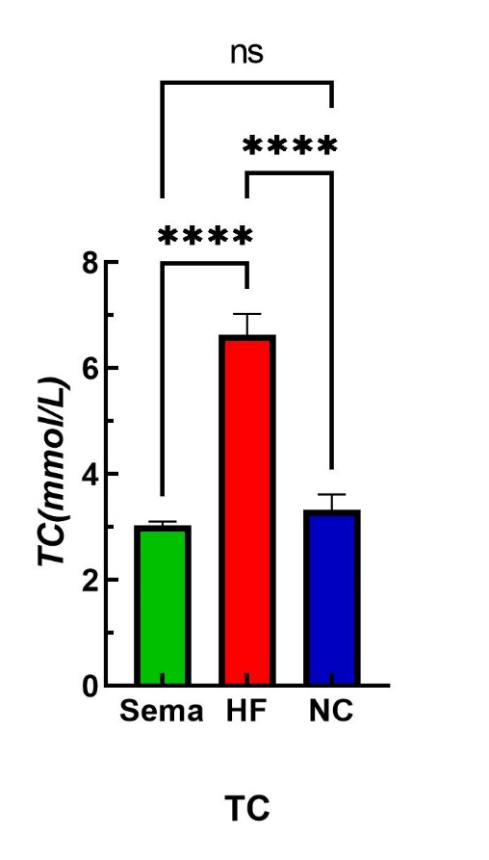

Supplementary Figure 5

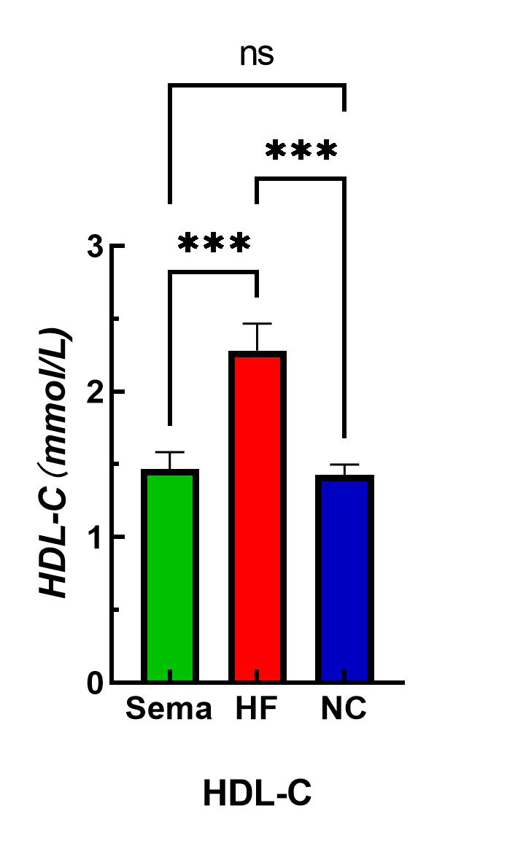

Supplementary Figure 6

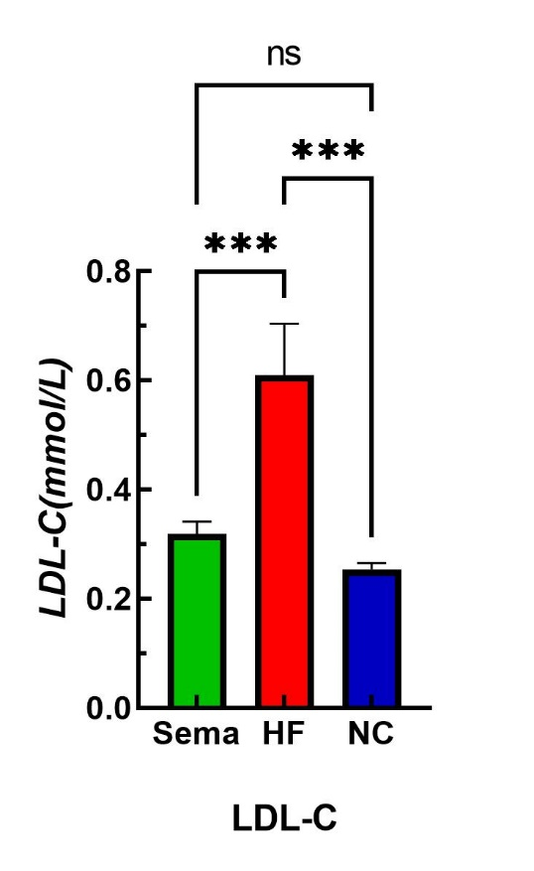

Supplementary Figure 7
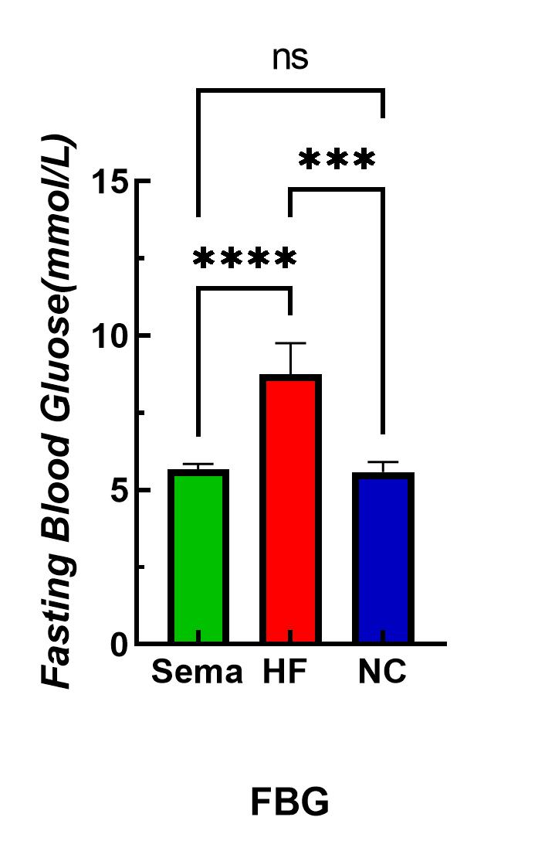

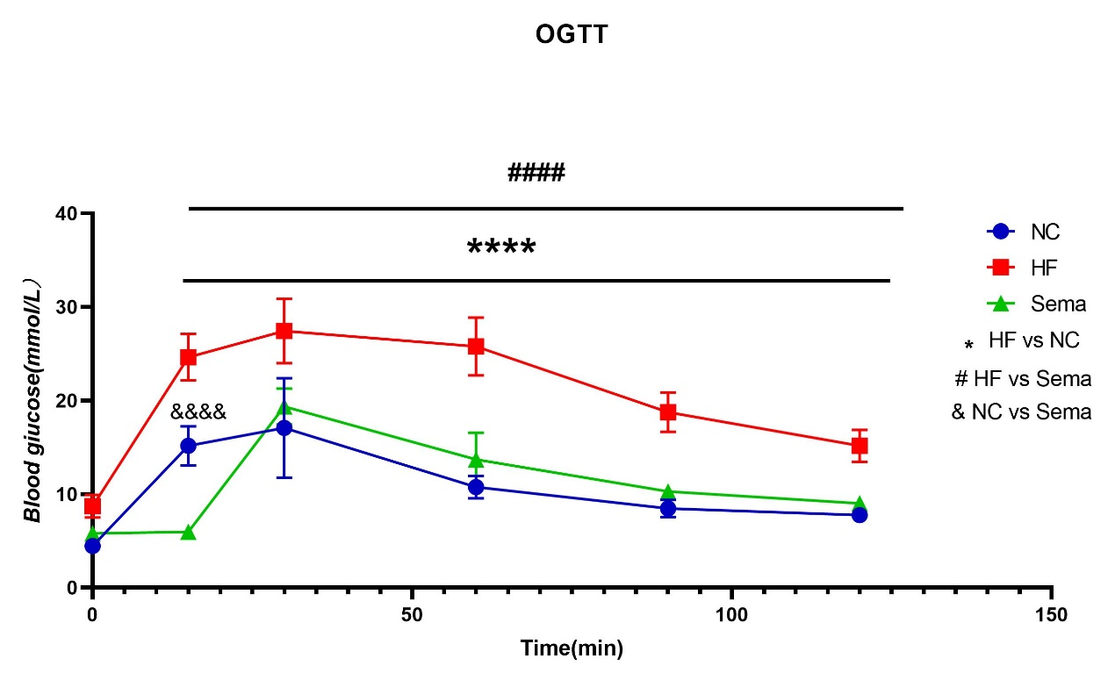
Supplementary Figure 8

Supplementary Figure 9
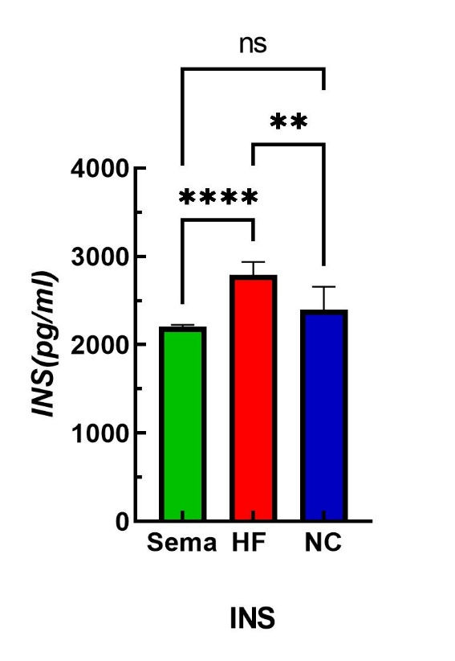

Supplementary Figure 10
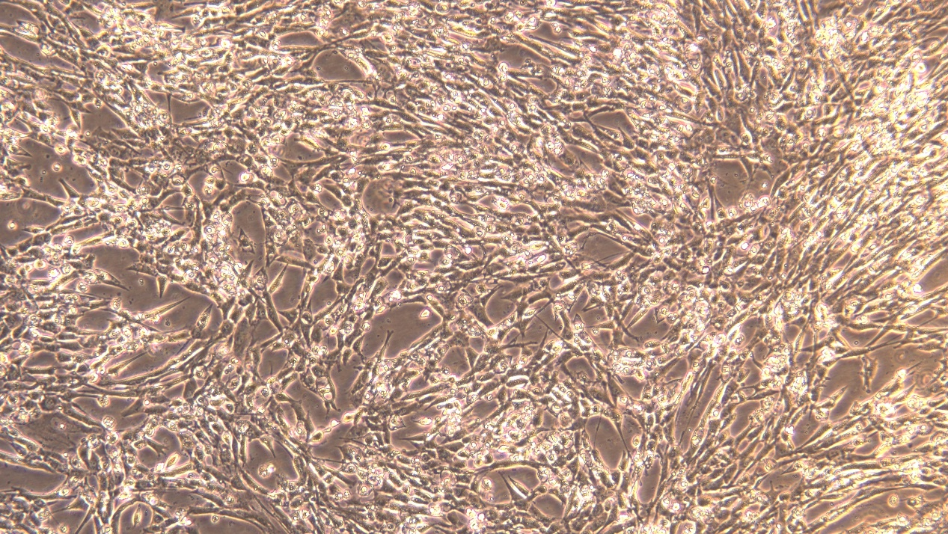
Supplementary Figure 11
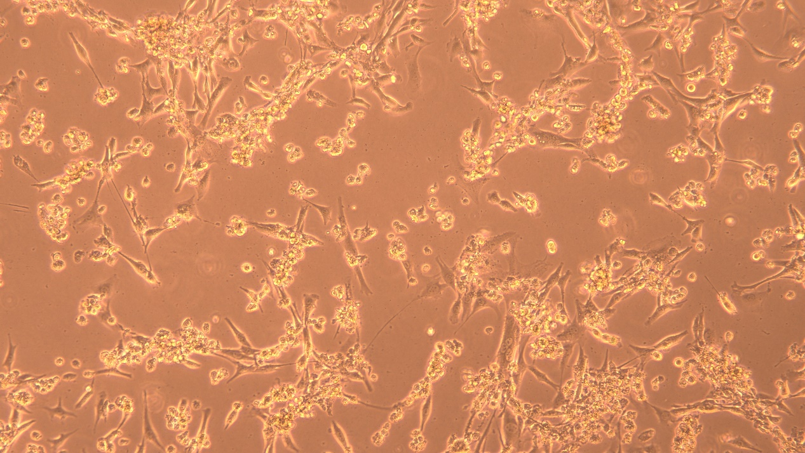
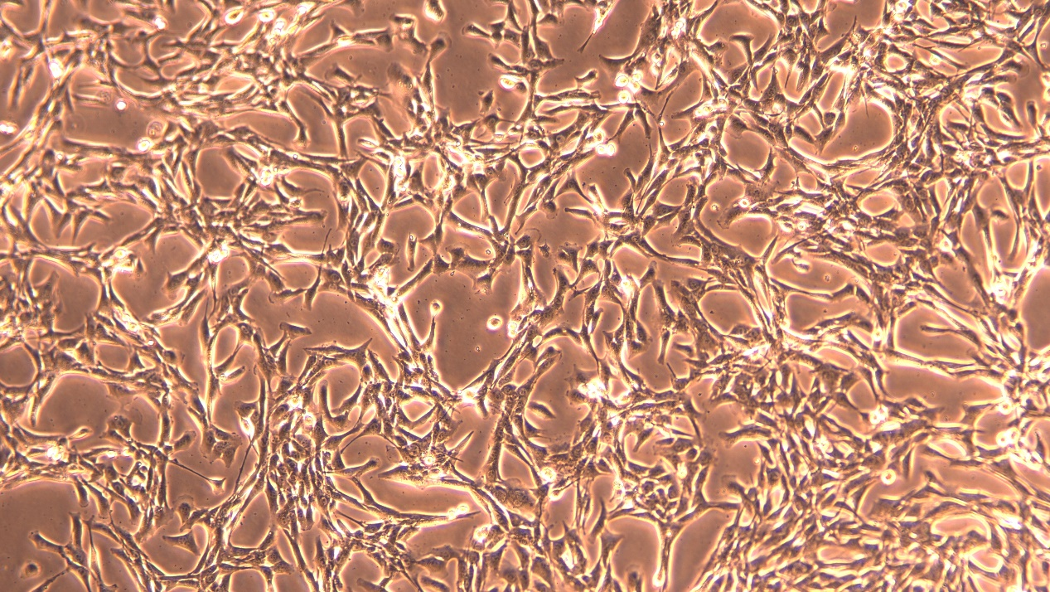
Supplementary Figure 12

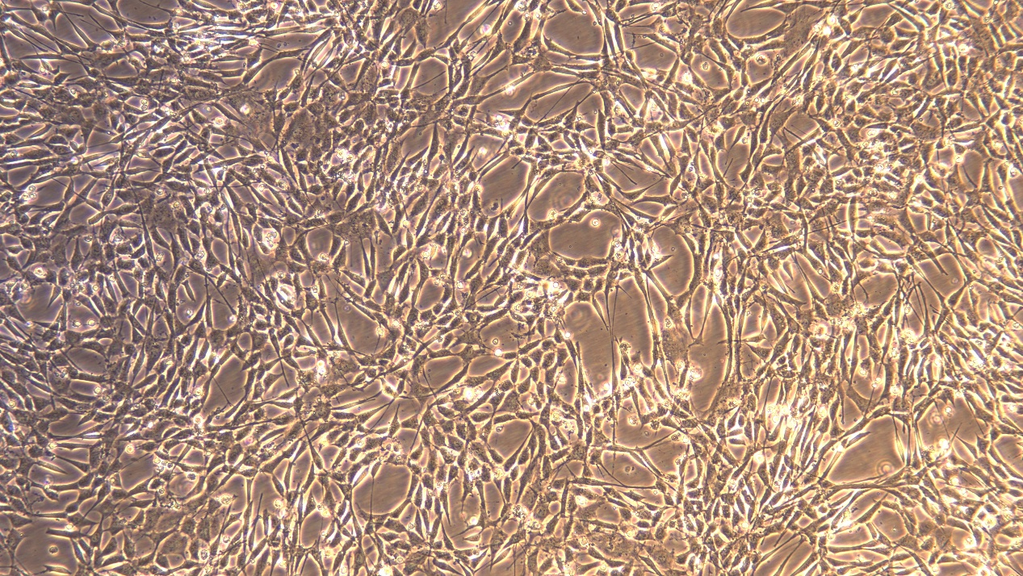
Supplementary Figure 13

Supplementary file:
Supplementary file（1）-（3）Effect of high-fat diet and semaglutide on body weight in mice.
（1）Trends in body weight of mice in the HF group and the NC group during 14 weeks
****P<0.001, **P<0.05
（2）The effect of semaglutide on mouse weight.
****P<0.001，NC vs HF。#### P<0.001，HF vs Sema
（3）The effect of HFD and semaglutide on mouse weight.
****P<0.001，ns P>0.05
（4）-（9）Semaglutide improves lipid metabolism disorders and Glucose Levels.
（4）TC （5）HDL-C（6）LDL-C（7）FBG（8）OGTT（9）INS
****P<0.001，#### P<0.001,*** P<0.01，** P<0.05，ns P>0.05
（10）-（13）Changes in cell morphology
（10）Cells were treated with PA for 24h
（11）Cells were treated with semaglutide for 24h
（12）Si-HSDL2 cell
（13）NC cell

