Supplementary material
Table S1 The edge weights in the stress‒interpersonal relationship network
 | S1 | S2 | S3 | R1 | R2 | R3 | R4
S1 | - | 0.3328 | 0.3135 | 0.0998 | 0.1101 | 0.1910 | 0.0431
S2 | 0.3328 | - | 0.3795 | 0.0128 | 0.0250 | 0.0000 | 0.0000
S3 | 0.3135 | 0.3795 | - | 0.0000 | 0.0312 | 0.0000 | 0.0413
R1 | 0.0998 | 0.0128 | 0.0000 | - | 0.4238 | 0.1127 | 0.2320
R2 | 0.1101 | 0.0250 | 0.0312 | 0.4238 | - | 0.2515 | 0.2198
R3 | 0.1910 | 0.0000 | 0.0000 | 0.1127 | 0.2515 | - | 0.0751
R4 | 0.0431 | 0.0000 | 0.0413 | 0.2320 | 0.2198 | 0.0751 | -

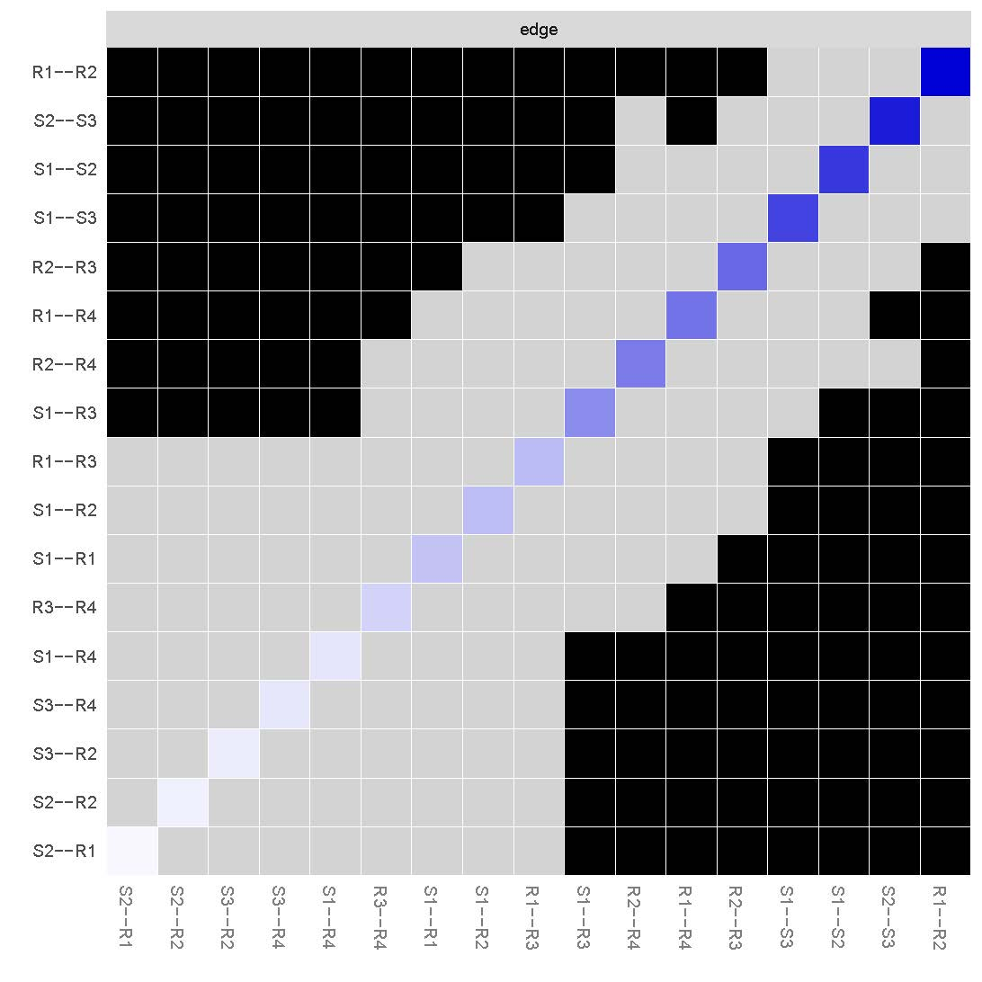
Figure S1 Accuracy test of edge weights in the network.
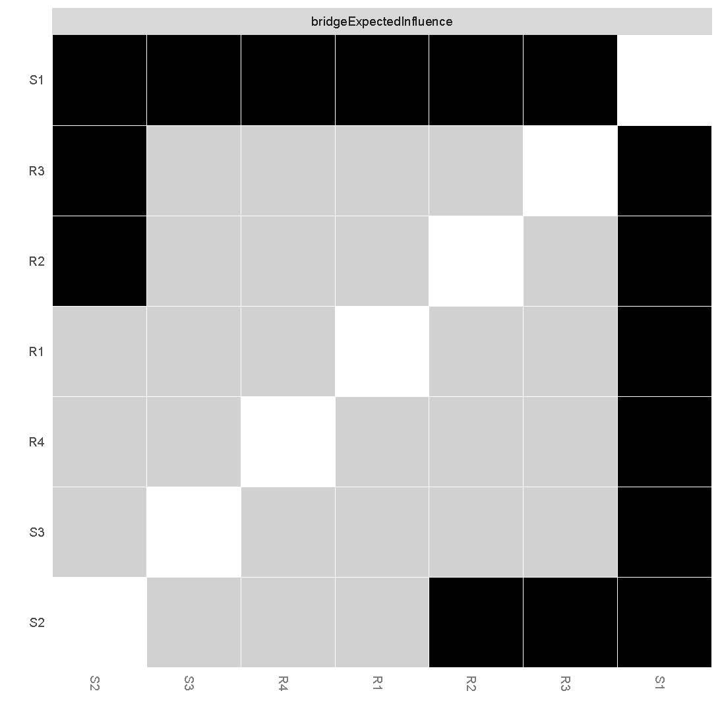
Figure S2 The results of the difference test of node BEIs.

