Supplementary Materials
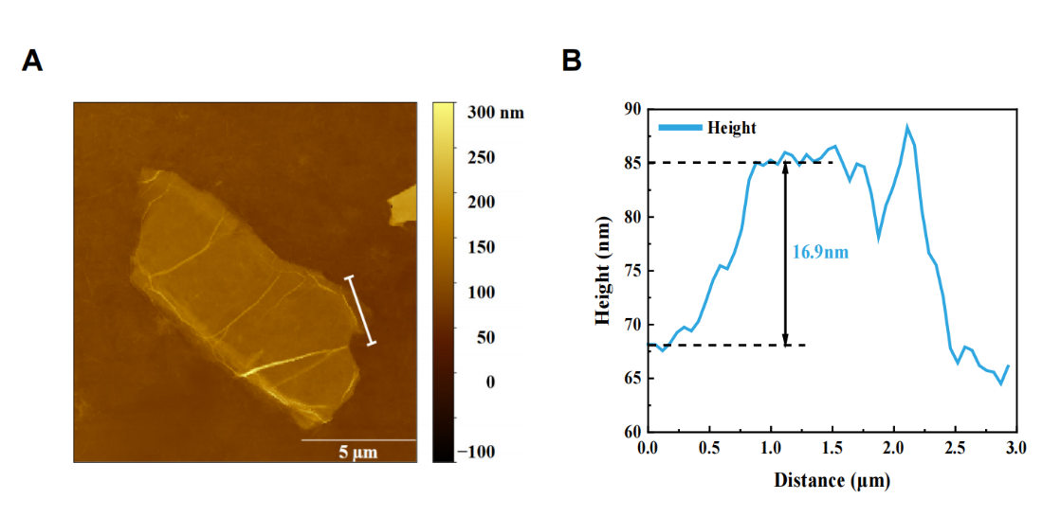
Figure S1. AFM analysis of GO nanosheet morphology. (A) AFM image of a GO nanosheet. (B) Size and height profile distribution of the delineated portion of GO nanosheets in (A).

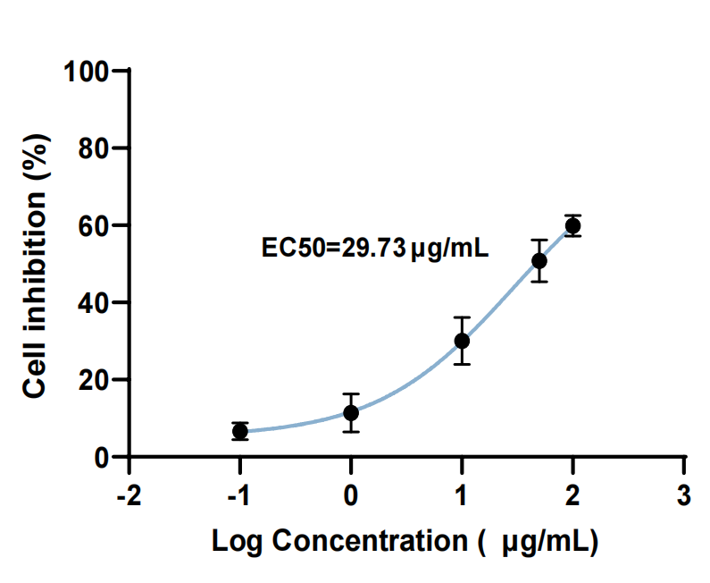
Figure S2. The 72h-EC50 value of GO nanosheets.

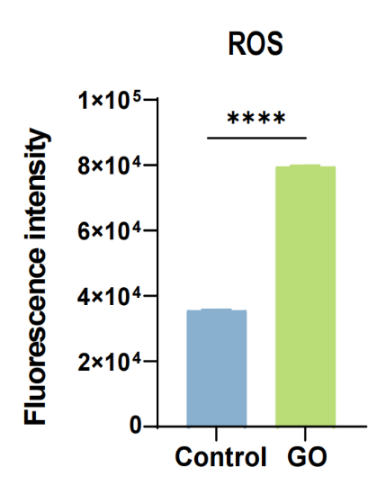
Figure S3. ROS levels in KGN cells of the GO nanosheet-treated group were quantified using a microplate reader (n=3). Data are expressed as Mean ± SEM and statistical differences between experimental groups were analyzed by the student t-test. ****p < 0.0001.

