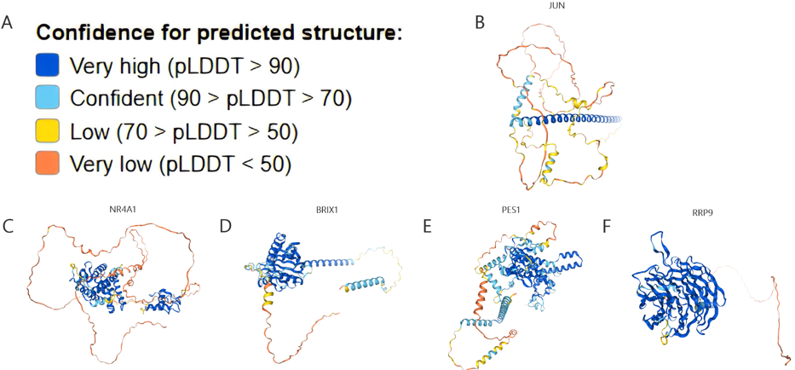

Supplementary Figure 1 Location and structure of hub genes
(A) Gene structure diagram: Dark blue indicates "Very high" with pLDDT > 90, light blue indicates "Confident" with 90 > pLDDT > 70, yellow indicates "Low" with 70 > pLDDT > 50, orange indicates "Very low" with pLDDT < 50. (B) JUN is located on chromosome 1. (C) NR4A1 is located on chromosome 12. (D) BRIX1 is located on chromosome 5. (E) PES1 is located on chromosome 22. (F) RRP9 is located on chromosome 3.

Supplementary Table 1 Functional annotation of the five hub genes
The introduction and function of critical genes in BPD.
Hub genes | Official full name | Aliases | Function
PES1 | pescadillo ribosomal biogenesis factor 1 | PES,NOP7 | Encode a nuclear protein.The encoded protein interacts with BOP1 and WDR12 to form the PeBoW complex, which plays a critical role in cell proliferation via pre-rRNA processing and 60S ribosomal subunit maturation.
BRIX1 | Biogenesis Of Ribosomes BRX1 | BRIX,BXDC2 | Enable RNA binding activity. Predicted to be involved in ribosomal large subunit assembly. Located in chromosome and nucleolus.
RRP9 | ribosomal RNA processing 9, U3 small nucleolar RNA binding protein | RNU3IP2,U3-55K | Encode a member of the WD-repeat protein family. The encoded protein is a component of the nucleolar small nuclear ribonucleoprotein particle (snoRNP) and is essential for 18s rRNA processing during ribosome synthesis.
JUN | Jun proto-oncogene, AP-1 transcription factor subunit | AP1, p39, AP-1,  cJUN, c-Jun | Encode a protein which is highly similar to the viral protein, and which interacts directly with specific target DNA sequences to regulate gene expression.
NR4A1 | nuclear receptor subfamily 4 group A member 1 | GFRP1,HMR,N10,  NAK-1, NGFIB,NP10, NUR77,TR3 | Encode a member of the steroid-thyroid hormone-retinoid receptor superfamily.The encoded protein acts as a nuclear transcription factor. Translocation of the protein from the nucleus to mitochondria induces apoptosis.

