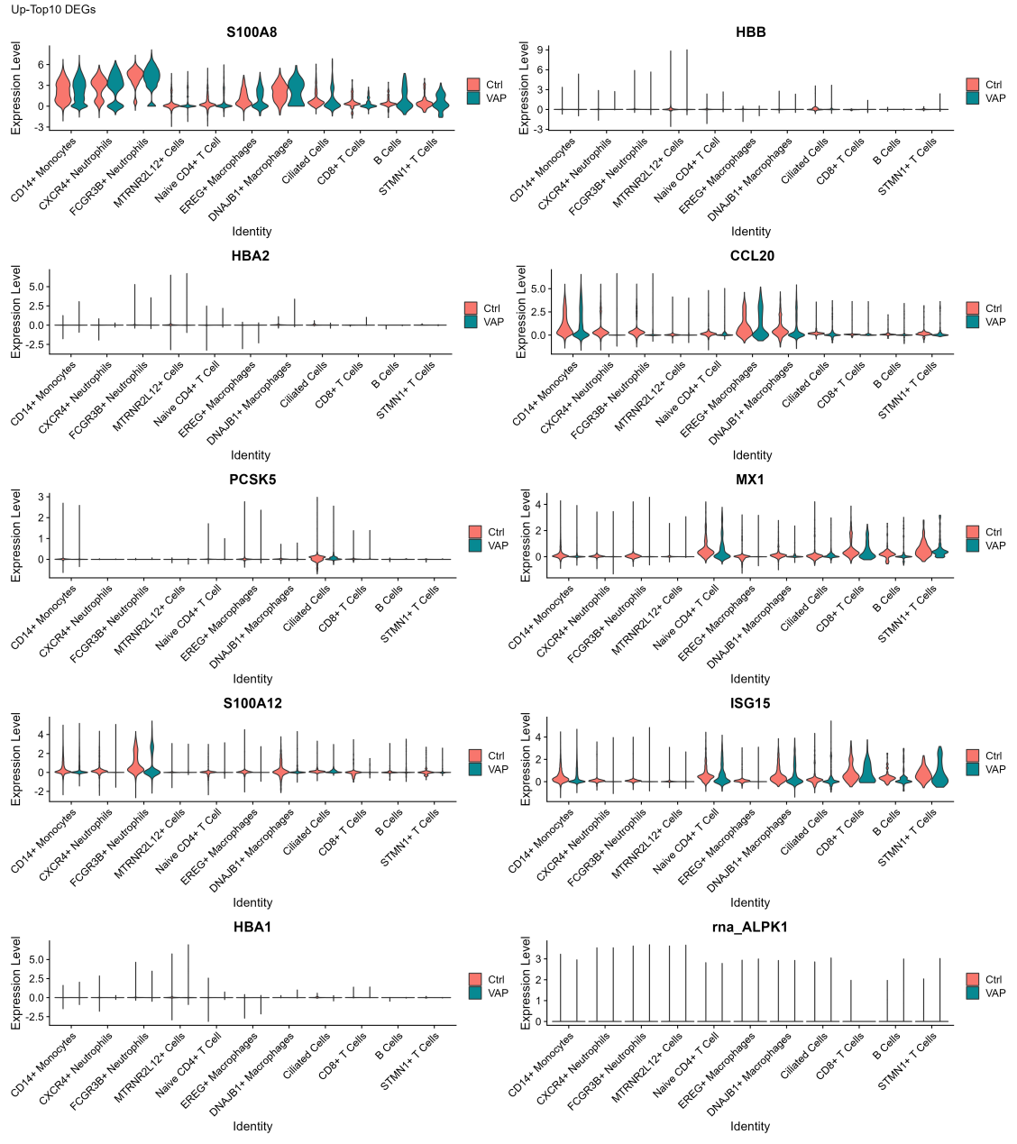
Supplementary Figure 1: The expression levels of the top-10 expressed upregulated DEGs.

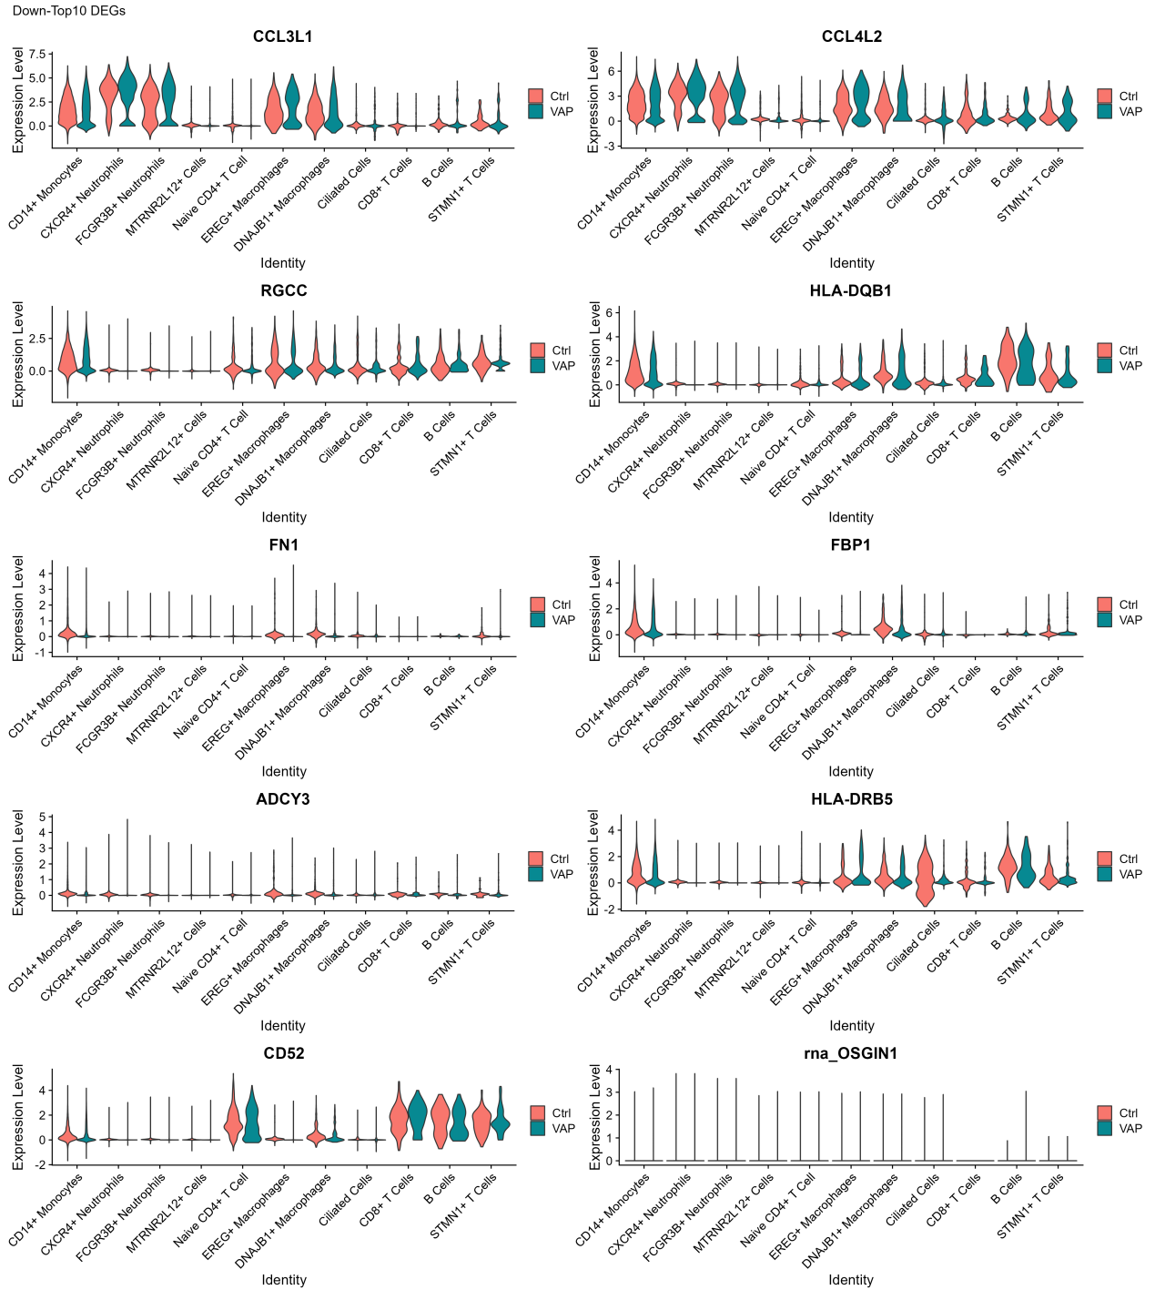
Supplementary Figure 2: The expression levels of the top-10 expressed down-regulated DEGs.

Supplementary 3

Sample Collection Method

For patients with endotracheal intubation, sputum was collected via tracheal suctioning through the endotracheal tube using sterile techniques. Specifically, a closed suction system or sterile suction catheter was employed to minimize contamination and ensure sample integrity. The collected sputum was immediately transferred to a sterile container and processed within 2 hours to preserve protein stability and prevent degradation^{[1]}.

[1]Toma I, Siegel MO, Keiser J, Yakovleva A, Kim A, Davenport L, Devaney J, Hoffman EP, Alsubail R, Crandall KA, Castro-Nallar E, Pérez-Losada M, Hilton SK, Chawla LS, McCaffrey TA, Simon GL. Single-molecule long-read 16S sequencing to characterize the lung microbiome from mechanically ventilated patients with suspected pneumonia. J Clin Microbiol. 2014 Nov;52(11):3913-21.

