Supporting Information
Supporting Information, Figure S1. The release of phosphate (PO₄³⁻). Data are presented as mean ± SD (***P < 0.001).
Supporting Information, Figure S2. The results of CCK8 after 5 days. Data are presented as mean ± SD (ns P > 0.05).
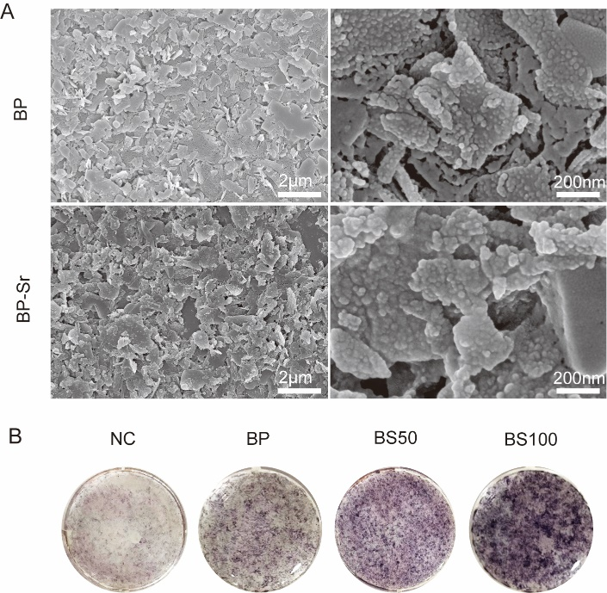
Supporting Information, Figure S3. The osteogenic potential of BP-Sr. (A) The SEM images of BP and BP-Sr which were soaked in the SBF for 2 weeks. (B) ALP staining of BP and BP-Sr.
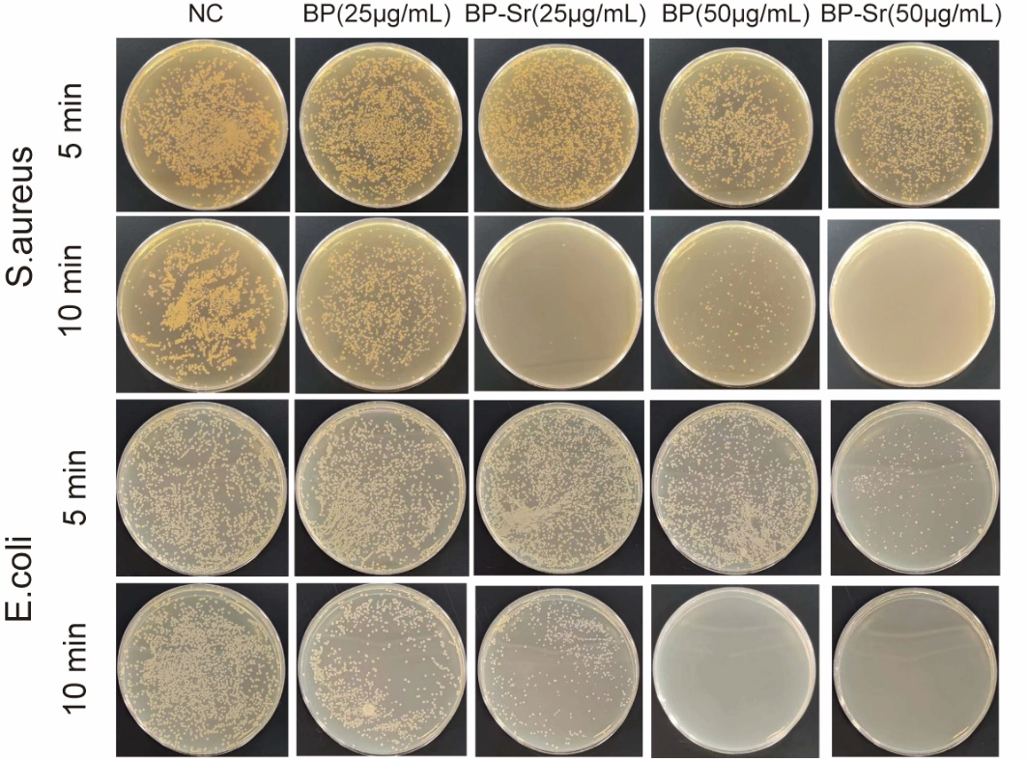
Supporting Information, Figure S4. Images of agar culture plate bacterial colonies in different groups.
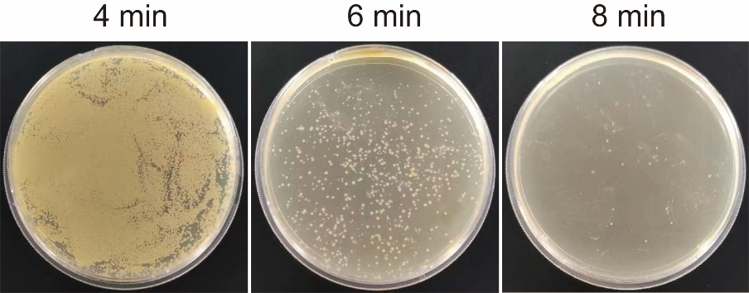
Supporting Information, Figure S5. The choice of stimulation time before RNA-seq.
Supporting Information, Figure S6. Genes related to leukotoxin was downregulated. Data are presented as mean ± SD (****P < 0.0001).

