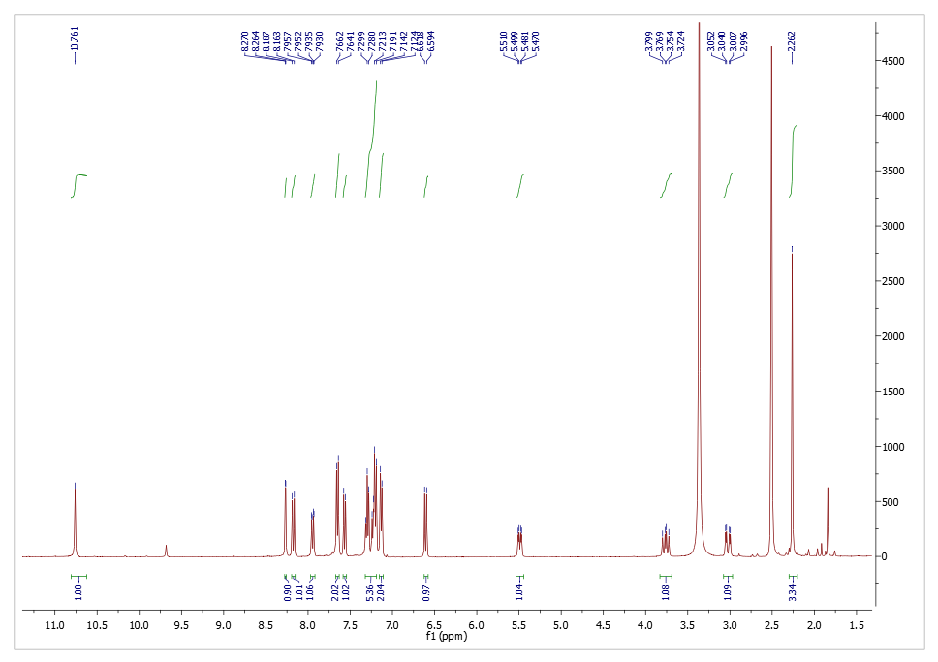
Figure S1. ¹HNMR of compound 6a

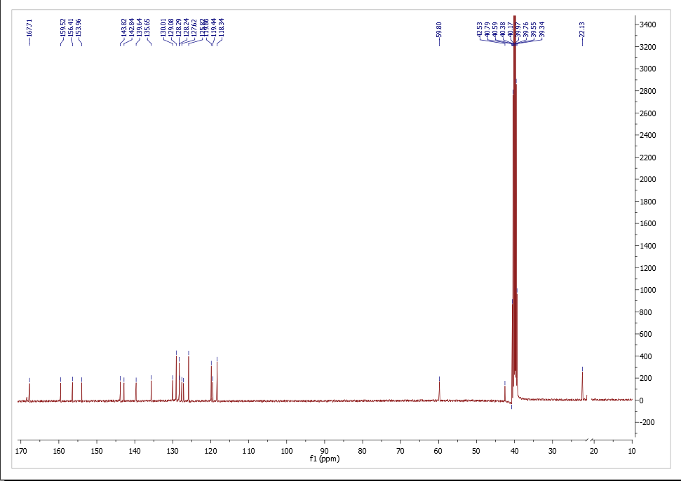
Figure S2. ¹³C NMR of compound 6a

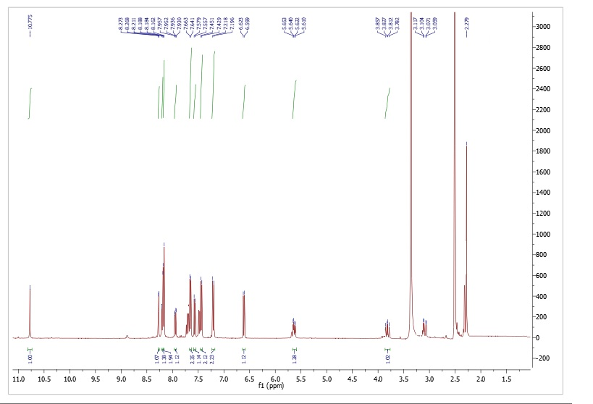

Figure S3. ¹H NMR of compound 6b

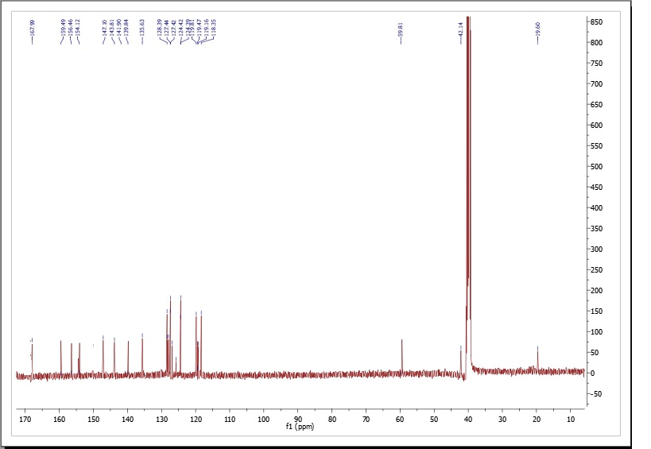

Figure S4. ¹³C NMR of compound 6b

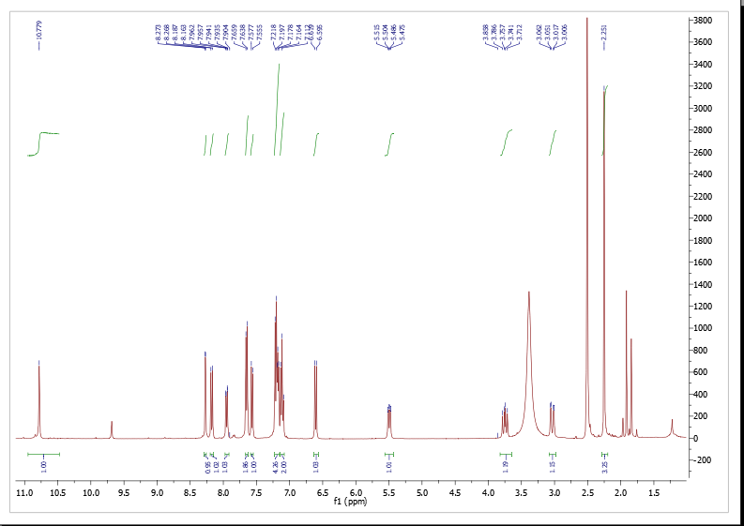
Figure S5. ¹H NMR of compound 6c

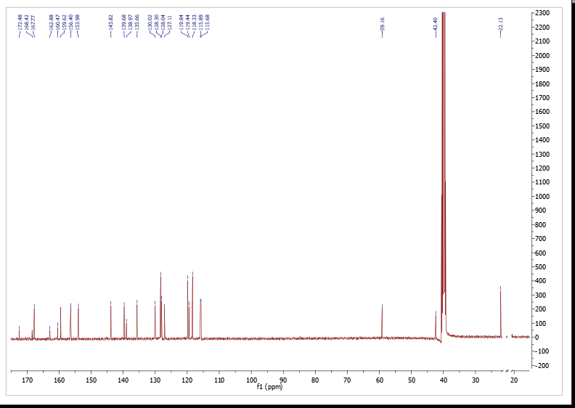

Figure S6. ¹³C NMR of compound 6c

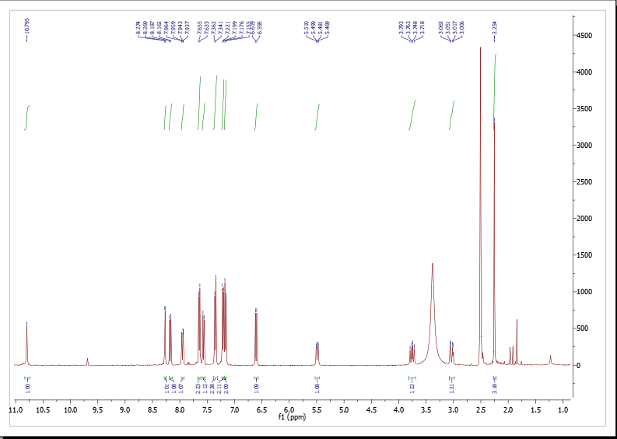
Figure S7. ¹H NMR of compound 6d

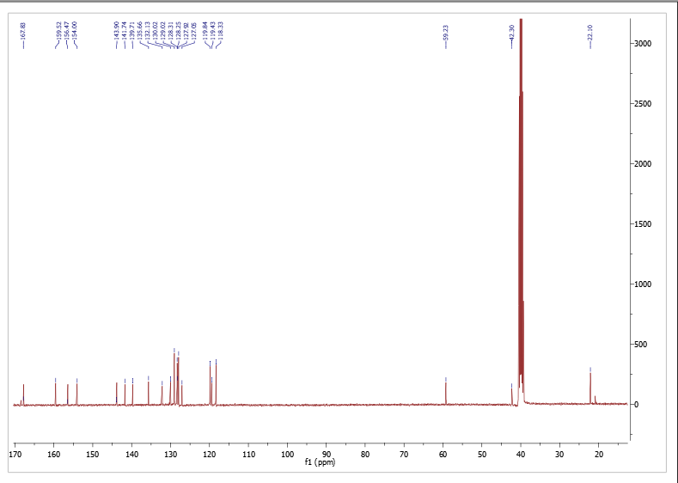

Figure S8. ¹³C NMR of compound 6d

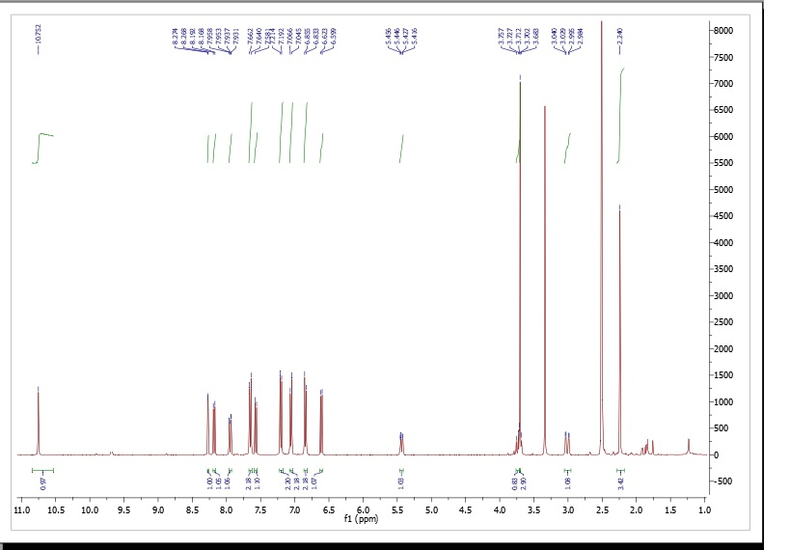
Figure S9. ¹H NMR of compound 6e

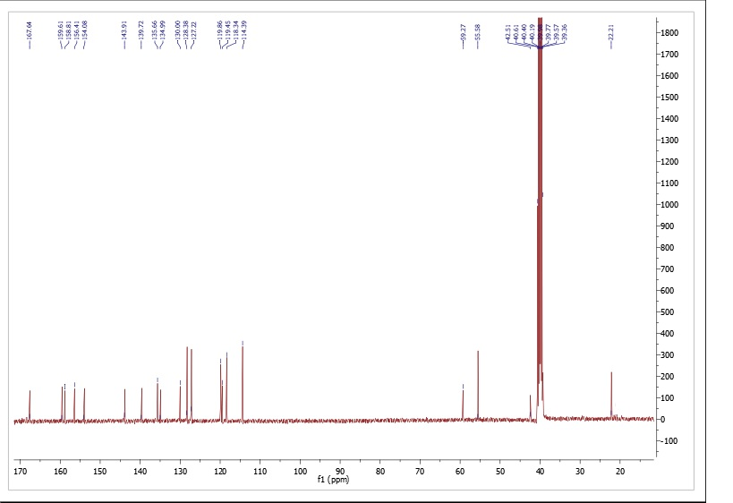

Figure S10. ¹³C NMR of compound 6e

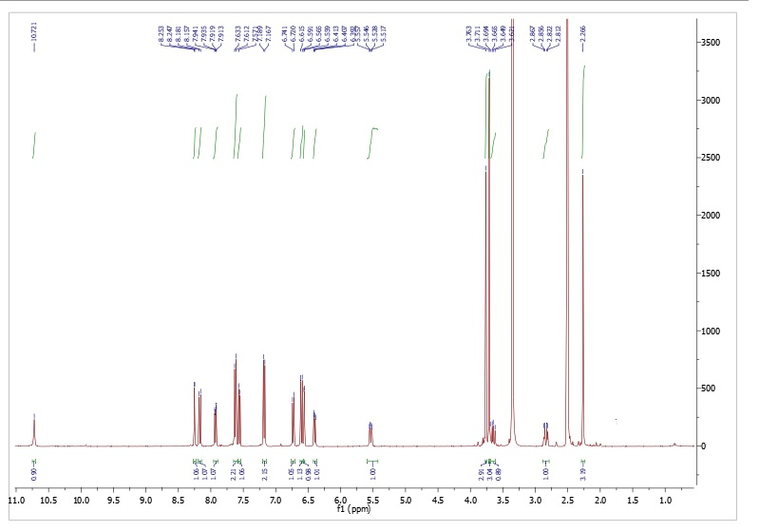
Figure S11. ¹H NMR of compound 6f

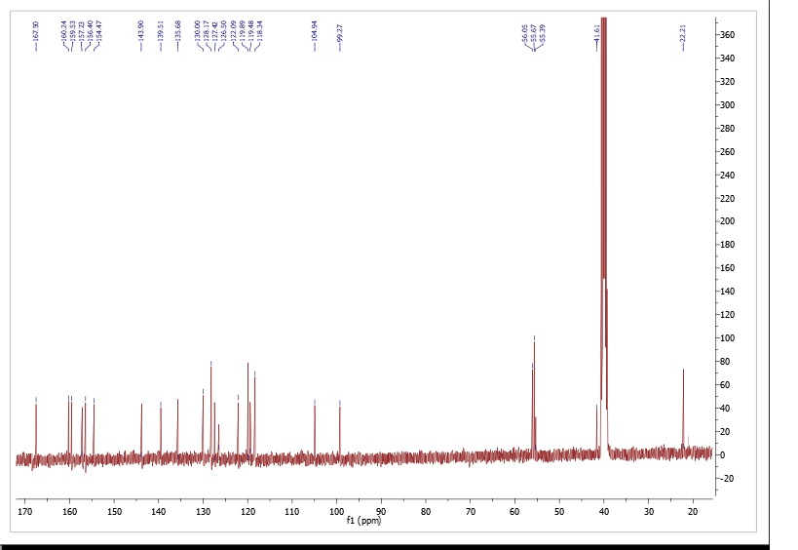

Figure S12. ¹³C NMR of compound 6f

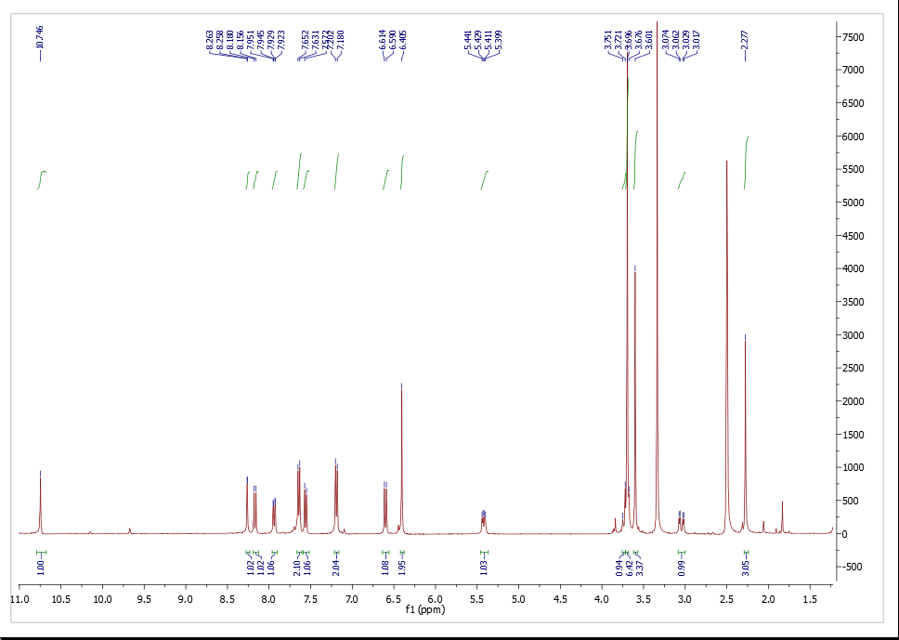
Figure S13. ¹H NMR of compound 6g

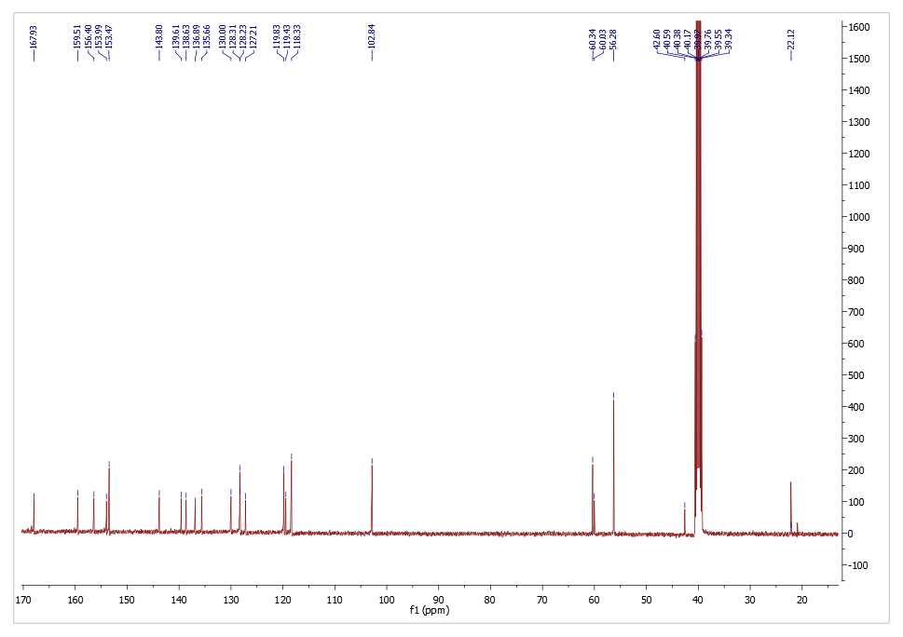
Figure S14. ¹³C NMR of compound 6g

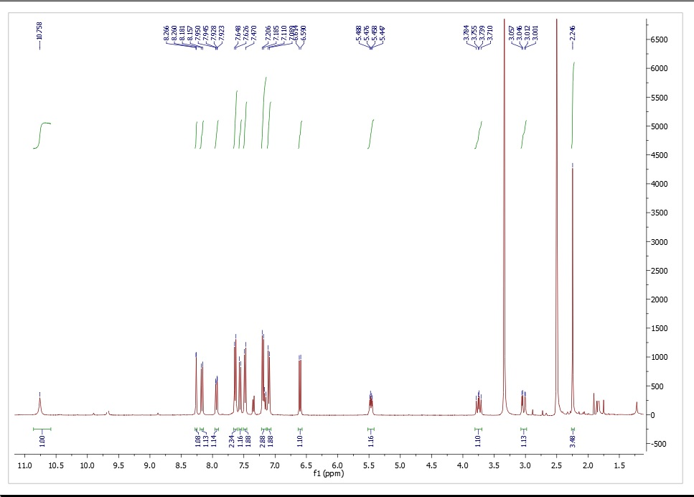
Figure S15. ¹H NMR of compound 6h

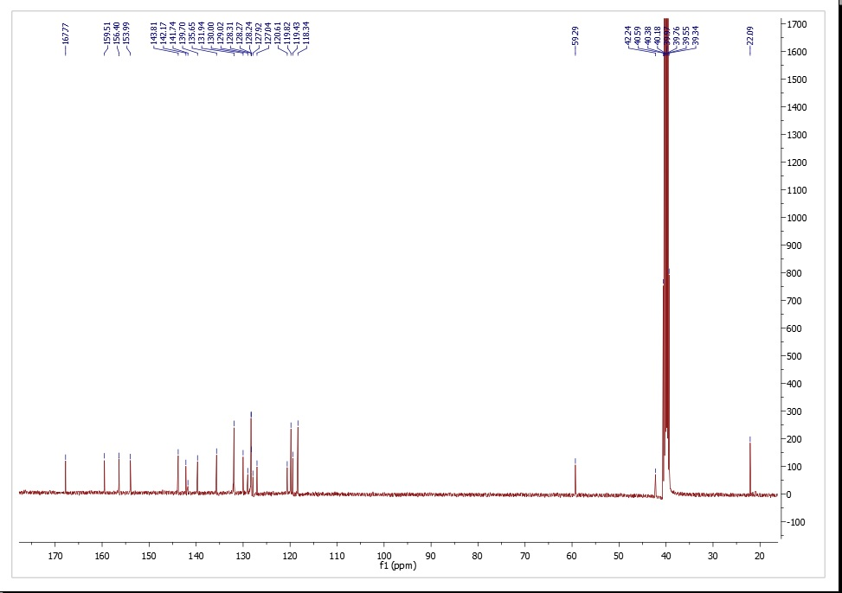

Figure S16. ¹³C NMR of compound 6h

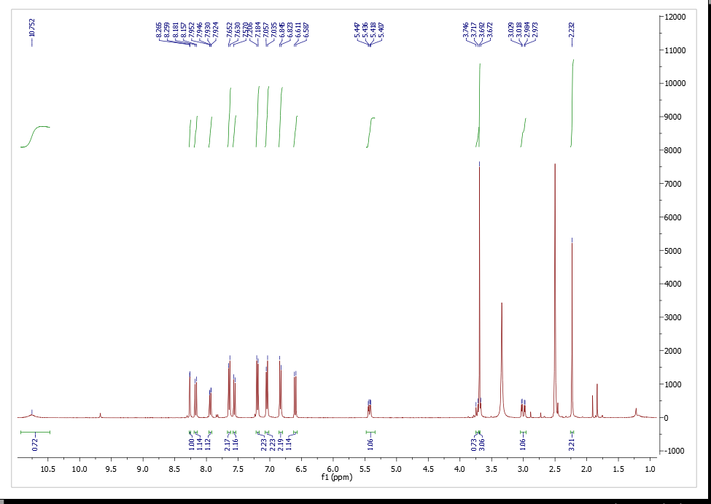
Figure S17. ¹H NMR of compound 6i

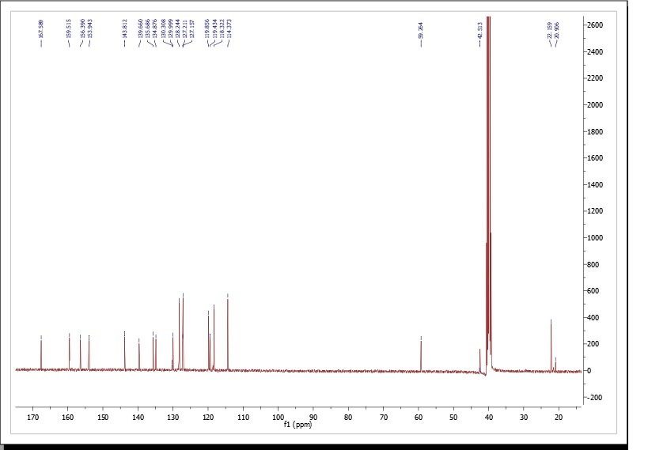

Figure S18. ¹³C NMR of compound 6i

