Supporting information

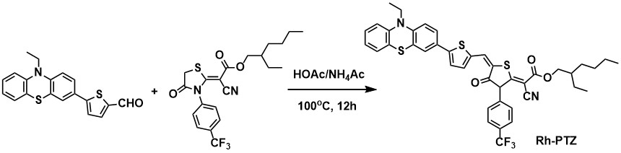
Scheme S1 The preparation of Rh-PTZ

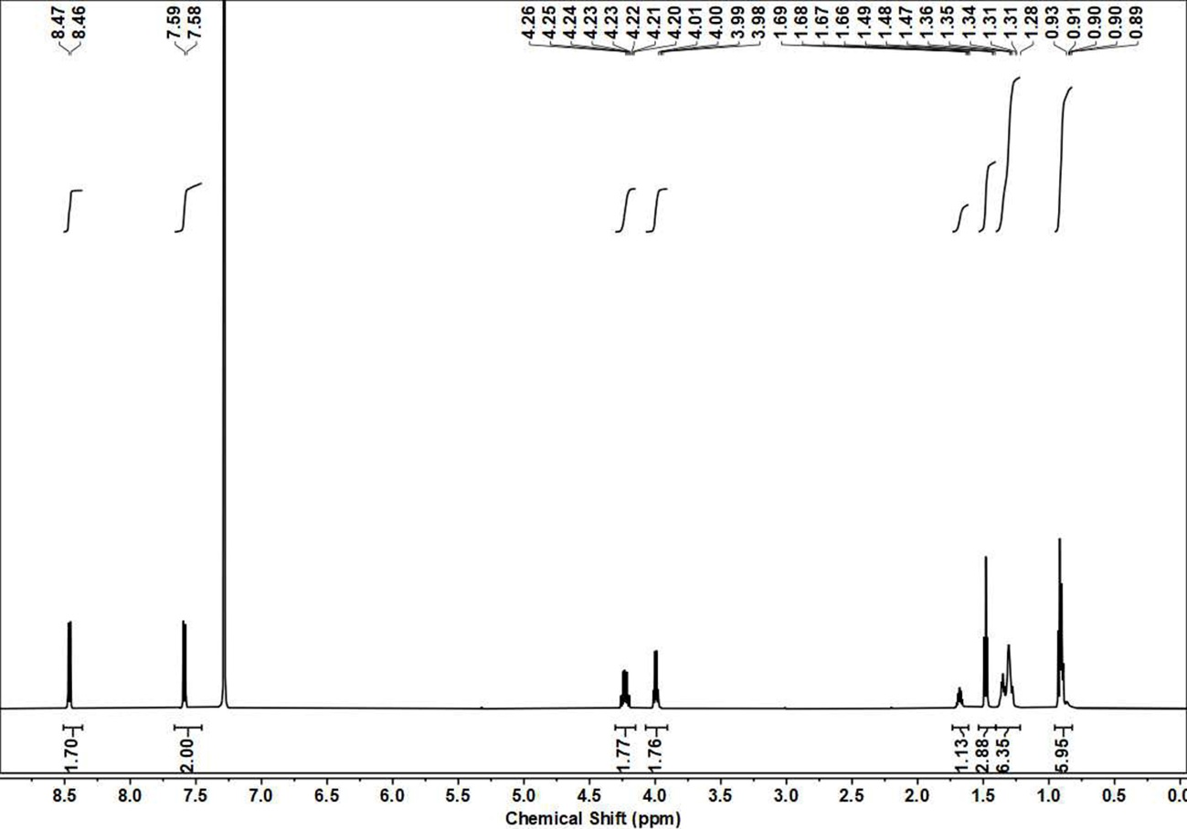
Figure S1 The ¹H NMR of Rhodium in CDCl₃
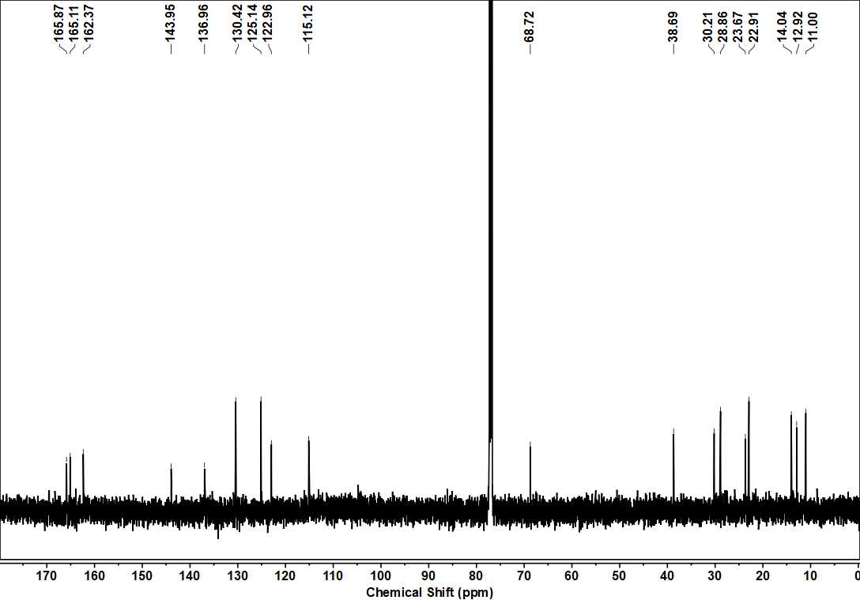
Figure S2 The ¹³C NMR of Rhodium in CDCl₃

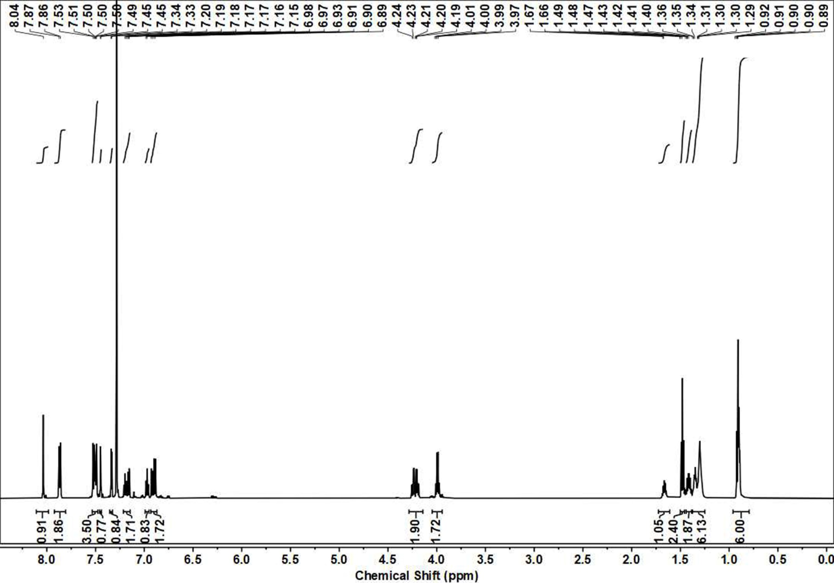
Figure S3 The ¹H NMR of Rh-PTZ in CDCl₃.

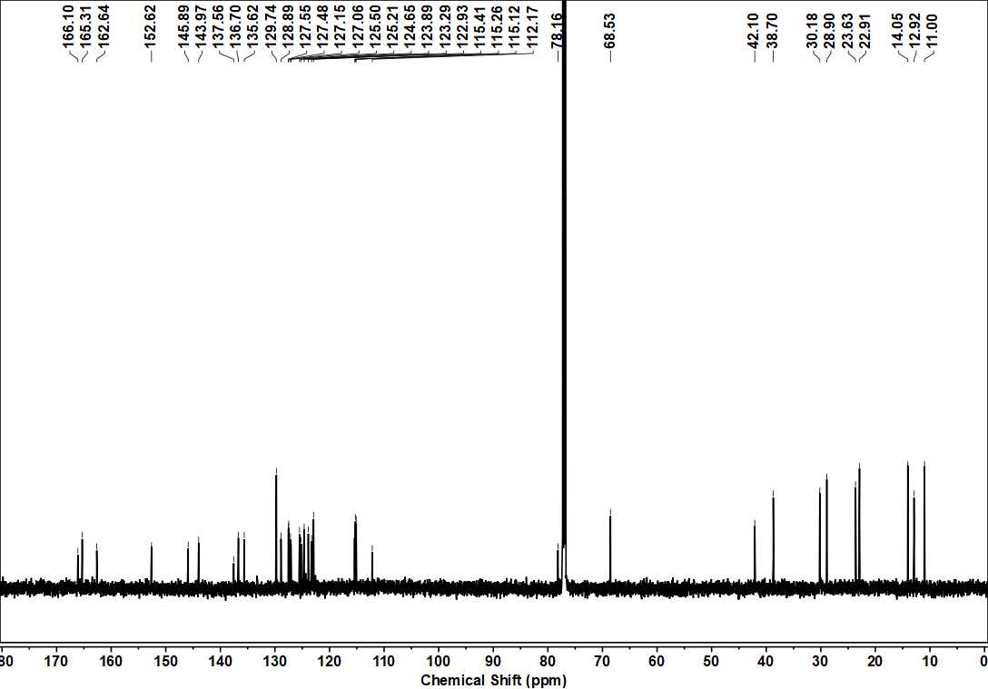
Figure S4 The ¹³C NMR of Rh-PTZ in CDCl₃

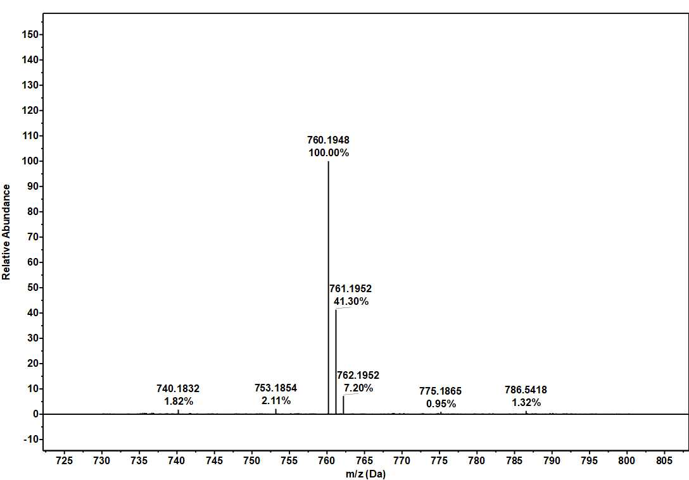
Figure S5 The Mass spectrum of Rh-PTZ

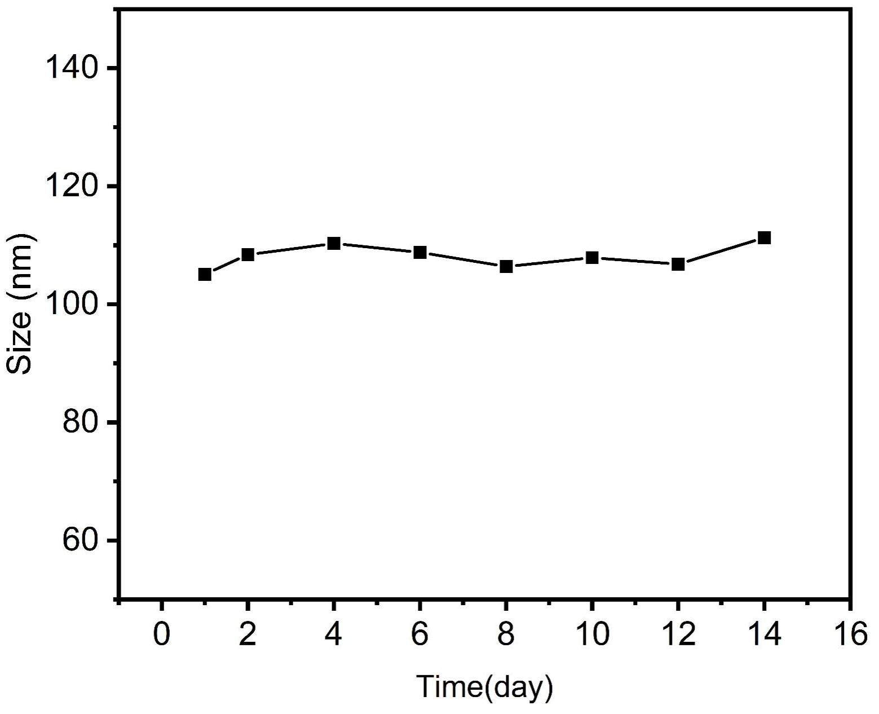
Figure S6 The size change of Rh-PTZ NPs stored for 2 weeks.

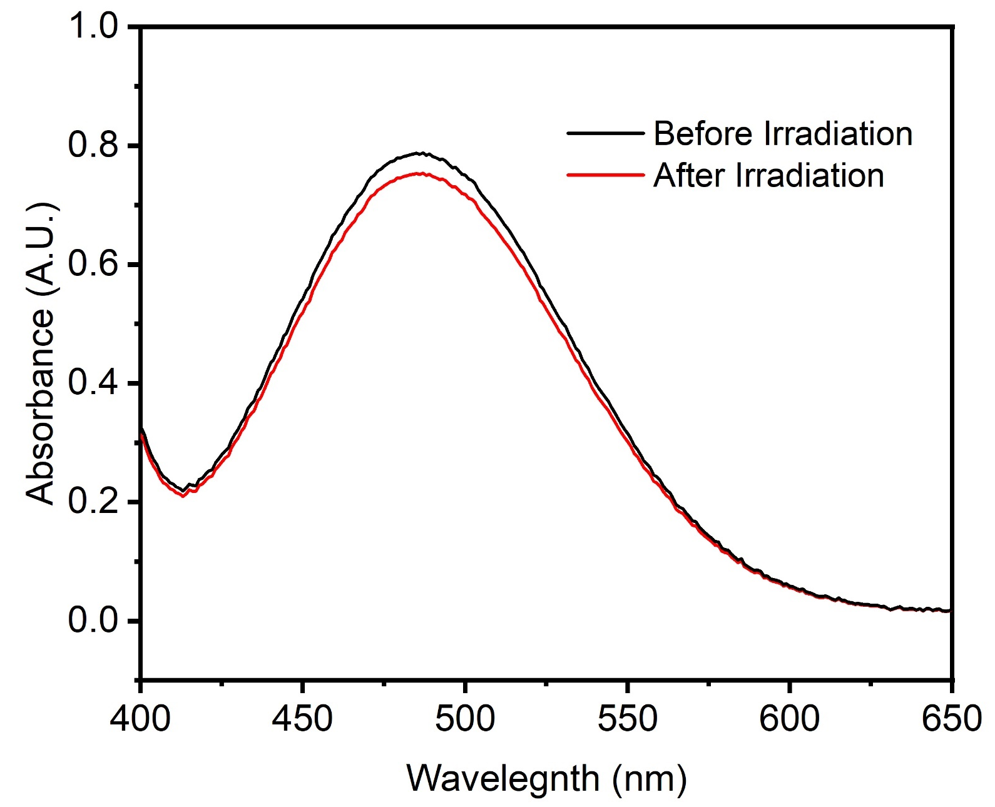
Figure S7 The absorption spectrum of Rh-PTZ after LED white irradiation (200mW/cm², 30min)
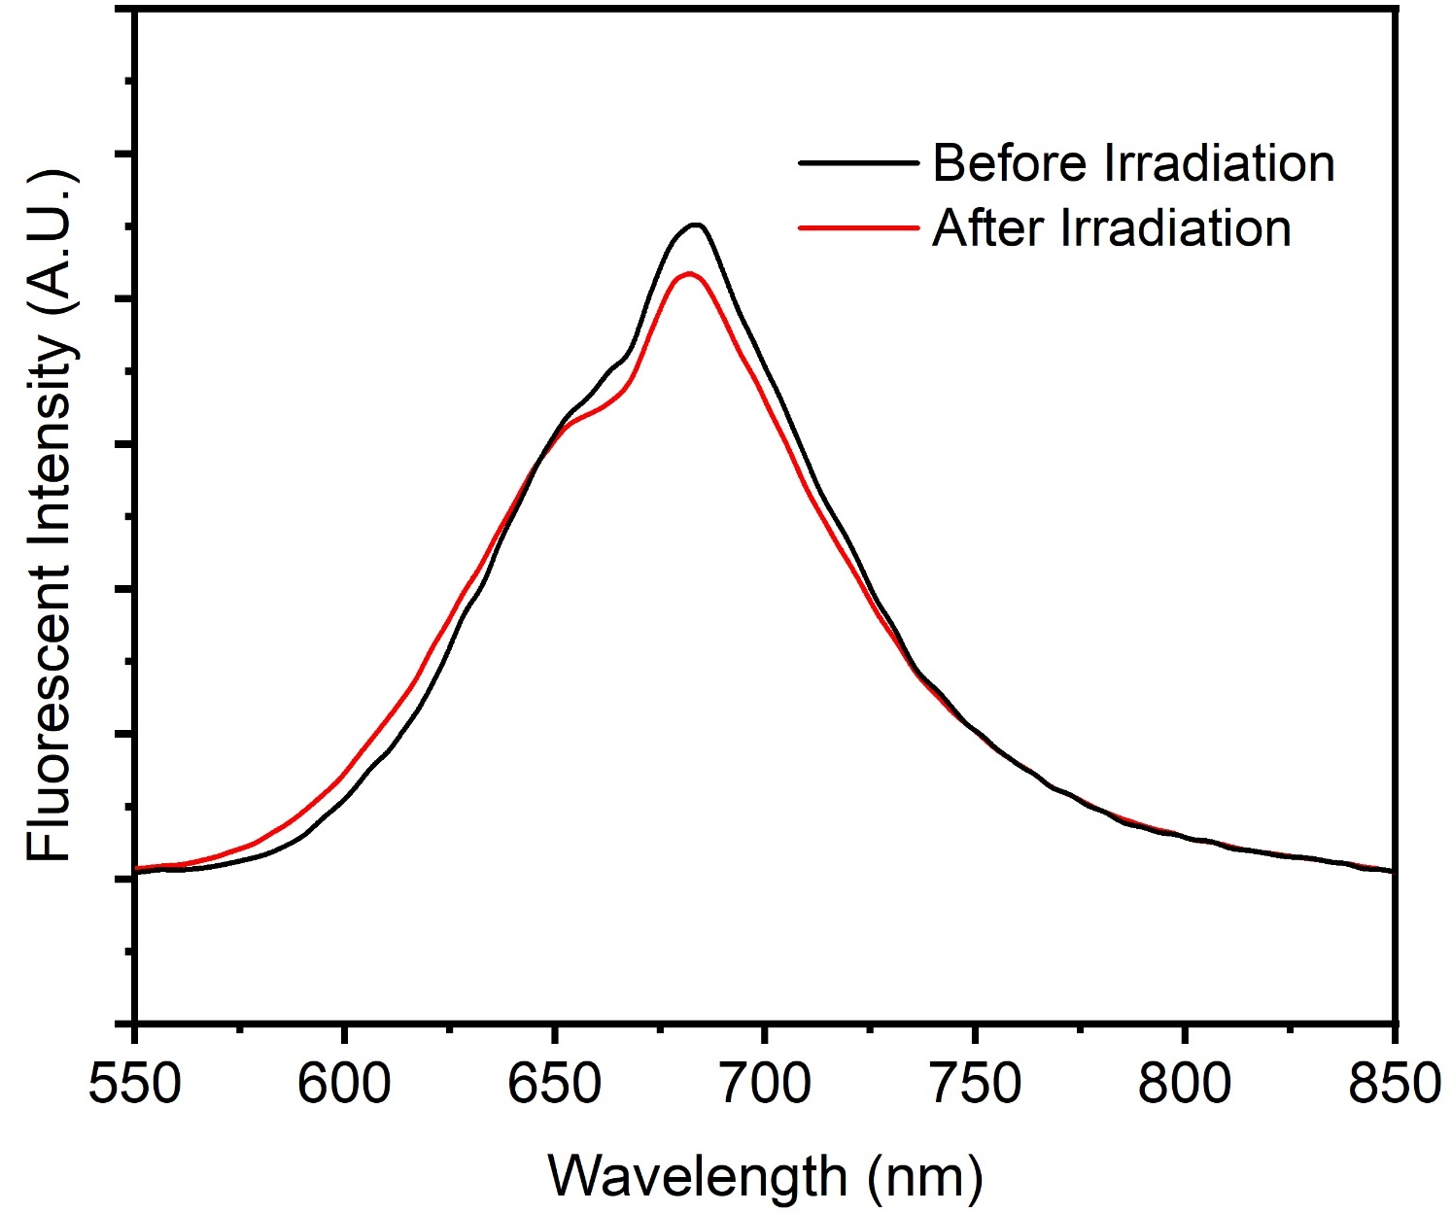
Figure S8 The fluorescent spectrum of Rh-PTZ after LED white irradiation (200mW/cm², 30min)

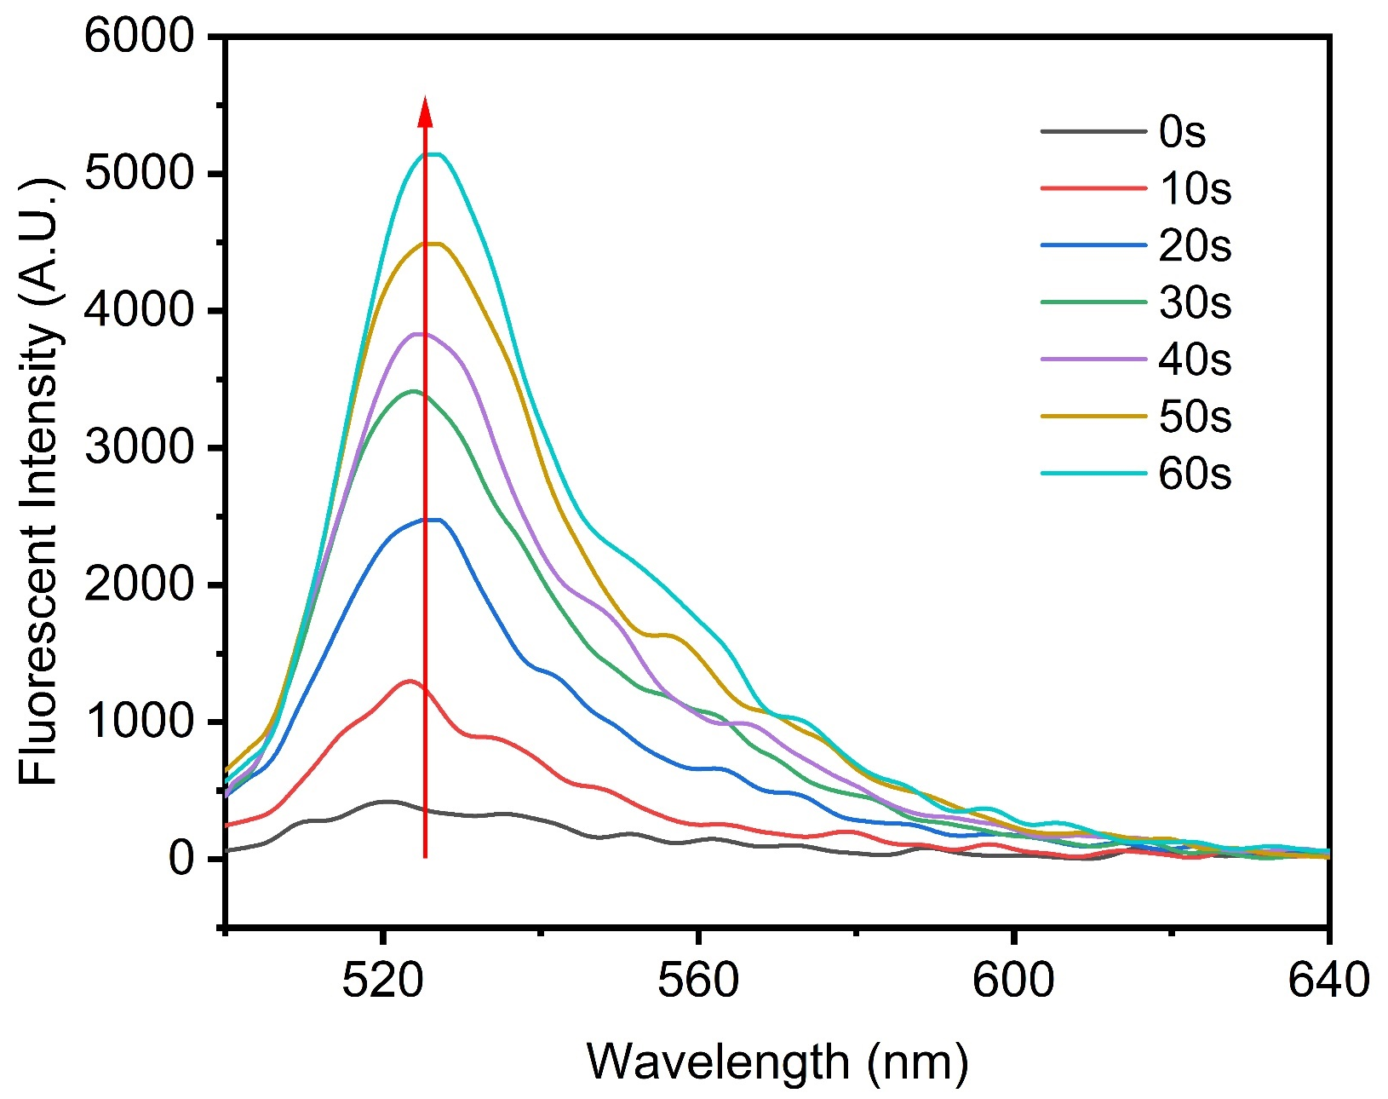
Figure S9 The fluorescent spectrum of DCFH with Rh-PTZ NPs (10μM) after LED white light irradiation (80mW/cm²) under normal condition
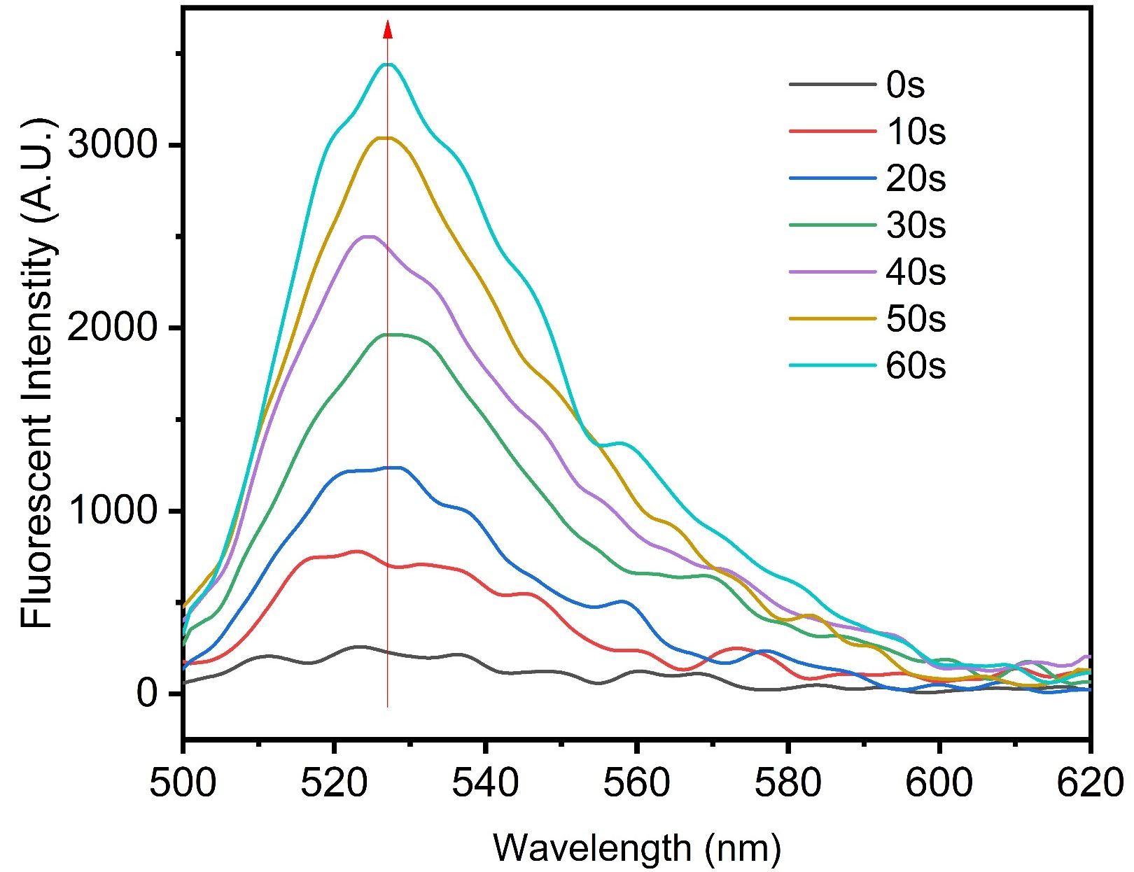
Figure S10 The fluorescent spectrum of DCFH with Rh-PTZ NPs (10μM) after LED white light irradiation (80mW/cm²) under hypoxia condition

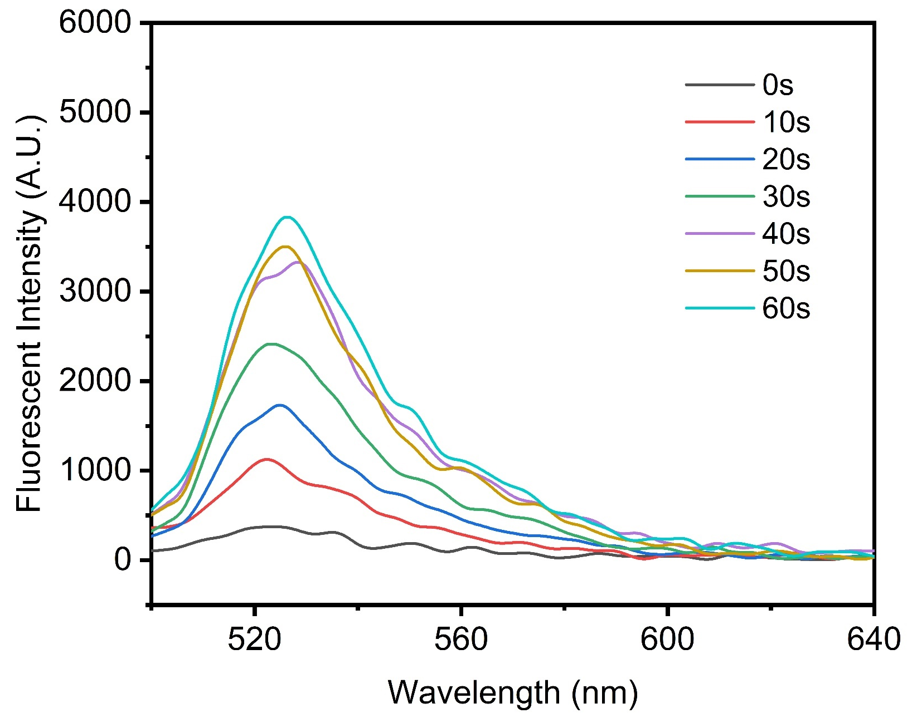
Figure S11 The fluorescent spectrum of DHR123 with Rh-PTZ NPs (10μM) after LED white light irradiation (80mW/cm²) under normal condition

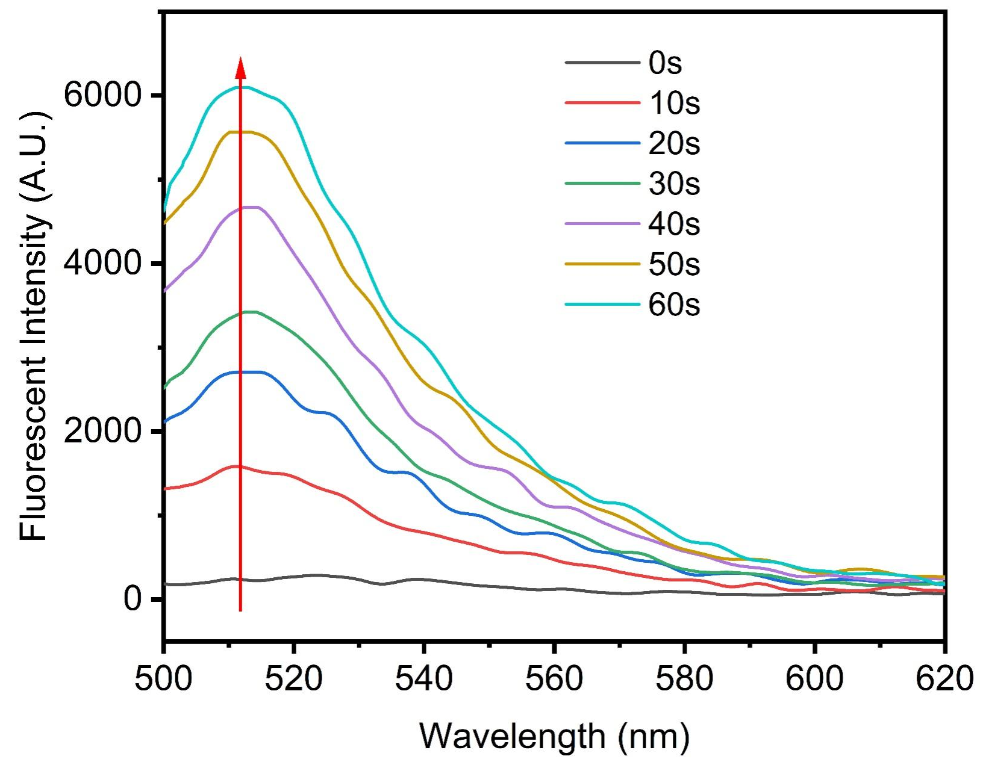
Figure S12 The fluorescent spectrum of HPF with Rh-PTZ NPs (10μM) after LED white light irradiation (80mW/cm²) under normal condition

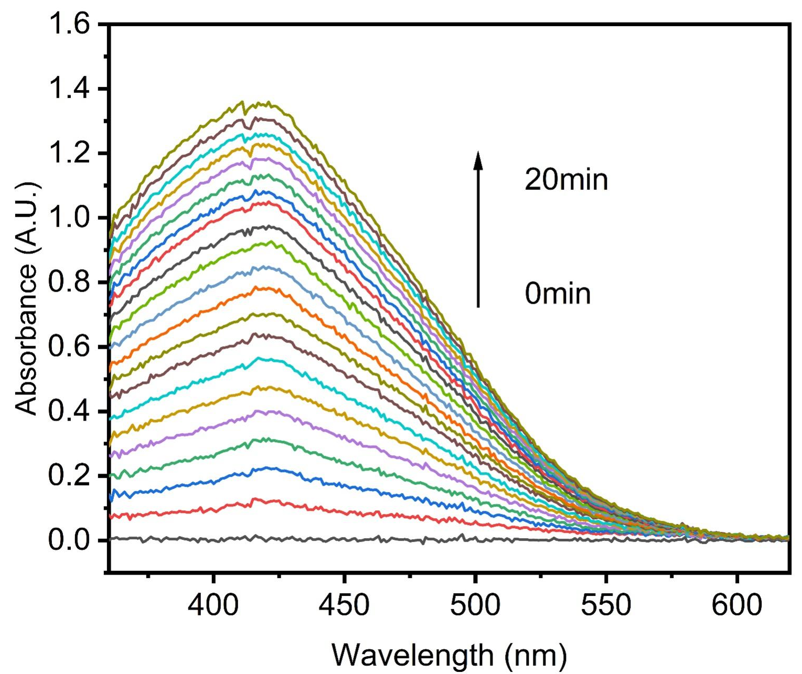
Figure S13 The UV spectrum of TMB with Rh-PTZ NPs (10μM) after LED white light irradiation (80mW/cm²) under normal condition

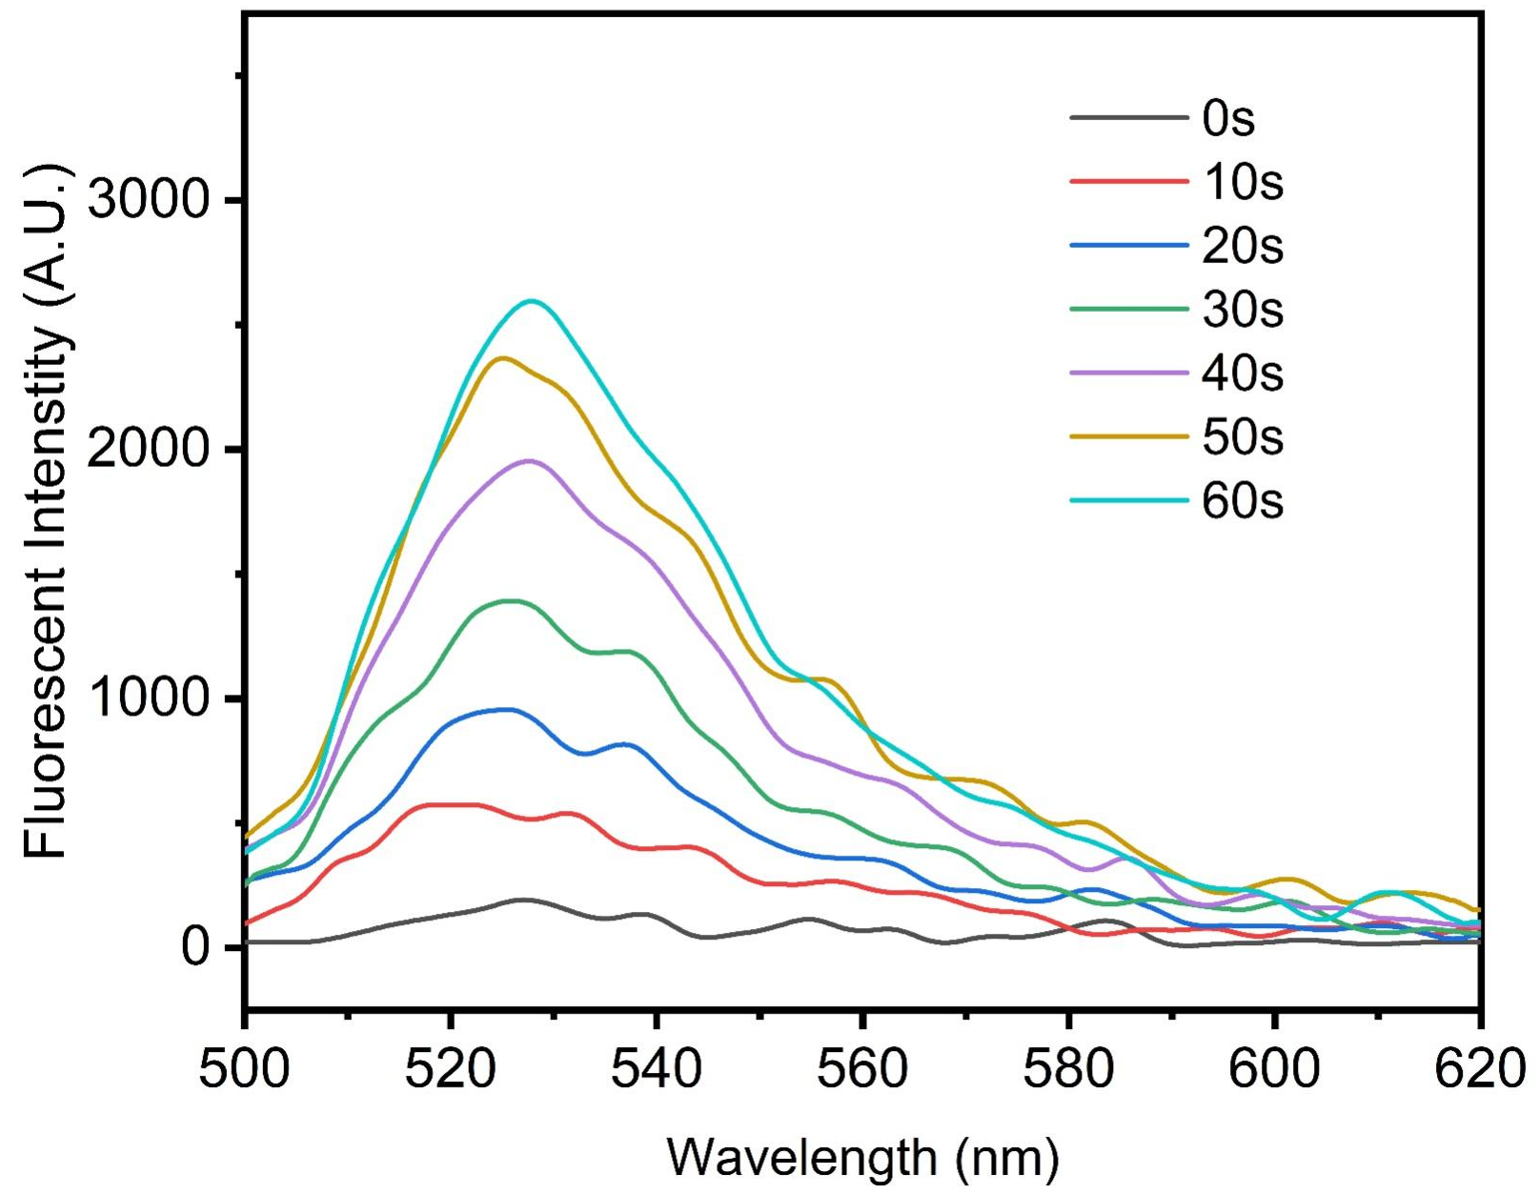
Figure S14 The fluorescent spectrum of DHR123 with Rh-PTZ NPs (10μM) after LED white light irradiation (80mW/cm²) under hypoxia condition

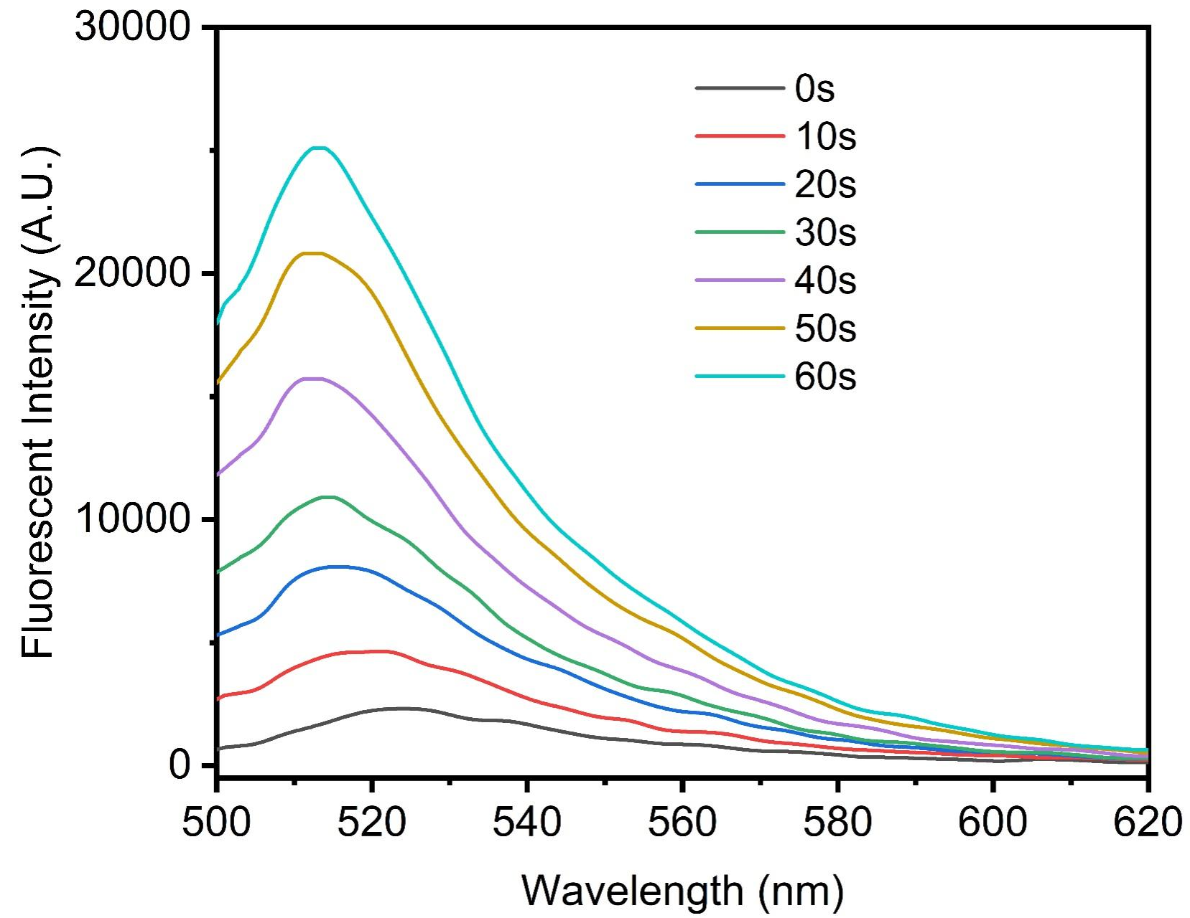
Figure S15 The fluorescent spectrum of HPF with Rh-PTZ NPs (10μM) after LED white light irradiation (80mW/cm²) under hypoxia condition

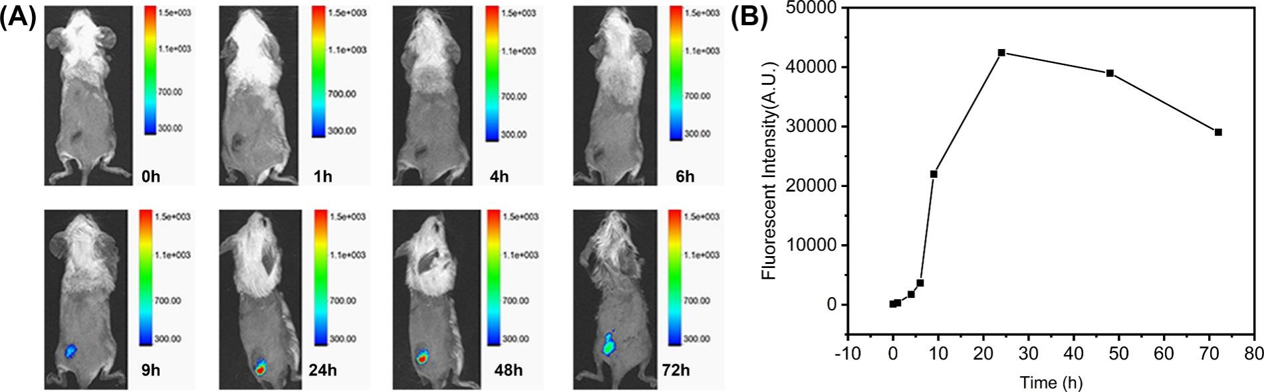
Figure S16 (A) The NIR fluorescent imaging of mouse after iv injection of Rh-PTZ NPs (100μM). (B) The fluorescent intensity of tumor area after iv injection of Rh-PTZ NPs (100μM).

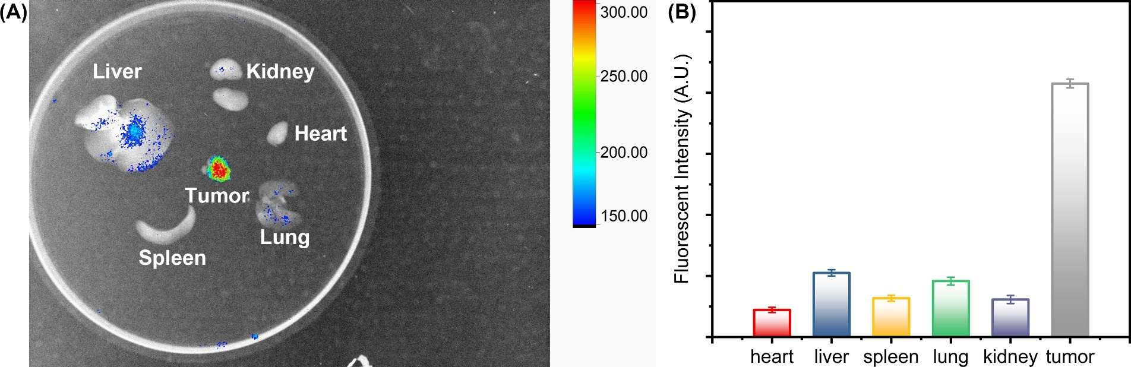
Figure S17 (A) The NIR fluorescent imaging of main organs. (B) The fluorescent intensity of main organs.

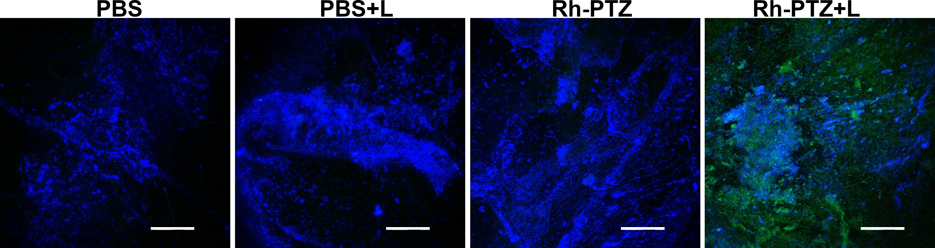
Figure S18 The ROS generation of tumor tissues after different treatments, the scale bar = 50 μM.

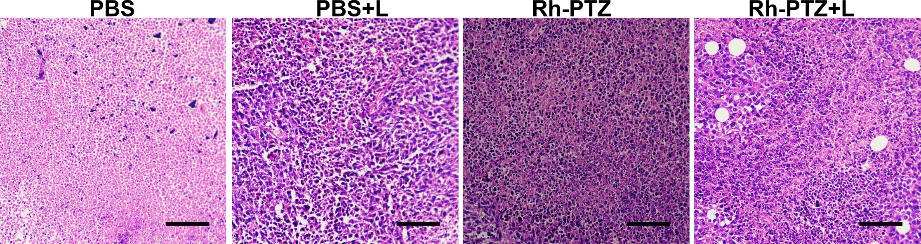
Figure S19 The H&E staining of tumor tissues after different treatments, the scale bar = 50 μM

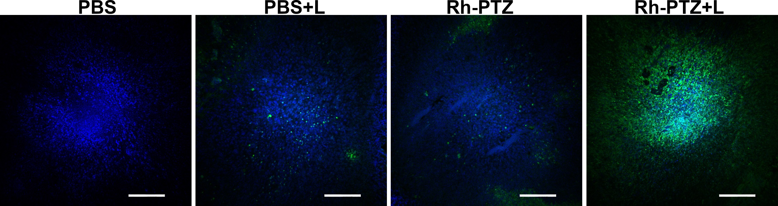
Figure S20 The tunnel staining of tumor tissues after different treatments, the scale bar = 50 μM

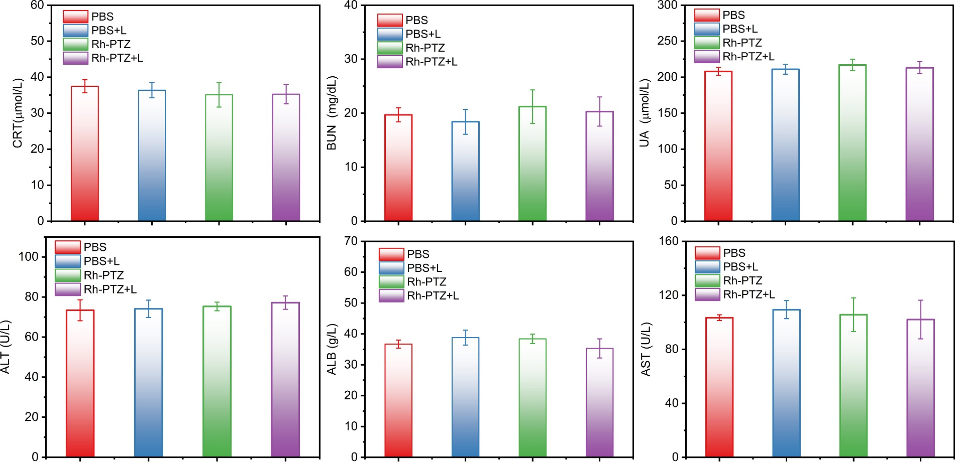
Figure S21 Blood biochemistry parameters of the mice after different treatments.

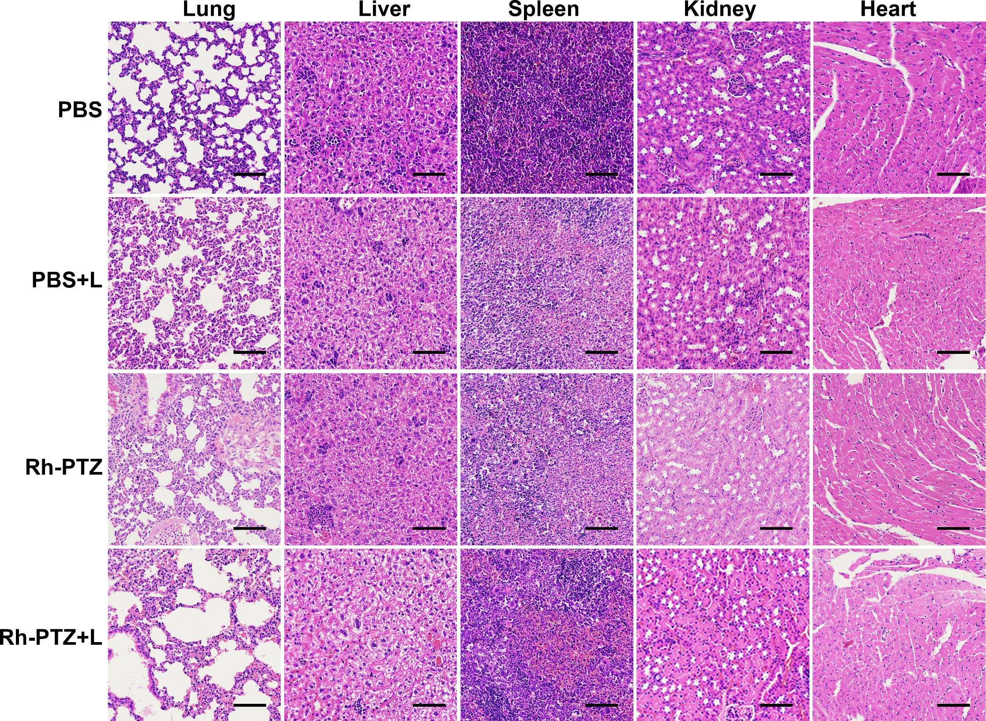
Figure S22 The H&E staining of main organ after different treatments, the scale bar = 50 μM.

