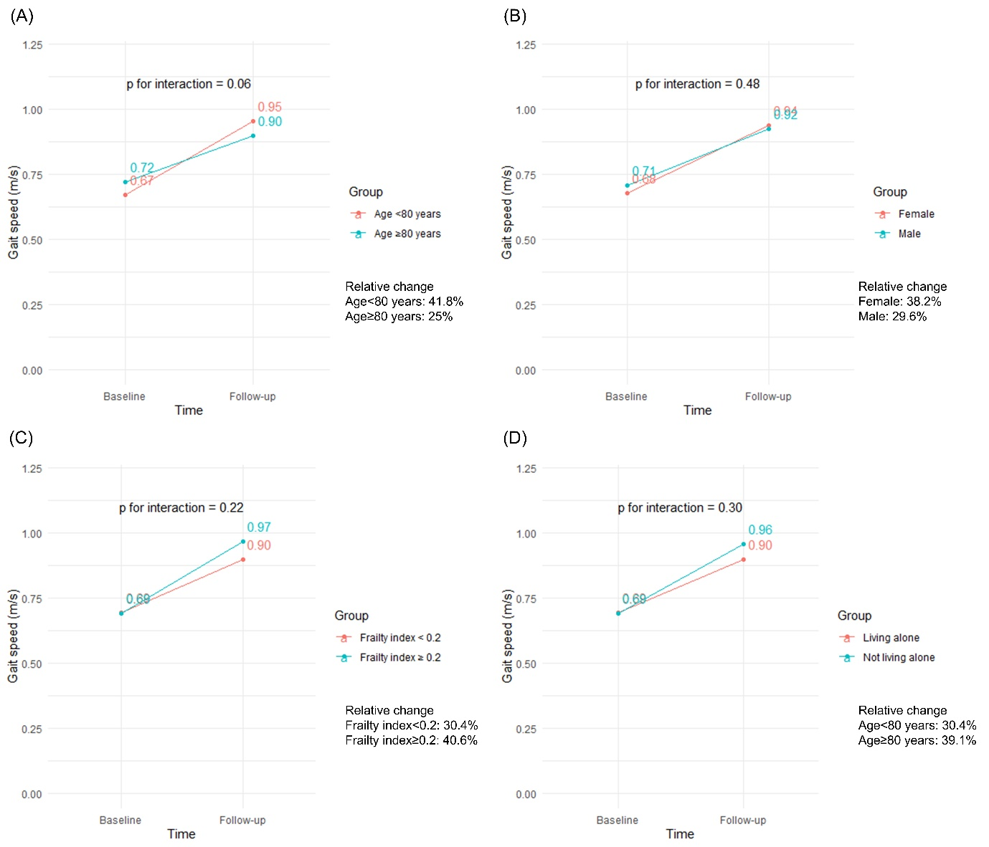Supplementary Figure S1. Subgroup analysis regarding changes in frailty index according to age ≥ 80 years or not, sex, frailty index ≥ 0.2 or not, and living alone
(A) age 80 years old and more or not
(B) sex
(C) frailty index
(D) living alone

Supplementary Data 1.
Exercise Program Description (Using CERT(Consensus on Exercise Reporting Template) Guidelines)
Participants in the intervention group participated in a 12-week exercise program conducted by the public healthcare center. The program was designed and delivered according to standardized protocols to ensure safety and effectiveness. Below are the detailed components based on the CERT guidelines. While the program followed a standardized protocol, individual adjustments, such as exercise progression, were determined by the exercise trainer to account for participants’ specific needs and ensure the practical applicability of this trial.
- What (Materials and Equipment):
  - The exercise program utilized basic equipment such as dumbbells, resistance bands, and treadmills. Written exercise guidelines were provided for independent exercise at home.
- Who (Provider):
  - The program was delivered by two trained community exercise trainers with expertise in resistance and aerobic exercise. Each trainer contributed approximately 15% of their 40-hour weekly workload.
- How (Delivery):
  - Participants attended supervised group exercise sessions twice weekly, resulting in a total of 24 sessions over the 12-week intervention. Each session lasted 60 minutes and was delivered in a community-based setting.
- Where (Location):
  - Supervised sessions took place in a community health center equipped with the necessary exercise tools. Participants were encouraged to perform additional independent exercises at home.
- When, How Much (Dosage):
  - Each 60-minute session began and ended with a 5-minute warm-up and cool-down phase focused on stretching the muscles involved in the workout. Active stretches for each muscle group were held for 15–30 seconds. The main portion of the session, lasting 50 minutes, was divided into:
    - Resistance Training (30 minutes): Alternating between upper-body (chest, back, arms) and lower-body (legs) exercises. Initial loads were set at 40% of each participant’s one-repetition maximum (1RM) and gradually increased every two weeks based on individual progress.
    - Aerobic Exercises (20 minutes): Treadmill walking or stationary cycling at an intensity of 50–70% of maximum oxygen uptake (VO₂ max). VO₂ max was determined through either the Bruce Treadmill Test or maximal heart rate calculations. Exercise intensity was monitored and progressively adjusted weekly based on individual tolerance.
- Tailoring (Individualization):
  - Resistance training loads were personalized using the 1RM test to assess baseline strength. Aerobic intensity was calibrated using estimated VO2max. Progressions in intensity and repetitions were tailored to individual capabilities, with adjustments made bi-weekly.
- How Well (Adherence and Compliance):
  - Adherence was tracked during supervised sessions, with participants’ attendance recorded. Trainers monitored participants’ performance and provided encouragement to maintain compliance.
  - Participants were also encouraged to perform 60 minutes of independent exercise daily and document their activities in a provided logbook.
- Progression:
  - Resistance training intensity was increased by 10–15% of baseline 1RM every two weeks based on individual improvements. Aerobic exercise intensity progressed from an initial 50% to 70% of VO2max over the 12-week period. Both progression protocols were individualized by the trainers based on each participant's adaptation and tolerance.
- Duration of the Intervention:
  - The program lasted for 12 weeks, with structured, supervised sessions supplemented by independent exercises.

Supplementary Data 2.
Will individual participant data be available (including data dictionaries)? Yes
What data in particular will be shared? Individual participant data that underlie the results reported in this article, after deidentification (text, tables, figures, and appendices).
What other documents will be available? Study protocol, statistical analysis plan, analytic code
When will data be available (start and end dates)? Beginning 9 months and ending 36 months following article publication.
With whom? Investigators whose proposed use of the data has been approved by an independent review committee (“learned intermediary”) identified for this purpose.
For what types of analyses? For individual participant data meta-analysis.
By what mechanism will data be made available? Proposals should be directed to onezero2@gmail.com. To gain access, data requestors will need to sign a data access agreement.

Table S1. The 45 items of the frailty index
Dressing | Low muscle mass
Face washing | Low grip strength
Bathing | Chair stand test
Eating | Balance test
Mobility | Gait speed test
Using the restroom | Mini-Cog
Bowel and bladder control | Patient Health Questionnaire-9
Dressing wounds | Mini Nutritional Assessment-Short Form
Household chores | Low physical activity
Meal preparation | Polypharmacy
Laundry | History of falls in 1 year
Short-distance outings | History of stroke
Using transportation | Hypertension
Shopping | Diabetes mellitus
Managing finances | Dyslipidemia
Using the telephone | Thyroid disease
Taking medication | Coronary artery disease
Physical fitness | Asthma
Self-management | Atopy
Daily activities (work, study, etc.) | Arthritis
Pain/discomfort | Chronic kidney disease
Anxiety/depression | Liver disease
 | Pulmonary tuberculosis

