Antibody | Expression quantity (mg/L) | Purification（SEC，280nm）% | Purification（SDS-PAGE）% | Z-Ave. Dia. (nm) | PDI | Pk 1 Mode Dia. (nm)
4A7 | 212.8 | 98.995 | >95 | 10.71 | 0.034 | 11.26
2H9 | 93.3 | 81.644 | >95 | 13.80 | 0.192 | 11.26
4A8 | 184.6 | 98.621 | >95 | 14.46 | 0.090 | 14.25
2D2 | 162.7 | 99.192 | >95 | 11.23 | 0.095 | 12.18
IMAB362 | 165.2 | 100 | >95 | 12.00 | 0.083 | 12.18

Supplementary Table 1. The expression quality, purity and the molecular size of the four clones. Z-Ave.Dia reflects the average particle size, Pk1 Mode Dia represents the main peak value of particle size (usually around 10 nm for proteins), and PDI indicates the uniformity of the solution, with values below 0.2 indicating relatively uniform particle size.

Groups | Animal ID | Days post inoculation / tumor volume(mm³)
Groups | Animal ID | 0 | 3 | 7 | 10 | 14 | 17 | 21
Vehicle | 28 | 79.40 | 207.00 | 313.10 | 666.23 | 1407.24 | 1265.98 | 2234.61
Vehicle | 27 | 92.87 | 217.60 | 295.90 | 440.15 | 960.61 | 1440.59 | 1886.76
Vehicle | 41 | 103.15 | 230.72 | 489.52 | 937.20 | 1844.79 | 2640.36
Vehicle | 29 | 115.39 | 254.29 | 324.67 | 463.36 | 934.51 | 1377.89 | 2438.63
Vehicle | 14 | 137.62 | 208.29 | 253.37 | 263.13 | 452.72 | 818.51 | 1588.11
Vehicle | Mean | 105.68 | 223.58 | 335.31 | 554.01 | 1119.97 | 1508.66 | 2037.03
Vehicle | SEM | 9.94 | 8.77 | 40.41 | 115.16 | 235.89 | 303.12
IMAB362, 10 mg/kg | 8 | 67.42 | 173.35 | 316.64 | 737.53 | 1234.92 | 1893.85
IMAB362, 10 mg/kg | 4 | 95.38 | 129.31 | 208.62 | 441.92 | 783.43 | 1124.18 | 1943.79
IMAB362, 10 mg/kg | 45 | 113.23 | 235.38 | 479.89 | 1083.40 | 1765.69 | 2432.02
IMAB362, 10 mg/kg | 25 | 116.30 | 253.21 | 380.93 | 508.34 | 785.05 | 1155.79
IMAB362, 10 mg/kg | 18 | 132.55 | 316.49 | 51.87 | 19.58 | 12.49 | 10.09
IMAB362, 10 mg/kg | Mean | 104.98 | 221.55 | 287.59 | 558.15 | 916.32 | 1323.19
IMAB362, 10 mg/kg | SEM | 11.09 | 32.43 | 73.60 | 175.23 | 289.37 | 409.08
IMAB362, 10 mg/kg | TGI |  | 0.91% | 14.23% | -0.75% | 18.18% | 12.29%
4A7, 10 mg/kg | 32 | 73.53 | 117.13 | 141.52 | 274.96 | 554.36
4A7, 10 mg/kg | 33 | 97.27 | 358.99 | 603.22 | 1408.24 | 2560.53
4A7, 10 mg/kg | 5 | 109.03 | 257.26 | 395.46 | 728.86 | 1375.28
4A7, 10 mg/kg | 34 | 116.80 | 331.92 | 696.19 | 1127.34 | 2107.63
4A7, 10 mg/kg | 3 | 129.84 | 302.01 | 128.25 | 60.77 | 41.05
4A7, 10 mg/kg | Mean | 105.29 | 273.46 | 392.93 | 720.04 | 1327.77
4A7, 10 mg/kg | SEM | 9.55 | 42.57 | 116.07 | 252.22 | 468.19
4A7, 10 mg/kg | TGI |  | -22.31% | -17.18% | -29.97% | -18.55%
anti-mPD-1, 3 mg/kg | 12 | 97.94 | 203.03 | 210.16 | 318.91 | 516.79 | 899.46 | 1891.78
anti-mPD-1, 3 mg/kg | 6 | 104.04 | 140.43 | 131.21 | 141.62 | 231.33 | 416.84 | 803.17
anti-mPD-1, 3 mg/kg | 22 | 117.57 | 232.56 | 234.42 | 355.66 | 244.62 | 336.60 | 589.15
anti-mPD-1, 3 mg/kg | 10 | 128.74 | 330.97 | 299.10 | 404.33 | 567.29 | 1004.65 | 1661.47
anti-mPD-1, 3 mg/kg | Mean | 104.04 | 229.47 | 231.79 | 331.54 | 407.99 | 651.18 | 1269.40
anti-mPD-1, 3 mg/kg | SEM | 9.65 | 30.87 | 29.88 | 51.61 | 70.81 | 131.01 | 248.86
anti-mPD-1, 3 mg/kg | TGI |  | -2.64% | 30.87% | 40.16% | 63.57% | 56.84% | 37.68%
anti-mPD-1+IMAB362, 3 mg/kg+10mg/kg | 11 | 74.08 | 136.29 | 46.31 | 14.29 | 11.72 | 18.55 | 23.91
anti-mPD-1+IMAB362, 3 mg/kg+10mg/kg | 35 | 98.32 | 310.39 | 501.64 | 619.65 | 806.93 | 1135.22 | 2043.17
anti-mPD-1+IMAB362, 3 mg/kg+10mg/kg | 23 | 103.57 | 191.96 | 337.38 | 619.00 | 1038.60 | 1797.92 | 3617.09
anti-mPD-1+IMAB362, 3 mg/kg+10mg/kg | 38 | 120.84 | 325.49 | 322.59 | 158.16 | 54.20 | 21.28 | 24.83
anti-mPD-1+IMAB362, 3 mg/kg+10mg/kg | 40 | 125.06 | 268.93 | 331.71 | 447.01 | 506.24 | 870.41 | 1748.91
anti-mPD-1+IMAB362, 3 mg/kg+10mg/kg | Mean | 104.38 | 246.61 | 307.93 | 371.62 | 483.54 | 768.68 | 1491.58
anti-mPD-1+IMAB362, 3 mg/kg+10mg/kg | SEM | 9.09 | 36.02 | 73.35 | 122.81 | 202.50 | 340.98 | 678.00
anti-mPD-1+IMAB362, 3 mg/kg+10mg/kg | TGI |  | -10.30% | 8.17% | 32.92% | 56.83% | 49.05% | 26.78%
anti-mPD-1+4A7, 3 mg/kg+10 mg/kg | 21 | 63.89 | 122.54 | 162.31 | 251.45 | 426.69 | 732.65 | 1575.30
anti-mPD-1+4A7, 3 mg/kg+10 mg/kg | 30 | 101.59 | 191.39 | 22.70 | 0.00 | 0.00 | 0.00 | 0.00
anti-mPD-1+4A7, 3 mg/kg+10 mg/kg | 7 | 113.77 | 261.18 | 256.01 | 121.19 | 39.08 | 18.38 | 24.31
anti-mPD-1+4A7, 3 mg/kg+10 mg/kg | 1 | 122.06 | 252.27 | 42.18 | 17.88 | 8.05 | 5.72 | 0.00
anti-mPD-1+4A7, 3 mg/kg+10 mg/kg | 39 | 123.70 | 271.28 | 550.48 | 657.25 | 245.88 | 111.52 | 62.50
anti-mPD-1+4A7, 3 mg/kg+10 mg/kg | Mean | 105.00 | 219.73 | 206.74 | 209.55 | 143.94 | 173.65 | 332.42
anti-mPD-1+4A7, 3 mg/kg+10 mg/kg | SEM | 11.00 | 28.00 | 95.79 | 120.55 | 83.82 | 141.21 | 310.93
anti-mPD-1+4A7, 3 mg/kg+10 mg/kg | TGI |  | 1.72% | 38.35% | 62.18% | 87.15% | 88.49% | 83.68%
Supplementary Table 2. The tumor ARRIVAL checklist of C57/BL6 mice treated with 4A7, IMAB36, 4A7+ anti-mPD-1 or IMAB362 + anti-mPD-1. PBS were designated as control. Each group consisted of five mice. Once the tumor volume was observed to exceed 2000mm³, we stopped observing it and euthanized the mice.

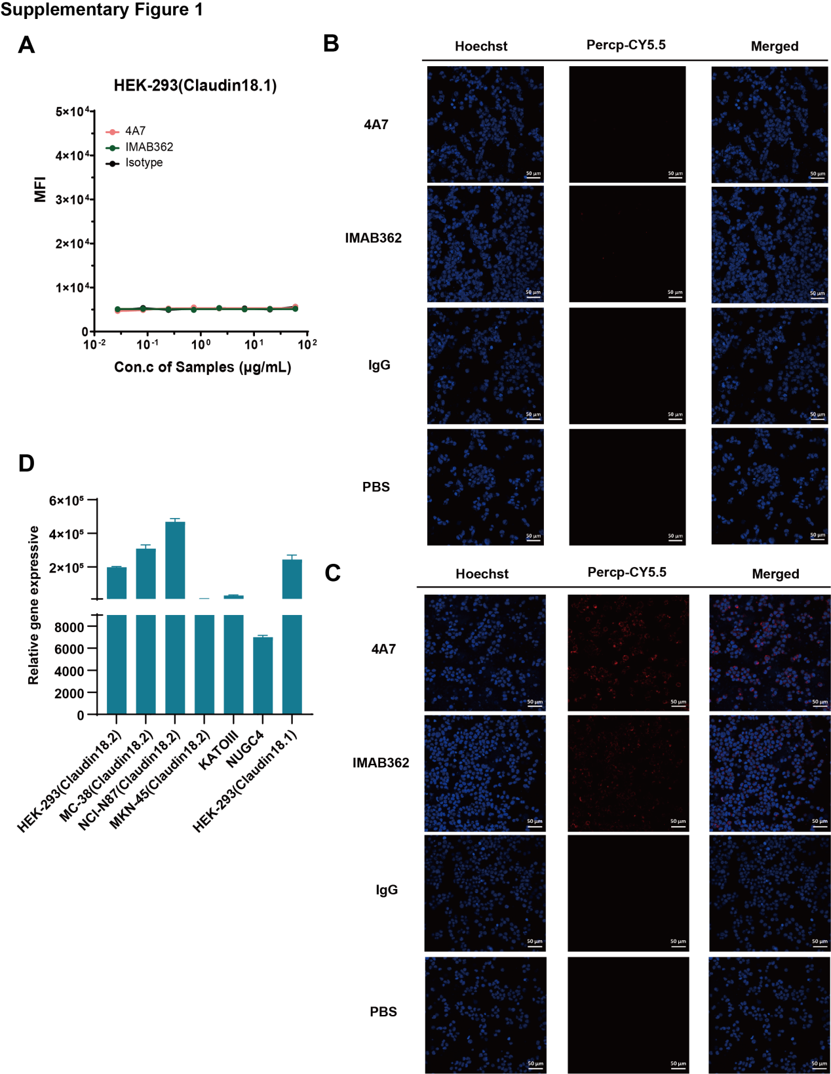
Supplementary Figure1. (A-C) Binding activity of 4A7 and IMAB362 to Claudin18.1-positive cell lines and Claudin18.2-positive cell lines. (A) Flow cytometry was used to detect the binding affinity to HEK-293 (Claudin18.1) (B-C) Confocal immunofluorescence examination was used to visualize the binding of 4A7 and IMAB362 to HEK-293 (Claudin18.1) (B)and HEK-293 (Claudin18.2) (C). (D)Transcript (qRT-PCR) levels of Claudin18.2 or Claudin18.1 in Corresponding cell lines with endogenous or transduced Claudin18.2/Claudin18.1 expression. qRT-PCR data are mean ± SD of 3 independent measurements.

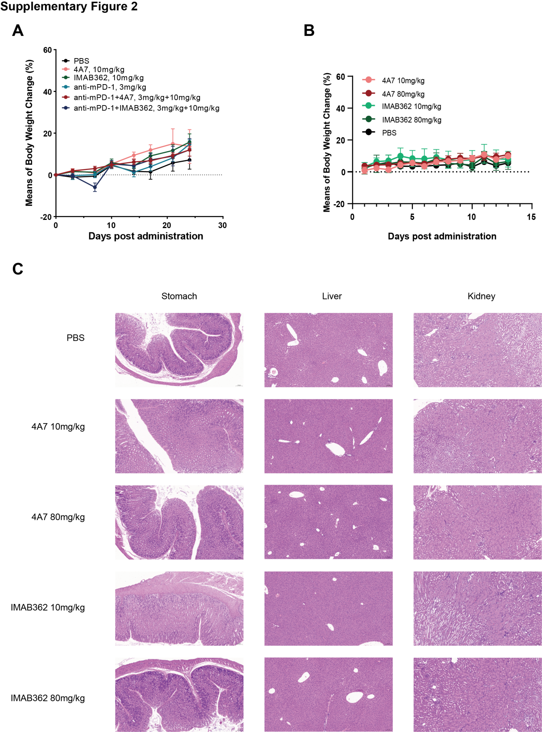
Supplementary Figure 2. (A) Body weight of C57/BL6 mice in different five treatment groups. Each group consisted of five mice. (B) Body weight measurements after 4A7 or IMAB362 antibody i.p. administration at 80 and 10 mg/kg. Each group consisted of three mice. Data are expressed as Mean ± SD. (C) representative histological photomicrographs of the histopathological analyses of tissue sections of the stomach, kidneys and livers observed with 10×.

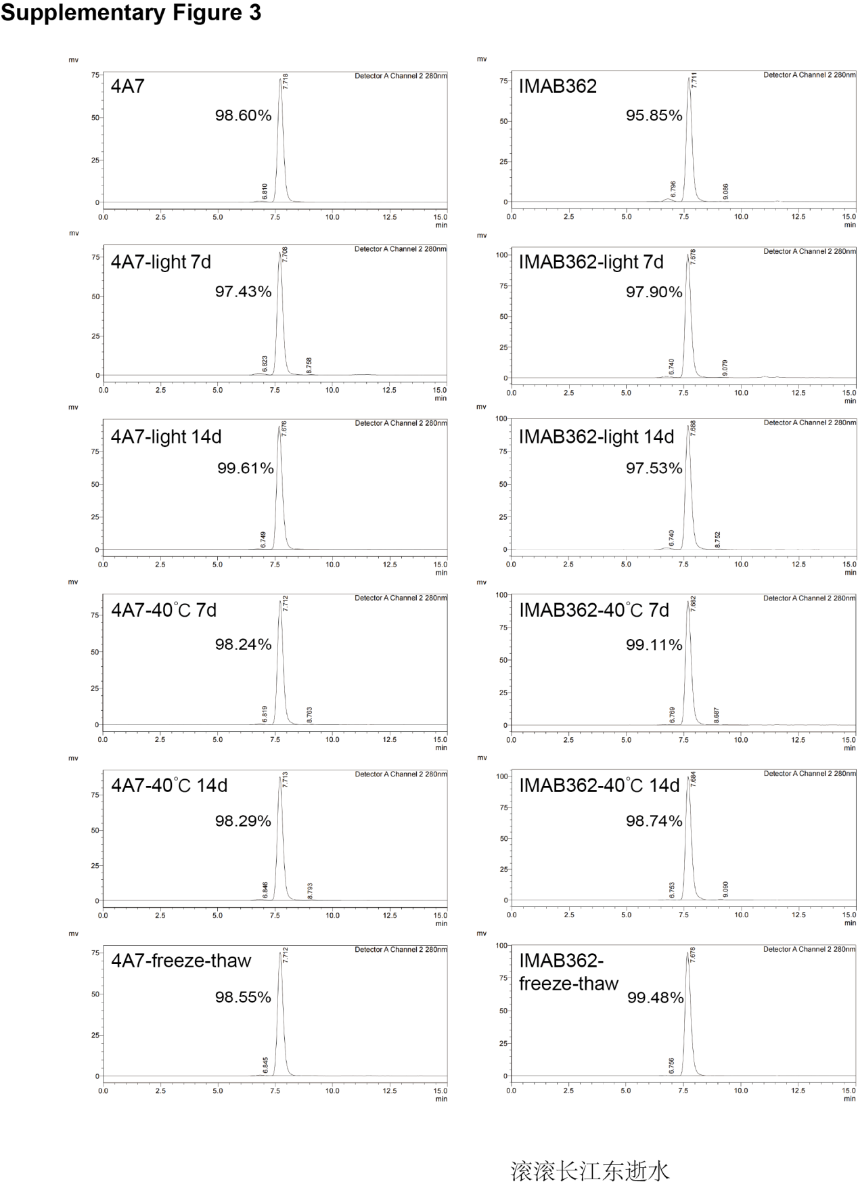
Supplementary Figure 3: The full view of the SEC-HPLC UV chromatogram of 4A7and IMAB362. The antibodies were applied to HPLC after ten freeze-thaw cycles and incubation at 40℃ or daylight for 7 and 14 days.

