Supplementary Material

Association of Uric Acid, High-Sensitivity C-Reactive Protein, and 90-Day Risk of Poor Function Outcome in Patients With Ischemic Stroke or Transient Ischemic Attacks

Supplementary Figure S1: Association of each biomarker with poor functional outcome by multivariate logistic regression with restricted cubic spline (RCS).

Supplementary Figure S2: Subgroup analysis for association of uric acid (UA) with poor functional outcome in patients with high levels of high-sensitivity c-reactive protein (hs-CRP).

Supplementary Figure S3: Standard mean differences plot for selected variables in the propensity score matching analysis.

Supplementary Table S1: Comparison of the Variables Before and After PSM for Low Uric Acid & High hsCRP Subgroup and High Uric Acid & High hsCRP Subgroup.

Supplementary Table S2: Spearman Correlation Coefficient Between Inflammatory Biomarkers.

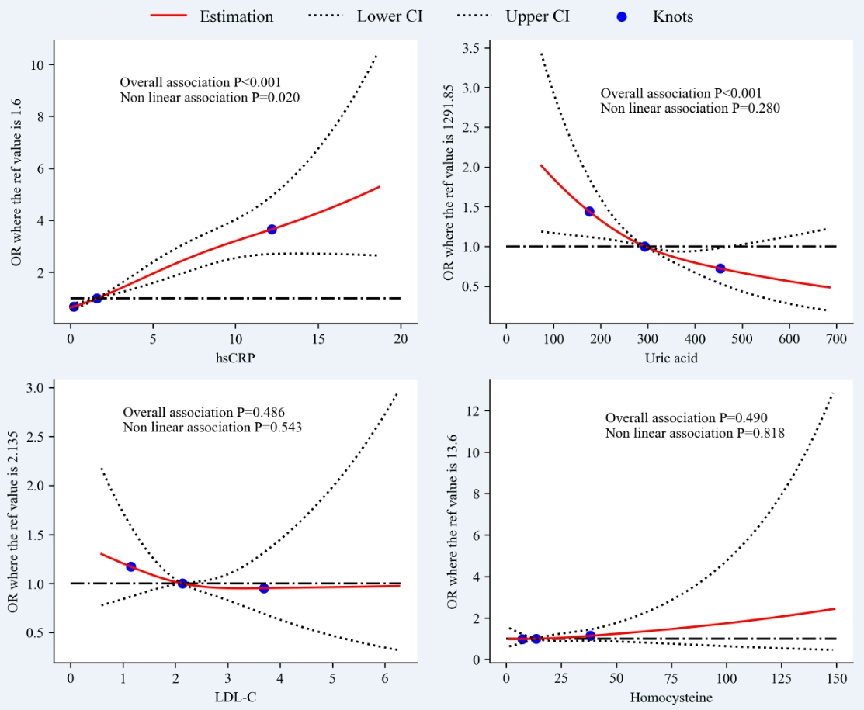
Supplementary Figure S1: Association of each biomarker with poor functional outcome by multivariate logistic regression with restricted cubic spline (RCS).
OR indicates odds ratio; hsCRP, high-sensitivity C-reactive protein; LDL-C, low density lipoprotein cholesterol.
The RCS was fitted to explore a dose-response relationship between a single biomarker and poor functional outcome. The knots were set at 5th, 50th, and 90th percentiles and the reference values (OR=1) were set at the median of each metal concentrations. The red line indicates adjusted OR, and the dashed lines indicate 95%CI. The dose-response relationship was considered to be nonlinear if “Non-linear association P<0.05”.

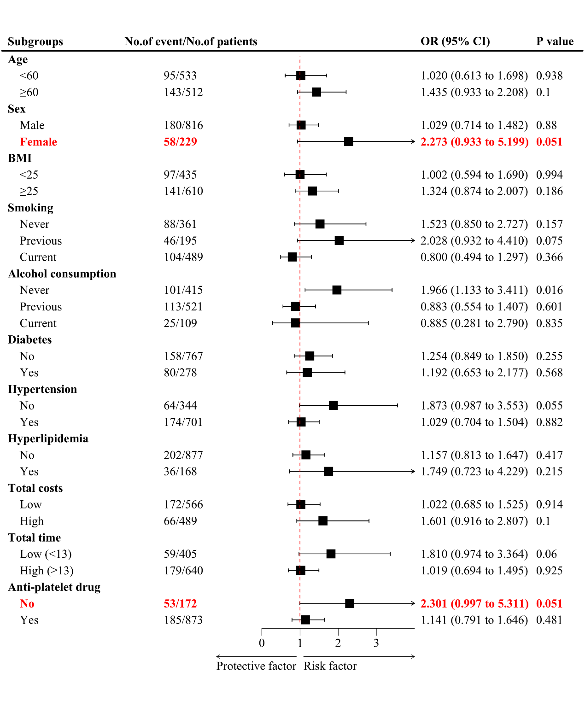
Supplementary Figure S2: Subgroup analysis for association of uric acid (UA) with poor functional outcome in patients with high levels of high-sensitivity c-reactive protein (hs-CRP).
OR indicates odds ratio; BMI, body mass index. Adjusted OR (95% CI) was calculated after adjusting for age, BMI, smoking, alcohol consumption, diabetes, hypertension, hyperlipidemia, total costs, total time and anti-platelet drug. BMI indicates body mass index, hsCRP, high-sensitivity C-reactive protein; LDL-C, low density lipoprotein cholesterol.

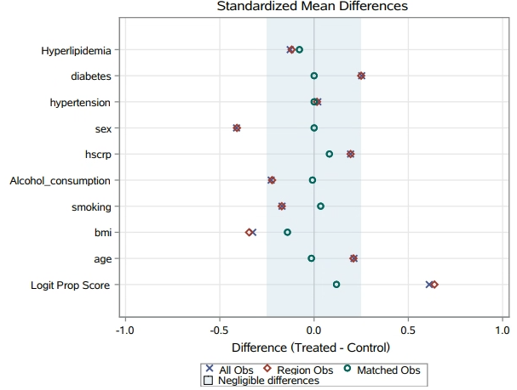
Supplementary Figure S3: Standard mean differences plot for selected variables in the propensity score matching analysis.
BMI indicates body mass index; hsCRP, high-sensitivity c-reactive protein; Logit Prob Score, the logit of the propensity score (used to compute differences between pairs of observations). The plot showed that the matched observations were within the recommended limits of -0.25 and 0.25, which were indicated by the shade area.

Supplementary Table S1: Comparison of the Variables Before and After PSM for Low Uric Acid & High hsCRP Subgroup and High Uric Acid & High hsCRP Subgroup.
 | Before PSM |  |  | After PSM
Variables | Low uric acid & high hsCRP subgroup | High uric acid & high hsCRP subgroup | P value | Low uric acid & high hsCRP subgroup | High uric acid & high hsCRP subgroup | P value
N | 542 | 503 |  | 387 | 387
Age |  |  | 0.001 |  |  | 0.867
Median(IOR) | 60(53,67) | 58(49,66) |  | 59(52,68) | 60(52,66)
Sex, n (%) |  |  | <0.001 |  |  | 1.000
Male | 380(70.1%) | 436(86.7%) |  | 324(83.7%) | 324(83.7%)
Female | 162(29.9%) | 67(13.3%) |  | 63(16.3%) | 63(16.3%)
BMI |  |  | <0.001 |  |  | 0.021
Median(IOR) | 24.9(22.9,27.3) | 26.1(24.2,28.7) |  | 25.8(23.9,27.5) | 24.9(23.4,27.2)
Smoking, n (%) |  |  | <0.05 |  |  | 0.864
Previous 4 | 98(18.1%) | 97(19.3%) |  | 75(19.4%) | 81(20.9%)
Never 1 | 211(45.6%) | 150(29.8%) |  | 122(31.5%) | 119(30.7%)
Current 3 | 233(43.0%) | 256(50.9%) |  | 190(49.1%) | 187(48.3%)
Alcohol consumption, n (%) |  |  | <0.001 |  |  | 0.972
Previous | 55(10.1%) | 54(10.7%) |  | 44(11.4%) | 42(10.9%)
Never | 247(45.6%) | 168(33.4%) |  | 136(35.1%) | 136(35.1%)
Current | 240(44.3%) | 281(55.9%) |  | 207(53.5%) | 209(54.0%)
Hypertension, n (%) |  |  | 0.745 |  |  | 1.000
Yes | 366(67.5%) | 335 (66.6%) |  | 269(69.5%) | 269 (69.5%)
No | 176(32.5%) | 168(33.4%) |  | 118(30.5%) | 118(30.5%)
Diabetes, n (%) |  |  | <0.001 |  |  | 1.000
Yes | 173(31.9%) | 105(20.9%) |  | 93(24.0%) | 93(24.0%)
No | 369(68.1%) | 398(79.1%) |  | 294(76.0%) | 294(76.0%)
Hyperlipidemia, n (%) |  |  | 0.041 |  |  | 0.256
Yes | 75(13.8%) | 93(18.5%) |  | 60(15.5%) | 49(12.7%)
No | 467(86.2%) | 410(81.5%) |  | 327(84.5%) | 338(87.3%)
hsCRP |  |  | 0.001 |  |  | 0.158
Median(IOR) | 4.8(2.7,10.8) | 4.3(2.4,8.7) |  | 4.5(2.6,9.7) | 4.5(27,108)
BMI indicates body mass index; hsCRP, high-sensitivity c-reactive protein; PSM, propensity score matching; IQR, interquartile range

Supplementary Table S2: Spearman Correlation Coefficient Between Inflammatory Biomarkers
Inflammatory biomarker | LDL-C | Cys
hsCRP | 0.102 | 0.062
 | P<0.001 | P=0.004
LDL-C |  | 0.103
 |  | P<0.001
hsCRP indicates high-sensitivity c-reactive protein, LDL-C, low-density lipoprotein cholesterol; Cys, homocysteine

