Appendix
Table S1. Overview of proposed measures.
Table S2. Overview of national classification standard.
Fig. S1. Geographic comparison diagram of high temperature-sensitive health risks (HTR) aspect.
Fig. S2. Geographic comparison diagram of low temperature-sensitive health exposure (LTE) aspect.
Fig. S3. Geographic comparison diagram of low temperature-sensitive health risks (LTR) aspect.
Fig. S4. Geographic comparison diagram of vulnerable factors (VF) aspect.
Fig. S5. Geographic comparison diagram of economic development in 2019.
Fig. S6. Geographic comparison diagram of social aging in 2019.

Table S1. Overview of proposed measures.
Database | Indicators |  | Feature | Definition | Website
ERA5-HEAT; Socioeconomic Data and Applications Center Gridded Population of the World version 4; The United Nations World Population Prospects | I1 | Children exposure to extreme cold (person-days/year⁻¹) | negative |  | https://cds.climate.copernicus.eu/cdsapp#!/dataset/10.24381/cds.553b7518?tab=overview; https://beta.sedac.ciesin.columbia.edu/data/collection/gpw-v4; https://population.un.org/wpp/Download/Standard/Population/
 | I2 | Older population exposure to extreme cold (person-days/year⁻¹) | negative
 | I3 | Older population exposure to extreme heat (person-days/year⁻¹) | negative
 | I4 | Children exposure to extreme heat (person-days/year⁻¹) | negative
The Climate Change Knowledge Portal of the World Bank | I5 | Average maximum temperature (°C) | interval | Based on the study ¹, the thermal adaptation has a temperature limit, and thermal neutrality can hardly be achieved outside the limit, which neutral temperature is the temperature at which people feel neither cool nor warm. And the limit was between 12.9 and 32.3 °C in air temperature. | https://climateknowledgeportal.worldbank.org/download-data
The Climate Change Knowledge Portal of the World Bank | I6 | Average mean temperature (°C) | interval |  | https://climateknowledgeportal.worldbank.org/download-data
The Climate Change Knowledge Portal of the World Bank | I7 | Average minimum temperature (°C) | interval |  | https://climateknowledgeportal.worldbank.org/download-data
The Climate Change Knowledge Portal of the World Bank | I8 | Relative humidity (%) | interval | The majority of adverse health effects caused by relative humidity would be minimized by maintaining indoor levels between 40 and 60%. ² | https://climateknowledgeportal.worldbank.org/download-data
The Climate Change Knowledge Portal of the World Bank | I9 | Cold spell duration index (days) | negative | The number of days that are part of a sequence of 6 or more days in which the daily minimum temperature exceeds the 10th percentile of the reference period. | https://climateknowledgeportal.worldbank.org/download-data
The Climate Change Knowledge Portal of the World Bank | I10 | Warm spell duration index (days) | negative | The number of days that are part of a sequence of 6 or more days in which the daily maximum temperature exceeds the 90th percentile of the reference period. | https://climateknowledgeportal.worldbank.org/download-data
The Climate Change Knowledge Portal of the World Bank | I11 | Number of very hot days (Tmax>35℃) (days) | negative | Average count of days when the maximum temperature surpassed 35°C. | https://climateknowledgeportal.worldbank.org/download-data
The Climate Change Knowledge Portal of the World Bank | I12 | Number of frost days (Tmin<0℃) (days) | negative | Average count of days when the minimum temperature dropped below the freezing point of water at 0°C. | https://climateknowledgeportal.worldbank.org/download-data
The Climate Change Knowledge Portal of the World Bank | I13 | Maximum length of consecutive dry spell (days) | negative | The number of days in the longest period without significant precipitation of at least 1mm. | https://climateknowledgeportal.worldbank.org/download-data
The Climate Change Knowledge Portal of the World Bank | I14 | Maximum length of consecutive wet spell (days) | negative | The number of days in the longest period with continuous significant rainfall of 1mm or more. | https://climateknowledgeportal.worldbank.org/download-data
The World Health Organization International Health Regulations State Parties Self-Assessment Annual Reporting Tool | I15 | National health emergency framework (%) | positive | The status of IHR implementation from 2010 to 2017 was assessed through the IHR monitoring questionnaire. Since 2018, it has been submitted online by IHR SPAR, and some contents have been revised. Thus, in order to maintain consistency of capacities for the period 2010-2019, this study consolidated Response and Preparedness capacities for 2010-2017 into the National health emergency framework capacity, while the capacity C1.2, C1.3 and C9 (Health service provision) for 2018 and 2019 were removed. | https://extranet.who.int/e-spar#capacity-score
 | I16 | Risk communication (%) | positive |  | https://extranet.who.int/e-spar#capacity-score
 | I17 | Laboratory (%) | positive |  | https://extranet.who.int/e-spar#capacity-score
 | I18 | Surveillance (%) | positive |  | https://extranet.who.int/e-spar#capacity-score
 | I19 | Coordination and NAP communications (%) | positive |  | https://extranet.who.int/e-spar#capacity-score
 | I20 | Zoonotic events (%) | positive |  | https://extranet.who.int/e-spar#capacity-score
 | I21 | National legislation, policy and financing (%) | positive |  | https://extranet.who.int/e-spar#capacity-score
 | I22 | Human resource capacity (%) | positive |  | https://extranet.who.int/e-spar#capacity-score
 | I23 | Chemical events (%) | positive |  | https://extranet.who.int/e-spar#capacity-score
 | I24 | Food safety (%) | positive |  | https://extranet.who.int/e-spar#capacity-score
 | I25 | Points of entry (%) | positive |  | https://extranet.who.int/e-spar#capacity-score
 | I26 | Radiation emergencies (%) | positive |  | https://extranet.who.int/e-spar#capacity-score
The Global Burden of Disease Study 2019 Air Pollution Exposure Estimates 1990-2019 | I27 | Ambient particulate matter pollution (ug/m³) | negative | The population-weighted annual average mass concentration of particles with an aerodynamic diameter less than 2.5 micrometers (PM_{2.5}) in a cubic meter of air. ³ | https://ghdx.healthdata.org/record/global-burden-disease-study-2019-gbd-2019-air-pollution-exposure-estimates-1990-2019
 | I28 | Ambient ozone pollution (ppd) | negative | The highest seasonal (six-month) average of eight-hour daily maximum ozone concentrations, in parts per billion
The Global Burden of Disease Study 2019 Results Tool database | I29 | Cardiovascular diseases mortality attributable to high temperature (per 100,000 population) | negative | Twelve causes were included as outcomes associated with non-optimal temperature: ischaemic heart disease, stroke, hypertensive heart disease, diabetes, chronic kidney disease, lower respiratory infection, chronic obstructive pulmonary disease, homicide, suicide, mechanical injuries, transport-related injuries, and drowning. Cardiovascular diseases attributed to temperature extremes included ischaemic heart disease, stroke and hypertensive heart disease. Chronic respiratory diseases attributed to temperature extremes included lower respiratory infection and chronic obstructive pulmonary disease. | https://vizhub.healthdata.org/gbd-results/
 | I30 | Cardiovascular diseases YLL attributable to high temperature (per 100,000 population) | negative |  | https://vizhub.healthdata.org/gbd-results/
 | I31 | All-cause mortality attributable to high temperature (per 100,000 population) | negative |  | https://vizhub.healthdata.org/gbd-results/
 | I32 | All-cause YLL attributable to high temperature (per 100,000 population) | negative |  | https://vizhub.healthdata.org/gbd-results/
 | I33 | Chronic respiratory diseases YLL attributable to high temperature (per 100,000 population) | negative |  | https://vizhub.healthdata.org/gbd-results/
 | I34 | Chronic respiratory diseases mortality attributable to high temperature (per 100,000 population) | negative |  | https://vizhub.healthdata.org/gbd-results/
 | I35 | All-cause YLL attributable to low temperature (per 100,000 population) | negative |  | https://vizhub.healthdata.org/gbd-results/
 | I36 | All-cause mortality attributable to low temperature (per 100,000 population) | negative |  | https://vizhub.healthdata.org/gbd-results/
 | I37 | Cardiovascular diseases YLL attributable to low temperature (per 100,000 population) | negative |  | https://vizhub.healthdata.org/gbd-results/
 | I38 | Cardiovascular diseases mortality attributable to low temperature (per 100,000 population) | negative |  | https://vizhub.healthdata.org/gbd-results/
 | I39 | Chronic respiratory diseases YLL attributable to low temperature (per 100,000 population) | negative |  | https://vizhub.healthdata.org/gbd-results/
 | I40 | Chronic respiratory diseases mortality attributable to low temperature (per 100,000 population) | negative |  | https://vizhub.healthdata.org/gbd-results/
 | I41 | All-cause mortality attributable to unsafe water, sanitation and handwashing (per 100,000 population) | negative |  | https://vizhub.healthdata.org/gbd-results/
 | I42 | All-cause mortality attributable to child growth failure (per 100,000 population) | negative |  | https://vizhub.healthdata.org/gbd-results/
 | I43 | Diarrheal diseases death rate (per 100,000 population) | negative |  | https://vizhub.healthdata.org/gbd-results/
 | I44 | All-cause mortality attributable to air pollution (per 100,000 population) | negative |  | https://vizhub.healthdata.org/gbd-results/
 | I45 | Malaria death rate (per 100,000 population) | negative |  | https://vizhub.healthdata.org/gbd-results/
 | I46 | Dengue death rate (per 100,000 population) | negative |  | https://vizhub.healthdata.org/gbd-results/
 | I47 | Zika virus death rate (per 100,000 population) | negative |  | https://vizhub.healthdata.org/gbd-results/
 | I48 | Yellow fever death rate (per 100,000 population) | negative |  | https://vizhub.healthdata.org/gbd-results/
The World Development Indicators database of the World Bank | I49 | PM_{2.5} air pollution, mean annual exposure (ug/m³) | negative | The average level of exposure of a nation's population to concentrations of suspended particles measuring less than 2.5 microns in aerodynamic diameter, which was calculated by weighting mean annual concentrations of PM_{2.5} by population in both urban and rural areas. | https://databank.worldbank.org/source/world-development-indicators
The World Development Indicators database of the World Bank | I50 | PM_{2.5} air pollution, population exposed to levels exceeding WHO guideline value (% of total) | negative | The portion of a country’s population living in places where mean annual concentrations of PM_{2.5} are greater than 10 micrograms per cubic meter, the guideline value recommended by the WHO as the lower end of the range of concentrations over which adverse health effects due to PM_{2.5} exposure have been observed.
The World Development Indicators database of the World Bank | I51 | Mortality rate, under-5 (per 1,000 live births) | negative
The World Development Indicators database of the World Bank | I52 | People using at least basic sanitation services (% of population) | positive
The World Development Indicators database of the World Bank | I53 | Life expectancy at birth, total (years) | positive
The World Development Indicators database of the World Bank | I54 | People using at least basic drinking water services (% of population) | positive
The World Development Indicators database of the World Bank | I55 | Maternal mortality ratio (modeled estimate, per 100,000 live births) | negative
The World Development Indicators database of the World Bank | I56 | Risk of impoverishing expenditure for surgical care (% of people at risk) | negative
The World Development Indicators database of the World Bank | I57 | Adolescent fertility rate (births per 1,000 women ages 15-19) | negative
The World Development Indicators database of the World Bank | I58 | Prevalence of undernourishment (% of population) | negative
The World Development Indicators database of the World Bank | I59 | Domestic general government health expenditure (% of current health expenditure) | positive
The World Development Indicators database of the World Bank | I60 | Urban population (% of total population) | positive
The World Development Indicators database of the World Bank | I61 | GDP per capita, PPP (current international $) | positive
The World Development Indicators database of the World Bank | I62 | GDP per capita growth (annual %) | positive
The World Development Indicators database of the World Bank | I63 | GDP growth (annual %) | positive
The World Development Indicators database of the World Bank | I64 | Cereal yield (kg per hectare) | positive
The World Development Indicators database of the World Bank | I65 | Agricultural land (% of land area) | positive
The World Development Indicators database of the World Bank | I66 | Arable land (% of land area) | positive
The World Development Indicators database of the World Bank | I67 | Death rate, crude (per 1,000 people) | negative
The World Development Indicators database of the World Bank | I68 | Population ages 65 and above (% of total population) | negative
The World Development Indicators database of the World Bank | I69 | Refugee population by country or territory of asylum | negative
The World Development Indicators database of the World Bank | I70 | Government expenditure on education, total (% of GDP) | positive
The World Development Indicators database of the World Bank | I71 | Current health expenditure (% of GDP) | positive
The World Development Indicators database of the World Bank | I72 | Out-of-pocket expenditure (% of current health expenditure) | negative
The World Development Indicators database of the World Bank | I73 | Unemployment, total (% of total labor force) (modeled ILO estimate) | negative
The World Development Indicators database of the World Bank | I74 | Inflation, consumer prices (annual %) | negative | [3, 6] could be seen as an ideal interval for Inflation (consumer prices) form economics perspective.
Global Health Observatory data repository of the World Health Organization | I75 | Prevalence of anemia among children (% of children ages 6-59 months) | negative |  | https://apps.who.int/gho/data/node.main
 | I76 | All-cause mortality rate in 60+ people (per 100,000 population) | negative |  | https://apps.who.int/gho/data/node.main
 | I77 | Age-standardized NCD mortality rate (per 100,000 population) | negative |  | https://apps.who.int/gho/data/node.main
 | I78 | Age-standardized suicide rates (per 100,000 population) | negative |  | https://apps.who.int/gho/data/node.main
PM, particulate matter; WHO, World Health Organization; NAP, National Adaptation Plans; IHR, International Health Regulation; GDP, gross domestic product; NCD, Noncommunicable diseases; YLL, years of life lost.
a. Age-standardized mortality rate.

Table S2. Overview of national classification standard.
(A) The classification of 171 countries based on economic development
Assignment | Group nameª | Value range^{b} | Ten-year average^{c} | % of total | 2019 | % of total
1 | low income | ≤1035 | 28 | 16.37 | 27 | 15.79
2 | lower middle income | 1036 - 4045 | 47 | 27.49 | 45 | 26.32
3 | upper middle income | 4046 - 12535 | 47 | 27.49 | 47 | 27.49
4 | high income | 12536 - 46500 | 32 | 18.71 | 35 | 20.47
5 | very high income | >46500 | 17 | 9.94 | 17 | 9.94
a. Country income classifications were obtained from World Bank Country and Lending Groups. b. Value range was measured with gross national income per capita in US$ (Atlas methodology) in 2019. c. Years from 2010 to 2019.

(B) The classification of 171 countries based on social aging
Assignment | Group nameª | Value range^{b} | Ten-year average^{c} | % of total | 2019 | % of total
1 | non-aging society (low) | <3.54 | 48 | 28.07 | 45 | 26.32
2 | non-aging society (middle) | ≥3.54 & <7 | 54 | 31.58 | 46 | 26.90
3 | aging society | ≥7 & <14 | 34 | 19.88 | 37 | 21.64
4 | aged society | ≥14 & <20 | 31 | 18.13 | 31 | 18.13
5 | hyper-aged society | ≥20 | 4 | 2.34 | 12
a. Countries aging classifications were obtained according to the definition provided by the United Nations. b. Societies with the proportion of older population (aged 65+) greater than or equal to 7, 14 and 20 were regarded as aging society, aged society and super-aging society, respectively. Moreover, countries belonging to the non-aging society was divided into two groups based on the medium value of non-aging countries in 2019 (3.54). c. Years from 2010 to 2019.
Fig. S1. Geographic comparison diagram of high temperature-sensitive risks (HTR) aspect.
Fig. S2. Geographic comparison diagram of low temperature-sensitive risks (LTR) aspect.
Fig. S3. Geographic comparison diagram of low temperature exposure (LTE) aspect.
Fig. S4. Geographic comparison diagram of vulnerability factors (VF) aspect.
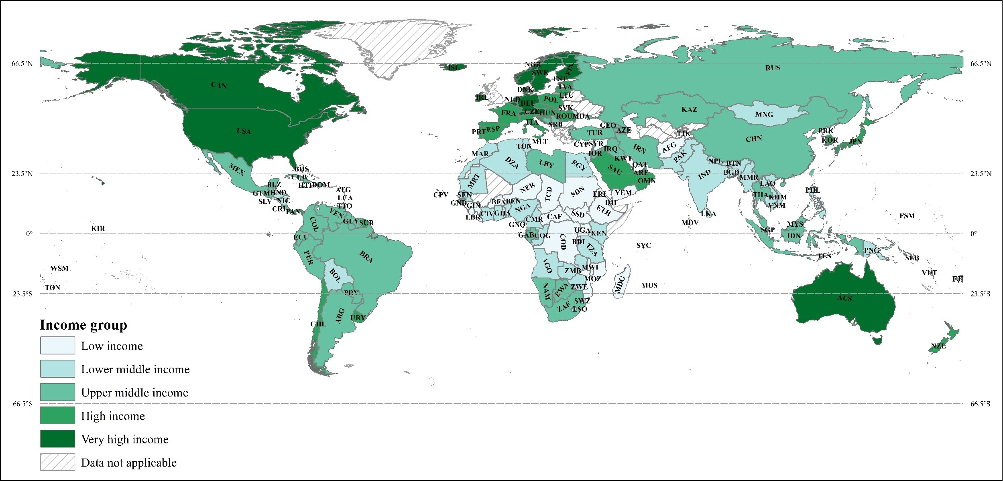Fig. S5. Geographic comparison diagram of economic development in 2019.

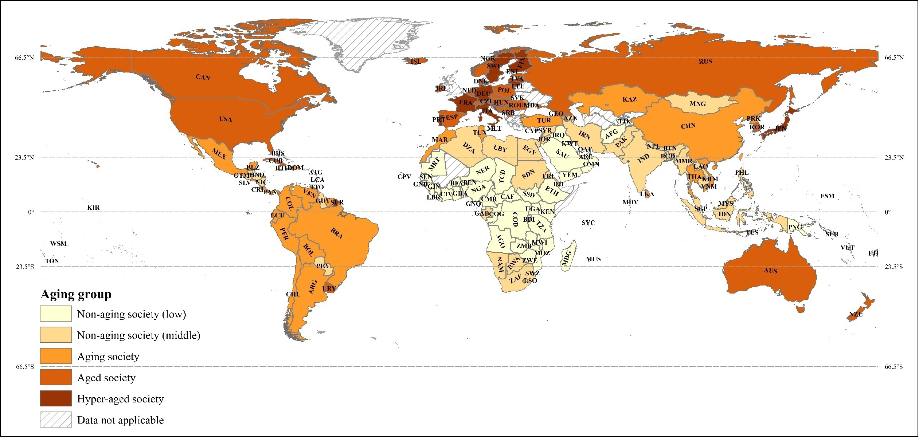Fig. S6. Geographic comparison diagram of social aging in 2019.
References
1. Arundel, A.V., Sterling, E.M., Biggin, J.H., Sterling, T.D., 1986. Indirect health effects of relative humidity in indoor environments. Environ. Health Perspect. 65, 351-361. https://doi.org/10.2307/3430203.
2. Cheung, P.K., Jim, C.Y., 2018. Global pattern of human thermal adaptation and limit of thermal neutrality: Systematic analysis of outdoor neutral temperature. Int J Climatol. 38(14), 5037-5049. https://doi.org/10.1002/joc.5732.
3. GBD 2019 Risk Factors Collaborators, 2020. Global burden of 87 risk factors in 204 countries and territories, 1990-2019: a systematic analysis for the Global Burden of Disease Study 2019. Lancet. 396(10258), 1223-1249. https://doi.org/10.1016/s0140-6736(20)30752-2.

