Supplemental tables
Table S1. baseline characteristics
Discovery cohort | TBAD patients(n=5) | Healthy control(n=3)
Neutrophil count (10⁹) | 5.2±2.9 | 3.3±1.2
Lymphocyte count (10⁹) | 1.4±0.8 | 1.9±0.6
Monocyte count (10⁹) | 0.6±0.1 | 0.4±0.1
RBC count (10¹²) | 4.6±1.1 | 5.1±0.6
Hemoglobin (g/L) | 131.6±24.0 | 156.77±19.7
MCV (fl) | 86.2±12.1 | 89.7±2.0
MCH (pg) | 29.2±4.6 | 30.5±1.3
PLT (10⁹) | 155.2±88.3 | 187.7±56.8
RDW (%) | 13.6±1.5 | 12.8±0.2
Albumin (g/L) | 37.9±3.1 | 42.6±2.0
Glucose (mmol/L) | 5.6±1.9 | 6.0±1.1
Uric Acid (μmol/L) | 348.6±76.5 | 362.3±95.7
BUN (mmol/L) | 8.2±2.7 | 5.3±0.8
Creatinine (μmol/L) | 99.5±58.9 | 68.7±2.1
Triglyceride (mmol/L) | 1.2±0.6 | 2.3±0.7
Cholesterol (mmol/L) | 4.1±1.1 | 4.5±0.8
HDL (mmol/L) | 1.1±0.4 | 0.9±0.1
LDL (mmol/L) | 2.3±1.0 | 2.7±0.9
eGFR (ml/min/1.73m²) | 93.2±44.8 | 112.2±6.4
Derivation cohort | TBAD patients(n=50) | Healthy control(n=30)
Neutrophil count (10⁹) | 8.4±3.4 | 3.6 (1.9)
Lymphocyte count (10⁹) | 1.0 (0.8) | 2.2 (0.6)
Monocyte count (10⁹) | 0.6 (0.5) | 0.4±0.1
RBC count (10¹²) | 4.2±0.8 | 5.0±0.3
Hemoglobin (g/L) | 137.0 (36.0) | 156.3±7.6
MCV (fl) | 92.3 (5.9) | 91.6±3.3
MCH (pg) | 31.5±1.7 | 31.2±1.2
PLT (10⁹) | 159.0 (92.5) | 216.3±38.2
RDW (%) | 13.0 (1.0) | 12.8 (0.8)
Albumin (g/L) | 38.3 (6.1) | 44.5±1.9
Glucose (mmol/L) | 6.3 (3.0) | 5.5 (1.3)
Uric Acid (μmol/L) | 388.0 (175.8) | 395.4±78.1
BUN (mmol/L) | 7.9 (4.5) | 5.0 (1.3)
Creatinine (μmol/L) | 87.1 (71.2) | 73.5 (14.0)
Triglyceride (mmol/L) | 1.2 (0.9) | 1.3 (1.2)
Cholesterol (mmol/L) | 3.6±1.1 | 4.9±0.9
HDL (mmol/L) | 0.9 (0.5) | 1.3 (0.4)
LDL (mmol/L) | 1.9±0.8 | 2.9±0.8
eGFR (ml/min/1.73m²) | 78.0±37.1 | 105.9 (22.4)
Validation cohort | TBAD patients(n=50) | Healthy control(n=30)
Neutrophil count (10⁹) | 5.6 (3.3) | 3.4±0.8
Lymphocyte count (10⁹) | 1.4±0.7 | 2.0±0.5
Monocyte count (10⁹) | 0.6 (0.4) | 0.4±0.1
RBC count (10¹²) | 4.2±0.7 | 4.9±0.4
Hemoglobin (g/L) | 126.7±25.3 | 151.5±10.2
MCV (fl) | 90.5 (4.9) | 90.9±3.6
MCH (pg) | 30.5 (2.3) | 30.8±1.3
PLT (10⁹) | 218.8±84.6 | 201.8±30.5
RDW (%) | 13.1 (1.4) | 12.9±0.4
Albumin (g/L) | 38.1±2.8 | 45.8±1.9
Glucose (mmol/L) | 5.0 (1.4) | 5.0 (0.6)
Uric Acid (μmol/L) | 260.5 (168.8) | 363.9±69.4
BUN (mmol/L) | 6.8 (3.8) | 5.2±1.1
Creatinine (μmol/L) | 70.5 (61.3) | 80.9±11.3
Triglyceride (mmol/L) | 1.1 (0.9) | 1.3±0.4
Cholesterol (mmol/L) | 4.0±0.9 | 4.6±0.6
HDL (mmol/L) | 1.0 (0.4) | 1.4±0.3
LDL (mmol/L) | 2.3±0.7 | 2.9±0.5
eGFR (ml/min/1.73m²) | 98.7±43.9 | 93.5±11.6
Data presented as n (%) for categorical variables and mean ± standard deviation (SD) or median (IQR) for continuous variables.
Abbreviations: HDL, high-density lipoprotein; LDL, low-density lipoprotein; RBC, red blood cell; MCV, mean corpuscular volume; MCH, mean corpuscular hemoglobin; PLT, blood platelet; RDW, red cell distribution width; BUN, blood urea nitrogen; HDL, high-density lipoprotein; LDL, low-density lipoprotein; eGFR, estimated glomerular filtration rate.
Table S2. The performance of 3 machine learning algorithms in classifying TBAD patients and healthy controls
Algorithms | Result
Algorithms | Accuracy | Recall | Precision | F1 | AUC
SVM | 73.12% | 74.41% | 92.33% | 82.41% | 0.7496±0.13
XGBoost | 84.42% | 87.91% | 93.29% | 90.52% | 0.7849±0.12
RF | 82.41% | 88.82% | 84.12% | 86.41% | 0.9039±0.06
Abbreviations: SVM, support vector machine; XGBoost, extreme gradient boosting; RF, random forest; AUC, area under curve
Table S3. The predictive model performance of TBAD based on relative quantitative biomarkers (via antibody microarrays), clinical indicators, and their combination
Algorithms | Result
Algorithms | Accuracy | Recall | Precision | F1 | AUC
RF(Biomarkers) | 77.85% | 83.65% | 81.63% | 82.63% | 0.8653±0.06
RF(Clinic) | 81.74% | 82.59% | 87.70% | 85.07% | 0.9039±0.06
RF(Combined) | 83.26% | 82.06% | 90.47% | 86.06% | 0.9091±0.05
Abbreviations: RF, random forest; AUC, area under curve
Table S4. The predictive model performance of TBAD based on absolute quantitative biomarkers (via ELISA), clinical indicators, and their combination
Algorithms | Result
Algorithms | Accuracy | Recall | Precision | F1 | AUC
RF(Biomarkers) | 79.71% | 90.00% | 80.02% | 84.72% | 0.8655±0.06
RF(Clinic) | 79.67% | 84.07% | 83.51% | 83.79% | 0.8682±0.09
RF(Combined) | 80.79% | 89.13% | 81.77% | 85.30% | 0.8861±0.09
Abbreviations: RF, random forest; AUC, area under curve

Table S5. The predictive model performance of TBAD in hypertensive participants from discovery and derivation cohort.
Algorithms | Result
Algorithms | Accuracy | Recall | Precision | F1 | AUC
RF(Biomarkers) | 79.00% | 80.30% | 94.66% | 86.89% | 0.8529±0.12
RF(Clinic) | 78.52% | 77.59% | 97.03% | 86.23% | 0.8936±0.09
RF(Combined) | 83.49% | 81.46% | 99.39% | 89.54% | 0.9246±0.05
Abbreviations: RF, random forest; AUC, area under curve

Table S6. The predictive model performance of TBAD in hypertensive participants from validation cohort.
Algorithms | Result
Algorithms | Accuracy | Recall | Precision | F1 | AUC
RF(Biomarkers) | 77.62% | 87.01% | 79.25% | 82.95% | 0.8572±0.08
RF(Clinic) | 78.14% | 89.47% | 78.56% | 83.66% | 0.8381±0.10
RF(Combined) | 83.90% | 88.49% | 86.15% | 87.30% | 0.9041±0.10
Abbreviations: RF, random forest; AUC, area under curve
Supplemental figures
Supplemental Figure 1. The serum samples in 1000 protein and customized antibody microarrays.
- PCA analysis of 8 serum samples in 1000 protein antibody microarrays.
- Scatter plot of 1000 detected proteins in discovery cohort.
- PCA analysis of 80 serum samples in customized antibody microarrays.
- Scatter plot of 31 detected proteins in derivation cohort.
Supplemental Figure 2. Random forest model (RF) of TBAD integrating 11 differentially expressed proteins (DEPs).
- The learning curve of the RF model based on the AUC of the training set and the testing set. The testing AUC of the RF model for TBAD was within a 95% CI of the training AUC.
- Importance plot of the RF model. Relative importance was calculated based on the Gini value.
Supplemental Figure 3. Learning curves of the models based on the biomarkers, clinic, and their combination.
- The learning curve of the biomarker model based on the AUC of the training set and the testing set. The testing AUC of the RF model for TBAD was within a 95% CI of the training AUC.
- The learning curve of the clinic model based on the AUC of the training set and the testing set. The testing AUC of the RF model for TBAD was within a 95% CI of the training AUC.
- The learning curve of the combined model based on the AUC of the training set and the testing set. The testing AUC of the RF model for TBAD was within a 95% CI of the training AUC.

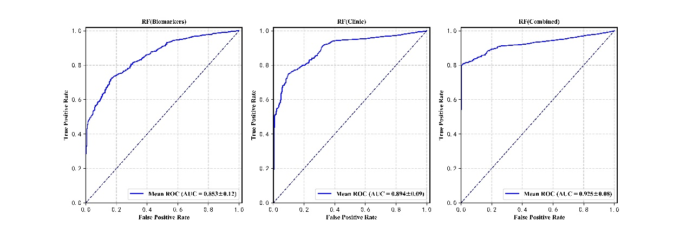
Supplemental Figure 4. Combined model performance with biomarkers and 10 clinical indicators in hypertensive participants from discovery and derivation cohorts.

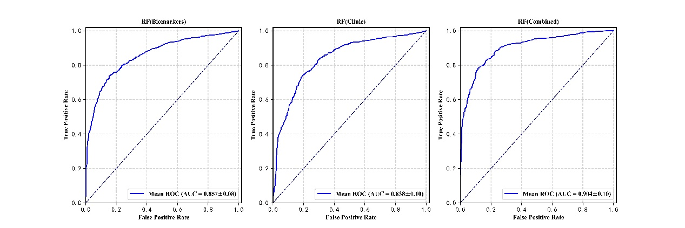
Supplemental Figure 5. Combined model performance with biomarkers and 10 clinical indicators in hypertensive participants from validation cohorts.

