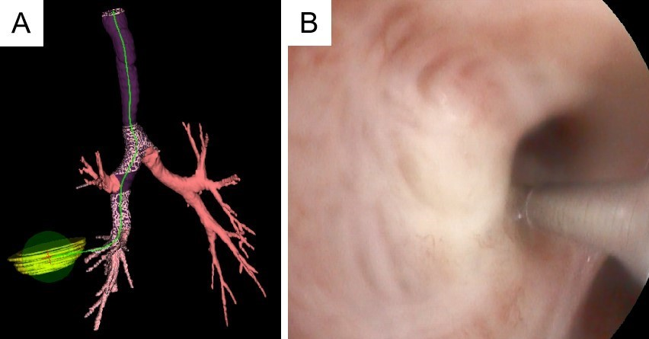

Supplementary Figure 1 . The preoperative planning of the pathway to pulmonary bullae is depicted in (A), while (B) indicates the precise location for needle insertion during surgery.

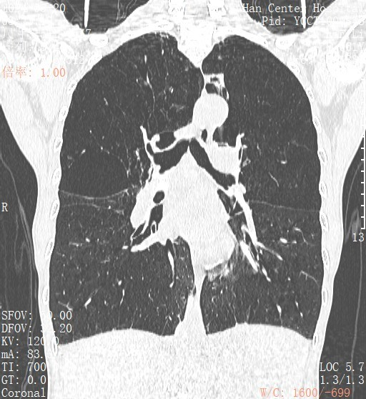

Supplementary Figure 2. The first image of figure 2 corresponds to the perioperative image.

