Supplementary materials
Supplementary Figure 1 scRNA-seq Data QC and Removal of Mitochondrial Genes
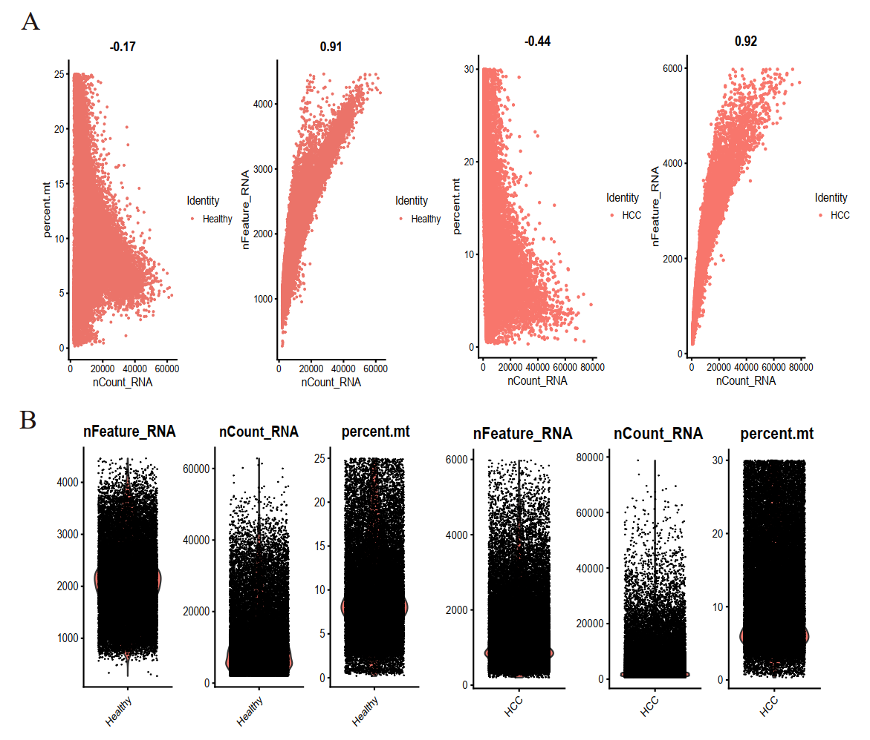

(A-B) Filtering criteria for cells based on unique feature counts and mitochondrial percentages, resulting in 48176 cells for analysis from two datasets (GSE158723 and GSE112271).

