Supplementary Material

(1A) 2.5D Deep Learning Training Process Details
Data Preparation: To ensure uniform intensity distribution across RGB channels, we applied Z-score normalization to the images, which were then used as inputs. For training, we employed real-time data-augmentation techniques such as random cropping, and horizontal and vertical flipping. For test images, only normalization was applied. Additionally, grayscale values of slices were standardized using a min-max transformation, and images were resized to 224 × 224 pixels by using nearest neighbor interpolation.
Training Parameters: We optimized our training by adjusting the learning rate through a cosine decay strategy to enhance model generalization, detailed by the equation:
$$η_{t}=η_{min}^{i}+\frac{1}{2}\left(η_{max}^{i}−η_{min}^{i}\right)\left(1+cos\left(\frac{T_{cur}}{T_{i}}π\right)\right)$$
where the learning rate ranges from $η_{min}^{i}=0$ to $η_{max}^{i}=0.01$. We employed Stochastic Gradient Descent (SGD) as the optimizer and softmax cross-entropy for the loss function.

(1B) Multi-Instance Learning-Based Feature Fusion
We utilized a multi-instance learning approach to enhance predictive accuracy, integrating various data points from a single sample to create a comprehensive feature set. The process involved the following steps:
- Slice Prediction: We used the deep learning model to predict the likelihood of HCC recurrence based on each slice, obtaining corresponding probabilities and labels, denoted as $Slice_{prob}$ and $Slice_{pred}$, respectively, with probabilities retained to two decimal places.
- Multi-Instance Learning Feature Aggregation:
  - Histogram Feature Aggregation:
    - Each distinct number was treated as a "bin" to count occurrences across types.
    - Frequencies of $Slice_{prob}$ and $Slice_{pred}$ in each bin were tallied.
    - All features were subjected to min-max normalization, resulting in $Histo_{prob}$ and $Histo_{pred}$.
  - Bag of Words (BoW) Feature Aggregation:
    - A dictionary was created from unique elements within $Slice_{prob}$ and $Slice_{pred}$.
    - Each slice was represented as a vector noting the frequency of each dictionary element.
    - Term Frequency-Inverse Document Frequency (TF-IDF) transformation was applied, emphasizing informative features.
    - This resulted in BoW feature representation for each slice, encapsulating both presence and significance of features.
- Feature Early Fusion: The final stage involved integrating $Histo_{prob}$, $Histo_{pred}$, $Bow_{prob}$, and $Bow_{pred}$ using a feature-concatenation method ($⊕$), and combining these sets into one comprehensive feature vector as follows:
$$feature_{fusion}=Histo_{prob}⊕Histo_{pred}⊕Bow_{prob}⊕Bow_{pred}$$

(1C) 3D Deep Learning Training Process Details
3D Image Cropping and Data Augmentation: For each patient, we cropped the smallest bounding box around the ROI and expanded it by 5 voxels to include peri-tumoral information, standardizing the intensity distribution across RGB channels by using Z-score normalization. Similar augmentation techniques as in 2.5D training were used, but normalization alone was applied to testing images.
Model Training and Hyperparameters: We evaluated the efficacy of networks like ShuffleNet, ResNet50, and DenseNet121, utilizing pre-trained weights from the ImageNet database to enhance adaptability to different datasets. The learning rate was fine-tuned using a cosine decay strategy, with SGD as the optimizer and softmax cross-entropy as the loss function. ShuffleNet, which performed best on our internal validation set, was selected for further comparative analyses.
Metrics: The comparative analysis of ShuffleNet across the training, internal validation, and external validation cohorts revealed its effectiveness and robustness in handling diverse datasets. Despite a modest AUC of 0.751 in the training cohort, it outperformed DenseNet121 and ResNet101 in the internal validation cohort with an AUC of 0.666, indicating better generalization. This was supported by its consistent performance in the external validation cohort, where it maintained a similar AUC of 0.567. In contrast, DenseNet121 and ResNet101 showed significant drops in performance outside the training environment, suggesting issues with overfitting and adaptability. The ability of ShuffleNet to maintain stability across different cohorts underscored its suitability for applications requiring reliable predictions in varied conditions, highlighting the importance of model selection based on generalization rather than just training performance.

Table S1. Metrics of different deep learning models used to construct the 3D signature
Model | Accuracy | AUC | 95% CI | Sensitivity | Specificity | PPV | NPV | Cohort
DenseNet121 | 0.840 | 0.904 | 0.8583–0.9506 | 0.829 | 0.860 | 0.916 | 0.731 | Training
DenseNet121 | 0.729 | 0.573 | 0.3771–0.7683 | 0.804 | 0.429 | 0.849 | 0.353 | Internal
DenseNet121 | 0.648 | 0.559 | 0.4323–0.6848 | 0.849 | 0.368 | 0.652 | 0.636 | External
ResNet101 | 0.765 | 0.816 | 0.7474–0.8843 | 0.800 | 0.702 | 0.832 | 0.656 | Training
ResNet101 | 0.600 | 0.540 | 0.3400–0.7391 | 0.625 | 0.500 | 0.833 | 0.250 | Internal
ResNet101 | 0.560 | 0.479 | 0.3506–0.6077 | 0.642 | 0.447 | 0.618 | 0.472 | External
ShuffleNet | 0.704 | 0.751 | 0.6741–0.8283 | 0.638 | 0.825 | 0.870 | 0.553 | Training
ShuffleNet | 0.614 | 0.666 | 0.4855–0.8461 | 0.571 | 0.786 | 0.914 | 0.314 | Internal
ShuffleNet | 0.571 | 0.567 | 0.4467–0.6874 | 0.528 | 0.632 | 0.667 | 0.490 | External
AUC, area under the curve; CI, confidence interval; PPV, positive predictive value; NPV, negative predictive value

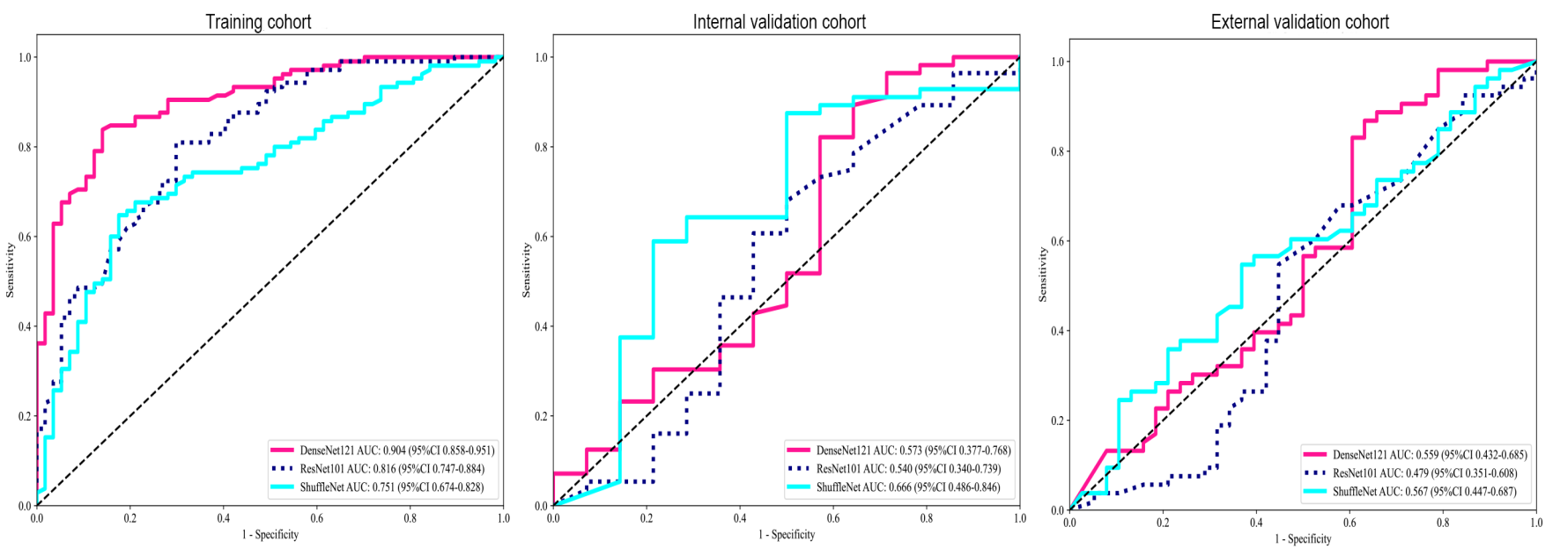

Figure S1. Receiver operating characteristic curves of different 3D models in the prediction of HCC recurrence

(2A) Details of Clinical Signature
Table S2. Metrics of different machine learning methods in the clinical models
Model | Accuracy | AUC | 95% CI | Sensitivity | Specificity | PPV | NPV | Cohort
LR | 0.747 | 0.789 | 0.718–0.859 | 0.743 | 0.754 | 0.848 | 0.614 | Training
LR | 0.529 | 0.505 | 0.337–0.673 | 0.536 | 0.500 | 0.811 | 0.212 | Internal
LR | 0.571 | 0.592 | 0.475–0.709 | 0.604 | 0.526 | 0.640 | 0.488 | External
RandomForest | 0.735 | 0.783 | 0.712–0.853 | 0.790 | 0.632 | 0.798 | 0.621 | Training
RandomForest | 0.486 | 0.508 | 0.334–0.682 | 0.464 | 0.571 | 0.812 | 0.211 | Internal
RandomForest | 0.505 | 0.645 | 0.529–0.761 | 0.302 | 0.789 | 0.667 | 0.448 | External
ExtraTrees | 0.735 | 0.815 | 0.748–0.882 | 0.733 | 0.737 | 0.837 | 0.600 | Training
ExtraTrees | 0.571 | 0.585 | 0.412–0.759 | 0.571 | 0.571 | 0.842 | 0.250 | Internal
ExtraTrees | 0.549 | 0.601 | 0.483–0.719 | 0.340 | 0.842 | 0.750 | 0.478 | External
XGBoost | 0.796 | 0.871 | 0.816–0.927 | 0.800 | 0.789 | 0.875 | 0.682 | Training
XGBoost | 0.543 | 0.608 | 0.446–0.771 | 0.536 | 0.571 | 0.833 | 0.235 | Internal
XGBoost | 0.571 | 0.653 | 0.538–0.769 | 0.434 | 0.763 | 0.719 | 0.492 | External
LightGBM | 0.623 | 0.719 | 0.641–0.797 | 0.533 | 0.789 | 0.824 | 0.479 | Training
LightGBM | 0.543 | 0.614 | 0.458–0.769 | 0.536 | 0.571 | 0.833 | 0.235 | Internal
LightGBM | 0.505 | 0.667 | 0.554– 0.780 | 0.302 | 0.789 | 0.667 | 0.448 | External
AUC, area under the curve; CI, confidence interval; PPV, positive predictive value; NPV, negative predictive value; LR, logistic regression

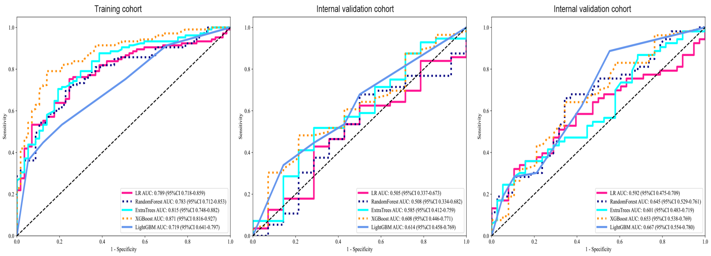
Figure S2. Receiver operating characteristic curves of clinical signatures based on different models.

(2B) Interpretation of 2.5D Deep Learning models
We employ popular machine learning algorithms, such as Logistic Regression, RandomForest, ExtraTrees, XGBoost and LightGBM to model features. Logistic Regression displays the weight (coefficient) of each feature which directly reflects its impact on prediction results. Random Forest and ExtraTrees use built-in feature importance indicators to show the relative importance of each feature in the entire model. Feature importance can be calculated using Gini index or information gain and a ranking chart can be drawn accordingly. XGBoost and LightGBM utilize "gain" and "cover" indicators to evaluate feature importance by showing their contribution towards improving model performance. We plan to provide visualization charts for feature importance rankings that will help further understand the decision-making process of our models (as shown in Figure A-E). The probability starts with 'prob', pred begins with label features while PREDICT1 is an extremely important attribute that explains predicted probabilities for every 2.5D depth across all slices in our dataset. This attribute is extracted through TF-IDF method which significantly affects prediction probabilities proving that single slice trained features are crucial in our 2.5D deep learning models.
Figure S3. The importance of variable characteristics.

