Figure S1: Mechanism of LPS-stimulated RAW264.7 cells uptake of HELNs. (A, B)The uptake of HELN by LPS-stimulated RAW264.7 cells after treatment with different drugs was detected by flow cytometry (n = 3). (C, D) Confocal microscopy images demonstrate the uptake of HELNs by LPS-stimulated RAW264.7 cells after treatment with different endocytosis inhibitors (n = 3). (Raw 264.7 cells were stimulated to an inflammatory state using 100 ng/mL LPS, and then pretreated with 50 μmol/l amiloride（HY-B0285, MCE）, 12.5 μmol/l chlorpromazine (HY-12708, MCE), 100 μmol/l indomethacin(HY-14397, MCE), and 2 mM NaN₃(S2002, Sigma) for 30 minutes, respectively. Then, they were incubated with DiL-labeled HELNs for 3 hours) Scale bar: 50 μm.Significance: ns p > 0.5, ***p < 0.001, ****p < 0.0001.

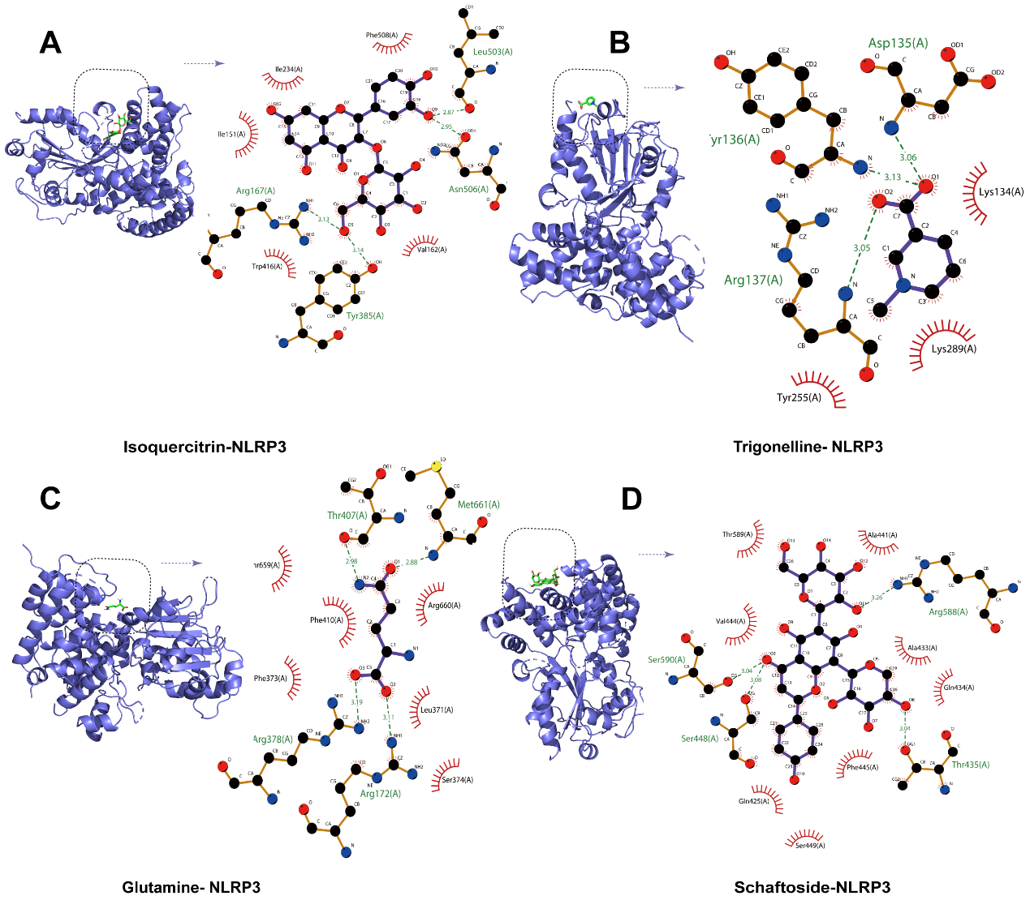

Figure S2: Molecular docking results. (A) Molecular docking results between small molecules-isoquercitrin and NLRP3 protein; (B) Molecular docking results between small molecules-trigonelline and NLRP3 protein; (C) Molecular docking results between small molecules-glutamine and NLRP3 protein; (D) Molecular docking results between small molecules-schaftoside and NLRP3 protein. The left image shows the binding site, with green representing the drug molecule. The right figure shows the binding mechanism, with the drug molecule in the middle, the red eyelashes for hydrophobic interaction, and the green dashed line for hydrogen bonding.
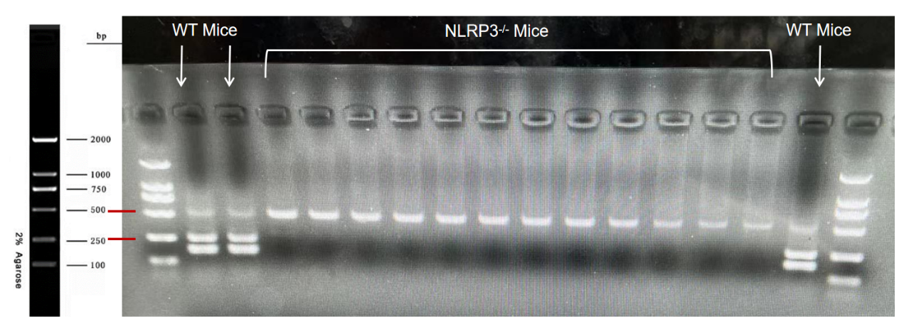
Figure S3: The result of nucleic acid electrophoresis identification of Nlrp3 gene knockout mice. The knockout homozygous genotype should exhibit a band at 500 bp, the wild-type at 250 bp, and the heterozygous genotype at both 500 bp and 250 bp.

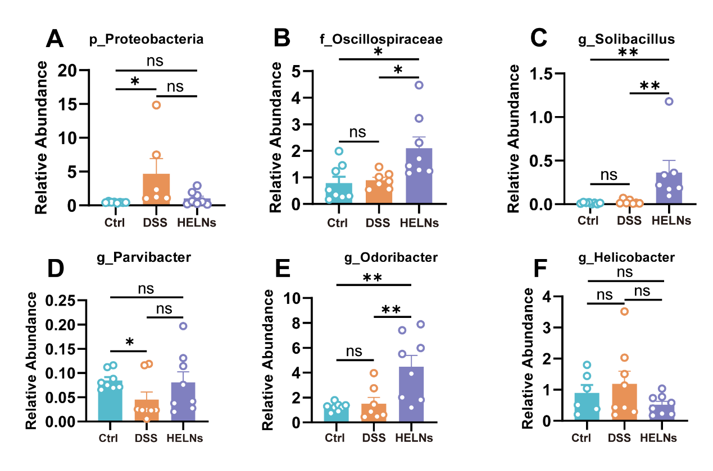
Figure S4:(A-F) The abundance levels of the top 30 selected bacteria at the genus level in the Control group (Ctrl), 3%DSS group (DSS), and 3%DSS+HELNs group (HELNs) (n=6-8). ns p > 0.5, *p＜0.05, **p＜0.01.

Table S1
Criteria of disease activity index.
Score | Weight loss（%） | Stool consistency | Gastrointestinal bleeding
0 | ＜0 | Well-formed | Negative hemoccult
1 | 1-5 | Soft | Weakly positive hemoccult
2 | 5-10 | Pasty or semi-formed | Positive hemoccult
3 | 10-20 | Adhering to the anus | Visible blooding
4 | ＞20 | Watery | Gross blooding

Table S2
Criteria of histological damage evaluation.
Score | Extent | Inflammation Severity | Crypt damage | Spread
0 | None | None | None | 0
1 | Mucosa | Mild | Basal 1/3 lost | ＜25
2 | Submucosa | Moderate | Basal 2/3 lost | 25-50
3 | Transmural | Severe | Only superficial epithelium intact | 50-75
4 | —— | —— | Complete loss of crypt and epithelium | ＞75

Table S3
Immunohistochemistry scoring staining criteria
Score | Cell staining intensity | Percentage of positive cells（%）
0 | No positive coloration (negative) | ——
1 | Pale yellow (weakly positive) | ≤25%
2 | Brownish yellow (positive) | 26%-50%
3 | Tan (strong positive) | 51%-75%
4 | —— | ＞75%

Table S4
Molecular docking information
Name | PUBCHEM-ID | Abbreviation | Position（x,y,z） | Range（x,y,z）
Procyanidin B2 | 122738 | YHQS | （14.531, 33.622, 135.89） | （126,126,126）
Schaftoside | 442658 | XFTG | （14.531, 33.622, 135.89） | （126,126,126）
Isoquercitrin | 5280804 | YHPG | （14.531, 33.622, 135.89） | （126,126,126）
Tricetin-O-hexoside | 53392996 | WQHT | （14.531, 33.622, 135.89） | （126,126,126）
Luteolin-4'-O-glucoside | 5319116 | MXCS | （14.531, 33.622, 135.89） | （126,126,126）
Diosgenin | 99474 | SYZS | （14.531, 33.622, 135.89） | （126,126,126）
Glutamine | 5961 | GAXA | （14.531, 33.622, 135.89） | （126,126,126）
Trigonelline | 5570 | HLBJ | （14.531, 33.622, 135.89） | （126,126,126）

Table S5
Molecular docking results
Name | Binding Energy（kcal/mol） | Binding Energy（kJ/mol） | Number of hydrogen bonds | Number of hydrophobic effects
MXCS | -10.2 | -42.677 | 10 | 6
SYZS | -9.3 | -38.911 | 1 | 10
WQHT | -8.1 | -33.890 | 5 | 8
YHQS | -8 | -33.472 | 7 | 4
YHPG | -7.6 | -31.798 | 4 | 5
XFTG | -7.5 | -31.380 | 4 | 8
HLBJ | -5 | -20.920 | 3 | 3
GAXA | -4.8 | -20.083 | 4 | 6

Table S6
Sequences of primers
Gene | Sequence
Zo-1 | Forward: 5’- CAAAGCCCACCAAGGTCAC-3’
 | Reverse: 5’- TCTCTTTCCGAGGCATTAGCA-3’
Occludin | Forward: 5’-GTGGAGTTGCGGGAGAGC-3’
 | Reverse: 5’- TCCCAAGATAAGCGAACCTGCC-3’
Muc2 | Forward: 5’-CCCAGAAGGGACTGTGTATG-3’
 | Reverse: 5’- TGCAGACACACTGCTCACA-3’
Tnfα | Forward: 5’-TTAGAAAGGGGATTATGGCTCA-3’
 | Reverse: 5’- ACTCTCCCTTTGCAGAACTCAG-3’
Il-6 | Forward: 5’-GTTGCCTTCTTGGGACTGATG-3’
 | Reverse: 5’- ATTGCCATTGCACAACTCTTT-3’
Il-1β | Forward: 5’-AGAGCATCCAGCTTCAAATCTC-3’
 | Reverse: 5’- CAGTTGTCTAATGGGAACGTCA-3’
Il-17a | Forward: 5’-CCTCAAAGCTCAGCGTGTCC-3’
 | Reverse: 5’- GAGCTCACTTTTGCGCCAAG-3’
Il-23a | Forward: 5’- CATGCTAGCCTGGAACGCACAT-3’
 | Reverse: 5’- ACTGGCTGTTGTCCTTGAGTCC-3’
Caspase-1 | Forward: 5’- GGCACATTTCCAGGACTGACTG-3’
 | Reverse: 5’- GCAAGACGTGTACGAGTGGTTG-3’
Il-10 | Forward: 5’-CGGGAAGACAATAACTGCACCC-3’
 | Reverse: 5’- CGGTTAGCAGTATGTTGTCCAGC-3’
NLRP3 | Forward: 5’- TCACAACTCGCCCAAGGAGGAA-3’
 | Reverse: 5’- AAGAGACCACGGCAGAAGCTAG-3’
Il-18 | Forward: 5’- GACAGCCTGTGTTCGAGGATATG-3’
 | Reverse: 5’- TGTTCTTACAGGAGAGGGTAGAC-3’

