Supplementary Figure 1. Serum HDL of patients with different gout flares during the whole follow-up. A. Serum HDL-C of patients with 0, 1, ≥2 gout flares during 12 weeks follow-up in all participants. B and C. Serum HDL-C of patients with 0, 1, ≥2 gout flares during 12 weeks follow-up in low (B) and high (C) HDL-C group. HDL-C, high-density lipoprotein cholesterol.

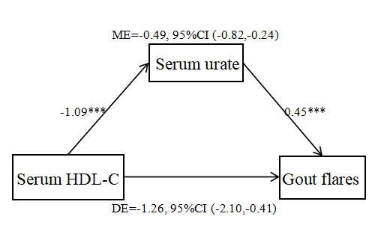

Supplementary Figure 2. Serum urate mediation model of the relationship between serum HDL-C and gout flares. ME: Mediation effect; DE: Direct effect; HDL-C, high-density lipoprotein cholesterol. *** means P < 0.001.
Supplementary Table 1. Sensitivity analysis in the risk of gout flares.
 | Risk of gout flares  (Model 1) |  | Risk of gout flares  (Model 2)
 | HR (95% CI) | P value | HR (95% CI) | P value
Extreme 5% of HDL-C excluded
HDL-C | 0.30 (0.15, 0.61) | 0.001 | 0.44 (0.21, 0.90) | 0.025
Serum urate > 10 mg/dL excluded
HDL-C | 0.34 (0.17, 0.68) | 0.002 | 0.43 (0.20, 0.89) | 0.024
Age > 60 years excluded
HDL-C | 0.34 (0.18, 0.64) | 0.001 | 0.45 (0.23, 0.87) | 0.018
Sensitivity analysis was conducted using cox regression analysis. Model 1 was a univariate analysis of HDL-Clevels. Model 2 was a backward stepwise regression adjusted for age, BMI, onset age, disease duration, positive family history, flared in the last year, recurrent flared in the last year, palpable tophus, ≥ 1 comorbidities, ULT drug, serum urate, blood glucose, triglyceride, total cholesterol, LDL-C, ALT, AST, eGFR and HDL-C.

Supplementary Table 2. Frequency of adverse events during the follow-up.
 | Low HDL-C  (n=203) | High HDL-C  (n=191) | P value
New onset AST level elevation | 25 (12.3) | 12 (6.3) | 0.056
1–2 times elevation | 23 (11.3) | 12 (6.3) | 0.110
2–3 times elevation | 1 (0.5) | 0 (0) | 1.000
>3 times elevation | 1 (0.5) | 0 (0) | 1.000
New onset ALT level elevation | 85 (41.9) | 49 (25.7) | 0.001
1–2 times elevation | 69 (34.0) | 44 (23.0) | 0.019
2–3 times elevation | 12 (5.9) | 5 (2.6) | 0.138
>3 times elevation | 4 (2.0) | 0 (0) | 0.124
eGFR <45 ml/minute/1.73 m² | 0 (0) | 0 (0) | 1.000
New-onset elevation was defined as elevation above the normal upper limit during follow-up. HDL-C, high-density lipoprotein cholesterol. ALT, alanine aminotransferase; AST, aspartate aminotransferase; eGFR, estimated glomerular filtration rate.

