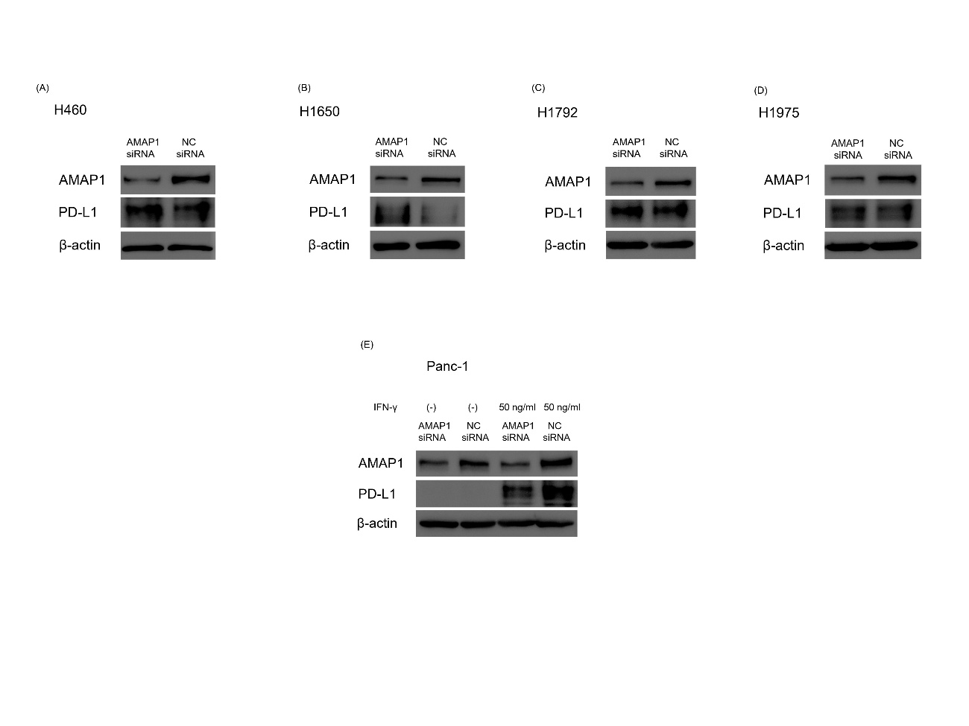
Supplementary Fig. S1
Results of AMAP1 knockdown: Western blot analysis showing the impact of AMAP1 knockdown on PD-L1 expression in non-small cell lung cancer cell lines: H460 (A), H1650 (B), H1792 (C), and H1975 (D), as well as in the pancreatic cancer cell line Panc-1 (E). In Panc-1, owing to the low expression of PD-L1, IFN-γ was used at a concentration of 50 ng/ml in some experiments. NC, negative control.

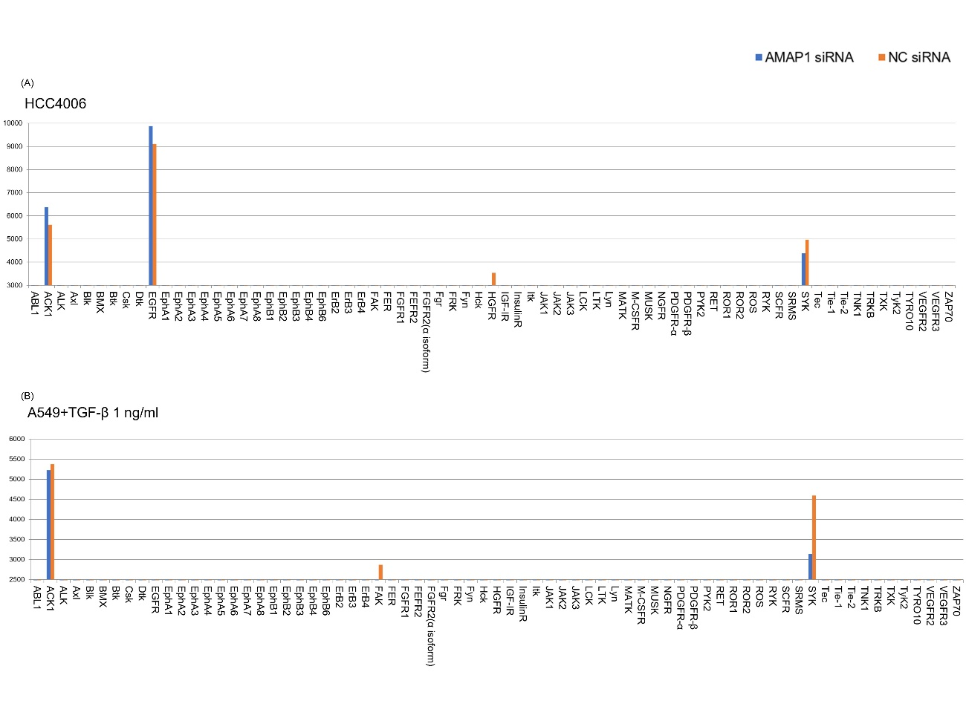
Supplementary Fig. S2
Changes in the expression of activated RTKs when AMAP1 was knocked down: Investigation of changes in activated RTK expression when AMAP1 was knocked down, using the activated RTKs assay. The graph represents the semi-quantification of 71 types of antibodies targeting activated receptor tyrosine kinases in (A) HCC4006 and (B) A549 cells using the ImageJ software. The vertical axis of the graph represents the brightness measured when the positive controls of each array were combined and standardized.

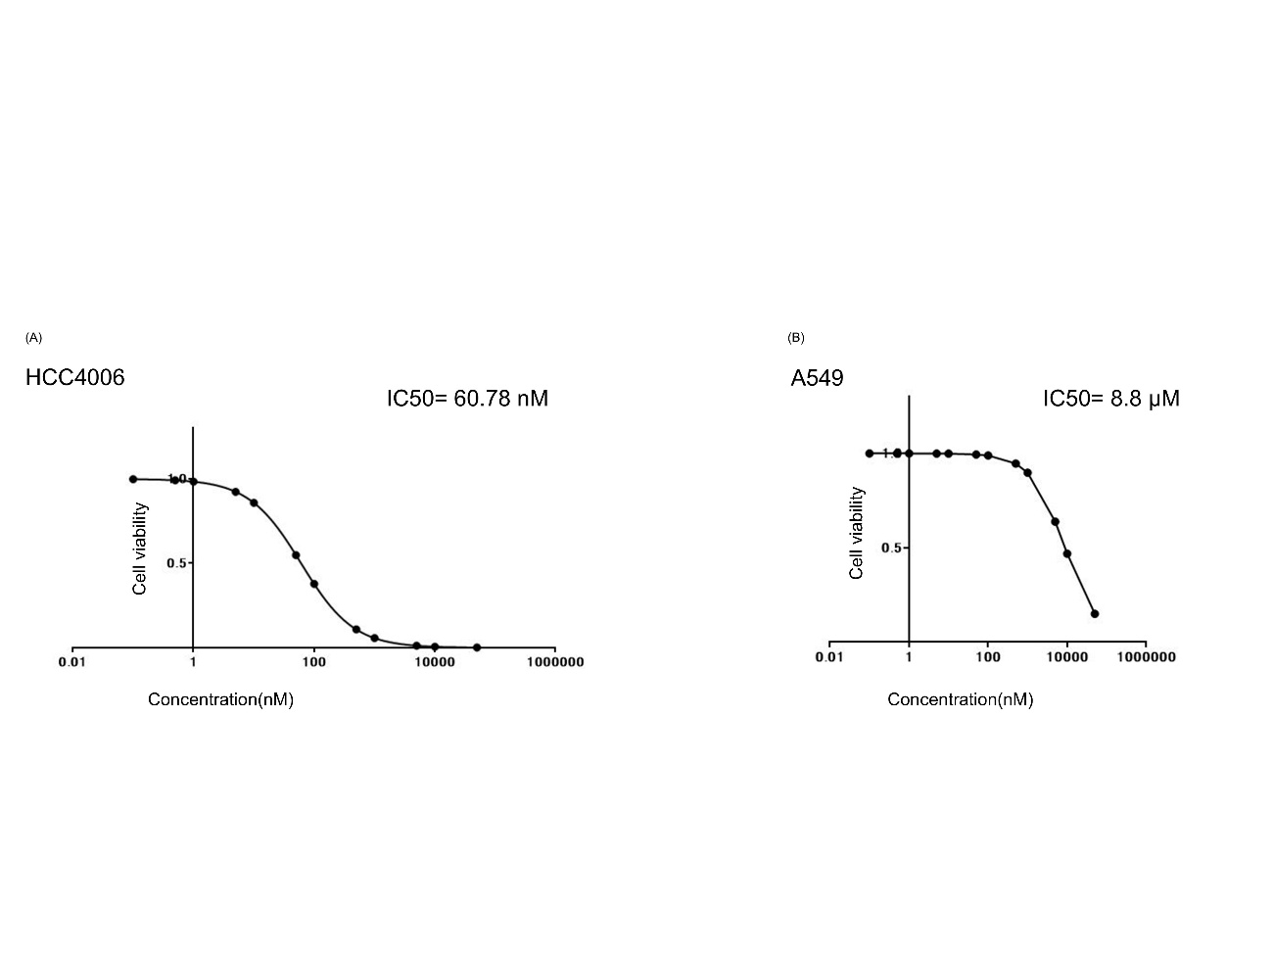
Supplementary Fig. S3
Results of the IC50 when using osimertinib: Viability of HCC4006 (A) and A549 (B) cells incubated with increasing concentrations of osimertinib for 72 h. IC50 values were calculated using Prism 7 (GraphPad).

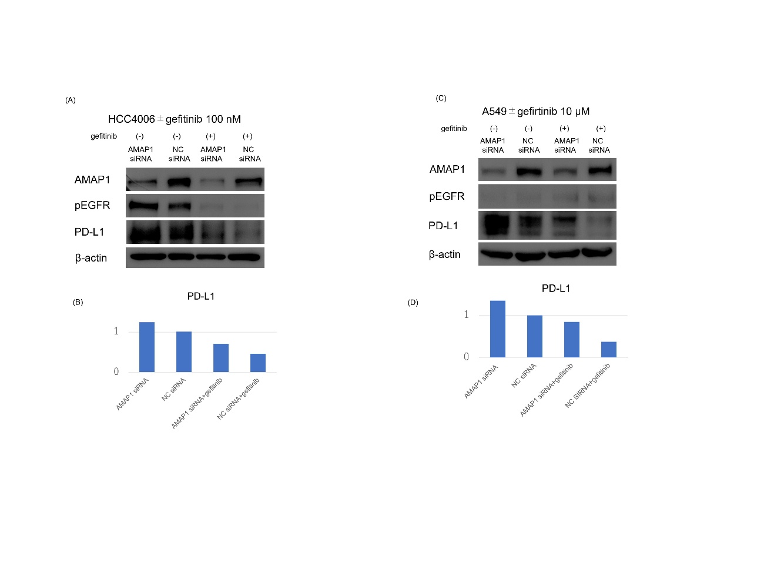
Supplementary Fig. S4
Results of inhibiting pEGFR using the EGFR inhibitor gefitinib: Western blot analysis showing the inhibition of pEGFR in HCC4006 (A) using gefitinib. The gefitinib was set to 100 nM. Western blot analysis demonstrates the inhibition of pEGFR in A549 (C) cells treated with gefitinib. The concentration of gefitinib was set at 10 μM. For A549 cells, owing to the low PD-L1 expression, stimulation was performed with TGF-β 1 ng/ml. Each result was semi-quantified using the ImageJ software (B and D). The vertical axis represents the band ratio normalized to the brightness of the negative control (set to 1). NC, negative control.

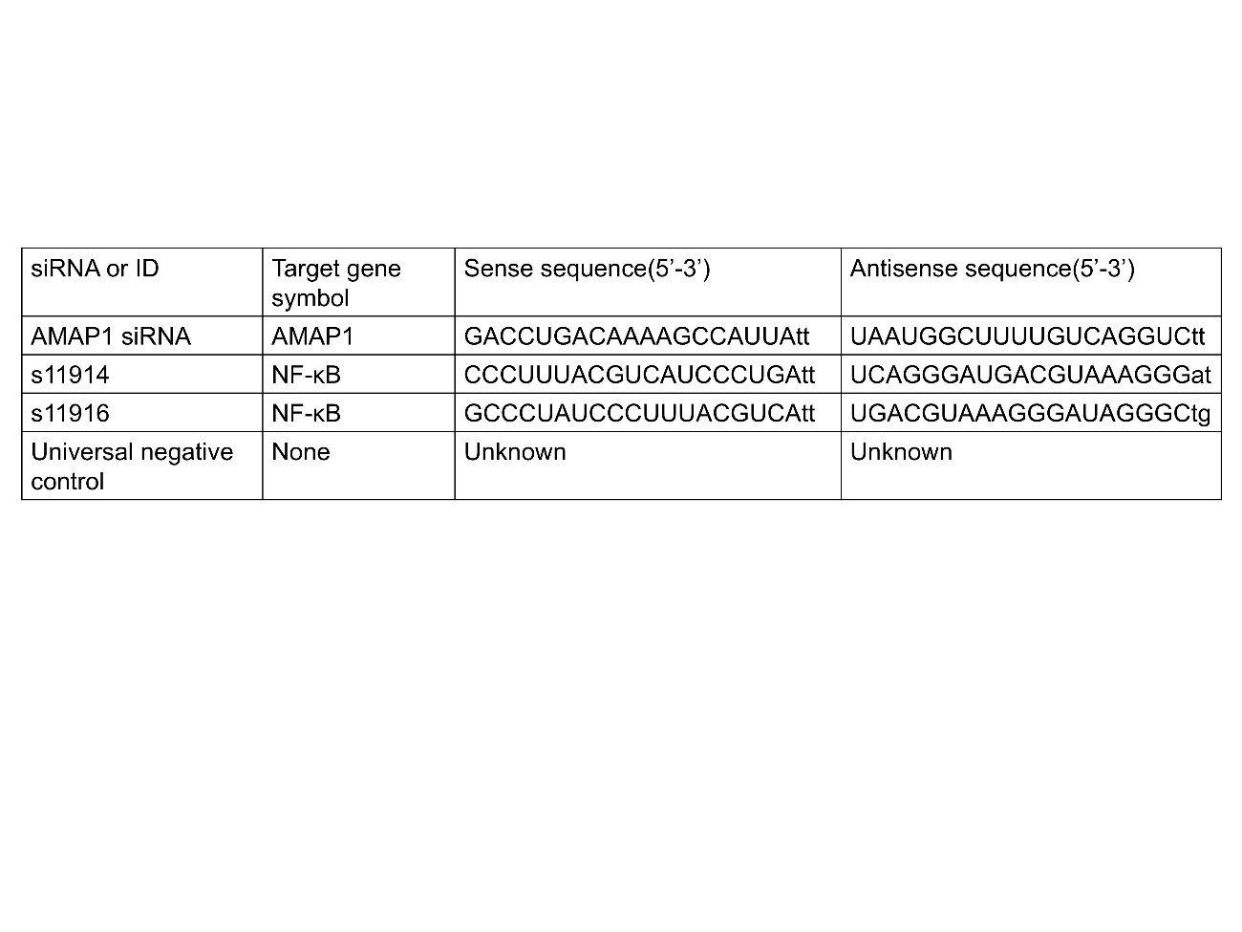
Table S1.
Sequences of siRNAs used in the present study

