Supplementary

Supplementary Figure 1. The feature selection in LASSO of each model.

Rad_SAG
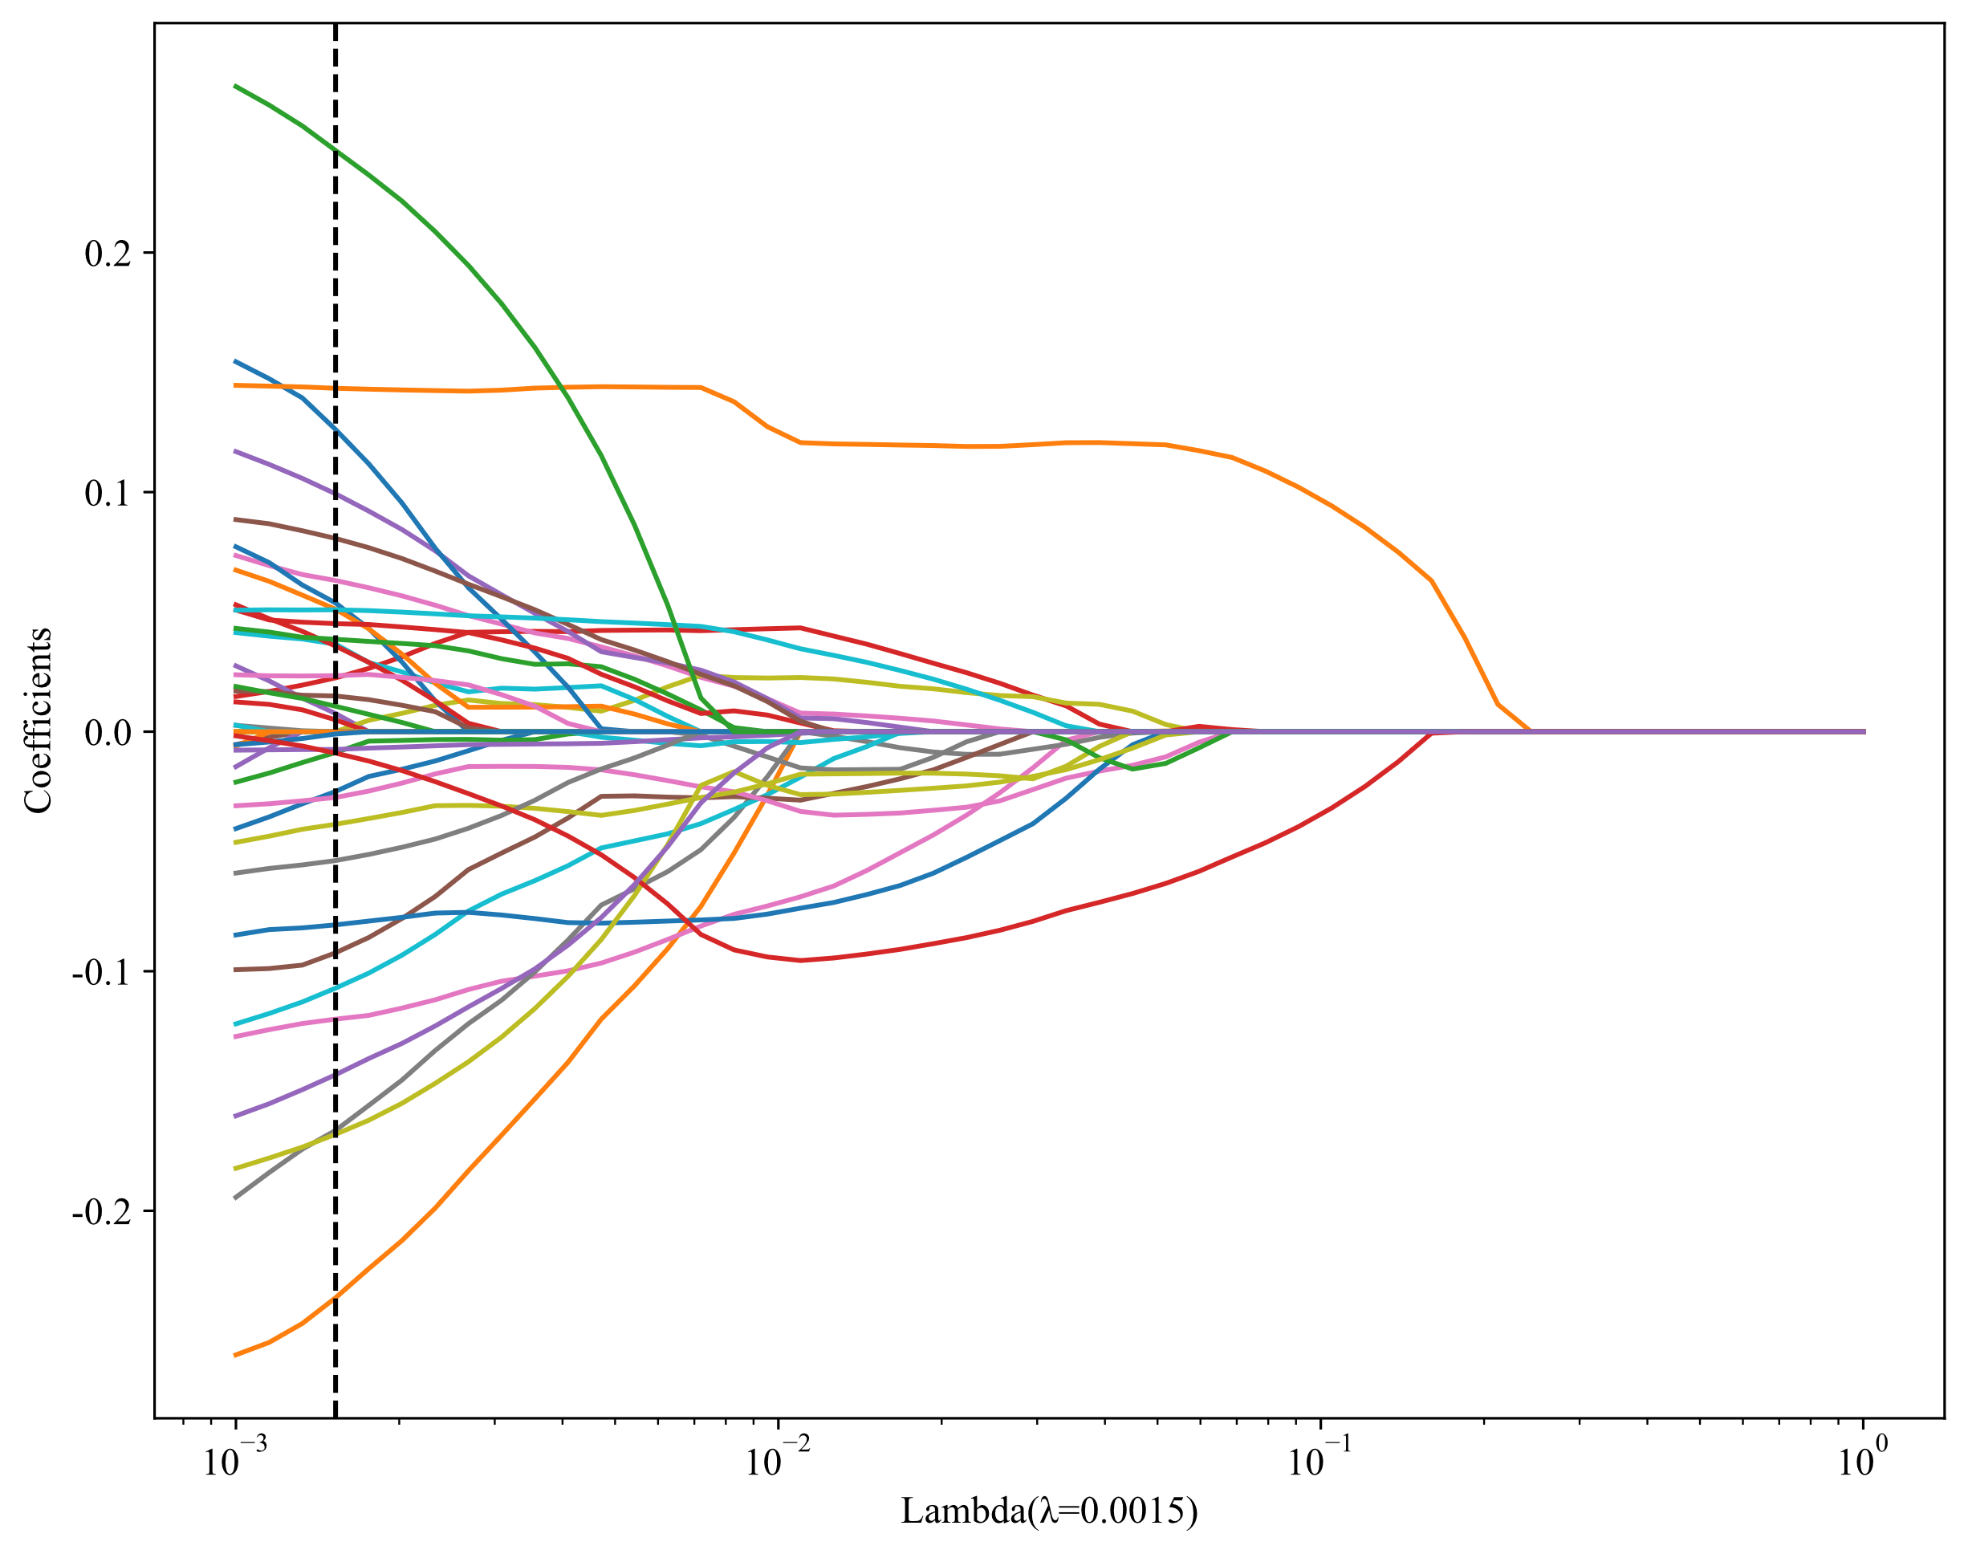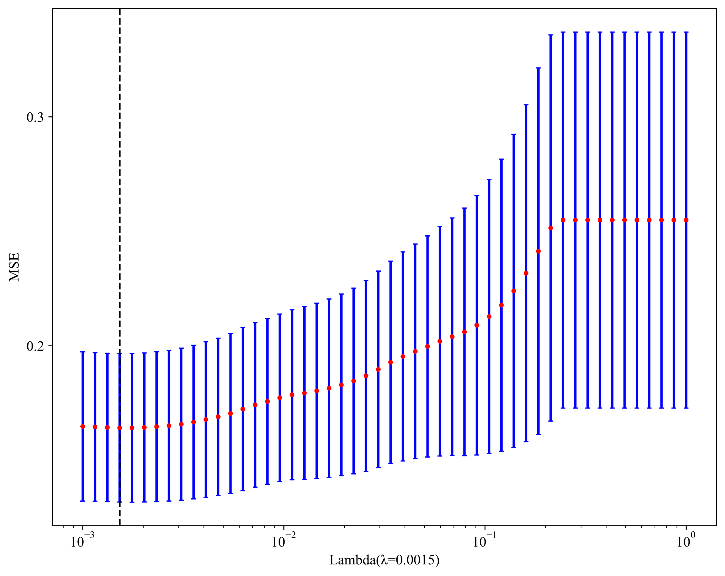

Rad_AXI
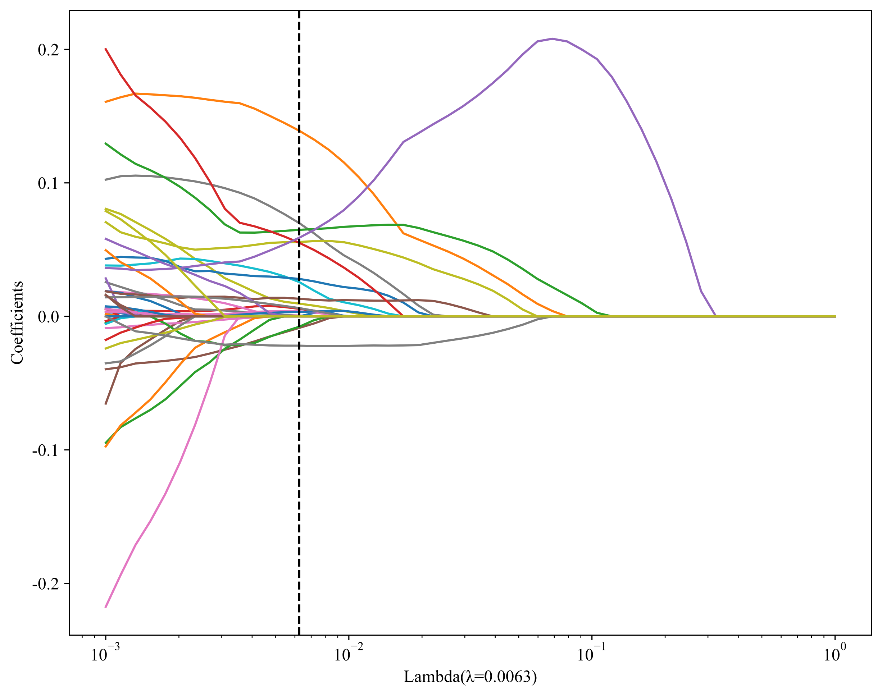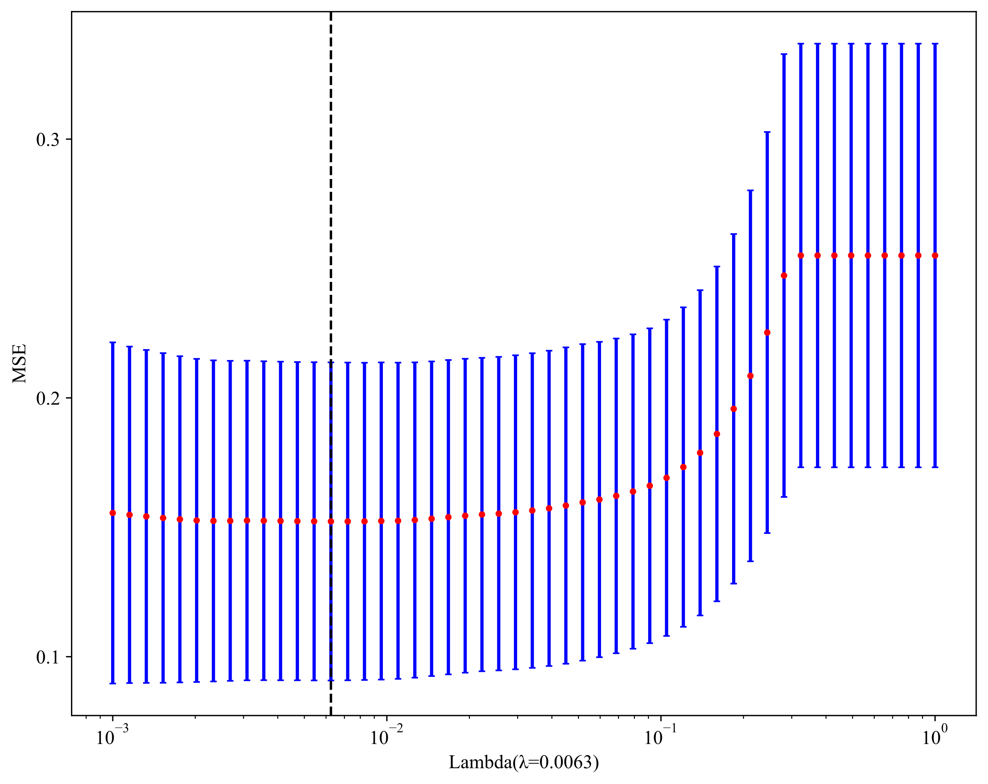
DL_SAG
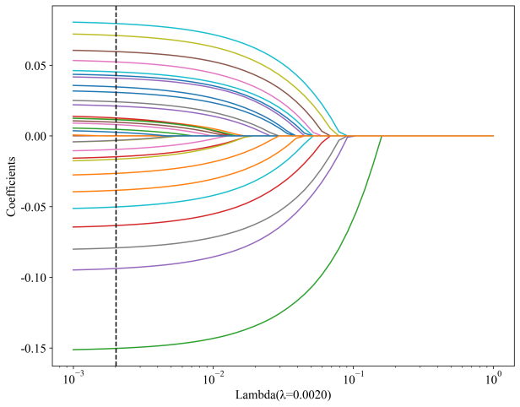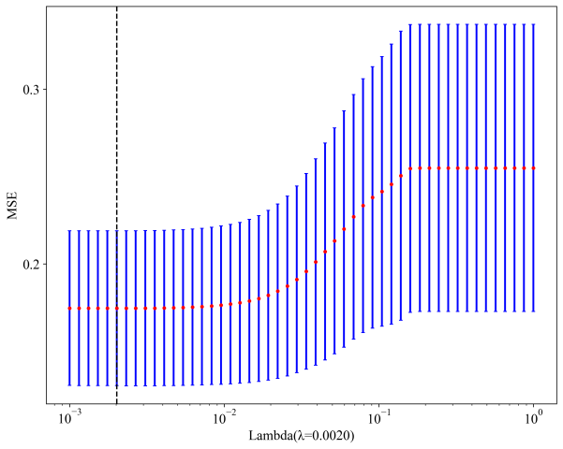

DL_AXI
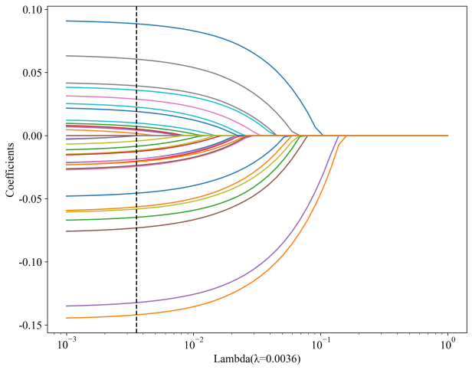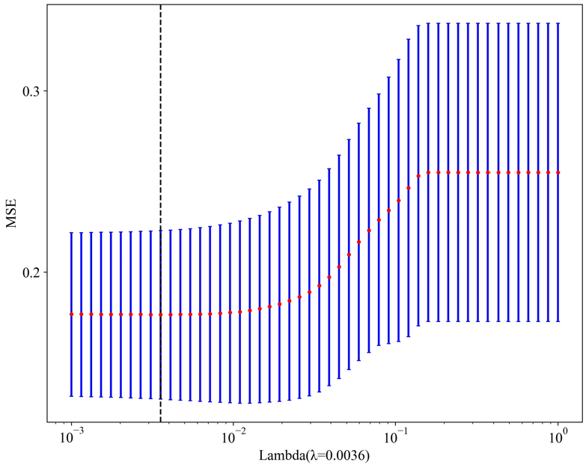
DLR
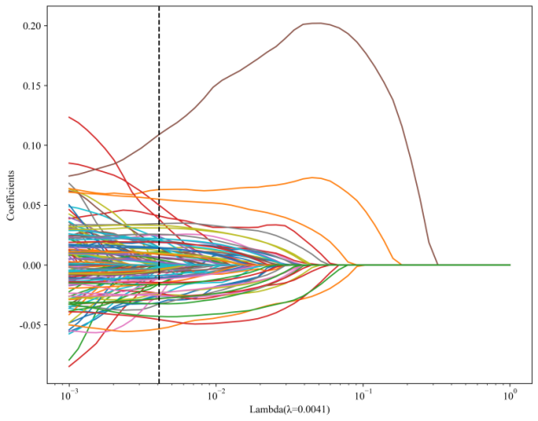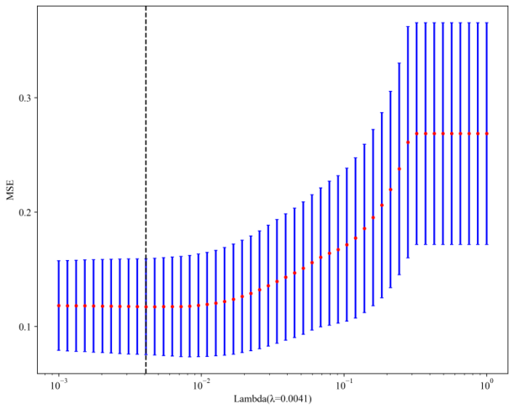
Nomogram
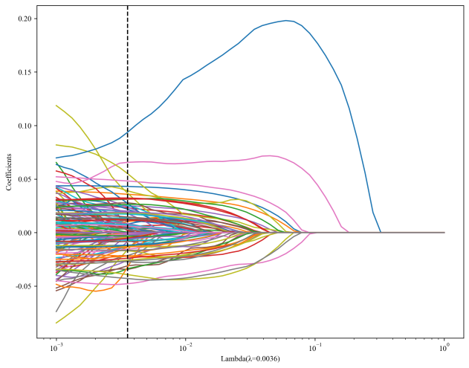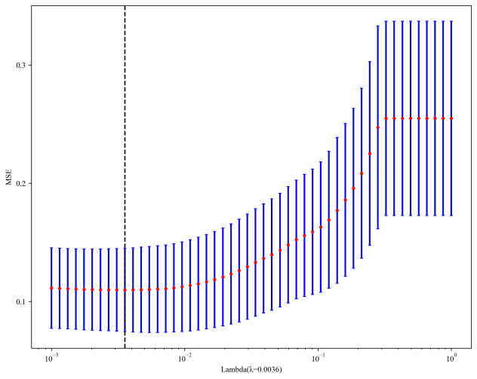

Supplementary Figure 2. Histograms of the rad scores based on the selected features of each model
Rad_SAG
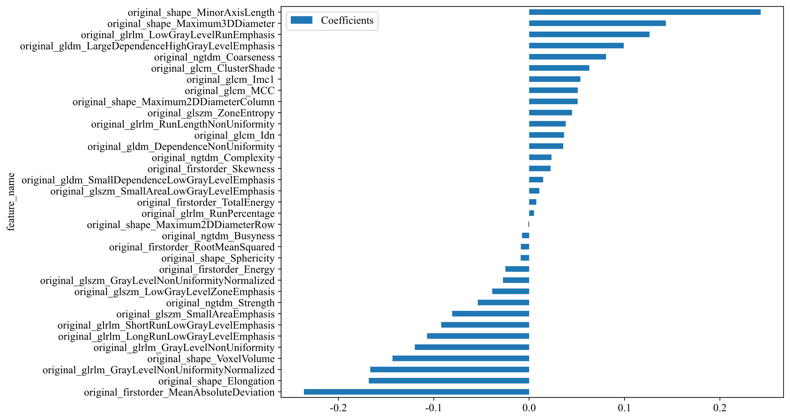
Rad_AXI
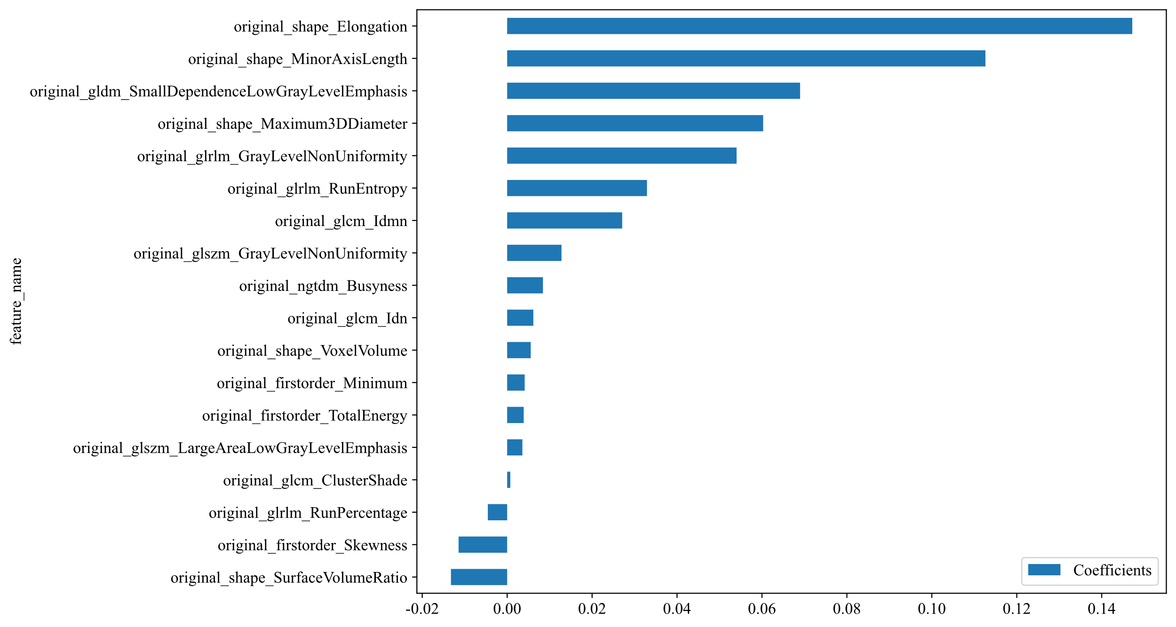
DL_SAG
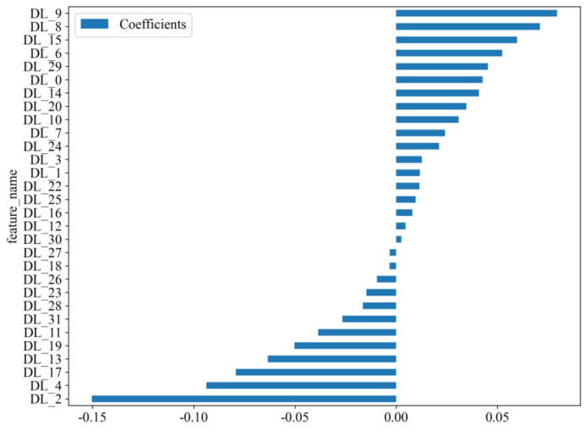
DL_AXI
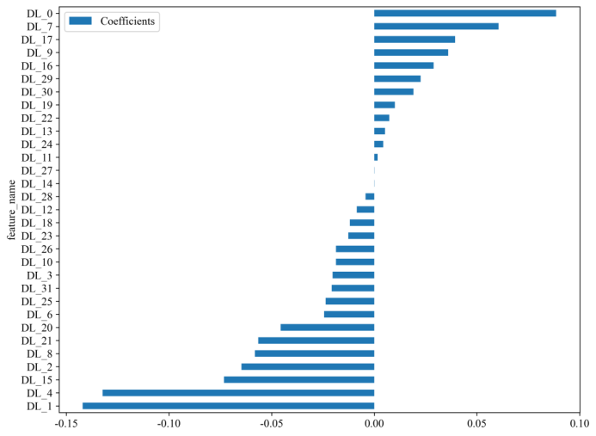

DLR
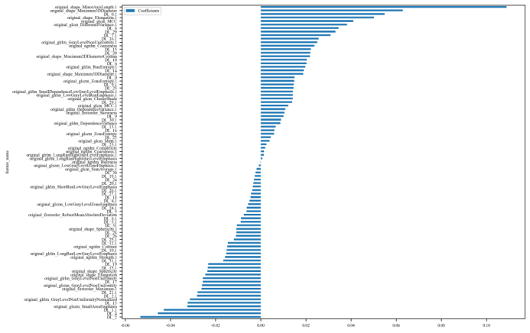
Nomogram
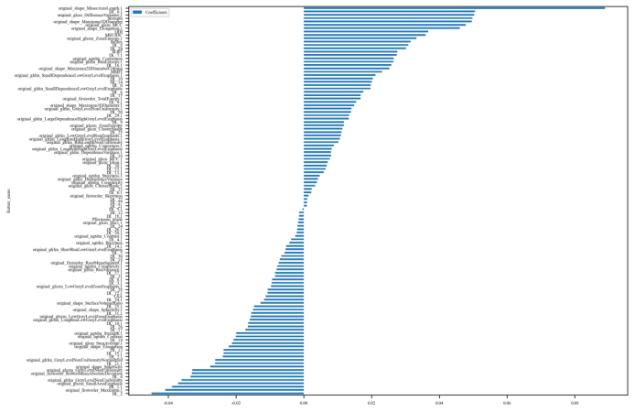

Supplementary Figure 3. ROC curves of different machine learning algorithms in each model in the test cohort. Based on the above results, SVM was the optimal algorithm.

Rad_SAG Rad_AXI
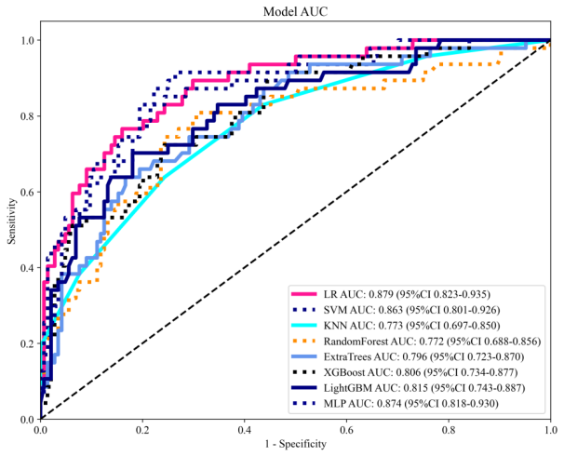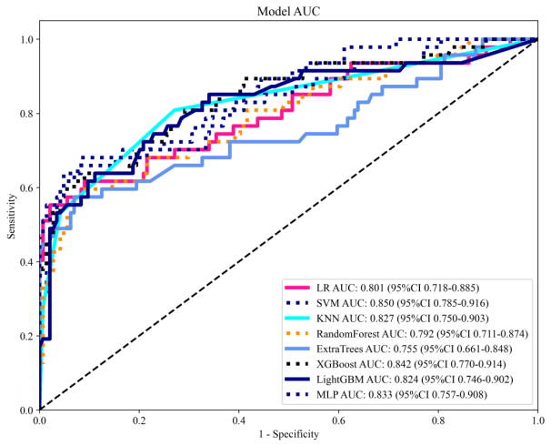
DL_SAG DL_AXI

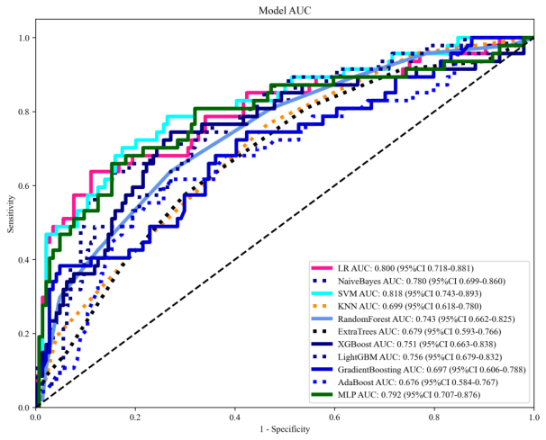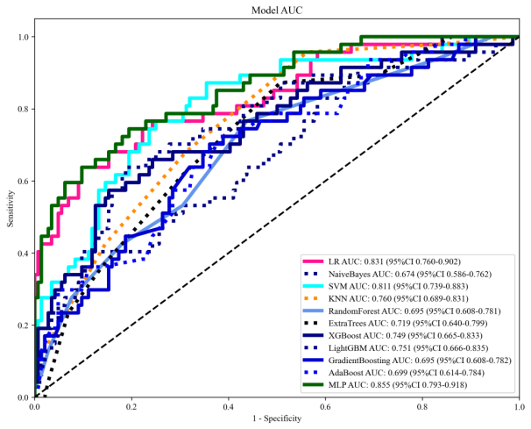
DLR Nomogram
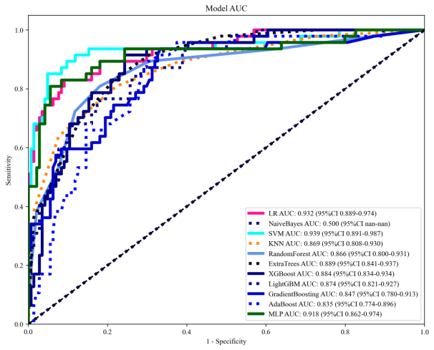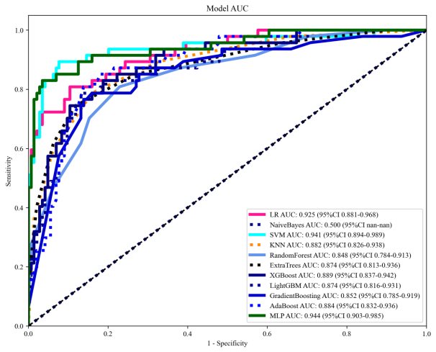

Supplementary Table 1. Performance of Rad_SAG features in the training and test cohort under different machine learning algorithms
Model | Accuracy | AUC | 95% CI | Sensitivity | Specificity | PPV | NPV | Threshold | Task
LR | 0.822 | 0.887 | 0.8663 - 0.9077 | 0.819 | 0.823 | 0.739 | 0.882 | 0.382 | train
LR | 0.817 | 0.879 | 0.8233 - 0.9347 | 0.745 | 0.84 | 0.603 | 0.91 | 0.561 | test
SVM | 0.856 | 0.914 | 0.8956 - 0.9324 | 0.859 | 0.853 | 0.782 | 0.908 | 0.357 | train
SVM | 0.791 | 0.863 | 0.8006 - 0.9255 | 0.809 | 0.785 | 0.551 | 0.926 | 0.444 | test
KNN | 0.815 | 0.898 | 0.8802 - 0.9151 | 0.73 | 0.867 | 0.77 | 0.84 | 0.4 | train
KNN | 0.791 | 0.773 | 0.6965 - 0.8497 | 0.383 | 0.924 | 0.621 | 0.821 | 0.6 | test
Random Forest | 0.777 | 0.837 | 0.8123 - 0.8625 | 0.762 | 0.785 | 0.684 | 0.844 | 0.381 | train
Random Forest | 0.717 | 0.772 | 0.6882 - 0.8556 | 0.787 | 0.694 | 0.457 | 0.909 | 0.394 | test
Extra Trees | 0.745 | 0.791 | 0.7637 - 0.8192 | 0.616 | 0.823 | 0.68 | 0.779 | 0.398 | train
Extra Trees | 0.78 | 0.796 | 0.7226 - 0.8697 | 0.617 | 0.833 | 0.547 | 0.87 | 0.412 | test
XGBoost | 0.854 | 0.917 | 0.9004 - 0.9338 | 0.817 | 0.876 | 0.801 | 0.887 | 0.419 | train
XGBoost | 0.743 | 0.806 | 0.7344 - 0.8772 | 0.702 | 0.757 | 0.485 | 0.886 | 0.442 | test
LightGBM | 0.811 | 0.88 | 0.8593 - 0.9010 | 0.775 | 0.834 | 0.74 | 0.858 | 0.392 | train
LightGBM | 0.785 | 0.815 | 0.7433 - 0.8868 | 0.681 | 0.819 | 0.552 | 0.887 | 0.457 | test
MLP | 0.865 | 0.93 | 0.9145 - 0.9451 | 0.859 | 0.869 | 0.8 | 0.91 | 0.411 | train
MLP | 0.775 | 0.874 | 0.8179 - 0.9297 | 0.894 | 0.736 | 0.525 | 0.955 | 0.403 | test

Supplementary Table 2. Performance of Rad_AXI features in the training and test cohort under different machine learning algorithms
Model | Accuracy | AUC | 95% CI | Sensitivity | Specificity | PPV | NPV | Threshold | Task
LR | 0.847 | 0.911 | 0.8936 - 0.9288 | 0.819 | 0.864 | 0.786 | 0.887 | 0.425 | train
LR | 0.869 | 0.801 | 0.7177 - 0.8846 | 0.532 | 0.979 | 0.893 | 0.865 | 0.765 | test
SVM | 0.878 | 0.927 | 0.9100 - 0.9446 | 0.874 | 0.881 | 0.817 | 0.92 | 0.367 | train
SVM | 0.848 | 0.85 | 0.7853 - 0.9156 | 0.638 | 0.917 | 0.714 | 0.886 | 0.646 | test
KNN | 0.87 | 0.943 | 0.9311 - 0.9552 | 0.79 | 0.918 | 0.855 | 0.877 | 0.4 | train
KNN | 0.812 | 0.827 | 0.7505 - 0.9031 | 0.638 | 0.868 | 0.612 | 0.88 | 0.4 | test
Random Forest | 0.848 | 0.916 | 0.8989 - 0.9331 | 0.834 | 0.856 | 0.78 | 0.894 | 0.392 | train
Random Forest | 0.827 | 0.792 | 0.7111 - 0.8737 | 0.574 | 0.91 | 0.675 | 0.868 | 0.62 | test
Extra Trees | 0.82 | 0.877 | 0.8557 - 0.8983 | 0.745 | 0.866 | 0.772 | 0.848 | 0.415 | train
Extra Trees | 0.838 | 0.755 | 0.6610 - 0.8485 | 0.553 | 0.931 | 0.722 | 0.865 | 0.453 | test
XGBoost | 0.873 | 0.947 | 0.9339 - 0.9592 | 0.891 | 0.863 | 0.798 | 0.928 | 0.407 | train
XGBoost | 0.838 | 0.842 | 0.7704 - 0.9135 | 0.617 | 0.91 | 0.69 | 0.879 | 0.71 | test
LightGBM | 0.858 | 0.932 | 0.9167 - 0.9465 | 0.876 | 0.847 | 0.778 | 0.918 | 0.355 | train
LightGBM | 0.822 | 0.824 | 0.7457 - 0.9022 | 0.617 | 0.889 | 0.644 | 0.877 | 0.591 | test
MLP | 0.87 | 0.927 | 0.9110 - 0.9429 | 0.844 | 0.885 | 0.818 | 0.903 | 0.44 | train
MLP | 0.853 | 0.833 | 0.7572 - 0.9080 | 0.66 | 0.917 | 0.721 | 0.892 | 0.602 | test

Supplementary Table 3. Performance of DL_SAG features in the training and test cohort under different machine learning algorithms
Model | Accuracy | AUC | 95% CI | Sensitivity | Specificity | PPV | NPV | Threshold | Task
LR | 0.781 | 0.85 | 0.8265 - 0.8737 | 0.691 | 0.837 | 0.721 | 0.816 | 0.451 | train
LR | 0.822 | 0.8 | 0.7183 - 0.8813 | 0.617 | 0.889 | 0.644 | 0.877 | 0.538 | test
Naive Bayes | 0.781 | 0.841 | 0.8172 - 0.8652 | 0.693 | 0.835 | 0.72 | 0.817 | 0.419 | train
Naive Bayes | 0.785 | 0.78 | 0.6993 - 0.8598 | 0.617 | 0.84 | 0.558 | 0.871 | 0.533 | test
SVM | 0.888 | 0.959 | 0.9469 - 0.9710 | 0.884 | 0.891 | 0.832 | 0.926 | 0.355 | train
SVM | 0.791 | 0.818 | 0.7431 - 0.8928 | 0.681 | 0.826 | 0.561 | 0.888 | 0.475 | test
KNN | 0.815 | 0.892 | 0.8736 - 0.9098 | 0.663 | 0.908 | 0.815 | 0.815 | 0.4 | train
KNN | 0.702 | 0.699 | 0.6180 - 0.7799 | 0.447 | 0.785 | 0.404 | 0.813 | 0.4 | test
Random Forest | 0.988 | 0.999 | 0.9979 - 1.0000 | 0.968 | 1 | 1 | 0.981 | 0.5 | train
Random Forest | 0.634 | 0.743 | 0.6737 - 0.8245 | 0.702 | 0.611 | 0.371 | 0.863 | 0.3 | test
Extra Trees | 0.621 | 1 | 1.0000 - 1.0000 | 0 | 1 | 0 | 0.621 | 1 | train
Extra Trees | 0.717 | 0.679 | 0.5925 - 0.7662 | 0.383 | 0.826 | 0.419 | 0.804 | 0.5 | test
XGBoost | 0.988 | 0.999 | 0.9985 - 1.0000 | 0.985 | 0.989 | 0.983 | 0.991 | 0.44 | train
XGBoost | 0.728 | 0.751 | 0.6634 - 0.8378 | 0.723 | 0.729 | 0.466 | 0.89 | 0.438 | test
LightGBM | 0.935 | 0.98 | 0.9736 - 0.9868 | 0.906 | 0.953 | 0.922 | 0.943 | 0.426 | train
LightGBM | 0.686 | 0.756 | 0.6788 - 0.8324 | 0.723 | 0.674 | 0.42 | 0.882 | 0.373 | test
Gradient Boosting | 0.781 | 0.86 | 0.8384 - 0.8821 | 0.79 | 0.776 | 0.683 | 0.858 | 0.376 | train
Gradient Boosting | 0.806 | 0.697 | 0.6062 - 0.7875 | 0.362 | 0.951 | 0.708 | 0.82 | 0.535 | test
AdaBoost | 0.727 | 0.816 | 0.7909 - 0.8415 | 0.804 | 0.68 | 0.605 | 0.851 | 0.482 | train
AdaBoost | 0.702 | 0.676 | 0.5842 - 0.7674 | 0.596 | 0.736 | 0.424 | 0.848 | 0.494 | test
MLP | 0.891 | 0.952 | 0.9399 - 0.9640 | 0.834 | 0.926 | 0.873 | 0.901 | 0.477 | train
MLP | 0.78 | 0.792 | 0.7089 - 0.8765 | 0.66 | 0.819 | 0.544 | 0.881 | 0.528 | test

Supplementary Table 4. Performance of DL_AXI features in the training and test cohort under different machine learning algorithms
Model | Accuracy | AUC | 95% CI | Sensitivity | Specificity | PPV | NPV | Threshold | Task
LR | 0.792 | 0.874 | 0.8530 - 0.8945 | 0.827 | 0.77 | 0.687 | 0.879 | 0.363 | train
LR | 0.832 | 0.831 | 0.7601 - 0.9019 | 0.617 | 0.903 | 0.674 | 0.878 | 0.624 | test
NaiveBayes | 0.723 | 0.796 | 0.7691 - 0.8226 | 0.748 | 0.708 | 0.61 | 0.821 | 0.47 | train
NaiveBayes | 0.759 | 0.674 | 0.5862 - 0.7625 | 0.383 | 0.882 | 0.514 | 0.814 | 0.815 | test
SVM | 0.909 | 0.96 | 0.9478 - 0.9720 | 0.918 | 0.903 | 0.853 | 0.948 | 0.378 | train
SVM | 0.696 | 0.811 | 0.7393 - 0.8828 | 0.851 | 0.646 | 0.44 | 0.93 | 0.272 | test
KNN | 0.806 | 0.912 | 0.8955 - 0.9278 | 0.525 | 0.977 | 0.934 | 0.771 | 0.6 | train
KNN | 0.686 | 0.76 | 0.6887 - 0.8314 | 0.681 | 0.687 | 0.416 | 0.868 | 0.4 | test
Random Forest | 0.985 | 0.999 | 0.9986 - 0.9998 | 0.965 | 0.997 | 0.995 | 0.979 | 0.5 | train
Random Forest | 0.607 | 0.707 | 0.6263 - 0.7880 | 0.681 | 0.583 | 0.348 | 0.848 | 0.3 | test
Extra Trees | 0.621 | 1 | 1.0000 - 1.0000 | 0 | 1 | 0 | 0.621 | 1 | train
Extra Trees | 0.675 | 0.719 | 0.6403 - 0.7986 | 0.617 | 0.694 | 0.397 | 0.847 | 0.4 | test
XGBoost | 0.984 | 0.998 | 0.9961 - 0.9994 | 0.985 | 0.983 | 0.973 | 0.991 | 0.492 | train
XGBoost | 0.775 | 0.749 | 0.6650 - 0.8332 | 0.553 | 0.847 | 0.542 | 0.853 | 0.591 | test
LightGBM | 0.929 | 0.979 | 0.9719 - 0.9851 | 0.886 | 0.955 | 0.923 | 0.932 | 0.444 | train
LightGBM | 0.764 | 0.751 | 0.6665 - 0.8347 | 0.617 | 0.812 | 0.518 | 0.867 | 0.477 | test
Gradient Boosting | 0.792 | 0.878 | 0.8579 - 0.8990 | 0.787 | 0.795 | 0.7 | 0.859 | 0.417 | train
Gradient Boosting | 0.649 | 0.695 | 0.6082 - 0.7822 | 0.681 | 0.639 | 0.381 | 0.86 | 0.415 | test
AdaBoost | 0.766 | 0.844 | 0.8211 - 0.8677 | 0.75 | 0.776 | 0.672 | 0.836 | 0.491 | train
AdaBoost | 0.639 | 0.699 | 0.6141 - 0.7843 | 0.702 | 0.618 | 0.375 | 0.864 | 0.485 | test
MLP | 0.879 | 0.948 | 0.9361 - 0.9608 | 0.901 | 0.866 | 0.804 | 0.935 | 0.421 | train
MLP | 0.838 | 0.856 | 0.7941 - 0.9181 | 0.617 | 0.91 | 0.69 | 0.879 | 0.685 | test

Supplementary Table 5. Performance of DLR features in the training and test cohort under different machine learning algorithms
Model | Accuracy | AUC | 95% CI | Sensitivity | Specificity | PPV | NPV | Threshold | Task
LR | 0.931 | 0.975 | 0.9660 - 0.9835 | 0.906 | 0.946 | 0.91 | 0.943 | 0.479 | train
LR | 0.885 | 0.932 | 0.8887 - 0.9744 | 0.809 | 0.91 | 0.745 | 0.936 | 0.572 | test
NaiveBayes | 0.853 | 0.919 | 0.9018 - 0.9353 | 0.901 | 0.823 | 0.757 | 0.932 | 1 | train
NaiveBayes | 0.754 | 0.5 | 1.0000 - 1.0000 | 0 | 1 | 0 | 0.754 | 0 | test
SVM | 0.967 | 0.991 | 0.9851 - 0.9968 | 0.975 | 0.962 | 0.94 | 0.985 | 0.366 | train
SVM | 0.921 | 0.939 | 0.8914 - 0.9874 | 0.83 | 0.951 | 0.848 | 0.945 | 0.624 | test
KNN | 0.867 | 0.962 | 0.9523 - 0.9711 | 0.683 | 0.979 | 0.952 | 0.835 | 0.6 | train
KNN | 0.853 | 0.869 | 0.8080 - 0.9300 | 0.638 | 0.924 | 0.732 | 0.887 | 0.6 | test
Random Forest | 0.992 | 1 | 0.9987 - 1.0000 | 0.983 | 0.998 | 0.997 | 0.99 | 0.5 | train
Random Forest | 0.843 | 0.866 | 0.8002 - 0.9314 | 0.723 | 0.882 | 0.667 | 0.907 | 0.5 | test
ExtraTrees | 0.621 | 1 | 1.0000 - 1.0000 | 0 | 1 | 0 | 0.621 | 1 | train
ExtraTrees | 0.827 | 0.889 | 0.8410 - 0.9369 | 0.681 | 0.875 | 0.64 | 0.894 | 0.5 | test
XGBoost | 0.997 | 1 | 1.0000 - 1.0000 | 0.998 | 0.997 | 0.995 | 0.998 | 0.431 | train
XGBoost | 0.791 | 0.884 | 0.8336 - 0.9342 | 0.894 | 0.757 | 0.545 | 0.956 | 0.363 | test
LightGBM | 0.95 | 0.992 | 0.9890 - 0.9953 | 0.923 | 0.967 | 0.944 | 0.954 | 0.486 | train
LightGBM | 0.801 | 0.874 | 0.8206 - 0.9271 | 0.745 | 0.819 | 0.574 | 0.908 | 0.478 | test
Gradient Boosting | 0.895 | 0.961 | 0.9501 - 0.9712 | 0.908 | 0.887 | 0.83 | 0.941 | 0.39 | train
Gradient Boosting | 0.733 | 0.847 | 0.7804 - 0.9130 | 0.915 | 0.674 | 0.478 | 0.96 | 0.226 | test
AdaBoost | 0.86 | 0.943 | 0.9299 - 0.9555 | 0.911 | 0.829 | 0.765 | 0.938 | 0.468 | train
AdaBoost | 0.743 | 0.835 | 0.7741 - 0.8963 | 0.872 | 0.701 | 0.488 | 0.944 | 0.472 | test
MLP | 0.987 | 0.997 | 0.9944 - 0.9997 | 0.99 | 0.985 | 0.976 | 0.994 | 0.411 | train
MLP | 0.906 | 0.918 | 0.8616 - 0.9738 | 0.787 | 0.944 | 0.822 | 0.932 | 0.814 | test

Supplementary Table 6. Performance of clinical features in the training and test cohort under different machine learning algorithms
Model | Accuracy | AUC | 95% CI | Sensitivity | Specificity | PPV | NPV | Precision | Task
LR | 0.729 | 0.765 | 0.7349 - 0.7953 | 0.705 | 0.743 | 0.626 | 0.805 | 0.626 | train
LR | 0.785 | 0.755 | 0.6687 - 0.8403 | 0.532 | 0.868 | 0.568 | 0.85 | 0.568 | test
SVM | 0.825 | 0.906 | 0.8885 - 0.9238 | 0.822 | 0.826 | 0.743 | 0.884 | 0.743 | train
SVM | 0.801 | 0.904 | 0.8549 - 0.9538 | 0.809 | 0.799 | 0.567 | 0.927 | 0.567 | test
KNN | 0.866 | 0.955 | 0.9443 - 0.9651 | 0.698 | 0.968 | 0.931 | 0.84 | 0.931 | train
KNN | 0.848 | 0.854 | 0.7822 - 0.9249 | 0.638 | 0.917 | 0.714 | 0.886 | 0.714 | test
Random Forest | 0.918 | 0.979 | 0.9730 - 0.9856 | 0.911 | 0.923 | 0.878 | 0.944 | 0.878 | train
Random Forest | 0.827 | 0.855 | 0.7848 - 0.9256 | 0.745 | 0.854 | 0.625 | 0.911 | 0.625 | test
Extra Trees | 0.929 | 0.986 | 0.9815 - 0.9906 | 0.916 | 0.937 | 0.898 | 0.948 | 0.898 | train
Extra Trees | 0.832 | 0.802 | 0.7242 - 0.8798 | 0.617 | 0.903 | 0.674 | 0.878 | 0.674 | test
XGBoost | 0.874 | 0.95 | 0.9381 - 0.9615 | 0.854 | 0.887 | 0.821 | 0.909 | 0.821 | train
XGBoost | 0.806 | 0.914 | 0.8676 - 0.9613 | 0.915 | 0.771 | 0.566 | 0.965 | 0.566 | test
LightGBM | 0.852 | 0.935 | 0.9212 - 0.9489 | 0.834 | 0.863 | 0.787 | 0.895 | 0.787 | train
LightGBM | 0.859 | 0.922 | 0.8760 - 0.9685 | 0.809 | 0.875 | 0.679 | 0.933 | 0.679 | test
MLP | 0.799 | 0.848 | 0.8247 - 0.8710 | 0.725 | 0.844 | 0.74 | 0.834 | 0.74 | train
MLP | 0.796 | 0.793 | 0.7212 - 0.8641 | 0.617 | 0.854 | 0.58 | 0.872 | 0.58 | test

Supplementary Table 7. Performance of DLRN features in the training and test cohort under different machine learning algorithms
Model | Accuracy | AUC | 95% CI | Sensitivity | Specificity | PPV | NPV | Threshold | Task
LR | 0.936 | 0.981 | 0.9742 - 0.9887 | 0.938 | 0.935 | 0.898 | 0.961 | 0.394 | train
LR | 0.869 | 0.925 | 0.8810 - 0.9683 | 0.787 | 0.896 | 0.712 | 0.928 | 0.478 | test
NaiveBayes | 0.847 | 0.913 | 0.8962 - 0.9301 | 0.923 | 0.801 | 0.739 | 0.945 | 0.967 | train
NaiveBayes | 0.754 | 0.5 | 1.0000 - 1.0000 | 0 | 1 | 0 | 0.754 | 0 | test
SVM | 0.973 | 0.994 | 0.9894 - 0.9990 | 0.983 | 0.967 | 0.947 | 0.989 | 0.329 | train
SVM | 0.911 | 0.941 | 0.8936 - 0.9885 | 0.872 | 0.924 | 0.788 | 0.957 | 0.57 | test
KNN | 0.894 | 0.961 | 0.9512 - 0.9703 | 0.824 | 0.937 | 0.888 | 0.897 | 0.4 | train
KNN | 0.853 | 0.882 | 0.8255 - 0.9381 | 0.596 | 0.937 | 0.757 | 0.877 | 0.6 | test
Random Forest | 0.996 | 1 | 0.9998 - 1.0000 | 0.99 | 1 | 1 | 0.994 | 0.5 | train
Random Forest | 0.812 | 0.848 | 0.7843 - 0.9127 | 0.702 | 0.847 | 0.6 | 0.897 | 0.5 | test
Extra Trees | 0.621 | 1 | 1.0000 - 1.0000 | 0 | 1 | 0 | 0.621 | 1 | train
Extra Trees | 0.859 | 0.874 | 0.8128 - 0.9359 | 0.617 | 0.937 | 0.763 | 0.882 | 0.6 | test
XGBoost | 0.991 | 1 | 0.9995 - 1.0000 | 0.99 | 0.991 | 0.985 | 0.994 | 0.443 | train
XGBoost | 0.812 | 0.889 | 0.8366 - 0.9423 | 0.809 | 0.812 | 0.585 | 0.929 | 0.529 | test
LightGBM | 0.947 | 0.992 | 0.9883 - 0.9949 | 0.916 | 0.965 | 0.941 | 0.949 | 0.506 | train
LightGBM | 0.843 | 0.874 | 0.8165 - 0.9309 | 0.766 | 0.868 | 0.655 | 0.919 | 0.57 | test
Gradient Boosting | 0.932 | 0.967 | 0.9559 - 0.9772 | 0.95 | 0.921 | 0.881 | 0.968 | 0.302 | train
Gradient Boosting | 0.832 | 0.852 | 0.7850 - 0.9189 | 0.766 | 0.854 | 0.632 | 0.918 | 0.581 | test
AdaBoost | 0.905 | 0.962 | 0.9518 - 0.9726 | 0.918 | 0.897 | 0.845 | 0.947 | 0.484 | train
AdaBoost | 0.827 | 0.884 | 0.8321 - 0.9358 | 0.83 | 0.826 | 0.609 | 0.937 | 0.492 | test
MLP | 0.995 | 0.999 | 0.9969 - 1.0000 | 0.993 | 0.997 | 0.995 | 0.995 | 0.534 | train
MLP | 0.927 | 0.944 | 0.9026 - 0.9854 | 0.809 | 0.965 | 0.884 | 0.939 | 0.757 | test

