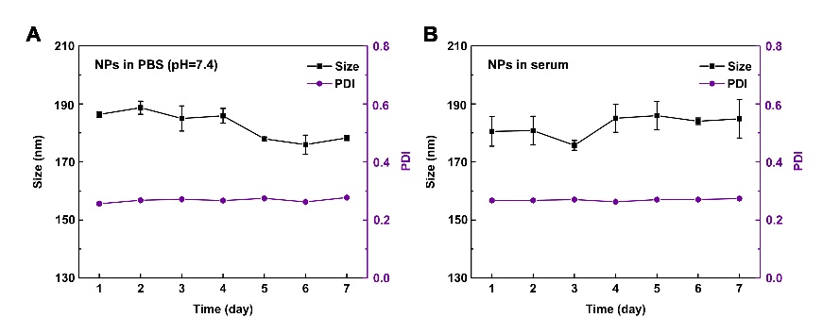
Figure S1. Changes in size and PDI of BA@ZIF(Mn)/FA-PEG nanoparticles over a 7-Day storage period in PBS (A), and serum (B).

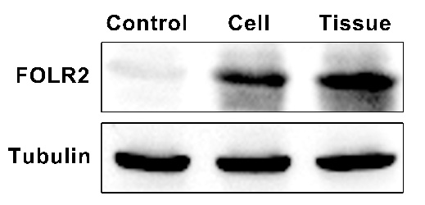
Figure S2. Validation of β-folate receptor as a target for BA@ZIF(Mn)/FA-PEG nanoparticles via western blot.

