Supplementary Materials

Supplemental Table 1. The details of the patients' backgrounds
Cases no. | n=1155
Gender (male: female) | 226: 929≈1: 4
Age (y/o) | 52.87 ± 11.53
Disease course (y) | 7.40 (range from 0.1 to 65)
Visiting times (in one year) | 5.18 (range from 1 to 21)

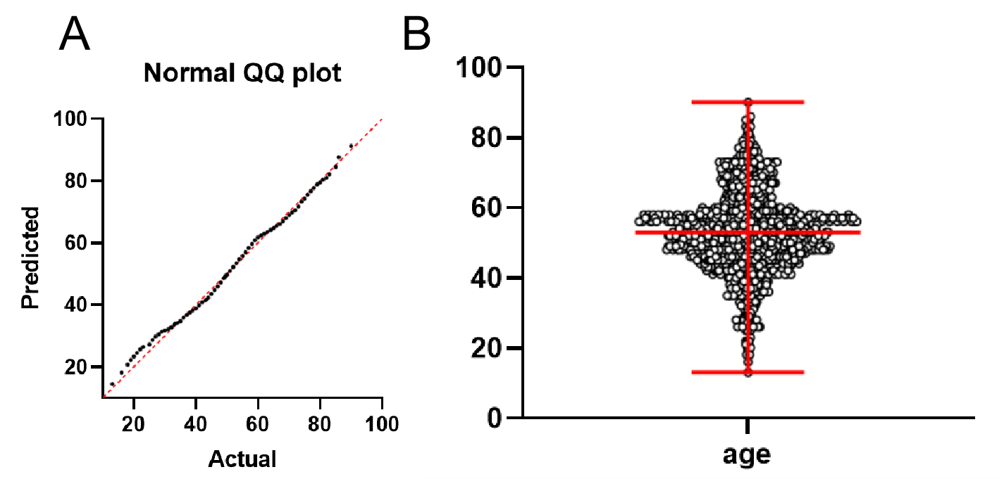
Supplemental figure 1. (A) The QQ plot and (B) scatter plot shows that the age (mean with range) is of normal distribution.
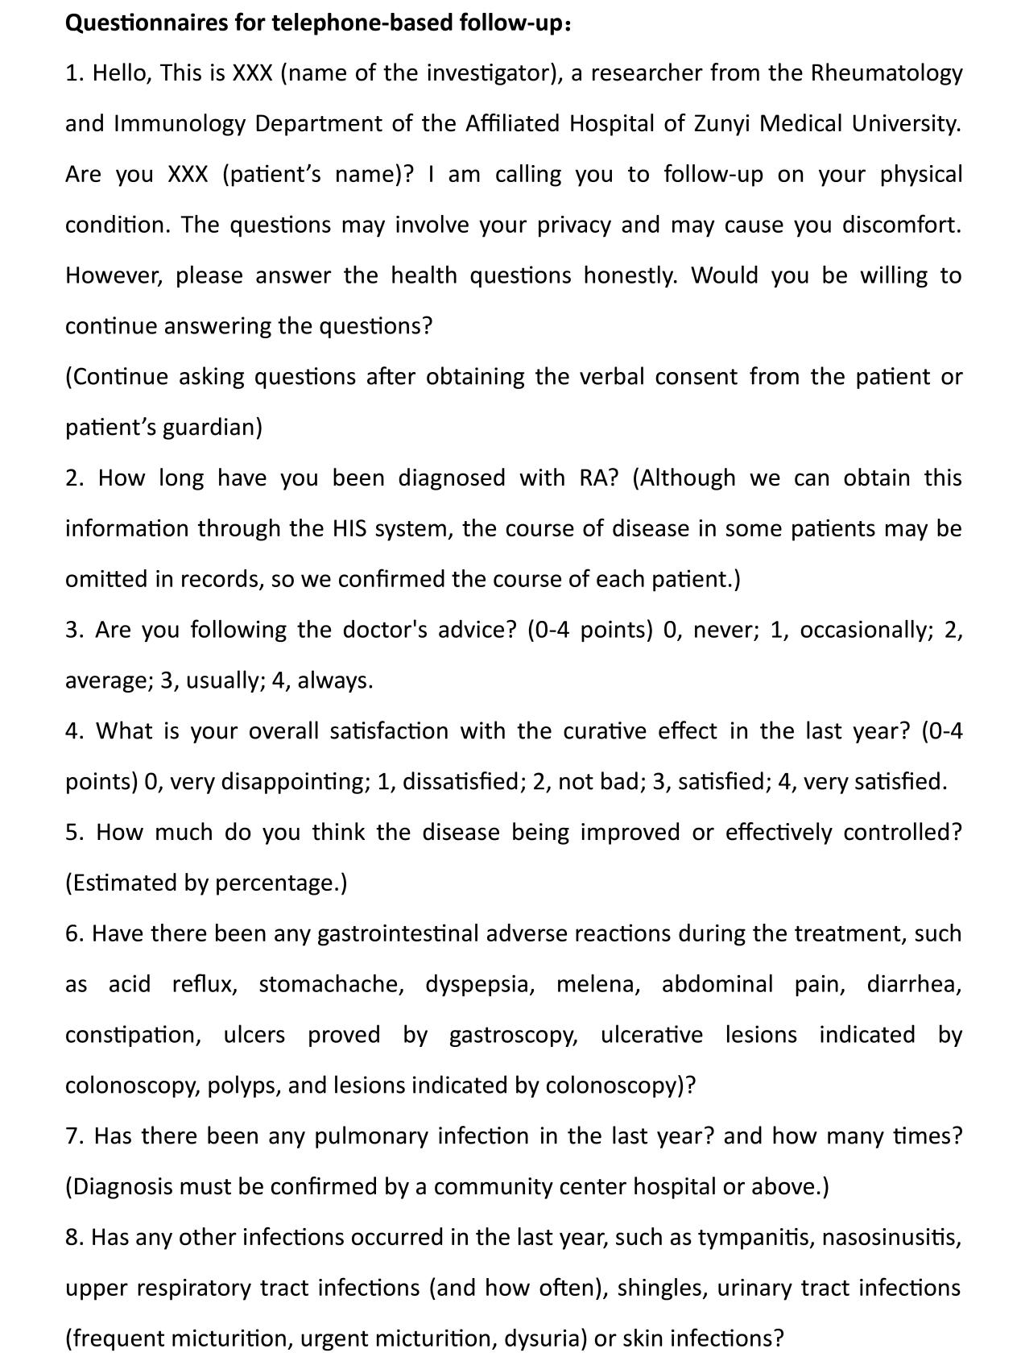
Supplemental figure 2. Questionnaires for telephone-based follow-up.

