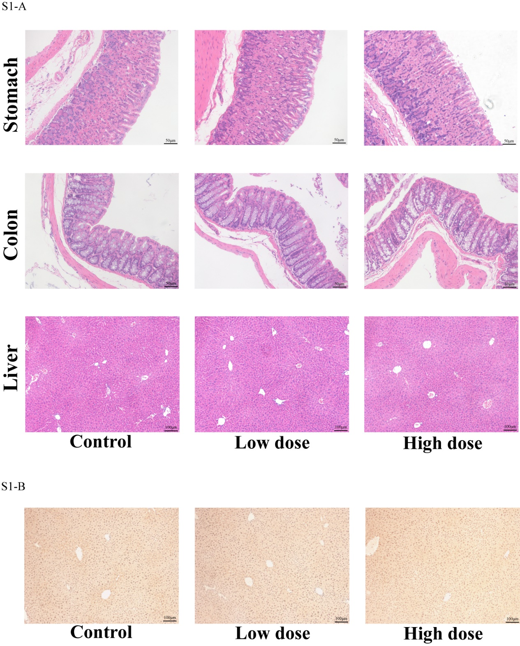

Figure S1 H&E staining and immunohistochemistry results of other organs.
(A) HE staining of paraffin sections of stomach, colon and liver. n = 5 per group. For the stomach and colon, the magnification is 200X with a field of view diameter of 1.1 mm. For liver, the magnification is 100X with a field of view diameter of 2.2 mm. (B) Immunohistochemical staining of 4-hydroxynonenal (4-HNE) revealed the degree of lipid peroxidation of liver in each group. n = 5 per group. The magnification is 100X, and the field of view diameter is 2.2 mm.

