Supplementary data

Supplementary Figure 1. Kaplan-Meier curves for progression-free survival by TMB status using the 10 mut/Mb cut-off (A) and the 16 mut/Mb cut-off (B) within strata defined by first-line treatment. Kaplan-Meier curves for overall survival by TMB status using the 10 mut/Mb cut-off (C), and the 16 mut/Mb cut-off (D) within strata defined by first-line treatment.

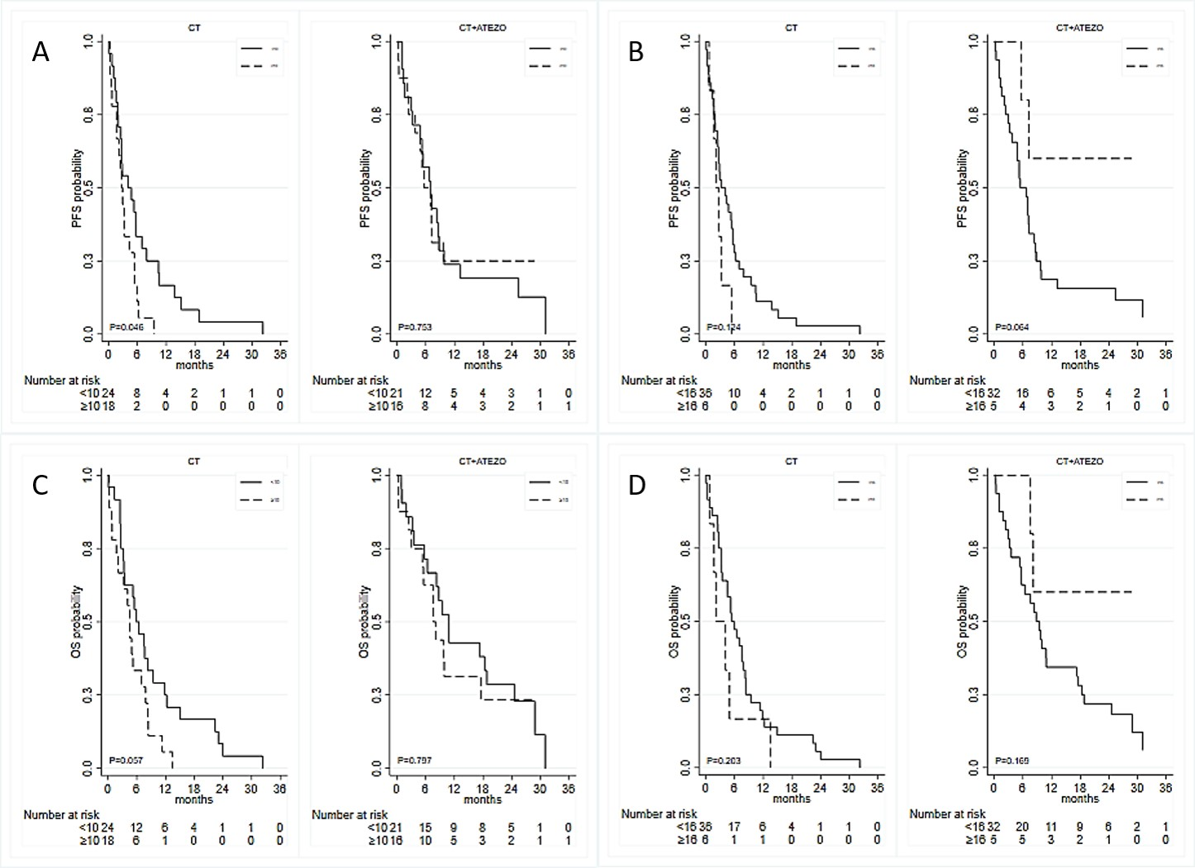

Supplementary Table 1. Results from univariable and multivariable Cox regression models for PFS and OS based on demographic and clinical factors.
 | PFS |  |  |  | OS
 | Univariate analyses |  | Multivariate analyses |  | Univariate analyses |  |  | Multivariate analyses
 | HR (95% CI) | p-value | HR (95% CI) | p-value | HR (95% CI) | p-value | HR (95% CI) |  | p-value
Gender
M | 1 (ref) |  | 1 (ref) |  | 1 (ref) |  | 1 (ref)
F | 0.97 (0.59 – 1.60) | 0.910 | 1.26 (0.72 – 2.20) | 0.421 | 0.99 (0.60 – 1.63) | 0.966 | 1.00 (0.56 – 1.81) |  | 0.992
Age at diagnosis (1-yr increment) | 1.00 (0.97 – 1.03) | 0.944 | 0.99 (0.96 – 1.03) | 0.686 | 1.01 (0.98 – 1.04) | 0.601 | 1.00 (0.97 – 1.03) |  | 0.985
Smoking habits
Former smoker | 1 (ref) |  |  |  | 1 (ref)
Current Smoker | 0.87 (0.52 – 1.45) | 0.592 |  |  | 0.94 (0.56 – 1.58) | 0.816
ECOG PS
≤1 | 1 (ref) |  | 1 (ref) |  | 1 (ref) |  | 1 (ref)
>1 | 2.98 (1.58 – 5.65) | 0.001 | 2.26 (1.08 – 4.70) | 0.030 | 3.20 (1.68 – 6.10) | <0.001 | 2.34 (1.06 – 5.14) |  | 0.034
Treatment
CT | 1 (ref) |  | 1 (ref) |  | 1 (ref) |  | 1 (ref)
CT+ATEZO | 0.52 (0.33 – 0.83) | 0.007 | 0.58 (0.33 – 1.01) | 0.054 | 0.50 (0.31 – 0.80) | 0.004 | 0.67 (0.37 – 1.22) |  | 0.192
Radiotherapy
No | 1 (ref) |  |  |  | 1 (ref) |  | 1 (ref)
Yes | 0.72 (0.44 – 1.17) | 0.185 |  |  | 0.57 (0.65 – 0.95) | 0.029 | 0.61 (0.34 – 1.09) |  | 0.092
Brain metastases
No | 1 (ref) |  |  |  | 1 (ref)
Yes | 1.57 (0.88 – 2.81) | 0.128 |  |  | 1.40 (0.79 – 2.51) | 0.250
Bone metastases
No | 1 (ref) |  | 1 (ref) |  | 1 (ref) |  | 1 (ref)
Yes | 1.77 (1.06 – 2.97) | 0.029 | 2.00 (1.15 – 3.47) | 0.014 | 1.75 (1.05 – 2.93) | 0.032 | 1.65 (0.95 – 2.85) |  | 0.073
PFS: Progression-Free Survival; OS: Overall Survival; HR: hazard ratio; CI: confidence interval; CT: chemotherapy; CT+ATEZO (CT plus atezolizumab); Age was included as a 1-year increment continuous variable.

Supplementary Table 2. Results from multivariable Cox regression models adjusting for gender, age, ECOG PS and presence of bone metastases
 | Multivariate analyses
 | Model 4 |  |  | Model 5 |  |  | Model 6
 | Coef. | 95% CI | P | Coef. | 95% CI | P | Coef. | 95% CI | P
PFS
TMB₁₀ | 0.77 | 0.01 – 1.53 | 0.048
TMB₁₆ |  |  |  | 0.82 | -0.13 – 1.78 | 0.090
TMB_{cont} |  |  |  |  |  |  | 0.63 | -0.03 – 1.30 | 0.062
Treatment | -0.32 | -1.00 – 0.37 | 0.361 | -0.36 | -0.94 – 0.21 | 0.218 | -0.66 | -1.22 – -0.09 | 0.025
TMB₁₀*Treatment | -0.75 | -1.85 – 0.35 | 0.181
TMB₁₆*Treatment |  |  |  | -2.03 | -3.81 – -0.24 | 0.026
TMB_{cont}*Treatment |  |  |  |  |  |  | -0.83 | -1.64 – -0.01 | 0.048
Gender | 0.34 | -0.26 – 0.94 | 0.272 | 0.40 | -0.17 – 0.98 | 0.172 | 0.34 | -0.23 – 0.91 | 0.251
Age_{cont} | -0.01 | -0.05 – 0.02 | 0.410 | -0.01 | -0.04 – 0.02 | 0.558 | -0.01 | -0.05 – 0.02 | 0.427
ECOG PS | 0.82 | 0.08 – 1.55 | 0.029 | 0.71 | -0.02 – 1.45 | 0.058 | 0.76 | 0.02 – 1.50 | 0.045
Bone metastases | 0.80 | 0.22 – 1.39 | 0.007 | 0.63 | 0.07 – 1.19 | 0.027 | 0.73 | 0.17 – 1.29 | 0.011
OS
TMB₁₀ | 0.58 | -0.20 – 1.35 | 0.148
TMB₁₆ |  |  |  | 0.60 | -0.35 – 1.56 | 0.216
TMB_{cont} |  |  |  |  |  |  | 0.30 | -0.37 – 0.96 | 0.384
Treatment | -0.45 | -1.15 – 0.25 | 0.208 | -0.41 | -1.00 – 0.18 | 0.174 | -0.60 | -1.17 – -0.03 | 0.041
TMB₁₀*Treatment | -0.31 | -1.42 – 0.80 | 0.585
TMB₁₆*Treatment |  |  |  | -1.47 | -3.25 – 0.31 | 0.105
TMB_{cont}*Treatment |  |  |  |  |  |  | -0.37 | -1.20 – 0.45 | 0.377
Gender | 0.03 | -0.62 – 0.68 | 0.934 | 0.14 | -0.48 – 0.76 | 0.657 | 0.03 | -0.58 – 0.64 | 0.924
Age_{cont} | -0.004 | -0.04 – 0.03 | 0.819 | 0.0002 | -0.03 – 0.03 | 0.992 | 0.001 | -0.03 – 0.04 | 0.975
ECOG PS | 0.75 | -0.06 – 1.55 | 0.070 | 0.68 | -0.12 – 1.48 | 0.096 | 0.68 | -0.15 – 1.50 | 0.109
Bone metastases | 0.61 | 0.01 – 1.21 | 0.046 | 0.45 | -0.12 – 1.02 | 0.122 | 0.49 | -0.08 – 1.06 | 0.090

PFS: Progression-Free Survival; OS: Overall Survival; Coef: regression coefficient derived from the Cox model; HR: hazard ratio; CI: confidence interval; TMB: Tumor mutation burden; TMB₁₀: TMB dichotomized using the cut-off of 10 mut/Mb; TMB₁₆: TMB dichotomized using the cut-off of 16 mut/Mb; TMB_{cont}: TMB as a continuous variable, log-transformed and centered on its mean. Treatment refers to CT+ATEZO (carboplatin and etoposide plus atezolizumab) versus CT (cis- or carboplatin plus etoposide). TMB₁₀*Treatment, TMB₁₆*Treatment, and TMB_{cont}*Treatment refers to the interaction terms between TMb and type of treatment. Gender refers to the comparison women versus men; ECOG PS to the comparison ≥2 versus <2; bone metastases to the comparison Yes versus No; Age_{cont} was included as a 1-year increment continuous variable.

