Supplementary Materials

Physical Examination
The physical examination includes measurements of height, weight, neck circumference, waist circumference,and body composition analysis. All measurements are conducted twice by trained technicians to ensure accuracy.
To measure height, find a vertical wall and ensure the floor is level. Remove any hats and shoes, and stand against the wall. Ensure that the head, shoulders, buttocks, and heels are in contact with the instrument, maintaining an upright posture. The measuring plate should be parallel to the wall and positioned accurately at the top of the head. Height is measured in centimeters (cm) and recorded to the nearest 0.1 cm.
Weight is measured using the TANITA BC-420 body composition analyzer (manufactured in Japan). Place the instrument on a flat surface and connect it to the appropriate power source. As the instrument measures body composition through foot resistance, shoes and socks must be removed. Select the correct gender and input the correct height. Choose the appropriate measurement mode as needed. Ensure both feet are evenly placed on the measurement plate for an accurate reading. The instrument typically completes the measurement in a few seconds, displaying various parameters, including weight, body fat percentage, muscle mass, and water content. Body Mass Index (BMI) is calculated as weight divided by the square of height.

Structured questionnaire
This study utilized a standard questionnaire consisting of four parts. Each part of the questionnaire required signatures and special annotations from respondents, ensuring that final verifiers could quickly confirm the completion of the survey. The first part collected sociodemographic information, including age, gender, education level, and marital status. The second part gathered self-reported professional diagnoses of diseases such as hypertension, coronary heart disease, diabetes, and dyslipidemia, along with the disease history of individuals and their family members. The third part documented participants' lifestyle habits, including smoking history, drinking history, and physical exercise. The fourth part recorded on-site physical examination results.
Smoking: Smoking continuously for more than six months. Quitting smoking refers to not smoking for at least six months after previously smoking. Drinking: Regularly drinking at least twice a month, with consumption of at least one bottle of beer or two liang of Baijiu/wine. Abstinence refers to not drinking for at least half a year. Physical Exercise: Engagement in physical exercise in the past year, averaging more than 20 minutes per session. Frequency categories are 5-7 days per week, 3-4 days per week, 1-2 days per week, ≤ 3 days per month, or never exercising. Diabetes: Fasting blood glucose ≥ 7 mmol/L or use of diabetes medications (oral hypoglycemic drugs and/or insulin).Family history of hypertension (FHH) was assessed based on the self-report of participants about whether any of his/ her family members (living or deceased) had hypertension diagnosed by a physician. Provided options were “yes”, “no”, and “don’t know”. If a participant selected “yes”, he/she was asked to ascertain the presence of hypertension in grandfather, grandmother, mother, father, siblings, and offspring. A high-salt diet is defined as a dietary pattern characterized by the consumption of sodium levels exceeding the recommended daily intake, typically more than 2,300 milligrams per day, as advised by health organizations such as the World Health Organization (WHO) and the American Heart Association (AHA).

The questionnaire was administered by a professional physician through face-to-face interviews. On-site supervisors conducted quality control inspections to ensure the completeness and authenticity of each questionnaire. At the end of each day, the questionnaires were scanned and converted into electronic format using specialized software, with data input checked for accuracy.
Participants with snoring and other sleep problems were evaluated using specific sleep questionnaires:
Epworth Sleepiness Scale (ESS): Developed by Murray W. Johns in 1991, this tool assesses daytime drowsiness tendencies with 8 descriptive questions, each scored from 0 to 3. Total scores range from 0 to 24, with a score of ≥ 10 indicating daytime sleepiness.
Pittsburgh Sleep Quality Index (PSQI): Compiled by sleep medicine experts from the University of Pittsburgh, the PSQI includes 19 items covering various aspects of sleep quality. Scores range from 0 to 21, with a score of ≤ 5 indicating good sleep quality and > 5 indicating poor sleep quality.
Insomnia Severity Index (ISI): Developed by Morin and Barlow in 1993, this scale assesses insomnia severity over the past week with 7 items, each scored from 0 to 4. Scores ≤ 7 indicate no insomnia, while scores > 7 indicate insomnia.
To evaluate the association between sleep parameters and the prevalence of MetS, an overall sleep quality score was calculated by combining all four sleep parameters, ranging from 0 (best) to 8 (worst), as detailed in Supplementary Table S1. In this study, the overall sleep score was considered both as a continuous variable and a categorical variable: scores > 5 were considered the worst sleep quality, 3-5 indicated poor sleep quality, and < 3 indicated the best sleep quality.

Figure S1. Type IV intelligent wearable sleep monitoring devices and method of use
(A)
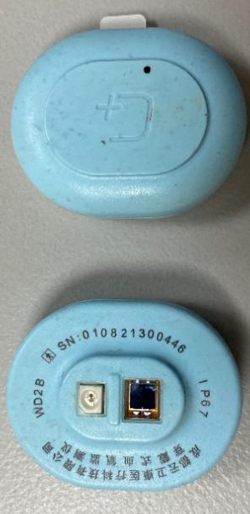
(B)
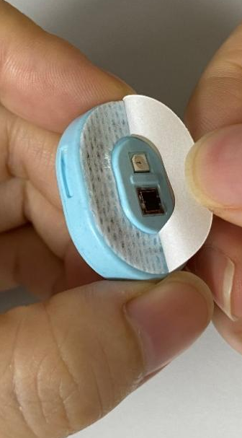
(C)
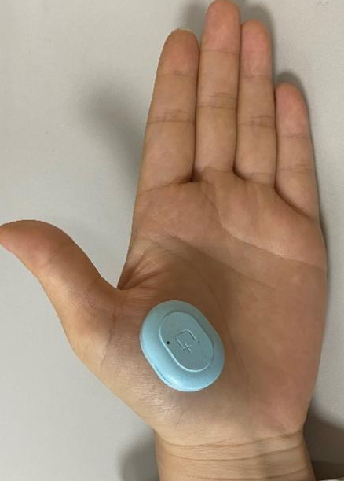
(A) Front and back photos of intelligent wearable sleep monitoring devices
(B) Double-sided adhesive is attached to the side with the photoelectric reflex sensor
(C) The device is tightly adhered to the position of palmar thenar major muscles with double-sided adhesive

Figure S2. Validation of intelligent wearable sleep monitoring devices by comparison against polysomnography
(B)
(A)
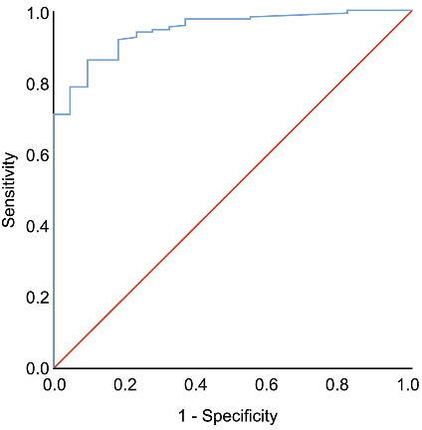
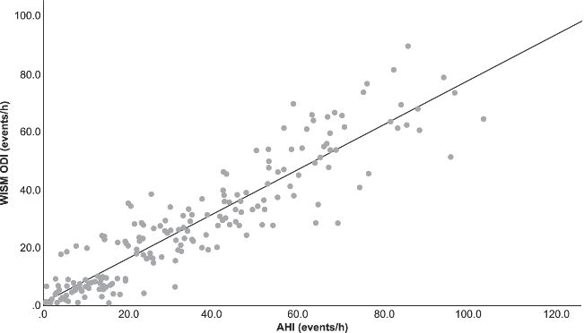
(A) ROC curve of SDB diagnosed by WISM at AHI threshold ≥ 5 times/hour as defined by PSG. (B) AHI and WISM ODI conformance analysis.

Note: Figures (A) and (B) are from the previously published study of our research team; Adapted with permission from Xu Y, Ou Q, Cheng Y, et al. Comparative study of a wearable intelligent sleep monitor and polysomnography monitor for the diagnosis of obstructive sleep apnea. Sleep Breath, 2022.¹

Our research team validated the wearable intelligent sleep monitoring device (WISM) by comparison against polysomnography (PSG) at the Sleep Center of Guangdong Provincial People's Hospital from July 2020 to March 2021. In total, 196 participants completed both PSG and WISM monitoring at the same time. When the ODI by WISM reaches 7.0 events/h, the optimal cut-off value, it has a sensitivity, specificity, and the area under the ROC curve of 86%, 91%, and 0.95, respectively, to predict SDB defined by an apnea-hypopnea index (AHI) ≥5 events/h (Figure (A)). In addition, the ODI had a strong correlation with the AHI from the PSG (R ² =0.843, P < 0.001, Figure (B)).

SDB= sleep-disordered breathing; ROC= receiver-operating characteristic; WISM= wearable intelligent sleep monitor; AHI apnea–hypopnea index; ODI= oxygen desaturation index; PSG= polysomnography

References
[1] Xu Y, Ou Q, Cheng Y, et al. Comparative study of a wearable intelligent sleep monitor and polysomnography monitor for the diagnosis of obstructive sleep apnea [J]. Sleep Breath, 2022. DOI: 10.1007/s11325-022-02599-x.

