Fig. S1 FNDC5 expression was decreased in DOX-treated mice hearts and cardiomyocytes (n = 4 per group)
(A and B). FNDC5 mRNA expression in hearts (A) and H9c2 cells (B) after DOX treatment.
Data are expressed as mean ± standard deviation (SD). ***P < 0.001 was considered statistically significant.

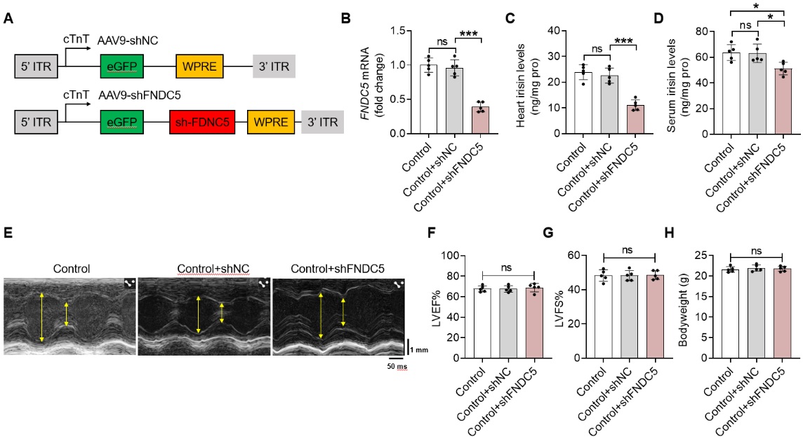

Fig. S2 FNDC knockdown showed no influence on heart function and body weight under normal condition. Mice receiving AAV9-cTnT-shFNDC5 or AAV9-cTnT-shNC injection. Hearts were harvested 4 weeks after virus injection for analysis (n = 6 per group).
(A). Schematic diagram of AAV9-cTnT-shFNDC5 construct.
(B). FNDC5 mRNA expression of heart tissues.
(C-D). Irisin level in heart (C) and serum (D).
(E). Representative echocardiography images of heart in M-mode.
(F-G). Quantification of LVEF% (E) and LVFS% (F).
(H). Quantification of body weight.
Data are expressed as mean ± SD. *P < 0.05, and ***P < 0.001 was considered statistically significant and ns indicates not significant.

