Supplementary tables
Supplementary Table 1. Detail information of selected SNPs for MR analysis in OSA and migraine.
SNP |  |  |  |  | Exposure  (OSA) |  |  |  |  |  |  |  |  | Outcome  (Migraine)
RS ID | EA | OA |  |  |  | F | Beta | Se | P-value | EAF |  |  | Beta |  | Se | P-value | EAF
rs10507084 | T | C |  |  |  | 47.99536 | 0.1027 | 0.0189 | 5.51E-08 | 0.1653 |  |  | 0.0190 |  | 0.0154 | 2.17E-01 | 0.1781
rs10906985 | A | G |  |  |  | 33.74462 | 0.0660 | 0.0130 | 4.05E-07 | 0.3779 |  |  | 0.0093 |  | 0.0118 | 4.33E-01 | 0.4555
rs11075985 | A | C |  |  |  | 82.87861 | 0.1036 | 0.0130 | 1.99E-15 | 0.3721 |  |  | -0.0025 |  | 0.0119 | 8.36E-01 | 0.4268
rs114983649 | A | C |  |  |  | 31.8088 | 0.1542 | 0.0303 | 3.66E-07 | 0.0424 |  |  | 0.0346 |  | 0.0251 | 1.68E-01 | 0.0582
rs115903639 | A | G |  |  |  | 16.58522 | 0.1931 | 0.0423 | 4.87E-06 | 0.0137 |  |  | -0.0357 |  | 0.0306 | 2.43E-01 | 0.0389
rs116182122 | G | T |  |  |  | 39.54076 | 0.3093 | 0.0598 | 2.27E-07 | 0.0127 |  |  | 0.0465 |  | 0.0534 | 3.84E-01 | 0.0125
rs116420235 | T | C |  |  |  | 22.50672 | -0.2090 | 0.0444 | 2.51E-06 | 0.0159 |  |  | -0.0080 |  | 0.0342 | 8.15E-01 | 0.0317
rs11774552 | T | C |  |  |  | 35.03456 | -0.0662 | 0.0132 | 5.05E-07 | 0.4139 |  |  | -0.0321 |  | 0.0120 | 7.62E-03 | 0.4302
rs12699649 | T | C |  |  |  | 30.23136 | 0.0629 | 0.0134 | 2.90E-06 | 0.3656 |  |  | 0.0205 |  | 0.0123 | 9.52E-02 | 0.3780
rs142416325 | A | G |  |  |  | 47.7181 | -0.3465 | 0.0667 | 2.09E-07 | 0.0122 |  |  | -0.0714 |  | 0.0651 | 2.73E-01 | 0.0090
rs144160082 | G | A |  |  |  | 25.95862 | 0.1252 | 0.0271 | 4.00E-06 | 0.0531 |  |  | -0.0132 |  | 0.0227 | 5.61E-01 | 0.0738
rs145058358 | C | A |  |  |  | 43.10932 | 0.1578 | 0.0315 | 5.58E-07 | 0.0556 |  |  | 0.0309 |  | 0.0313 | 3.24E-01 | 0.0393
rs146794654 | T | C |  |  |  | 25.25257 | -0.2023 | 0.0425 | 1.90E-06 | 0.0191 |  |  | 0.0601 |  | 0.0392 | 1.25E-01 | 0.0231
rs16861404 | A | G |  |  |  | 29.01464 | 0.0791 | 0.0167 | 2.10E-06 | 0.1695 |  |  | -0.0278 |  | 0.0156 | 7.53E-02 | 0.1717
rs17547430 | G | A |  |  |  | 29.78071 | 0.1268 | 0.0255 | 6.36E-07 | 0.0598 |  |  | 0.0075 |  | 0.0251 | 7.63E-01 | 0.0599
rs181154734 | A | G |  |  |  | 30.24046 | 0.4060 | 0.0791 | 2.83E-07 | 0.0056 |  |  | 0.0133 |  | 0.0614 | 8.28E-01 | 0.0090
rs1885070 | G | A |  |  |  | 29.37048 | 0.0663 | 0.0144 | 4.32E-06 | 0.2828 |  |  | -0.0171 |  | 0.0131 | 1.94E-01 | 0.2807
rs1956376 | T | C |  |  |  | 38.5755 | 0.0690 | 0.0132 | 1.59E-07 | 0.4353 |  |  | 0.0222 |  | 0.0118 | 6.00E-02 | 0.4485
rs2277339 | G | T |  |  |  | 41.52853 | -0.1037 | 0.0197 | 1.49E-07 | 0.1355 |  |  | -0.0008 |  | 0.0176 | 9.65E-01 | 0.1302
rs2611742 | C | T |  |  |  | 31.79784 | 0.0629 | 0.0130 | 1.30E-06 | 0.4221 |  |  | -0.0157 |  | 0.0119 | 1.85E-01 | 0.5533
rs4488813 | G | A |  |  |  | 42.47262 | -0.1059 | 0.0231 | 4.50E-06 | 0.1324 |  |  | 0.0167 |  | 0.0213 | 4.33E-01 | 0.0844
rs58138946 | A | G |  |  |  | 39.75073 | 0.1695 | 0.0368 | 4.05E-06 | 0.0439 |  |  | -0.0726 |  | 0.0359 | 4.30E-02 | 0.0273
rs6815442 | T | A |  |  |  | 33.54016 | 0.0687 | 0.0146 | 2.53E-06 | 0.3147 |  |  | 0.0079 |  | 0.0139 | 5.72E-01 | 0.2370
rs7133573 | T | C |  |  |  | 30.37355 | -0.0613 | 0.0130 | 2.44E-06 | 0.5682 |  |  | -0.0073 |  | 0.0121 | 5.44E-01 | 0.5874
rs72683533 | A | G |  |  |  | 38.90483 | 0.1659 | 0.0363 | 4.75E-06 | 0.0449 |  |  | -0.0113 |  | 0.0401 | 7.79E-01 | 0.0232
rs73156514 | G | C |  |  |  | 29.27454 | 0.0919 | 0.0189 | 1.17E-06 | 0.1195 |  |  | 0.0250 |  | 0.0167 | 1.34E-01 | 0.1448
rs76054872 | T | G |  |  |  | 34.07697 | 0.2076 | 0.0445 | 3.10E-06 | 0.0246 |  |  | 0.0194 |  | 0.0416 | 6.41E-01 | 0.0208
rs79672111 | A | G |  |  |  | 33.11547 | 0.2391 | 0.0521 | 4.46E-06 | 0.0179 |  |  | -0.0246 |  | 0.0494 | 6.18E-01 | 0.0149
rs9318788 | G | A |  |  |  | 78.80665 | 1.4733 | 0.3002 | 9.21E-07 | 0.0011 |  |  | 0.0335 |  | 0.1650 | 8.39E-01 | 0.0014

EA: Effect allele; OA: Other allele; EAF: Effect allele frequency; OSA: Obstructive sleep apnea.

Supplementary Table 2. Detail information of selected SNPs for MR analysis in OSA and MA.
SNP |  |  |  | Exposure  (OSA) |  |  |  |  |  | Outcome  (MA)
RS ID | EA | OA |  | F | Beta | Se | P-value | EAF |  |  | Beta | Se | P-value | EAF
rs10507084 | T | C |  | 47.99536 | 0.1027 | 0.0189 | 5.51E-08 | 0.1653 |  |  | 0.0309 | 0.0229 | 1.77E-01 | 0.1779
rs10906985 | A | G |  | 33.74462 | 0.0660 | 0.0130 | 4.05E-07 | 0.3779 |  |  | 0.0112 | 0.0177 | 5.26E-01 | 0.4555
rs11075985 | A | C |  | 82.87861 | 0.1036 | 0.0130 | 1.99E-15 | 0.3721 |  |  | -0.0009 | 0.0178 | 9.61E-01 | 0.4269
rs114983649 | A | C |  | 31.8088 | 0.1542 | 0.0303 | 3.66E-07 | 0.0424 |  |  | 0.0587 | 0.0375 | 1.18E-01 | 0.0582
rs115903639 | A | G |  | 16.58522 | 0.1931 | 0.0423 | 4.87E-06 | 0.0137 |  |  | -0.0457 | 0.0454 | 3.14E-01 | 0.0389
rs116182122 | G | T |  | 39.54076 | 0.3093 | 0.0598 | 2.27E-07 | 0.0127 |  |  | 0.0906 | 0.0801 | 2.58E-01 | 0.0125
rs116420235 | T | C |  | 22.50672 | -0.2090 | 0.0444 | 2.51E-06 | 0.0159 |  |  | -0.0095 | 0.0510 | 8.51E-01 | 0.0317
rs11774552 | T | C |  | 35.03456 | -0.0662 | 0.0132 | 5.05E-07 | 0.4139 |  |  | -0.0587 | 0.0180 | 1.10E-03 | 0.4305
rs12699649 | T | C |  | 30.23136 | 0.0629 | 0.0134 | 2.90E-06 | 0.3656 |  |  | 0.0184 | 0.0183 | 3.15E-01 | 0.3778
rs142416325 | A | G |  | 47.7181 | -0.3465 | 0.0667 | 2.09E-07 | 0.0122 |  |  | -0.1445 | 0.0979 | 1.40E-01 | 0.0091
rs144160082 | G | A |  | 25.95862 | 0.1252 | 0.0271 | 4.00E-06 | 0.0531 |  |  | -0.0029 | 0.0340 | 9.32E-01 | 0.0738
rs145058358 | C | A |  | 43.10932 | 0.1578 | 0.0315 | 5.58E-07 | 0.0556 |  |  | 0.0612 | 0.0470 | 1.93E-01 | 0.0393
rs146794654 | T | C |  | 25.25257 | -0.2023 | 0.0425 | 1.90E-06 | 0.0191 |  |  | 0.0606 | 0.0585 | 3.00E-01 | 0.0230
rs16861404 | A | G |  | 29.01464 | 0.0791 | 0.0167 | 2.10E-06 | 0.1695 |  |  | -0.0287 | 0.0233 | 2.19E-01 | 0.1718
rs17547430 | G | A |  | 29.78071 | 0.1268 | 0.0255 | 6.36E-07 | 0.0598 |  |  | 0.0600 | 0.0375 | 1.10E-01 | 0.0600
rs181154734 | A | G |  | 30.24046 | 0.4060 | 0.0791 | 2.83E-07 | 0.0056 |  |  | 0.1539 | 0.0913 | 9.20E-02 | 0.0090
rs1885070 | G | A |  | 29.37048 | 0.0663 | 0.0144 | 4.32E-06 | 0.2828 |  |  | -0.0094 | 0.0196 | 6.32E-01 | 0.2807
rs1956376 | T | C |  | 38.5755 | 0.0690 | 0.0132 | 1.59E-07 | 0.4353 |  |  | 0.0270 | 0.0177 | 1.27E-01 | 0.4482
rs2277339 | G | T |  | 41.52853 | -0.1037 | 0.0197 | 1.49E-07 | 0.1355 |  |  | -0.0414 | 0.0263 | 1.15E-01 | 0.1300
rs2611742 | C | T |  | 31.79784 | 0.0629 | 0.0130 | 1.30E-06 | 0.4221 |  |  | -0.0494 | 0.0177 | 5.18E-03 | 0.5532
rs4488813 | G | A |  | 42.47262 | -0.1059 | 0.0231 | 4.50E-06 | 0.1324 |  |  | 0.0345 | 0.0317 | 2.77E-01 | 0.0844
rs58138946 | A | G |  | 39.75073 | 0.1695 | 0.0368 | 4.05E-06 | 0.0439 |  |  | -0.0556 | 0.0535 | 2.99E-01 | 0.0274
rs6815442 | T | A |  | 33.54016 | 0.0687 | 0.0146 | 2.53E-06 | 0.3147 |  |  | 0.0253 | 0.0208 | 2.22E-01 | 0.2370
rs7133573 | T | C |  | 30.37355 | -0.0613 | 0.0130 | 2.44E-06 | 0.5682 |  |  | -0.0291 | 0.0180 | 1.06E-01 | 0.5871
rs72683533 | A | G |  | 38.90483 | 0.1659 | 0.0363 | 4.75E-06 | 0.0449 |  |  | -0.0442 | 0.0602 | 4.63E-01 | 0.0233
rs73156514 | G | C |  | 29.27454 | 0.0919 | 0.0189 | 1.17E-06 | 0.1195 |  |  | 0.0195 | 0.0249 | 4.35E-01 | 0.1446
rs76054872 | T | G |  | 34.07697 | 0.2076 | 0.0445 | 3.10E-06 | 0.0246 |  |  | 0.0416 | 0.0624 | 5.05E-01 | 0.0208
rs79672111 | A | G |  | 33.11547 | 0.2391 | 0.0521 | 4.46E-06 | 0.0179 |  |  | -0.0398 | 0.0739 | 5.91E-01 | 0.0149
rs9318788 | G | A |  | 78.80665 | 1.4733 | 0.3002 | 9.21E-07 | 0.0011 |  |  | 0.3836 | 0.2519 | 1.28E-01 | 0.0014

EA: Effect allele; OA: Other allele; EAF: Effect allele frequency; OSA: Obstructive sleep apnea; MA: Migraine with aura

Supplementary Table 3. Detail information of selected SNPs for MR analysis in OSA and MoA.
SNP |  |  |  | Exposure  (OSA) |  |  |  |  |  | Outcome  (MoA)
RS ID | EA | OA |  | F | Beta | Se | P-value | EAF |  | Beta | Se | P-value | EAF
rs10507084 | T | C |  | 47.99536 | 0.1027 | 0.0189 | 5.51E-08 | 0.1653 |  | 0.0309 | 0.0229 | 1.77E-01 | 0.1779
rs10906985 | A | G |  | 33.74462 | 0.0660 | 0.0130 | 4.05E-07 | 0.3779 |  | 0.0112 | 0.0177 | 5.26E-01 | 0.4555
rs11075985 | A | C |  | 82.87861 | 0.1036 | 0.0130 | 1.99E-15 | 0.3721 |  | -0.0009 | 0.0178 | 9.61E-01 | 0.4269
rs114983649 | A | C |  | 31.8088 | 0.1542 | 0.0303 | 3.66E-07 | 0.0424 |  | 0.0587 | 0.0375 | 1.18E-01 | 0.0582
rs115903639 | A | G |  | 16.58522 | 0.1931 | 0.0423 | 4.87E-06 | 0.0137 |  | -0.0457 | 0.0454 | 3.14E-01 | 0.0389
rs116182122 | G | T |  | 39.54076 | 0.3093 | 0.0598 | 2.27E-07 | 0.0127 |  | 0.0906 | 0.0801 | 2.58E-01 | 0.0125
rs116420235 | T | C |  | 22.50672 | -0.2090 | 0.0444 | 2.51E-06 | 0.0159 |  | -0.0095 | 0.0510 | 8.51E-01 | 0.0317
rs11774552 | T | C |  | 35.03456 | -0.0662 | 0.0132 | 5.05E-07 | 0.4139 |  | -0.0587 | 0.0180 | 1.10E-03 | 0.4305
rs12699649 | T | C |  | 30.23136 | 0.0629 | 0.0134 | 2.90E-06 | 0.3656 |  | 0.0184 | 0.0183 | 3.15E-01 | 0.3778
rs142416325 | A | G |  | 47.7181 | -0.3465 | 0.0667 | 2.09E-07 | 0.0122 |  | -0.1445 | 0.0979 | 1.40E-01 | 0.0091
rs144160082 | G | A |  | 25.95862 | 0.1252 | 0.0271 | 4.00E-06 | 0.0531 |  | -0.0029 | 0.0340 | 9.32E-01 | 0.0738
rs145058358 | C | A |  | 43.10932 | 0.1578 | 0.0315 | 5.58E-07 | 0.0556 |  | 0.0612 | 0.0470 | 1.93E-01 | 0.0393
rs146794654 | T | C |  | 25.25257 | -0.2023 | 0.0425 | 1.90E-06 | 0.0191 |  | 0.0606 | 0.0585 | 3.00E-01 | 0.0230
rs16861404 | A | G |  | 29.01464 | 0.0791 | 0.0167 | 2.10E-06 | 0.1695 |  | -0.0287 | 0.0233 | 2.19E-01 | 0.1718
rs17547430 | G | A |  | 29.78071 | 0.1268 | 0.0255 | 6.36E-07 | 0.0598 |  | 0.0600 | 0.0375 | 1.10E-01 | 0.0600
rs181154734 | A | G |  | 30.24046 | 0.4060 | 0.0791 | 2.83E-07 | 0.0056 |  | 0.1539 | 0.0913 | 9.20E-02 | 0.0090
rs1885070 | G | A |  | 29.37048 | 0.0663 | 0.0144 | 4.32E-06 | 0.2828 |  | -0.0094 | 0.0196 | 6.32E-01 | 0.2807
rs1956376 | T | C |  | 38.5755 | 0.0690 | 0.0132 | 1.59E-07 | 0.4353 |  | 0.0270 | 0.0177 | 1.27E-01 | 0.4482
rs2277339 | G | T |  | 41.52853 | -0.1037 | 0.0197 | 1.49E-07 | 0.1355 |  | -0.0414 | 0.0263 | 1.15E-01 | 0.1300
rs2611742 | C | T |  | 31.79784 | 0.0629 | 0.0130 | 1.30E-06 | 0.4221 |  | -0.0494 | 0.0177 | 5.18E-03 | 0.5532
rs4488813 | G | A |  | 42.47262 | -0.1059 | 0.0231 | 4.50E-06 | 0.1324 |  | 0.0345 | 0.0317 | 2.77E-01 | 0.0844
rs58138946 | A | G |  | 39.75073 | 0.1695 | 0.0368 | 4.05E-06 | 0.0439 |  | -0.0556 | 0.0535 | 2.99E-01 | 0.0274
rs6815442 | T | A |  | 33.54016 | 0.0687 | 0.0146 | 2.53E-06 | 0.3147 |  | 0.0253 | 0.0208 | 2.22E-01 | 0.2370
rs7133573 | T | C |  | 30.37355 | -0.0613 | 0.0130 | 2.44E-06 | 0.5682 |  | -0.0291 | 0.0180 | 1.06E-01 | 0.5871
rs72683533 | A | G |  | 38.90483 | 0.1659 | 0.0363 | 4.75E-06 | 0.0449 |  | -0.0442 | 0.0602 | 4.63E-01 | 0.0233
rs73156514 | G | C |  | 29.27454 | 0.0919 | 0.0189 | 1.17E-06 | 0.1195 |  | 0.0195 | 0.0249 | 4.35E-01 | 0.1446
rs76054872 | T | G |  | 34.07697 | 0.2076 | 0.0445 | 3.10E-06 | 0.0246 |  | 0.0416 | 0.0624 | 5.05E-01 | 0.0208
rs79672111 | A | G |  | 33.11547 | 0.2391 | 0.0521 | 4.46E-06 | 0.0179 |  | -0.0398 | 0.0739 | 5.91E-01 | 0.0149
rs9318788 | G | A |  | 78.80665 | 1.4733 | 0.3002 | 9.21E-07 | 0.0011 |  | 0.3836 | 0.2519 | 1.28E-01 | 0.0014

EA: Effect allele; OA: Other allele; EAF: Effect allele frequency; OSA: Obstructive sleep apnea; MoA: Migraine without aura.

Supplementary Table 4. Detail information of selected SNPs for MR analysis in migraine and OSA
SNP |  |  |  | Exposure  (Migraine) |  |  |  |  |  | Outcome  (OSA)
RS ID | EA | OA |  | F | Beta | Se | P-value | EAF |  | Beta | Se | P-value | EAF
rs113567824 | T | C |  | 15.56914 | -0.2543 | 0.0555 | 4.69E-06 | 0.0139 |  | 0.0108 | 0.0480 | 8.21E-01 | 0.0254
rs12811859 | T | G |  | 16.92836 | -0.2505 | 0.0502 | 5.94E-07 | 0.0156 |  | -0.0895 | 0.0511 | 7.99E-02 | 0.0207
rs142115564 | A | T |  | 13.97351 | -0.1389 | 0.0302 | 4.12E-06 | 0.0431 |  | -0.0005 | 0.0351 | 9.89E-01 | 0.0299
rs144208700 | T | C |  | 14.42593 | -0.1475 | 0.0319 | 3.69E-06 | 0.0393 |  | 0.0300 | 0.0347 | 3.86E-01 | 0.0346
rs144646256 | G | A |  | 14.9732 | -0.2327 | 0.0492 | 2.20E-06 | 0.0160 |  | -0.0259 | 0.0493 | 5.99E-01 | 0.0198
rs146463602 | G | T |  | 11.95163 | 0.1921 | 0.0408 | 2.56E-06 | 0.0188 |  | 0.0083 | 0.0557 | 8.81E-01 | 0.0114
rs17548604 | T | G |  | 13.46123 | -0.0803 | 0.0174 | 3.73E-06 | 0.1379 |  | -0.0433 | 0.0190 | 2.30E-02 | 0.1115
rs17678460 | A | G |  | 14.36911 | -0.0711 | 0.0150 | 1.98E-06 | 0.2031 |  | -0.0020 | 0.0159 | 9.02E-01 | 0.1697
rs2183947 | A | G |  | 14.07551 | -0.0671 | 0.0141 | 1.90E-06 | 0.2317 |  | -0.0436 | 0.0154 | 4.59E-03 | 0.1998
rs2738814 | A | C |  | 16.33443 | -0.0634 | 0.0122 | 2.03E-07 | 0.6366 |  | 0.0051 | 0.0134 | 7.05E-01 | 0.6234
rs28667298 | G | T |  | 13.48693 | 0.0662 | 0.0139 | 1.98E-06 | 0.2266 |  | 0.0270 | 0.0240 | 2.62E-01 | 0.1834
rs36010570 | C | G |  | 13.06008 | 0.1462 | 0.0307 | 1.87E-06 | 0.0361 |  | 0.0177 | 0.0317 | 5.77E-01 | 0.0465
rs4683465 | C | T |  | 17.63914 | 0.0677 | 0.0125 | 5.89E-08 | 0.3241 |  | 0.0059 | 0.0136 | 6.65E-01 | 0.3673
rs56221187 | C | G |  | 13.8457 | 0.1705 | 0.0346 | 8.38E-07 | 0.0279 |  | 0.0896 | 0.0346 | 9.70E-03 | 0.0471
rs71416856 | T | C |  | 15.11376 | -0.0785 | 0.0159 | 8.58E-07 | 0.1678 |  | -0.0581 | 0.0186 | 1.82E-03 | 0.0935
rs7398375 | G | C |  | 21.37044 | 0.0741 | 0.0126 | 3.91E-09 | 0.3310 |  | 0.0142 | 0.0142 | 3.16E-01 | 0.3680
rs74522625 | G | A |  | 15.04936 | -0.1142 | 0.0236 | 1.25E-06 | 0.0707 |  | -0.0040 | 0.0278 | 8.85E-01 | 0.0532
rs75470495 | T | C |  | 12.16365 | 0.1467 | 0.0316 | 3.54E-06 | 0.0333 |  | 0.0092 | 0.0426 | 8.30E-01 | 0.0178
rs75537311 | A | G |  | 17.74693 | -0.2931 | 0.0623 | 2.54E-06 | 0.0119 |  | 0.0520 | 0.0425 | 2.21E-01 | 0.0371
rs76710367 | T | C |  | 11.33088 | 0.5192 | 0.1129 | 4.26E-06 | 0.0024 |  | 0.0833 | 0.0711 | 2.41E-01 | 0.0148
rs76968534 | C | G |  | 15.61585 | -0.1446 | 0.0294 | 8.69E-07 | 0.0445 |  | 0.0075 | 0.0343 | 8.26E-01 | 0.0318
rs77106170 | C | T |  | 13.75838 | -0.1092 | 0.0237 | 4.24E-06 | 0.0707 |  | 0.0425 | 0.0249 | 8.82E-02 | 0.0862
rs77400760 | T | G |  | 11.66867 | 0.2792 | 0.0595 | 2.74E-06 | 0.0086 |  | 0.0929 | 0.0711 | 1.91E-01 | 0.0089
rs78853734 | G | C |  | 15.19899 | -0.2091 | 0.0448 | 3.13E-06 | 0.0202 |  | 0.0285 | 0.0479 | 5.52E-01 | 0.0202
rs8003921 | C | T |  | 15.03964 | 0.0612 | 0.0128 | 1.60E-06 | 0.6462 |  | -0.0043 | 0.0183 | 8.14E-01 | 0.6477
rs8073061 | G | A |  | 13.52736 | 0.1836 | 0.0381 | 1.40E-06 | 0.0234 |  | 0.0411 | 0.0417 | 3.25E-01 | 0.0274
rs921038 | C | T |  | 15.50829 | -0.0607 | 0.0120 | 4.40E-07 | 0.6018 |  | -0.0245 | 0.0133 | 6.48E-02 | 0.5651
rs9266329 | A | G |  | 18.58282 | -0.0747 | 0.0136 | 4.22E-08 | 0.2541 |  | -0.0036 | 0.0155 | 8.14E-01 | 0.2715
rs9349379 | G | A |  | 28.37934 | -0.0807 | 0.0119 | 1.04E-11 | 0.4524 |  | -0.0132 | 0.0130 | 3.10E-01 | 0.4810
rs9568980 | A | T |  | 12.83684 | 0.0817 | 0.0175 | 2.98E-06 | 0.1252 |  | 0.0207 | 0.0188 | 2.73E-01 | 0.1589
rs9611746 | G | A |  | 13.49854 | -0.0822 | 0.0178 | 3.84E-06 | 0.1309 |  | -0.0119 | 0.0171 | 4.86E-01 | 0.2400
rs9653353 | T | C |  | 13.82911 | -0.0570 | 0.0120 | 1.96E-06 | 0.5873 |  | -0.0031 | 0.0132 | 8.17E-01 | 0.5244

EA: Effect allele; OA: Other allele; EAF: Effect allele frequency; OSA: Obstructive sleep apnea.

Supplementary Table 5. Detail information of selected SNPs for MR analysis in MA and OSA.
SNP |  |  |  | Exposure  (MA) |  |  |  |  |  | Outcome  (OSA)
RS ID | EA | OA |  | F | Beta | Se | P-value | EAF |  | Beta | Se | P-value | EAF
rs114572408 | T | C |  | 126.123 | -1.9861 | 0.4319 | 4.26E-06 | 0.0014 |  | -0.0146 | 0.0844 | 8.62E-01 | 0.0104
rs11712982 | T | C |  | 36.04067 | 0.1091 | 0.0235 | 3.44E-06 | 0.1586 |  | 0.0122 | 0.0180 | 4.98E-01 | 0.1599
rs117208805 | A | T |  | 47.2309 | -0.1798 | 0.0367 | 9.53E-07 | 0.0691 |  | 0.0550 | 0.0289 | 5.74E-02 | 0.0467
rs117750534 | T | A |  | 65.32393 | -0.3271 | 0.0598 | 4.58E-08 | 0.0276 |  | -0.0470 | 0.0457 | 3.04E-01 | 0.0162
rs12529313 | G | A |  | 39.52159 | -0.1022 | 0.0220 | 3.22E-06 | 0.2114 |  | 0.0106 | 0.0166 | 5.23E-01 | 0.1572
rs12653486 | T | A |  | 40.49569 | 1.8894 | 0.4055 | 3.17E-06 | 0.0005 |  | 2.2819 | 0.7427 | 2.12E-03 | 0.0003
rs16035 | G | T |  | 51.36917 | -0.0951 | 0.0176 | 6.64E-08 | 0.5036 |  | -0.0105 | 0.0131 | 4.23E-01 | 0.6472
rs17564412 | A | G |  | 39.27416 | -0.1271 | 0.0277 | 4.54E-06 | 0.1220 |  | -0.0348 | 0.0197 | 7.81E-02 | 0.1345
rs1822266 | T | C |  | 35.26183 | -0.1494 | 0.0324 | 3.91E-06 | 0.9247 |  | 0.0114 | 0.0228 | 6.16E-01 | 0.8837
rs2293631 | A | C |  | 62.246 | -0.1477 | 0.0256 | 7.83E-09 | 0.1471 |  | 0.0396 | 0.0177 | 2.55E-02 | 0.2183
rs2303400 | C | T |  | 42.56026 | 0.0867 | 0.0177 | 9.63E-07 | 0.5247 |  | 0.0123 | 0.0131 | 3.45E-01 | 0.4976
rs2517653 | A | G |  | 52.65859 | -0.1014 | 0.0187 | 5.83E-08 | 0.3431 |  | -0.0012 | 0.0144 | 9.32E-01 | 0.2514
rs34353835 | T | C |  | 42.53982 | -0.1664 | 0.0353 | 2.45E-06 | 0.0730 |  | -0.0062 | 0.0272 | 8.18E-01 | 0.0545
rs35069141 | A | G |  | 35.39803 | 0.1067 | 0.0232 | 4.20E-06 | 0.1639 |  | 0.0291 | 0.0171 | 9.00E-02 | 0.1468
rs353869 | T | C |  | 38.18196 | 0.0867 | 0.0185 | 2.88E-06 | 0.3382 |  | -0.0031 | 0.0138 | 8.22E-01 | 0.3362
rs3845979 | G | A |  | 38.91494 | 0.0829 | 0.0176 | 2.56E-06 | 0.4775 |  | 0.0103 | 0.0130 | 4.29E-01 | 0.4351
rs4362053 | G | A |  | 37.80731 | 0.0931 | 0.0203 | 4.59E-06 | 0.7404 |  | 0.0100 | 0.0153 | 5.13E-01 | 0.7716
rs4683465 | C | T |  | 42.62492 | 0.0926 | 0.0186 | 6.23E-07 | 0.3238 |  | 0.0059 | 0.0136 | 6.65E-01 | 0.3673
rs4998284 | G | A |  | 33.54366 | 0.3638 | 0.0782 | 3.25E-06 | 0.0113 |  | -0.0338 | 0.0475 | 4.77E-01 | 0.0673
rs7135461 | A | C |  | 36.92528 | 0.0809 | 0.0177 | 4.72E-06 | 0.5370 |  | 0.0246 | 0.0129 | 5.69E-02 | 0.4064
rs73166594 | C | A |  | 37.15214 | 0.1589 | 0.0333 | 1.78E-06 | 0.0697 |  | 0.0134 | 0.0234 | 5.68E-01 | 0.0882
rs73328777 | A | G |  | 33.07069 | 0.3205 | 0.0679 | 2.34E-06 | 0.0144 |  | 0.0834 | 0.0482 | 8.35E-02 | 0.0240
rs79003543 | C | G |  | 36.79187 | 0.1661 | 0.0354 | 2.62E-06 | 0.0627 |  | -0.0034 | 0.0285 | 9.05E-01 | 0.0519
rs8002734 | A | T |  | 42.59536 | 0.1031 | 0.0209 | 8.18E-07 | 0.2289 |  | 0.0169 | 0.0157 | 2.83E-01 | 0.2504

EA: Effect allele; OA: Other allele; EAF: Effect allele frequency; MA: Migraine with aura; OSA: Obstructive sleep apnea.

Supplementary Table 6. Detail information of selected SNPs for MR analysis in MoA and OSA.
SNP |  |  |  | Exposure  (MoA) |  |  |  |  |  |  |  | Outcome  (OSA)
RS ID | EA | OA |  | F | Beta | Se | P-value | EAF |  |  | Beta |  | Se | P-value | EAF
rs10774231 | C | T |  | 92.1768 | -0.1047 | 0.0191 | 4.24E-08 | 0.5510 |  |  | -0.0267 |  | 0.0130 | 3.93E-02 | 0.5234
rs11153082 | G | A |  | 85.7549 | 0.1098 | 0.0205 | 8.19E-08 | 0.2984 |  |  | 0.0292 |  | 0.0138 | 3.50E-02 | 0.3485
rs112019670 | A | G |  | 51.4636 | 0.6332 | 0.1276 | 6.95E-07 | 0.0038 |  |  | 0.0226 |  | 0.0703 | 7.48E-01 | 0.0154
rs114940828 | C | A |  | 79.1791 | -0.2464 | 0.0523 | 2.46E-06 | 0.0400 |  |  | 0.0079 |  | 0.0324 | 8.08E-01 | 0.0451
rs117872033 | T | C |  | 59.882 | 0.2833 | 0.0603 | 2.61E-06 | 0.0225 |  |  | 0.0003 |  | 0.0384 | 9.94E-01 | 0.0375
rs117992237 | T | A |  | 81.9254 | -0.3704 | 0.0810 | 4.83E-06 | 0.0179 |  |  | -0.0749 |  | 0.0539 | 1.65E-01 | 0.0131
rs12578533 | G | C |  | 66.1113 | 0.1141 | 0.0240 | 2.05E-06 | 0.1832 |  |  | -0.0013 |  | 0.0164 | 9.36E-01 | 0.2240
rs12761264 | C | T |  | 67.959 | 0.1400 | 0.0289 | 1.28E-06 | 0.1155 |  |  | 0.0028 |  | 0.0189 | 8.81E-01 | 0.2046
rs1407894 | G | A |  | 129.332 | 0.8408 | 0.1725 | 1.09E-06 | 0.9946 |  |  | -0.0583 |  | 0.0585 | 3.19E-01 | 0.9800
rs1458265 | A | T |  | 61.4584 | 0.2082 | 0.0443 | 2.54E-06 | 0.0437 |  |  | -0.0204 |  | 0.0298 | 4.93E-01 | 0.0712
rs72802542 | G | A |  | 65.4309 | 0.1444 | 0.0305 | 2.14E-06 | 0.1031 |  |  | 0.0217 |  | 0.0204 | 2.89E-01 | 0.1334
rs7398375 | G | C |  | 84.476 | 0.1060 | 0.0203 | 1.66E-07 | 0.3306 |  |  | 0.0142 |  | 0.0142 | 3.16E-01 | 0.3680
rs76462598 | T | A |  | 89.8305 | -0.2337 | 0.0464 | 4.74E-07 | 0.0510 |  |  | -0.0592 |  | 0.0291 | 4.17E-02 | 0.0462
rs77276355 | A | G |  | 85.4554 | 0.1304 | 0.0241 | 6.50E-08 | 0.1805 |  |  | 0.0360 |  | 0.0176 | 4.10E-02 | 0.1242
rs9349379 | G | A |  | 88.2943 | -0.1024 | 0.0192 | 9.58E-08 | 0.4531 |  |  | -0.0132 |  | 0.0130 | 3.10E-01 | 0.4810
rs9611746 | G | A |  | 78.3355 | -0.1423 | 0.0292 | 1.07E-06 | 0.1311 |  |  | -0.0119 |  | 0.0171 | 4.86E-01 | 0.2400

EA: Effect allele; OA: Other allele; EAF: Effect allele frequency; MoA: Migraine without aura; OSA: Obstructive sleep apnea.
Supplementary figures
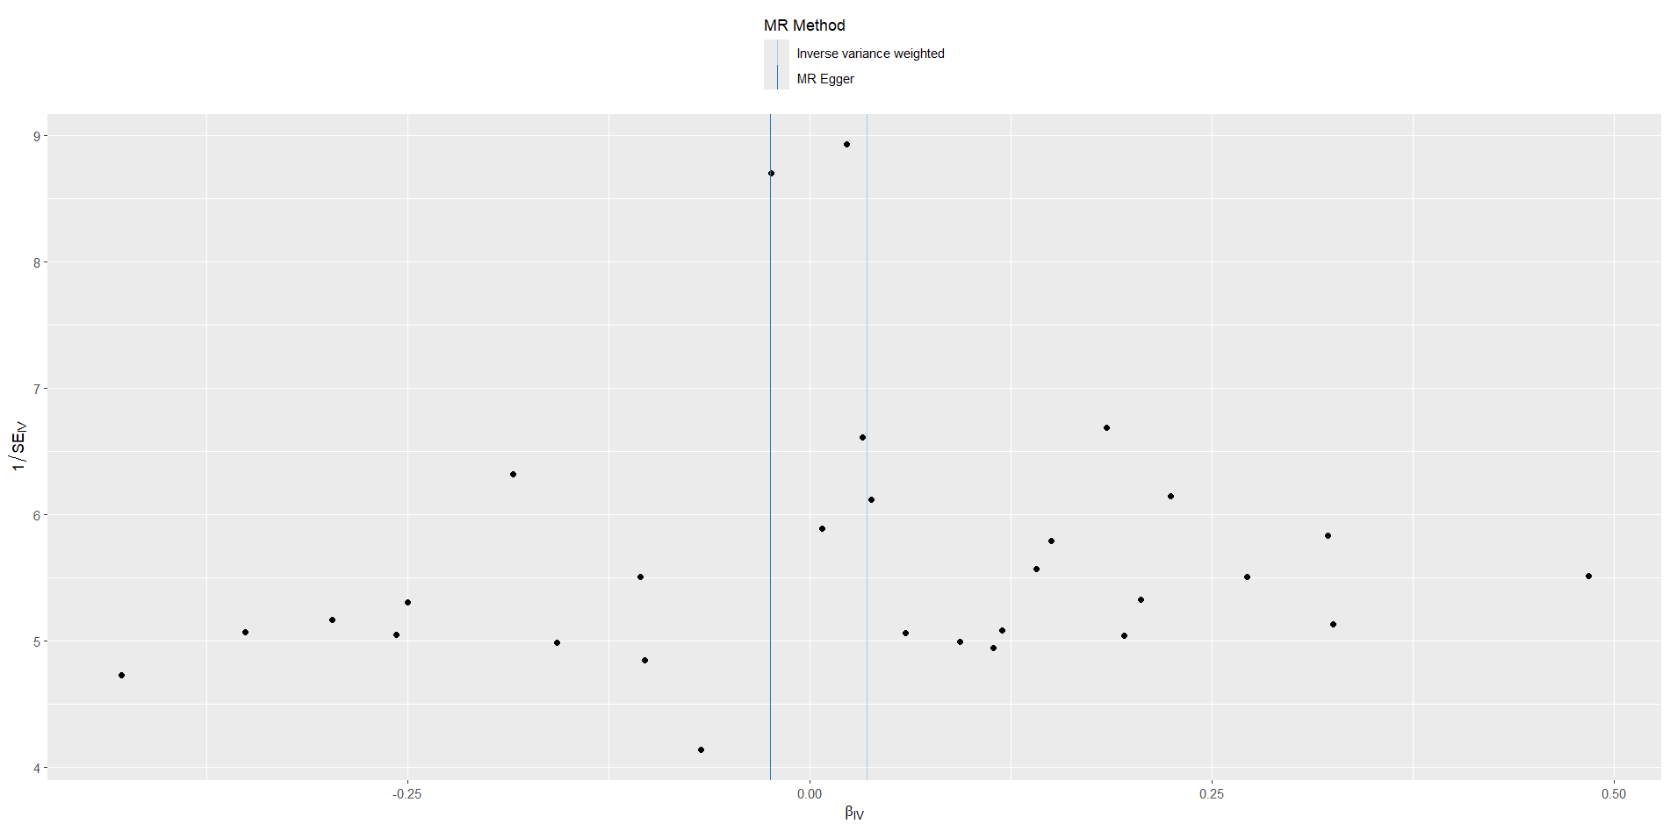
Supplementary Figure 1. The funnel plot of the heterogeneity of obstructive sleep apnea on migraine.

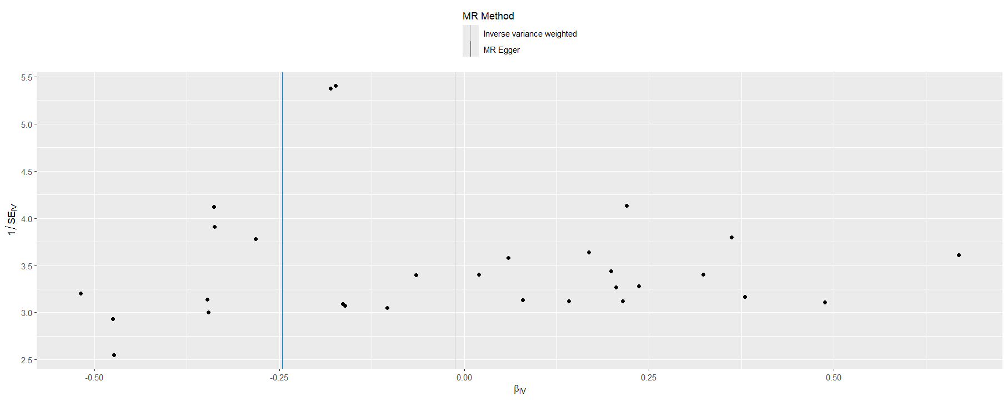
Supplementary Figure 2. The funnel plot of the heterogeneity of obstructive sleep apnea on migraine with aura.

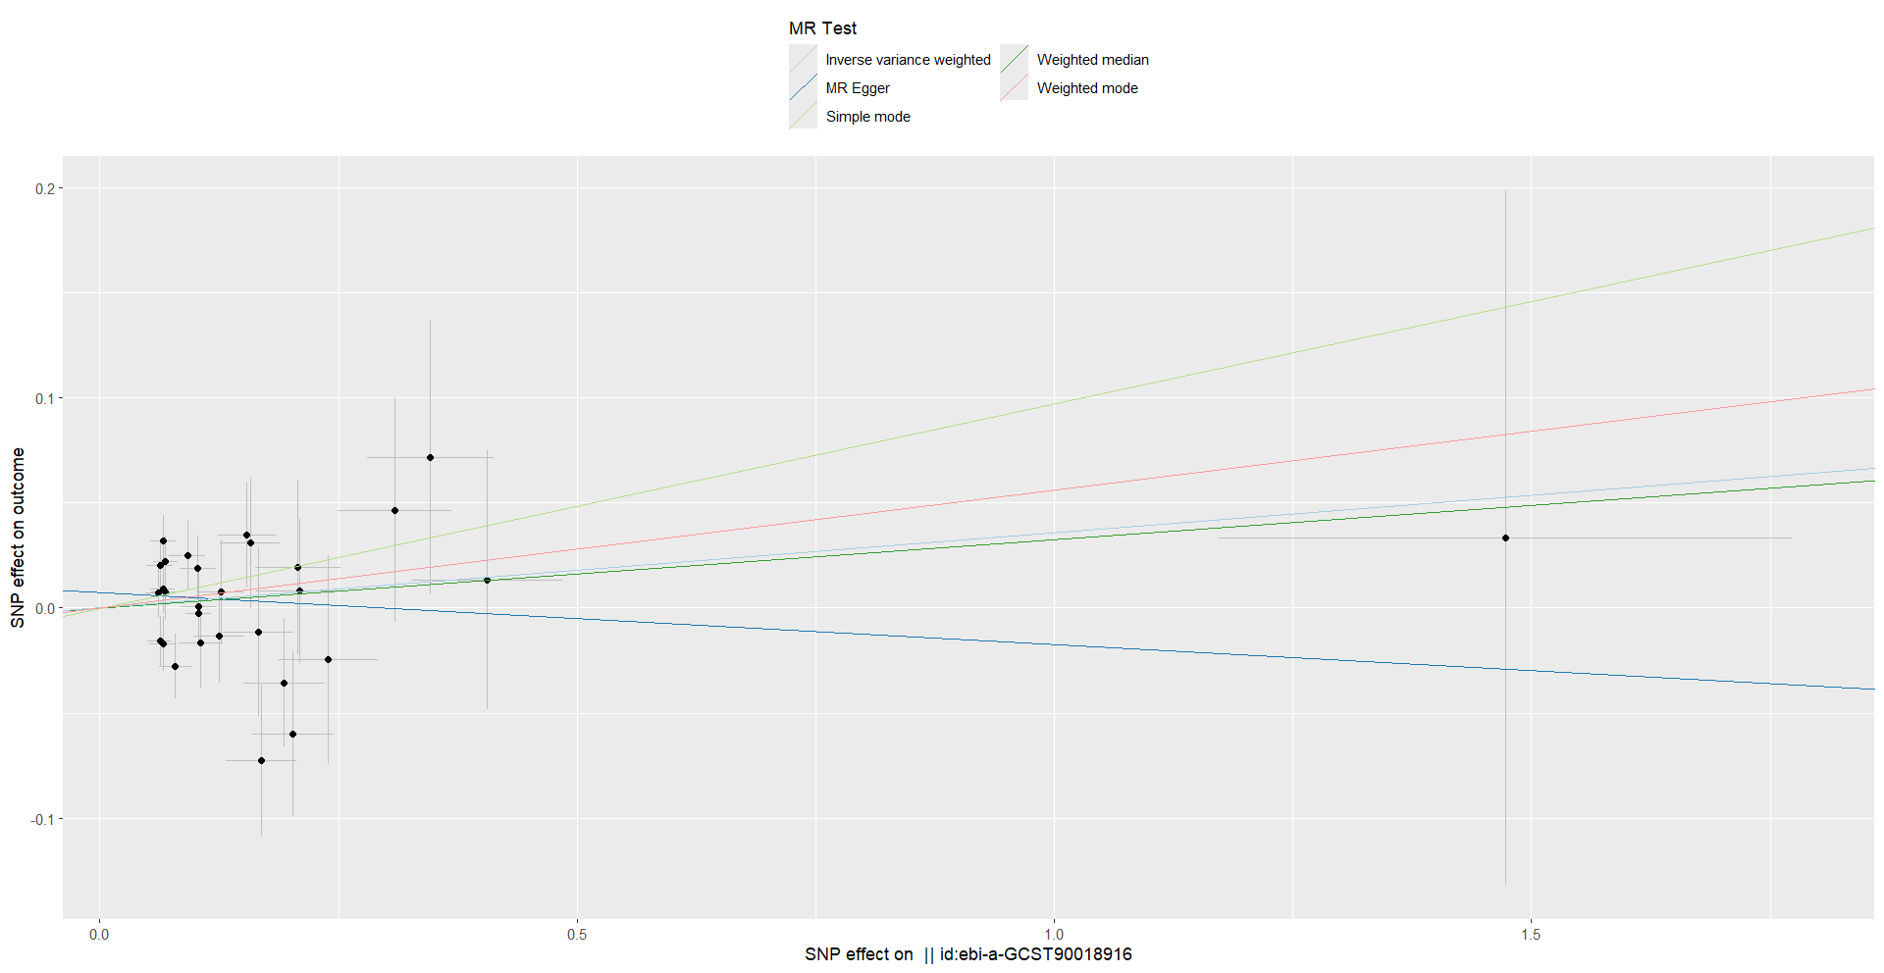
Supplementary Figure 3. The scatter plot of the causal effect of obstructive sleep apnea on migraine.

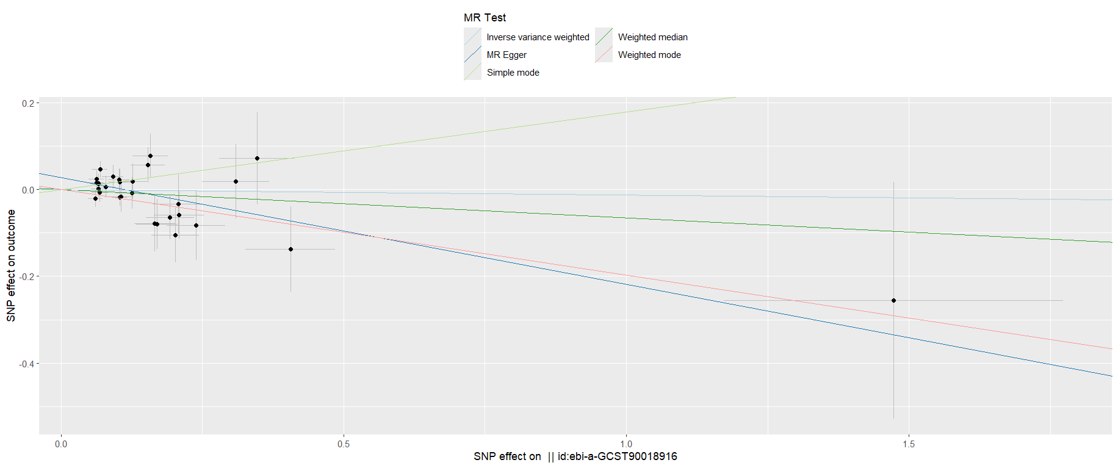
Supplementary Figure 4. The scatter plot of the causal effect of obstructive sleep apnea on migraine without aura.

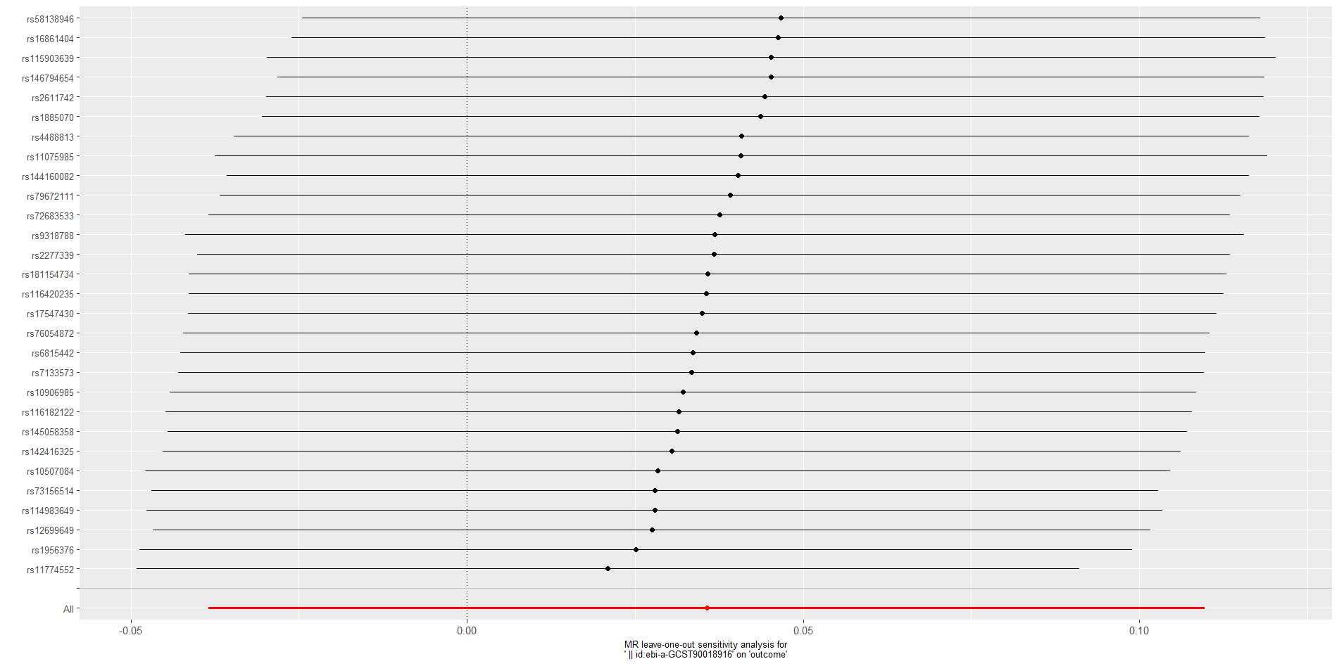
Supplementary Figure 5. The forest plot of the “leave-one-out” sensitivity analysis of the result of obstructive sleep apnea on migraine.

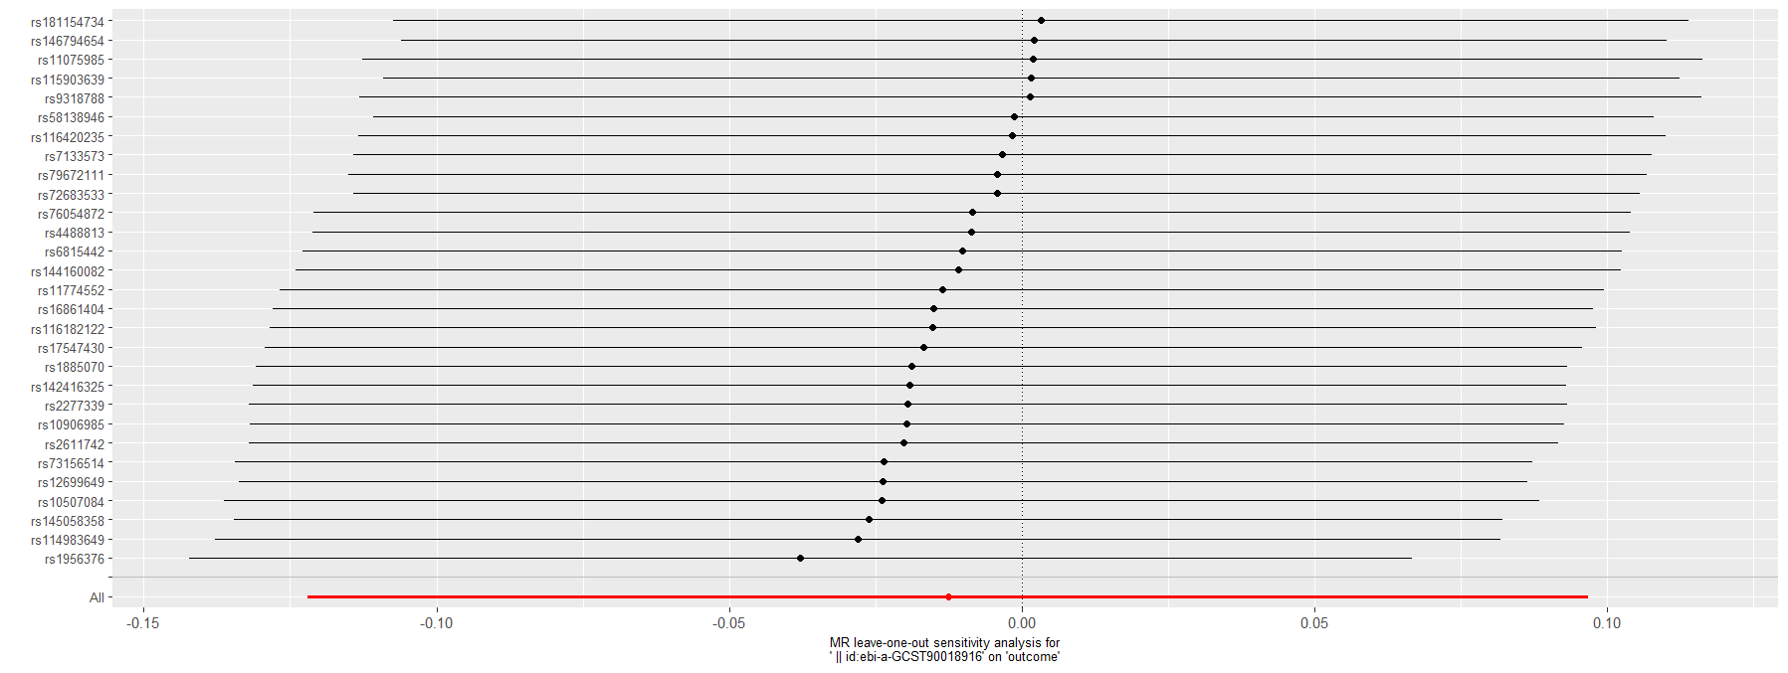
Supplementary Figure 6. The forest plot of the “leave-one-out” sensitivity analysis of the result of obstructive sleep apnea on migraine without aura.

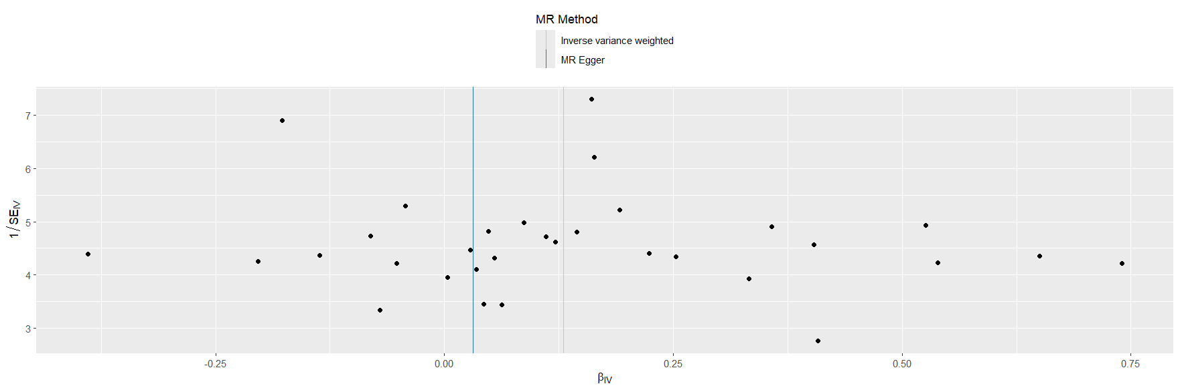
Supplementary Figure 7. The funnel plot of the heterogeneity of migraine on obstructive sleep apnea.

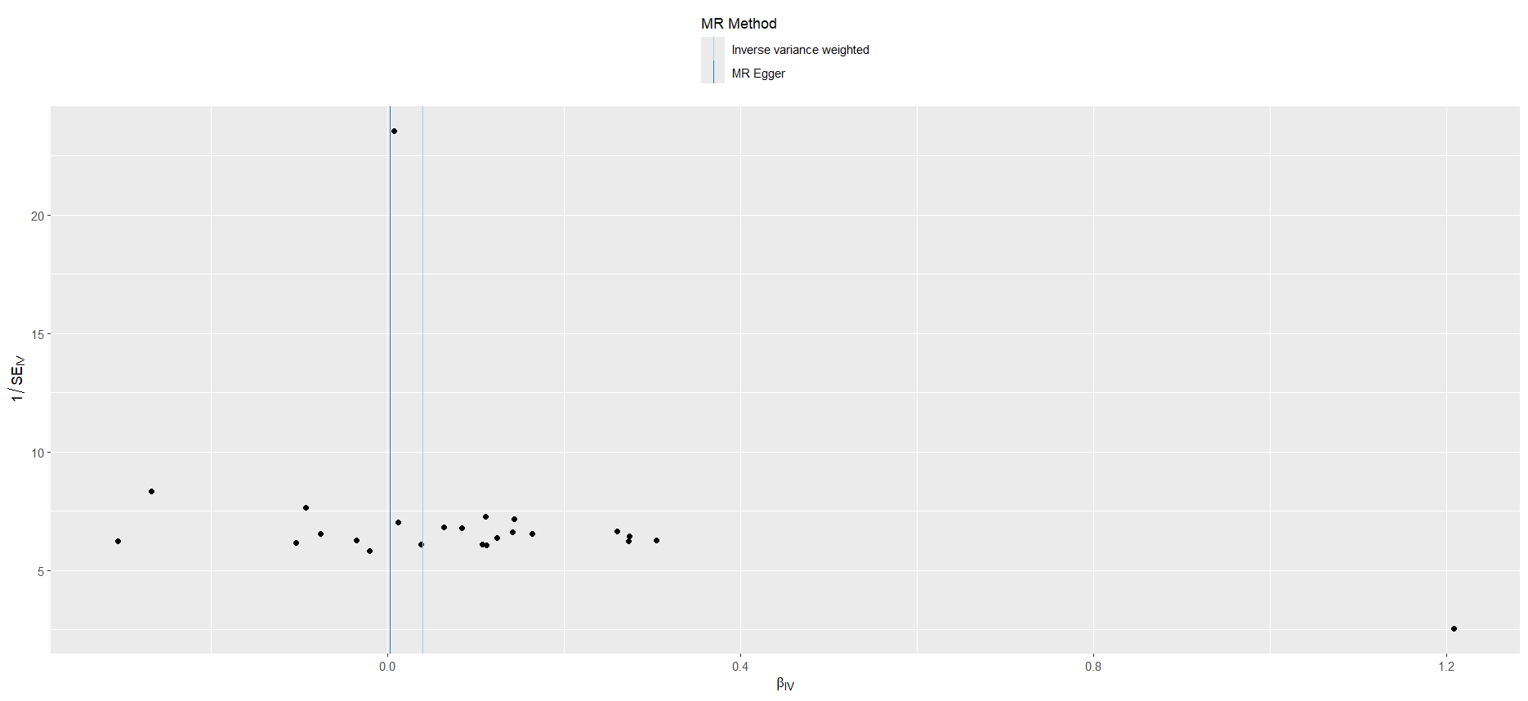
Supplementary Figure 8. The funnel plot of the heterogeneity of migraine with aura on obstructive sleep apnea.

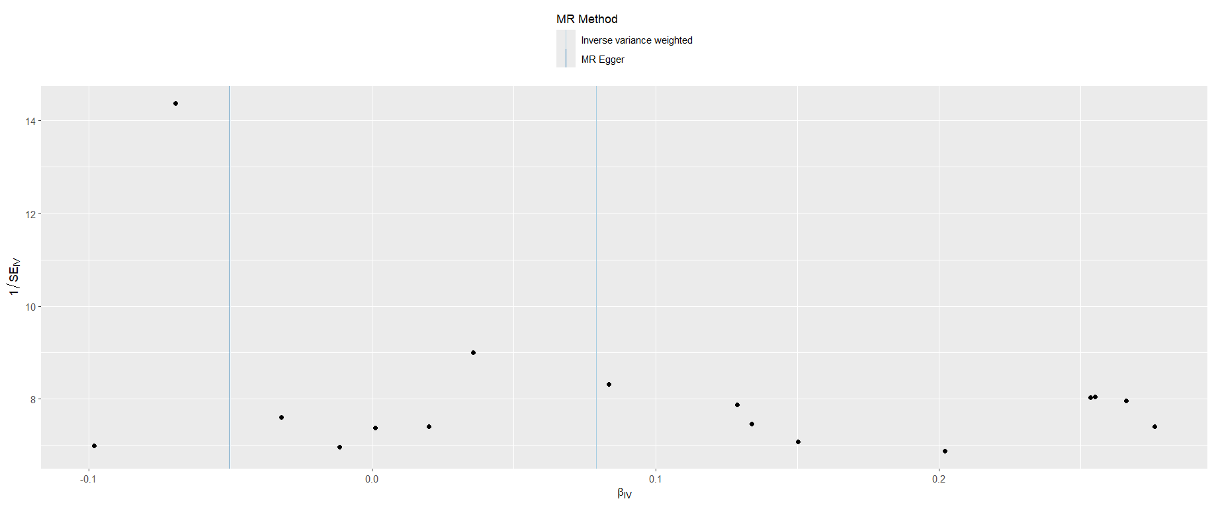
Supplementary Figure 9. The funnel plot of the heterogeneity of migraine without aura on obstructive sleep apnea.

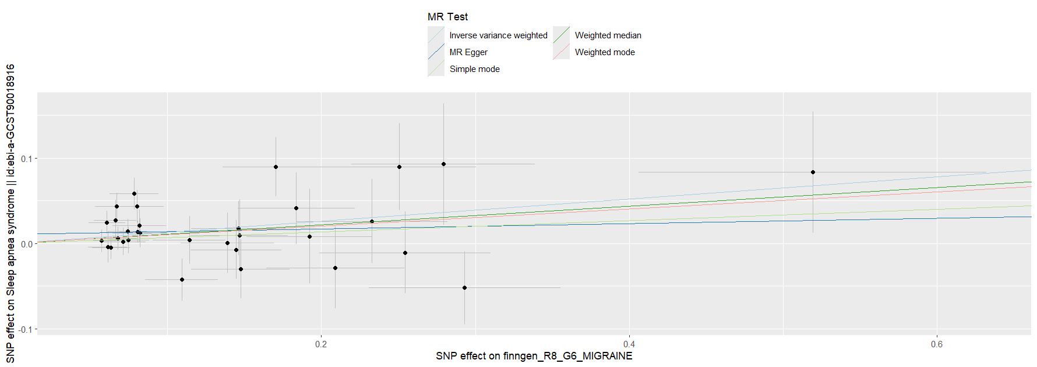
Supplementary Figure 10. The scatter plot of the causal effect of migraine in obstructive sleep apnea.

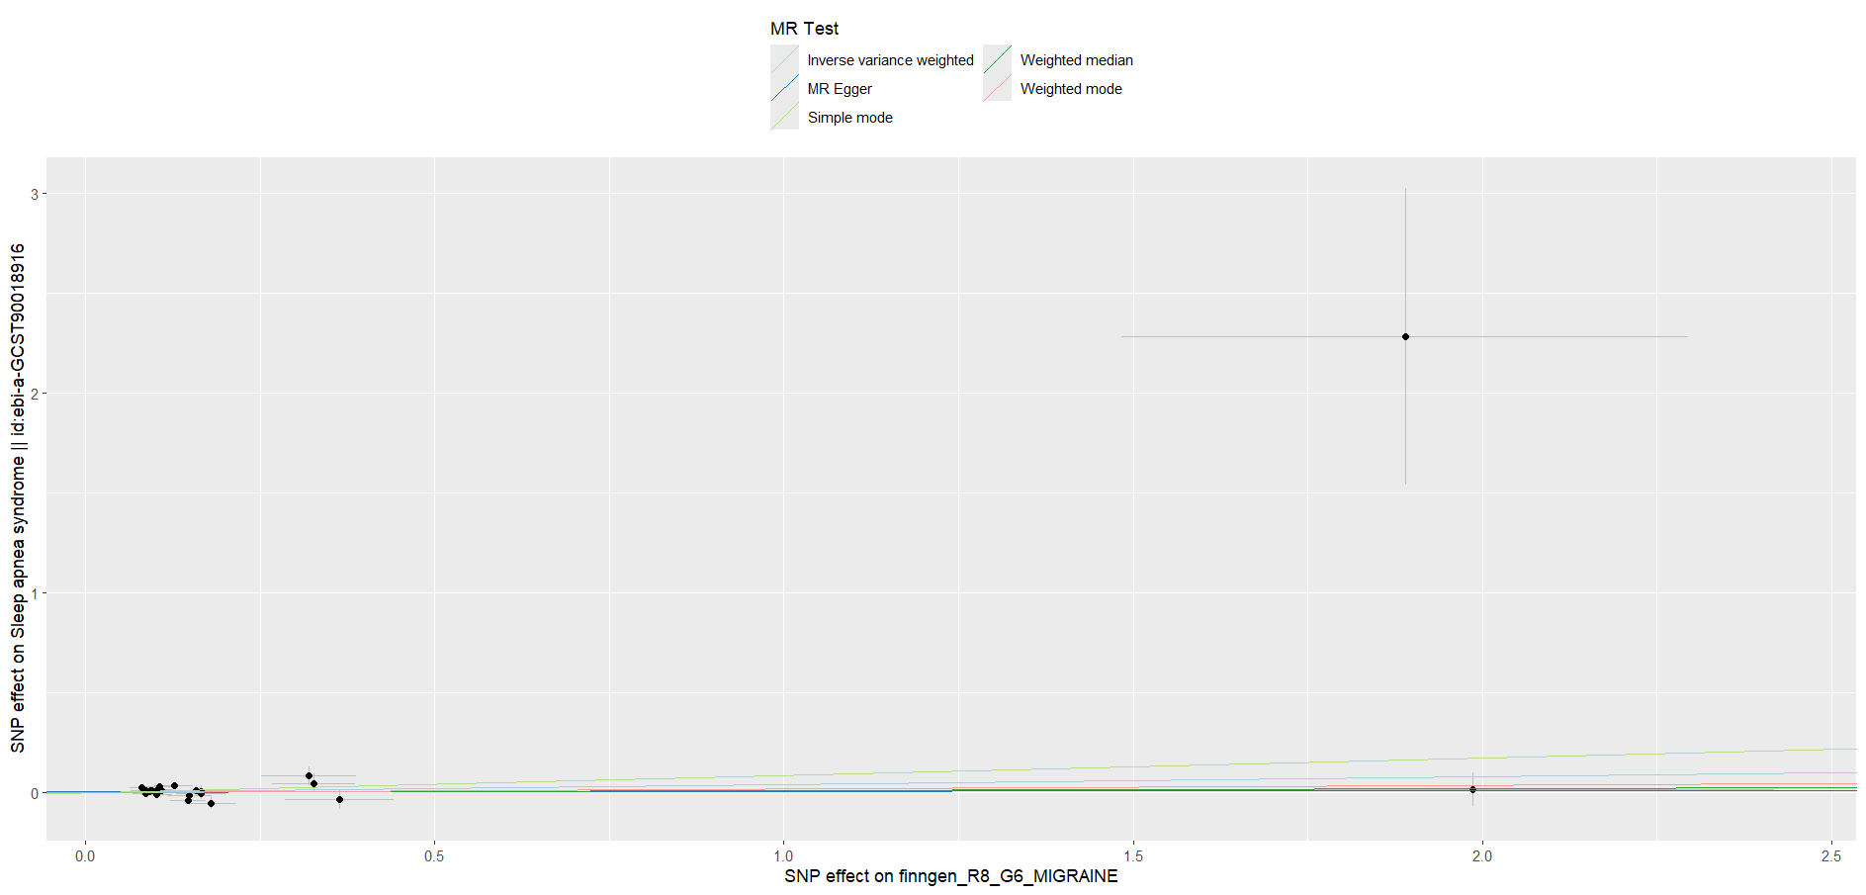
Supplementary Figure 11. The scatter plot of the causal effect of migraine with aura on obstructive sleep apnea.

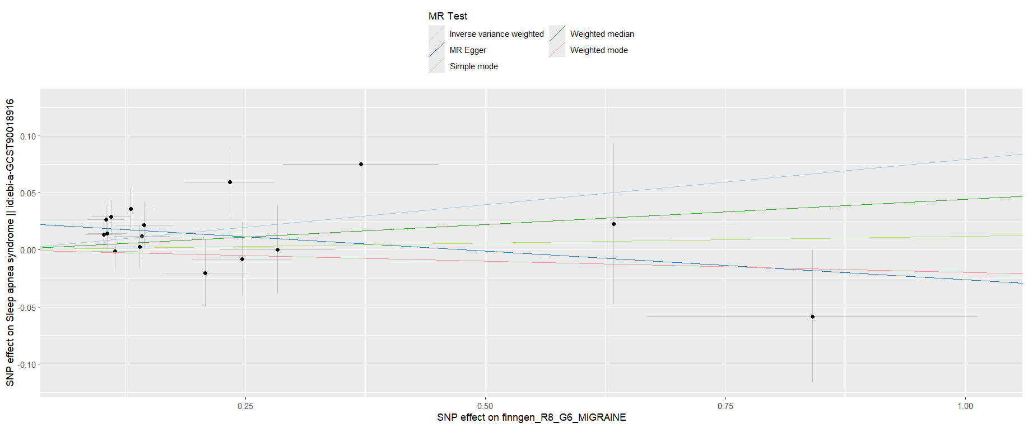
Supplementary Figure 12. The scatter plot of the causal effect of migraine without aura on obstructive sleep apnea.

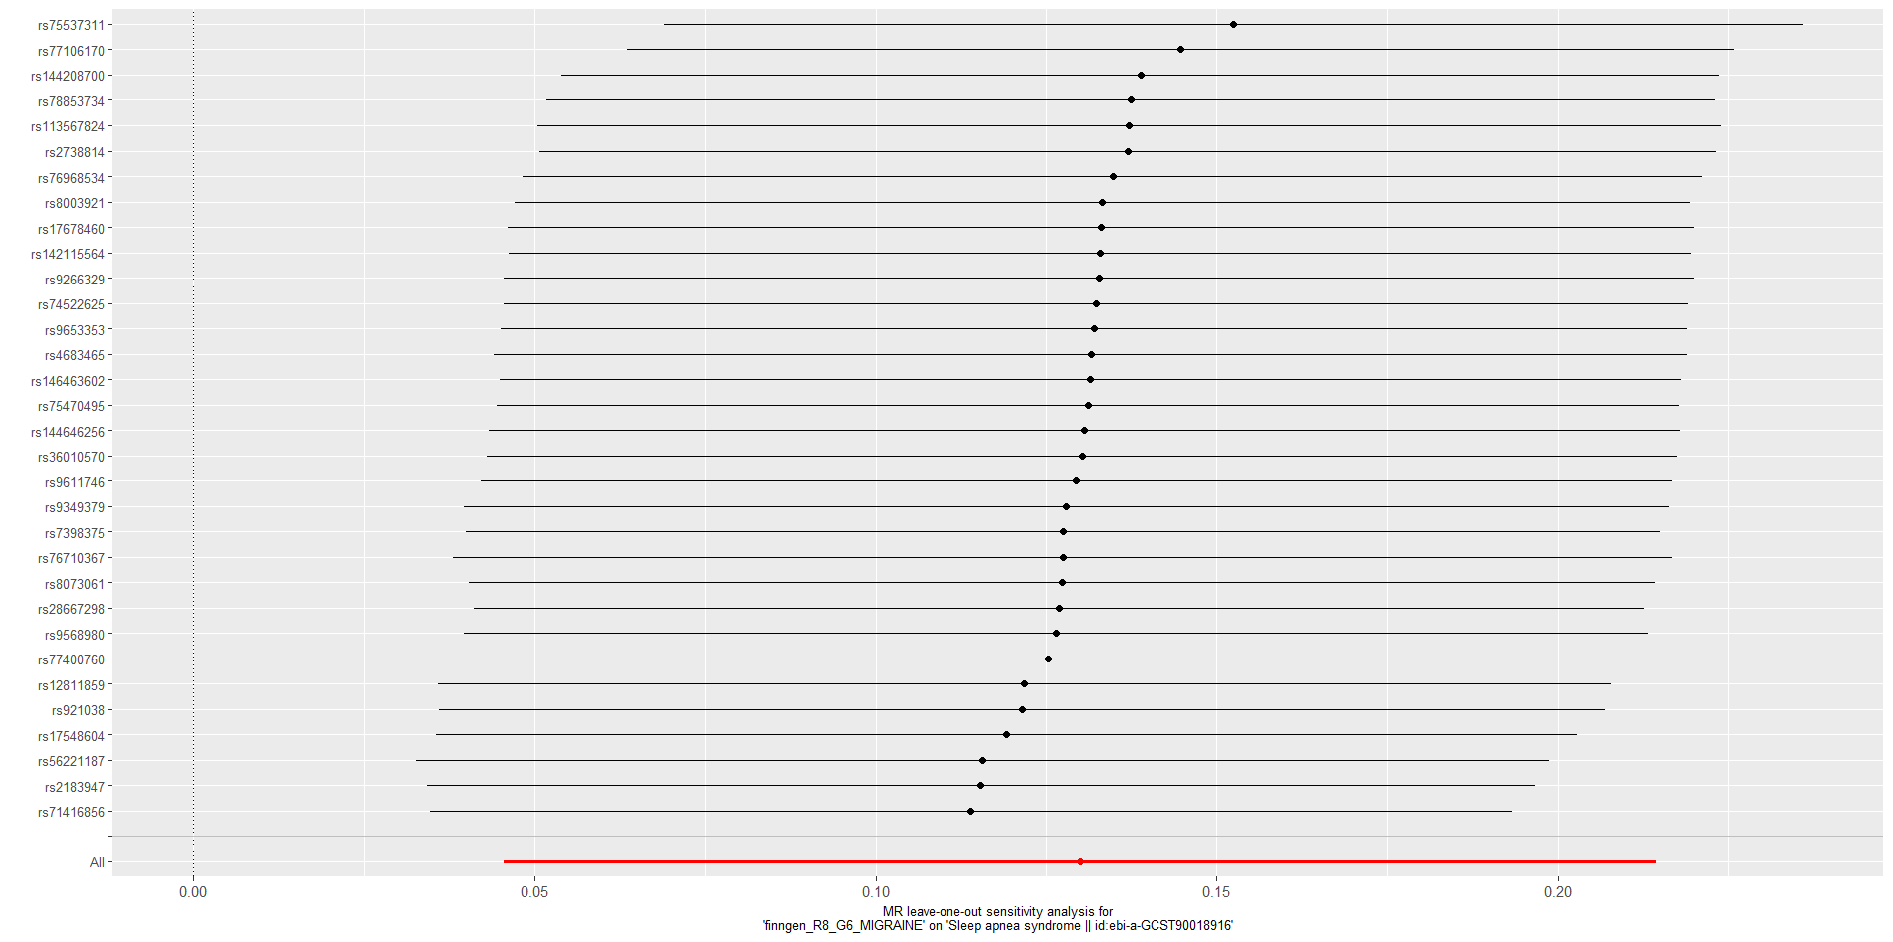
Supplementary Figure 13. The forest plot of the “leave-one-out” sensitivity analysis of the result of migraine on obstructive sleep apnea.

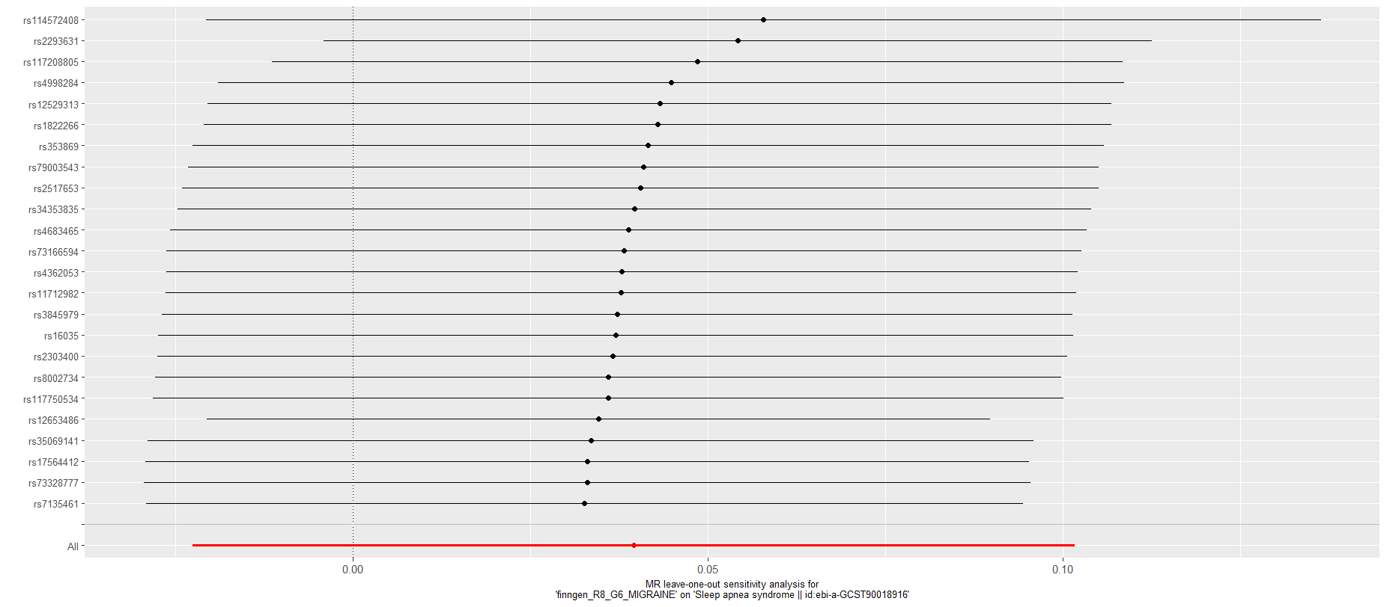
Supplementary Figure 14. The forest plot of the “leave-one-out” sensitivity analysis of the result of migraine with aura on obstructive sleep apnea.

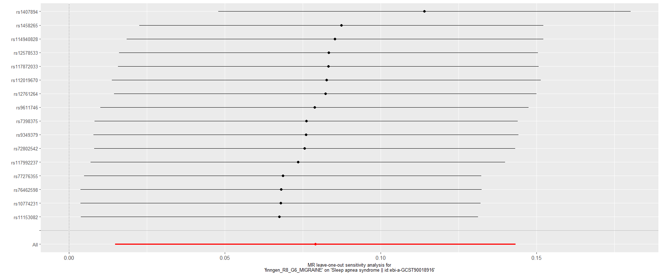
Supplementary Figure 15. The forest plot of the “leave-one-out” sensitivity analysis of the result of migraine without aura on obstructive sleep apnea.

