Supplementary Table 1
The demographic characteristics of the patients.
 | HCC  (n=56) | YFJP  (n=27) | ICI  (n=32) | p
Patients background
Age ,median | 59[55,66] | 58[53,69] | 64[53,67] | 0.942
Gender(female/male) (%) | 46(82.143) | 20(74.074) | 30(93.750) | 0.119
 | 10(17.857) | 7(25.926) | 2(6.250)
Hypertension(Yes/No) (%) | 37(66.071) | 11(40.741) | 13(40.625) | 0.024
 | 19(33.929) | 16(59.259) | 19(59.375)
Diabetes (Yes/No) (%) | 34(60.714) | 17(62.963) | 19(59.375) | 0.961
 | 22(39.286) | 10(37.037) | 13(40.625)
Hypertension(Yes/No) (%) | 36(64.286) | 24(88.889) | 21(65.625) | 0.055
 | 20(35.714) | 3(11.111) | 11(34.375)
HBV-related indicators
HBsAg(Positive/Negative) | 46(83.636) | 16(59.259) | 21(65.625) | 0.037
 | 9(16.364) | 11(40.741) | 11(34.375)
HBV-DNA (Positive/Negative) | 39(70.909) | 22(84.615) | 22(68.750) | 0.332
 | 16(29.091) | 4(15.385) | 10(31.250)
Laboratory data
Leukocyte counts(10⁹/l) | 4.62[3.17,6.03] | 3.79[2.60,4.84] | 3.85[3.30,6.63] | 0.417
Platelets (109/l) | 101[66,144] | 92[63,140] | 82[62,112] | 0.654
NLR | 3.33[2.29,5.62] | 2.55[1.68,3.42] | 4.23[2.65,6.28] | 0.005
ALT (U/l) | 27.8[21.8,48.3] | 20.9[13.9,35.8] | 32.1[18.5,36.4] | 0.179
AST (U/l) | 39.4[28.0,67.2] | 30.1[24.9,48.6] | 41.4[24.8,48.6] | 0.307
Totall Bilirubin (umol/l) | 24.1[14.3,41.3] | 15.8[10.6,26.1] | 27.8[15.6,35.6] | 0.032
γ-GGT (U/l) | 87.5[27.9,188.6] | 66.0[26.4,81.3] | 60.9[35.5,97.5] | 0.162
Albumin (g/l) | 34.6[30.9,37.8] | 38.4[33.8,41.0] | 33.7[28.9,38.0] | 0.022
Creatinine (μmol/l) | 68.8 [57.5,84.8] | 66.2[50.9,72.6] | 69.4[60.1,87.4] | 0.105
Prothrombin activity(%) | 71 [65,83] | 78 [63,84] | 73 [61,75] | 0.137
Tumor-related indicators
Child grade A | 26(46.429) | 20(80.000) | 12(40.000) | 0.453
B | 20(35.714) | 5(20.000) | 13(43.333)
C | 10(17.857) | 0(0.000) | 5(16.667)
Tumor solitary (solitary/multiple)) | 13(23.214) | 8(29.630) | 8(25.000) | 0.819
 | 43(76.786) | 19(70.370) | 24(75.000)
Tumor size, cm, (<5/≥5) | 32(57.143) | 21(77.778) | 18(56.250) | 0.146
 | 24(42.857) | 6(22.222) | 14(43.750)
AFP≥8.8(ng/ml) | 24(42.857) | 13(48.148) | 16(50.000) | 0.754
 | 31(55.357) | 14(51.852) | 16(50.000)
Portal Vein Tumor Thrombus (Yes/No) | 20(35.714) | 11(40.741) | 9(28.125) | 0.586
 | 36(64.286) | 16(59.259) | 23(71.875)

Supplementary Figure 1
A | 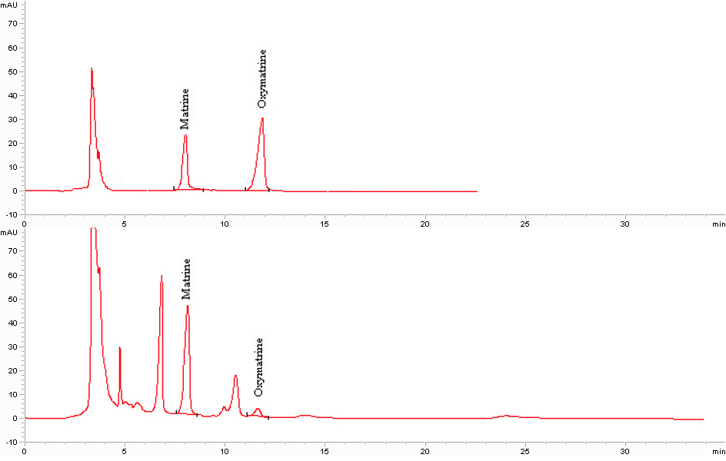
B

Supplementary Figure 1. Analysis of YFJP components in serum of H22 Tumor bearing mice by high-performance liquid chromatography (HPLC). Matrine and Oxymatrine, known components of Kushen, were detected, both known components were detected in the serum of H22 tumor-bearing mice (B) compared with the standard control (A).

