Supplementary Figure 1, Quality control of sample data
(A) Show the proportion of data below LOD in all samples in the form of bar chart, where blue represents the part of data above LOD and red represents the part of data below LOD. (B) Is the Interquartile Range (Interquartile Range, IQR are much less) as a result, compared with the standard deviation to estimate the discrete degree, IQR are much less data can get rid of the influence of extreme value, used to estimate the discrete degree will be more conservative. (C) The distribution of NPX values of all samples in the selected Panel is shown in a boxplot, where the samples of QC warning are marked in different colors.

Supplementary Figure 2. Correlation Analysis between Samples
(A) Heat map of protein expression was displayed according to sample grouping (B-D) PCA, tSNE and UMAP were used to analyze the data and explore the relationship between each sample. In the PCA dimensionality reduction analysis image, the horizontal axis represents the first principal component, and the vertical axis is the second principal component. In tSNE and UMAP two-dimensional image, the horizontal axis and vertical axis represents the two-dimensional axis after the dimension, each point corresponds to a sample. The diagram shows different ways of coloring of two-dimensional images, and illustrations are a sample group of color information. Blue stands for colorectal cancer samples, red representative samples of healthy controls.

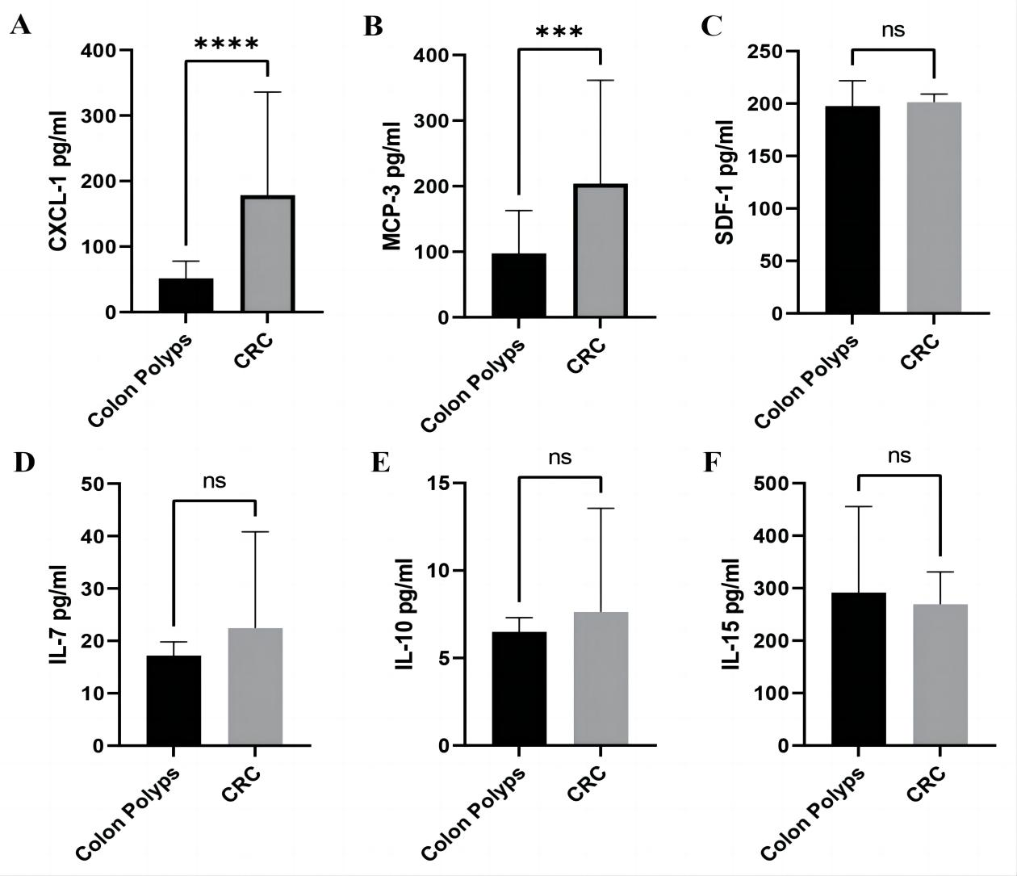
Supplementary Figure 3. Verify the relative content of IL 7, CXCL12, IL 10, IL 15, CXCL 1 and MCP-3 in the CRC group and the control group use ELISA assay.
(A-F) the relative content of IL 7, CXCL12, IL 10, IL 15, CXCL 1 and MCP-3 in the CRC group and the control group,****P<0.05,***P<0.01.

 | control | CRC | P value
N | 51 | 47
Age | 55.84±13.08 | 63.68±13.82 | 0.896
AFP | 2.70±1.08 | 2.91±1.69 | 0.010
CEA | 2.09±1.09 | 27.76±88.34 | 0.001
CA19-9 | 10.71±5.75 | 51.26±200.09 | 0.015
CA72-4 | 2.27±1.83 | 2.67±4.70 | 0.154
Supplementary Table 1. General information of the patients in discover cohorts

Supplementary Table 2. General information of the patients in validation cohorts

 | control | CRC | P value
N | 31 | 31
Age | 57.03±12.08 | 68.03±10.59 | 0.268
AFP | 2.86±1.35 | 2.87±1.64 | 0.002
CEA | 2.76±2.79 | 19.88±34.13 | <0.0001
CA19-9 | 9.62±5.04 | 29.46±44.52 | <0.0001
CA72-4 | 7.98±18.26 | 1.932±0.78 | <0.0001

Supplementary Table 3. Tumor-immune-related factors

Name | Abbreviation | Number
Adenosine deaminase | (ADA) | P00813
Adhesion G-protein coupled receptor G1 | (ADGRG1) | Q9Y653
Angiopoietin-1 | (ANGPT1) | Q15389
Angiopoietin-1 receptor | (TIE2) | Q02763
Angiopoietin-2 | (ANGPT2) | O15123
Arginase-1 | (ARG1) | P05089
Carbonic anhydrase 9 | (CAIX) | Q16790
Caspase-8 | (CASP-8) | Q14790
C-C motif chemokine 13 | (MCP-4) | Q99616
C-C motif chemokine 17 | (CCL17) | Q92583
C-C motif chemokine 19 | (CCL19) | Q99731
C-C motif chemokine 2 | (MCP-1) | P13500
C-C motif chemokine 20 | (CCL20) | P78556
C-C motif chemokine 23 | (CCL23) | P55773
C-C motif chemokine 3 | (CCL3) | P10147
C-C motif chemokine 4 | (CCL4) | P13236
C-C motif chemokine 7 | (MCP-3) | P80098
C-C motif chemokine 8 | (MCP-2) | P80075
CD27 antigen | (CD27) | P26842
CD40 ligand | (CD40-L) | P29965
CD40L receptor | (CD40) | P25942
CD70 antigen | (CD70) | P32970
CD83 antigen | (CD83) | Q01151
C-X-C motif chemokine 1 | (CXCL1) | P09341
C-X-C motif chemokine 10 | (CXCL10) | P02778
C-X-C motif chemokine 11 | (CXCL11) | O14625
C-X-C motif chemokine 13 | (CXCL13) | O43927
C-X-C motif chemokine 5 | (CXCL5) | P42830
C-X-C motif chemokine 9 | (CXCL9) | Q07325
Cytotoxic and regulatory T-cell molecule | (CRTAM) | O95727
Macrophage colony-stimulating factor 1 | (CSF-1) | P09603
Macrophage metalloproteinase-12 | (MMP12) | P39900
Matrix metalloproteinase-7 | (MMP7) | P09237
MHC class I polypeptide-related sequence A/B | (MIC-A/B) | Q29983,Q29980
Mucin-16 | (MUC-16) | Q8WXI7
Natural cytotoxicity triggering receptor | (NCR1) | O76036
Natural killer cell receptor 2B4 | (CD244) | Q9BZW8
Natural killer cells antigen CD94 | (KLRD1) | Q13241
Nitric oxide synthase, endothelial | (NOS3) | P29474
Placenta growth factor | (PGF) | P49763
Platelet-derived growth factor subunit B | (PDGF subunit B) | P01127
Pleiotrophin | (PTN) | P21246
Pro-epidermal growth factor | (EGF) | P01133
Programmed cell death 1 ligand 1 | (PD-L1) | Q9NZQ7
Programmed cell death 1 ligand 2 | (PD-L2) | Q9BQ51
Programmed cell death protein 1 | (PDCD1) | Q15116
Decorin | (DCN) | P07585
Fibroblast growth factor 2 | (FGF2) | P090
Fractalkine | (CX3CL1) | P78423
Galectin-1 | (Gal-1) | P09382
Galectin-9 | (Gal-9) | O00182
Granzyme A | (GZMA) | P12544
Granzyme B | (GZMB) | P10144
Granzyme H | (GZMH) | P20718
Heme oxygenase 1 | (HO-1) | P09601
Hepatocyte growth factor | (HGF) | P14210
ICOS ligand | (ICOSLG) | O75144
Interferon gamma | (IFN-gamma) | P01579
Interleukin-1 alpha | (IL-1 alpha) | P01583
Interleukin-10 | (IL10) | P22301
Interleukin-12 | (IL12) | P29459,P29460
Interleukin-12 receptor subunit beta-1 | (IL12RB1) | P42701
Interleukin-13 | (IL13) | P35225
Interleukin-15 | (IL15) | P40933
Interleukin-18 | (IL18) | Q14116
Interleukin-2 | (IL2) | P60568
Interleukin-33 | (IL33) | O95760
Interleukin-4 | (IL4) | P05112
Interleukin-5 | (IL5) | P05113
Interleukin-6 | (IL6) | P05231
Interleukin-7 | (IL7) | P13232
Interleukin-8 | (IL8) | P10145
Killer cell immunoglobulin-like receptor 3DL1 | (KIR3DL1) | P43629
Latency-associated peptide transforming growth factor beta-1 | (LAP TGF-beta-1) | P01137
Lymphocyte activation gene 3 protein | (LAG3) | P18627
Lysosome-associated membrane glycoprotein 3 | (LAMP3) | Q9UQV4
Stromal cell-derived factor 1 | (CXCL12) | P48061
T-cell surface glycoprotein CD4 | (CD4) | P01730
T-cell surface glycoprotein CD5 | (CD5) | P06127
T-cell surface glycoprotein CD8 alpha chain | (CD8A) | P01732
T-cell-specific surface glycoprotein CD28 | (CD28) | P10747
TNF-related apoptosis-inducing ligand | (TRAIL) | P50591
Tumor necrosis factor | (TNF) | P01375
Tumor necrosis factor ligand superfamily member 12 | (TWEAK) | O43508
Tumor necrosis factor ligand superfamily member 14 | (TNFSF14) | O43557
Tumor necrosis factor ligand superfamily member 6 | (FASLG) | P48023
Tumor necrosis factor receptor superfamily member 12A | (TNFRSF12A) | Q9NP84
Tumor necrosis factor receptor superfamily member 21 | (TNFRSF21) | O75509
Tumor necrosis factor receptor superfamily member 4 | (TNFRSF4) | P43489
Tumor necrosis factor receptor superfamily member 9 | (TNFRSF9) | Q07011
Vascular endothelial growth factor A | (VEGFA) | P15692
Vascular endothelial growth factor receptor 2 | (VEGFR-2) | P35968

 | AUC | Sensitivity | Specificity
IL7 | 0.8690 | 78.72 | 90.20
IL10 | 0.7334 | 82.98 | 60.78
IL15 | 0.8444 | 74.47 | 82.35
CXCL1 | 0.7778 | 80.85 | 72.55
CXCL12 | 0.6567 | 44.68 | 82.35
MCP-3 | 0.6366 | 59.57 | 80.39
CEA | 0.7651 | 63.83 | 82.35
CA19-9 | 0.6045 | 34.04 | 88.24
Supplementary Table 4. Sensitivity and specificity analysis

Supplementary Table 5. Relationship between IL15 expression and the clinical characteristics of
CRC patients
 | Patients (n) | Mean±standard deviation | P-value
Sex |  |  | 0.8523
male | 30 | 4.87±0.67
female | 17 | 4.75±0.41
Age (years) |  |  | 0.4626
≥60 | 32 | 4.86±0.57
<60 | 15 | 4.76±0.65
Tumor size (cm) |  |  | 0.0004
≥4 | 31 | 4.97±0.56
<4 | 11 | 4.31±0.46
Degree of infiltration |  |  | 0.2248
T1 | 2 | 4.28±0.07
T2 | 5 | 4.91±0.46
T3 | 21 | 4.80±0.66
T4 | 10 | 4.97±0.62
Lymphatic metastasis |  |  | 0.9779
Yes | 19 | 4.81±0.72
No | 22 | 4.81±0.50
Distant metastasis |  |  | 0.1747
Yes | 6 | 5.03±0.85
No | 30 | 4.68±0.49
TNM |  |  | 0.1276
I | 10 | 4.84±0.64
II | 12 | 4.72±0.41
III | 20 | 4.74±0.58
IV | 5 | 5.41±0.71
Differentiation |  |  | 0.9756
High | 0 | 0
Moderate | 39 | 4.82±0.61
Poor | 2 | 4.77±0.12
Location |  |  | 0.4483
rectum | 20 | 4.83±0.58
colon | 26 | 4.81±0.62

Supplementary Table 6. Relationship between MCP-3 expression and the clinical characteristics of CRC patients
 | Patients (n) | Mean±standard deviation | P-value
Sex |  |  | 0.5176
male | 30 | 3.33±2.48
female | 17 | 2.75±2.08
Age (years) |  |  | 0.4626
≥60 | 32 | 2.94±2.17
<60 | 15 | 3.49±2.70
Tumor size (cm) |  |  | 0.4123
≥4 | 31 | 3.18±2.42
<4 | 11 | 2.44±1.62
Degree of infiltration |  |  | 0.4184
T1 | 2 | 1.37±0.37
T2 | 5 | 2.17±1.00
T3 | 21 | 3.31±2.48
T4 | 10 | 2.91±2.05
Lymphatic metastasis |  |  | 0.2072
Yes | 19 | 3.51±2.69
No | 22 | 2.37±1.34
Distant metastasis |  |  | 0.0465
Yes | 6 | 3.79±2.30
No | 30 | 2.70±2.19
TNM |  |  | 0.0496
I | 10 | 2.16±1.47
II | 12 | 2.22±1.06
III | 20 | 3.69±2.85
IV | 5 | 4.92±2.47
Differentiation |  |  | 0.1756
High | 0 | 0
Moderate | 39 | 3.05±2.29
Poor | 2 | 1.31±0.59
Location |  |  | 0.9738
rectum | 20 | 3.03±2.16
colon | 26 | 3.00±2.35

Supplementary Table 7. Relationship between CXCL1 expression and the clinical characteristics of CRC patients
 | Patients (n) | Mean±standard deviation | P-value
Sex |  |  | 0.3419
male | 30 | 9.55±1.02
female | 17 | 9.42±0.91
Age (years) |  |  | 0.6778
≥60 | 32 | 0.16±0.20
<60 | 15 | 0.25±0.36
Tumor size (cm) |  |  | 0.332
≥4 | 31 | 9.60±0.92
<4 | 11 | 9.26±1.22
Degree of infiltration |  |  | 0.29
T1 | 2 | 9.68±1.01
T2 | 5 | 10.22±0.91
T3 | 21 | 9.36±0.80
T4 | 10 | 9.71±1.01
Lymphatic metastasis |  |  | 0.7942
Yes | 19 | 9.50±0.87
No | 22 | 9.57±0.93
Distant metastasis |  |  | 0.5535
Yes | 6 | 9.31±0.92
No | 30 | 9.56±0.94
TNM |  |  | 0.8598
I | 10 | 9.61±1.23
II | 12 | 9.40±0.98
III | 20 | 9.45±0.87
IV | 5 | 9.81±1.09
Differentiation |  |  | 0.322
High | 0 | 0
Moderate | 39 | 9.50±0.99
Poor | 2 | 10.32±1.19
Location |  |  | 0.0909
rectum | 20 | 9.24±0.80
colon | 26 | 9.74±1.08

Supplementary Table 8. Relationship between CXCL12 expression and the clinical characteristics of CRC patients
 | Patients (n) | Mean±standard deviation | P-value
Sex |  |  | 0.1932
male | 30 | 0.46±0.61
female | 17 | 0.20±0.75
Age (years) |  |  | 0.5634
≥60 | 32 | 0.41±0.73
<60 | 15 | 0.28±0.53
Tumor size (cm) |  |  | 0.1816
≥4 | 31 | 0.35±0.69
<4 | 11 | 0.67±0.57
Degree of infiltration |  |  | 0.0716
T1 | 2 | 1.15±0.10
T2 | 5 | 0.77±0.61
T3 | 21 | 0.22±0.58
T4 | 10 | 0.70±0.81
Lymphatic metastasis |  |  | 0.5698
Yes | 19 | 0.49±0.71
No | 22 | 0.37±0.66
Distant metastasis |  |  | 0.8182
Yes | 6 | 0.51±0.72
No | 30 | 0.43±0.70
TNM |  |  | 0.1392
I | 10 | 0.73±0.55
II | 12 | 0.25±0.58
III | 20 | 0.37±0.76
IV | 5 | -0.07±0.38
Differentiation |  |  | 0.2951
High | 0 | 0
Moderate | 39 | 0.42±0.67
Poor | 2 | 0.98±0.74
Location |  |  | 0.1969
rectum | 20 | 0.24±0.50
colon | 26 | 0.50±0.76

Supplementary Table 9. Relationship between IL7 expression and the clinical characteristics of CRC patients
 | Patients (n) | Mean±standard deviation | P-value
Sex |  |  | 0.2302
male | 30 | 5.33±1.11
female | 17 | 5.44±1.33
Age (years) |  |  | 0.1692
≥60 | 32 | 5.54±1.15
<60 | 15 | 5.00±1.21
Tumor size (cm) |  |  | 0.0113
≥4 | 31 | 5.64±0.96
<4 | 11 | 4.53±1.43
Degree of infiltration |  |  | 0.2136
T1 | 2 | 4.74±0.74
T2 | 5 | 5.48±0.52
T3 | 21 | 5.36±1.26
T4 | 10 | 5.90±0.81
Lymphatic metastasis |  |  | 0.4763
Yes | 19 | 5.27±1.27
No | 22 | 5.60±1.04
Distant metastasis |  |  | 0.6741
Yes | 6 | 5.59±0.99
No | 30 | 5.36±1.24
TNM |  |  | 0.2571
I | 10 | 5.28±1.15
II | 12 | 5.71±1.31
III | 20 | 5.15±1.25
IV | 5 | 5.56±0.46
Differentiation |  |  | 0.2195
High | 0 | 0
Moderate | 39 | 5.36±1.11
Poor | 2 | 6.51±0.77
Location |  |  | 0.9975
rectum | 20 | 5.34±1.24
colon | 26 | 5.34±1.16

Supplementary Table 10. Relationship between IL10 expression and the clinical characteristics of CRC patients
 | Patients (n) | Mean±standard deviation | P-value
Sex |  |  | 0.3008
male | 30 | 3.25±1.06
female | 17 | 2.94±0.83
Age (years) |  |  | 0.9384
≥60 | 32 | 3.13±0.95
<60 | 15 | 3.15±1.09
Tumor size (cm) |  |  | 0.1207
≥4 | 31 | 3.25±1.03
<4 | 11 | 2.70±0.91
Degree of infiltration |  |  | 0.105
T1 | 2 | 1.80±0.09
T2 | 5 | 3.34±0.85
T3 | 21 | 3.14±0.97
T4 | 10 | 3.11±1.00
Lymphatic metastasis |  |  | 0.8769
Yes | 19 | 3.01±1.01
No | 22 | 3.06±0.95
Distant metastasis |  |  | 0.2085
Yes | 6 | 3.42±1.14
No | 30 | 2.89±0.90
TNM |  |  | 0.4767
I | 10 | 3.09±1.03
II | 12 | 2.99±0.91
III | 20 | 3.09±0.99
IV | 5 | 3.79±1.12
Differentiation |  |  | 0.7463
High | 0 | 0
Moderate | 39 | 3.16±1.02
Poor | 2 | 2.74±0.47
Location |  |  | 0.0617
rectum | 20 | 2.80±0.75
colon | 26 | 3.34±1.07

