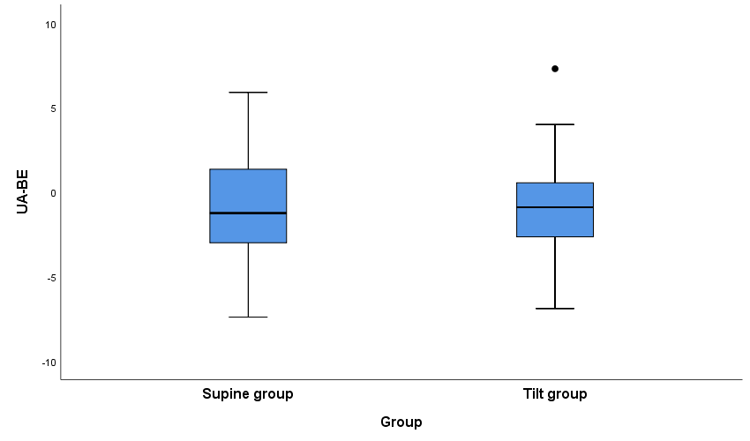
Figure S1: Box plot of the distribution of the base excess of the umbilical artery by group. The line outlier median, box outlier interquartile range, whisker outlier 2.5th percentile and 97.5th percentile and dots represent outlier values.

