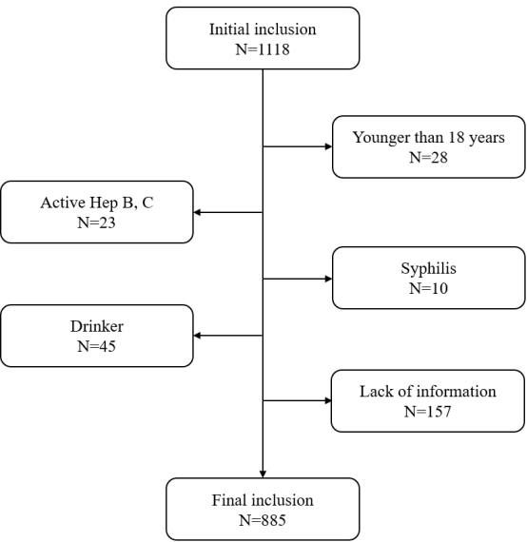S
Supplementary Fig 1. Flowchart of participant exclusion in cohort of MAFLD patients referred for specialist assessment by primary care physicians

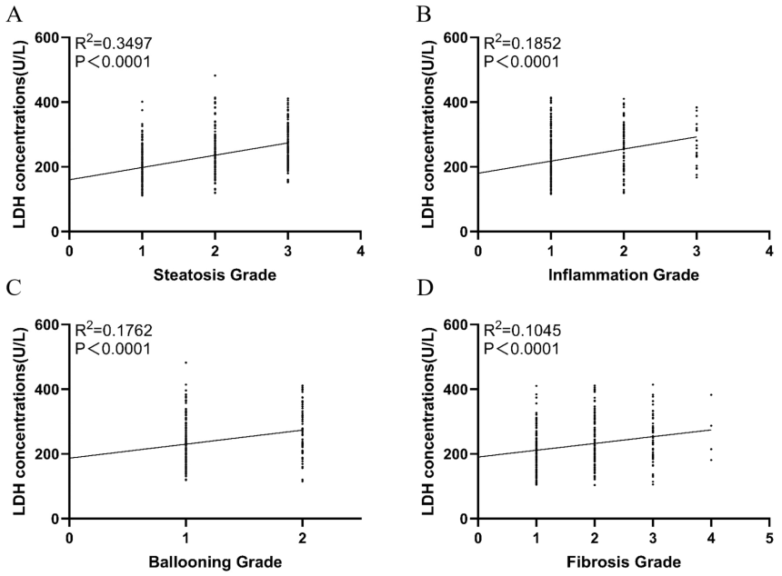

Supplementary Fig 2. Comparisons relevance of steatosis, inflammation, ballooning, fibrosis and serum LDH levels. LDH was positively associated with the severity of steatosis (R2 = 0.3497, P<.0001) (A), inflammation (R2 = 0.1852, P<.0001) (B), ballooning (R2 = 0.1762, P<.0001) (C), and fibrosis (R2 = 0.1045, P<.0001) (D)

