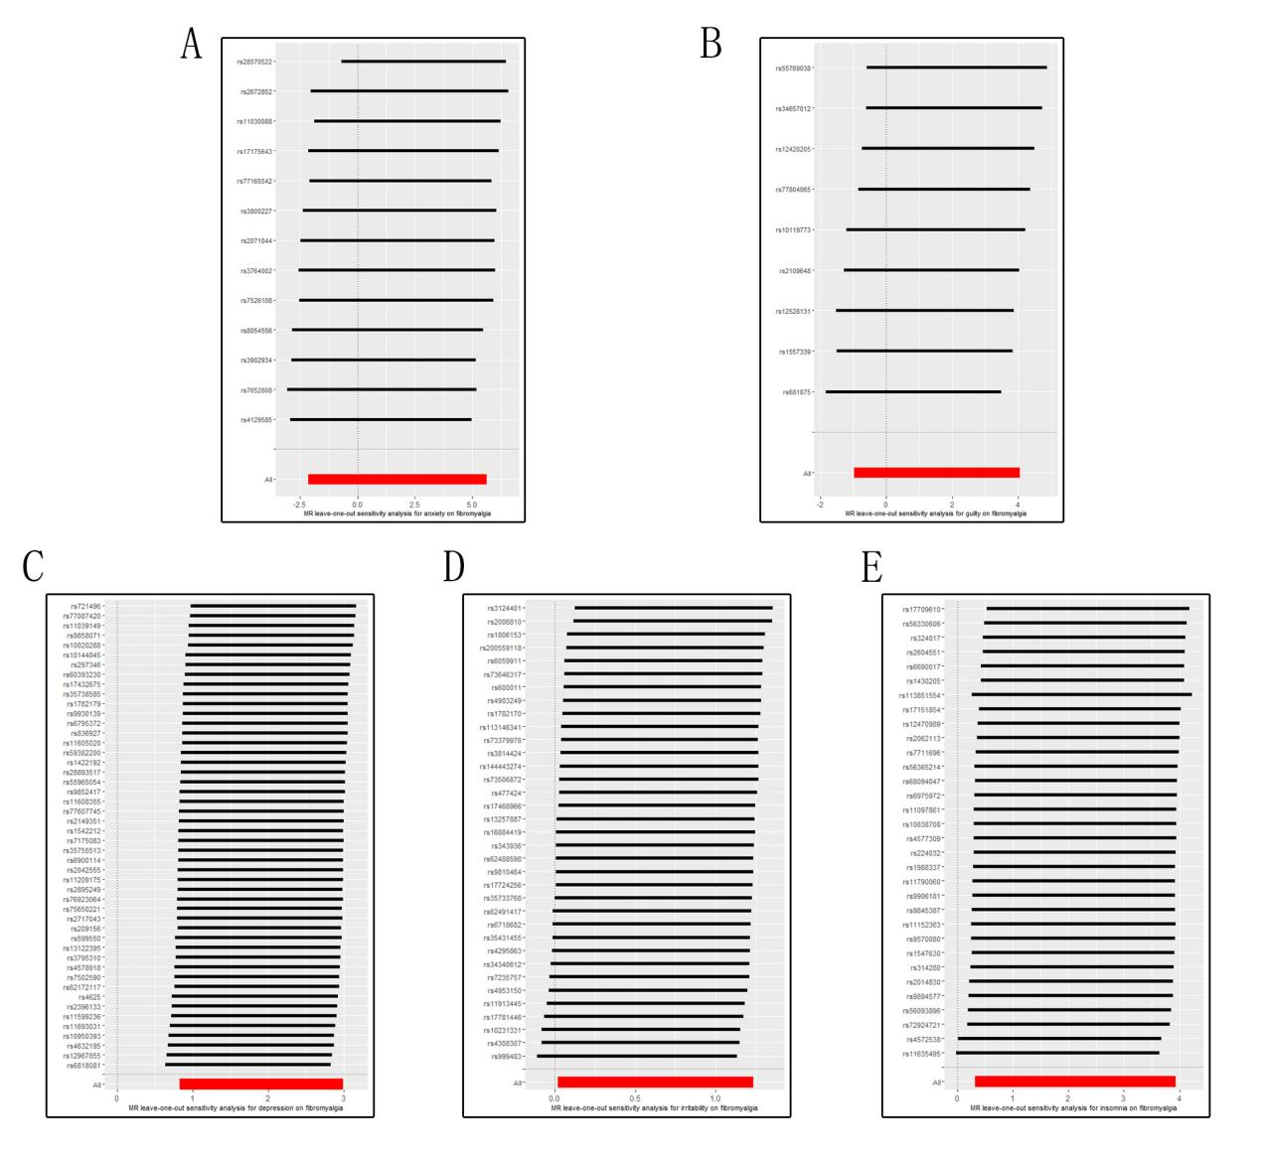Figure S1. The “leave-one-out” analysis plots for analysis of mental disorders and insomnia with risk of fibromyalgia. A. MR leave-one-out sensitivity analysis for anxiety on fibromyalgia. B. MR leave-one-out sensitivity analysis for guility on fibromyalgia. C. MR leave-one-out sensitivity analysis for depression on fibromyalgia. D. MR leave-one-out sensitivity analysis for irritability on fibromyalgia. E. MR leave-one-out sensitivity analysis for insomnia on fibromyalgia.

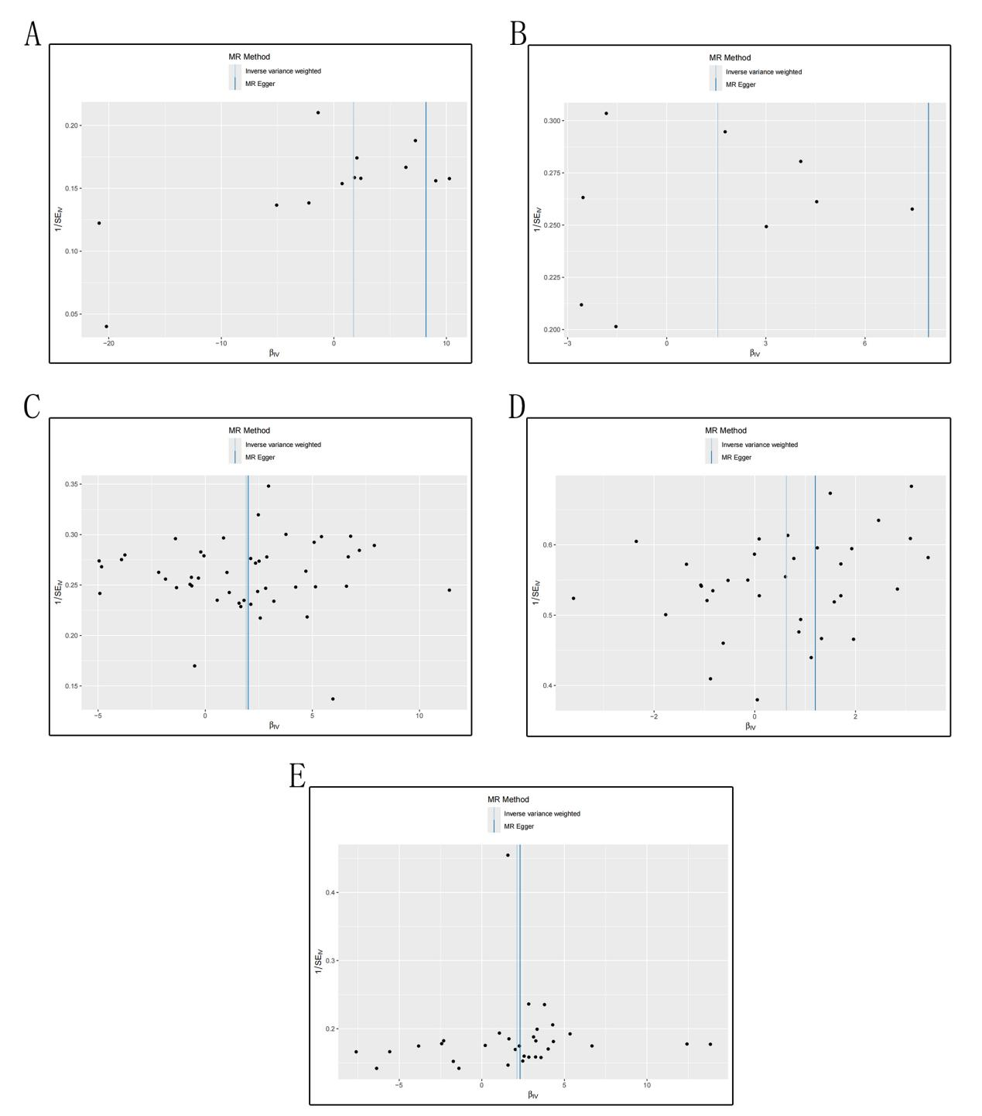Figure S2. The funnel plots for analysis of mental disorders and insomnia with risk of fibromyalgia. A. MR funnel plot for analysis of anxiety on fibromyalgia. B. MR funnel plot for analysis of guility on fibromyalgia. C. MR funnel plot for analysis of depression on fibromyalgia. D. MR funnel plot for analysis of irritability on fibromyalgia. E. MR funnel plot for analysis of insomnia on fibromyalgia.

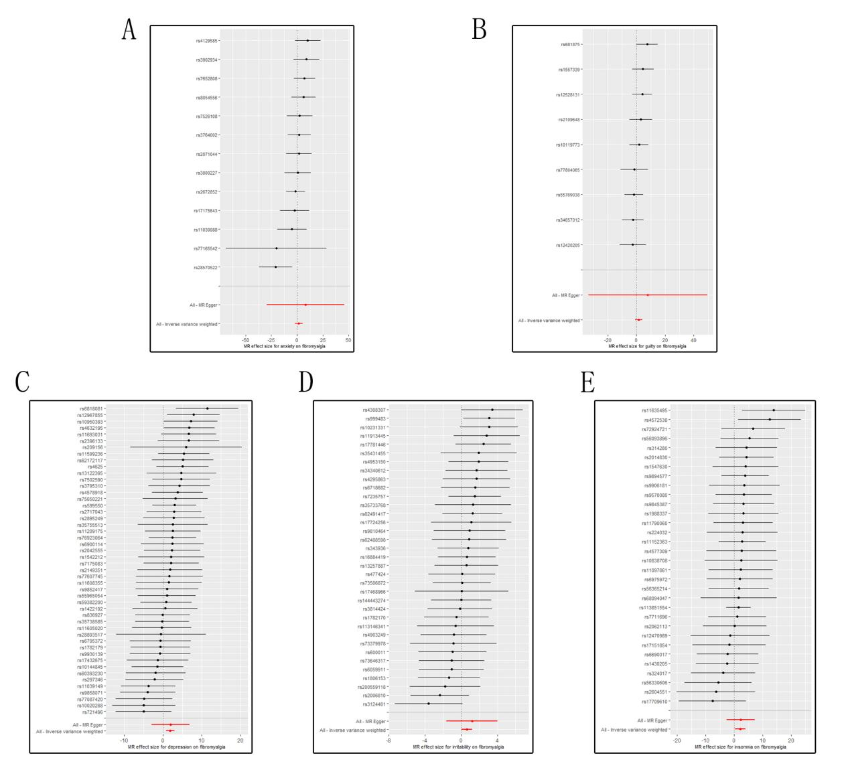Figure S3. The forest plots for analysis of mental disorders and insomnia with risk of fibromyalgia.
A. MR forest plot for analysis of anxiety on fibromyalgia. B. MR forest plot for analysis of guility on fibromyalgia. C. MR forest plot for analysis of depression on fibromyalgia. D. MR forest plot for analysis of irritability on fibromyalgia. E. MR forest plot for analysis of insomnia on fibromyalgia.

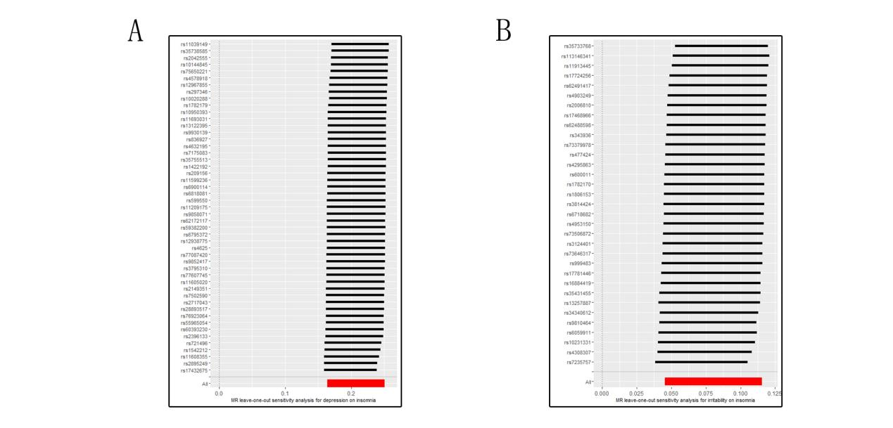
Figure S4. The “leave-one-out” analysis plots for analysis of depression and irritability with risk of insomnia. A. MR leave-one-out sensitivity analysis for depression on insomnia. B. MR leave-one-out sensitivity analysis for irritability on insomnia.

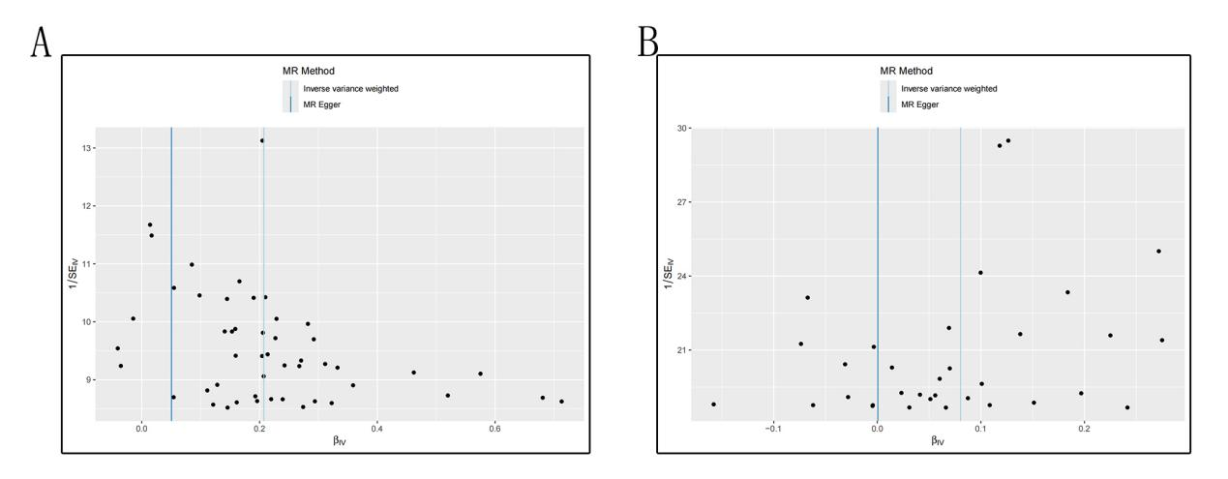Figure S5. The funnel plots for analysis of depression and irritability with risk of insomnia. A. MR funnel plot for analysis of depression on insomnia. B. MR funnel plot for analysis of irritability on insomnia.

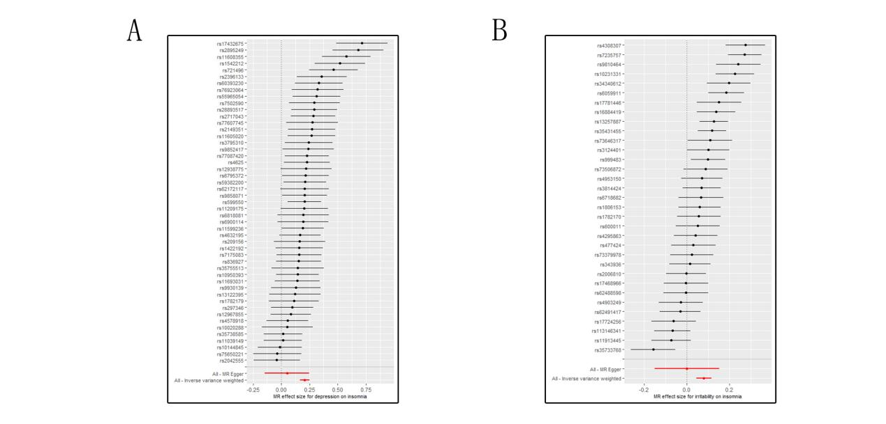
Figure S6. The forest plots for analysis of depression and irritability with risk of insomnia. A. MR forest plot for analysis of depression on insomnia. B. MR forest plot for analysis of irritability on insomnia.

Table S1 Characteristics of selected SNPs
exposure | outcome | SNP | ea | oa | beta | eaf | se | pval | F statistic
anxitey | fibromyalgia | rs11030088 | A | G | -0.0084 | 0.244 | 0.0015 | 2.02E-08 | 31.35976775
anxitey | fibromyalgia | rs17175643 | T | C | -0.0092 | 0.2638 | 0.0015 | 1.28E-09 | 37.61749919
anxitey | fibromyalgia | rs2071044 | T | C | -0.0084 | 0.4638 | 0.0015 | 4.31E-08 | 31.35976775
anxitey | fibromyalgia | rs2672852 | T | C | 0.0112 | 0.5124 | 0.0015 | 2.85E-13 | 55.75069823
anxitey | fibromyalgia | rs28570522 | G | A | 0.0084 | 0.6226 | 0.0015 | 3.81E-08 | 31.35976775
anxitey | fibromyalgia | rs3764002 | T | C | 0.0097 | 0.26 | 0.0015 | 2.41E-10 | 41.81746808
anxitey | fibromyalgia | rs3800227 | G | A | -0.0087 | 0.7299 | 0.0016 | 2.49E-08 | 29.56618729
anxitey | fibromyalgia | rs3902934 | G | A | -0.0085 | 0.3932 | 0.0015 | 2.39E-08 | 32.1108733
anxitey | fibromyalgia | rs4129585 | C | A | -0.0085 | 0.5733 | 0.0015 | 2.17E-08 | 32.1108733
anxitey | fibromyalgia | rs7526108 | A | G | 0.009 | 0.767 | 0.0015 | 3.77E-09 | 35.99973339
anxitey | fibromyalgia | rs7652808 | G | T | 0.0112 | 0.6523 | 0.0015 | 1.61E-13 | 55.75069823
anxitey | fibromyalgia | rs77165542 | T | C | 0.0082 | 0.0341 | 0.0015 | 4.61E-08 | 29.88422313
anxitey | fibromyalgia | rs8054556 | A | G | -0.0089 | 0.4647 | 0.0015 | 5.09E-09 | 35.20418373

Table S2 Characteristics of selected SNPs
exposure | outcome | SNP | ea | oa | beta | eaf | se | pval | F statistic
guilty | fibromyalgia | rs10119773 | A | G | -0.015734849 | 0.465998 | 0.002377943 | 3.67E-11 | 43.78444347
guilty | fibromyalgia | rs12420205 | T | C | 0.014957392 | 0.677505 | 0.002502073 | 2.26E-09 | 35.73628657
guilty | fibromyalgia | rs12528131 | A | G | -0.014921473 | 0.5174 | 0.002324217 | 1.37E-10 | 41.21617682
guilty | fibromyalgia | rs1557339 | A | C | -0.016664905 | 0.738067 | 0.002659152 | 3.69E-10 | 39.27507147
guilty | fibromyalgia | rs2109648 | A | G | 0.014110267 | 0.63965 | 0.002416142 | 5.22E-09 | 34.10540539
guilty | fibromyalgia | rs34657012 | A | C | 0.015476738 | 0.279037 | 0.002584626 | 2.13E-09 | 35.8559397
guilty | fibromyalgia | rs55769038 | A | G | -0.016083331 | 0.578002 | 0.002350677 | 7.83E-12 | 46.81270557
guilty | fibromyalgia | rs681875 | A | C | 0.017006068 | 0.206279 | 0.002871677 | 3.18E-09 | 35.0698814
guilty | fibromyalgia | rs77804065 | T | C | 0.017505573 | 0.217158 | 0.002833534 | 6.48E-10 | 38.16747537

Table S3 Characteristics of selected SNPs
exposure | outcome | SNP | ea | oa | beta | eaf | pval | se | F statistic
depression | fibromyalgia | rs10020288 | A | G | -0.01346 | 0.3604 | 2.56E-08 | 0.002416 | 31.03800747
depression | fibromyalgia | rs10144845 | T | C | 0.01604 | 0.6833 | 1.05E-10 | 0.002483 | 41.73043024
depression | fibromyalgia | rs10950393 | C | T | 0.01561 | 0.4172 | 2.37E-11 | 0.002336 | 44.65372595
depression | fibromyalgia | rs11039149 | G | A | 0.01936 | 0.2775 | 6.01E-14 | 0.002579 | 56.35151483
depression | fibromyalgia | rs11209175 | T | C | -0.01453 | 0.6348 | 1.65E-09 | 0.00241 | 36.34918827
depression | fibromyalgia | rs11599236 | C | T | -0.01585 | 0.41 | 3.31E-11 | 0.00239 | 43.98051441
depression | fibromyalgia | rs11605020 | A | G | 0.01387 | 0.5136 | 3.59E-09 | 0.002351 | 34.80528845
depression | fibromyalgia | rs11608355 | C | T | 0.01457 | 0.3148 | 5.10E-09 | 0.002494 | 34.12901692
depression | fibromyalgia | rs11693031 | G | A | -0.01573 | 0.3211 | 4.59E-10 | 0.002524 | 38.83974032
depression | fibromyalgia | rs12967855 | G | A | -0.01741 | 0.6711 | 2.11E-12 | 0.002478 | 49.36197317
depression | fibromyalgia | rs13122395 | A | G | 0.01356 | 0.3255 | 3.63E-08 | 0.002461 | 30.35943781
depression | fibromyalgia | rs1422192 | A | G | 0.01917 | 0.158 | 1.44E-09 | 0.003168 | 36.61604671
depression | fibromyalgia | rs1542212 | G | T | 0.0133 | 0.3923 | 2.31E-08 | 0.002381 | 31.20197357
depression | fibromyalgia | rs17432675 | C | T | -0.01373 | 0.3266 | 4.04E-08 | 0.002502 | 30.11369429
depression | fibromyalgia | rs1782179 | C | T | 0.01471 | 0.7267 | 1.50E-08 | 0.002597 | 32.08329907
depression | fibromyalgia | rs2042555 | A | G | 0.0144 | 0.415 | 9.45E-10 | 0.002354 | 37.4205047
depression | fibromyalgia | rs209156 | A | C | 0.02831 | 0.05364 | 4.03E-08 | 0.005157 | 30.13582251
depression | fibromyalgia | rs2149351 | G | T | -0.0162 | 0.7584 | 2.27E-09 | 0.002711 | 35.70825006
depression | fibromyalgia | rs2396133 | G | A | 0.01326 | 0.4762 | 1.18E-08 | 0.002325 | 32.52660286
depression | fibromyalgia | rs2717043 | T | C | 0.01528 | 0.6234 | 1.64E-10 | 0.00239 | 40.87412606
depression | fibromyalgia | rs28893517 | G | A | 0.02848 | 0.06824 | 5.16E-10 | 0.004583 | 38.61693747
depression | fibromyalgia | rs2895249 | A | G | -0.0133 | 0.3913 | 2.34E-08 | 0.002381 | 31.20197357
depression | fibromyalgia | rs297346 | G | A | -0.0162 | 0.6383 | 1.81E-11 | 0.00241 | 45.18491997
depression | fibromyalgia | rs35738585 | G | T | -0.01722 | 0.4341 | 1.73E-13 | 0.002337 | 54.29332546
depression | fibromyalgia | rs35755513 | T | C | 0.02414 | 0.07424 | 4.12E-08 | 0.0044 | 30.10001777
depression | fibromyalgia | rs3795310 | T | C | 0.01376 | 0.4518 | 3.24E-09 | 0.002325 | 35.02583737
depression | fibromyalgia | rs4578918 | C | T | -0.01792 | 0.7395 | 1.03E-11 | 0.002634 | 46.28518915
depression | fibromyalgia | rs4625 | G | A | -0.01564 | 0.3067 | 4.21E-10 | 0.002503 | 39.04355657
depression | fibromyalgia | rs4632195 | T | C | 0.0159 | 0.5126 | 6.63E-12 | 0.002316 | 47.13187444
depression | fibromyalgia | rs55965054 | T | C | -0.01391 | 0.5587 | 2.67E-09 | 0.002337 | 35.42700256
depression | fibromyalgia | rs59382200 | G | A | -0.01581 | 0.4009 | 2.44E-11 | 0.002368 | 44.57567386
depression | fibromyalgia | rs599550 | A | G | 0.02725 | 0.8495 | 3.69E-17 | 0.003235 | 70.95483863
depression | fibromyalgia | rs60393230 | G | A | 0.01397 | 0.5957 | 3.57E-09 | 0.002366 | 34.86269088
depression | fibromyalgia | rs62172117 | A | G | -0.01405 | 0.3572 | 6.19E-09 | 0.002417 | 33.79067919
depression | fibromyalgia | rs6795372 | G | T | 0.0145 | 0.3707 | 1.39E-09 | 0.002393 | 36.71539296
depression | fibromyalgia | rs6818081 | T | C | 0.01805 | 0.1478 | 2.83E-08 | 0.003251 | 30.82606196
depression | fibromyalgia | rs6900114 | A | G | -0.01464 | 0.2653 | 2.30E-08 | 0.002621 | 31.19935998
depression | fibromyalgia | rs7175083 | C | T | -0.01467 | 0.5224 | 2.21E-10 | 0.002311 | 40.2956263
depression | fibromyalgia | rs721496 | A | G | 0.01561 | 0.252 | 4.60E-09 | 0.002663 | 34.36062436
depression | fibromyalgia | rs7502590 | G | A | -0.01801 | 0.1476 | 3.12E-08 | 0.003254 | 30.63302617
depression | fibromyalgia | rs75650221 | T | C | -0.03572 | 0.03814 | 3.08E-09 | 0.006026 | 35.13680102
depression | fibromyalgia | rs76923064 | C | T | 0.05634 | 0.01298 | 3.24E-08 | 0.01019 | 30.56911676
depression | fibromyalgia | rs77087420 | G | A | -0.03284 | 0.05457 | 1.06E-10 | 0.005085 | 41.70824883
depression | fibromyalgia | rs77607745 | C | A | 0.01614 | 0.1897 | 4.95E-08 | 0.002959 | 29.75189988
depression | fibromyalgia | rs836927 | A | C | 0.01484 | 0.427 | 4.11E-10 | 0.002374 | 39.07544622
depression | fibromyalgia | rs9852417 | A | C | -0.0131 | 0.5896 | 2.84E-08 | 0.002361 | 30.78564029
depression | fibromyalgia | rs9858071 | C | T | 0.01607 | 0.2881 | 3.25E-10 | 0.002556 | 39.52825368
depression | fibromyalgia | rs9930139 | C | A | 0.01351 | 0.5876 | 1.19E-08 | 0.002369 | 32.52206774

Table S4 Characteristics of selected SNPs
exposure | outcome | SNP | ea | oa | beta | eaf | se | pval | F statistic
irritability | fibromyalgia | rs10231331 | G | A | 0.0325832 | 0.5089 | 0.00512675 | 2.08E-10 | 40.39253016
irritability | fibromyalgia | rs113146341 | T | C | 0.0449569 | 0.2097 | 0.00653915 | 6.20E-12 | 47.2659057
irritability | fibromyalgia | rs11913445 | A | C | -0.0425427 | 0.166 | 0.00681247 | 4.24E-10 | 38.99767922
irritability | fibromyalgia | rs13257887 | C | T | 0.050197 | 0.5487 | 0.00578628 | 4.13E-18 | 75.25831733
irritability | fibromyalgia | rs144443274 | T | C | -0.0428314 | 0.173 | 0.00678799 | 2.79E-10 | 39.81438597
irritability | fibromyalgia | rs16884419 | A | G | 0.0378484 | 0.2594 | 0.00594747 | 1.97E-10 | 40.49751728
irritability | fibromyalgia | rs17468966 | C | T | -0.0782519 | 0.0159 | 0.0141221 | 3.01E-08 | 30.703585
irritability | fibromyalgia | rs17724256 | G | A | -0.0391318 | 0.1352 | 0.00706234 | 3.01E-08 | 30.70154821
irritability | fibromyalgia | rs17781446 | T | C | 0.0559297 | 0.0746 | 0.0100288 | 2.45E-08 | 31.1017559
irritability | fibromyalgia | rs1782170 | C | A | 0.0319802 | 0.7445 | 0.00565044 | 1.52E-08 | 32.03285776
irritability | fibromyalgia | rs1806153 | T | G | 0.0350306 | 0.2018 | 0.00599311 | 5.06E-09 | 34.16555844
irritability | fibromyalgia | rs200559118 | C | T | -0.0410595 | - | 0.00671514 | 9.69E-10 | 37.3865198
irritability | fibromyalgia | rs2006810 | C | T | -0.0321826 | 0.3956 | 0.00517113 | 4.86E-10 | 38.73193664
irritability | fibromyalgia | rs3124401 | T | C | -0.0328513 | 0.7555 | 0.00568314 | 7.45E-09 | 33.4138317
irritability | fibromyalgia | rs34340612 | A | G | -0.0347721 | 0.2117 | 0.00613268 | 1.43E-08 | 32.14838063
irritability | fibromyalgia | rs343936 | C | T | -0.0405292 | 0.1859 | 0.00676969 | 2.14E-09 | 35.84234113
irritability | fibromyalgia | rs35431455 | C | T | -0.0436869 | 0.4404 | 0.00506672 | 6.56E-18 | 74.34410154
irritability | fibromyalgia | rs35733768 | A | G | -0.0555423 | 0.0785 | 0.0100272 | 3.04E-08 | 30.68218151
irritability | fibromyalgia | rs3814424 | T | C | 0.0446501 | 0.172 | 0.00694651 | 1.30E-10 | 41.31515734
irritability | fibromyalgia | rs4295863 | A | C | -0.0288634 | 0.4642 | 0.00510783 | 1.60E-08 | 31.93154827
irritability | fibromyalgia | rs4308307 | T | C | -0.0328205 | 0.6451 | 0.00520562 | 2.89E-10 | 39.75056731
irritability | fibromyalgia | rs477424 | G | A | 0.028018 | 0.4254 | 0.00509788 | 3.88E-08 | 30.20597893
irritability | fibromyalgia | rs4903249 | T | C | 0.0283421 | 0.5 | 0.00503934 | 1.86E-08 | 31.63112222
irritability | fibromyalgia | rs4953150 | T | C | 0.0318094 | 0.337 | 0.00534082 | 2.59E-09 | 35.47259348
irritability | fibromyalgia | rs600011 | C | A | 0.0307788 | 0.2724 | 0.00549752 | 2.16E-08 | 31.34495141
irritability | fibromyalgia | rs6059911 | G | T | -0.045327 | 0.8797 | 0.00656711 | 5.12E-12 | 47.63906619
irritability | fibromyalgia | rs62488598 | G | T | 0.0330469 | 0.2396 | 0.00597958 | 3.26E-08 | 30.54344088
irritability | fibromyalgia | rs62491417 | A | C | -0.061242 | 0.0457 | 0.0101587 | 1.65E-09 | 36.34296281
irritability | fibromyalgia | rs6718682 | T | C | -0.0311312 | 0.2664 | 0.00565283 | 3.65E-08 | 30.32897569
irritability | fibromyalgia | rs7235757 | A | G | 0.0403331 | 0.3151 | 0.00547887 | 1.82E-13 | 54.19248729
irritability | fibromyalgia | rs73379978 | C | T | 0.103243 | 0.0209 | 0.0183957 | 2.00E-08 | 31.4982528
irritability | fibromyalgia | rs73506872 | T | G | 0.0404598 | 0.17 | 0.00721221 | 2.02E-08 | 31.47085961
irritability | fibromyalgia | rs73646317 | G | A | -0.0425413 | 0.1481 | 0.00770793 | 3.41E-08 | 30.46097921
irritability | fibromyalgia | rs9810464 | A | G | 0.0284478 | 0.3748 | 0.0051777 | 3.92E-08 | 30.18710566
irritability | fibromyalgia | rs999483 | G | T | 0.0414071 | 0.2197 | 0.00582153 | 1.14E-12 | 50.59099494

Table S5 Characteristics of selected SNPs
exposure | outcome | SNP | ea | oa | beta | eaf | se | pval | F statistic
insomnia | fibromyalgia | rs10838708 | A | G | -0.00947656 | 0.45899 | 0.00150271 | 2.90E-10 | 39.76941491
insomnia | fibromyalgia | rs11097861 | G | A | 0.0100437 | 0.716256 | 0.00164946 | 1.10E-09 | 37.07677992
insomnia | fibromyalgia | rs11152363 | A | G | 0.0156393 | 0.186319 | 0.00192518 | 4.50E-16 | 65.99181298
insomnia | fibromyalgia | rs113851554 | T | G | 0.0467802 | 0.057291 | 0.00331329 | 2.90E-45 | 199.3440926
insomnia | fibromyalgia | rs11635495 | C | T | 0.00937342 | 0.512179 | 0.00148509 | 2.80E-10 | 39.83719286
insomnia | fibromyalgia | rs11790060 | C | T | -0.0103391 | 0.330834 | 0.00157854 | 5.80E-11 | 42.89951777
insomnia | fibromyalgia | rs12470989 | G | A | -0.0102429 | 0.203934 | 0.00184485 | 2.80E-08 | 30.82633301
insomnia | fibromyalgia | rs1430205 | T | C | 0.00947493 | 0.461507 | 0.00149107 | 2.10E-10 | 40.37886216
insomnia | fibromyalgia | rs1547630 | A | G | 0.00910814 | 0.651513 | 0.00156447 | 5.80E-09 | 33.89401654
insomnia | fibromyalgia | rs17151854 | T | G | 0.0129893 | 0.15241 | 0.00207434 | 3.80E-10 | 39.21116375
insomnia | fibromyalgia | rs17709610 | G | A | -0.0099161 | 0.297979 | 0.00162078 | 9.50E-10 | 37.4310301
insomnia | fibromyalgia | rs1988337 | G | A | 0.00838726 | 0.552395 | 0.00149645 | 2.10E-08 | 31.41332535
insomnia | fibromyalgia | rs2014830 | T | C | -0.0116018 | 0.303519 | 0.0016233 | 8.90E-13 | 51.08004757
insomnia | fibromyalgia | rs2062113 | C | T | -0.00961678 | 0.568257 | 0.00150275 | 1.60E-10 | 40.95283861
insomnia | fibromyalgia | rs224032 | A | G | 0.00839066 | 0.550358 | 0.00149108 | 1.80E-08 | 31.66565515
insomnia | fibromyalgia | rs2604551 | G | T | -0.00848084 | 0.640384 | 0.00155238 | 4.70E-08 | 29.84556352
insomnia | fibromyalgia | rs314280 | G | A | 0.00971363 | 0.547047 | 0.00149134 | 7.30E-11 | 42.42363739
insomnia | fibromyalgia | rs324017 | C | A | -0.00988248 | 0.705433 | 0.00163145 | 1.40E-09 | 36.69293681
insomnia | fibromyalgia | rs4572538 | T | C | -0.00960596 | 0.364055 | 0.00156161 | 7.70E-10 | 37.8385518
insomnia | fibromyalgia | rs4577309 | G | A | -0.00854833 | 0.533655 | 0.00149214 | 1.00E-08 | 32.82022353
insomnia | fibromyalgia | rs56093896 | A | C | -0.0124111 | 0.214053 | 0.00181352 | 7.70E-12 | 46.83537179
insomnia | fibromyalgia | rs56330606 | G | A | 0.00930932 | 0.378954 | 0.00153044 | 1.20E-09 | 36.99997439
insomnia | fibromyalgia | rs56365214 | A | C | -0.0147948 | 0.155781 | 0.00205225 | 5.60E-13 | 51.97036774
insomnia | fibromyalgia | rs6690017 | G | T | -0.0102669 | 0.408855 | 0.00151022 | 1.10E-11 | 46.21642524
insomnia | fibromyalgia | rs68094047 | T | C | 0.0103356 | 0.251267 | 0.0017167 | 1.70E-09 | 36.24771993
insomnia | fibromyalgia | rs6975972 | G | A | -0.00902066 | 0.578726 | 0.00150428 | 2.00E-09 | 35.95980984
insomnia | fibromyalgia | rs72924721 | T | C | 0.016478 | 0.073137 | 0.00288103 | 1.10E-08 | 32.71233591
insomnia | fibromyalgia | rs7711696 | T | G | 0.0111716 | 0.305042 | 0.00161138 | 4.10E-12 | 48.06544174
insomnia | fibromyalgia | rs9570080 | C | T | -0.0106379 | 0.344131 | 0.00157858 | 1.60E-11 | 45.41263856
insomnia | fibromyalgia | rs9845387 | A | C | -0.0218562 | 0.040279 | 0.00377648 | 7.10E-09 | 33.49446579
insomnia | fibromyalgia | rs9894577 | A | G | 0.0132051 | 0.3182 | 0.00159687 | 1.30E-16 | 68.3820925
insomnia | fibromyalgia | rs9906181 | G | A | -0.00915026 | 0.687567 | 0.00163869 | 2.40E-08 | 31.1796606

Table S6 Characteristics of selected SNPs
exposure | outcome | SNP | ea | oa | beta | eaf | pval | se | F statistic
depression | insomnia | rs10020288 | A | G | -0.01346 | 0.3604 | 2.56E-08 | 0.002416 | 31.03800747
depression | insomnia | rs10144845 | T | C | 0.01604 | 0.6833 | 1.05E-10 | 0.002483 | 41.73043024
depression | insomnia | rs10950393 | C | T | 0.01561 | 0.4172 | 2.37E-11 | 0.002336 | 44.65372595
depression | insomnia | rs11039149 | G | A | 0.01936 | 0.2775 | 6.01E-14 | 0.002579 | 56.35151483
depression | insomnia | rs11209175 | T | C | -0.01453 | 0.6348 | 1.65E-09 | 0.00241 | 36.34918827
depression | insomnia | rs11599236 | C | T | -0.01585 | 0.41 | 3.31E-11 | 0.00239 | 43.98051441
depression | insomnia | rs11605020 | A | G | 0.01387 | 0.5136 | 3.59E-09 | 0.002351 | 34.80528845
depression | insomnia | rs11608355 | C | T | 0.01457 | 0.3148 | 5.10E-09 | 0.002494 | 34.12901692
depression | insomnia | rs11693031 | G | A | -0.01573 | 0.3211 | 4.59E-10 | 0.002524 | 38.83974032
depression | insomnia | rs12938775 | A | G | -0.01288 | 0.5025 | 2.49E-08 | 0.002311 | 31.06199951
depression | insomnia | rs12967855 | G | A | -0.01741 | 0.6711 | 2.11E-12 | 0.002478 | 49.36197317
depression | insomnia | rs13122395 | A | G | 0.01356 | 0.3255 | 3.63E-08 | 0.002461 | 30.35943781
depression | insomnia | rs1422192 | A | G | 0.01917 | 0.158 | 1.44E-09 | 0.003168 | 36.61604671
depression | insomnia | rs1542212 | G | T | 0.0133 | 0.3923 | 2.31E-08 | 0.002381 | 31.20197357
depression | insomnia | rs17432675 | C | T | -0.01373 | 0.3266 | 4.04E-08 | 0.002502 | 30.11369429
depression | insomnia | rs1782179 | C | T | 0.01471 | 0.7267 | 1.50E-08 | 0.002597 | 32.08329907
depression | insomnia | rs2042555 | A | G | 0.0144 | 0.415 | 9.45E-10 | 0.002354 | 37.4205047
depression | insomnia | rs209156 | A | C | 0.02831 | 0.05364 | 4.03E-08 | 0.005157 | 30.13582251
depression | insomnia | rs2149351 | G | T | -0.0162 | 0.7584 | 2.27E-09 | 0.002711 | 35.70825006
depression | insomnia | rs2396133 | G | A | 0.01326 | 0.4762 | 1.18E-08 | 0.002325 | 32.52660286
depression | insomnia | rs2717043 | T | C | 0.01528 | 0.6234 | 1.64E-10 | 0.00239 | 40.87412606
depression | insomnia | rs28893517 | G | A | 0.02848 | 0.06824 | 5.16E-10 | 0.004583 | 38.61693747
depression | insomnia | rs2895249 | A | G | -0.0133 | 0.3913 | 2.34E-08 | 0.002381 | 31.20197357
depression | insomnia | rs297346 | G | A | -0.0162 | 0.6383 | 1.81E-11 | 0.00241 | 45.18491997
depression | insomnia | rs35738585 | G | T | -0.01722 | 0.4341 | 1.73E-13 | 0.002337 | 54.29332546
depression | insomnia | rs35755513 | T | C | 0.02414 | 0.07424 | 4.12E-08 | 0.0044 | 30.10001777
depression | insomnia | rs3795310 | T | C | 0.01376 | 0.4518 | 3.24E-09 | 0.002325 | 35.02583737
depression | insomnia | rs4578918 | C | T | -0.01792 | 0.7395 | 1.03E-11 | 0.002634 | 46.28518915
depression | insomnia | rs4625 | G | A | -0.01564 | 0.3067 | 4.21E-10 | 0.002503 | 39.04355657
depression | insomnia | rs4632195 | T | C | 0.0159 | 0.5126 | 6.63E-12 | 0.002316 | 47.13187444
depression | insomnia | rs55965054 | T | C | -0.01391 | 0.5587 | 2.67E-09 | 0.002337 | 35.42700256
depression | insomnia | rs59382200 | G | A | -0.01581 | 0.4009 | 2.44E-11 | 0.002368 | 44.57567386
depression | insomnia | rs599550 | A | G | 0.02725 | 0.8495 | 3.69E-17 | 0.003235 | 70.95483863
depression | insomnia | rs60393230 | G | A | 0.01397 | 0.5957 | 3.57E-09 | 0.002366 | 34.86269088
depression | insomnia | rs62172117 | A | G | -0.01405 | 0.3572 | 6.19E-09 | 0.002417 | 33.79067919
depression | insomnia | rs6795372 | G | T | 0.0145 | 0.3707 | 1.39E-09 | 0.002393 | 36.71539296
depression | insomnia | rs6818081 | T | C | 0.01805 | 0.1478 | 2.83E-08 | 0.003251 | 30.82606196
depression | insomnia | rs6900114 | A | G | -0.01464 | 0.2653 | 2.30E-08 | 0.002621 | 31.19935998
depression | insomnia | rs7175083 | C | T | -0.01467 | 0.5224 | 2.21E-10 | 0.002311 | 40.2956263
depression | insomnia | rs721496 | A | G | 0.01561 | 0.252 | 4.60E-09 | 0.002663 | 34.36062436
depression | insomnia | rs7502590 | G | A | -0.01801 | 0.1476 | 3.12E-08 | 0.003254 | 30.63302617
depression | insomnia | rs75650221 | T | C | -0.03572 | 0.03814 | 3.08E-09 | 0.006026 | 35.13680102
depression | insomnia | rs76923064 | C | T | 0.05634 | 0.01298 | 3.24E-08 | 0.01019 | 30.56911676
depression | insomnia | rs77087420 | G | A | -0.03284 | 0.05457 | 1.06E-10 | 0.005085 | 41.70824883
depression | insomnia | rs77607745 | C | A | 0.01614 | 0.1897 | 4.95E-08 | 0.002959 | 29.75189988
depression | insomnia | rs836927 | A | C | 0.01484 | 0.427 | 4.11E-10 | 0.002374 | 39.07544622
depression | insomnia | rs9852417 | A | C | -0.0131 | 0.5896 | 2.84E-08 | 0.002361 | 30.78564029
depression | insomnia | rs9858071 | C | T | 0.01607 | 0.2881 | 3.25E-10 | 0.002556 | 39.52825368
depression | insomnia | rs9930139 | C | A | 0.01351 | 0.5876 | 1.19E-08 | 0.002369 | 32.52206774

Table S7 Characteristics of selected SNPs
exposure | outcome | SNP | ea | oa | beta | eaf | se | pval | F statistic
irritability | insomnia | rs10231331 | G | A | 0.0325832 | 0.5089 | 0.00512675 | 2.08E-10 | 40.39253016
irritability | insomnia | rs113146341 | T | C | 0.0449569 | 0.2097 | 0.00653915 | 6.20E-12 | 47.2659057
irritability | insomnia | rs11913445 | A | C | -0.0425427 | 0.166 | 0.00681247 | 4.24E-10 | 38.99767922
irritability | insomnia | rs13257887 | C | T | 0.050197 | 0.5487 | 0.00578628 | 4.13E-18 | 75.25831733
irritability | insomnia | rs16884419 | A | G | 0.0378484 | 0.2594 | 0.00594747 | 1.97E-10 | 40.49751728
irritability | insomnia | rs17468966 | C | T | -0.0782519 | 0.0159 | 0.0141221 | 3.01E-08 | 30.703585
irritability | insomnia | rs17724256 | G | A | -0.0391318 | 0.1352 | 0.00706234 | 3.01E-08 | 30.70154821
irritability | insomnia | rs17781446 | T | C | 0.0559297 | 0.0746 | 0.0100288 | 2.45E-08 | 31.1017559
irritability | insomnia | rs1782170 | C | A | 0.0319802 | 0.7445 | 0.00565044 | 1.52E-08 | 32.03285776
irritability | insomnia | rs1806153 | T | G | 0.0350306 | 0.2018 | 0.00599311 | 5.06E-09 | 34.16555844
irritability | insomnia | rs2006810 | C | T | -0.0321826 | 0.3956 | 0.00517113 | 4.86E-10 | 38.73193664
irritability | insomnia | rs3124401 | T | C | -0.0328513 | 0.7555 | 0.00568314 | 7.45E-09 | 33.4138317
irritability | insomnia | rs34340612 | A | G | -0.0347721 | 0.2117 | 0.00613268 | 1.43E-08 | 32.14838063
irritability | insomnia | rs343936 | C | T | -0.0405292 | 0.1859 | 0.00676969 | 2.14E-09 | 35.84234113
irritability | insomnia | rs35431455 | C | T | -0.0436869 | 0.4404 | 0.00506672 | 6.56E-18 | 74.34410154
irritability | insomnia | rs35733768 | A | G | -0.0555423 | 0.0785 | 0.0100272 | 3.04E-08 | 30.68218151
irritability | insomnia | rs3814424 | T | C | 0.0446501 | 0.172 | 0.00694651 | 1.30E-10 | 41.31515734
irritability | insomnia | rs4295863 | A | C | -0.0288634 | 0.4642 | 0.00510783 | 1.60E-08 | 31.93154827
irritability | insomnia | rs4308307 | T | C | -0.0328205 | 0.6451 | 0.00520562 | 2.89E-10 | 39.75056731
irritability | insomnia | rs477424 | G | A | 0.028018 | 0.4254 | 0.00509788 | 3.88E-08 | 30.20597893
irritability | insomnia | rs4903249 | T | C | 0.0283421 | 0.5 | 0.00503934 | 1.86E-08 | 31.63112222
irritability | insomnia | rs4953150 | T | C | 0.0318094 | 0.337 | 0.00534082 | 2.59E-09 | 35.47259348
irritability | insomnia | rs600011 | C | A | 0.0307788 | 0.2724 | 0.00549752 | 2.16E-08 | 31.34495141
irritability | insomnia | rs6059911 | G | T | -0.045327 | 0.8797 | 0.00656711 | 5.12E-12 | 47.63906619
irritability | insomnia | rs62488598 | G | T | 0.0330469 | 0.2396 | 0.00597958 | 3.26E-08 | 30.54344088
irritability | insomnia | rs62491417 | A | C | -0.061242 | 0.0457 | 0.0101587 | 1.65E-09 | 36.34296281
irritability | insomnia | rs6718682 | T | C | -0.0311312 | 0.2664 | 0.00565283 | 3.65E-08 | 30.32897569
irritability | insomnia | rs7235757 | A | G | 0.0403331 | 0.3151 | 0.00547887 | 1.82E-13 | 54.19248729
irritability | insomnia | rs73379978 | C | T | 0.103243 | 0.0209 | 0.0183957 | 2.00E-08 | 31.4982528
irritability | insomnia | rs73506872 | T | G | 0.0404598 | 0.17 | 0.00721221 | 2.02E-08 | 31.47085961
irritability | insomnia | rs73646317 | G | A | -0.0425413 | 0.1481 | 0.00770793 | 3.41E-08 | 30.46097921
irritability | insomnia | rs9810464 | A | G | 0.0284478 | 0.3748 | 0.0051777 | 3.92E-08 | 30.18710566
irritability | insomnia | rs999483 | G | T | 0.0414071 | 0.2197 | 0.00582153 | 1.14E-12 | 50.59099494

Table S8 MR analysis of the causal relationship between exposures and fibromyalgia
exposures | method | nsnp | b | se | pval | or | or_lci95 | or_uci95
Anxiety | MR Egger | 13 | 8.186358646 | 19.18873452 | 0.677883454 | 3591.620045 | 1.67E-13 | 7.74588E+19
Anxiety | Weighted median | 13 | 2.002722922 | 2.396231083 | 0.403278467 | 7.409203342 | 0.067617395 | 811.8664414
Anxiety | Inverse variance weighted | 13 | 1.753832757 | 1.981841423 | 0.376183003 | 5.776700994 | 0.118768812 | 280.9683264
Anxiety | Simple mode | 13 | 1.712773378 | 3.439200622 | 0.627474829 | 5.544316662 | 0.006551509 | 4691.964285
Anxiety | Weighted mode | 13 | 1.712773378 | 3.119582719 | 0.593048063 | 5.544316662 | 0.012257605 | 2507.785839
guilty | MR Egger | 9 | 7.919005289 | 21.16949096 | 0.719421016 | 2749.03519 | 2.63E-15 | 2.88E+21
guilty | Weighted median | 9 | 1.922982278 | 1.7497111 | 0.271755657 | 6.841330829 | 0.221695275 | 211.1177498
guilty | Inverse variance weighted | 9 | 1.543534052 | 1.281319241 | 0.228340607 | 4.681104338 | 0.379898313 | 57.68053474
guilty | Simple mode | 9 | -1.728819086 | 2.865466484 | 0.56300032 | 0.177493891 | 0.000645727 | 48.78852893
guilty | Weighted mode | 9 | 3.155731046 | 2.931527352 | 0.313101166 | 23.47018862 | 0.075015347 | 7343.160812
insomnia | MR Egger | 32 | 2.315379969 | 2.494879261 | 0.360787243 | 10.1287708 | 0.076185556 | 1346.606926
insomnia | Weighted median | 32 | 2.245679991 | 1.327247818 | 0.090649323 | 9.446837141 | 0.700664764 | 127.3686598
insomnia | Inverse variance weighted | 32 | 2.127683166 | 0.919793057 | 0.020710578 | 8.395393525 | 1.383876713 | 50.93129451
insomnia | Simple mode | 32 | 2.929261552 | 2.340515571 | 0.220097648 | 18.71380623 | 0.19049126 | 1838.438908
insomnia | Weighted mode | 32 | 2.394004824 | 1.782781413 | 0.189071406 | 10.9572882 | 0.332788959 | 360.775685
depression | MR Egger | 48 | 2.00805142 | 2.506960508 | 0.427255168 | 7.448788638 | 0.054716434 | 1014.036334
depression | Weighted median | 48 | 2.127328023 | 0.785577228 | 0.006769395 | 8.392412495 | 1.799658017 | 39.13665086
depression | Inverse variance weighted | 48 | 1.909392398 | 0.550872315 | 0.000528017 | 6.748986854 | 2.292591095 | 19.86783586
depression | Simple mode | 48 | 2.010650681 | 1.768104793 | 0.261228184 | 7.468175164 | 0.233438945 | 238.9217456
depression | Weighted mode | 48 | 2.158989455 | 1.803209649 | 0.237192184 | 8.662379509 | 0.252763387 | 296.8658543
Irritability | MR Egger | 35 | 1.200211231 | 1.43629684 | 0.40937337 | 3.320818309 | 0.198904479 | 55.44286533
Irritability | Weighted median | 35 | 0.724611169 | 0.433470268 | 0.094593088 | 2.063928425 | 0.882505236 | 4.826940814
Irritability | Inverse variance weighted | 35 | 0.627447334 | 0.308462276 | 0.041940135 | 1.872823778 | 1.023124595 | 3.428193321
Irritability | Simple mode | 35 | 0.977137169 | 0.939563691 | 0.305683823 | 2.656839261 | 0.42130103 | 16.75475339
Irritability | Weighted mode | 35 | 1.021608374 | 0.998798249 | 0.313607522 | 2.777658687 | 0.392179281 | 19.67311418

Table S9 MR analysis of the causal relationship between exposures and insomnia
exposures | method | nsnp | b | se | pval | or | or_lci95 | or_uci95
depression | MR Egger | 49 | 0.050433129 | 0.099573124 | 0.614878209 | 1.051726531 | 0.865255712 | 1.278383582
depression | Weighted median | 49 | 0.191913282 | 0.023145702 | 1.12E-16 | 1.211565448 | 1.157830167 | 1.267794602
depression | Inverse variance weighted | 49 | 0.207375084 | 0.022058622 | 5.40E-21 | 1.230444005 | 1.178379495 | 1.284808889
depression | Simple mode | 49 | 0.195106438 | 0.047546327 | 0.00015687 | 1.215440349 | 1.107290054 | 1.334153807
depression | Weighted mode | 49 | 0.191162003 | 0.050708967 | 0.00044767 | 1.210655566 | 1.096115348 | 1.337164835
irritability | MR Egger | 33 | 0.000450641 | 0.077530299 | 0.995399603 | 1.000450743 | 0.859410366 | 1.164637673
irritability | Weighted median | 33 | 0.066919252 | 0.015310436 | 1.24E-05 | 1.069209139 | 1.03760046 | 1.10178072
irritability | Inverse variance weighted | 33 | 0.080380465 | 0.017936437 | 7.42E-06 | 1.083699299 | 1.046263293 | 1.12247479
irritability | Simple mode | 33 | 0.060571581 | 0.034189957 | 0.085981622 | 1.062443645 | 0.993579962 | 1.136080177
irritability | Weighted mode | 33 | 0.071674784 | 0.031874486 | 0.031550796 | 1.074305906 | 1.00924325 | 1.143562941

Table S10 MVMR analysis of mediating effect
 | outcome | nsnp | b | se | pval | or | or_lci95 | or_uci95
depression(exposure) | fibromyalgia | 43 | 0.905697917 | 0.578164681 | 0.117230417 | 2.473657728 | 0.796518552 | 7.682159493
insomnia(mediator) | fibromyalgia | 35 | 2.316672362 | 0.897640117 | 0.009855807 | 10.14186962 | 1.745948103 | 58.91212877
irritability(exposure) | fibromyalgia | 27 | 0.575919179 | 0.272876023 | 0.034810792 | 1.778764778 | 1.041937722 | 3.036653793
insomnia(mediator) | fibromyalgia | 29 | 2.032539377 | 0.759819321 | 0.007472259 | 7.633445961 | 1.721667861 | 33.84479583

