Supplementary Table 1. Comprehensive geriatric assessment
Geriatric condition | All（195） | Insulin（96） | Placebo（99）
Comorbidity
1-2 types | 136(69.7%) | 63(65.6%) | 73(73.7%)
3+ types | 59(30.3%) | 33(34.4%) | 26(26.3%)
Medicine
0-4 types | 153(78.5%) | 71(74.0%) | 82(82.8%)
5+types | 42(21.5%) | 25(26.0%) | 17(17.2%)
BMI
Undernutrition (BMI<20 kg/m²) | 22(11.3%) | 14(14.6%) | 8(8.1%)
Normal (20≤BMI≤30 kg/m²) | 156(80.0%) | 73(76.0%) | 83(83.8%)
Overweight (BMI >30 kg/m²) | 17(8.7%) | 9(9.4%) | 8(8.1%)
Physical activity
Inactivity | 89(45.6%) | 41(42.7%) | 48(48.5%)
1-2 times/week | 74(37.9%) | 37(38.5%) | 37(37.4%)
≧3 times/week | 32(16.4%) | 18(18.8.6%) | 14(14.1%)
MMSE | 25.38±3.72 | 25.19±3.50 | 25.58±3.93
Comorbidity, including hypertension, diabetes, cardiac disease, cerebral infarction and chronic obstructive pulmonary disease; BMI, Body Mass Index. MMSE, Mini-mental State Examination.

.
Supplementary Table 2. Comparison of the osteocalcin levels between the two groups
markers | all（n=195） | placebo group(n=99) | insulin group(n=96) | P value
ucOC in CSF at D₀ (ng/mL) | 10.22±2.38 | 8.12±0.61 | 12.38±1.37 | <0.001*
ucOC in plasma at D₀ (ng/mL) | 2.78±1.48 | 1.57±0.57 | 4.03±1.00 | <0.001*
ucOC in plasma at D₁ (ng/mL) | 5.10±1.48 | 5.50±1.78 | 4.68±0.94 | <0.001*
ucOC in plasma at D₃ (ng/mL) | 5.15±1.82 | 5.95±2.08 | 4.31±0.98 | <0.001*
tOC in CSF at D₀ (ng/mL) | 192.24±31.28 | 171.29±10.60 | 213.85±30.86 | <0.001*
tOC in plasma at D₀ (ng/mL) | 38.42±31.69 | 13.47±8.92 | 64.14±25.51 | <0.001*
tOC in plasma at D₁ (ng/mL) | 56.06±17.57 | 48.37±15.37 | 63.99±16.19 | <0.001*
tOC in plasma at D₃ (ng/mL) | 55.02±23.39 | 46.98±21.84 | 63.31±22.11 | <0.001*
BDNF in CSF at D₀(ng/mL) | 88.80±6.84 | 86.77±7.25 | 90.77±5.82 | <0.001*
ucOC/tOC in plasma at D₀(%) | 11.54±9.97 | 16.11±12.27 | 6.82±1.75 | <0.001*
ucOC/tOC in plasma at D₁(%) | 9.86±3.88 | 11.97±3.95 | 7.69±2.30 | <0.001*
ucOC/tOC in plasma at D₃(%) | 10.87±5.94 | 14.32±6.45 | 7.31±2.02 | <0.001*
ucOC, uncarboxylated osteocalcin, tOC, total osteocalcin, BDNF, Brain derived neurotrophic factor, CSF, cerebrospinal fluid, D₀, the day of surgery, D₁, ths first day after surgery, D₃, the third day after surgery.

.
Supplementary Table 3. Correlations between osteocalcin levels and BDNF levels
group | Variable | Pearson correlation | P value
all | tOC | -0.027 | 0.706
all | ucOC | -0.185 | 0.009*
Insulin group | tOC | 0.263 | 0.010*
Insulin group | ucOC | 0.360 | <0.01*
Placebo group | tOC | -0.077 | 0.449
Placebo group | ucOC | -0.004 | 0.971
ucOC, uncarboxylated osteocalcin, tOC, total osteocalcin.

.
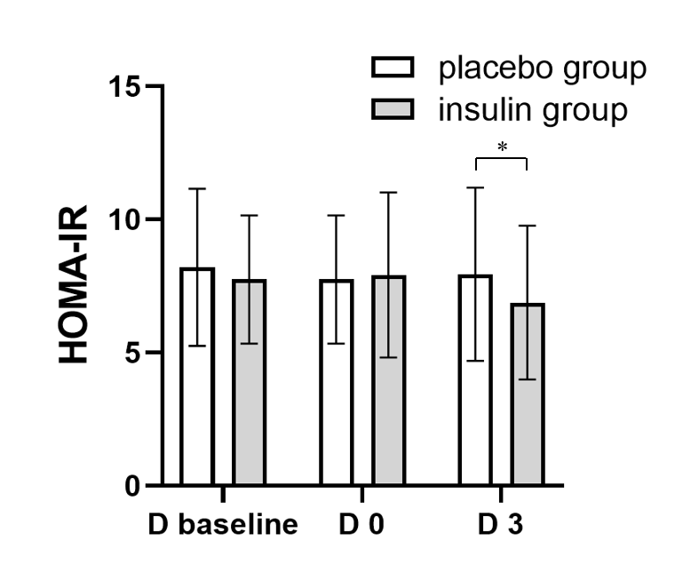
Supplementary Figure 1. Comparison of HOMA-IR between the two groups. It shows the comparison of HOMA-IR between the two groups at D_{baseline}, D₀, and D₃. *P<0.05.

.

