Table S1: UV-vis absorbance comparison with literature results. The literature values were taken from ref. [1].
NPs  (Au:Ag) | Experimental (nm) | Literature  (nm)
Au | 522 | 521
Au75:Ag25 | 487 | N/A
Au50:Ag50 | 457 | 462
Au25:Ag75 | 429 | N/A
Ag | 405 | 406
Abbreviations: NPs, Nanoparticles; Au:Ag, Gold:Silver

Table S2: Cubic lattice parameter (a) and crystallite size (L) for Au:Ag NPs.
NPs  (Au:Ag) | Cubic lattice parameter  a (Å) | Crystallite size  L (nm)
Au | 4.07 ± 0.0059 | 13.01 ± 5.78
Au75:Ag25 | 4.07 ± 0.017 | 8.45 ± 4.82
Au50:Ag50 | 4.08 ± 0.024 | 8.35 ± 3.97
Au25:Ag75 | 4.07 ± 0.014 | 9.08 ± 5.91
Ag | 4.09 ± 0.011 | 7.60 ± 8.83
Abbreviations: NPs, Nanoparticles; Au:Ag, Gold:Silver
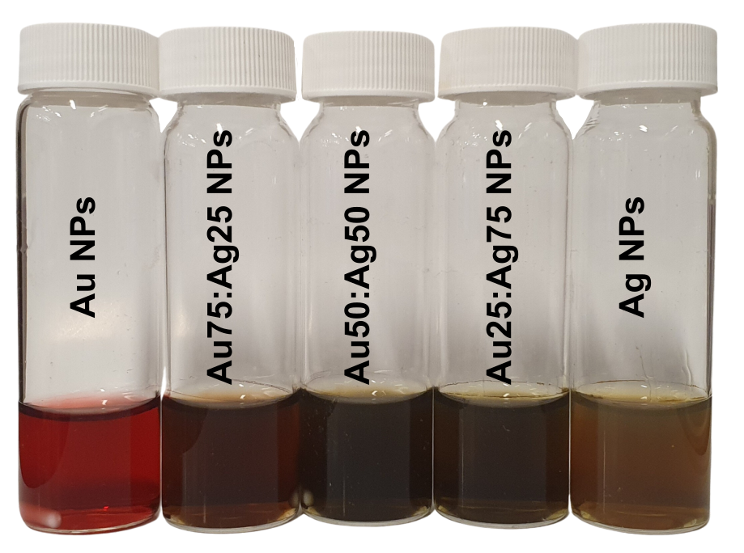
Figure S1. Photograph of colloids. From left to right Au NPs, Au75:Ag25 NPs, Au50:Ag50 NPs, Au75:Ag25 NPs, and Ag NPs.

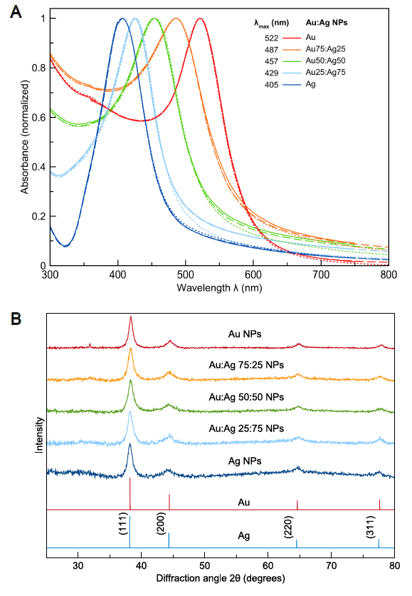
Figure S2. A) Representative normalized UV–vis absorption spectra for the colloidal Au:Ag NPs, analyzed on the day of synthesis (continuous line), after 14 days (dashed line) and 26 days after synthesis (dotted line). B) XRD patterns of the same samples (database code amcsd 0011140) and Ag (database code amcsd 0011135).

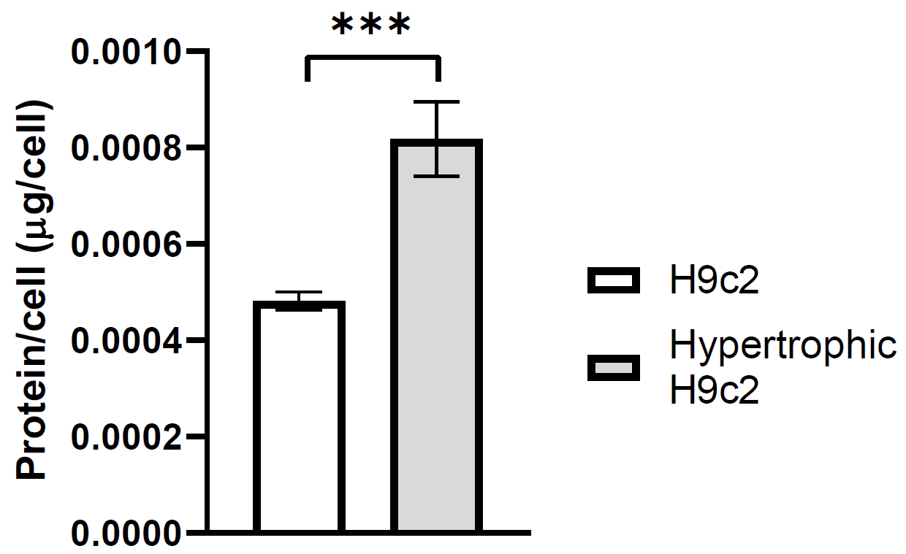
Figure S3. Protein quantification of non- and hypertrophic H9c2 cells. Data are presented as mean ± SEM of triplicates of at least three independent experiments.
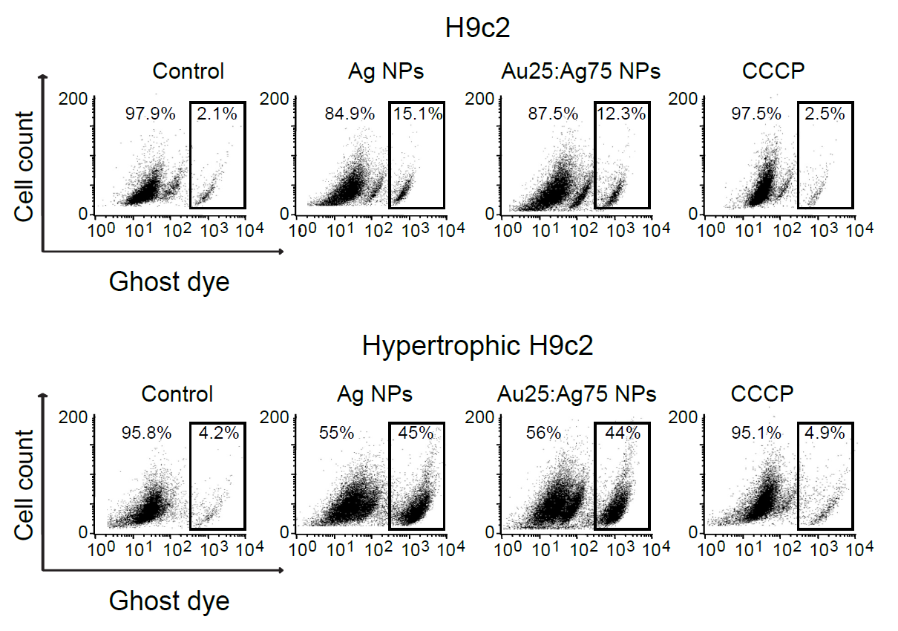Figure S4. Representative dot plots of cell viability analysis using Ghost dye stain by flow cytometry on H9c2 cells and hypertrophic H9c2 cells treated for 24 h with IC₅₀ of Ag NPs and Au25:Ag75 NPs and, CCCP (80 nM).

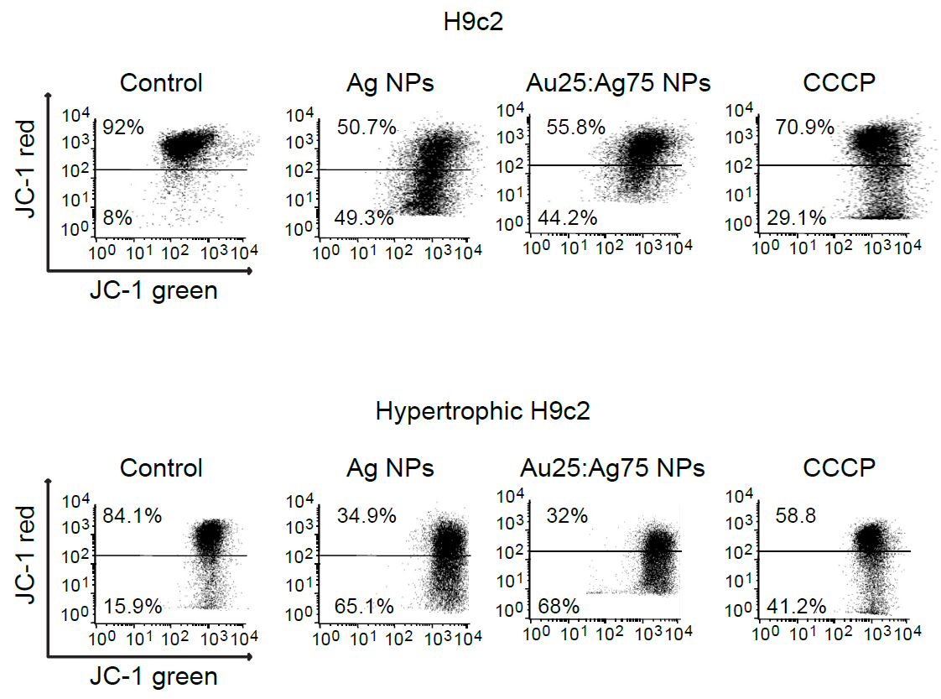Figure S5. Representative dot plots of mitochondrial membrane potential (∆Ψm) analysis using JC-1 stain by flow cytometry on H9c2 cells and hypertrophic H9c2 cells treated for 24 h with IC₅₀ of Ag NPs and Au25:Ag75 NPs and, CCCP (80 nM).

References
- Lomelí-Marroquín D, Cruz DM, Nieto-Argüello A, et al. Starch-mediated synthesis of mono- and bimetallic silver/gold nanoparticles as antimicrobial and anticancer agents. Int J Nanomedicine. 2019;14:2171-2190. doi:10.2147/IJN.S192757

