Supplementary materials
Supplementary Table 1. The summary information for instrumental variables of Chronotype.

Sort | Phenotype | SNP | effect_allele | other_allele | beta | se | eaf | pval | F-statistic
1 | Chronotype | rs17374439 | C | T | -0.034 | 0.003 | 0.803 | 1.20E-23 | 102.047
2 | Chronotype | rs17448682 | C | T | -0.022 | 0.003 | 0.768 | 2.20E-12 | 48.454
3 | Chronotype | rs3816454 | T | G | 0.020 | 0.003 | 0.375 | 4.90E-13 | 52.124
4 | Chronotype | rs12140153 | G | T | 0.034 | 0.005 | 0.905 | 1.60E-13 | 52.632
5 | Chronotype | rs7547493 | A | G | -0.038 | 0.004 | 0.822 | 3.90E-27 | 115.382
6 | Chronotype | rs985277 | T | G | -0.015 | 0.003 | 0.400 | 1.70E-08 | 30.879
7 | Chronotype | rs11588913 | G | A | 0.015 | 0.003 | 0.602 | 1.50E-08 | 31.838
8 | Chronotype | rs72720396 | A | G | -0.027 | 0.003 | 0.770 | 8.40E-18 | 72.526
9 | Chronotype | rs4949980 | A | G | -0.032 | 0.005 | 0.932 | 2.70E-09 | 35.612
10 | Chronotype | rs17575798 | G | A | 0.023 | 0.003 | 0.807 | 4.20E-11 | 44.170
11 | Chronotype | rs11587758 | G | A | -0.024 | 0.003 | 0.604 | 5.50E-19 | 77.570
12 | Chronotype | rs140206235 | C | T | -0.055 | 0.010 | 0.981 | 2.30E-08 | 30.872
13 | Chronotype | rs975025 | C | T | 0.032 | 0.005 | 0.923 | 1.30E-10 | 40.819
14 | Chronotype | rs509476 | T | C | 0.114 | 0.008 | 0.030 | 5.70E-47 | 209.387
15 | Chronotype | rs13011556 | C | G | -0.023 | 0.003 | 0.761 | 1.10E-12 | 51.771
16 | Chronotype | rs2712056 | C | T | -0.022 | 0.003 | 0.815 | 5.10E-11 | 41.076
17 | Chronotype | rs75120545 | C | T | -0.061 | 0.008 | 0.970 | 1.10E-13 | 54.896
18 | Chronotype | rs786406 | A | G | -0.024 | 0.003 | 0.298 | 1.90E-16 | 64.521
19 | Chronotype | rs10495976 | A | T | -0.018 | 0.003 | 0.610 | 5.10E-11 | 41.622
20 | Chronotype | rs7602425 | C | T | -0.031 | 0.005 | 0.924 | 8.50E-10 | 37.464
21 | Chronotype | rs359250 | G | T | -0.017 | 0.003 | 0.364 | 9.20E-10 | 36.575
22 | Chronotype | rs778138 | A | C | -0.021 | 0.003 | 0.649 | 6.90E-13 | 53.659
23 | Chronotype | rs2311837 | T | C | -0.015 | 0.003 | 0.592 | 3.60E-08 | 30.835
24 | Chronotype | rs6744983 | G | T | -0.016 | 0.003 | 0.622 | 3.60E-09 | 34.624
25 | Chronotype | rs10520176 | T | C | 0.023 | 0.003 | 0.502 | 1.40E-17 | 74.098
26 | Chronotype | rs28380327 | A | T | 0.021 | 0.003 | 0.629 | 2.90E-13 | 54.547
27 | Chronotype | rs1947198 | C | T | -0.024 | 0.004 | 0.878 | 1.80E-09 | 34.878
28 | Chronotype | rs197273 | A | G | 0.016 | 0.003 | 0.470 | 1.30E-08 | 34.714
29 | Chronotype | rs1064213 | G | A | -0.019 | 0.003 | 0.522 | 1.30E-12 | 50.782
30 | Chronotype | rs114670539 | C | T | -0.034 | 0.006 | 0.942 | 4.60E-09 | 34.830
31 | Chronotype | rs57435966 | C | T | 0.055 | 0.005 | 0.913 | 2.60E-30 | 132.835
32 | Chronotype | rs114870822 | G | A | -0.070 | 0.012 | 0.987 | 2.00E-09 | 33.642
33 | Chronotype | rs62182135 | C | A | 0.018 | 0.003 | 0.668 | 3.70E-10 | 39.698
34 | Chronotype | rs149611468 | T | C | 0.078 | 0.013 | 0.988 | 8.50E-10 | 37.977
35 | Chronotype | rs6442446 | A | G | 0.017 | 0.003 | 0.291 | 3.10E-09 | 34.543
36 | Chronotype | rs9817740 | A | G | 0.018 | 0.003 | 0.784 | 2.00E-08 | 30.270
37 | Chronotype | rs13059636 | A | G | -0.018 | 0.003 | 0.528 | 1.60E-11 | 45.707
38 | Chronotype | rs114848860 | A | T | -0.056 | 0.009 | 0.976 | 3.60E-10 | 40.574
39 | Chronotype | rs11712056 | T | C | 0.020 | 0.003 | 0.556 | 1.60E-13 | 55.205
40 | Chronotype | rs17399554 | G | A | -0.018 | 0.003 | 0.746 | 1.70E-08 | 33.571
41 | Chronotype | rs11924337 | G | C | -0.019 | 0.003 | 0.728 | 2.20E-10 | 39.920
42 | Chronotype | rs957501 | T | A | 0.015 | 0.003 | 0.336 | 3.00E-08 | 29.348
43 | Chronotype | rs1800828 | C | G | 0.018 | 0.003 | 0.746 | 1.70E-08 | 32.642
44 | Chronotype | rs13065394 | G | T | 0.018 | 0.003 | 0.712 | 3.00E-09 | 34.874
45 | Chronotype | rs885255 | T | C | 0.017 | 0.003 | 0.348 | 4.40E-09 | 35.882
46 | Chronotype | rs9831488 | A | G | -0.018 | 0.003 | 0.650 | 8.40E-11 | 41.636
47 | Chronotype | rs3850174 | T | A | 0.019 | 0.003 | 0.743 | 6.80E-10 | 39.369
48 | Chronotype | rs2239626 | T | C | -0.020 | 0.003 | 0.695 | 2.30E-12 | 47.987
49 | Chronotype | rs231398 | G | A | 0.021 | 0.004 | 0.838 | 8.40E-09 | 32.048
50 | Chronotype | rs28634184 | C | T | 0.018 | 0.003 | 0.749 | 2.80E-08 | 32.223
51 | Chronotype | rs6846730 | C | T | 0.022 | 0.003 | 0.768 | 5.60E-12 | 47.900
52 | Chronotype | rs4339281 | A | G | 0.022 | 0.004 | 0.873 | 3.20E-08 | 30.512
53 | Chronotype | rs4241964 | T | G | -0.021 | 0.003 | 0.525 | 1.10E-14 | 58.781
54 | Chronotype | rs10067113 | C | T | -0.016 | 0.003 | 0.381 | 6.30E-09 | 34.262
55 | Chronotype | rs7701529 | A | T | -0.019 | 0.003 | 0.238 | 3.60E-09 | 35.285
56 | Chronotype | rs11748798 | G | T | 0.020 | 0.003 | 0.750 | 5.20E-11 | 43.236
57 | Chronotype | rs56947091 | C | T | -0.019 | 0.003 | 0.489 | 6.00E-13 | 50.981
58 | Chronotype | rs12055234 | G | A | -0.019 | 0.003 | 0.672 | 4.00E-11 | 43.377
59 | Chronotype | rs286805 | A | T | 0.014 | 0.003 | 0.477 | 4.50E-08 | 28.173
60 | Chronotype | rs1027742 | A | G | 0.018 | 0.003 | 0.738 | 2.80E-09 | 35.699
61 | Chronotype | rs4246036 | C | T | 0.024 | 0.003 | 0.292 | 2.40E-15 | 64.388
62 | Chronotype | rs7735794 | G | A | -0.020 | 0.003 | 0.776 | 4.70E-09 | 34.911
63 | Chronotype | rs9395520 | C | T | -0.023 | 0.003 | 0.695 | 2.10E-15 | 62.768
64 | Chronotype | rs521977 | T | G | 0.016 | 0.003 | 0.322 | 2.10E-08 | 31.119
65 | Chronotype | rs4714475 | G | T | 0.019 | 0.003 | 0.754 | 1.60E-09 | 35.833
66 | Chronotype | rs62405438 | T | A | -0.020 | 0.004 | 0.820 | 6.30E-09 | 33.264
67 | Chronotype | rs2653349 | A | G | 0.039 | 0.003 | 0.215 | 5.20E-32 | 139.860
68 | Chronotype | rs2881955 | C | T | -0.016 | 0.003 | 0.721 | 4.30E-08 | 28.834
69 | Chronotype | rs60616179 | A | G | 0.038 | 0.006 | 0.945 | 1.10E-10 | 39.938
70 | Chronotype | rs520954 | A | G | -0.024 | 0.003 | 0.673 | 1.00E-16 | 68.101
71 | Chronotype | rs9364767 | T | G | 0.016 | 0.003 | 0.447 | 5.40E-09 | 34.495
72 | Chronotype | rs9348050 | T | C | 0.017 | 0.003 | 0.489 | 7.50E-10 | 38.242
73 | Chronotype | rs10280205 | T | C | 0.017 | 0.003 | 0.692 | 1.40E-09 | 35.898
74 | Chronotype | rs17161045 | T | C | 0.021 | 0.003 | 0.631 | 7.20E-14 | 54.223
75 | Chronotype | rs6967481 | C | T | -0.021 | 0.003 | 0.503 | 6.90E-15 | 58.488
76 | Chronotype | rs2968511 | C | G | -0.017 | 0.003 | 0.695 | 4.90E-09 | 35.771
77 | Chronotype | rs202157 | C | T | 0.026 | 0.003 | 0.299 | 4.10E-18 | 75.346
78 | Chronotype | rs4729854 | T | A | 0.029 | 0.003 | 0.517 | 3.30E-25 | 109.030
79 | Chronotype | rs1113295 | T | G | 0.016 | 0.003 | 0.441 | 6.80E-09 | 33.535
80 | Chronotype | rs2971970 | T | G | 0.019 | 0.003 | 0.218 | 6.00E-09 | 33.435
81 | Chronotype | rs35524253 | G | A | -0.016 | 0.003 | 0.643 | 5.80E-09 | 31.805
82 | Chronotype | rs11786306 | G | C | -0.018 | 0.003 | 0.646 | 8.70E-11 | 41.931
83 | Chronotype | rs13255030 | A | G | 0.016 | 0.003 | 0.585 | 2.80E-09 | 35.244
84 | Chronotype | rs12541362 | A | T | -0.021 | 0.003 | 0.650 | 3.50E-14 | 57.174
85 | Chronotype | rs769066 | T | C | -0.022 | 0.003 | 0.817 | 3.20E-10 | 39.695
86 | Chronotype | rs4321976 | T | C | 0.023 | 0.003 | 0.779 | 3.10E-13 | 51.686
87 | Chronotype | rs3100052 | A | G | 0.017 | 0.003 | 0.387 | 6.90E-10 | 38.278
88 | Chronotype | rs3808477 | C | T | -0.022 | 0.003 | 0.719 | 2.80E-13 | 51.960
89 | Chronotype | rs34340407 | T | C | -0.018 | 0.003 | 0.753 | 4.30E-09 | 35.095
90 | Chronotype | rs6477309 | C | T | -0.017 | 0.003 | 0.335 | 8.00E-10 | 37.112
91 | Chronotype | rs308521 | T | C | 0.020 | 0.003 | 0.603 | 3.70E-13 | 52.580
92 | Chronotype | rs62553781 | C | T | 0.050 | 0.007 | 0.965 | 1.20E-11 | 47.065
93 | Chronotype | rs4838161 | T | G | 0.016 | 0.003 | 0.561 | 2.20E-09 | 35.467
94 | Chronotype | rs10988239 | C | T | 0.019 | 0.003 | 0.487 | 1.60E-11 | 46.483
95 | Chronotype | rs34619169 | G | A | -0.017 | 0.003 | 0.692 | 3.80E-09 | 33.643
96 | Chronotype | rs28458909 | C | T | 0.043 | 0.004 | 0.876 | 2.60E-26 | 112.666
97 | Chronotype | rs4948547 | C | A | 0.019 | 0.003 | 0.256 | 1.20E-09 | 38.094
98 | Chronotype | rs10823233 | T | C | -0.015 | 0.003 | 0.452 | 4.30E-08 | 31.512
99 | Chronotype | rs3808964 | G | T | -0.016 | 0.003 | 0.365 | 2.70E-08 | 31.568
100 | Chronotype | rs72632979 | A | G | 0.022 | 0.004 | 0.828 | 1.20E-09 | 36.419
101 | Chronotype | rs10742179 | A | G | 0.018 | 0.003 | 0.260 | 1.50E-09 | 35.644
102 | Chronotype | rs4141920 | G | A | 0.016 | 0.003 | 0.544 | 4.60E-09 | 33.302
103 | Chronotype | rs11032362 | G | A | -0.040 | 0.005 | 0.909 | 4.80E-17 | 71.559
104 | Chronotype | rs34239319 | G | T | -0.028 | 0.004 | 0.898 | 3.90E-10 | 39.831
105 | Chronotype | rs11229545 | A | G | 0.021 | 0.003 | 0.760 | 2.90E-11 | 43.552
106 | Chronotype | rs11227452 | G | A | -0.019 | 0.004 | 0.828 | 4.60E-08 | 29.431
107 | Chronotype | rs4237555 | C | T | -0.016 | 0.003 | 0.473 | 6.00E-10 | 37.427
108 | Chronotype | rs4936291 | A | G | -0.018 | 0.003 | 0.611 | 3.80E-10 | 40.050
109 | Chronotype | rs74357745 | A | G | 0.027 | 0.004 | 0.879 | 8.70E-11 | 41.483
110 | Chronotype | rs7977610 | A | T | 0.016 | 0.003 | 0.673 | 2.10E-08 | 31.201
111 | Chronotype | rs12811046 | A | G | 0.017 | 0.003 | 0.553 | 6.20E-10 | 39.389
112 | Chronotype | rs7313852 | G | A | 0.030 | 0.003 | 0.565 | 2.70E-27 | 119.179
113 | Chronotype | rs77384811 | G | C | 0.025 | 0.004 | 0.843 | 2.80E-11 | 44.075
114 | Chronotype | rs7959983 | T | C | -0.020 | 0.003 | 0.596 | 9.50E-13 | 51.212
115 | Chronotype | rs7304278 | A | G | -0.020 | 0.003 | 0.275 | 2.20E-11 | 44.904
116 | Chronotype | rs80097534 | G | T | 0.028 | 0.005 | 0.901 | 9.30E-10 | 38.072
117 | Chronotype | rs9597250 | C | A | 0.021 | 0.003 | 0.810 | 6.90E-10 | 38.408
118 | Chronotype | rs9573971 | A | G | 0.073 | 0.007 | 0.966 | 3.60E-22 | 95.825
119 | Chronotype | rs17267683 | C | G | 0.020 | 0.003 | 0.761 | 2.70E-10 | 38.868
120 | Chronotype | rs17517 | G | A | 0.015 | 0.003 | 0.487 | 3.00E-08 | 30.294
121 | Chronotype | rs1952923 | G | A | 0.017 | 0.003 | 0.261 | 3.60E-08 | 30.426
122 | Chronotype | rs698015 | C | T | -0.016 | 0.003 | 0.353 | 8.80E-09 | 32.112
123 | Chronotype | rs7148842 | C | T | 0.015 | 0.003 | 0.612 | 1.80E-08 | 30.529
124 | Chronotype | rs10149448 | A | G | 0.016 | 0.003 | 0.604 | 2.70E-09 | 35.694
125 | Chronotype | rs12432176 | C | A | -0.016 | 0.003 | 0.621 | 6.50E-09 | 33.508
126 | Chronotype | rs59986227 | C | G | -0.018 | 0.003 | 0.742 | 8.30E-09 | 33.072
127 | Chronotype | rs9932577 | C | A | 0.017 | 0.003 | 0.495 | 6.80E-10 | 37.476
128 | Chronotype | rs12927162 | A | G | 0.029 | 0.003 | 0.722 | 6.80E-22 | 91.160
129 | Chronotype | rs1421085 | T | C | -0.028 | 0.003 | 0.597 | 1.50E-23 | 101.131
130 | Chronotype | rs4784655 | G | C | 0.021 | 0.003 | 0.679 | 1.50E-13 | 53.551
131 | Chronotype | rs17604349 | G | A | 0.026 | 0.004 | 0.821 | 1.70E-13 | 53.651
132 | Chronotype | rs2518022 | T | C | 0.040 | 0.005 | 0.084 | 4.80E-17 | 69.044
133 | Chronotype | rs3760185 | C | T | 0.024 | 0.003 | 0.752 | 2.60E-14 | 58.834
134 | Chronotype | rs226090 | C | T | 0.021 | 0.004 | 0.168 | 4.10E-09 | 33.724
135 | Chronotype | rs28647842 | G | C | 0.016 | 0.003 | 0.477 | 2.00E-09 | 35.636
136 | Chronotype | rs72829706 | A | G | 0.041 | 0.007 | 0.961 | 5.10E-09 | 34.452
137 | Chronotype | rs114352914 | G | A | -0.020 | 0.003 | 0.812 | 7.90E-09 | 33.072
138 | Chronotype | rs2364972 | A | G | -0.016 | 0.003 | 0.537 | 2.10E-09 | 36.007
139 | Chronotype | rs62082406 | C | T | -0.026 | 0.003 | 0.808 | 1.60E-14 | 55.949
140 | Chronotype | rs4239386 | T | A | 0.022 | 0.003 | 0.665 | 1.00E-14 | 58.794
141 | Chronotype | rs12969848 | C | T | -0.022 | 0.003 | 0.470 | 1.30E-15 | 65.423
142 | Chronotype | rs9962650 | C | G | -0.017 | 0.003 | 0.577 | 1.60E-10 | 40.277
143 | Chronotype | rs9964420 | C | A | 0.028 | 0.003 | 0.695 | 8.60E-22 | 94.068
144 | Chronotype | rs56076457 | C | T | -0.016 | 0.003 | 0.471 | 1.30E-09 | 36.584
145 | Chronotype | rs10402849 | C | T | -0.019 | 0.003 | 0.799 | 8.90E-09 | 32.871
146 | Chronotype | rs9636202 | G | A | 0.018 | 0.003 | 0.734 | 7.50E-10 | 36.162
147 | Chronotype | rs11670534 | C | T | 0.021 | 0.004 | 0.834 | 8.50E-09 | 33.426
148 | Chronotype | rs78095690 | T | C | -0.016 | 0.003 | 0.564 | 1.40E-09 | 36.086
149 | Chronotype | rs6131942 | A | G | -0.018 | 0.003 | 0.420 | 9.40E-11 | 41.226
150 | Chronotype | rs2072727 | T | C | 0.016 | 0.003 | 0.436 | 8.50E-10 | 36.271
151 | Chronotype | rs139911 | C | T | 0.023 | 0.003 | 0.424 | 2.30E-17 | 73.292
152 | Chronotype | rs4822107 | G | A | -0.016 | 0.003 | 0.494 | 9.60E-09 | 32.923
SNP, single nucleotide polymorphism; se, standard error
Supplementary Table 2. The summary information for instrumental variables of Sleep duration.

Sort | Phenotype | SNP | effect_allele | other_allele | beta | se | eaf | pval | F-statistic
1 | Sleep duration | rs915416 | C | G | 0.019 | 0.002 | 0.290 | 9.90E-15 | 59.604
2 | Sleep duration | rs269054 | T | A | -0.014 | 0.002 | 0.578 | 2.10E-09 | 35.393
3 | Sleep duration | rs61796569 | C | T | -0.015 | 0.003 | 0.730 | 1.50E-09 | 36.270
4 | Sleep duration | rs12567114 | G | A | -0.015 | 0.003 | 0.724 | 4.30E-09 | 34.084
5 | Sleep duration | rs62120041 | T | C | 0.026 | 0.005 | 0.934 | 9.60E-09 | 32.575
6 | Sleep duration | rs374153 | C | T | 0.018 | 0.003 | 0.158 | 9.10E-09 | 32.213
7 | Sleep duration | rs2717076 | C | T | -0.018 | 0.002 | 0.373 | 3.10E-15 | 61.854
8 | Sleep duration | rs75539574 | A | C | -0.036 | 0.004 | 0.914 | 6.90E-19 | 79.507
9 | Sleep duration | rs7556815 | G | A | -0.041 | 0.003 | 0.781 | 1.30E-49 | 220.873
10 | Sleep duration | rs4128364 | T | C | -0.015 | 0.002 | 0.661 | 1.40E-09 | 37.265
11 | Sleep duration | rs11885663 | C | T | -0.016 | 0.003 | 0.752 | 8.60E-10 | 38.370
12 | Sleep duration | rs10173260 | T | C | -0.013 | 0.002 | 0.394 | 2.90E-08 | 30.795
13 | Sleep duration | rs112230981 | A | G | 0.032 | 0.005 | 0.950 | 2.20E-09 | 36.369
14 | Sleep duration | rs17732997 | C | G | 0.013 | 0.002 | 0.569 | 1.20E-08 | 31.953
15 | Sleep duration | rs7644809 | T | C | 0.013 | 0.002 | 0.422 | 1.60E-08 | 32.211
16 | Sleep duration | rs13088093 | T | G | -0.016 | 0.002 | 0.664 | 7.00E-12 | 45.879
17 | Sleep duration | rs2192528 | A | G | 0.013 | 0.002 | 0.480 | 2.70E-09 | 34.708
18 | Sleep duration | rs17427571 | A | G | 0.014 | 0.002 | 0.684 | 1.30E-08 | 32.226
19 | Sleep duration | rs35531607 | T | C | -0.013 | 0.002 | 0.526 | 1.50E-08 | 31.917
20 | Sleep duration | rs13109404 | T | G | 0.031 | 0.004 | 0.928 | 1.40E-12 | 50.103
21 | Sleep duration | rs365663 | A | G | 0.015 | 0.002 | 0.546 | 1.00E-10 | 41.220
22 | Sleep duration | rs465700 | C | G | 0.023 | 0.004 | 0.108 | 1.40E-09 | 37.562
23 | Sleep duration | rs56372231 | C | T | -0.017 | 0.002 | 0.666 | 2.20E-12 | 49.851
24 | Sleep duration | rs11567976 | C | T | -0.013 | 0.002 | 0.429 | 2.10E-08 | 31.396
25 | Sleep duration | rs151014368 | G | A | -0.016 | 0.003 | 0.794 | 9.10E-09 | 32.574
26 | Sleep duration | rs34556183 | A | G | 0.017 | 0.003 | 0.720 | 2.30E-11 | 44.981
27 | Sleep duration | rs113113059 | T | C | 0.016 | 0.003 | 0.780 | 8.40E-09 | 34.769
28 | Sleep duration | rs9382445 | T | C | 0.015 | 0.002 | 0.623 | 4.80E-10 | 38.791
29 | Sleep duration | rs2231265 | A | G | -0.015 | 0.003 | 0.228 | 2.70E-08 | 30.698
30 | Sleep duration | rs9345234 | A | C | -0.013 | 0.002 | 0.422 | 1.80E-08 | 32.034
31 | Sleep duration | rs34731055 | C | T | -0.019 | 0.003 | 0.819 | 3.70E-11 | 43.582
32 | Sleep duration | rs2079070 | C | G | 0.018 | 0.003 | 0.265 | 7.50E-12 | 46.751
33 | Sleep duration | rs7806045 | T | C | 0.015 | 0.003 | 0.755 | 1.40E-08 | 31.733
34 | Sleep duration | rs2001329 | C | T | 0.014 | 0.002 | 0.486 | 1.20E-09 | 37.911
35 | Sleep duration | rs73219758 | G | A | 0.016 | 0.002 | 0.708 | 5.60E-11 | 43.203
36 | Sleep duration | rs10973207 | G | T | -0.020 | 0.003 | 0.842 | 6.00E-11 | 42.785
37 | Sleep duration | rs1776776 | T | C | 0.020 | 0.003 | 0.874 | 4.90E-09 | 34.258
38 | Sleep duration | rs12246842 | A | G | 0.013 | 0.002 | 0.460 | 3.90E-09 | 34.690
39 | Sleep duration | rs10761674 | C | T | 0.012 | 0.002 | 0.477 | 4.20E-08 | 29.624
40 | Sleep duration | rs11190970 | G | A | 0.015 | 0.003 | 0.799 | 4.60E-08 | 29.674
41 | Sleep duration | rs7915425 | T | C | 0.019 | 0.003 | 0.175 | 2.00E-10 | 40.662
42 | Sleep duration | rs1517572 | A | C | -0.015 | 0.002 | 0.419 | 1.50E-10 | 40.728
43 | Sleep duration | rs4592416 | A | G | -0.015 | 0.002 | 0.536 | 9.30E-11 | 41.834
44 | Sleep duration | rs11039544 | G | A | 0.018 | 0.003 | 0.838 | 1.90E-09 | 35.795
45 | Sleep duration | rs174560 | T | C | -0.014 | 0.002 | 0.686 | 2.80E-08 | 31.036
46 | Sleep duration | rs12791153 | A | T | -0.024 | 0.004 | 0.919 | 1.90E-08 | 31.183
47 | Sleep duration | rs1553132 | A | G | -0.015 | 0.003 | 0.742 | 2.50E-08 | 31.506
48 | Sleep duration | rs1939455 | G | T | 0.020 | 0.004 | 0.879 | 1.20E-08 | 32.896
49 | Sleep duration | rs1079727 | T | C | -0.018 | 0.003 | 0.842 | 5.30E-09 | 34.740
50 | Sleep duration | rs1057703 | T | G | -0.019 | 0.003 | 0.853 | 1.10E-09 | 36.609
51 | Sleep duration | rs34354917 | C | A | 0.014 | 0.003 | 0.710 | 3.90E-08 | 30.214
52 | Sleep duration | rs4767550 | A | G | -0.014 | 0.002 | 0.586 | 6.30E-10 | 38.336
53 | Sleep duration | rs6575005 | T | C | 0.016 | 0.003 | 0.758 | 4.40E-09 | 34.710
54 | Sleep duration | rs10483350 | A | G | -0.017 | 0.003 | 0.805 | 1.50E-09 | 36.687
55 | Sleep duration | rs61985058 | C | T | -0.019 | 0.003 | 0.857 | 1.30E-08 | 33.160
56 | Sleep duration | rs55658675 | C | T | 0.013 | 0.002 | 0.645 | 2.00E-08 | 30.774
57 | Sleep duration | rs11621908 | C | T | 0.024 | 0.004 | 0.917 | 5.60E-09 | 33.500
58 | Sleep duration | rs8038326 | A | G | 0.016 | 0.003 | 0.727 | 2.80E-10 | 39.264
59 | Sleep duration | rs3095508 | C | A | 0.015 | 0.002 | 0.594 | 3.10E-11 | 44.383
60 | Sleep duration | rs11643715 | C | G | -0.014 | 0.002 | 0.709 | 3.20E-08 | 30.976
61 | Sleep duration | rs9940278 | C | T | 0.017 | 0.002 | 0.578 | 1.20E-13 | 54.702
62 | Sleep duration | rs2032925 | C | T | -0.015 | 0.002 | 0.537 | 1.30E-10 | 41.335
63 | Sleep duration | rs3027234 | C | T | 0.015 | 0.003 | 0.773 | 2.30E-08 | 31.353
64 | Sleep duration | rs205024 | C | T | -0.014 | 0.002 | 0.616 | 3.90E-09 | 35.299
65 | Sleep duration | rs8072993 | T | G | -0.017 | 0.003 | 0.363 | 4.20E-10 | 38.366
66 | Sleep duration | rs147114641 | C | A | 0.016 | 0.003 | 0.774 | 3.10E-09 | 34.931
67 | Sleep duration | rs2696429 | G | A | 0.017 | 0.003 | 0.774 | 4.00E-10 | 38.904
68 | Sleep duration | rs12607679 | T | C | 0.020 | 0.003 | 0.738 | 8.30E-15 | 60.327
69 | Sleep duration | rs10421649 | T | A | -0.013 | 0.002 | 0.443 | 6.90E-09 | 33.583
70 | Sleep duration | rs2072727 | T | C | 0.013 | 0.002 | 0.436 | 7.90E-09 | 33.585

Supplementary Table 3. The summary information for instrumental variables of Short sleep duration.

Sort | Phenotype | SNP | effect_allele | other_allele | beta | se | eaf | pval | F-statistic
1 | Short sleep duration | rs7524118 | T | C | -0.006 | 0.001 | 0.292 | 4.90E-08 | 29.901
2 | Short sleep duration | rs2186122 | A | T | -0.006 | 0.001 | 0.438 | 4.80E-09 | 34.006
3 | Short sleep duration | rs12567114 | G | A | 0.006 | 0.001 | 0.725 | 4.10E-09 | 34.497
4 | Short sleep duration | rs2820313 | A | G | -0.006 | 0.001 | 0.659 | 2.30E-09 | 35.348
5 | Short sleep duration | rs1380703 | A | G | -0.007 | 0.001 | 0.616 | 1.60E-11 | 45.337
6 | Short sleep duration | rs2863957 | C | A | 0.010 | 0.001 | 0.782 | 2.60E-18 | 77.041
7 | Short sleep duration | rs2014830 | C | T | 0.006 | 0.001 | 0.698 | 2.70E-08 | 30.348
8 | Short sleep duration | rs17005118 | G | A | -0.006 | 0.001 | 0.735 | 2.50E-09 | 35.564
9 | Short sleep duration | rs13107325 | C | T | -0.013 | 0.002 | 0.925 | 2.50E-13 | 52.671
10 | Short sleep duration | rs12518468 | T | C | -0.006 | 0.001 | 0.672 | 8.50E-09 | 33.225
11 | Short sleep duration | rs3776864 | A | C | 0.006 | 0.001 | 0.667 | 1.70E-08 | 31.537
12 | Short sleep duration | rs4585442 | A | G | -0.006 | 0.001 | 0.689 | 8.10E-10 | 37.513
13 | Short sleep duration | rs2517827 | C | A | -0.006 | 0.001 | 0.689 | 5.70E-09 | 32.738
14 | Short sleep duration | rs12661667 | C | T | -0.006 | 0.001 | 0.737 | 2.80E-08 | 30.681
15 | Short sleep duration | rs9367621 | T | A | 0.005 | 0.001 | 0.431 | 1.60E-08 | 31.516
16 | Short sleep duration | rs9321171 | C | T | 0.005 | 0.001 | 0.540 | 4.20E-08 | 30.717
17 | Short sleep duration | rs11763750 | G | A | 0.007 | 0.001 | 0.814 | 5.10E-09 | 34.178
18 | Short sleep duration | rs1229762 | C | T | -0.007 | 0.001 | 0.335 | 1.00E-12 | 50.714
19 | Short sleep duration | rs60882754 | A | T | 0.011 | 0.002 | 0.939 | 1.80E-08 | 31.899
20 | Short sleep duration | rs1607227 | G | T | 0.006 | 0.001 | 0.705 | 1.50E-09 | 36.468
21 | Short sleep duration | rs7939345 | T | G | 0.006 | 0.001 | 0.208 | 4.00E-08 | 30.236
22 | Short sleep duration | rs17388803 | A | C | -0.010 | 0.002 | 0.894 | 6.50E-10 | 38.334
23 | Short sleep duration | rs59779556 | T | G | 0.005 | 0.001 | 0.554 | 2.00E-08 | 32.317
24 | Short sleep duration | rs205024 | C | T | 0.006 | 0.001 | 0.617 | 2.70E-08 | 31.231
25 | Short sleep duration | rs12963463 | C | T | 0.007 | 0.001 | 0.299 | 1.90E-11 | 45.038
26 | Short sleep duration | rs5757675 | G | T | 0.006 | 0.001 | 0.260 | 2.70E-09 | 34.498

Supplementary Table 4. The summary information for instrumental variables of Long sleep duration.

Sort | Phenotype | SNP | effect_allele | other_allele | beta | se | eaf | pval | F-statistic
1 | Long sleep duration | rs7534398 | T | A | -0.005 | 0.001 | 0.799 | 2.10E-08 | 31.256
2 | Long sleep duration | rs6737318 | A | G | -0.006 | 0.001 | 0.778 | 3.40E-13 | 52.982
3 | Long sleep duration | rs10899257 | G | A | -0.006 | 0.001 | 0.856 | 4.60E-08 | 29.889
4 | Long sleep duration | rs75458655 | C | T | -0.017 | 0.002 | 0.977 | 5.40E-12 | 47.681
5 | Long sleep duration | rs3751046 | A | G | -0.006 | 0.001 | 0.853 | 2.00E-08 | 31.606
6 | Long sleep duration | rs17817288 | A | G | 0.004 | 0.001 | 0.518 | 8.90E-09 | 33.233
7 | Long sleep duration | rs147114641 | C | A | 0.006 | 0.001 | 0.774 | 4.90E-11 | 42.999
8 | Long sleep duration | rs146467757 | G | T | 0.006 | 0.001 | 0.772 | 8.10E-11 | 42.004
9 | Long sleep duration | rs572857764 | T | A | 0.006 | 0.001 | 0.775 | 1.30E-10 | 41.115
10 | Long sleep duration | rs62073915 | A | G | 0.006 | 0.001 | 0.779 | 1.00E-11 | 46.154

Supplementary Table 5. The summary information for instrumental variables of Daytime napping.

Sort | Phenotype | SNP | effect_allele | other_allele | beta | se | eaf | pval | F-statistic
1 | Daytime napping | rs35570980 | G | A | -0.008 | 0.001 | 0.438 | 1.40E-10 | 39.519
2 | Daytime napping | rs2786547 | C | T | 0.011 | 0.002 | 0.823 | 1.00E-11 | 45.988
3 | Daytime napping | rs4653052 | C | A | -0.007 | 0.001 | 0.340 | 3.40E-08 | 30.224
4 | Daytime napping | rs12140153 | G | T | 0.025 | 0.002 | 0.905 | 2.40E-31 | 136.466
5 | Daytime napping | rs1931175 | C | G | -0.008 | 0.001 | 0.616 | 4.60E-10 | 38.722
6 | Daytime napping | rs12042846 | T | C | -0.009 | 0.002 | 0.821 | 1.90E-08 | 32.141
7 | Daytime napping | rs6665690 | A | C | 0.009 | 0.002 | 0.830 | 6.00E-09 | 32.743
8 | Daytime napping | rs35039375 | A | G | -0.014 | 0.002 | 0.908 | 8.70E-11 | 41.819
9 | Daytime napping | rs200435329 | G | T | -0.010 | 0.001 | 0.762 | 9.90E-12 | 47.048
10 | Daytime napping | rs2250377 | A | G | 0.013 | 0.001 | 0.339 | 1.40E-24 | 105.682
11 | Daytime napping | rs13033444 | A | G | -0.010 | 0.001 | 0.717 | 3.60E-13 | 52.059
12 | Daytime napping | rs75022160 | C | T | 0.010 | 0.002 | 0.863 | 1.70E-08 | 31.213
13 | Daytime napping | rs13023587 | C | G | 0.007 | 0.001 | 0.491 | 6.50E-10 | 37.764
14 | Daytime napping | rs350788 | A | C | 0.010 | 0.002 | 0.136 | 9.30E-09 | 32.004
15 | Daytime napping | rs17049683 | A | G | -0.008 | 0.001 | 0.667 | 4.10E-10 | 37.957
16 | Daytime napping | rs11125776 | T | G | 0.012 | 0.002 | 0.854 | 1.50E-11 | 45.615
17 | Daytime napping | rs2341089 | A | G | 0.012 | 0.002 | 0.087 | 2.00E-08 | 32.416
18 | Daytime napping | rs62189006 | A | G | 0.012 | 0.002 | 0.907 | 8.30E-09 | 33.225
19 | Daytime napping | rs80163246 | T | C | -0.012 | 0.002 | 0.883 | 1.40E-10 | 39.966
20 | Daytime napping | rs12992648 | A | G | 0.008 | 0.001 | 0.717 | 2.40E-08 | 32.301
21 | Daytime napping | rs7422655 | C | T | 0.008 | 0.001 | 0.263 | 1.10E-08 | 32.303
22 | Daytime napping | rs908442 | A | T | 0.010 | 0.001 | 0.591 | 1.40E-16 | 69.196
23 | Daytime napping | rs77154532 | A | G | 0.008 | 0.001 | 0.642 | 1.40E-09 | 36.666
24 | Daytime napping | rs12497609 | G | T | -0.009 | 0.002 | 0.837 | 3.20E-08 | 30.926
25 | Daytime napping | rs76824303 | A | C | 0.012 | 0.002 | 0.901 | 1.70E-08 | 32.249
26 | Daytime napping | rs4511908 | T | G | -0.007 | 0.001 | 0.419 | 1.40E-08 | 32.032
27 | Daytime napping | rs1601440 | C | T | 0.009 | 0.001 | 0.279 | 1.90E-11 | 45.316
28 | Daytime napping | rs2699869 | A | C | 0.007 | 0.001 | 0.454 | 3.10E-08 | 31.007
29 | Daytime napping | rs253666 | G | A | -0.008 | 0.001 | 0.235 | 1.80E-08 | 32.259
30 | Daytime napping | rs1001817 | C | T | 0.008 | 0.001 | 0.507 | 1.70E-10 | 40.786
31 | Daytime napping | rs7697461 | A | T | -0.008 | 0.001 | 0.258 | 6.00E-09 | 34.423
32 | Daytime napping | rs13150944 | A | G | -0.009 | 0.001 | 0.311 | 6.80E-11 | 42.339
33 | Daytime napping | rs4692709 | C | T | 0.007 | 0.001 | 0.455 | 2.40E-09 | 34.918
34 | Daytime napping | rs12657723 | C | T | -0.008 | 0.001 | 0.678 | 2.00E-10 | 39.716
35 | Daytime napping | rs6452787 | A | G | 0.008 | 0.001 | 0.536 | 2.00E-10 | 40.343
36 | Daytime napping | rs2943023 | C | T | 0.007 | 0.001 | 0.580 | 7.40E-09 | 33.330
37 | Daytime napping | rs467897 | G | A | 0.010 | 0.001 | 0.322 | 2.60E-13 | 53.956
38 | Daytime napping | rs2431108 | T | C | -0.013 | 0.001 | 0.671 | 7.70E-24 | 101.242
39 | Daytime napping | rs2099810 | A | G | 0.008 | 0.001 | 0.503 | 2.80E-10 | 40.114
40 | Daytime napping | rs10875606 | C | A | 0.007 | 0.001 | 0.316 | 1.30E-08 | 31.824
41 | Daytime napping | rs10875622 | G | A | -0.010 | 0.001 | 0.425 | 1.30E-17 | 72.454
42 | Daytime napping | rs73817091 | C | T | -0.017 | 0.003 | 0.958 | 3.80E-08 | 29.852
43 | Daytime napping | rs3799380 | T | C | 0.009 | 0.002 | 0.800 | 1.30E-08 | 34.586
44 | Daytime napping | rs34262487 | C | A | 0.015 | 0.002 | 0.928 | 1.20E-09 | 37.978
45 | Daytime napping | rs6919087 | T | G | 0.011 | 0.001 | 0.688 | 1.00E-16 | 67.579
46 | Daytime napping | rs9475168 | T | G | 0.009 | 0.001 | 0.781 | 1.90E-09 | 35.257
47 | Daytime napping | rs2653349 | A | G | 0.017 | 0.001 | 0.215 | 3.40E-29 | 126.009
48 | Daytime napping | rs2143792 | G | A | 0.007 | 0.001 | 0.568 | 9.10E-09 | 33.422
49 | Daytime napping | rs1546977 | A | G | -0.008 | 0.001 | 0.560 | 1.00E-11 | 45.789
50 | Daytime napping | rs9389556 | C | G | -0.008 | 0.001 | 0.739 | 9.70E-10 | 37.032
51 | Daytime napping | rs785145 | T | G | -0.007 | 0.001 | 0.569 | 1.00E-08 | 32.535
52 | Daytime napping | rs614987 | A | C | -0.011 | 0.001 | 0.386 | 7.50E-19 | 77.839
53 | Daytime napping | rs140506252 | A | T | 0.023 | 0.004 | 0.978 | 4.30E-08 | 30.896
54 | Daytime napping | rs9460110 | T | C | -0.007 | 0.001 | 0.630 | 8.40E-09 | 34.215
55 | Daytime napping | rs35851551 | A | G | 0.011 | 0.002 | 0.898 | 3.50E-08 | 30.511
56 | Daytime napping | rs10257273 | A | T | 0.011 | 0.002 | 0.851 | 8.90E-10 | 39.694
57 | Daytime napping | rs76257331 | G | A | -0.009 | 0.002 | 0.802 | 1.20E-08 | 32.508
58 | Daytime napping | rs13263535 | G | T | 0.007 | 0.001 | 0.531 | 1.60E-08 | 31.910
59 | Daytime napping | rs351776 | A | C | -0.008 | 0.001 | 0.450 | 8.40E-10 | 38.290
60 | Daytime napping | rs2059639 | C | T | 0.007 | 0.001 | 0.479 | 2.40E-08 | 30.139
61 | Daytime napping | rs285815 | T | A | 0.008 | 0.001 | 0.456 | 5.80E-10 | 38.107
62 | Daytime napping | rs7814873 | C | T | 0.007 | 0.001 | 0.383 | 1.50E-08 | 32.542
63 | Daytime napping | rs10811438 | G | C | 0.007 | 0.001 | 0.607 | 3.20E-09 | 33.719
64 | Daytime napping | rs17502738 | T | C | 0.009 | 0.002 | 0.804 | 2.00E-08 | 32.366
65 | Daytime napping | rs13284688 | T | C | -0.015 | 0.001 | 0.793 | 1.70E-23 | 101.101
66 | Daytime napping | rs295278 | G | A | 0.008 | 0.001 | 0.605 | 2.20E-10 | 40.209
67 | Daytime napping | rs971415 | A | G | 0.011 | 0.002 | 0.878 | 1.20E-09 | 35.733
68 | Daytime napping | rs4604518 | G | A | 0.007 | 0.001 | 0.546 | 1.40E-08 | 32.051
69 | Daytime napping | rs12346996 | T | C | 0.008 | 0.001 | 0.272 | 5.00E-09 | 34.036
70 | Daytime napping | rs11258652 | C | A | 0.010 | 0.001 | 0.763 | 3.70E-13 | 52.957
71 | Daytime napping | rs224111 | G | A | 0.008 | 0.001 | 0.612 | 1.60E-10 | 40.855
72 | Daytime napping | rs10840017 | A | G | 0.009 | 0.001 | 0.767 | 2.00E-09 | 36.450
73 | Daytime napping | rs10835420 | T | A | 0.009 | 0.001 | 0.751 | 1.70E-10 | 40.276
74 | Daytime napping | rs174541 | T | C | -0.010 | 0.001 | 0.640 | 4.40E-15 | 61.227
75 | Daytime napping | rs7932966 | A | T | 0.009 | 0.001 | 0.237 | 1.10E-09 | 37.348
76 | Daytime napping | rs530669754 | A | G | 0.012 | 0.002 | 0.877 | 1.60E-10 | 40.943
77 | Daytime napping | rs2417268 | A | T | -0.008 | 0.001 | 0.560 | 1.20E-09 | 37.089
78 | Daytime napping | rs35011311 | G | T | 0.009 | 0.001 | 0.734 | 4.40E-11 | 43.156
79 | Daytime napping | rs60222088 | C | A | 0.011 | 0.002 | 0.853 | 6.40E-11 | 42.528
80 | Daytime napping | rs11615756 | C | T | -0.018 | 0.001 | 0.595 | 1.40E-49 | 217.432
81 | Daytime napping | rs2769916 | G | A | -0.009 | 0.001 | 0.311 | 1.70E-11 | 44.414
82 | Daytime napping | rs10149986 | T | G | -0.011 | 0.002 | 0.815 | 4.40E-12 | 48.784
83 | Daytime napping | rs2370926 | T | C | 0.008 | 0.001 | 0.634 | 1.70E-10 | 41.418
84 | Daytime napping | rs11071755 | G | A | 0.007 | 0.001 | 0.575 | 5.20E-09 | 33.550
85 | Daytime napping | rs17158413 | G | A | -0.009 | 0.001 | 0.763 | 4.40E-11 | 41.869
86 | Daytime napping | rs10152428 | G | C | -0.008 | 0.001 | 0.270 | 1.10E-08 | 32.474
87 | Daytime napping | rs60920123 | G | A | 0.008 | 0.001 | 0.567 | 4.50E-10 | 38.749
88 | Daytime napping | rs9939355 | C | T | 0.007 | 0.001 | 0.442 | 4.50E-09 | 35.198
89 | Daytime napping | rs378421 | G | A | -0.007 | 0.001 | 0.583 | 2.40E-08 | 31.758
90 | Daytime napping | rs11860072 | C | T | 0.009 | 0.001 | 0.553 | 2.80E-13 | 52.459
91 | Daytime napping | rs528301822 | A | T | -0.008 | 0.001 | 0.713 | 2.80E-09 | 35.830
92 | Daytime napping | rs12451365 | T | C | -0.011 | 0.002 | 0.795 | 1.50E-12 | 49.943
93 | Daytime napping | rs385199 | A | C | 0.021 | 0.001 | 0.772 | 7.50E-47 | 208.103
94 | Daytime napping | rs112520848 | G | C | -0.007 | 0.001 | 0.614 | 1.80E-08 | 31.483
95 | Daytime napping | rs3935190 | G | A | -0.008 | 0.001 | 0.464 | 5.40E-11 | 42.904
96 | Daytime napping | rs962247 | G | A | 0.008 | 0.001 | 0.523 | 5.70E-11 | 42.266
97 | Daytime napping | rs2033103 | C | T | -0.007 | 0.001 | 0.548 | 2.60E-09 | 35.373
98 | Daytime napping | rs9965170 | G | A | 0.014 | 0.001 | 0.577 | 7.80E-29 | 123.180
99 | Daytime napping | rs17265513 | T | C | -0.009 | 0.002 | 0.801 | 2.00E-09 | 36.110
100 | Daytime napping | rs910187 | G | A | 0.007 | 0.001 | 0.626 | 4.90E-09 | 33.946
101 | Daytime napping | rs3810484 | A | G | 0.007 | 0.001 | 0.556 | 2.20E-08 | 31.344
102 | Daytime napping | rs1883048 | T | C | -0.008 | 0.001 | 0.476 | 1.80E-10 | 41.415
103 | Daytime napping | rs2284015 | C | G | -0.008 | 0.001 | 0.741 | 4.10E-08 | 30.930

Supplementary Table 6. The summary information for instrumental variables of Daytime sleepiness.

Sort | Phenotype | SNP | effect_allele | other_allele | beta | se | eaf | pval | F-statistic
1 | Daytime sleepiness | rs811483 | C | T | 0.008 | 0.001 | 0.833 | 2.00E-08 | 31.922
2 | Daytime sleepiness | rs12140153 | G | T | 0.017 | 0.002 | 0.905 | 2.80E-20 | 85.186
3 | Daytime sleepiness | rs501701 | A | G | 0.006 | 0.001 | 0.531 | 6.50E-09 | 34.161
4 | Daytime sleepiness | rs17131124 | C | G | -0.011 | 0.002 | 0.912 | 1.70E-09 | 37.027
5 | Daytime sleepiness | rs57746981 | C | T | 0.007 | 0.001 | 0.644 | 2.20E-10 | 40.068
6 | Daytime sleepiness | rs825127 | T | G | 0.006 | 0.001 | 0.531 | 9.50E-09 | 32.781
7 | Daytime sleepiness | rs4665972 | T | C | 0.007 | 0.001 | 0.394 | 3.90E-10 | 39.165
8 | Daytime sleepiness | rs7598712 | G | T | 0.006 | 0.001 | 0.555 | 2.20E-08 | 30.923
9 | Daytime sleepiness | rs6741951 | G | A | 0.007 | 0.001 | 0.711 | 2.70E-09 | 35.682
10 | Daytime sleepiness | rs11123962 | T | G | -0.008 | 0.001 | 0.553 | 7.50E-15 | 60.480
11 | Daytime sleepiness | rs9712275 | C | T | -0.006 | 0.001 | 0.486 | 1.30E-08 | 32.514
12 | Daytime sleepiness | rs7607363 | A | G | -0.006 | 0.001 | 0.561 | 8.00E-09 | 33.658
13 | Daytime sleepiness | rs13010456 | A | G | 0.008 | 0.001 | 0.595 | 2.10E-13 | 54.228
14 | Daytime sleepiness | rs13097760 | A | C | -0.006 | 0.001 | 0.639 | 3.20E-08 | 30.864
15 | Daytime sleepiness | rs960986 | C | T | 0.007 | 0.001 | 0.637 | 1.50E-11 | 44.950
16 | Daytime sleepiness | rs843372 | C | T | 0.008 | 0.001 | 0.230 | 2.20E-11 | 44.341
17 | Daytime sleepiness | rs11942333 | G | A | -0.006 | 0.001 | 0.676 | 3.80E-08 | 30.105
18 | Daytime sleepiness | rs13135092 | A | G | -0.010 | 0.002 | 0.917 | 3.10E-08 | 30.277
19 | Daytime sleepiness | rs6897863 | A | C | 0.006 | 0.001 | 0.584 | 7.60E-10 | 38.012
20 | Daytime sleepiness | rs12153518 | A | G | 0.007 | 0.001 | 0.472 | 6.80E-11 | 42.213
21 | Daytime sleepiness | rs6923811 | T | C | 0.007 | 0.001 | 0.679 | 9.10E-10 | 37.568
22 | Daytime sleepiness | rs55960940 | T | C | 0.008 | 0.001 | 0.822 | 2.00E-08 | 31.838
23 | Daytime sleepiness | rs3122170 | C | A | 0.010 | 0.001 | 0.231 | 5.60E-15 | 60.001
24 | Daytime sleepiness | rs62519825 | T | C | -0.009 | 0.002 | 0.887 | 3.80E-09 | 33.892
25 | Daytime sleepiness | rs285793 | G | A | 0.007 | 0.001 | 0.461 | 7.90E-11 | 42.685
26 | Daytime sleepiness | rs7837226 | A | G | -0.006 | 0.001 | 0.473 | 2.00E-08 | 30.916
27 | Daytime sleepiness | rs55818482 | T | C | -0.010 | 0.001 | 0.785 | 1.40E-14 | 59.701
28 | Daytime sleepiness | rs1566362 | T | C | 0.006 | 0.001 | 0.632 | 3.80E-09 | 34.971
29 | Daytime sleepiness | rs7476897 | G | A | 0.007 | 0.001 | 0.679 | 2.70E-11 | 45.466
30 | Daytime sleepiness | rs4765939 | G | C | -0.006 | 0.001 | 0.583 | 2.00E-09 | 36.011
31 | Daytime sleepiness | rs1846644 | T | C | -0.011 | 0.001 | 0.591 | 2.50E-27 | 117.438
32 | Daytime sleepiness | rs8015449 | A | G | 0.006 | 0.001 | 0.539 | 1.90E-09 | 35.812
33 | Daytime sleepiness | rs17356118 | A | G | -0.008 | 0.001 | 0.769 | 2.60E-10 | 39.320
34 | Daytime sleepiness | rs886114 | C | T | 0.006 | 0.001 | 0.357 | 1.90E-08 | 31.639
35 | Daytime sleepiness | rs11078398 | G | A | 0.008 | 0.001 | 0.744 | 7.10E-10 | 38.088
36 | Daytime sleepiness | rs147114641 | C | A | 0.008 | 0.001 | 0.774 | 1.70E-10 | 41.038
37 | Daytime sleepiness | rs62055936 | T | A | 0.008 | 0.001 | 0.777 | 4.40E-11 | 43.648
38 | Daytime sleepiness | rs2048522 | A | T | 0.006 | 0.001 | 0.565 | 3.50E-08 | 30.666

Supplementary Table 7. The summary information for instrumental variables of Insomnia.

Sort | Phenotype | SNP | effect_allele | other_allele | beta | se | eaf | pval | F-statistic
1 | Insomnia | rs4751 | G | T | -0.008 | 0.001 | 0.575 | 1.60E-08 | 30.613
2 | Insomnia | rs12405761 | A | C | 0.009 | 0.001 | 0.571 | 2.60E-11 | 43.644
3 | Insomnia | rs11804386 | G | A | -0.008 | 0.001 | 0.667 | 2.60E-08 | 30.283
4 | Insomnia | rs11184946 | C | T | -0.009 | 0.001 | 0.583 | 2.90E-10 | 39.407
5 | Insomnia | rs6664467 | G | A | 0.011 | 0.002 | 0.864 | 4.50E-08 | 31.240
6 | Insomnia | rs2644128 | C | G | -0.010 | 0.001 | 0.450 | 1.00E-12 | 49.281
7 | Insomnia | rs7572387 | A | C | -0.010 | 0.001 | 0.571 | 1.50E-12 | 49.218
8 | Insomnia | rs113851554 | G | T | -0.041 | 0.003 | 0.943 | 1.30E-41 | 181.158
9 | Insomnia | rs62158170 | A | G | 0.012 | 0.002 | 0.785 | 5.70E-13 | 51.282
10 | Insomnia | rs4577309 | A | G | 0.008 | 0.001 | 0.469 | 3.70E-09 | 34.191
11 | Insomnia | rs4688760 | C | T | -0.011 | 0.001 | 0.310 | 1.00E-12 | 51.564
12 | Insomnia | rs9845387 | C | A | 0.020 | 0.004 | 0.959 | 2.10E-08 | 31.506
13 | Insomnia | rs2100842 | T | G | -0.008 | 0.001 | 0.568 | 3.60E-08 | 30.409
14 | Insomnia | rs11097861 | A | G | -0.009 | 0.002 | 0.284 | 1.70E-09 | 35.641
15 | Insomnia | rs1430205 | C | T | -0.008 | 0.001 | 0.542 | 3.60E-08 | 30.596
16 | Insomnia | rs1592757 | G | C | -0.009 | 0.001 | 0.644 | 4.60E-10 | 39.194
17 | Insomnia | rs7711696 | G | T | -0.010 | 0.002 | 0.695 | 9.90E-12 | 45.975
18 | Insomnia | rs10947690 | A | G | -0.009 | 0.002 | 0.738 | 3.50E-08 | 30.464
19 | Insomnia | rs314280 | A | G | -0.009 | 0.001 | 0.453 | 3.50E-10 | 38.665
20 | Insomnia | rs4723649 | T | C | 0.008 | 0.001 | 0.421 | 1.10E-08 | 33.324
21 | Insomnia | rs6593005 | A | G | -0.009 | 0.002 | 0.259 | 8.60E-09 | 32.680
22 | Insomnia | rs10280045 | C | G | -0.009 | 0.001 | 0.427 | 1.00E-10 | 41.465
23 | Insomnia | rs17151854 | G | T | -0.011 | 0.002 | 0.847 | 2.40E-08 | 30.994
24 | Insomnia | rs10156602 | A | G | 0.010 | 0.001 | 0.638 | 3.40E-12 | 48.757
25 | Insomnia | rs2296580 | G | T | 0.010 | 0.002 | 0.702 | 8.70E-12 | 46.624
26 | Insomnia | rs2297787 | T | A | 0.015 | 0.003 | 0.921 | 2.10E-09 | 35.617
27 | Insomnia | rs10838708 | G | A | 0.008 | 0.001 | 0.541 | 2.50E-09 | 36.008
28 | Insomnia | rs324017 | A | C | 0.010 | 0.002 | 0.295 | 1.10E-10 | 40.577
29 | Insomnia | rs2956278 | A | G | -0.010 | 0.002 | 0.785 | 1.30E-08 | 31.953
30 | Insomnia | rs12424599 | A | G | -0.009 | 0.002 | 0.750 | 3.30E-09 | 34.743
31 | Insomnia | rs1923770 | T | A | 0.010 | 0.001 | 0.383 | 2.30E-12 | 48.964
32 | Insomnia | rs1327938 | T | C | -0.009 | 0.001 | 0.346 | 3.80E-10 | 38.658
33 | Insomnia | rs11635495 | T | C | -0.008 | 0.001 | 0.486 | 6.80E-09 | 34.425
34 | Insomnia | rs4886860 | G | C | 0.011 | 0.002 | 0.234 | 6.10E-12 | 47.363
35 | Insomnia | rs17139246 | T | C | -0.008 | 0.001 | 0.611 | 4.10E-08 | 29.594
36 | Insomnia | rs2062113 | T | C | 0.009 | 0.001 | 0.429 | 1.90E-10 | 40.220
37 | Insomnia | rs17669584 | A | G | -0.010 | 0.002 | 0.805 | 3.60E-08 | 29.241
38 | Insomnia | rs575346808 | T | A | -0.011 | 0.002 | 0.732 | 2.50E-11 | 45.301
39 | Insomnia | rs9894577 | G | A | -0.012 | 0.001 | 0.682 | 1.50E-16 | 69.090
40 | Insomnia | rs1942262 | G | A | -0.011 | 0.002 | 0.708 | 1.10E-13 | 53.614
41 | Insomnia | rs11673344 | A | G | -0.009 | 0.001 | 0.620 | 9.00E-10 | 36.945

Supplementary Table 8. The summary information for instrumental variables of Number of sleep episode.

Sort |  | Phenotype | SNP | effect_allele | other_allele | beta | se | eaf | pval | F-statistic
1 | Number of sleep episode |  | rs12714404 | T | G | 0.135 | 0.019 | 0.283 | 1.70E-12 | 50.029
2 | Number of sleep episode |  | rs310727 | T | C | 0.097 | 0.017 | 0.475 | 2.00E-08 | 31.647
3 | Number of sleep episode |  | rs55754932 | A | C | -0.137 | 0.019 | 0.716 | 2.00E-12 | 50.617
4 | Number of sleep episode |  | rs9864672 | T | C | 0.109 | 0.017 | 0.522 | 1.70E-10 | 39.640
5 | Number of sleep episode |  | rs7377083 | C | A | -0.106 | 0.017 | 0.570 | 1.90E-09 | 36.446
6 | Number of sleep episode |  | rs749100 | A | G | 0.121 | 0.017 | 0.582 | 5.30E-12 | 48.388
7 | Number of sleep episode |  | rs35823995 | A | C | -0.209 | 0.034 | 0.924 | 1.10E-09 | 37.382
8 | Number of sleep episode |  | rs9341399 | T | C | -0.242 | 0.035 | 0.064 | 1.00E-11 | 46.532
9 | Number of sleep episode |  | rs1889978 | C | T | 0.100 | 0.017 | 0.485 | 5.00E-09 | 33.294
10 | Number of sleep episode |  | rs6462892 | T | C | 0.098 | 0.017 | 0.478 | 9.40E-09 | 31.826
11 | Number of sleep episode |  | rs10233848 | A | G | -0.128 | 0.019 | 0.707 | 1.40E-11 | 45.855
12 | Number of sleep episode |  | rs1124116 | A | G | 0.114 | 0.019 | 0.730 | 3.20E-09 | 34.368
13 | Number of sleep episode |  | rs4755731 | A | G | -0.103 | 0.017 | 0.569 | 3.20E-09 | 34.719
14 | Number of sleep episode |  | rs3751837 | C | T | 0.123 | 0.021 | 0.781 | 4.10E-09 | 34.413
15 | Number of sleep episode |  | rs8045740 | G | T | 0.194 | 0.026 | 0.868 | 5.80E-14 | 55.642
16 | Number of sleep episode |  | rs11078916 | T | C | 0.106 | 0.019 | 0.279 | 2.60E-08 | 30.309
17 | Number of sleep episode |  | rs11082030 | T | C | 0.110 | 0.019 | 0.725 | 8.40E-09 | 32.237
18 | Number of sleep episode |  | rs8098424 | G | A | 0.098 | 0.018 | 0.619 | 2.20E-08 | 30.524
19 | Number of sleep episode |  | rs76753486 | C | T | -0.174 | 0.031 | 0.916 | 2.00E-08 | 31.105
20 | Number of sleep episode |  | rs429358 | T | C | 0.132 | 0.024 | 0.848 | 3.20E-08 | 30.236
21 | Number of sleep episode |  | rs12479469 | G | A | -0.115 | 0.019 | 0.658 | 5.60E-10 | 38.723

Supplementary Table 9. The summary information for instrumental variables of Sleep efficiency.

Sort | Phenotype | SNP | effect_allele | other_allele | beta | se | eaf | pval | F-statistic
1 | Sleep efficiency | rs59483654 | C | T | 0.005 | 0.001 | 0.977 | 4.50E-06 | 20.847
2 | Sleep efficiency | rs150939397 | G | A | 0.004 | 0.001 | 0.954 | 1.90E-06 | 22.656
3 | Sleep efficiency | rs55722026 | C | T | 0.002 | 0.001 | 0.862 | 2.00E-06 | 22.380
4 | Sleep efficiency | rs113851554 | G | T | 0.008 | 0.001 | 0.943 | 4.90E-25 | 106.648
5 | Sleep efficiency | rs1820987 | C | T | -0.002 | 0.000 | 0.430 | 4.90E-07 | 25.399
6 | Sleep efficiency | rs62158160 | C | T | -0.002 | 0.000 | 0.743 | 2.70E-07 | 26.325
7 | Sleep efficiency | rs17400325 | T | C | 0.005 | 0.001 | 0.958 | 3.20E-10 | 39.109
8 | Sleep efficiency | rs10180073 | C | A | -0.002 | 0.000 | 0.600 | 4.30E-06 | 21.037
9 | Sleep efficiency | rs2442779 | C | T | 0.002 | 0.000 | 0.854 | 3.50E-06 | 21.712
10 | Sleep efficiency | rs13094687 | A | G | -0.002 | 0.000 | 0.685 | 9.10E-08 | 28.481
11 | Sleep efficiency | rs76372123 | T | G | 0.009 | 0.002 | 0.990 | 2.40E-06 | 22.324
12 | Sleep efficiency | rs13080973 | A | G | -0.002 | 0.000 | 0.798 | 3.40E-07 | 26.036
13 | Sleep efficiency | rs182096 | C | G | -0.003 | 0.001 | 0.893 | 5.80E-08 | 29.535
14 | Sleep efficiency | rs1422192 | G | A | 0.002 | 0.000 | 0.842 | 1.40E-06 | 23.192
15 | Sleep efficiency | rs10484380 | G | A | -0.003 | 0.001 | 0.904 | 3.00E-06 | 21.804
16 | Sleep efficiency | rs9369062 | A | C | -0.002 | 0.000 | 0.708 | 1.70E-07 | 27.367
17 | Sleep efficiency | rs11755292 | A | G | -0.007 | 0.001 | 0.982 | 3.00E-06 | 21.993
18 | Sleep efficiency | rs36172208 | C | T | -0.002 | 0.000 | 0.839 | 2.30E-06 | 22.330
19 | Sleep efficiency | rs73557392 | C | T | -0.004 | 0.001 | 0.940 | 4.90E-07 | 25.168
20 | Sleep efficiency | rs4737188 | A | T | 0.002 | 0.000 | 0.529 | 2.20E-07 | 26.773
21 | Sleep efficiency | rs72706534 | G | T | 0.003 | 0.001 | 0.939 | 3.70E-06 | 21.409
22 | Sleep efficiency | rs117415386 | G | A | -0.008 | 0.002 | 0.989 | 3.60E-06 | 21.477
23 | Sleep efficiency | rs148829139 | G | A | 0.005 | 0.001 | 0.971 | 4.70E-06 | 21.089
24 | Sleep efficiency | rs80045732 | G | T | 0.003 | 0.001 | 0.929 | 2.60E-06 | 21.906
25 | Sleep efficiency | rs12295166 | T | C | -0.002 | 0.000 | 0.624 | 2.80E-06 | 22.058
26 | Sleep efficiency | rs11217323 | A | C | 0.004 | 0.001 | 0.947 | 4.70E-06 | 20.945
27 | Sleep efficiency | rs80308939 | C | T | -0.004 | 0.001 | 0.956 | 2.70E-06 | 21.834
28 | Sleep efficiency | rs138877611 | A | G | -0.007 | 0.002 | 0.984 | 4.00E-06 | 21.230
29 | Sleep efficiency | rs4887349 | C | T | 0.004 | 0.001 | 0.051 | 4.90E-06 | 20.707
30 | Sleep efficiency | rs79993873 | A | C | -0.004 | 0.001 | 0.945 | 3.60E-06 | 21.345
31 | Sleep efficiency | rs4387634 | C | T | 0.002 | 0.000 | 0.847 | 2.60E-06 | 21.947
32 | Sleep efficiency | rs45499393 | C | T | -0.006 | 0.001 | 0.978 | 2.10E-06 | 22.563
33 | Sleep efficiency | rs78413726 | G | C | -0.006 | 0.001 | 0.973 | 6.70E-07 | 24.850
34 | Sleep efficiency | rs9941763 | G | A | -0.002 | 0.000 | 0.615 | 3.20E-06 | 21.656
35 | Sleep efficiency | rs9608642 | C | A | -0.002 | 0.000 | 0.600 | 9.90E-07 | 23.900

Supplementary Table 10. The summary information for instrumental variables of RBD.

Sort | Phenotype | SNP | effect_allele | other_allele | beta | se | eaf | pval | F-statistic
1 | RBD | rs3756059 | A | G | 0.401 | 0.049 | 0.496 | 2.42E-16 | 67.216
2 | RBD | rs189954564 | G | C | 1.630 | 0.283 | 0.004 | 7.99E-09 | 33.270
3 | RBD | rs146507933 | T | C | 2.259 | 0.417 | 0.003 | 6.21E-08 | 29.290
4 | RBD | rs16947905 | A | G | 0.491 | 0.092 | 0.053 | 8.36E-08 | 28.714
5 | RBD | rs191280681 | G | A | 1.166 | 0.221 | 0.009 | 1.28E-07 | 27.891
6 | RBD | rs192260324 | G | A | 1.736 | 0.330 | 0.004 | 1.43E-07 | 27.680
7 | RBD | rs376489951 | T | G | 1.421 | 0.277 | 0.004 | 2.88E-07 | 26.325
8 | RBD | rs76917400 | G | A | 0.441 | 0.086 | 0.081 | 2.94E-07 | 26.282
9 | RBD | rs112506767 | C | T | 1.249 | 0.244 | 0.008 | 2.97E-07 | 26.266
10 | RBD | rs112927259 | C | T | 1.093 | 0.216 | 0.009 | 4.11E-07 | 25.635
11 | RBD | rs142735667 | A | G | 0.947 | 0.188 | 0.011 | 5.10E-07 | 25.220
12 | RBD | rs71456122 | A | G | 0.901 | 0.180 | 0.017 | 5.40E-07 | 25.109
13 | RBD | rs73157595 | C | T | 0.767 | 0.154 | 0.018 | 6.36E-07 | 24.793
14 | RBD | rs360284 | A | G | 0.693 | 0.139 | 0.050 | 6.38E-07 | 24.788
15 | RBD | rs140857507 | A | G | 1.025 | 0.206 | 0.011 | 6.40E-07 | 24.782
16 | RBD | rs274759 | T | G | -0.432 | 0.087 | 0.136 | 6.41E-07 | 24.779
17 | RBD | rs11622216 | C | A | 0.255 | 0.052 | 0.295 | 7.76E-07 | 24.411
18 | RBD | rs13022991 | A | G | 0.334 | 0.068 | 0.130 | 8.23E-07 | 24.297
19 | RBD | rs148224267 | G | C | -0.332 | 0.067 | 0.194 | 8.65E-07 | 24.202
20 | RBD | rs114060722 | A | G | 0.849 | 0.174 | 0.011 | 1.01E-06 | 23.895
21 | RBD | rs4641471 | T | C | 0.276 | 0.057 | 0.229 | 1.11E-06 | 23.726
22 | RBD | rs365605 | C | T | 0.238 | 0.049 | 0.336 | 1.18E-06 | 23.604
23 | RBD | rs78433421 | A | G | 0.743 | 0.153 | 0.019 | 1.22E-06 | 23.546
24 | RBD | rs116509380 | T | C | 0.975 | 0.201 | 0.012 | 1.30E-06 | 23.420
25 | RBD | rs79297179 | T | C | 0.788 | 0.163 | 0.025 | 1.32E-06 | 23.382
26 | RBD | rs139948796 | G | A | 1.231 | 0.255 | 0.005 | 1.35E-06 | 23.339
27 | RBD | rs73093704 | C | T | 0.697 | 0.145 | 0.018 | 1.44E-06 | 23.216
28 | RBD | rs79864715 | C | T | 1.338 | 0.278 | 0.008 | 1.55E-06 | 23.085
29 | RBD | rs7519408 | G | C | 0.328 | 0.068 | 0.128 | 1.55E-06 | 23.083
30 | RBD | rs139150608 | A | G | 1.143 | 0.238 | 0.006 | 1.62E-06 | 22.992
31 | RBD | rs11585102 | A | C | 0.657 | 0.137 | 0.038 | 1.74E-06 | 22.860
32 | RBD | rs6785147 | C | G | 0.657 | 0.138 | 0.023 | 1.77E-06 | 22.826
33 | RBD | rs142239059 | A | G | 0.901 | 0.189 | 0.012 | 1.85E-06 | 22.742
34 | RBD | rs149525467 | G | A | 0.722 | 0.153 | 0.017 | 2.36E-06 | 22.271
35 | RBD | rs149586975 | A | C | 0.561 | 0.119 | 0.034 | 2.49E-06 | 22.168
36 | RBD | rs79286193 | A | G | 0.836 | 0.178 | 0.016 | 2.59E-06 | 22.094
37 | RBD | rs114106519 | C | T | 0.967 | 0.206 | 0.010 | 2.67E-06 | 22.035
38 | RBD | rs7179187 | C | T | 0.223 | 0.048 | 0.486 | 2.85E-06 | 21.909
39 | RBD | rs4701532 | A | G | 0.249 | 0.053 | 0.252 | 2.96E-06 | 21.836
40 | RBD | rs113568427 | A | G | 1.261 | 0.270 | 0.005 | 3.06E-06 | 21.773
41 | RBD | rs562579670 | T | C | 1.872 | 0.402 | 0.003 | 3.17E-06 | 21.705
42 | RBD | rs4785910 | A | G | 0.319 | 0.069 | 0.170 | 3.35E-06 | 21.599
43 | RBD | rs115284053 | T | C | 0.541 | 0.117 | 0.041 | 3.64E-06 | 21.441
44 | RBD | rs144112322 | G | A | 1.070 | 0.231 | 0.010 | 3.77E-06 | 21.373
45 | RBD | rs76485411 | A | G | 0.560 | 0.121 | 0.028 | 3.86E-06 | 21.331
46 | RBD | rs113356890 | C | G | 0.377 | 0.082 | 0.080 | 4.18E-06 | 21.178
47 | RBD | rs74053824 | A | C | 0.851 | 0.185 | 0.010 | 4.21E-06 | 21.164
48 | RBD | rs113973820 | A | G | 0.962 | 0.209 | 0.018 | 4.32E-06 | 21.115
49 | RBD | rs3775144 | T | C | 0.433 | 0.094 | 0.054 | 4.34E-06 | 21.104
50 | RBD | rs2903455 | G | A | 0.297 | 0.065 | 0.158 | 4.84E-06 | 20.897
Abbreviations: Rapid-eye-movement sleep behavior disorder.
Supplementary Table 11. The summary information for instrumental variables of Delirium.

Sort | Phenotype | SNP | effect_allele | other_allele | beta | se | eaf | pval | F-statistic
1 | Delirium | rs77833655 | C | T | -0.329 | 0.071 | 0.033 | 3.77E-06 | 21.379
2 | Delirium | rs6661783 | G | A | -0.190 | 0.039 | 0.110 | 1.06E-06 | 23.809
3 | Delirium | rs61763023 | T | C | 0.223 | 0.049 | 0.054 | 4.607E-06 | 20.995
4 | Delirium | rs1831043 | C | T | 0.111 | 0.024 | 0.624 | 4.51E-06 | 21.036
5 | Delirium | rs12769722 | C | T | 0.136 | 0.024 | 0.325 | 2.34E-08 | 31.189
6 | Delirium | rs72888179 | T | C | -0.196 | 0.039 | 0.107 | 6.84E-07 | 24.659
7 | Delirium | rs77490325 | C | T | -0.711 | 0.147 | 0.010 | 1.21E-06 | 23.561
8 | Delirium | rs429358 | T | C | 0.454 | 0.029 | 0.177 | 4.46E-56 | 248.921
9 | Delirium | rs9612887 | T | C | -0.111 | 0.024 | 0.387 | 3.72E-06 | 21.405

Supplementary Table 12. The F statistic for each exposure.

Exposure | Samplesize | No. of IVs | R² | F-statistic
Chronotype | 403195 | 152 | 0.018 | 49 (28-209)
Daytime napping | 452633 | 103 | 0.011 | 47 (30-217)
Daytime sleepiness | 452071 | 38 | 0.004 | 42 (30-117)
Insomnia | 453379 | 41 | 0.004 | 43 (29-181)
Long sleep duration | 339926 | 10 | 0.001 | 40 (30-53)
Number of sleep episodes | 84810 | 21 | 0.009 | 39 (30-56)
Short sleep duration | 411934 | 26 | 0.002 | 37 (30-77)
RBD | 9447 | 50 | 0.130 | 28 (21-67)
Sleep duration | 446118 | 70 | 0.006 | 41 (30-221)
Sleep efficiency | 84810 | 35 | 0.011 | 26 (21-107)
Delirium | 431880 | 9 | 0.001 | 49 (21-249)
Abbreviations: IVs, instrumental variables;

Supplementary Table 13. Heterogeneity and horizontal multiplicity test results before and after outlier removal.
Exposure |  | Outcome | Method | Q-Pval | Egger_intercept  -Pval | MR_PRESSO |  | Q-Pval* | Egger_intercept  -Pval* | MR_PRESSO  -Pval*
 |  |  |  |  |  | Global test-Pval | Outliers | Q-Pval* | Egger_intercept  -Pval* | MR_PRESSO  -Pval*
Chronotype |  | Delirium | IVW | 0.101 | 0.850 | 0.090 | NA | 0.101 | 0.850 | 0.105
Daytime napping |  | Delirium | IVW | 0.543 | 0.692 | 0.556 | NA | 0.543 | 0.692 | 0.550
Daytime sleepiness |  | Delirium | IVW | 0.23 | 0.826 | 0.234 | NA | 0.230 | 0.826 | 0.240
Insomnia |  | Delirium | IVW | 0.029 | 0.856 | 0.023 | rs7711696 | 0.211 | 0.757 | 0.216
Long sleep duration |  | Delirium | IVW | 0.762 | 0.948 | 0.734 | NA | 0.762 | 0.948 | 0.742
Number of sleep episodes |  | Delirium | IVW | <0.001 | 0.620 | <0.001 | rs429358 | 0.713 | 0.617 | 0.716
Short sleep duration |  | Delirium | IVW | 0.016 | 0.232 | 0.024 | rs4585442 | 0.186 | 0.222 | 0.193
RBD |  | Delirium | IVW | 0.839 | 0.462 | 0.841 | NA | 0.839 | 0.462 | 0.792
Sleep duration |  | Delirium | IVW | 0.115 | 0.976 | 0.112 | NA | 0.115 | 0.976 | 0.142
Sleep efficiency |  | Delirium | IVW | 0.617 | 0.076 | 0.63 | NA | 0.617 | 0.076 | 0.626
Delirium | Chronotype |  | IVW | 0.545 | 0.259 | 0.425 | NA | 0.545 | 0.259 | 0.434
Delirium | Daytime napping |  | IVW | 0.001 | 0.226 | 0.030 | rs1831043; rs429358 | 0.276 | 0.626 | 0.318
Delirium | Daytime sleepiness |  | IVW | 0.651 | 0.858 | 0.562 | NA | 0.651 | 0.858 | 0.560
Delirium | Long sleep duration |  | IVW | 0.307 | 0.579 | 0.327 | NA | 0.307 | 0.579 | 0.299
Delirium | Number of sleep episodes |  | IVW | 0.011 | 0.064 | 0.058 | rs429358 | 0.849 | 0.406 | 0.786
Delirium | Short sleep duration |  | IVW | 0.017 | 0.543 | 0.061 | NA | 0.017 | 0.543 | 0.058
Delirium | RBD |  | IVW | 0.876 | 0.800 | 0.907 | NA | 0.876 | 0.800 | 0.897
Delirium | Sleep duration |  | IVW | 0.048 | 0.753 | 0.097 | NA | 0.048 | 0.753 | 0.109
Delirium | Sleep efficiency |  | IVW | 0.363 | 0.909 | 0.495 | NA | 0.363 | 0.909 | 0.492
Abbreviations: *, Outlier removed test results

Supplementary Figure 1. STROBE-MR checklist of recommended items to address in reports of Mendelian randomization studies ^{1,2}
Item No. | Section | Checklist item | Page No. | Relevant text from manuscript
1 | TITLE and ABSTRACT | Indicate Mendelian randomization (MR) as the study’s design in the title and/or the abstract if that is a main purpose of the study | 1-2 | Causal Associations between Sleep Traits and Delirium: A Bidirectional Two-Sample Mendelian Randomization Study
 | INTRODUCTION
2 | Background | Explain the scientific background and rationale for the reported study. What is the exposure? Is a potential causal relationship between exposure and outcome plausible? Justify why MR is a helpful method to address the study question | 5-6 | Delirium is a cognitive disorder characterized by sudden, fluctuating disturbances in attention and awareness. Postoperative delirium typically manifests between the second and fifth postoperative days. Although it occurs in only 2–3% of the general surgical population, it has been reported in up to 50–70% of high-risk patient groups. It is considered a significant health concern due to its potential to cause various short-term and long-term negative effects. It affects not only the patients' cognitive function and quality of life but is also associated to significantly higher morbidity and mortality.  Although the etiology of delirium is not well known, evidence suggests a possible association between sleep disorders and delirium. Sleep quality and disruptions are currently receiving significant interest in the field of delirium research. The sleep patterns of individuals with delirium are characterized by short duration of rapid eye movement sleep and poor quality of sleep. Evidence indicates that individuals with a history of sleep disorders have a fivefold increased risk of experiencing postoperative delirium compared to those without such conditions. By synthesizing the results of numerous studies demostrated significant associations between certain sleep traits and delirium and suggested that sleep disturbances could be a modifiable risk factor for delirium. Additionally, since sleep disorders often coexist with delirium and share common pathophysiological pathways and mechanisms, it remains unclear whether sleep disturbances are a cause of delirium or a consequence. Some researchers believe that the relationship between sleep and delirium is bidirectional. Nevertheless, due to lack of specific sleep trait categorizations and the susceptibility of published studies to confounding variables, elucidating the causal association between sleep and delirium remains challenging. Conducting extensive randomized trials that encompass all categories of sleep traits in real-world settings is equally challenging.
3 | Objectives | State specific objectives clearly, including pre-specified causal hypotheses (if any). State that MR is a method that, under specific assumptions, intends to estimate causal effects | 6-7 | We therefore used MR to assess the causal relationship between ten sleep traits and delirium, including chronotype, sleep duration, long sleep duration, short sleep duration, daytime napping, daytime sleepiness, insomnia, number of sleep episodes, sleep efficiency, and rapid-eye-movement sleep behavior disorder (RBD).
 | METHODS
4 | Study design and data sources | Present key elements of the study design early in the article. Consider including a table listing sources of data for all phases of the study. For each data source contributing to the analysis, describe the following: | 8-9 | The METHOD section of our manuscript details the detailed characterization of each GWAS data. Detailed data sources are summarized in Table1
 | a) | Setting: Describe the study design and the underlying population, if possible. Describe the setting, locations, and relevant dates, including periods of recruitment, exposure, follow-up, and data collection, when available.
 | b) | Participants: Give the eligibility criteria, and the sources and methods of selection of participants. Report the sample size, and whether any power or sample size calculations were carried out prior to the main analysis
 | c) | Describe measurement, quality control and selection of genetic variants
 | d) | For each exposure, outcome, and other relevant variables, describe methods of assessment and diagnostic criteria for diseases
 | e) | Provide details of ethics committee approval and participant informed consent, if relevant
5 | Assumptions | Explicitly state the three core IV assumptions for the main analysis (relevance, independence and exclusion restriction) as well assumptions for any additional or sensitivity analysis | 9-10 | We rigorously selected IVs following the steps below. Initially, single nucleotide polymorphisms (SNPs) significantly associated with exposure (significance threshold: p < 5×10-8) were selected. To prevent co-linearity among SNPs, we established the linkage disequilibrium threshold (r2) at 0.001, and ensured independence of each SNP by setting the clumping window to 10 MB 26. If the number of SNPs examined was insufficient, we modified the threshold to p < 5×10-6. The F-statistic was then employed to evaluate the strength of association between the IVs and the exposure. IVs were considered robust and MR results unlikely to be affected by weak IV when F statistic is greater than 10. Conversely, IVs were excluded if the F statistic is less than 10. Then, We utilized online data from the GWAS Catalog and the LDlink dataset to remove SNPs associated with confounding factors such as neuroticism, diabetes, and cognitive impairment. Finally, we harmonized the data between SNPexposure and SNPoutcome.
6 | Statistical methods: main analysis | Describe statistical methods and statistics used | 10-11 | A two-sample MR analysis was conducted to assess the causal relationship between sleep traits and delirium. The MR analyses primarily employed inverse variance weighting (IVW) to assess causality. Additionally, MR Egger and WM was utilized as a complementary analytical approaches to assess the consistency of the causal estimates. IVW is characterized by omitting the intercept term and weighting the data by the inverse of the outcome variance to optimize the fit. In contrast to IVW, MR Egger includes an intercept term in its regression model while also weighting data by the inverse of the outcome variance to improve the fit. WM calculates the median effect estimate of the distribution function by ranking all SNP effect values based on their weights. It offers robust estimates of causal effects, even when up to 50% of the IVs are null. For inference of final causal inferences, it is necessary to satisfy the p < 0.05 in the IVW test along with the following conditions: (1) Either MR Egger or WM test shows a p < 0.05. (2) the ORs of the IVW and the WM consistently indicate that the effect is in the same direction. (3) No statistically significant evidence of horizontal pleiotropy is detected (p > 0.05). (4) In the leave-one-out analysis, all error bars consistently remained on one side of zero. (5) These criteria remain valid even after adjusting for heterogeneity. At last, the P value of the IVW was modified by considering the false detection rate (FDR)
 | a) | Describe how quantitative variables were handled in the analyses (i.e., scale, units, model)
 | b) | Describe how genetic variants were handled in the analyses and, if applicable, how their weights were selected
 | c) | Describe the MR estimator (e.g. two-stage least squares, Wald ratio) and related statistics. Detail the included covariates and, in case of two-sample MR, whether the same covariate set was used for adjustment in the two samples
 | d) | Explain how missing data were addressed
 | e) | If applicable, indicate how multiple testing was addressed
7 | Assessment of assumptions | Describe any methods or prior knowledge used to assess the assumptions or justify their validity | 9-10 | the F statistic was used to assess the association strength between the IVs and the exposure. We considered the IVs robust and MR results were unlikely to be affected by weak IV When F statistic is greater than 10. Similarly, we should exclude the IVs if the F statistic falls below 10.
8 | Sensitivity analyses and additional analyses | Describe any sensitivity analyses or additional analyses performed (e.g. comparison of effect estimates from different approaches, independent replication, bias analytic techniques, validation of instruments, simulations) | 11-12 | To assess potential violations of the MR assumptions, we conducted sensitivity analyses using Cochran's Q test, MR-Egger intercept, MR PRESSO test, and leave-one-out method to evaluate the stability and reliability of the results. We used Cochran's Q test to assess the degree of heterogeneity. When significant heterogeneity was detected, a random effects model was used; otherwise, a fixed effects model was applied 34. The MR-Egger intercept and MR PRESSO test were used to assess the presence of horizontal pleiotropy, while the MR PRESSO global was used to identify potential outliers. If the test results indicated the presence of horizontal pleiotropy or outliers, we adjusted the MR analysis by excluding the outliers. Finally, a leave-one-out analysis was conducted to remove each SNP individually to assess the combined effect of the remaining SNPs. All error lines consistently remained on the side of zero, indicating the results were reliable.
9 | Software and pre-registration
 | a) | Name statistical software and package(s), including version and settings used | 11 | All analyses were conducted using R software (version 4.4.0) incorporating the TwoSampleMR and MR-PRESSO packages.
 | b) | State whether the study protocol and details were pre-registered (as well as when and where) |  | This study did not register a research protocol.
 | RESULTS
10 | Descriptive data
 | a) | Report the numbers of individuals at each stage of included studies and reasons for exclusion. Consider use of a flow diagram | 9 | The number of participants in the sample is  provided in the Methods section of this paper; consequently, it is not reiterated in the Results section.
 | b) | Report summary statistics for phenotypic exposure(s), outcome(s), and other relevant variables (e.g. means, SDs, proportions) | Tables 1, Supplement Table 1-11 | Tables 1, Supplement Table 1-11 present a detailed summary of the summary statistics for phenotypic exposures and outcomes.
 | c) | If the data sources include meta-analyses of previous studies, provide the assessments of heterogeneity across these studies | / | /
 | d) | For two-sample MR:  i. Provide justification of the similarity of the genetic variant-exposure associations between the exposure and outcome samples  ii. Provide information on the number of individuals who overlap between the exposure and outcome studies |  | i. All the sample populations in this study originate from Europe, thus exhibiting minimal ethnic heterogeneity.  ii. The exposure and outcome populations investigated in this study are sourced from different databases, thereby avoiding potential biases caused by sample overlap.
11 | Main results
 | a) | Report the associations between genetic variant and exposure, and between genetic variant and outcome, preferably on an interpretable scale | 13 | This article reports the content of this entry in Tables S1-S12 of the "Supplementary Material", including the number of instrumental variable SNPs, specific information about the SNPs, the association strength between the exposure and instrumental variables, and the association strength between the outcome and instrumental variables.
 | b) | Report MR estimates of the relationship between exposure and outcome, and the measures of uncertainty from the MR analysis, on an interpretable scale, such as odds ratio or relative risk per SD difference | 13-14, Figures 2 and 3 | Delirium may be a risk factor for morning chronotype when used as an exposure [ORIVW, 1.025; 95%CI, 1.012-1.036; P = 1.50E-05; adjusted p values (P_{adjusted} )= 1.35E-04]. In contrast, the results of delirium on long sleep duration were not statistically significant after adjustment [ORIVW, 0.996; 95%CI, 0.993-0.999; P = 0.013; P_{adjusted}= 0.059] (Figure 3). Furthermore, when estimating the effect of delirium on insomnia, we did not find an outcome variable corresponding to the IV for delirium. Finally, we did not find a causal relationship between delirium and the remaining sleep traits. (Figure 3, Supplementary Figures S5-S7).
 | c) | If relevant, consider translating estimates of relative risk into absolute risk for a meaningful time period | 13-14 | This study continues to use relative risk for causal assessment.
 | d) | Consider plots to visualize results (e.g. forest plot, scatterplot of associations between genetic variants and outcome versus between genetic variants and exposure) | Figure 2-4, supplementary material: Figure 1-7 | Forest plots and scatter plots can be found  : in Figures 2-4, as well  as in supplementary material Figures 1-  7.
12 | Assessment of assumptions
 | a) | Report the assessment of the validity of the assumptions | 9-11 | We rigorously selected IVs following the steps below. Initially, single nucleotide polymorphisms (SNPs) significantly associated with exposure (significance threshold: p < 5×10-8) were selected. To prevent co-linearity among SNPs, we established the linkage disequilibrium threshold (r2) at 0.001, and ensured independence of each SNP by setting the clumping window to 10 MB 26. If the number of SNPs examined was insufficient, we modified the threshold to p < 5×10-6. The F-statistic was then employed to evaluate the strength of association between the IVs and the exposure. IVs were considered robust and MR results unlikely to be affected by weak IV when F statistic is greater than 10. Conversely, IVs were excluded if the F statistic is less than 10. Then, We utilized online data from the GWAS Catalog and the LDlink dataset to remove SNPs associated with confounding factors such as neuroticism, diabetes, and cognitive impairment. Finally, we harmonized the data between SNPexposure and SNPoutcome.
 | b) | Report any additional statistics (e.g., assessments of heterogeneity across genetic variants, such as I², Q statistic or E-value) | 14 | we conducted sensitivity analyses using Cochran's Q test.
13 | Sensitivity analyses and additional analyses
 | a) | Report any sensitivity analyses to assess the robustness of the main results to violations of the assumptions | 14 | We observed significant heterogeneity in the effects of insomnia, NSE, and short sleep duration on delirium. Similarly, reverse MR analysis revealed substantial heterogeneity in the impact of delirium on daytime napping, NSE, short sleep duration, and sleep duration (Q-Pval < 0.05). The MR-Egger intercept test did not detect horizontal pleiotropy; however, the MR-PRESSO test detected significant horizontal pleiotropy between insomnia, the NSE, short sleep duration, and delirium, as well as between delirium and daytime napping. Therefore, we reanalyzed after removing the outlier SNPs detected: rs7711696, rs429358, rs4585442, and rs1831043—which effectively mitigated pleiotropy and heterogeneity (Supplementary material: Table 14). Furthermore, we performed leave-one-out analyses, displaying the results in Figure 4 and Supplementary material: Figures 1-7.
 | b) | Report results from other sensitivity analyses or additional analyses | Figure 4, Supplement material: Figure 1-7 | we conducted leave-one-out analyses, displaying the results in Figure 4 and Supplementary Figures 1-7.
 | c) | Report any assessment of direction of causal relationship (e.g., bidirectional MR) | 13 | This study is a bidirectional two-sample Mendelian Randomization analysis. The results section not only provides a detailed report on the evaluation of the bidirectional MR analysis but also organizes the relevant detailed data in the supplementary materials
 | d) | When relevant, report and compare with estimates from non-MR analyses | Figure 4, Figure S1-S7 | We conducted a comprehensive discussion of the MR analysis results and their correlation with observational studies and disease mechanisms in the discussion section.
 | e) | Consider additional plots to visualize results (e.g., leave-one-out analyses) | Figure 4, Supplement material: Figure 1-7 | we conducted leave-one-out analyses, displaying the results in Figure 4 and Supplementary Figures 1-7.
 | DISCUSSION
14 | Key results | Summarize key results with reference to study objectives | 15 | Gene prediction results indicated that none of the ten sleep traits were risk factors for delirium, but rather, delirium may increase the risk of morning chronotype and decrease the risk of long sleep duration.
15 | Limitations | Discuss limitations of the study, taking into account the validity of the IV assumptions, other sources of potential bias, and imprecision. Discuss both direction and magnitude of any potential bias and any efforts to address them | 18 | There are some limitations to our study. Firstly, we need to further investigate whether we can extrapolate the results of our analyses to populations of other origins, given that the GWAS datasets are all of European origin. Second, this study primarily obtained the GWAS data for some sleep traits through self-reported questionnaires rather than objective measurements, which could potentially bias the results.
16 | Interpretation
 | a) | Meaning: Give a cautious overall interpretation of results in the context of their limitations and in comparison with other studies | 15-16 | Overall, our bidirectional two-sample MR analysis study did not find direct evidence that sleep traits increase the risk of delirium, which is contrary to the results of previous related studies. At the same time, we speculate whether sleep could indirectly increase the risk of delirium through factors such as depression, frailty index, and gut flora.
 | b) | Mechanism: Discuss underlying biological mechanisms that could drive a potential causal relationship between the investigated exposure and the outcome, and whether the gene-environment equivalence assumption is reasonable. Use causal language carefully, clarifying that IV estimates may provide causal effects only under certain assumptions | 16-17 | we speculate whether sleep could indirectly increase the risk of delirium through factors such as depression, frailty index, and gut flora.
 | c) | Clinical relevance: Discuss whether the results have clinical or public policy relevance, and to what extent they inform effect sizes of possible interventions | 17 | Gene prediction results indicated that none of the ten sleep traits were risk factors for delirium, but rather, delirium may increase the risk of morning chronotype and decrease the risk of long sleep duration. our bidirectional two-sample MR analysis study did not find direct evidence that sleep traits increase the risk of delirium, which is contrary to the results of previous related studies. At the same time, we speculate whether sleep could indirectly increase the risk of delirium through factors such as depression, frailty index, and gut flora.
17 | Generalizability | Discuss the generalizability of the study results (a) to other populations, (b) across other exposure periods/timings, and (c) across other levels of exposure | 18 | we need to further investigate whether we can extrapolate the results of our analyses to populations of other origins, given that the GWAS datasets are all of European origin.
 | OTHER INFORMATION
18 | Funding | Describe sources of funding and the role of funders in the present study and, if applicable, sources of funding for the databases and original study or studies on which the present study is based | 22 | This work was supported by National Natural Science Foundation of China (82074357); Guangzhou Municipal Science and Technology Bureau (202201010812).
19 | Data and data sharing | Provide the data used to perform all analyses or report where and how the data can be accessed, and reference these sources in the article. Provide the statistical code needed to reproduce the results in the article, or report whether the code is publicly accessible and if so, where | 20 | The complete data and GWAS data sources are available in the article/Supplementary Materials. If you need additional data, please contact the corresponding author.
20 | Conflicts of Interest | All authors should declare all potential conflicts of interest | 24 | The authors state that the research was conducted in the absence of any commercial or financial relationship that could be construed as a potential conflict of interest.
This checklist is copyrighted by the Equator Network under the Creative Commons Attribution 3.0 Unported (CC BY 3.0) license.

1. Skrivankova VW, Richmond RC, Woolf BAR, et al. Strengthening the reporting of observational studies in epidemiology u sing mendelian randomisation (STROBE-MR): explanation and elaboration. BMJ (Clinical research ed). 2021/10/26/ 375:n2233. doi:10.1136/bmj.n2233
2. Skrivankova VW, Richmond RC, Woolf BAR, et al. Strengthening the Reporting of Observational Studies in Epidemiology Using Mendelian Randomization: The STROBE-MR Statement. Jama. Oct 26 2021;326(16):1614-1621. doi:10.1001/jama.2021.18236

Supplementary Figure 2. Forest plot (A) Scatter plot of the MR analysis and Leave-one-out sensitivity analysis of the effect of Chronotype on Delirium; (B) Scatter plot of the MR analysis and Leave-one-out sensitivity analysis of the effect of Sleep duration on Delirium; (C) Scatter plot of the MR analysis and Leave-one-out sensitivity analysis of the effect of Short sleep duration on Delirium.
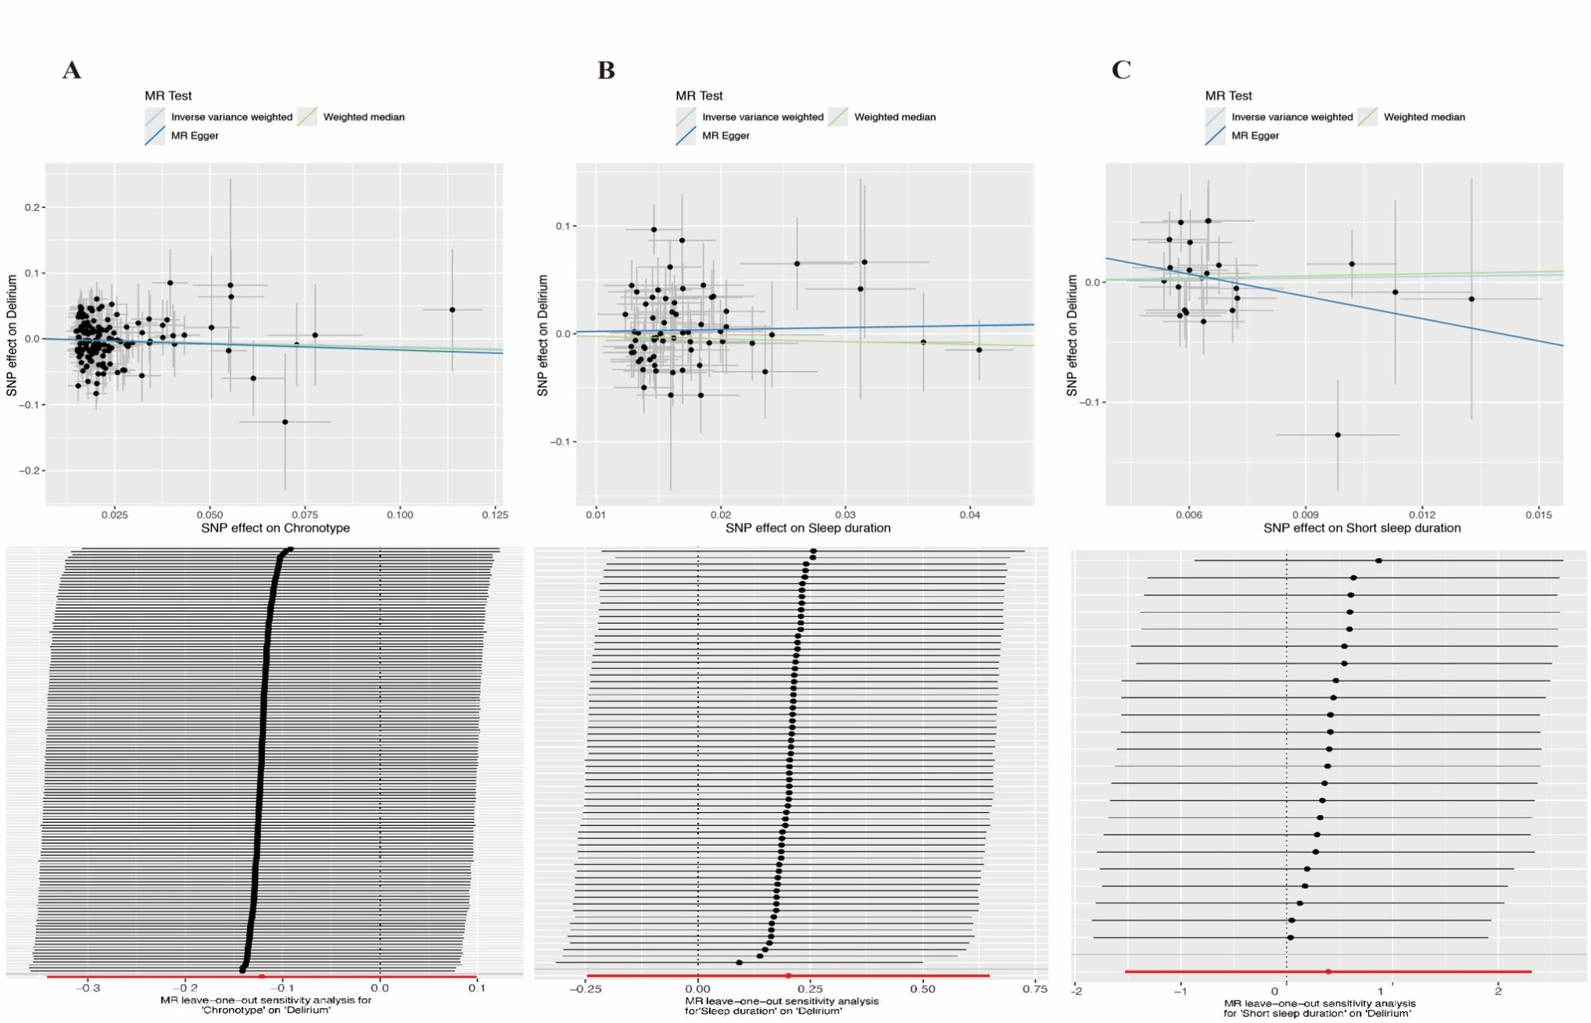

Supplementary Figure 3. Forest plot (A) Scatter plot of the MR analysis and Leave-one-out sensitivity analysis of the effect of Long sleep duration on Delirium; (B) Scatter plot of the MR analysis and Leave-one-out sensitivity analysis of the effect of Daytime napping on Delirium; (C) Scatter plot of the MR analysis and Leave-one-out sensitivity analysis of the effect of Daytime sleepiness on Delirium.
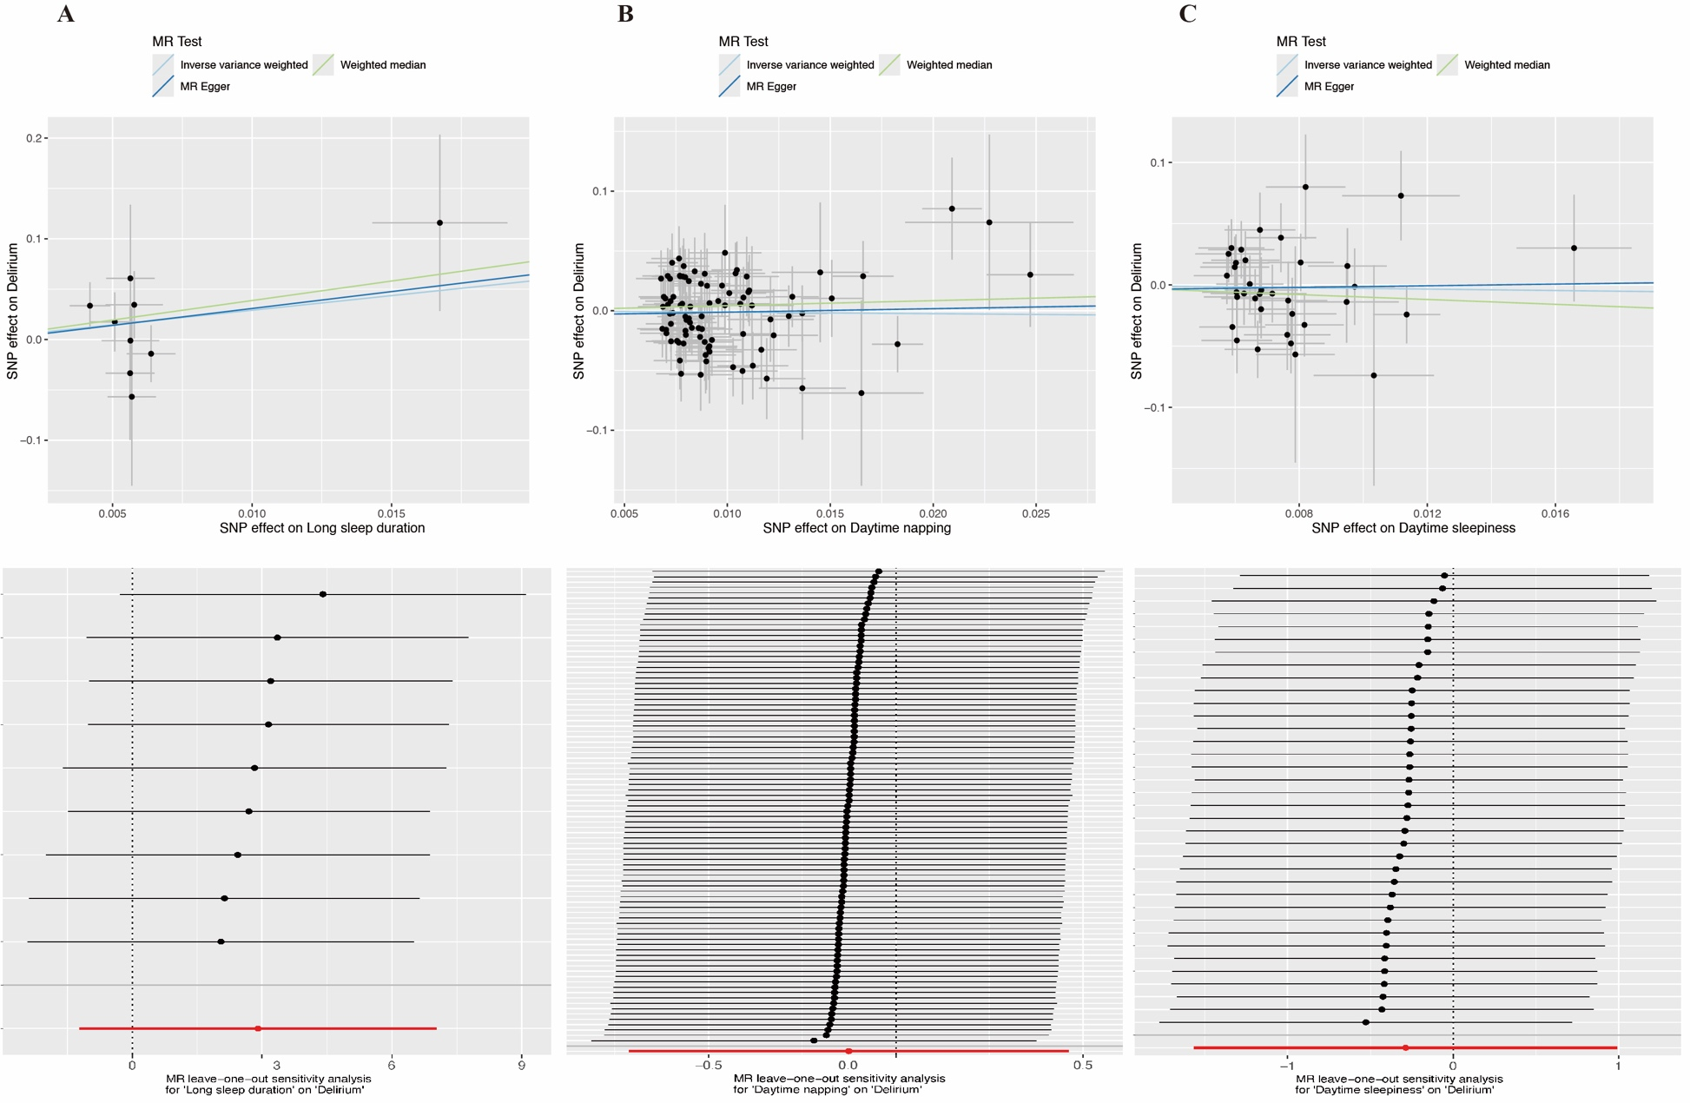

Supplementary Figure 4. Forest plot (A) Scatter plot of the MR analysis and Leave-one-out sensitivity analysis of the effect of Insomnia on Delirium; (B) Scatter plot of the MR analysis and Leave-one-out sensitivity analysis of the effect of Number of sleep episodes on Delirium; (C) Scatter plot of the MR analysis and Leave-one-out sensitivity analysis of the effect of Sleep efficiency on Delirium
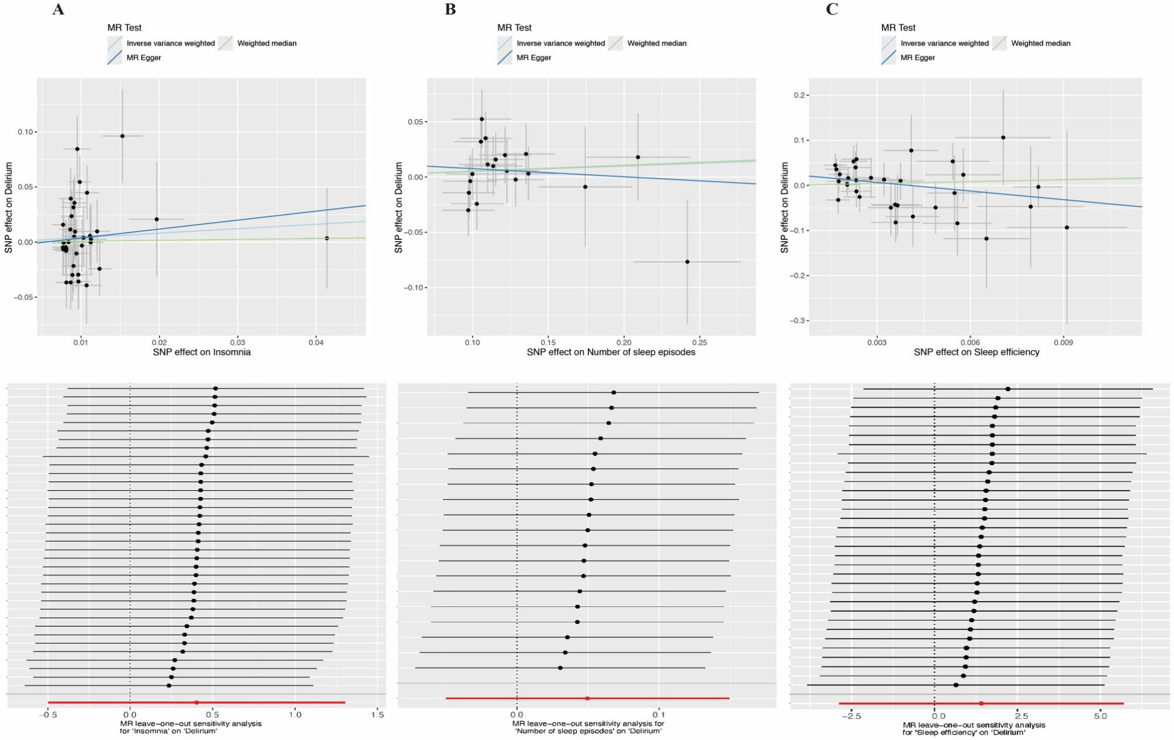

Supplementary Figure 5. Forest plot (A) Scatter plot of the MR analysis and Leave-one-out sensitivity analysis of the effect of Chronotype on Delirium.
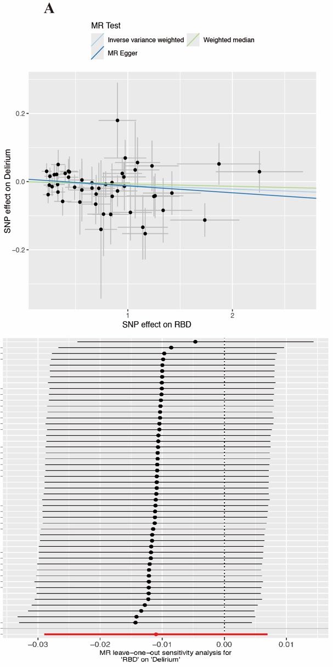
Abbreviation: RBD, Rapid-eye movement sleep behavior disorder.
Supplementary Figure 6. Forest plot (A) Scatter plot of the MR analysis and Leave-one-out sensitivity analysis of the effect of Delirium on Sleep duration; (B) Scatter plot of the MR analysis and Leave-one-out sensitivity analysis of the effect of Delirium on Daytime napping; (C) Scatter plot of the MR analysis and Leave-one-out sensitivity analysis of the effect of Delirium on Daytime sleepiness;

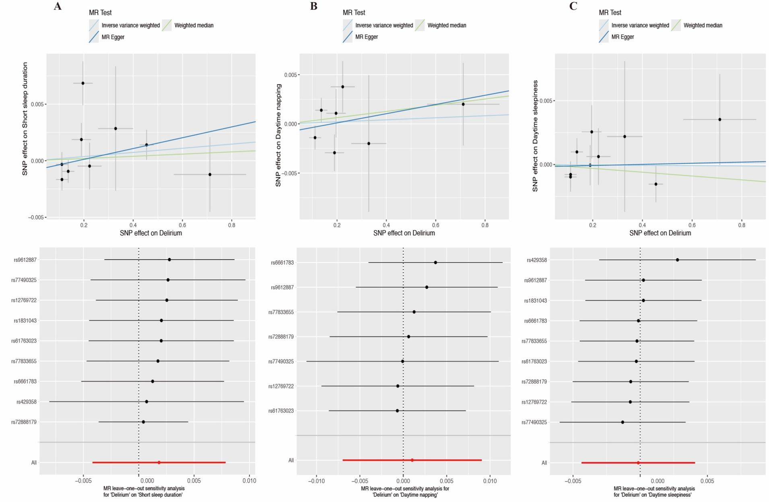.

Supplementary Figure 7. Forest plot (A) Scatter plot of the MR analysis and Leave-one-out sensitivity analysis of the effect of Delirium on Sleep duration; (B) Scatter plot of the MR analysis and Leave-one-out sensitivity analysis of the effect of Delirium on RBD; (C) Scatter plot of the MR analysis and Leave-one-out sensitivity analysis of the effect of Delirium on Sleep efficiency;

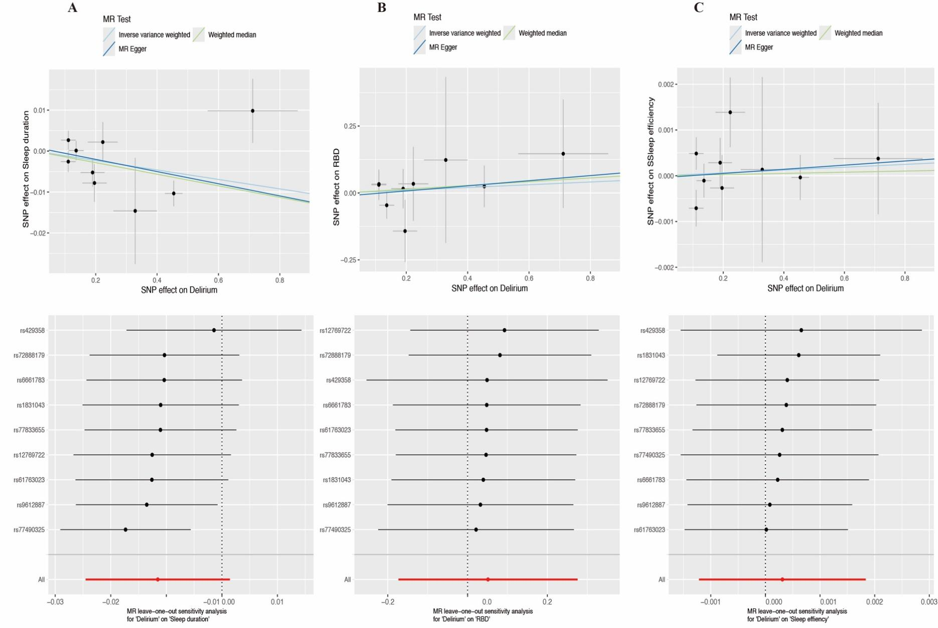

Supplementary Figure 8. Forest plot (A) Scatter plot of the MR analysis and Leave-one-out sensitivity analysis of the effect of Delirium on Number of sleep episodes;
