Appendix Table A.1: Patient demographic, health, and screening information

Patient | Age | Sex | Marital status | Health Insurance | Ethnicity | Native language | Medical conditions | Current medications | Last dilated eye exam | Ocular history | Glasses | Ability to see | Falls in the last year | Mobility | Screening result | Comments
1 | 84 | M | Married | OHIP | Chinese-Vietnamese | Cantonese, Chaozhou | Asthma, Parkinson's, atrial fibrillation, hypertension, stroke, benign prostatic hyperplasia, hyperlipidemia | atorvastatin, bisoprolol, citrical, combigan, ipratropium, levadopa, mometasone formoterol, pantoprazole, salbutamol, tamsulosin | 10+ yr ago | Myopia  Cataract  Glaucoma | No | A lot of difficulty | No | Moderately dependent ^{f} | Repeat screening in 1 year | Some disc cupping OD that could represent Glaucoma
2 | 61 | M | Married | OHIP and private | Chinese-Vietnamese | Cantonese, English | Hypertension, COVID, stroke, depression, hypercholesterolemia, atrial fibrillation, seizure | atorvastatin, divalproex, pantoprazole, pregabalin, rivaroxaban | Never | Left eye stroke | No | No difficulty | Yes | Independent ^{h} | Repeat screening in 1 year | -
3 | 91 | F | Married | No OHIP | Hong Kongese | Cantonese | Atrial flutter, osteoporosis, Alzheimers, depression, hypertension, arthritis | denosumab, donepezil, edoxaban, metoprolol, pravastatin | 3 yr ago | Cataract | No | No difficulty | No | Minimal assistance required ^{g} | Repeat screening in 1 year | No evidence of Diabetic Retinopathy on provided images. There are soft Drusen present, consistent with Dry AMD
4 | 84 | F | Married | OHIP and private | Chinese | Cantonese | Back pain, transient ischemic attack, schizophrenia, arthritis, osteoporosis | ASA, betamethasone, janumet, ketoderm, methylcellulose, metoprolol, olanzapine, prolia, zopiclone | 3 yr ago | Cataract | Yes | Some difficulty | Yes, 2 | Minimal assistance required ^{g} | Repeat screening in 1 year | -
5 | 88 | M | Married | OHIP | Chinese | Shanghainese | Stroke, Parkinson's, hypertension, atrial fibrillation, abdominal aortic aneurysm, chronic kidney disease, osteoporosis, sleep apnea | apixaban, clobetasol, ferrous gluconate, ketoconazole, levodopa, methylcellulose, potassium chloride, simvastatin | 3 yr ago | Cataract | Yes | Some difficulty | Yes | Dependent patient ^{e} | Repeat screening in 1 year | -
6 | 100 | F | Married | OHIP | Chinese | Cantonese | Osteopororsis, arthrosis, hypertension, kidney failure | atorvastatin, denosumab, empagliflozin, hydrocortisone, methylcellulose, pantoprazole, sitagliptin, trandolapril | Never | Myopia | Yes | Some difficulty | Yes, 1 | Independent ^{h} | Repeat screening in 1 year | Large drusen present in both eyes, indicative of Dry AMD
7ª | 90 | F | N/A | N/A | Chinese | Fukien | Hypertension, osteoporosis, transient ischemic attack | amlodipine, quetiapine, telmisartan | Unsure | Right eye conjunctivitis | No | Some difficulty | Yes | Dependent patient ^{e} | Repeat screening in 1 year | -
8 | 98 | F | Widowed | OHIP | Chinese | Cantonese | Congestive heart failure, hyperlipideamia, hypertension, acute renal failure, thrombocythaemia | ASA, atorvastatin, citalopram, trazadone | N/A | None | Yes | No difficulty | Yes, 4 | Minimal assistance required ^{h} | Repeat screening in 1 year | ERM+lamellar hole changes noted on last screening in 2019 and no significant change
9 | 88 | F | Widowed | OHIP | Chinese | Cantonese | Transient ischemic attack, depression, aneurysm, gastric ulcer, atherosclerosis, onsteoarthritis, vein thrombosis, hypertension | anusol, bisoprolol, bupropion, clotrimazole, enoxaparin, mirtazapine, pantoprazole, quetiapine, rosuvastatin | N/A | None | No | N/A | No | Minimal assistance required ^{g} | Repeat screening in 1 year | -
10 | 97 | F | Married | OHIP | Chinese | Mandarin | Hypertension, pulmonary embolism, arthritis, kidney failure, osteoarthritis, osteoporosis, atrial fibrillation, stroke, gout | amlopdipine, betahistine, cholecalciferol, darbepoetin, furosemide, lodoxamide, quetiapine, trazodone, warfarin | Unsure | Cataract | Yes | No difficulty | Yes, 1 | Moderately dependent ^{f} | Repeat screening in 1 year | Dry AMD OU
11 | 77 | M | Married | OHIP | Chinese | Cantonese | COVID, stroke, arthritis, hypertension, benign prostatic hyperplasia, hepatitis chronic | alfacalcidol, indapamide, rosuvastatin, telmisartan | 3 yr ago | None | Yes | No difficulty | No | Minimal assistance required ^{g} | Repeat screening in 1 year | Dry AMD OD + also collateral vessel at disc likely from previous vein occlusion + ERM
12 ª | 90 | F | Widowed | OHIP | Chinese | Cantonese | Atrial fibrillation, hypertension, osteoporosis, stroke, Alzehimer's, arthrosis, transient ischemic attack | ASA, cholecalciferol, furosemide, memantine, quetiapine, rosuvastatin, trazadone | N/A | None | No | N/A | Yes, 9 | Dependent patient ^{e} | Repeat screening in 1 year | -
13 ª | 87 | F | Widowed | OHIP | Chinese | Cantonese | Dementia, transient ischemic attack, NSTEMI, hypertension, atherosclerosis, hyperlipidemia, hearing loss, osteoporosis, gastritis | atorvastatin, betahistine, bisoprolol, gliclazide, dextromethorphan, linagliptin, nitroglycerine, risperidone, ticagrelor | N/A | Cataract | Yes | N/A | Yes, 4 | Moderately dependent ^{f} | Repeat screening in 1 year | Dry AMD OU
14 ª | 95 | F | Widowed | OHIP | Chinese | Cantonese | Hypertension, arthritis, osteoporosis, anemia, thalassemia | duloxetine, dextromethorphan, denosumab, artificial tears, linagliptin, trazadone | N/A | None | Yes | N/A | No | Dependent patient ^{e} | Screen at increased frequency | Dry AMD OU
15 ª | 81 | F | Widowed | OHIP | Chinese | Cantonese | Hypercholesterolemia, aneurysm, hypertension, stroke, epilepsy, transient ischemic attack | cholecalciferol, cyanocobalamine, linagliptin, metformin, rosuvastatin | N/A | Vision impairment (unspecified) | No | N/A | No | Dependent patient ^{e} | Screen at increased frequency | OD mod-severe NPDR, OS moderate NPDR + Dry AMD
16 ª | 89 | F | Widowed | OHIP | Chinese | Cantonese | Depression, osteoporosis, transient ischemic attack, hypertension, hyperlipidemia | atorvastatin, denosumab, risperidone, trazadone | N/A | Vision impairment (unspecified) | Yes | N/A | Yes, 4 | Moderately dependent ^{f} | Repeat screening in 1 year | Images are limited due to difficult compliance with examination. In limited images obtained there is no evidence of diabetic retinopathy.
17 | 85 | M | Divorced | OHIP | Chinese | Cantonese | Hypertension, kidney failure, transient ischemic attack, hyperlipidemia, hyperkalemia | amlodipine, apixaban, calcitriol, candesartan, quetiapine, rosuvastatin, trazadone | N/A | Glaucoma | No | Some difficulty | Yes, 1 | Independent ^{h} | Arrange appointment with ophthalmologist URGENTLY | Patient has past ocular history of glaucoma. His pressure on assessment at screening was not under control (32) and therefore it is recommended to see clinician managing glaucoma to optimise treatment
18 | 89 | F | Married | OHIP | Chinese-Vietnamese | Cantonese | Anxiety. transient ischemic attack, osteoporosis, hypertension | citalopram, levothyroxine, risperidone | N/A | Cataract | Yes | No difficulty | Yes, 1 | Moderately dependent ^{f} | Repeat screening in 1 year | Limited images but no DR seen in either eye; dry AMD OU
19 ª | 80 | F | Married | OHIP | Chinese | Cantonese | Stroke, hemiplegia, dysphagia, atrial fibrillation | clobetasol, pancrelipase, apixaban, glargine, metformin, metaprolol, rosuvastatin, sodium bicarbonate, artificial tears | N/A | Vision impairment (unspecified) | No | N/A | No | Dependent patient ^{e} | Arrange appointment with ophthalmologist due to insufficient image quality | -
20 | 80 | M | Separated | OHIP | Chinese-Vietnamese | Cantonese | Hypertension, hyperlipidemia, anemia | atorvastatin, dextromethorphan, dorzolamide, duloxetine, dutasteride, latanoprost, metformin, methylcobalamin, mirtazipine, pantoprazole, perindopril, tamsulosin | 3 yr ago | None | No | No difficulty | Yes, 1 | Minimal assistance required ^{g} | Repeat screening in 1 year | Photo quality insufficient. Ophthalmologic examination recommended
21 | 89 | F | Widowed | OHIP | Chinese | Cantonese | Athersclerotic heart disease, arthritis, hypertension, osteoporosis, depression | amcinonide, amlodipine, atorvastatin ,betamethasone, cetirizine, cholecalciferol, dextran, dextromethorphan, dimenhydrinate, empagliflozin, gliclazide, sitagliptin / metformin, methylcobalamin, ciclesonide, pantoprazole, perindopril, terbinafine | 10+ yr ago | Glaucoma | Yes | Some difficulty | No | Minimal assistance required ^{g} | Arrange appointment with ophthalmologist URGENTLY | Right macular heme + OCT shows PED with small amount of subretinal fluid and subretinal hyperreflective material which may indicate choroidal neovascular membrane (CNV); Refer to retina specialist within 1 month; Moderate NPDR + wet AMD OD; mild NPDR + ERM OS
22 | 91 | F | Widowed | OHIP | Chinese | Cantonese | Hypertension, osteoporosis, atherosclerotic heart disease, gastric reflux, fatty liver, transient ischemic attack | amlodipine, antiphlogistine, bimatoprost, cetirizine, cholecalciferol, denosumab, dextran, furosemide, irbesartan, dextromethorphan, lorazepam, metoprolol, pregabalin | Unsure | Glaucoma | Yes | Some difficulty | No | Dependent patient ^{e} | Repeat screening in 1 year | Raised pressure OS but discs healthy both eyes; Dry AMD OU; ERM OS
23 | 80 | F | Married | OHIP | Chinese | Cantonese | Hypertension, stroke, hemiplegia, stroke, mental disorder, hypothyroidism | amlodipine, atorvastatin, hypromellose, dextromethorphan, metformin, ramipril, levothyroxine, linagliptin | Unsure | None | No | Some difficulty | No | Dependent patient ^{e} | Repeat screening in 1 year | -
24 | 96 | F | Widowed | OHIP | Chinese | Cantonese | Hypertension, osteoporosis, degeneration of macula and posterior pole, atrial fibrillation, congestive heart failure, transient ischemic attack | risedronic acid, amlodipine, antiphloglistine, apixaban, candesartan, salbutamol, artificial tears | Unsure | Vision impairment | No | No difficulty | Yes, 2 | Minimal assistance required ^{g} | Repeat screening in 1 year | -
25 ^{b} | 71 | F | Married | OHIP | Chinese | Cantonese | COVID, hypertension, stroke, dysphasia, intracranial hemorrhage, quadriplegia | atorvastatin, candesartan, lansoprazole, metformin, metoprolol | N/A | None | No | N/A | No | Dependent patient ^{e} | N/A | N/A
26 ^{c} | 99 | F | Widowed | OHIP | Chinese | Cantonese | Hypertension, transient ischemic attack, osteoporosis, arthritis, cerebral infarctino, hearing loss | calamine, cholecalciferol, denosumab, dextran/hypromellose, perindopril, quetiapine | Elementary | Cataract | No | Legally blind | No | Moderately dependent patient ^{f} | N/A | N/A
27 ^{d} | 72 | F | Single | OHIP | Chinese-Vietnamese | Vietnamese | COVID, osteoarthritis, transient ischemic attack, hypertension, schizophrenia, osteoporosis, Colles' fracture, intraductal carcinoma in situ right breast | ASA, alendronate, aripiprazole, cholecalciferol, ezetimibe, metformin, pantoprazole, quetiapine, rosuvastatin, sertraline | Unsure | Cataract | No | No difficulty | No | Minimal assistance required ^{g} | N/A | N/A
28 ^{c} | 90 | F | Married | OHIP | Chinese | Cantonese | Hypertension, osteoporosis, astherosclerosis, gastric reflux, fatty liver, transient ischemic attack | betaderm, betamethasone, cetirizine, clobetasol, denosumab, donepezil, paroxetine, rosuvastatin | N/A | None | No | N/A | No | Dependent patient ^{e} | N/A | N/A

ª Patient has missing data due to reasons mentioned in Discussion
^{b} Patient did not have images taken due to dense cataracts
^{c} Patients did not have images taken due to severe cognitive impairment
^{d} Patient did not have images taken due to refusal
^{e} Dependent patient: unable to move or transfer self
^{f} Moderately dependent: can sit but cannot stand or transfer
^{g} Minimal assistance required: can bear weight and may require assistive devices
^{h} Independent: can move and transfer self without assistance

Appendix Table A.2. Patient end-of-study survey results.

Patient | Would you be able to attend a hospital appointment if needed? | Do you have anyone who can take you to medical appointments? | If transportation was arranged, would you be WILLING to attend a hospital appointment if needed? | Rate your experience today | Likeliness to return for regular screening
1 | No | No; children are too busy | Yes | Brilliant | Very likely
2 | Yes | Yes, brother | Yes | Brilliant | Very likely
3 | No | No | No, no reason provided | Brilliant | Very likely
4 | No | No; children are too busy | Yes | Really good | Likely
5 | Yes | Yes, daughter | Yes | Brilliant | Very likely
6 | Yes | Yes, son | No, does not feel this service is necessary due to HCP on site | Brilliant | Very unlikely
7 | Yes | Yes, daughter | Yes | Brilliant | Very likely
8 | Yes | Yes, daughter | Yes | Brilliant | Very likely
9 | Yes | Yes, son | Yes | Really good | Likely
10 | Yes | Yes, children | Yes | Not very good, expected new prescriptions | Unlikely
11 | Yes | Yes, children | Yes | Brilliant | Very likely
12 | Yes | Yes, children | N/A | N/A | N/A
13 | Yes | Yes, daughter | N/A | N/A | N/A
14 | Yes | Yes, daughter | N/A | N/A | N/A
15 | Yes | Yes, brother | N/A | N/A | N/A
16 | Yes | Yes, children | N/A | N/A | N/A
17 | Yes | Yes, daughter | Undecided; will not go if not feeling symptoms | Undecided | Undecided
18 | Yes | Yes, children | Yes | Brilliant | Very likely
19 | N/A | N/A | N/A | N/A | N/A
20 | Yes | Yes, wife | ª No, no interest in the program | Brilliant | ª Very likely
21 | Yes | N/A | Yes | Brilliant | Very likely
22 | Yes | Yes, children | Yes | Brilliant | Very likely
23 | No | No | ª No, no reason provided | Really good | ª Very likely
24 | No | No | Yes | Brilliant | Very likely
25 | Yes | Yes, brother | N/A | N/A | N/A
26 | Yes | Yes, son | Undecided | Really good | Very likely
27 | Yes | Yes, public trustee | Yes | N/A | N/A
28 | N/A | N/A | N/A | N/A | N/A
ª Inconsistent answers

Appendix Table A.3: Retrospective diagnoses of tabletop versus handheld images

 | OD |  | OS
Patient | Tabletop | Handheld |  | Handheld
  Tabletop
1 | - | No DR seen  Glaucoma suspected | - | No DR seen  Glaucoma suspected  (peripheral incidental scar)
2 | No DR (possible microaneurysm / mild NPDR)  No other pathology | - | No DR  No other pathology | -
3 | No DR  Dry AMD | No DR  Dry AMD | No DR  Dry AMD | Images not good enough for screening
4 | No DR seen  Glaucoma suspected | No DR seen  Glaucoma suspected | No DR seen  Glaucoma suspected | No DR seen  Glaucoma suspected
5 | Moderate NPDR  Dry AMD | Moderate NPDR seen | No DR seen  Dry AMD | Images not good enough for screening
6 | No DR  Dry AMD | No DR  Dry AMD | No DR  Dry AMD | No DR  Dry AMD
7 | - | Images not good enough for screening | - | Images not good enough for screening
8 | Disc not imaged therefore not good enough for DR screening  Mild NPDR  Dry AMD (macular atrophy) | No DR  Dry AMD (atrophy) | Mild NPDR  Dry AMD | Mild NPDR  Dry AMD
9 | No DR  Glaucoma suspected | No DR  Glaucoma suspected | No DR  Dry AMD | No DR  Dry AMD
10 | No DR seen | No DR seen | No DR seen | No DR seen
11 | No DR  epiretinal membrane, dry AMD, ?collateral vessel | No DR seen  epiretinal membrane, dry AMD, ?collateral vessel | No DR  : dry AMD | No DR  Dry AMD
12 | - | no DR | - | No DR
13 | No DR  Dry AMD | No DR  Dry AMD | No DR  Dry AMD | No DR  Dry AMD
14 | No DR  Dry AMD (macular drusen). | No DR  Dry AMD (macular drusen). | No DR  Dry AMD (macular drusen) | No DR  No other pathology seen
15 | Severe NPDR  Some macular hemorrhages | Severe NPDR  Some macular hemorrhages | Moderate NPDR | Moderate NPDR
16 | - | Images not good enough for screening | - | Images not good enough for screening
17 | No DR  (peripapillary atrophy noted) | No DR  (peripapillary atrophy noted) | - | -
18 | - | No DR or maculopathy | - | Images borderline (No DR)
19 | - | - | - | -
20 | No DR  Glaucoma suspected | No DR  Glaucoma suspected | No DR | No DR
21 | Mild NPDR  Haemorrhage within macular ?edema – need OCT | Mild NPDR  Haemorrhage within macular | Mild NPDR  No maculopathy seen  Epiretinal membrane | No retinopathy seen  Epiretinal membrane
22 | No DR or maculopathy  Dry AMD | No DR or maculopathy  Dry AMD | No DR or maculopathy  Dry AMD | No DR or maculopathy  Dry AMD
23 | No DR or maculopathy  No other pathology | No DR or maculopathy  No other pathology | No DR or maculopathy  No other pathology | No DR or maculopathy  No other pathology
24 | No DR or maculopathy  Dry AMD | - | No DR or maculopathy  Macular degeneration – drusen and atrophy. ?macular haemorrhage – need OCT ?wet or dry. | -
25 | Patient did not have images taken due to dense cataracts
26 | Patients did not have images taken due to severe cognitive impairment
27 | Patient did not have images taken due to refusal
28 | Patients did not have images taken due to severe cognitive impairment

Appendix Figure 1: Questionnaire
DEMOGRAPHICS
Sex
DOB
Ethnicity
Marital status
Health insurance status
Native language

What is your highest level of education/ How many years of education do you have? | Elementary school  High school  College  Undergraduate  Graduate  Professional Program  Other: ______

OCULAR HEALTH
Ocular history
Last eye examination | When:  By Whom:
Last dilated eye examination (year)
Do you wear eyeglasses?
Which of the following best describes your ability to see? | No difficulty  Some difficulty  A lot of difficulty  Legally blind

GENERAL HEALTH
Past medical history other than diabetes
Smoking status | Current smoker  Previous Smoker  Never smoked
Alcohol intake (drinks/week)
Currently Driving? (Y/N)
Have you had a fall in the last 1 year
If yes, how many times?
Diabetes | Type 1  Type 2
HbA1c (date)
Diabetes Duration

BARRIERS TO MEDICAL ASSESSMENT
Do you have anyone who can take you to medical appointments? | Y/N:  Who (relationship):
If transportation was arranged for you, would you be willing to attend a hospital appointment if needed?

How would you rate your experience today? | 
How likely are you to return for regular screening? | Very likely  Likely  Neutral  Unlikely  Very unlikely

MOBILITY:
Level | Dependent patient. This patient is unable to move or transfer self  Moderately dependent patient. This patient can come to a sitting position but cannot stand or transfer  Minimal assistance required. This patient can bear weight and may require assistive devices  Independent. This patient can move and transfer self and requires no patient handling asst
Are you able to get out of bed and sit in a chair on your own? | Yes  Yes but with great difficulty  No

Near vision (with correction):

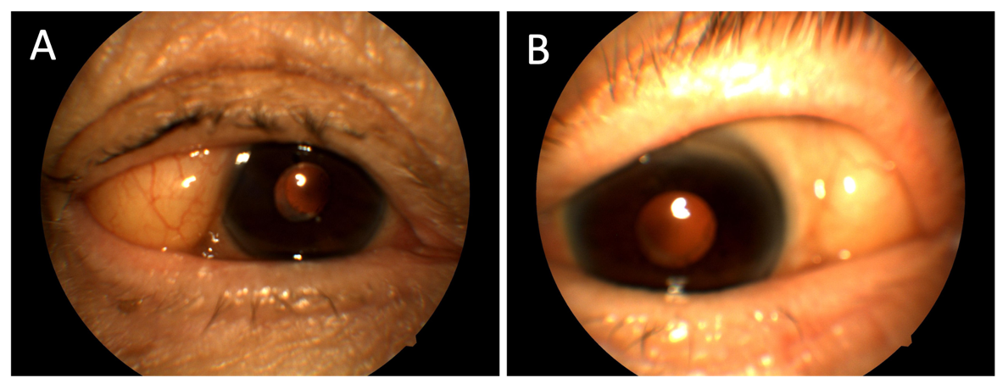
Appendix Figure 2. A 98-year-old female incidentally discovered to have herniated orbital fat OS (A) and OD (B). Her screening results were to repeat screening.

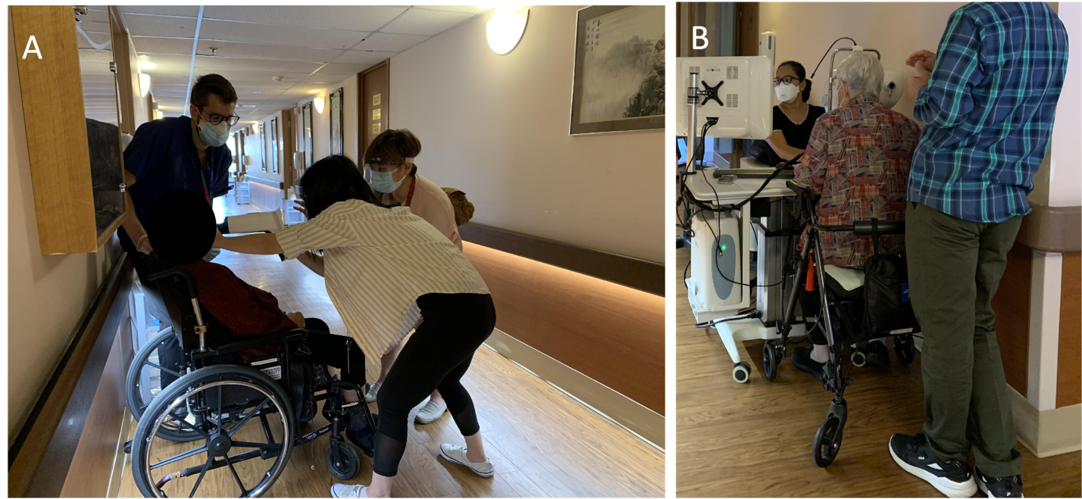
Appendix Figure 3: A) Due to the mobility of the handheld fundus camera, color fundus photos can be taken of patients confined to wheelchairs who are unable to adjust their head at a tabletop camera. B) Patients who are wheelchair-bound with the ability to adjust head positioning can have higher quality color fundus photos taken on a tabletop camera.

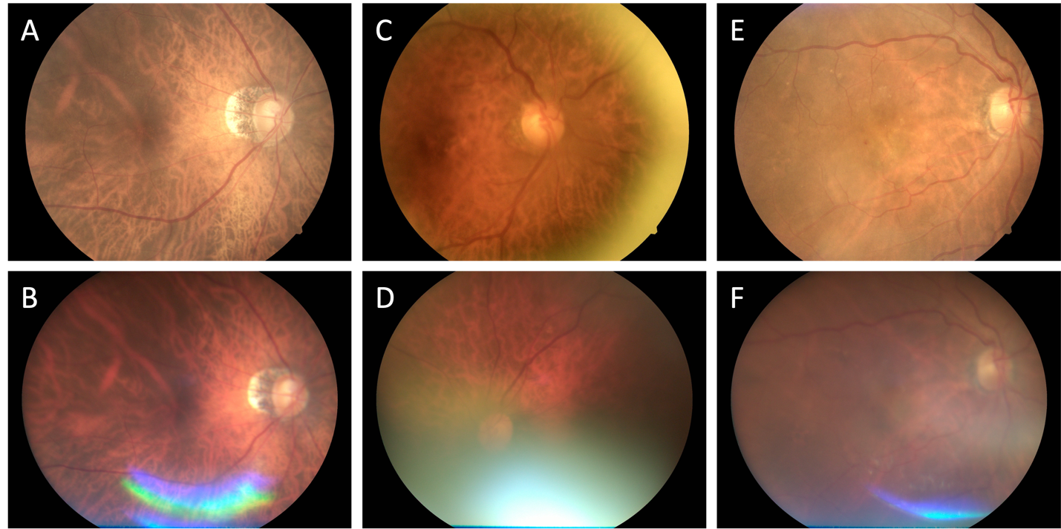
Appendix Figure 4: Comparison of image quality obtained from the handheld camera and tabletop camera. Small macular drusen are identified in both tabletop (A) and handheld (B) images of a 95-year-old female diagnosed with dry age-related macular degeneration. The handheld image produced a glare inferiorly. No pathology was found on the images of an 80-year-old female with either tabletop (C) or handheld imaging (D). Macular heme was identified in an 89-year-old female with tabletop imaging (E) that is less visible in the handheld image (F).

