Evaluation of estimated glucose disposal rate with neutrophil to lymphocyte ratio integrated for prognosticating adverse cardiovascular and cerebrovascular events and risk stratification among acute coronary syndrome with type 2 diabetes mellitus following percutaneous coronary intervention

Supplement materials

Table of Contents |  | Page Number
Table S1 | Univariable and multivariable Cox proportional hazard analysis for MACCE | 2-3
Table S2 | Predictive value of the eGDR and NLR in univariable and multivariable analysis | 4
Figure S1 | Study flow chart | 5
Figure S2 | C-statistics evaluating incremental effect of eGDR, NLR or eGDR + NLR for stroke beyond baseline risk model | 6
Figure S3 | C-statistics evaluating incremental effect of eGDR, NLR or eGDR + NLR for TVR beyond baseline risk model | 7
Figure S4 | C-statistics evaluating incremental effect of eGDR, NLR or eGDR + NLR for nonfatal stroke beyond baseline risk model | 8

Table S1. Univariable and multivariable Cox proportional hazard analysis for MACCE
Variable | Univariable  HR (95%CI) | P value | Multivariable  HR (95%CI) | P value
Category
eGDR-L + NLR-L | 3.464 (1.827-6.569) | <0.001 | 2.920 (1.525-5.588) | 0.001
eGDR-H + NLR-L | References | NA | References | NA
eGDR-L + NLR-H | 6.122 (3.314-8.310) | <0.001 | 5.201 (2.764-7.786) | <0.001
eGDR-H + NLR-H | 2.458 (1.263-4.787) | 0.008 | 2.327 (1.186-4.566) | 0.014
Age, per 1 year | 1.002 (0.985-1.019) | 0.837 | 0.997 (0.961-1.035) | 0.869
Sex, (male) | 0.990 (0.696-1.408) | 0.955 | 1.025 (0.433-2.429) | 0.776
BMI, per 1 kg/m2 | 1.066 (1.019-1.115) | 0.006
SBP, per 1 mmHg | 1.002 (0.993-1.012) | 0.637
DBP, per 1 mmHg | 0.986 (0.971-1.002) | 0.078
Hypertension | 2.125 (1.433-3.151) | <0.001
Dyslipidemia | 1.172 (0.822-1.671) | 0.380 | 1.066 (0.686-1.658) | 0.776
Previous smoking | 1.013 (0.620-1.657) | 0.957 | 0.643 (0.334-1.237) | 0.186
Previous MI | 2.157 (1.504-3.092) | <0.001 | 1.226 (0.717-2.094) | 0.457
Previous PCI | 1.548 (1.119-2.143) | 0.008 | 1.400 (0.899-2.180) | 0.136
Previous stroke | 0.800 (0.328-1.950) | 0.623 | 0.848 (0.305-2.359) | 0.752
Family history of CVD | 1.310 (0.792-2.170) | 0.293 | 1.573 (0.877-2.819) | 0.128
TG, per 1 mmol/L | 1.131 (0.964-1.326) | 0.131 | 0.959 (0.609-1.508) | 0.855
TC, per 1 mmol/L | 1.117 (0.936-1.334) | 0.219 | 1.175 (0.283-4.874) | 0.824
LDL-C, per 1 mmol/L | 1.154 (0.940-1.417) | 0.172 | 0.898 (0.211-3.818) | 0.884
HDL-C, per 1 mmol/L | 0.591 (0.290-1.206) | 0.148 | 0.676 (0.119-3.843) | 0.659
eGFR, per 1 mL/min/1.73 m² | 0.989 (0.979-1.000) | 0.055 | 0.996 (0.954-1.039) | 0.843
FBG, per 1 mmol/L | 1.086 (1.043-1.131) | <0.001 | 1.084 (1.029-1.141) | 0.002
HbA1c, per 1% | 1.223 (1.107-1.352) | <0.001
Creatinine, per 1 μmol/L | 1.011 (1.000-1.021) | 0.043 | 1.012 (0.974-1.051) | 0.553
hs-CRP, per 1 mg/L | 1.032 (1.002-1.064) | 0.038 | 1.035 (0.998-1.074) | 0.066
LVEF, per 1 % | 0.981 (0.960-1.001) | 0.068 | 0.995 (0.969-1.021) | 0.687
SYNTAX score, per 1 point | 1.035 (1.013-1.058) | 0.002 | 1.017 (0.982-1.053) | 0.354
Complete revascularization | 0.575 (0.395-0.839) | 0.004 | 0.734 (0.438-1.229) | 0.239
Number of stents | 0.861 (0.734-1.008) | 0.063 | 0.880 (0.729-1.063) | 0.185
LM disease | 1.655 (0.972-2.820) | 0.064 | 1.338 (0.621-2.880) | 0.457
Three-vessel disease | 1.515 (1.100-2.086) | 0.011 | 1.033 (0.638-1.672) | 0.894
Chronic total occlusion | 1.210 (0.844-1.736) | 0.299
Diffuse lesion | 0.991 (0.717-1.369) | 0.955
Bifurcation lesion | 1.258 (0.750-2.112) | 0.385
DAPT use | 0.482 (0.067-3.444) | 0.467 | 0.510 (0.680-3.845) | 0.514
ACEI/ARB use | 1.148 (0.837-1.574) | 0.393
Statin use | 0.320 (0.102-1.004) | 0.051 | 0.328 (0.105-1.029) | 0.056
OAD use | 1.018 (0.735-1.408) | 0.916 | 0.931 (0.623-1.394) | 0.730
Insulin use | 1.698 (1.207-2.387) | 0.002 | 1.134 (0.719-1.789) | 0.589

MACCE, major adverse cardiovascular and cerebrovascular events; HR, hazard ratios; CI, confidence intervals; eGDR-H, higher eGDR; eGDR-L, lower eGDR; NLR-H, higher NLR; NLR-L, lower NLR; BMI, body mass index; SBP, systolic blood pressure; DBP, diastolic blood pressure; MI, myocardial infarction; PCI, percutaneous coronary intervention; CVD, cardiovascular diseases; TG, triglycerides; TC, total cholesterol; HDL-C, high-density lipoprotein cholesterol; LDL-C, low-density lipoprotein cholesterol; eGFR, estimated glomerular filtration rate; FBG, fasting blood glucose; HbA1c, glycosylated hemoglobin A1c; hs-CRP, high sensitivity C-reactive protein; LVEF, left ventricular ejection fraction; SYNTAX, Synergy between PCI with TAXUS and Cardiac Surgery; LM, left main; DAPT, Dual antiplatelet therapy; ACEI, angiotensin converting; enzyme inhibitor, ARB, angiotensin receptor blocker; OAD, oral antidiabetic drugs.

Table S2. Predictive value of the eGDR and NLR in univariable and multivariable analysis

Groups | Events, n/Total | Univariable  HR (95%CI) | P value | Multivariable  HR (95%CI) | P value
MACCE
eGDR-L + NLR-L | 43/418 | 3.464 (1.827-6.569) | <0.001 | 2.920 (1.525-5.588) | 0.001
eGDR-H + NLR-L | 12/390 | References | NA | References | NA
eGDR-L + NLR-H | 68/390 | 6.122 (3.314-8.310) | <0.001 | 5.201 (2.764-7.786) | <0.001
eGDR-H + NLR-H | 31/418 | 2.458 (1.263-4.787) | 0.008 | 2.327 (1.186-4.566) | 0.014
Cardiac death/ Nonfatal MI
eGDR-L + NLR-L | 29/418 | 2.758 (1.344-5.659) | 0.006 | 2.385 (1.146-4.960) | 0.020
eGDR-H + NLR-L | 10/390 | References | NA | References | NA
eGDR-L + NLR-H | 49/390 | 5.143 (2.605-8.154) | <0.001 | 4.651 (2.302-7.396) | <0.001
eGDR-H + NLR-H | 18/418 | 1.700 (0.785-3.682) | 0.179 | 1.550 (0.708-3.391) | 0.273
TVR
eGDR-L + NLR-L | 32/418 | 3.058 (1.504-6.221) | 0.002 | 2.563 (1.249-5.257) | 0.010
eGDR-H + NLR-L | 10/390 | References | NA | References | NA
eGDR-L + NLR-H | 54/390 | 5.742 (2.942-8.275) | <0.001 | 5.151 (2.565-8.347) | <0.001
eGDR-H + NLR-H | 24/418 | 2.267 (1.084-4.741) | 0.030 | 2.167 (1.027-4.574) | 0.042
Nonfatal stroke
eGDR-L + NLR-L | 2/418 | 1.742 (0.418-3.479) | 0.238 | 1.626 (0.405-2.438) | 0.249
eGDR-H + NLR-L | 0/390 | References | NA | References | NA
eGDR-L + NLR-H | 6/390 | 2.098 (0.873-5.694) | 0.067 | 2.629 (0.689-5.961) | 0.107
eGDR-H + NLR-H | 2/418 | 1.821 (0.293-2.116) | 0.369 | 1.436 (0.253-1.496) | 0.441
eGDR, estimated glucose disposal rate; NLR, neutrophil to lymphocyte ratio; MACCE, major adverse cardiovascular and cerebrovascular events; HR, hazard ratios; CI, confidence intervals; eGDR-H, higher eGDR; eGDR-L, lower eGDR; NLR-H, higher NLR; NLR-L, lower NLR. MI, myocardial infarction; TVR, target vessel revascularization.
Adjusted model included: Model 3 in multivariate Cox analyses.

Figure S1. Study flow chart
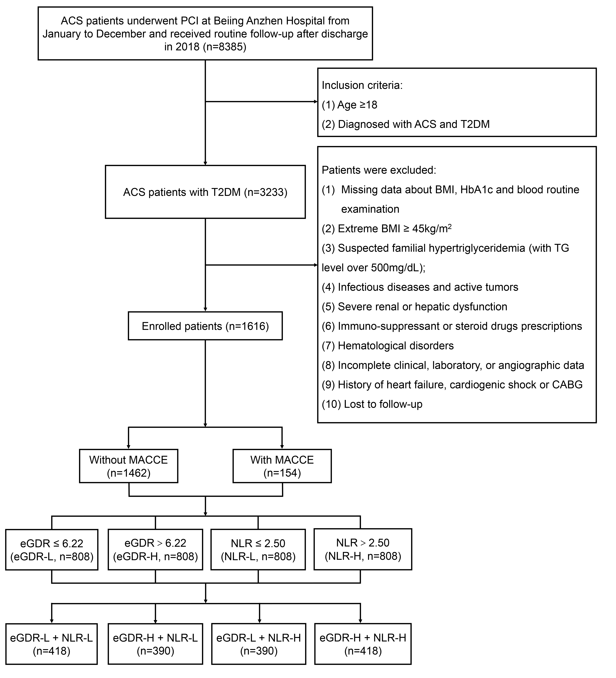
ACS, acute coronary syndromes; PCI, percutaneous coronary intervention; T2DM, type 2 diabetes mellitus; BMI, body mass index; HbA1c, glycosylated hemoglobin A1c; TG, triglycerides; CABG, coronary artery bypass grafting; MACCE, major adverse cardiovascular and cerebrovascular events; eGDR-L, lower eGDR; eGDR-H, higher eGDR; NLR-L, lower NLR; NLR-H, higher NLR.

Figure S2. C-statistics evaluating incremental effect of eGDR, NLR or eGDR + NLR for cardiac death/nonfatal MI beyond baseline risk model
(A) 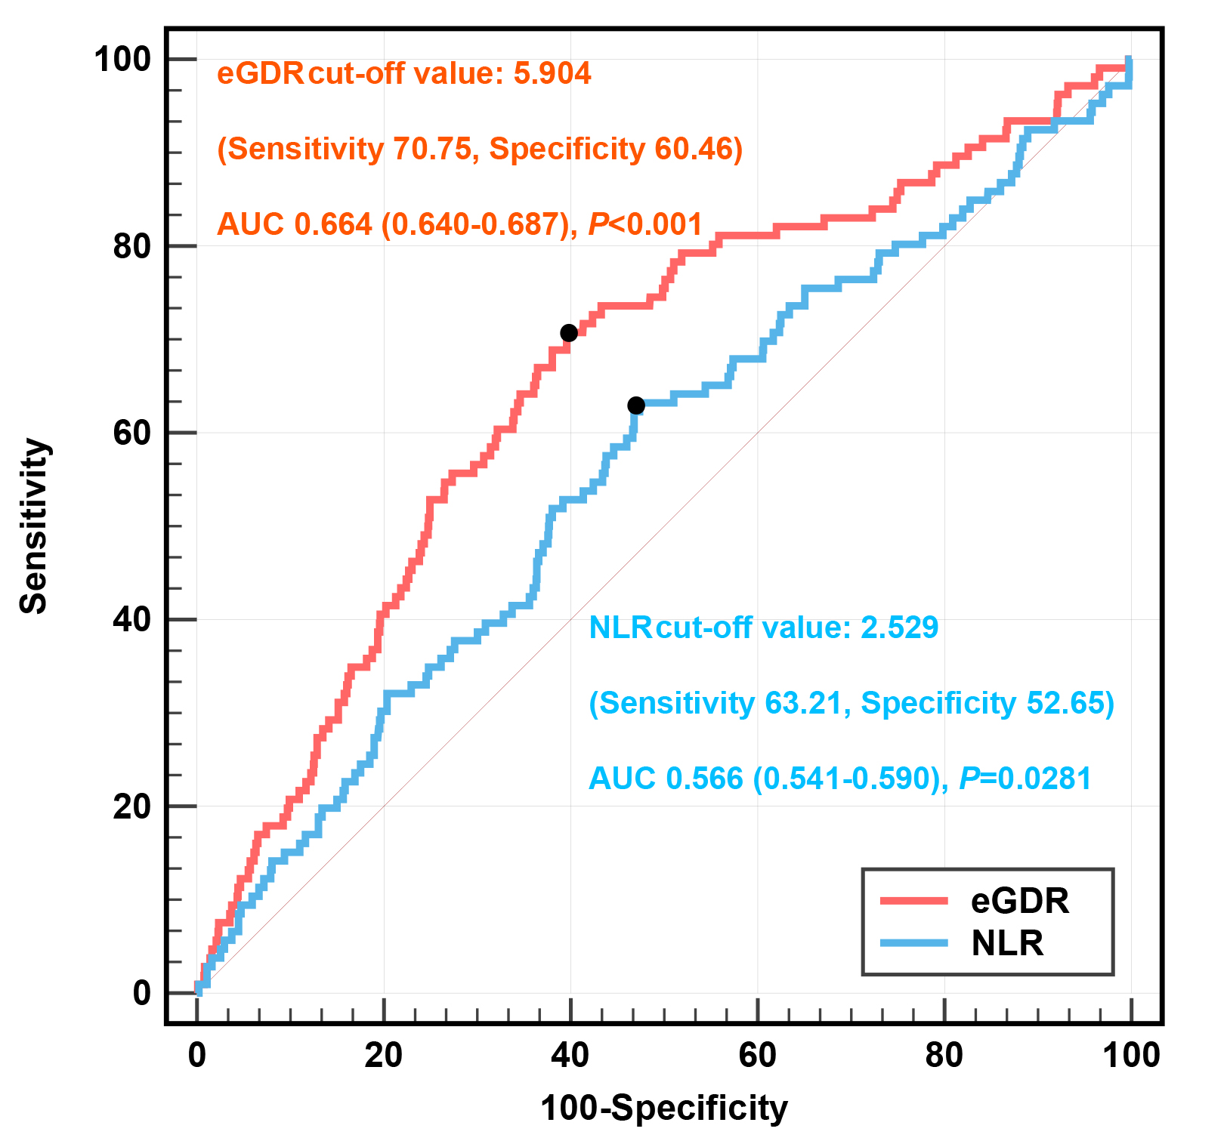 (B)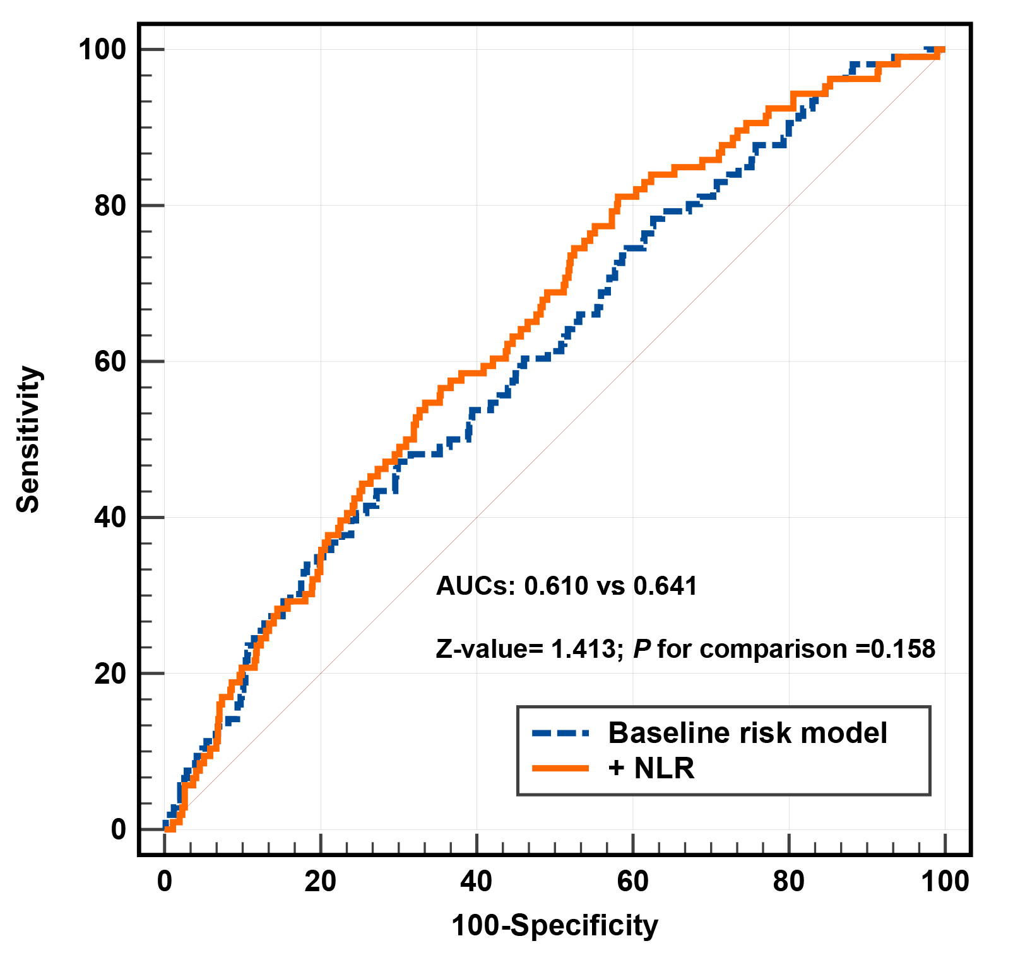
(C) 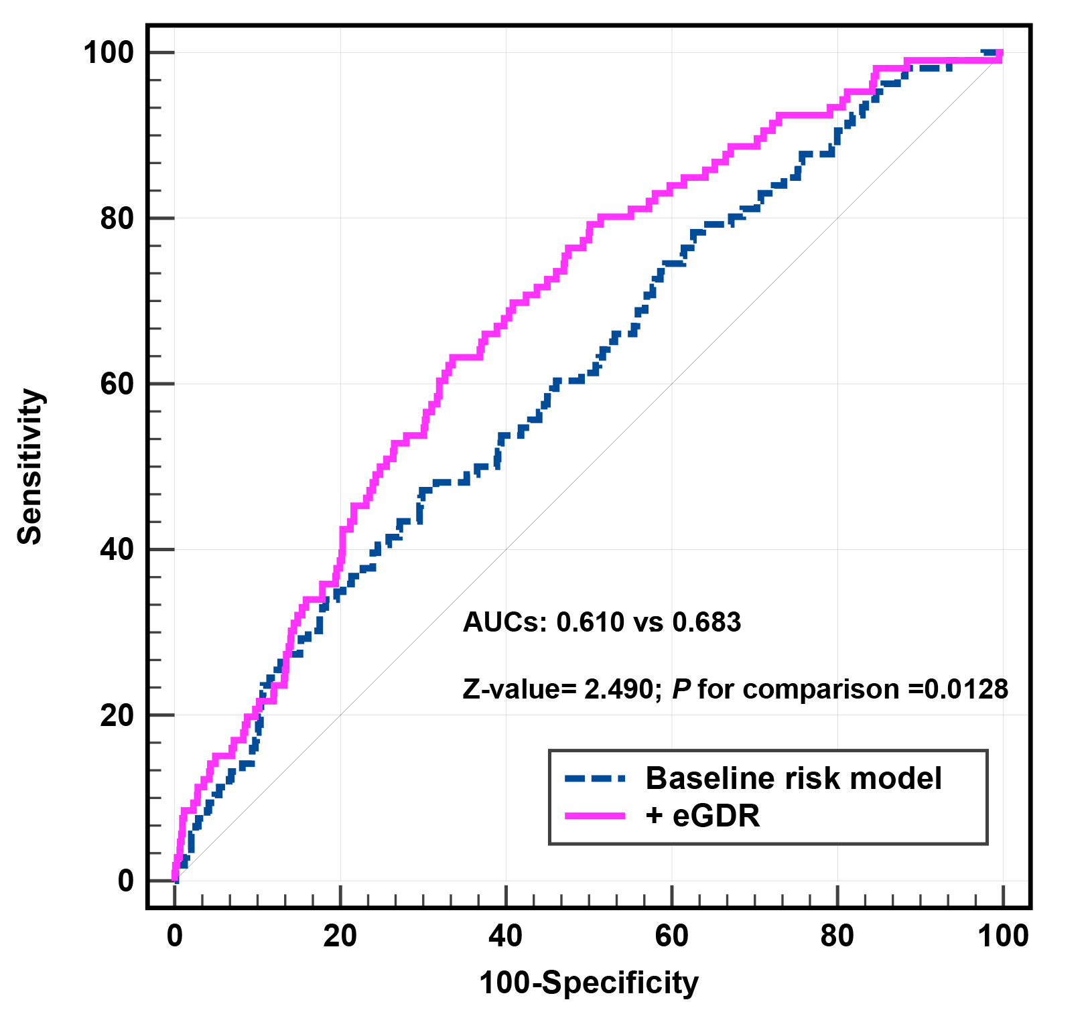 (D)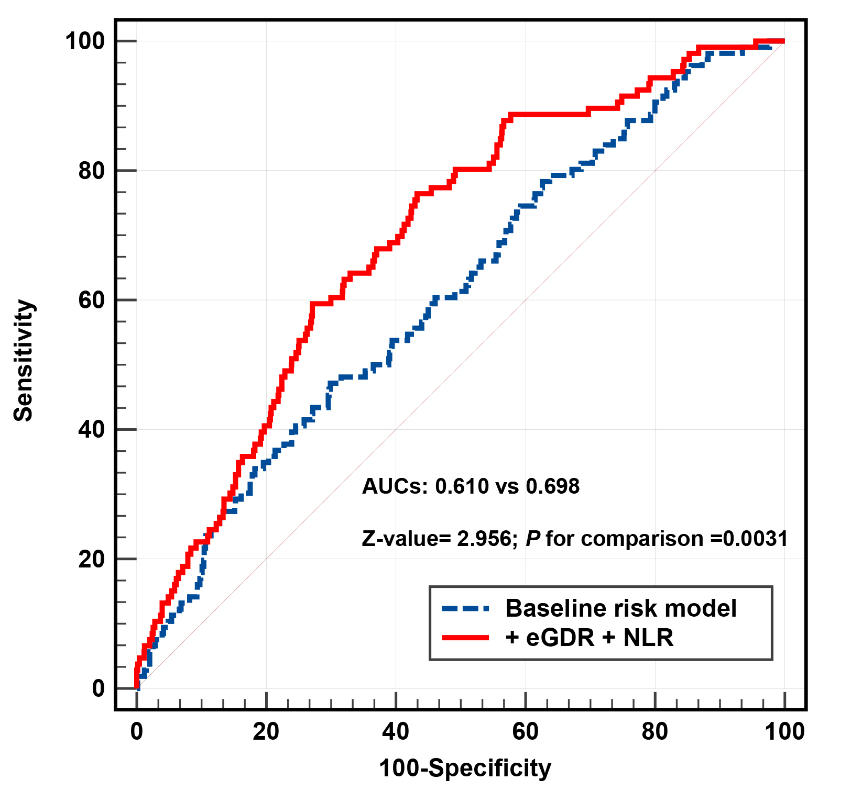
(A) ROC curve analysis of eGDR and NLR for cardiac death/nonfatal MI; (B) baseline risk model vs. + NLR; (C) baseline risk model vs. + eGDR; (D) baseline risk model vs. + NLR + eGDR.
eGDR, estimated glucose disposal rate; NLR, neutrophil to lymphocyte ratio; MI, myocardial infarction; AUC, area under the curve.
Adjusted model included: Model 3 in multivariate Cox analyses.

Figure S3. C-statistics evaluating incremental effect of eGDR, NLR or eGDR + NLR for TVR beyond baseline risk model
(A) 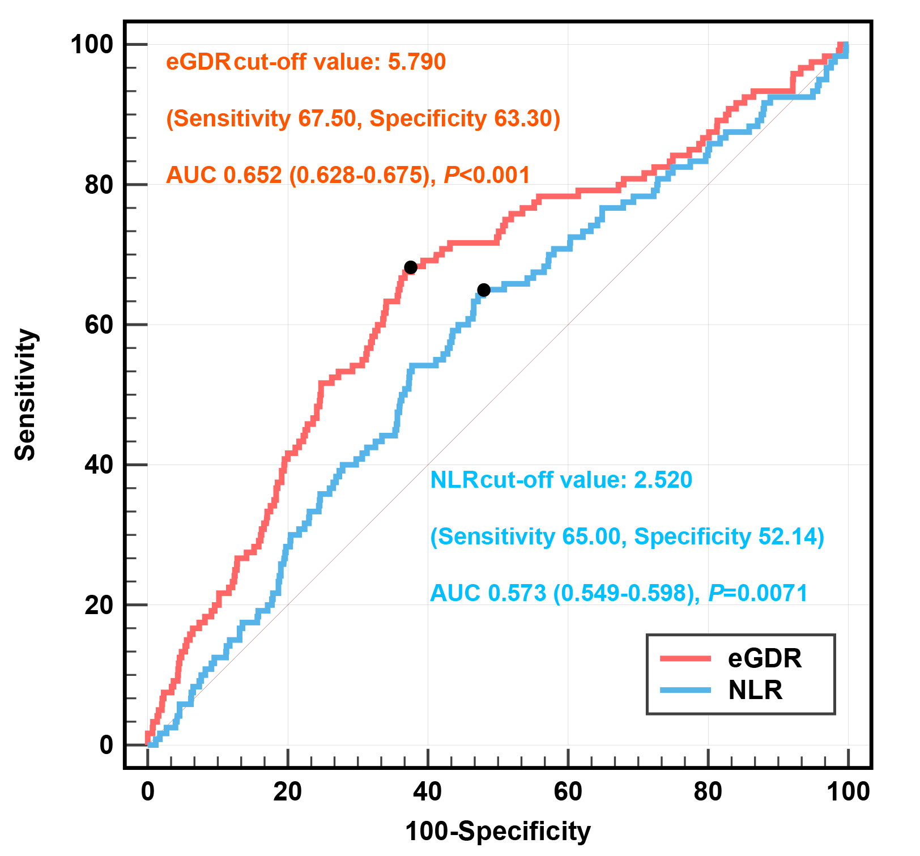 (B)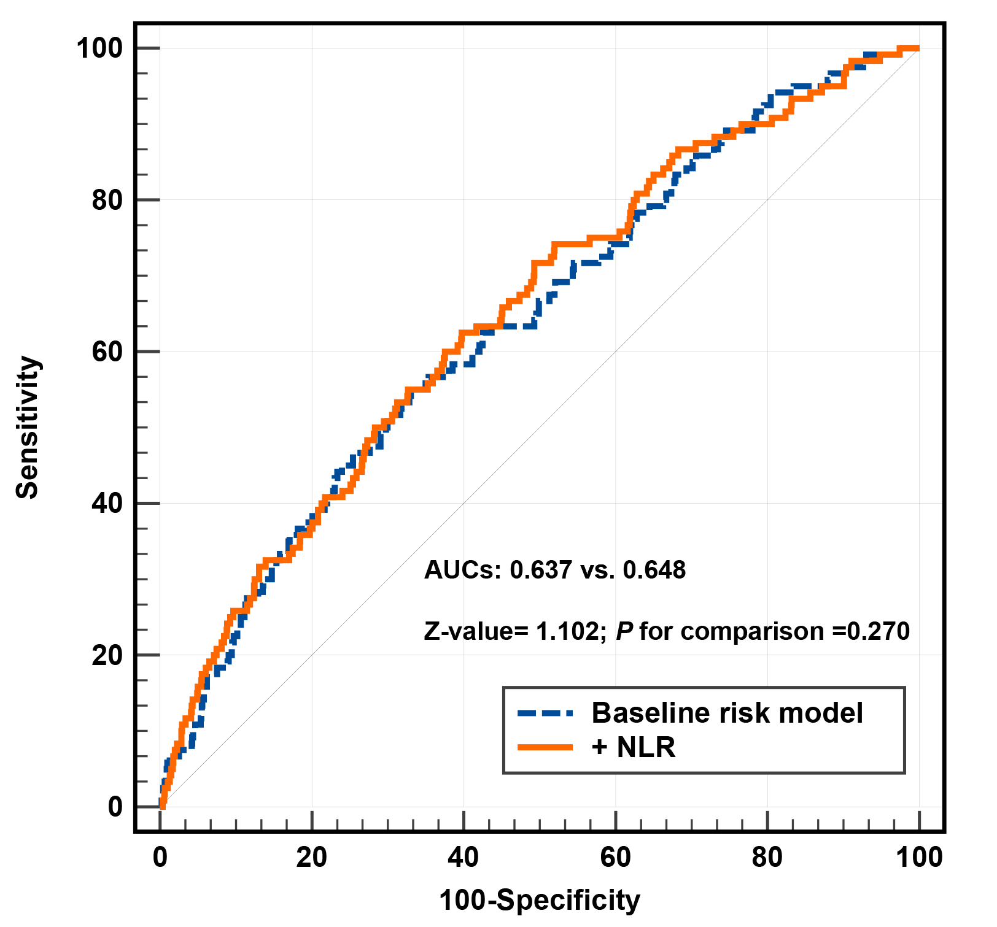
(C) 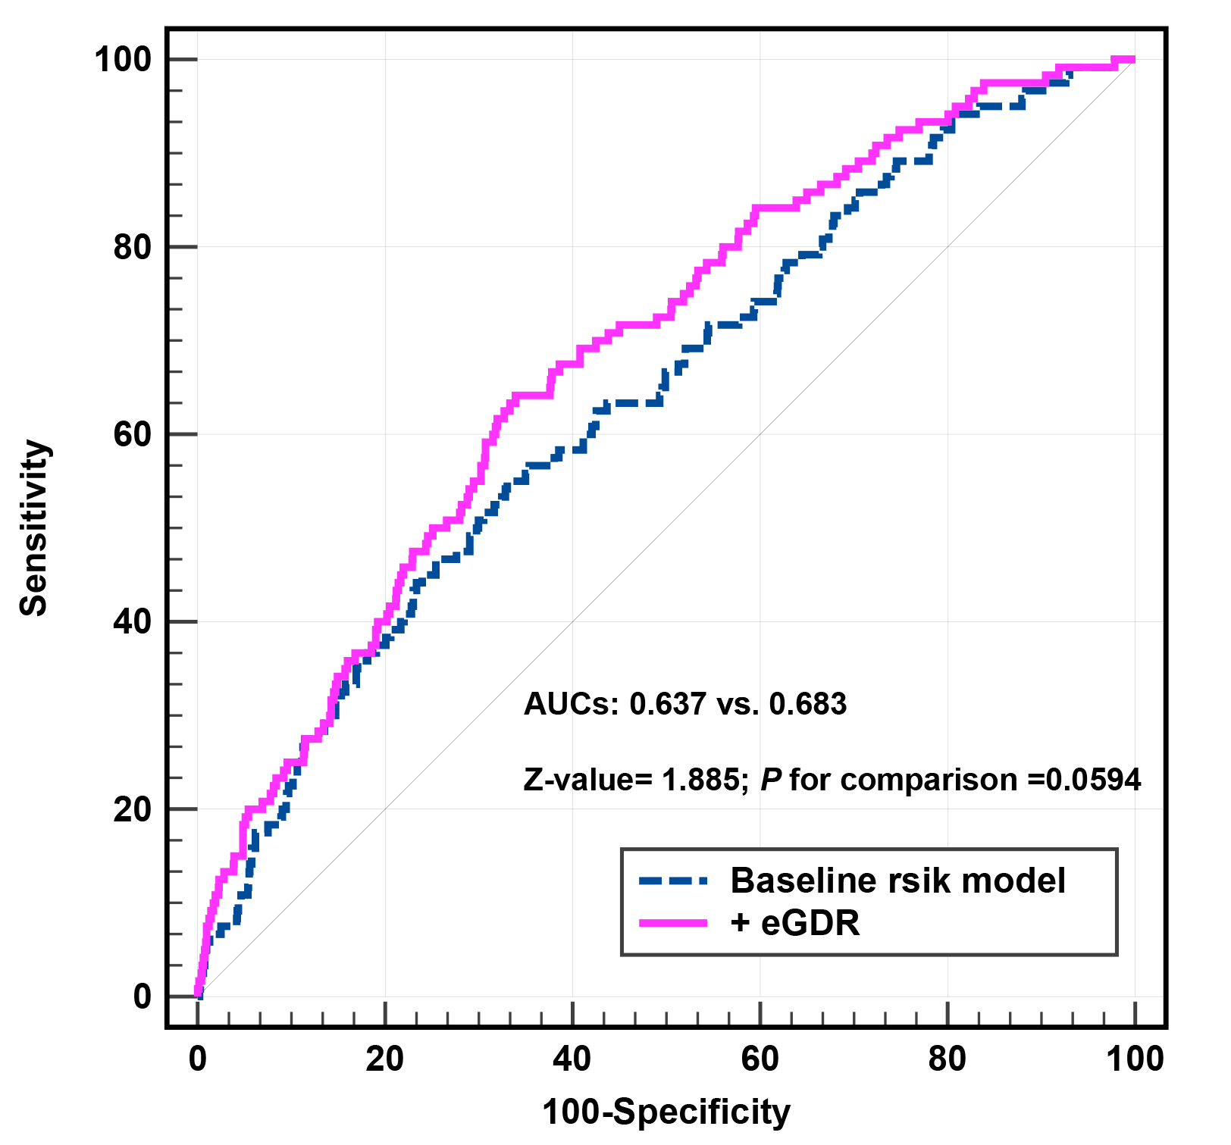 (D)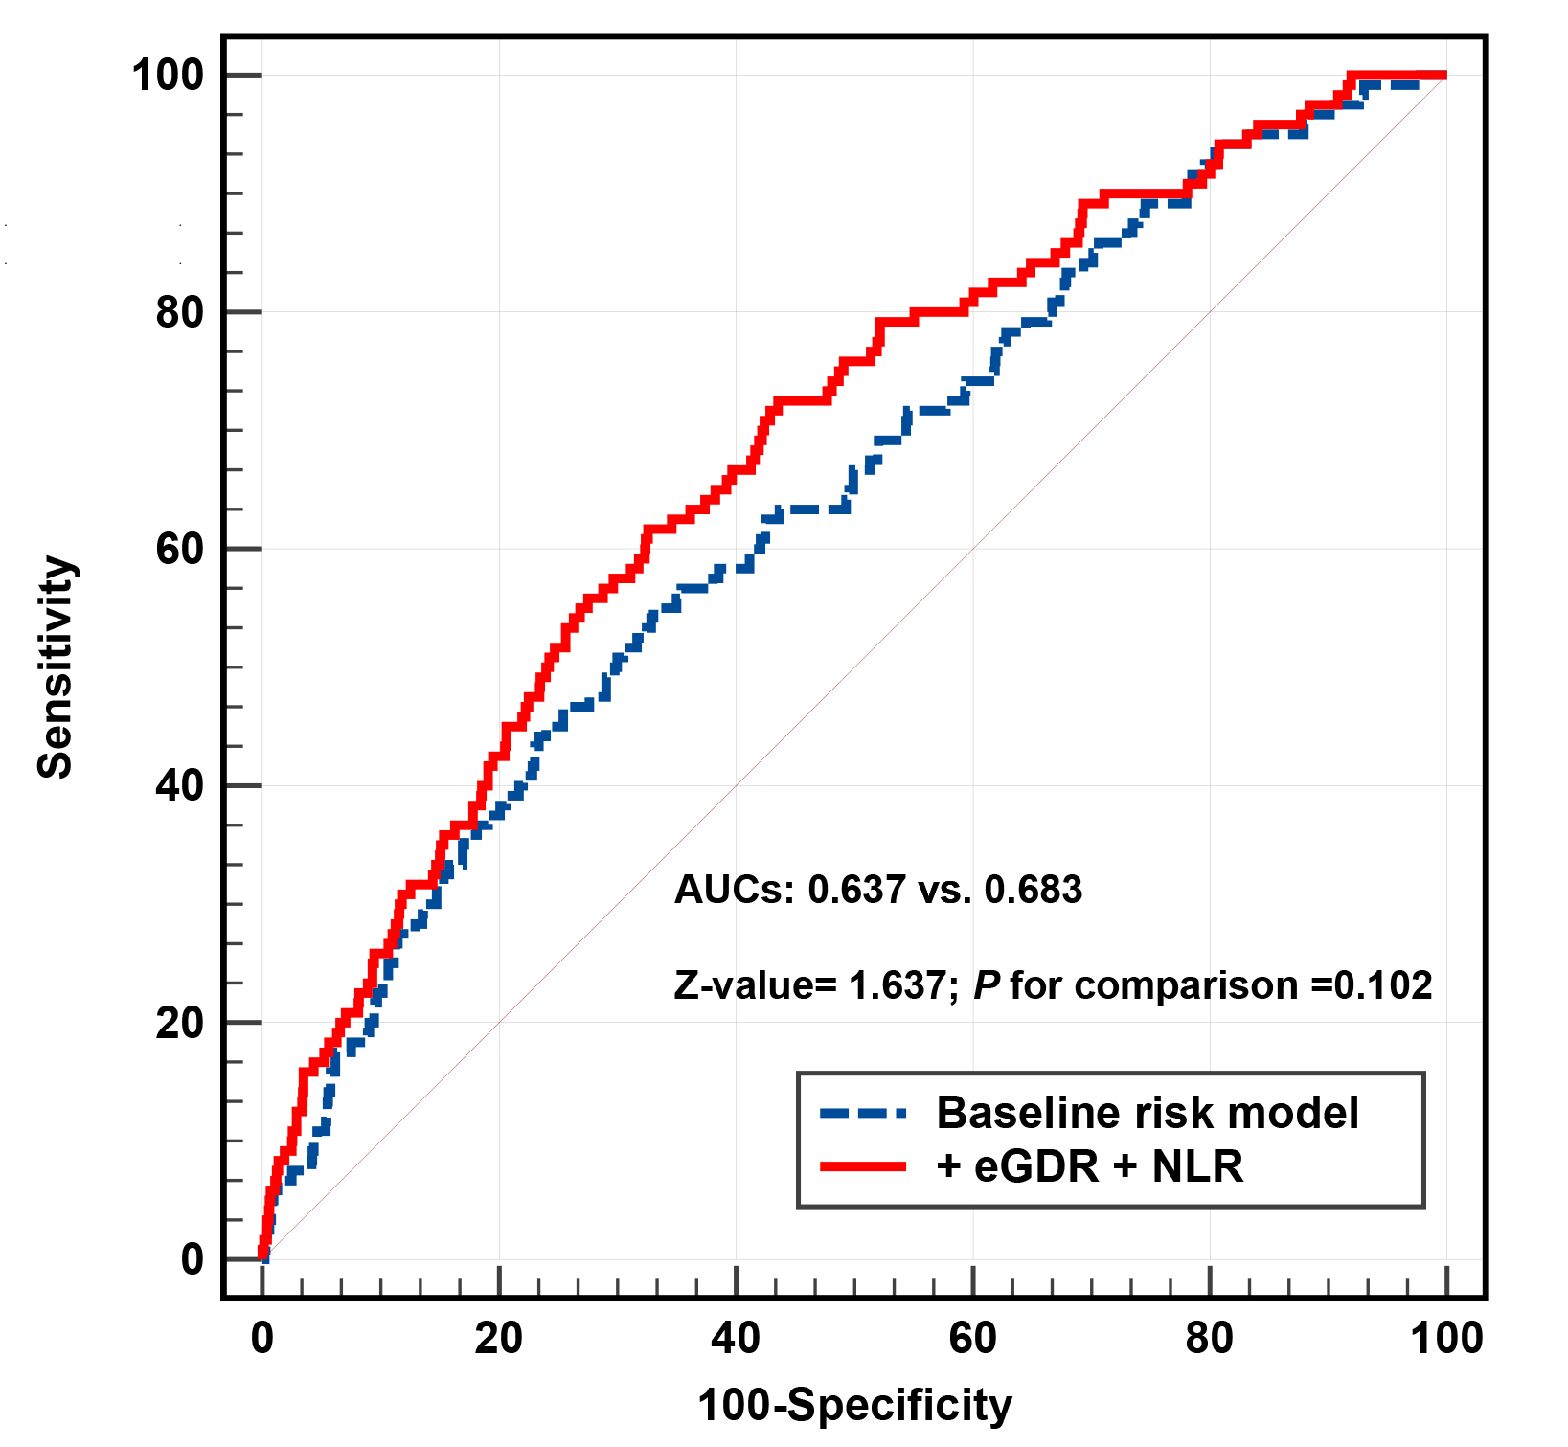
(A) ROC curve analysis of eGDR and NLR for TVR; (B) baseline risk model vs. + NLR; (C) baseline risk model vs. + eGDR; (D) baseline risk model vs. + NLR + eGDR.
eGDR, estimated glucose disposal rate; NLR, neutrophil to lymphocyte ratio; TVR, target vessel revascularization; AUC, area under the curve.
Adjusted model included: Model 3 in multivariate Cox analyses.

Figure S4. C-statistics evaluating incremental effect of eGDR, NLR or eGDR + NLR for nonfatal stroke beyond baseline risk model
(A) 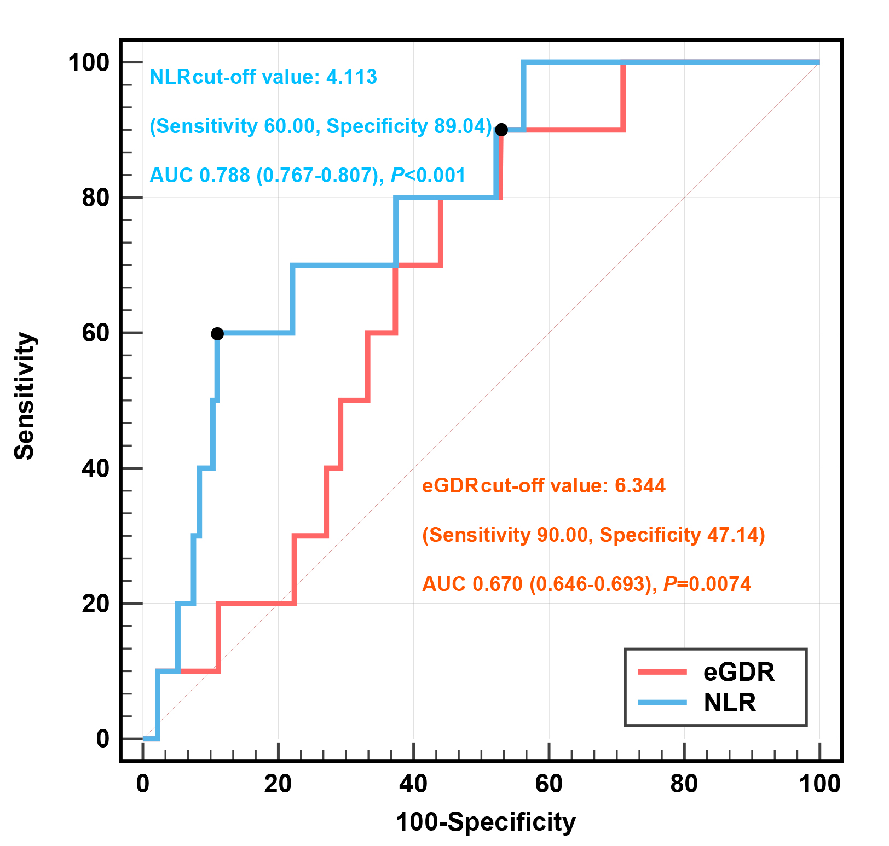 (B)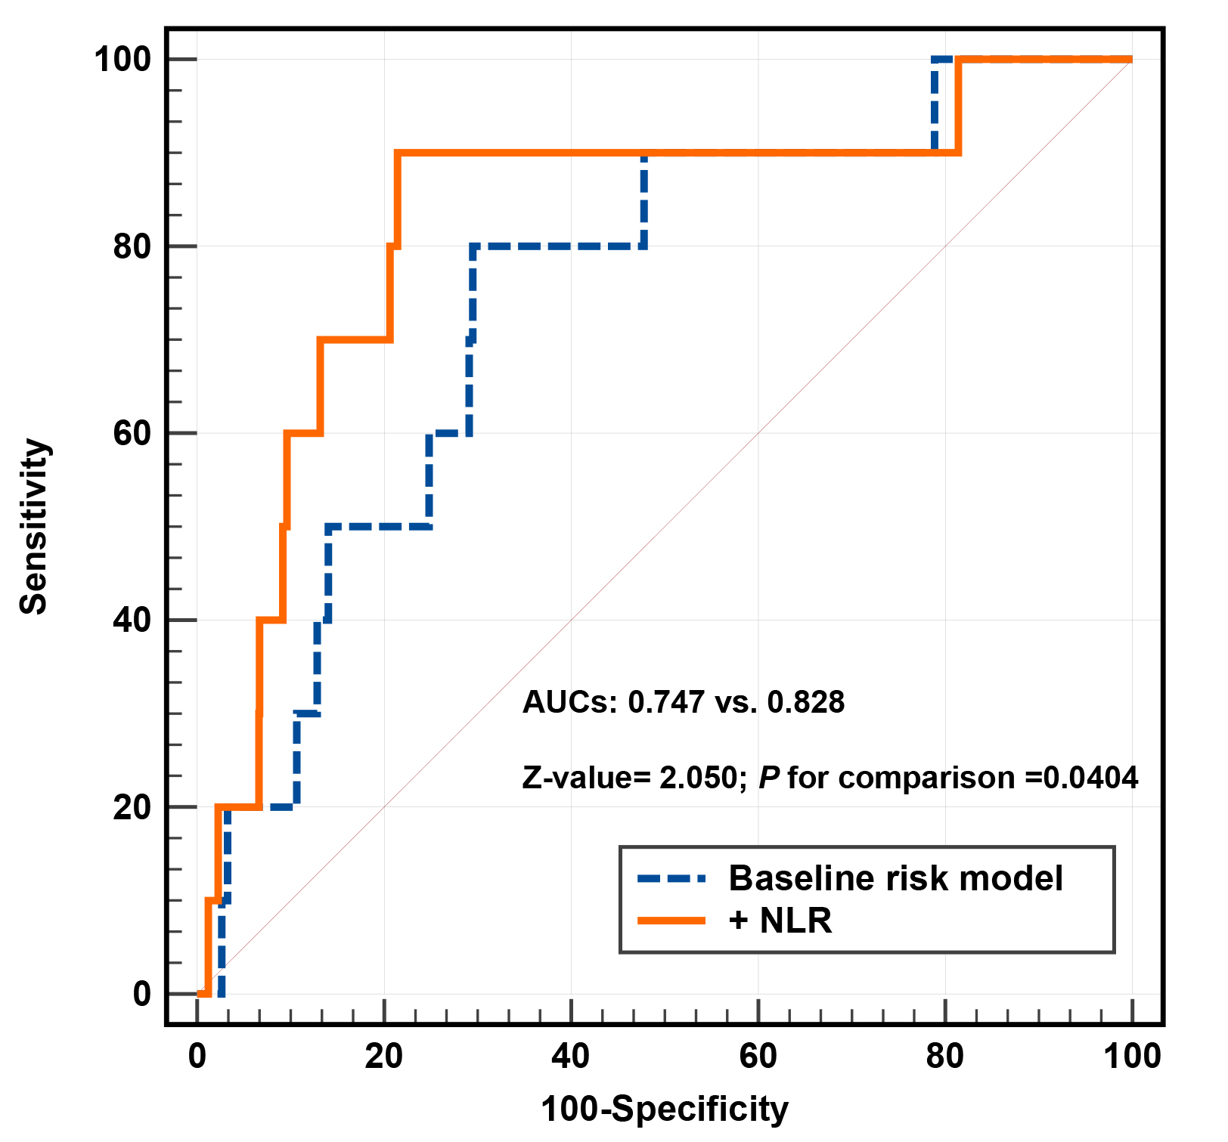
(C) 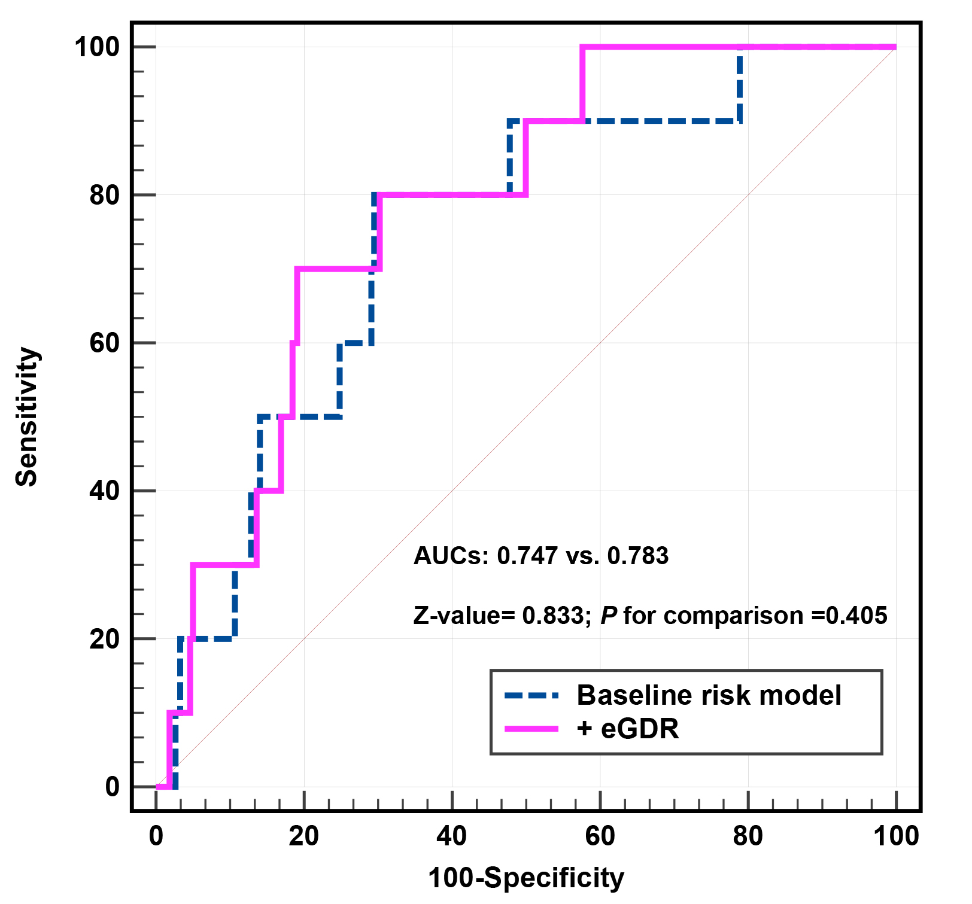 (D)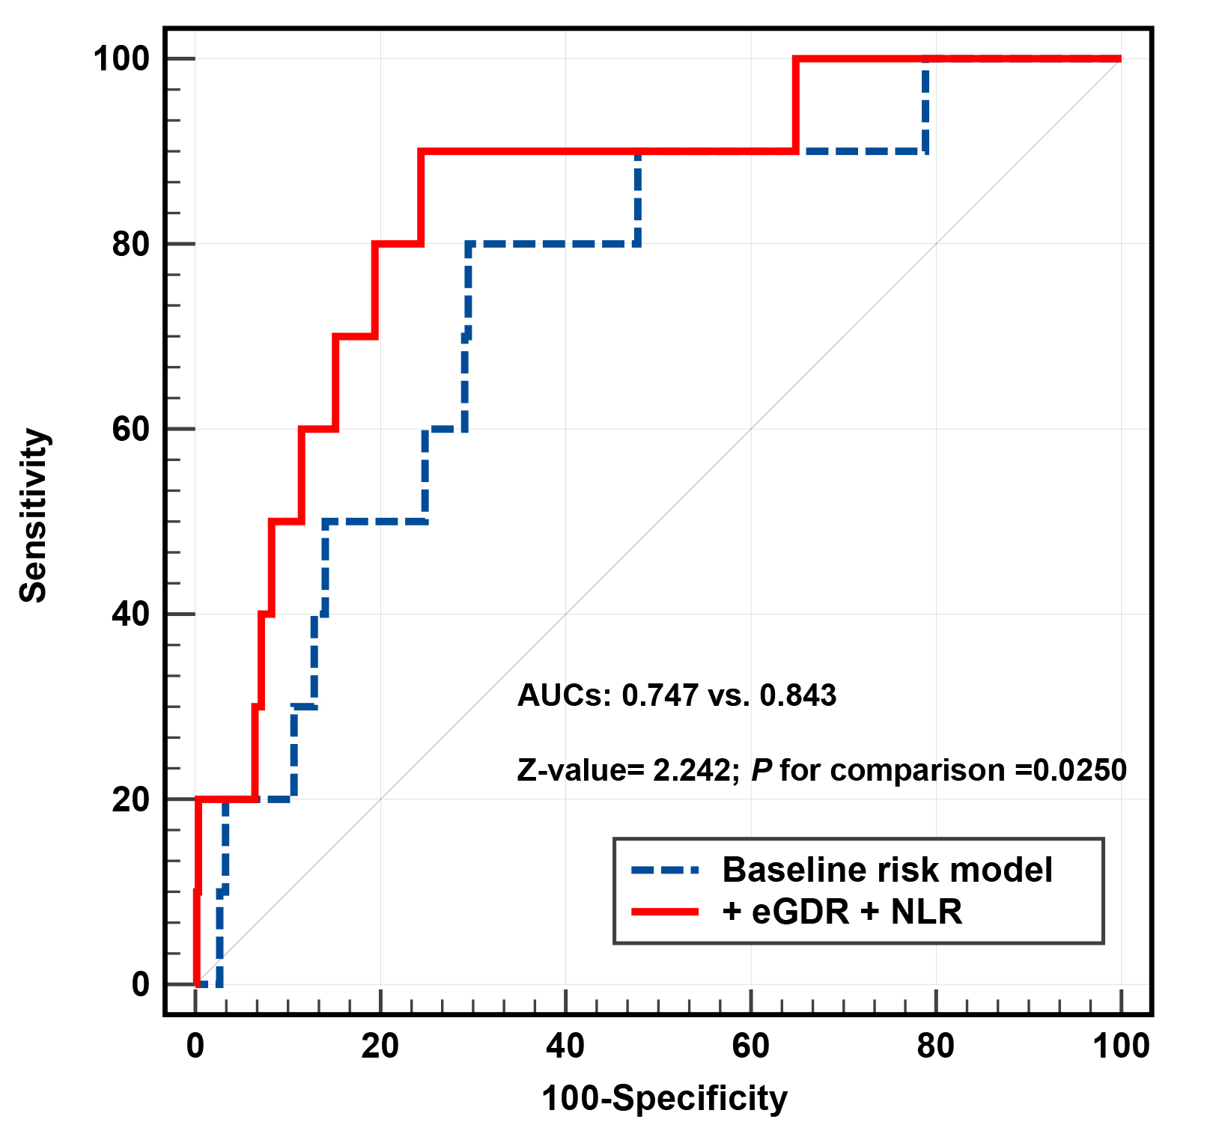
(A) ROC curve analysis of eGDR and NLR for stroke; (B) baseline risk model vs. + NLR; (C) baseline risk model vs. + eGDR; (D) baseline risk model vs. + NLR + eGDR.
eGDR, estimated glucose disposal rate; NLR, neutrophil to lymphocyte ratio; AUC, area under the curve.
Adjusted model included: Model 3 in multivariate Cox analyses.

