1 Material and method
1.1CUMS animal model
To ensure the random unpredictability of stimuli, we administered 1-2 types of stimuli daily, totaling 12 types over the 28-day period: 24-hour water fasting, 24-hour food fasting, 1-hour empty bottle stimulation, 24-hour damp bedding, 24-hour tilting of rat cages at 45°, 24-hour combination of rat cages, 3-minute tail pinching, 3-hour whole-body restraint, 24-hour placement of foreign objects in cages, 10 instances of plantar electrostimulation at 1mA for 10 seconds each, 85dB noise stimulation for 3 hours with intermittent intervals, and 5-hour strobe light stimulation at 120 times per minute. Each stimulus occurred non-consecutively, limited to a maximum of 3 occurrences. Throughout this period, normal control rats remained in their usual environment.
1.2Primer sequence
Gene target | Forward sequence(5’ to 3’) | Reverse sequence(5’ to 3’)
APLN | AGAAGAAGGCAACATGCGCT | GGAGAGCCCTTCAATCCTGCT
LEP | TTTCACACACGCAGTCGGT | CTGCAGCACGTTTTGGGAAG
MHC Ⅱ | TGTGAGATACCAGGAGGTGATG | TCTCTGCTGAGGTGAAGAGC
TLR2 | TGGAGGTCTCCAGGTCAAATC | ACAGAGATGCCTGGGCAGAAT
TLR4 | CTGAGCTTCAACCCCCTGAA | TGTCTCAATTTCACACCTGGAT

2 Result
2.1Immune cell correlation analysis
We analyzed correlations between 24 immune cells. Strong positive correlations were found between Tr1 and CD4_T (r=0.95, p<0.001), nTreg and Tr1 (r=0.80, p<0.001), and Gamma_delta and CD8_T (r=0.66, p=0.001). Conversely, strong negative correlations were observed between Neutrophil and Gamma_delta (r=-0.65, p=0.001), Monocyte and DC (r=-0.67, p<0.001), and CD4_T and NK (r=-0.61, p=0.003) (Figure 4F).
2.2 CIBERSORT analysis
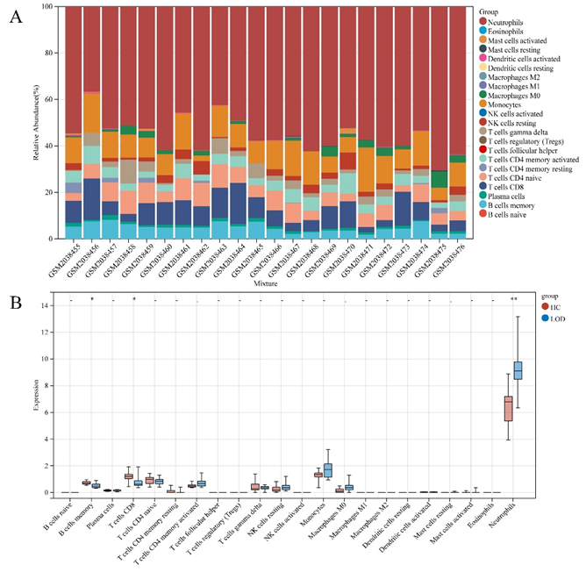
Figure S1 Immune infiltration analysis by CIBERSORT. (A) Stacked bar plots showing the proportion of each 22 subtypes of immune cells. (E) Violin plots of the abundance of 22 immune-cell subtypes between HC and LOD.

Table S1 Details of the RNA expression profile datasets
Dataset | Platform | PMID | LOD/HC | Sample  type | Gender  (female/male) | Age  (mean ± SD)
GSE76826 | GPL17077  Agilent-039494 SurePrint G3 Human GE v2 8x60K Microarray 039381 (Probe Name version) | 26926397 | 10/12 | blood | 13/9 | 65.6±11.02

Table S2 GSEA analysis
Term | NES | pvalue | FDR
EPITHELIAL_CELL_SIGNALING_IN_HELICOBACTER_PYLORI_INFECTION | -1.6913 | 0 | 0.1234
FC_GAMMA_R_MEDIATED_PHAGOCYTOSIS | -1.7418 | 0.002 | 0.0828
LEISHMANIA_INFECTION | -1.8449 | 0.002 | 0.1244
MAPK_SIGNALING_PATHWAY | -1.5686 | 0.002 | 0.1536
TYPE_II_DIABETES_MELLITUS | -1.6547 | 0.0039 | 0.1177
O_GLYCAN_BIOSYNTHESIS | -1.7633 | 0.004 | 0.1097
NOD_LIKE_RECEPTOR_SIGNALING_PATHWAY | -1.6139 | 0.0063 | 0.1149
FRUCTOSE_AND_MANNOSE_METABOLISM | -1.665 | 0.0078 | 0.1361
TOLL_LIKE_RECEPTOR_SIGNALING_PATHWAY | -1.7554 | 0.0081 | 0.0881
JAK_STAT_SIGNALING_PATHWAY | -1.4462 | 0.0081 | 0.1651
RIG_I_LIKE_RECEPTOR_SIGNALING_PATHWAY | -1.6282 | 0.012 | 0.117
REGULATION_OF_ACTIN_CYTOSKELETON | -1.4558 | 0.0122 | 0.1577
INOSITOL_PHOSPHATE_METABOLISM | -1.6156 | 0.0146 | 0.1221
ERBB_SIGNALING_PATHWAY | -1.5082 | 0.0157 | 0.1601
PHOSPHATIDYLINOSITOL_SIGNALING_SYSTEM | -1.4594 | 0.0182 | 0.1666
ADIPOCYTOKINE_SIGNALING_PATHWAY | -1.5215 | 0.0186 | 0.1635
GLYCOSAMINOGLYCAN_DEGRADATION | -1.5436 | 0.0202 | 0.1662
ENDOCYTOSIS | -1.5068 | 0.0204 | 0.1557
REGULATION_OF_AUTOPHAGY | -1.4828 | 0.0207 | 0.1575
GNRH_SIGNALING_PATHWAY | -1.486 | 0.0231 | 0.1644
ALZHEIMERS_DISEASE | -1.5798 | 0.0248 | 0.1493
GLYCOSAMINOGLYCAN_BIOSYNTHESIS_CHONDROITIN_SULFATE | -1.4967 | 0.0264 | 0.1567
GLYCEROPHOSPHOLIPID_METABOLISM | -1.403 | 0.0267 | 0.1804
RIBOFLAVIN_METABOLISM | -1.5227 | 0.0323 | 0.1697
CHEMOKINE_SIGNALING_PATHWAY | -1.4852 | 0.0329 | 0.1598
PARKINSONS_DISEASE | -1.7736 | 0.0331 | 0.146
STARCH_AND_SUCROSE_METABOLISM | -1.4741 | 0.0348 | 0.1585
GLYCOSAMINOGLYCAN_BIOSYNTHESIS_HEPARAN_SULFATE | -1.4334 | 0.0353 | 0.1716
INSULIN_SIGNALING_PATHWAY | -1.5142 | 0.0363 | 0.1589
ETHER_LIPID_METABOLISM | -1.3742 | 0.0376 | 0.183
NEUROTROPHIN_SIGNALING_PATHWAY | -1.5495 | 0.0409 | 0.1688
NICOTINATE_AND_NICOTINAMIDE_METABOLISM | -1.4573 | 0.0425 | 0.1601
ALDOSTERONE_REGULATED_SODIUM_REABSORPTION | -1.3815 | 0.043 | 0.1845
PANCREATIC_CANCER | -1.5038 | 0.0439 | 0.1535
ENDOMETRIAL_CANCER | -1.5434 | 0.0439 | 0.1578
HUNTINGTONS_DISEASE | -1.6511 | 0.0461 | 0.1091
PROSTATE_CANCER | -1.4209 | 0.0466 | 0.1745
CHRONIC_MYELOID_LEUKEMIA | -1.5157 | 0.0468 | 0.1645
RENAL_CELL_CARCINOMA | -1.5296 | 0.0499 | 0.1686

Table S3 The interacting genes for APLN and LEP
Genes
NMU
APLN
NUCB2
NPY5R
PYY
PMCH
HCRT
LEP
GHRL
AGRP
RETNLB
ITLN1
NPB
SERPINA12
RBP4
FNDC5
NPY4R
NMS
NPW
RARRES2
APELA
CCL24
CCL23

Table S4 Top five compounds
Score | ID | Name | Description
99.86 | BRD-K48735772 | PD-158780 | EGFR inhibitor
99.82 | BRD-K97399794 | quercetin | Polar auxin transport inhibitor
99.72 | BRD-A76093993 | cromakalim | Potassium channel activator
99.65 | BRD-A36066264 | estradiol-benzoate | Estrogen receptor agonist
99.65 | BRD-K43405658 | tyrphostin-AG-527 | Protein tyrosine kinase inhibitor

